GOVERNMENT ARTS COLLEGE, TRICHY – 22

NAAN MUDHALVAN

SCRIPT - CONTROLLED ACL Restrict Record Access Based on Field Value

Phase-Wise Project Document

Project Team

Role | Name
Team Leader | Bhavani U
Team Member | Anish Fathima B
Team Member | Vimala T
Team Member | Krishna Veni M

Project Overview
This project demonstrates how ServiceNow record-level ACLs can be used to control access to records according to user roles and a field-based scenario. The main example focuses on EEE branch records in the Institution Details table. The project separates access into READ, CREATE, WRITE and DELETE operations so that each permission can be configured and verified independently.
The supplied project scenario uses the roles bb1, bb2, bb3 and bb4. The READ scenario requires bb1 and uses the EEE branch condition together with the supplied script. Additional roles progressively provide CREATE, WRITE and DELETE permissions. Administrators retain full READ access through the supplied script.

Project Objective
- Create a test user and the required security roles.
- Create a custom Institution Details table and sample records for ECE, EEE and CSE branches.
- Configure ACLs for READ, CREATE, WRITE and DELETE operations.
- Verify access by impersonating users with different role combinations.
- Document the implementation, testing evidence and final access behavior.

Expected Learning Outcome
The project provides practical understanding of the relationship between users, roles, ACL operations, conditions, scripts, impersonation and record access. It also shows how security rules can be applied consistently to protect institutional records.

1. Phase 1 – Brainstorming and Ideation
The first phase identifies the security problem and converts it into a small ServiceNow implementation. The project is based on the need to prevent every user from viewing or modifying all institutional records. Instead, access is controlled through defined roles and an ACL rule that focuses on the Branch value.

Problem Identified
- Different users require different levels of access to institutional and student-related records.
- Record visibility should be controlled by explicit security rules rather than being open to every user.
- Administrators must retain access for administration and verification.
- The project should demonstrate all four major record operations: READ, CREATE, WRITE and DELETE.
- The access model should be simple enough to test through impersonation and visible list actions.

Proposed Idea
- Create the u_institution_details table with ECE, EEE and CSE sample records.
- Create the roles bb1, bb2, bb3 and bb4 and assign them to the test user.
- Use bb1 for the READ scenario and apply the EEE branch rule.
- Use bb2, bb3 and bb4 to progressively control CREATE, WRITE and DELETE.
- Verify each stage by checking which records and actions are available to the impersonated user.

Security Concept
An ACL determines whether a user is allowed to perform a particular operation on a record or table. In this project, the important distinction is between the operation being tested and the user's role. READ controls visibility, CREATE controls creation, WRITE controls modification, and DELETE controls deletion.

Project Scope
The supplied reference limits the implementation to one custom table, one main field-based READ scenario and three additional operation-specific ACLs. The objective is demonstration and verification of access behavior rather than a large application build.
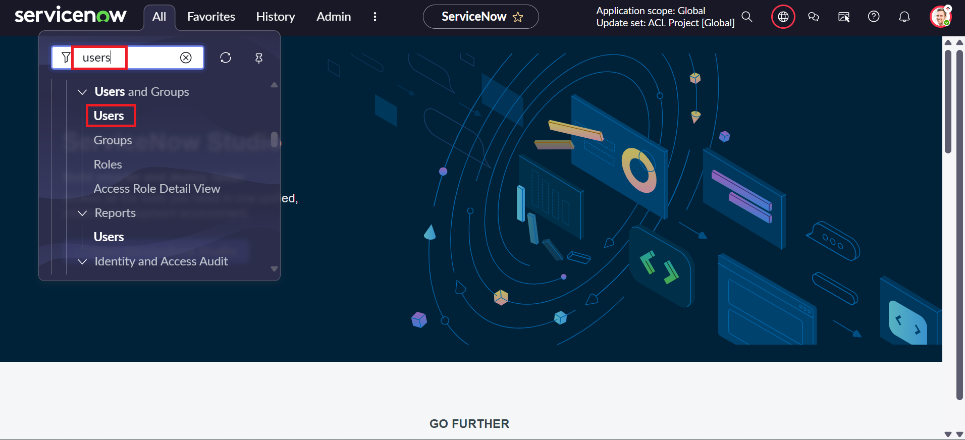
Reference screenshot – ServiceNow interface/configuration.

2. Phase 2 – Requirement Analysis

Functional Requirements
ID | Requirement
FR1 | Create the test user EEE User.
FR2 | Create roles bb1, bb2, bb3 and bb4.
FR3 | Assign the required roles to EEE User.
FR4 | Create Institution Details table u_institution_details.
FR5 | Create required fields including Branch: ECE, EEE, CSE.
FR6 | Create sample records with different branch values.
FR7 | Create READ ACL using bb1 and the EEE condition/script.
FR8 | Create CREATE ACL using bb2.
FR9 | Create WRITE ACL using bb3.
FR10 | Create DELETE ACL using bb4.
FR11 | Verify access using impersonation and record lists.

Data Requirements
Field | Type / Value
Student Roll Number | Auto Number
Student Name | Reference – User
Faculty Name | Reference – User
Branch | Choice: ECE, EEE, CSE
Email | String
Phone Number | String
Description | Multi String

Role Requirements
Role | Purpose
bb1 | READ access
bb2 | CREATE permission
bb3 | WRITE permission
bb4 | DELETE permission
admin | Full access through the supplied READ script

3. Phase 3 – Project Design

System Design
The design connects a test user to a set of roles, then connects those roles to operation-specific ACLs on the Institution Details table. The Branch field provides the business value used in the READ scenario.

Component Design
Component | Design
Test User | EEE User
Roles | bb1, bb2, bb3, bb4
Custom Table | Institution Details – u_institution_details
Branch Values | ECE, EEE, CSE
READ | bb1 + EEE branch condition/script
CREATE | bb2
WRITE | bb3
DELETE | bb4

Access Flow
User → Role Check → ACL Operation → Condition / Script Evaluation → Allow or Deny

Design Principle
Permissions are incremental. The first stage establishes the READ scenario through bb1 and the EEE branch rule. The second stage adds CREATE through bb2. The third stage adds WRITE through bb3, and the final stage adds DELETE through bb4. This makes it possible to demonstrate exactly how each additional role changes the available operation.

Access Model
- bb1: intended READ access for EEE records in the supplied scenario.
- bb1 + bb2: READ plus CREATE.
- bb1 + bb2 + bb3: READ plus CREATE plus WRITE.
- bb1 + bb2 + bb3 + bb4: READ plus CREATE plus WRITE plus DELETE.
- admin: all records are visible in the supplied READ script.
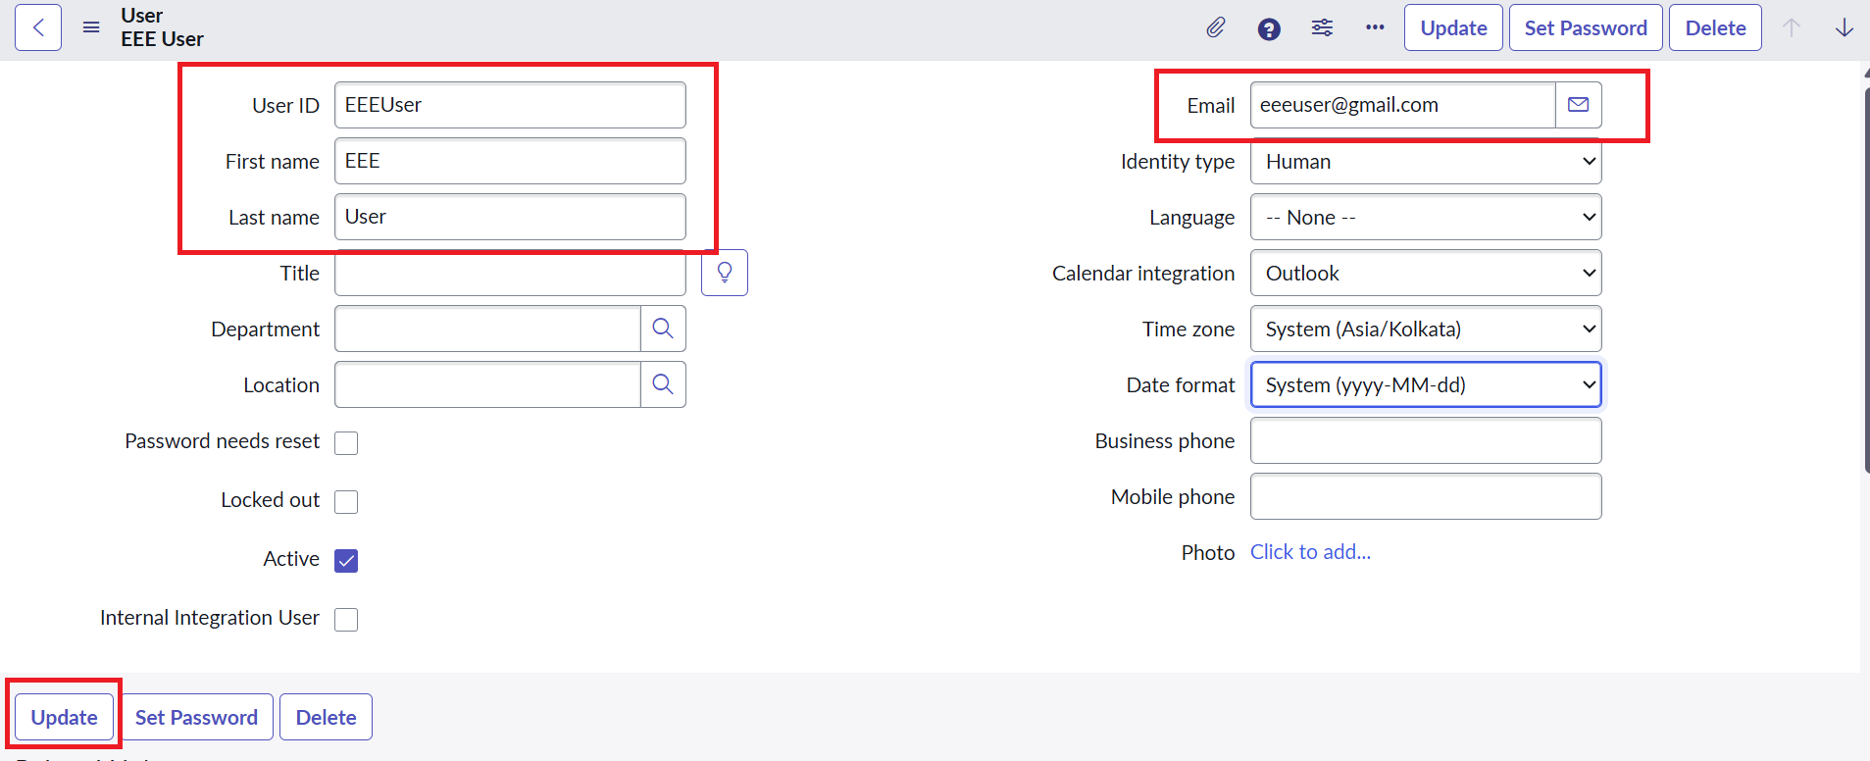
Reference screenshot – user/security configuration.

4. Phase 4 – Project Planning
The project is planned as a short, milestone-driven ServiceNow implementation. The supplied reference specifies a three-hour timer. Work is arranged so that configuration is completed first and verification follows immediately after each ACL stage.

Order of Planned Work
- Create EEE User and roles bb1–bb4.
- Create the u_institution_details table and required fields.
- Create sample records containing ECE, EEE and CSE Branch values.
- Configure and test the READ ACL.
- Configure and test the CREATE ACL.
- Configure and test the WRITE ACL.
- Configure and test the DELETE ACL.
- Capture evidence and prepare the final demonstration.

Milestone Mapping
Milestone | Activity
1 | Creation of Users and Roles
2 | Tables Creation
3 | ACL – READ
4 | ACL – CREATE
5 | ACL – WRITE
6 | ACL – DELETE
7 | Conclusion

Planning Considerations
- Keep the role names consistent with the supplied reference so testing results are easy to compare.
- Create records for all three branch values before testing the READ condition.
- Verify each ACL after saving it rather than waiting until the end of the project.
- Use impersonation to observe the application from the perspective of the test user.
- Capture screenshots of configuration and results as evidence for documentation and demonstration.
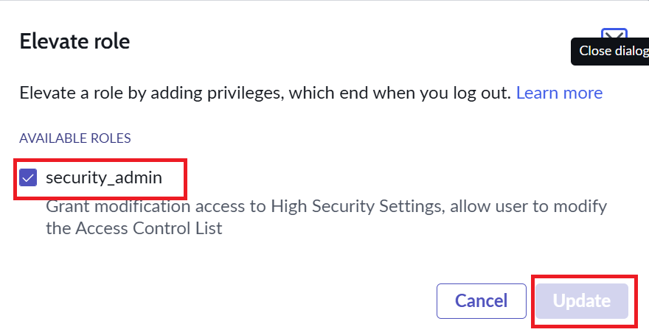
Reference screenshot – role/security setup.

5. Phase 5 – Project Development

Milestone 1 – Creation of Users and Roles
- Open User Administration → Users → New.
- Create the test user with User ID: EEE User; First name: EEE; Last name: User; Email: eeeuser@gmail.com.
- Open User Administration → Roles and create bb1, bb2, bb3 and bb4.
- Assign the roles to EEE User as specified in the project.

Milestone 2 – Creation of the Table
- Open System Definition → Tables → New.
- Set Label to Institution Details and Name to u_institution_details.
- Set Extends for to false.
- Add Student Roll Number, Student Name, Faculty Name, Branch, Email, Phone Number and Description.
- Create sample records using ECE, EEE and CSE values in the Branch field.

Milestone 3 – READ ACL
Open System Security → Access Control (ACL) and elevate Security_admin as required by the supplied procedure. Configure a record ACL for the u_institution_details table with Operation = read, Active = true and Advanced = true. Set the required role to bb1 and use the Branch is EEE data condition.
The supplied script is:
(function () {
if (gs.hasRole('admin')) return true;
if (gs.hasRole('bb1')) return true;
return false;
})();
The script explicitly allows an administrator and allows a user with bb1. The project verification then checks the EEE branch scenario and confirms that users without the required role do not receive the intended access.

5. Phase 5 – Project Development (Continued)

READ Verification
- Impersonate EEE User and open the u_institution_details list.
- Verify that the bb1 scenario can view EEE branch records.
- Verify that a user without the required role cannot view the records.
- Impersonate Admin and verify that all records are visible.

Milestone 4 – CREATE ACL
- Create a record ACL for u_institution_details with Operation = create and Active = true.
- Set Requires role to bb2; the supplied reference specifies no Data condition for this ACL.
- Verify that bb1 + bb2 has New/create permission while retaining the READ behavior.

Milestone 5 – WRITE ACL
- Create a record ACL for u_institution_details with Operation = Write and Active = true.
- Set Requires role to bb3; the supplied reference specifies no Data condition for this ACL.
- Verify that bb1 + bb2 + bb3 can view and edit EEE branch records.

Milestone 6 – DELETE ACL
- Create a record ACL for u_institution_details with Operation = Delete and Active = true.
- Set Requires role to bb4; the supplied reference specifies no Data condition for this ACL.
- Verify that bb1 + bb2 + bb3 + bb4 can see, create, edit and delete EEE branch records.

Development Result
At the end of development, the project contains one custom table, the required fields and sample branch records, together with four ACLs that demonstrate progressively controlled operations. The configuration is ready for structured testing through impersonation.
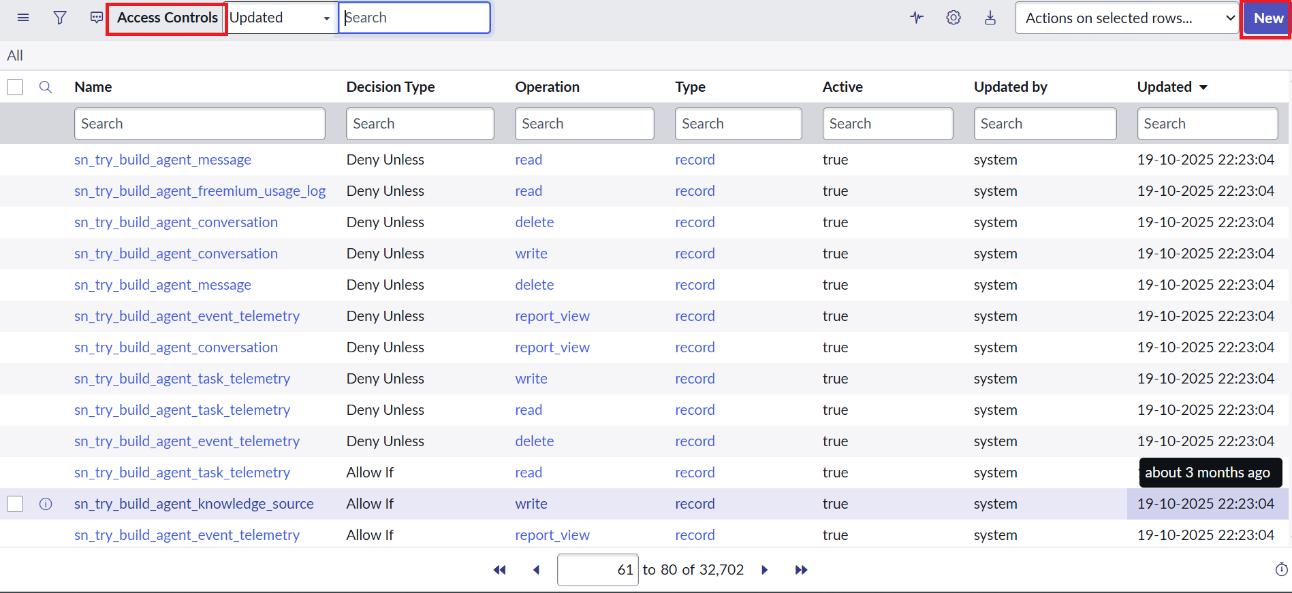
Reference screenshot – ACL/list configuration.

6. Phase 6 – Project Testing
Testing is performed through impersonation by checking visible records and available actions for each role combination. The purpose is to confirm that each ACL adds the intended operation without losing the earlier access behavior described in the project.

Test Cases
Test Case | Roles / User | Operation | Expected Result
TC01 | bb1 | READ | EEE records visible
TC02 | No required role | READ | Records not visible
TC03 | Admin | READ | All records visible
TC04 | bb1 + bb2 | CREATE | New/create available
TC05 | bb1 + bb2 + bb3 | WRITE | EEE records editable
TC06 | bb1 + bb2 + bb3 + bb4 | DELETE | EEE records deletable

Testing Procedure
- Impersonate the required user or role combination.
- Open the u_institution_details list.
- Check which records are visible and which New/Edit/Delete actions are available.
- Add the next role and repeat the verification.
- Impersonate Admin and verify administrative access.
- Record the result and capture screenshots for project evidence.

Security Verification Matrix
Roles | READ | CREATE | WRITE | DELETE
bb1 | EEE records | — | — | —
bb1 + bb2 | EEE records | Granted | — | —
bb1 + bb2 + bb3 | EEE records | Granted | Granted | —
bb1 + bb2 + bb3 + bb4 | EEE records | Granted | Granted | Granted
admin | All records in supplied READ script | Administrative access | Administrative access | Administrative access

Testing Observation
The verification sequence makes the effect of each role visible. READ is established first, then CREATE, WRITE and DELETE are added in order. This provides a clear demonstration of incremental permission control and makes the final access level easy to explain during the project demonstration.

7. Phase 7 – Project Documentation
The documentation phase converts the implementation and testing evidence into a structured project record. A good project document should allow another learner or evaluator to understand the objective, reproduce the main configuration steps and interpret the testing results.

Documentation Contents
- Project title, overview, objective and expected learning outcome.
- Eight-phase project lifecycle from ideation through demonstration.
- User and role creation procedure.
- Custom table and field definitions.
- READ, CREATE, WRITE and DELETE ACL configuration.
- The supplied READ ACL script.
- Verification procedures and the testing matrix.
- Reference screenshots and the final project outcome.

Evidence to Maintain
Evidence | Purpose
User / role configuration | Shows the test user and required roles.
Table and field configuration | Shows the custom Institution Details structure.
READ ACL configuration | Shows role, condition and supplied script.
CREATE / WRITE / DELETE ACLs | Shows operation-specific permissions.
Impersonation results | Shows actual access behavior for each role combination.
Testing matrix | Summarizes expected access at each stage.

Documentation Result
The completed record contains the project idea, requirements, design, implementation steps, script, screenshots, test results and conclusion. The structure also makes the project suitable for a classroom demonstration because each phase can be explained in the same order in which the system was developed.

Eight-Phase Lifecycle Summary
01 Brainstorming and Ideation → 02 Requirement Analysis → 03 Project Design → 04 Project Planning → 05 Project Development → 06 Project Testing → 07 Project Documentation → 08 Project Demonstration

8. Phase 8 – Project Demonstration

Demonstration Flow
- Introduce the project title and explain the security requirement.
- Show the EEE User and roles bb1, bb2, bb3 and bb4.
- Show the u_institution_details table and its fields.
- Demonstrate the READ behavior for EEE User and Admin.
- Demonstrate CREATE after bb2, WRITE after bb3 and DELETE after bb4.
- Show the testing results and explain the final access level.

Demonstration Explanation
The demonstration should proceed from configuration to behavior. First, the evaluator is shown the user, roles and table. Next, the READ ACL is explained, including the EEE branch scenario and the supplied script. The remaining ACLs are then shown in operation order so that the increase in available actions can be observed.

Conclusion / Outcome
The Script-Controlled ACL project demonstrates record-level security in ServiceNow. It begins with user and role creation, continues with the Institution Details table, and applies separate ACLs for READ, CREATE, WRITE and DELETE. The READ scenario uses bb1, the EEE branch condition and the supplied script, while bb2, bb3 and bb4 progressively add CREATE, WRITE and DELETE permissions.
Through impersonation and record-list verification, the project provides practical understanding of how role combinations affect access to records and actions. It demonstrates how ACL configuration can protect records from unauthorized viewing, creation, modification and deletion within the supplied scenario.

References
- Supplied project reference document: Script-Controlled ACL – Restrict Record Access Based on Field Value.
- Supplied project overview showing Milestones 1–7.
- Screenshots reproduced from the supplied reference document.

Final Project Outcome
The completed micro project provides a clear, role-based access model for the Institution Details table. It connects project planning, ServiceNow configuration, scripted access control, testing and demonstration into one documented workflow.

