Digital Circuits

Experiment 1
Familiarisation with Digital Test Kit and Logic Gates

This laboratory session will be devoted to
- getting conversant with the features of the Digital Test Kit to be used for this course, and
- using this Test Kit and a Multimeter to understand the implications of binary logic levels.

Digital Test Kit

As digital circuits are required to handle just two levels of voltage – to represent the two possible values of any binary variable, functional testing of simple digital circuits can be conveniently carried out by applying each input (binary) variable through a switch and observing each output (binary) variable on a simple LED display. Note the number of Input Switches and the number of LED Displays provided in the kit you are using. Each Input Pin is either at LOW (≡ Ground ≅ 0V.) level or at a HIGH (≅ 5V.) level depending on whether the corresponding switch is OFF or ON. Note how the LED glows when the corresponding Display input Pin is at a HIGH level and when it is at a LOW level.
All circuits we will study in this course will need a 5V d-c power supply, and this has been provided in the Digital Test Kit. The Clock Generator provides different choices of the frequency of a continuously running clock.
The circuit to be studied will have to be assembled on the breadboard. Fig. 1.1 shows the schematic of the breadboard. It has 128 vertical strips, 64 on each side of the horizontal divider in the middle, each strip consisting of 5 spring-loaded tie-points internally connected to one another. Each connection among the circuit components is made with the help of tie-points connected together on the same strip. The breadboard also has 8 horizontal strips, four on the top side and 4 on the bottom side, each having 25 tie-points. These strips are generally used for making power supply connections.

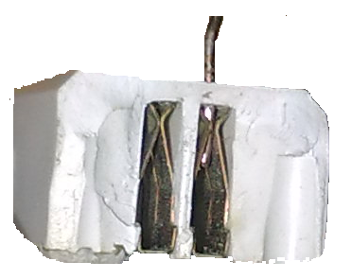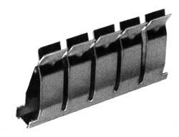

o o o o o o o o o o o o o o o o o o o o o o o o o o o o o o o o o o o o o o o o o o o o o o o o o o
o o o o o o o o o o o o o o o o o o o o o o o o o o o o o o o o o o o o o o o o o o o o o o o o o o
1 5 10 15 20 25 30 35 40 45 50 55 60
A o o o o o o o o o o o o o o o o o o o o o o o o o o o o o o o o o o o o o o o o o o o o o o o o o o o o o o o o o o o o o o o o A
B o o o o o o o o o o o o o o o o o o o o o o o o o o o o o o o o o o o o o o o o o o o o o o o o o o o o o o o o o o o o o o o o B
C o o o o o o o o o o o o o o o o o o o o o o o o o o o o o o o o o o o o o o o o o o o o o o o o o o o o o o o o o o o o o o o o C
D o o o o o o o o o o o o o o o o o o o o o o o o o o o o o o o o o o o o o o o o o o o o o o o o o o o o o o o o o o o o o o o o D
E o o o o o o o o o o o o o o o o o o o o o o o o o o o o o o o o o o o o o o o o o o o o o o o o o o o o o o o o o o o o o o o o E

F o o o o o o o o o o o o o o o o o o o o o o o o o o o o o o o o o o o o o o o o o o o o o o o o o o o o o o o o o o o o o o o o F
G o o o o o o o o o o o o o o o o o o o o o o o o o o o o o o o o o o o o o o o o o o o o o o o o o o o o o o o o o o o o o o o o G
H o o o o o o o o o o o o o o o o o o o o o o o o o o o o o o o o o o o o o o o o o o o o o o o o o o o o o o o o o o o o o o o o H
I o o o o o o o o o o o o o o o o o o o o o o o o o o o o o o o o o o o o o o o o o o o o o o o o o o o o o o o o o o o o o o o o I
J o o o o o o o o o o o o o o o o o o o o o o o o o o o o o o o o o o o o o o o o o o o o o o o o o o o o o o o o o o o o o o o o J
1 5 10 15 20 25 30 35 40 45 50 55 60
o o o o o o o o o o o o o o o o o o o o o o o o o o o o o o o o o o o o o o o o o o o o o o o o o o
o o o o o o o o o o o o o o o o o o o o o o o o o o o o o o o o o o o o o o o o o o o o o o o o o o

Fig. 1.1 Breadboard Schematic

Basic Logic Gates
Two families of digital ICs are commonly used: the TTL 74LSxx series and the CMOS CD 40xx series. Many of these ICs have 14 pins, and some have 16 or more. Two pins are used for power supply connections. Thus 12 pins are available in a 14-pin IC for gate inputs and outputs. A 2-input gate requires three pins per gate (two for inputs and one output), and so ICs that implement 2-input logic functions generally have 4 gates per IC. TTL ICs require a fixed d-c power supply voltage V_{CC} having the nominal value of 5V and a tolerance of 5%, i.e. 4.75V ≤ V_{CC} ≤ 5.25V; a voltage outside this range can damage the IC. Most CMOS ICs can work with 3V ≤ V_{CC} ≤ 15V.

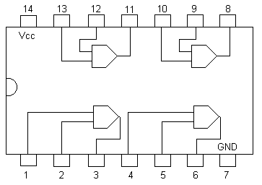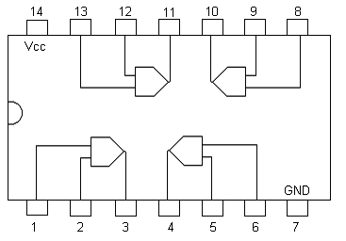
- (b)

Fig. 1.2 Two types of Pin Connections of Quad 2-input Gates

Part A. Familiarisation with the Kit
- Get familiar with the schematic and the usage of the breadboard. Get a feel for the proper grip of the wire inserted into a tie-point.
- Switch on the kit and verify the working of all the LED displays by connecting their inputs to the +5V and Gnd pins alternately. Verify the working of all the Input Switches provided in the kit by connecting their outputs one by one to one of the LED displays and observing the of the glow of the LED for both positions of the Input Switch.

Part B. Gate Identification
Seven different ICs, each consisting of four AND / OR / NAND / NOR gates have been placed on the breadboard. The 3 ICs on the lower breadboard belong to the TTL 74LSxx family and have the pin connections shown in Fig. 1.2(a); the remaining 4 on the upper breadboard belong to the CMOS CD40xx family and have the pin connections shown in Fig. 1.2(b). Find out the logic function of each of the given ICs by proceeding step by step as follows:
- Connect the two horizontal strips on the top of the breadboard to the +5V d-c supply, thereby creating a V_{CC} bus, and similarly connect the two horizontal strips at the bottom of the breadboard to create a Gnd bus.
- Connect the V_{CC} and Gnd pins of one of the given chips to the V_{CC} and Gnd busses. Connect the input pins of one of the four gates in the IC to two input switches, and the output pin of the same gate to an LED display.
- Apply the four possible combinations of (binary) values to the gate inputs one by one by means of the input switches and tabulate the corresponding values of the gate output as observed on the LED display to obtain the truth table of the gate.
- Repeat step B.3 for the other three gates in the same IC and verify that all the four gates in the IC are identical.
- Identify the given ICs by repeating steps 1, 2, and 3 for each IC one by one.

