**MY SQL Assignment**

**1)**

**3)**

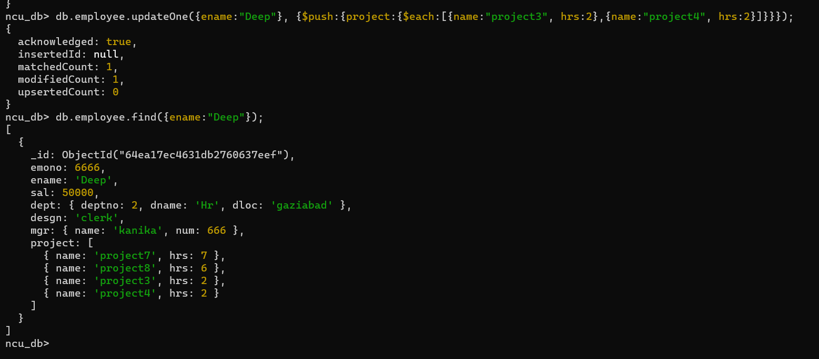

**4)**

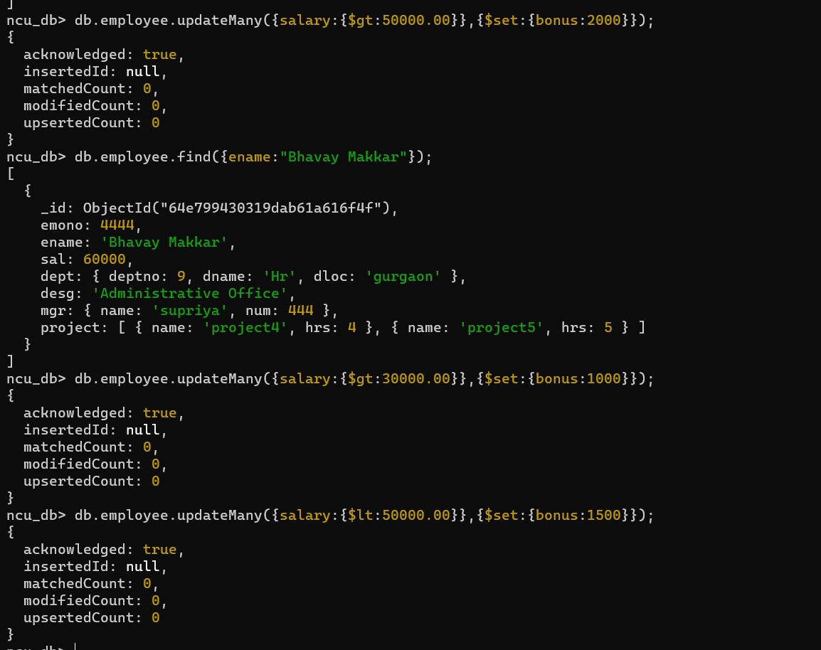

**5)**

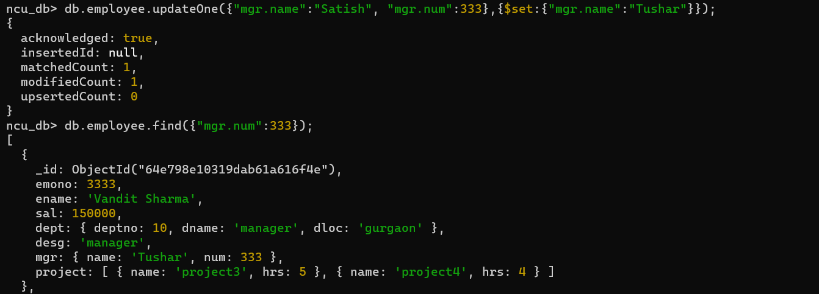

**6)**

**7)**

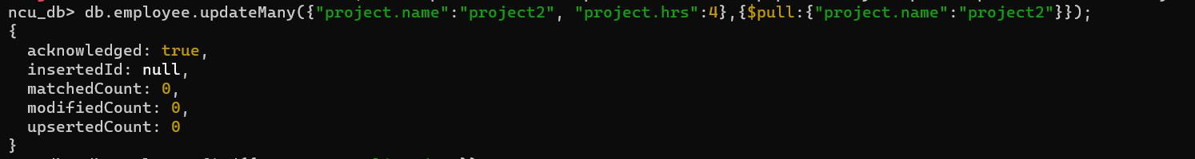

**9)**

**10)**

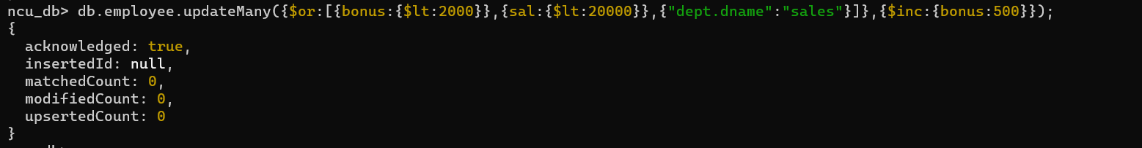

**11)**

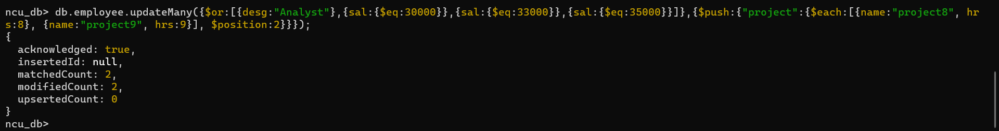

**13)**

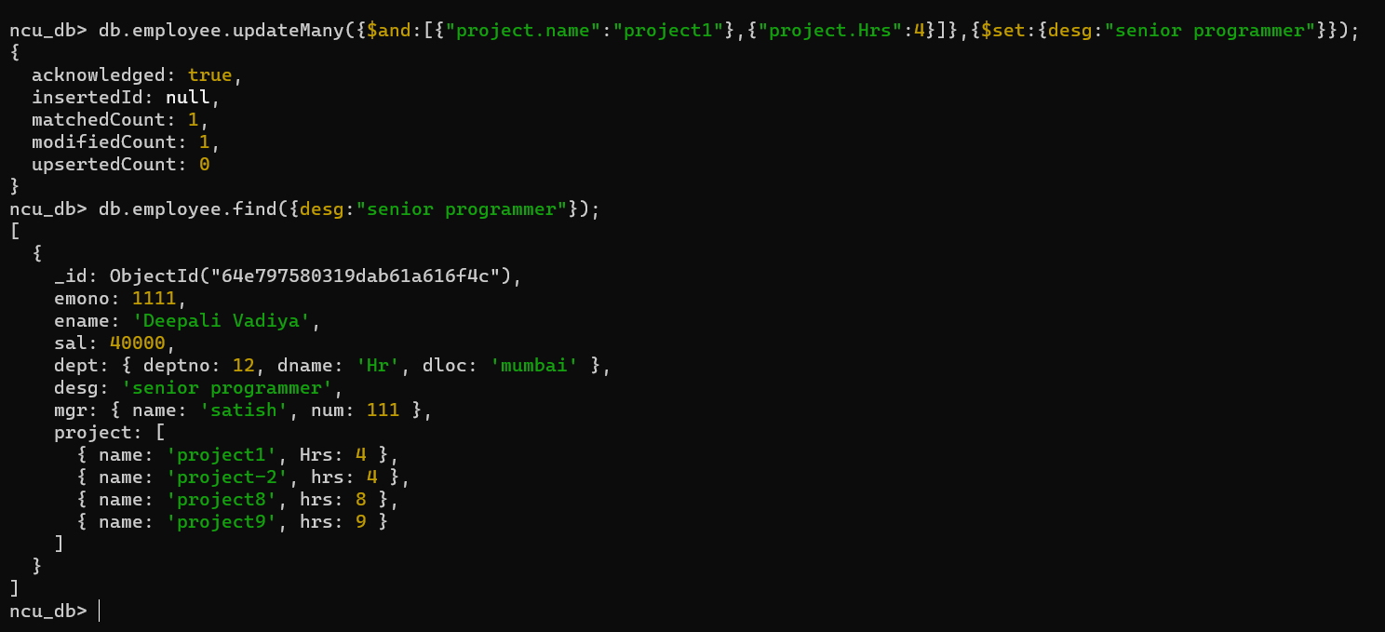

**14)**

