**FEATURE EXTRACTION**

In machine learning, pattern recognition and in image processing, feature extraction starts from an initial set of measured data and builds derived values (features) intended to be informative, non redundant, facilitating the subsequent learning and generalization steps, in some cases leading to better human interpretations. Feature extraction is related to dimensionality reduction.

When the input data to an algorithm is too large to be processed and it is suspected to be redundant (e.g. the same measurement in both feet and meters, or the repetitiveness of images presented as pixels), then it can be transformed into a reduced set of features (also named features vector). This process is called **feature extraction**. The extracted features are expected to contain the relevant information from the input data, so that the desired task can be performed by using this reduced representation instead of the complete initial data.

**MFCC**

Mel Frequency Cepstral Coefficients (MFCCs) are a feature widely used in automatic speech and speaker recognition. They were introduced by Davis and Mermelstein in the 1980's, and have been state-of-the-art ever since. Prior to the introduction of MFCCs, Linear Prediction Coefficients (LPCs) and Linear Prediction Cepstral Coefficients (LPCCs) and were the main feature type for automatic speech recognition (ASR).

**Mel scale**

Psychophysical studies have shown that human perception of the frequency content of sounds, either for pure tones or for speech signals, does not follow a linear scale. This research has led to the idea of defining subjective pitch of pure tones. Thus for each tone with an actual frequency, f, measured in Hz, a subjective pitch is measured on a scale called ''Mel'' scale. As a reference point, the pitch of a 1kHz tone, 40 dB above the perceptual hearing threshold, is defined as 1000 mels. Other subjective pitch values are obtained by adjusting the frequency of a tone such that it is half or twice the perceived pitch of a reference tone (with a known mel frequency). Feature extraction based on Mel Frequency Cepstral Coefficients (MFCC) utilizes the filter bank of which center frequency and bandwidth are scaled by subjective measure, Mel.

The Mel scale relates perceived frequency, or pitch, of a pure tone to its actual measured frequency. Humans are much better at discerning small changes in pitch at low frequencies than they are at high frequencies. Incorporating this scale makes our features match more closely what humans hear.

The formula for converting from frequency to Mel scale is:



To go from Mels back to frequency:



**Basic steps to calculate MFCC**

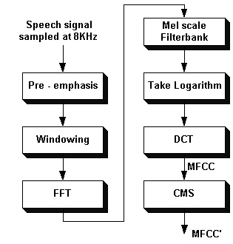

1. Frame the signal into short frames.
2. For each frame calculate the periodogram estimate of the power spectrum.
3. Apply the mel filterbank to the power spectra, sum the energy in each filter.
4. Take the logarithm of all filterbank energies.
5. Take the DCT of the log filterbank energies.
6. Keep DCT coefficients 2-13, discard the rest.

There are a few more things commonly done, sometimes the frame energy is appended to each feature vector. Delta and Delta-Delta features are usually also appended. Liftering is also commonly applied to the final features.

**Detailed analysis of the steps in MFCC**

An audio signal is constantly changing, so to simplify things we assume that on short time scales the audio signal doesn't change much (when we say it doesn't change, we mean statistically i.e. statistically stationary, obviously the samples are constantly changing on even short time scales). This is why we frame the signal into 20-40ms frames. If the frame is much shorter we don't have enough samples to get a reliable spectral estimate, if it is longer the signal changes too much throughout the frame.

The next step is to calculate the power spectrum of each frame. This is motivated by the human cochlea (an organ in the ear) which vibrates at different spots depending on the frequency of the incoming sounds. Depending on the location in the cochlea that vibrates (which wobbles small hairs), different nerves fire informing the brain that certain frequencies are present. Our periodogram estimate performs a similar job for us, identifying which frequencies are present in the frame.

The periodogram spectral estimate still contains a lot of information not required for Automatic Speech Recognition (ASR). In particular the cochlea can not discern the difference between two closely spaced frequencies. This effect becomes more pronounced as the frequencies increase. For this reason we take clumps of periodogram bins and sum them up to get an idea of how much energy exists in various frequency regions. This is performed by our Mel filterbank: the first filter is very narrow and gives an indication of how much energy exists near 0 Hertz. As the frequencies get higher our filters get wider as we become less concerned about variations. We are only interested in roughly how much energy occurs at each spot. The Mel scale tells us exactly how to space our filterbanks and how wide to make them. See below for how to calculate the spacing.

Once we have the filterbank energies, we take the logarithm of them. This is also motivated by human hearing: we don't hear loudness on a linear scale. Generally to double the perceived volume of a sound we need to put 8 times as much energy into it. This means that large variations in energy may not sound all that different if the sound is loud to begin with. This compression operation makes our features match more closely what humans actually hear. Why the logarithm and not a cube root? The logarithm allows us to use cepstral mean subtraction, which is a channel normalisation technique.

The final step is to compute the DCT of the log filterbank energies. There are 2 main reasons this is performed. Because our filterbanks are all overlapping, the filterbank energies are quite correlated with each other. The DCT decorrelates the energies which means diagonal covariance matrices can be used to model the features in e.g. a HMM classifier. But notice that only 12 of the 26 DCT coefficients are kept. This is because the higher DCT coefficients represent fast changes in the filterbank energies and it turns out that these fast changes actually degrade ASR performance, so we get a small improvement by dropping them.

## Implementation steps

1. Frame the signal into 20-40 ms frames. 25ms is standard. This means the frame length for a 16kHz signal is 0.025*16000 = 400 samples. Frame step is usually something like 10ms (160 samples), which allows some overlap to the frames. The first 400 sample frame starts at sample 0, the next 400 sample frame starts at sample 160 etc. until the end of the speech file is reached. If the speech file does not divide into an even number of frames, pad it with zeros so that it does.

The next steps are applied to every single frame, one set of 12 MFCC coefficients is extracted for each frame. A short aside on notation: we call our time domain signal **s(n)**. Once it is framed we have **si(n)** where n ranges over 1-400 (if our frames are 400 samples) and **i** ranges over the number of frames. When we calculate the complex DFT, we get **Si(k)**- where the **i** denotes the frame number corresponding to the time-domain frame. **Pi(k)** is then the power spectrum of frame **i**.

2. To take the Discrete Fourier Transform of the frame, perform the following:



where **h(n)** is an **N** sample long analysis window (e.g. hamming window), and **K** is the length of the DFT. The periodogram-based power spectral estimate for the speech frame **si(n)** is given by:



This is called the Periodogram estimate of the power spectrum. We take the absolute value of the complex fourier transform, and square the result. We would generally perform a 512 point FFT and keep only the first 257 coefficients.

3. Compute the Mel-spaced filterbank. This is a set of 20-40 (26 is standard) triangular filters that we apply to the periodogram power spectral estimate from step 2. Our filterbank comes in the form of 26 vectors of length 257 (assuming the FFT settings from step 2). Each vector is mostly zeros, but is non-zero for a certain section of the spectrum. To calculate filterbank energies we multiply each filterbank with the power spectrum, then add up the coefficients. Once this is performed we are left with 26 numbers that give us an indication of how much energy was in each filterbank. For a detailed explanation of how to calculate the filterbanks see below. Here is a plot to hopefully clear things up:

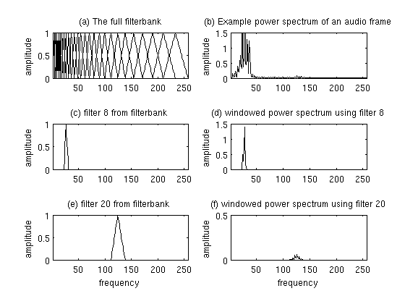

Plot of Mel Filterbank and windowed power spectrum

4. Take the log of each of the 26 energies from step 3. This leaves us with 26 log filterbank energies.

5. Take the Discrete Cosine Transform (DCT) of the 26 log filterbank energies to give 26 cepstral coefficents. For ASR, only the lower 12-13 of the 26 coefficients are kept.

The resulting features (12 numbers for each frame) are called Mel Frequency Cepstral Coefficients.

**Deltas and Delta-Deltas**

Also known as differential and acceleration coefficients. The MFCC feature vector describes only the power spectral envelope of a single frame, but it seems like speech would also have information in the dynamics i.e. what are the trajectories of the MFCC coefficients over time. It turns out that calculating the MFCC trajectories and appending them to the original feature vector increases ASR performance by quite a bit (if we have 12 MFCC coefficients, we would also get 12 delta coefficients, which would combine to give a feature vector of length 24).

To calculate the delta coefficients, the following formula is used:



where **dt** is a delta coefficient, from frame **t** computed in terms of the static coefficients **ct+n** to **ct-n**. A typical value for **N** is 2. Delta-Delta (Acceleration) coefficients are calculated in the same way, but they are calculated from the deltas, not the static coefficients.