**AVITA Database Schema**

1. **User Table**

* Id
* Full Name
* Phone
* Countries
* Email
* Password
* Photo
* Role
* Status
* Gender
* Birthday

1. **Countries**

* Id
* Name

1. **Role**

* Id
* Name

1. **Status**

* Id
* Name

1. **Product Type**

* Id
* Type

1. **Product Series**

* Id
* Series name
* product_type_id

1. **Product Models**

* Id
* model_number
* product_series_id

1. **Product Numbers**

* Id
* product_model_id
* product_number
* titleName

1. **Warranty Registration**

* Id
* user_id
* product_number_id
* serial_number
* reseller_name
* purchase_date
* purchase_invoice

**10. Warranty Extend**

* Id
* user_id
* product_number_id
* serial_number
* reseller_name
* purchase_date
* purchase_invoice
* purchase_code

**11. Certificates**

* id
* user_id
* order_id
* serial_number
* product_number
* product_configuration
* reseller_name
* purchase_date
* extend_date

**12. Warranty Code**

* id
* code

**13. Service Centers**

* id
* locale
* country
* shop Name
* address
* opening_hour
* phone
* email
* city
* state
* pin
* latitude
* longitude

**14. Where to buys**

* id
* locale
* country
* shop Name
* address
* opening_hour
* phone
* email
* city
* state
* pin
* latitude
* longitude

**15. Blogs**

* Id
* country
* thumbnail_path
* image_path
* is_publish
* published_date
* locale
* title
* content

**16. Banners**

* id
* country
* thumbnail_path
* image_path
* status
* seq
* start_date
* end_date
* url

**17. Gird Banners 4**

* id
* type
* thumbnail_path
* image_path
* seq
* url
* country

**18. News**

* id
* country
* thumbnail_path
* image_path
* is_publish
* published_date
* locale
* title
* content

**19. Events**

* id
* country
* thumbnail_path
* image_path
* is_publish
* published_date
* locale
* title
* content

**20. Campus**

* id
* name
* email
* phone
* internship
* college
* team
* represent

**21. Subscriptions**

* id
* email

**Modeling**

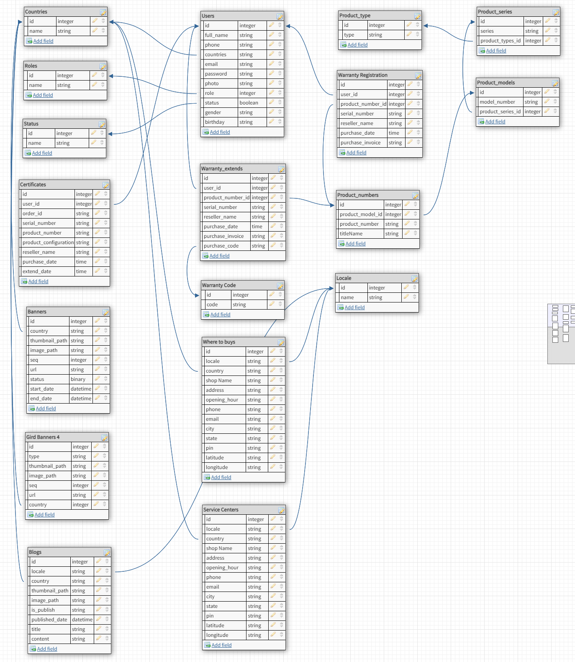

**App**

**Product**

1. Product Type
2. Product Series
3. Product Models
4. Product Numbers

**Articles**

1. Events
2. News
3. Blogs
4. Banners

**Service**

1. **Service Centers**
2. **Where to buys**

**Warranty**

1. Warranty Registration
2. Warranty Extend
3. Certificates

**Main**

1. Countries
2. Campus
3. Subscriptions