|  |  |
| --- | --- |
|  | **Semester-IV**  **2023**  **IT Project**  **ITCC14** |
|  |  |

**A Project Re**

**A Project Report on**

REACT (TASK BASED)

Submitted as partial fulfillment of the requirement

For M.Sc**. IT - Semester IV**

Prepared for Subject: **IT Project** (**ITCC14**)

**Prepared By**

**Name of Student : Baldaniya bhavdip h**

**Enrollment No.:21mscit22001**

**Exam No.:**

Submitted as partial fulfillment of the requirement

For M.Sc**. IT - Semester IV**

Prepared for Subject: **IT Project** (**ITCC14**)

**Prepared By**

**Name of Student : dobariya kishan R.**

**Enrollment No.:21mscit22003**

**Exam No.:**

SHR◤

I MANEKLAL M.PATEL INSTITUTE OF SCIENCE & RESEARCH

### M.SC(INFORMATION TECHNOLOGY)

SEM-4

PROJECT REPORT: **TASK BASE**



COMPANY NAME : **Tridhya Tech Limited**

LANGUAGE : **REACT**

STUDENT NAME: **BALDANIYA BHAVDIP HIMMATBHAI**

ENROLLMENT NO: **21MSCIT22001**

◤ INDEX



1. Create login form, navbar and footer
2. Create todo app
3. Create calculator
4. Creat responsive demo in dashboard
5. create demo calculator
6. create demo timer
7. create demo tasks clock
8. create demo nevbar
9. create demo DOM array model with sorting serching

filtering

1. create demo DOM year counter
2. create demo DOM age calculeter



USING HTML AND CSS

# Create login form, navbar and footer

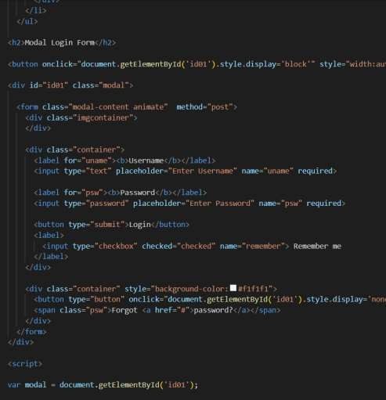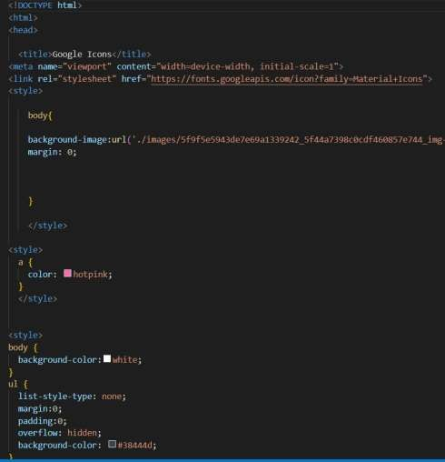

### ◤

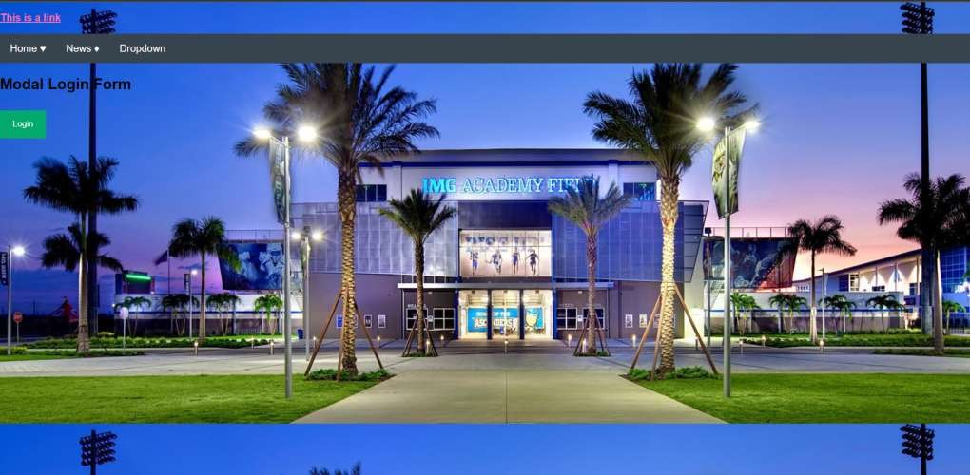

◤

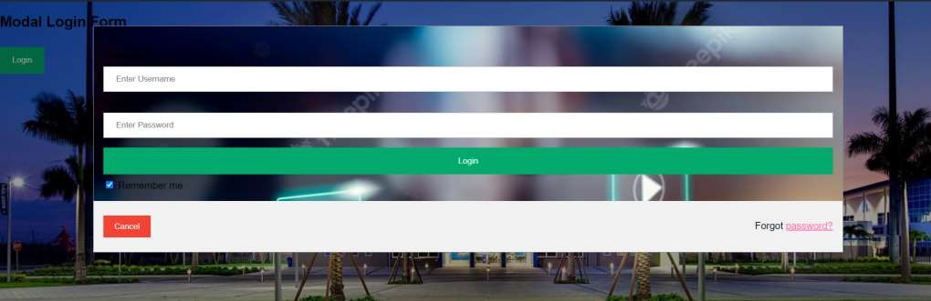

### ◤



using HTML CSS

# Create todo app

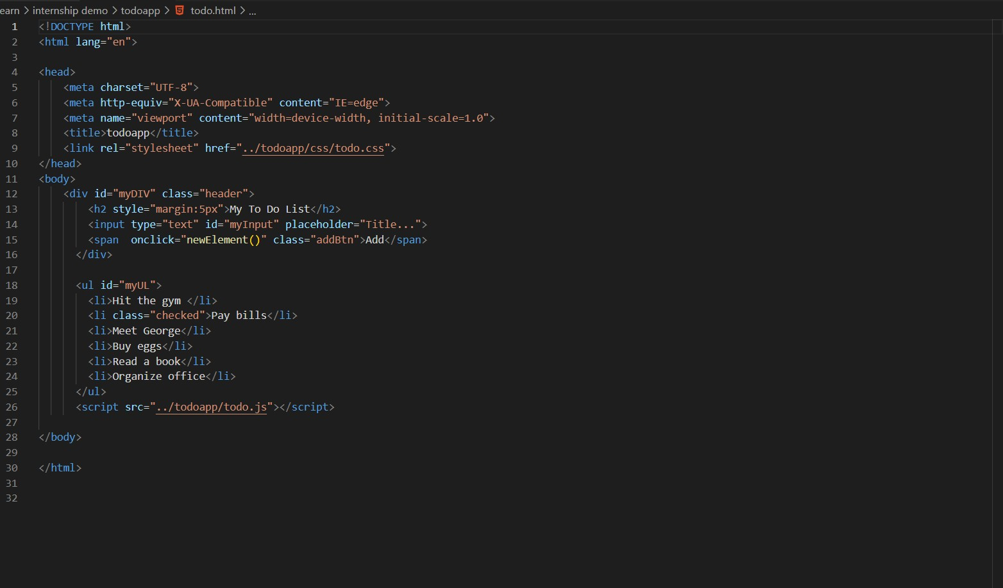

### ◤

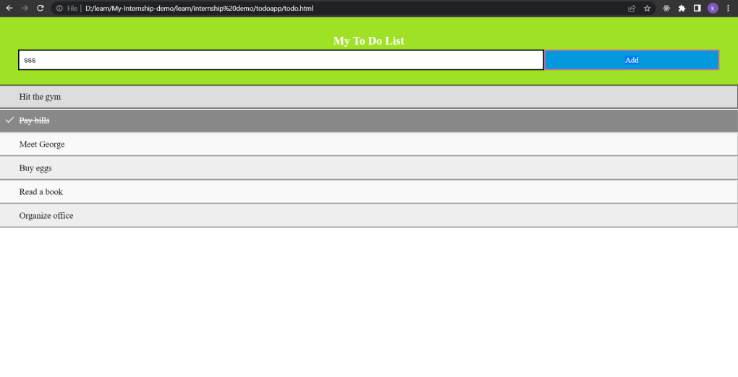

◤



using HTML CSS

# Create calculator

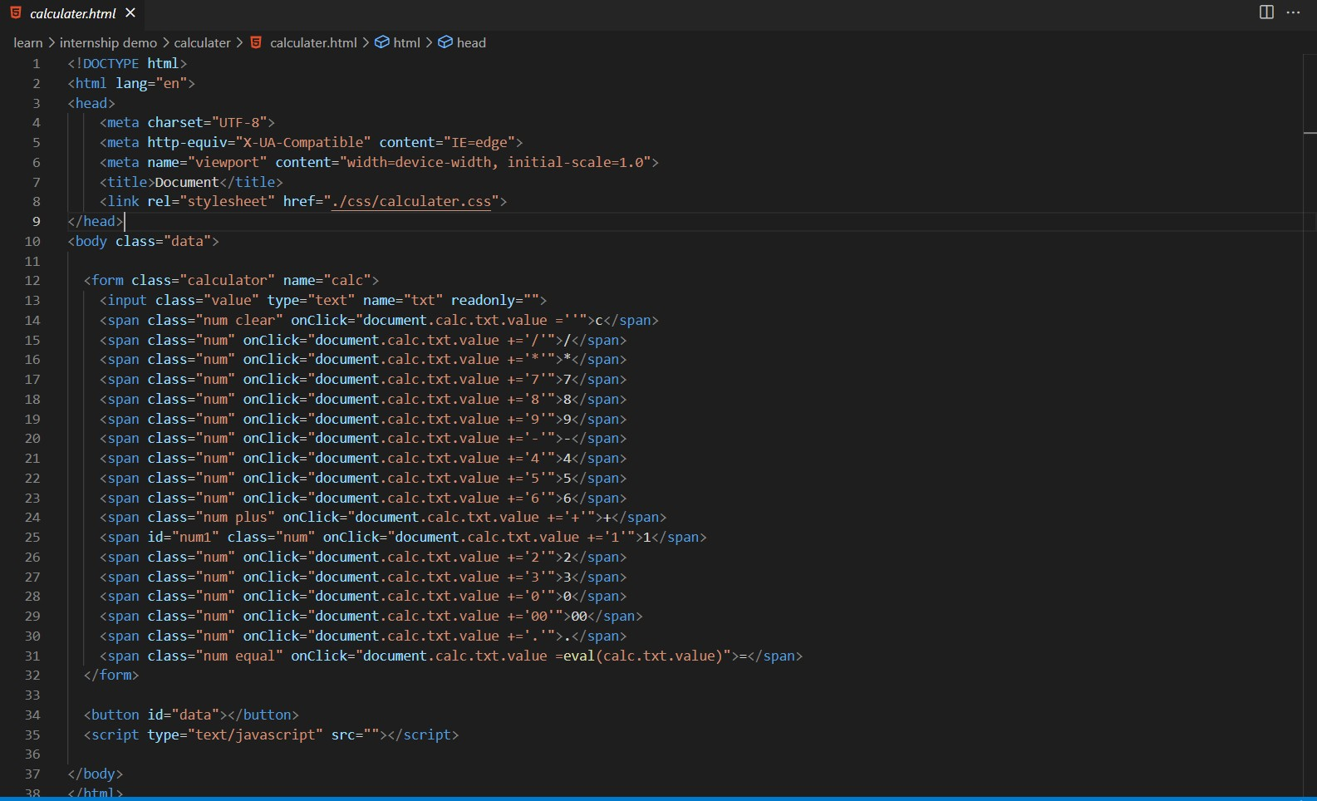

### ◤

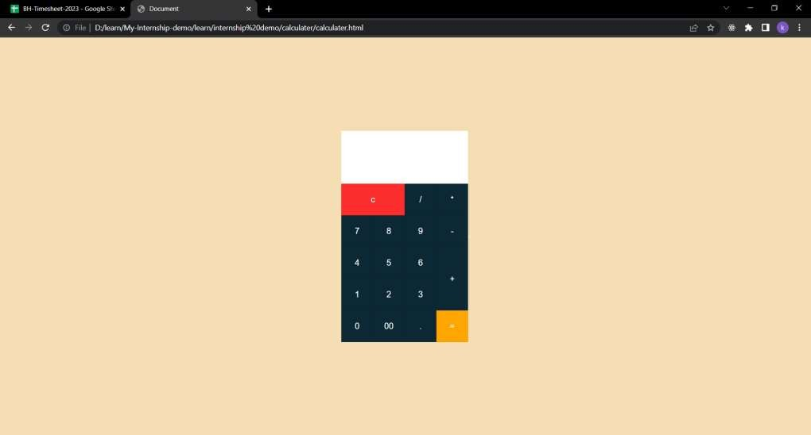

◤



using HTML , CSS and JS

Creat responsive demo in dashboard

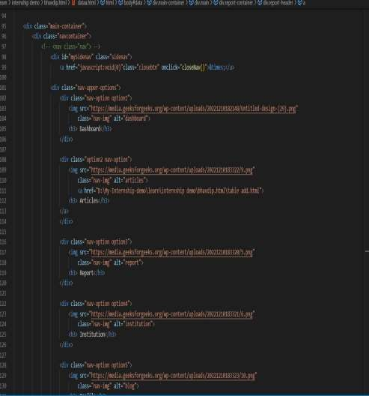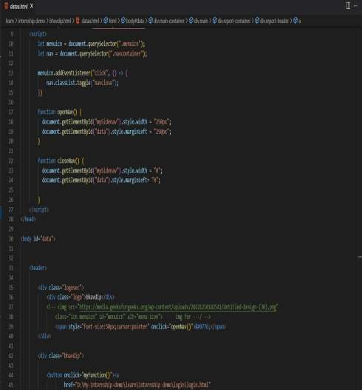

### ◤

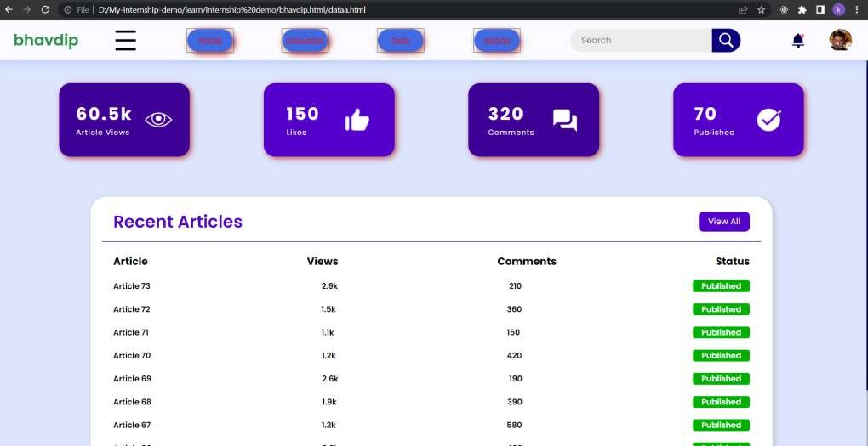

◤



using Java script

# create demo calculator

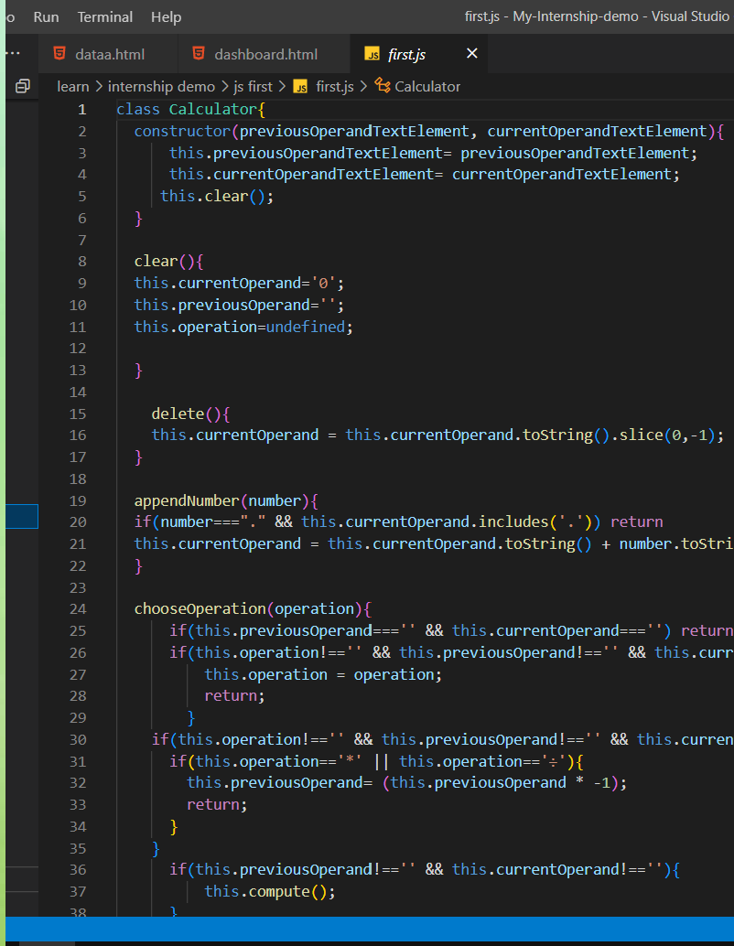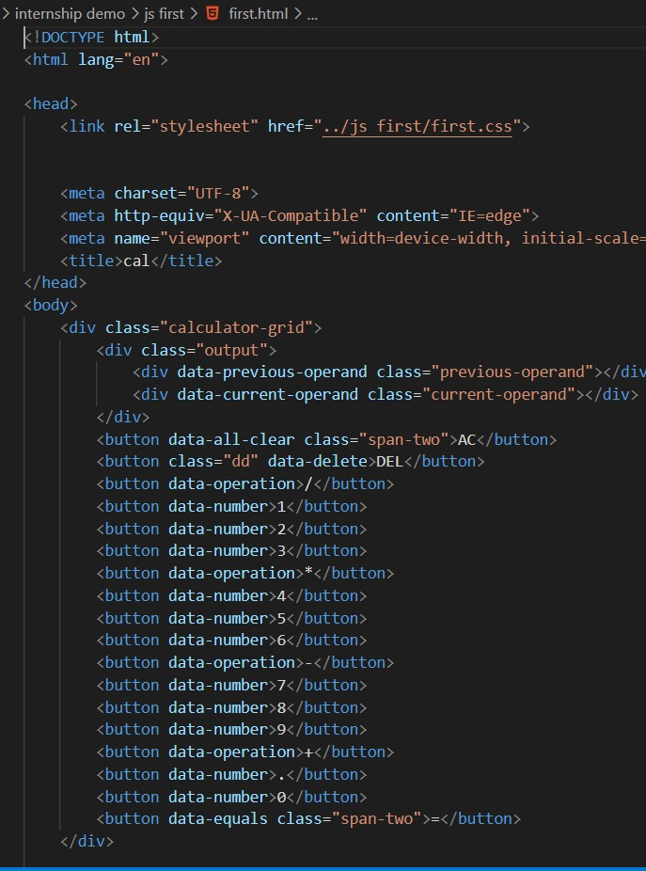

### ◤

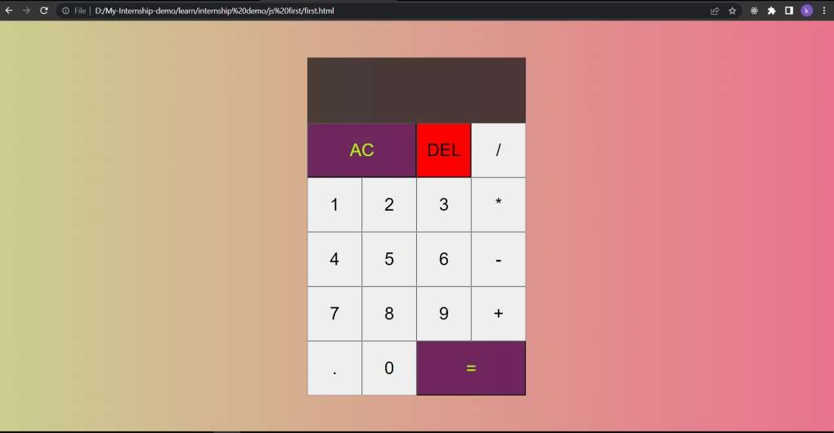

◤



using HTML,CSS,JS

# create demo timer

◤

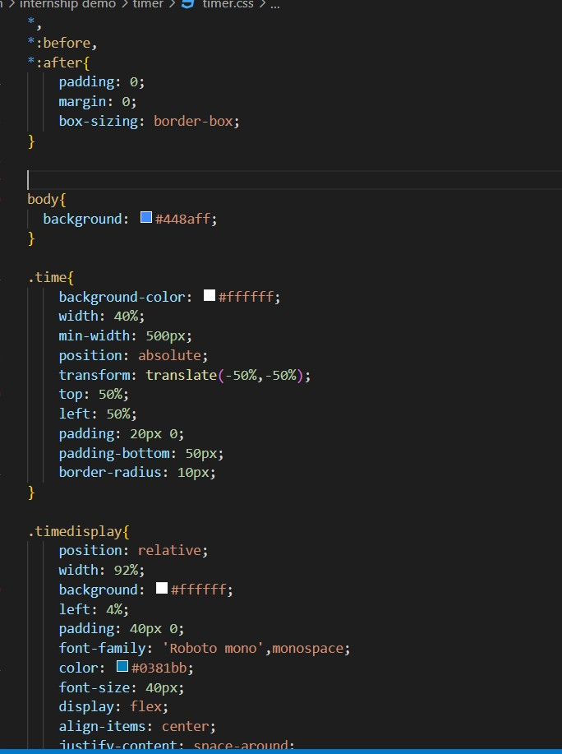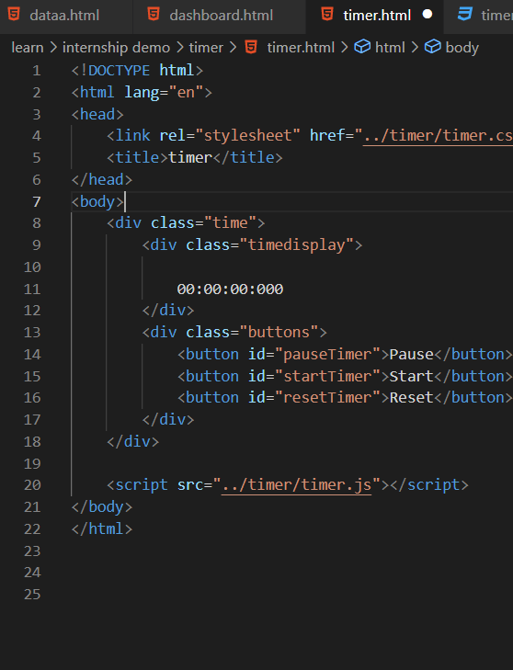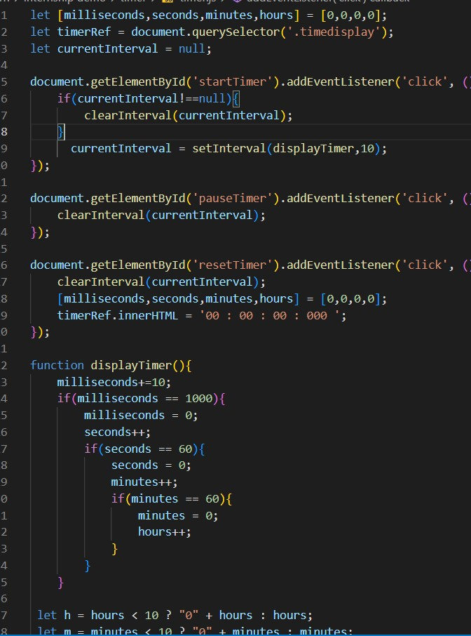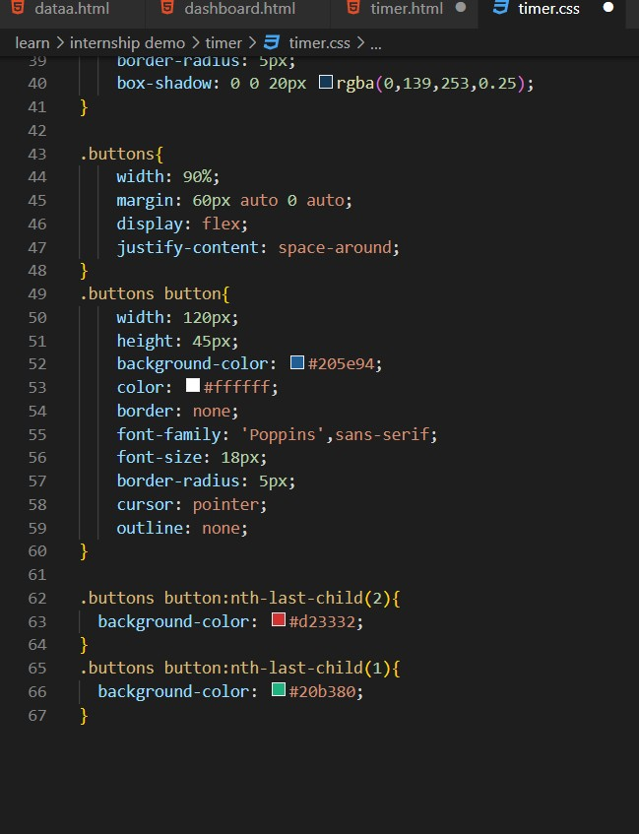

### ◤

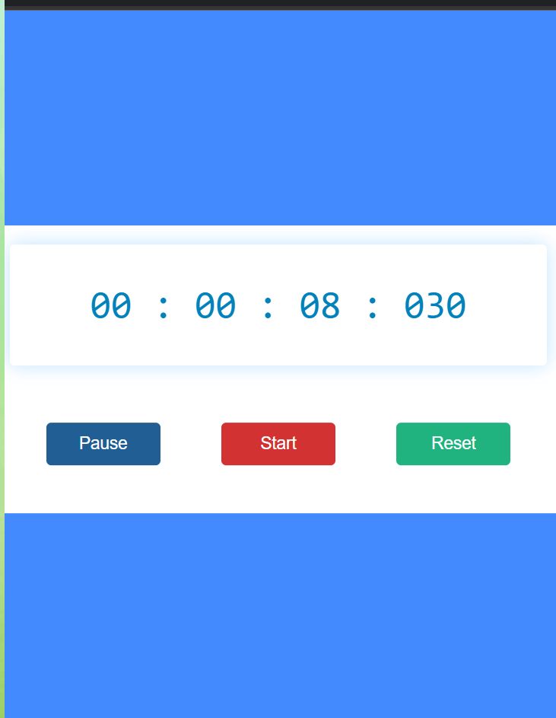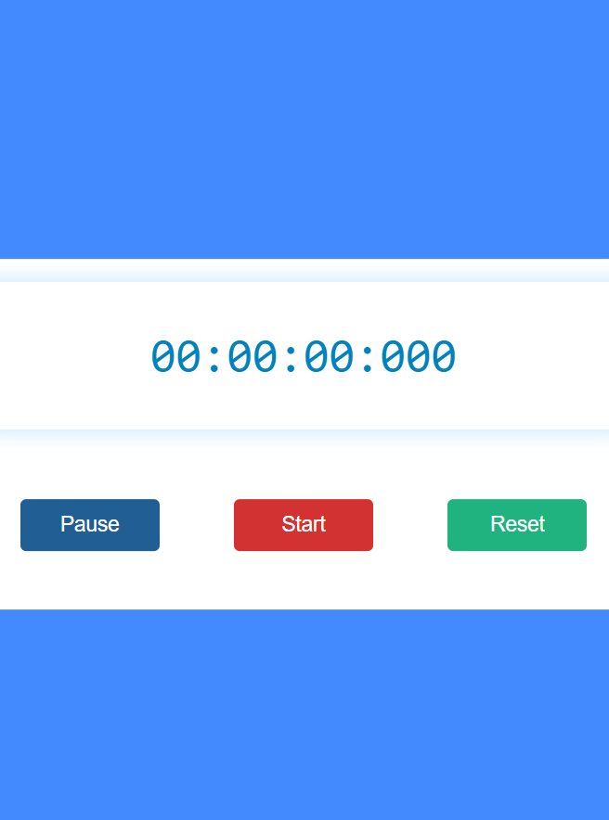

◤



using javascript

# create demo tasks clock

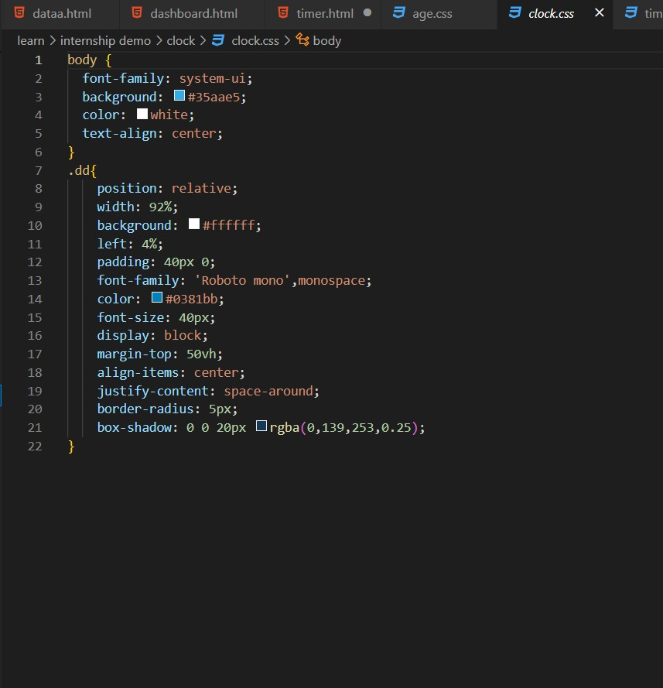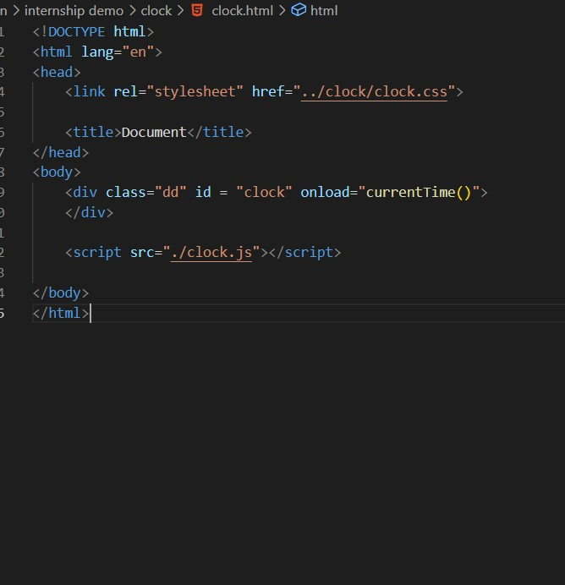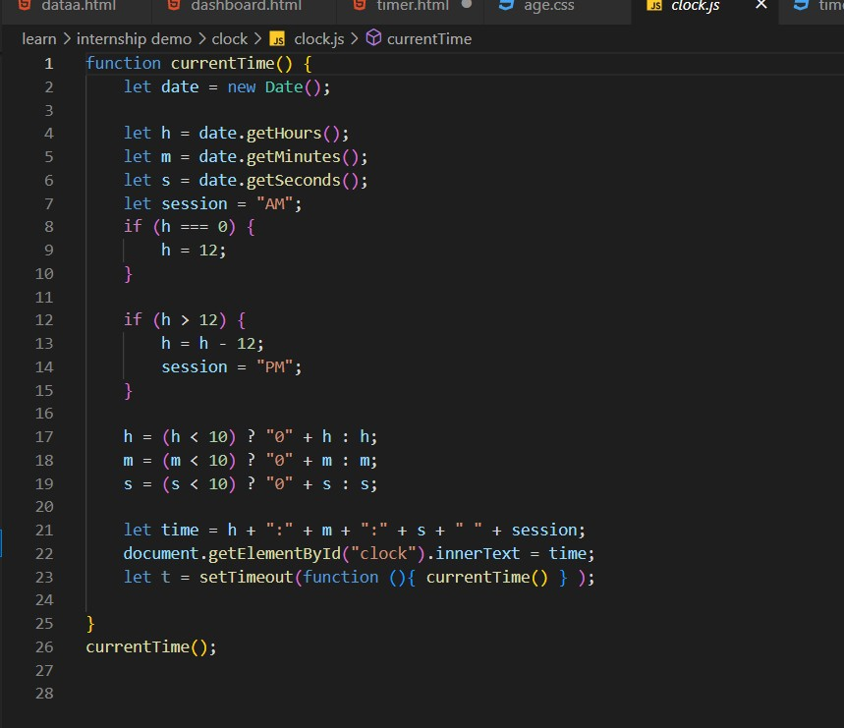

### ◤

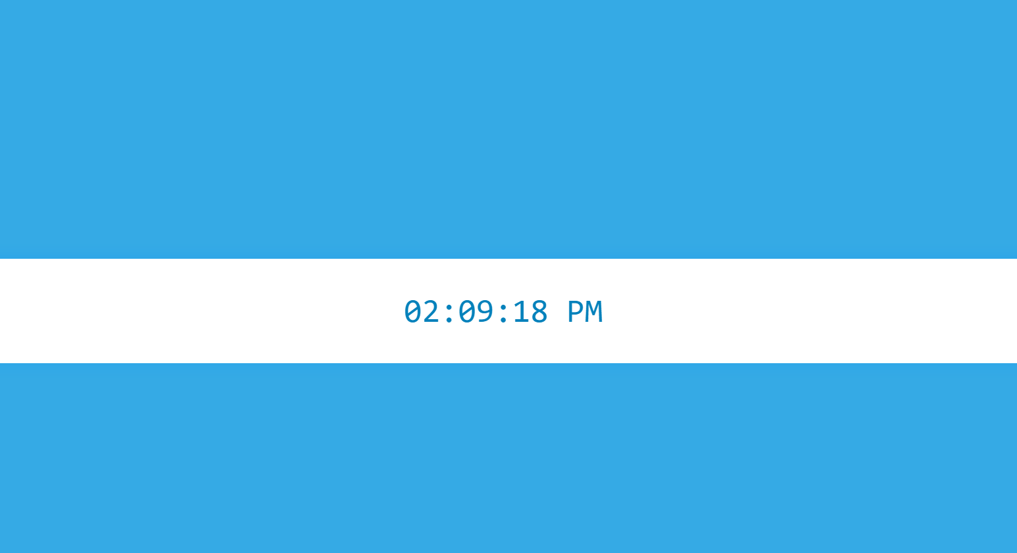

◤



using HTML,CSS

# create demo nevbar

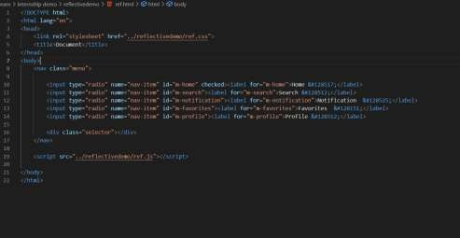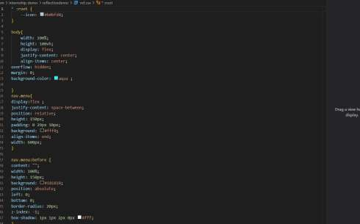

### ◤

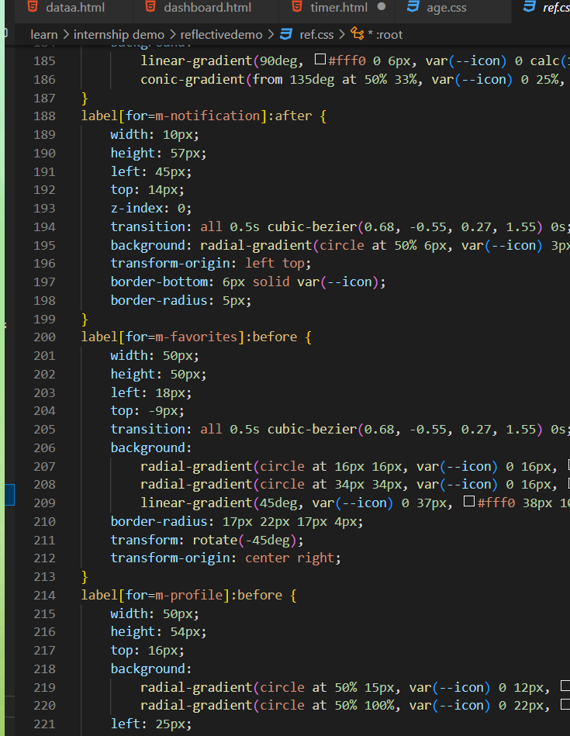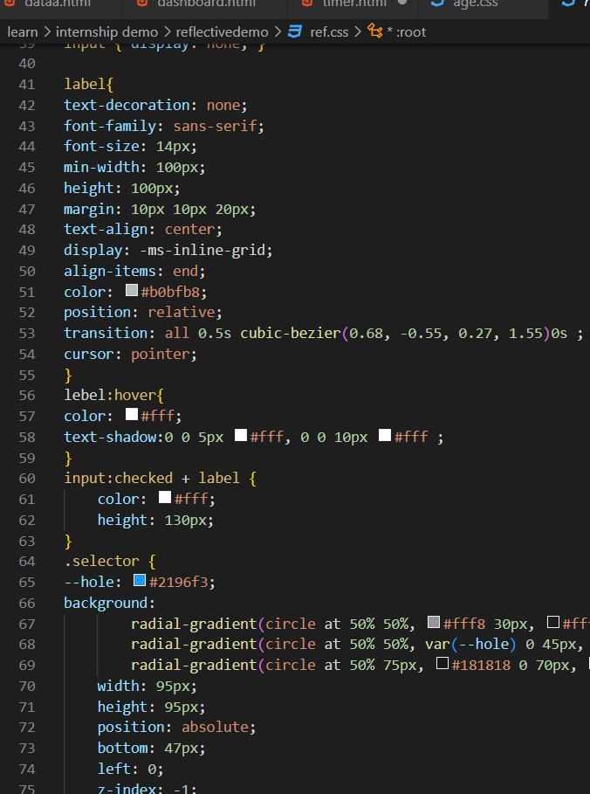

◤

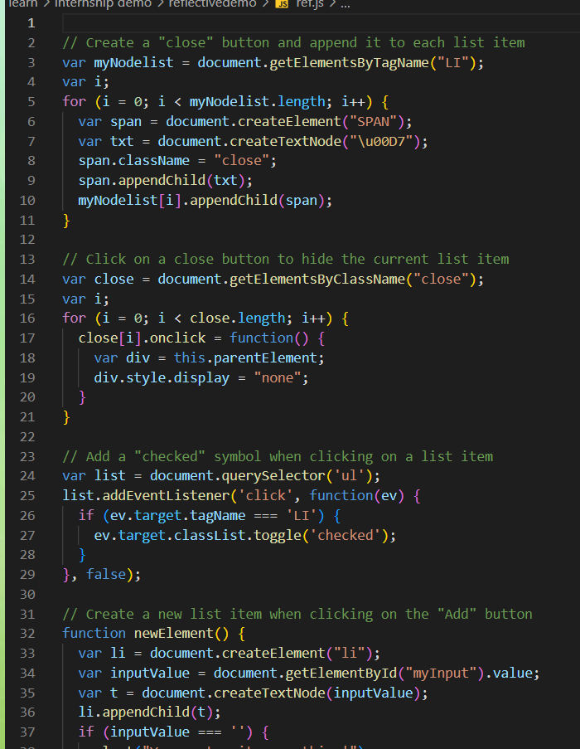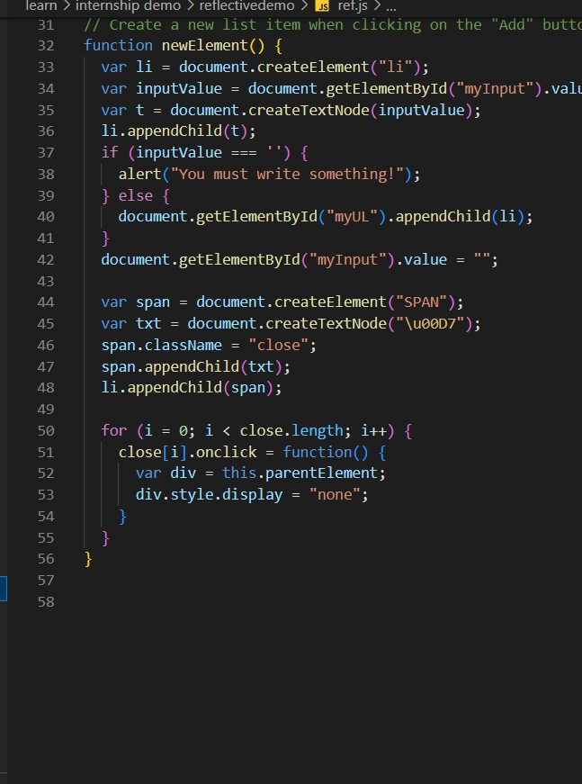

### ◤

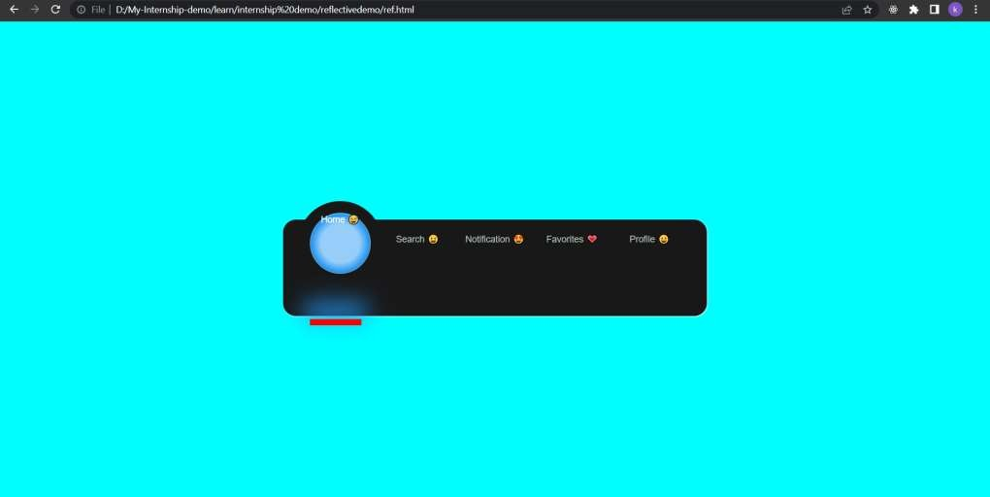

◤



using API, HTML,CSS,JAVASCRIPT

create demo DOM array model with sorting serching filtering

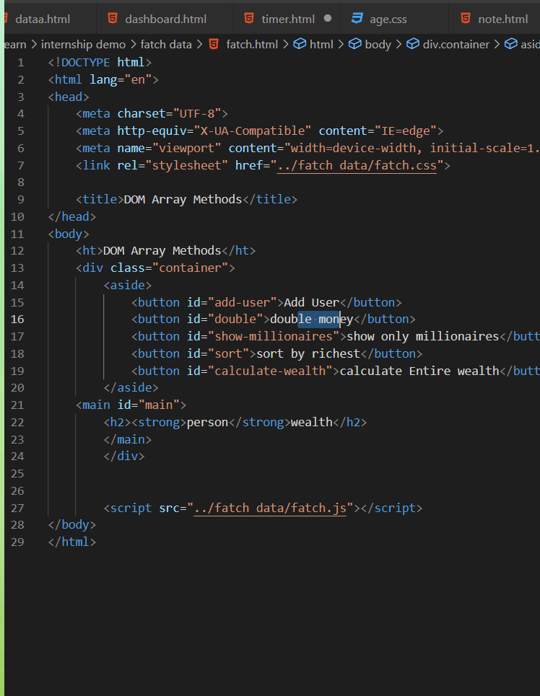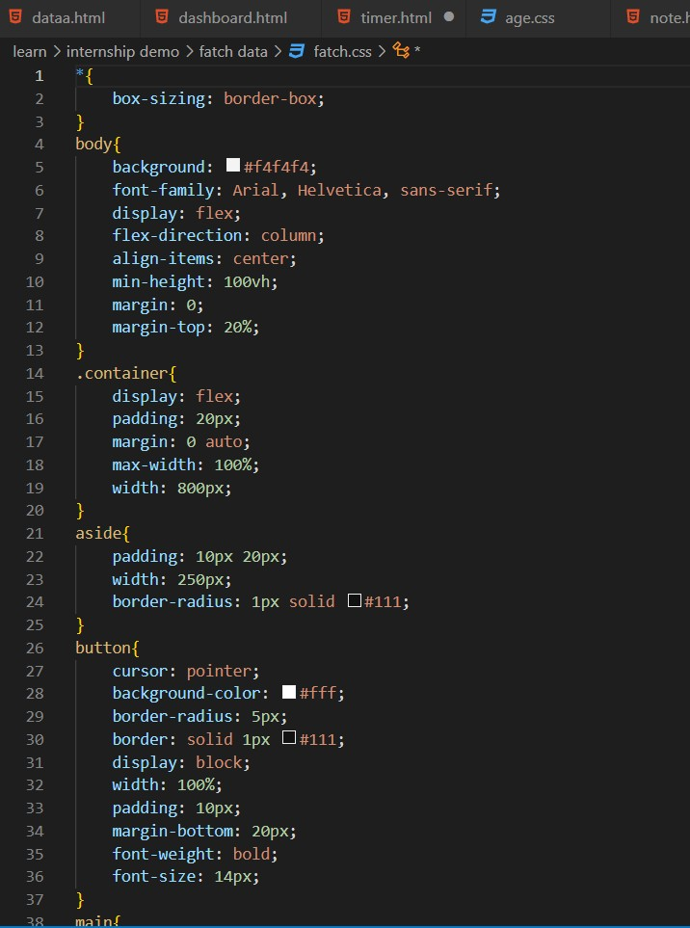

### ◤

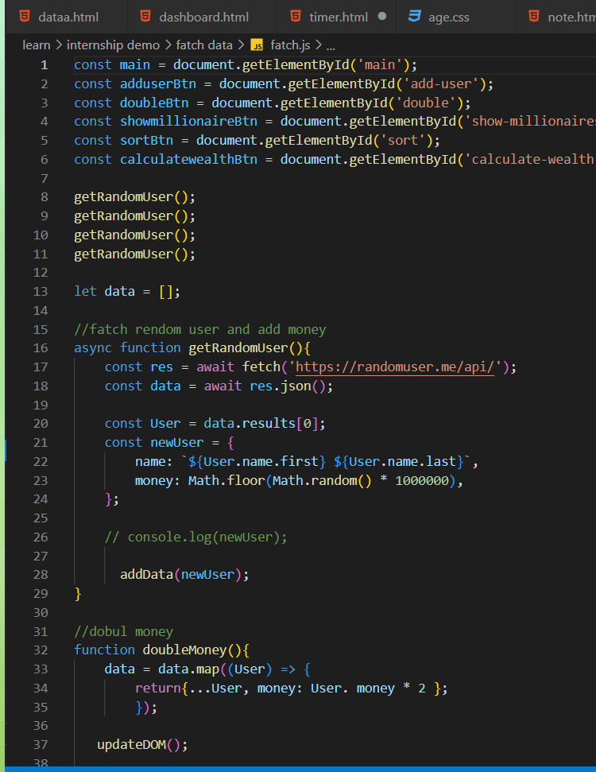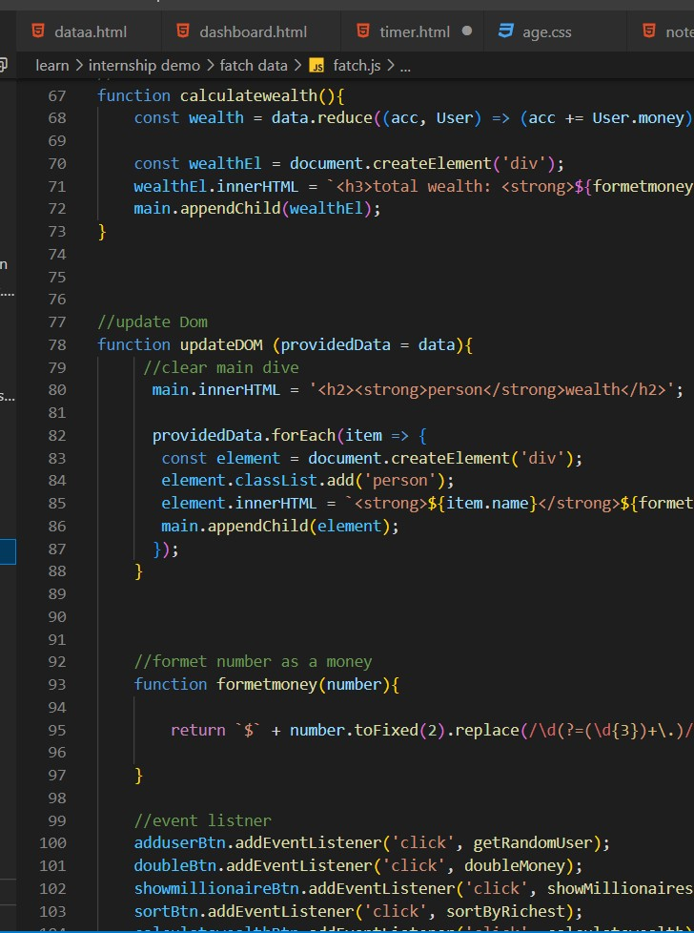

◤

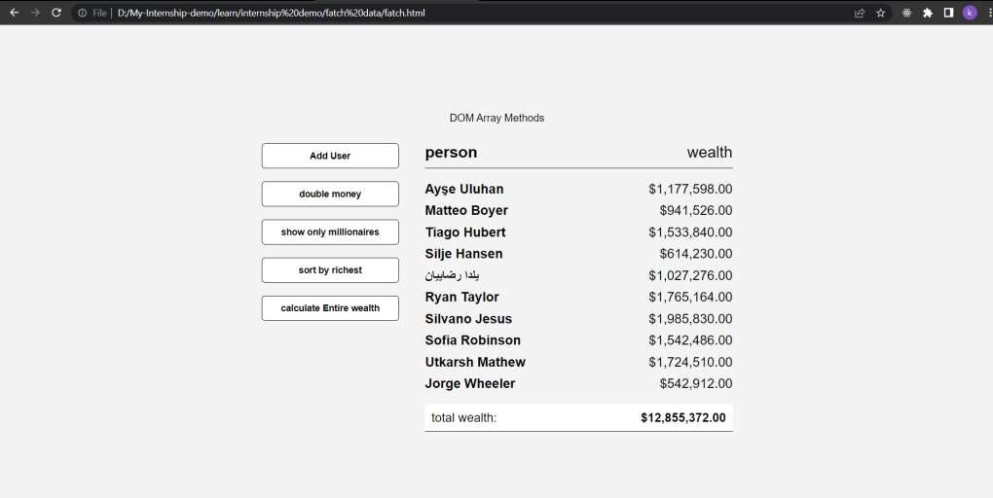

### ◤



HTML,CSS,JAVASCRIPT

## create demo DOM year counter

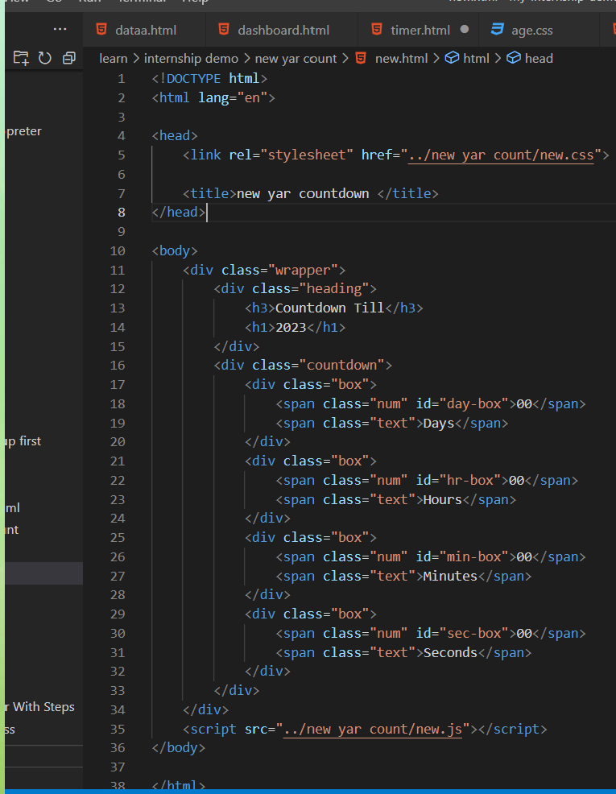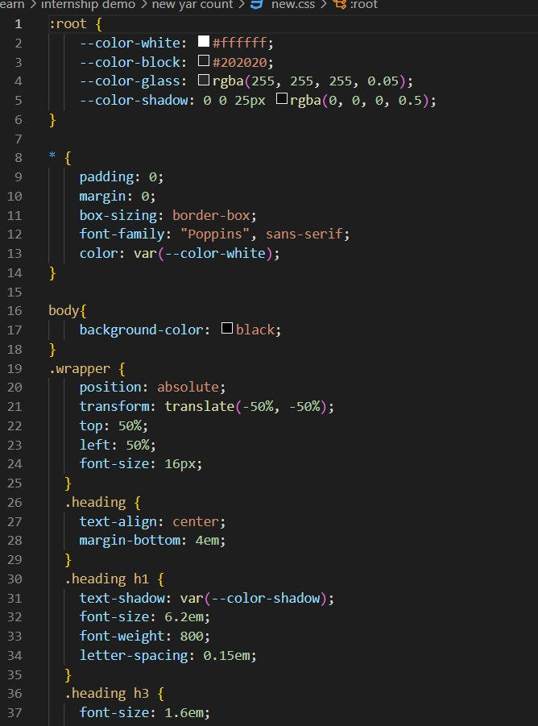

### ◤

◤

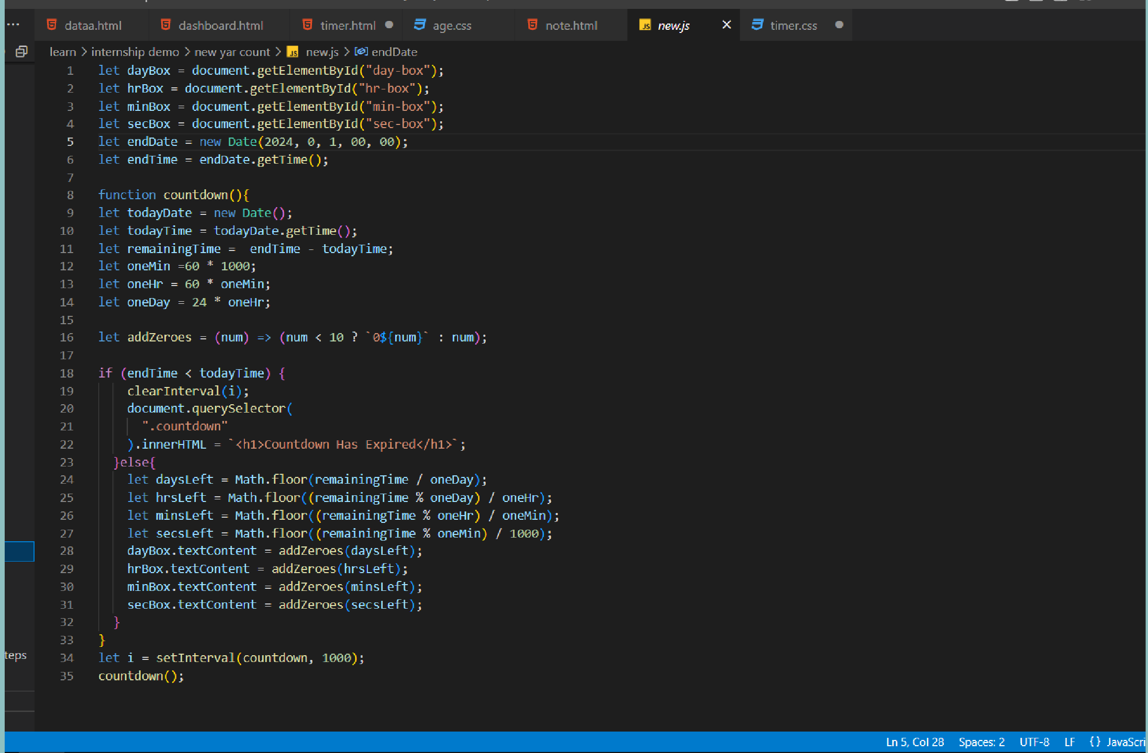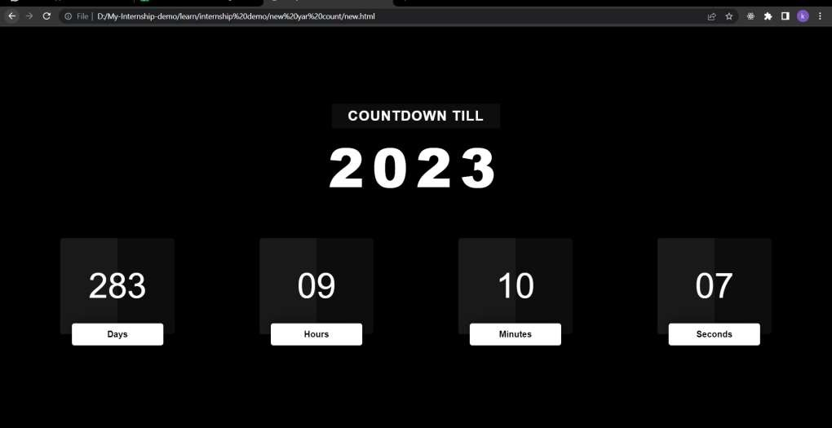

### ◤



using HTML,JAVASCRIPT

# create demo DOM scrin recoder

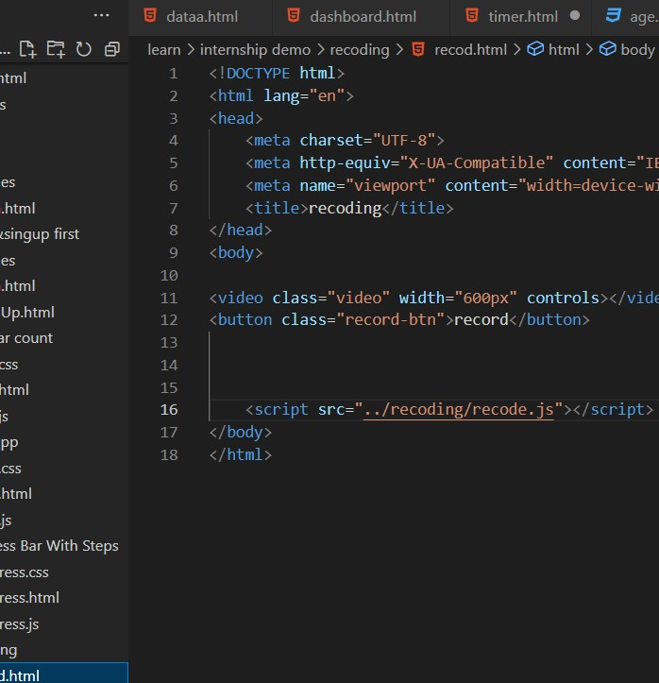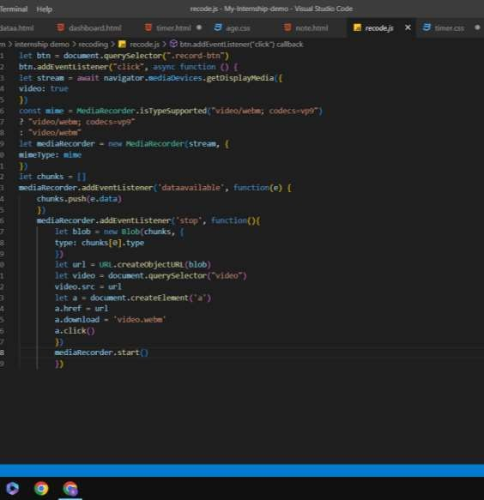

### ◤

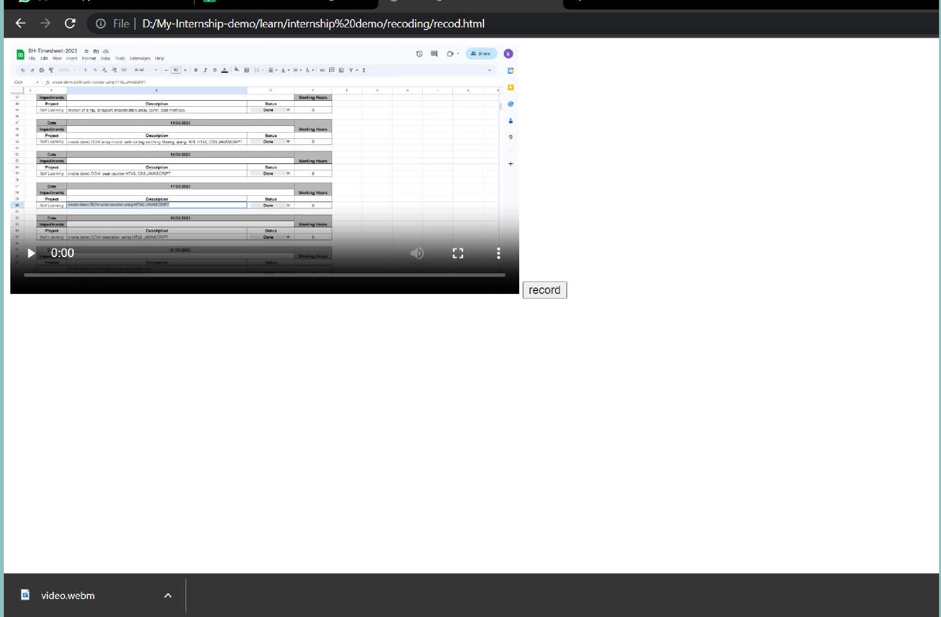

using HTML,JAVASCRIPT

# create demo DOM color picker

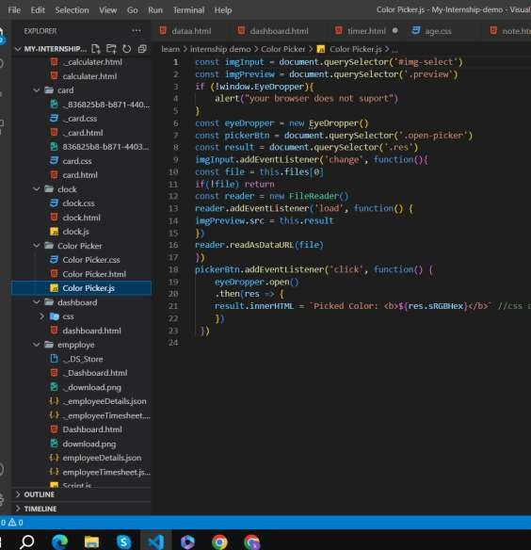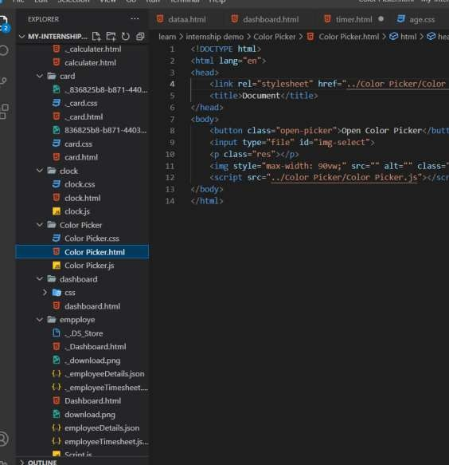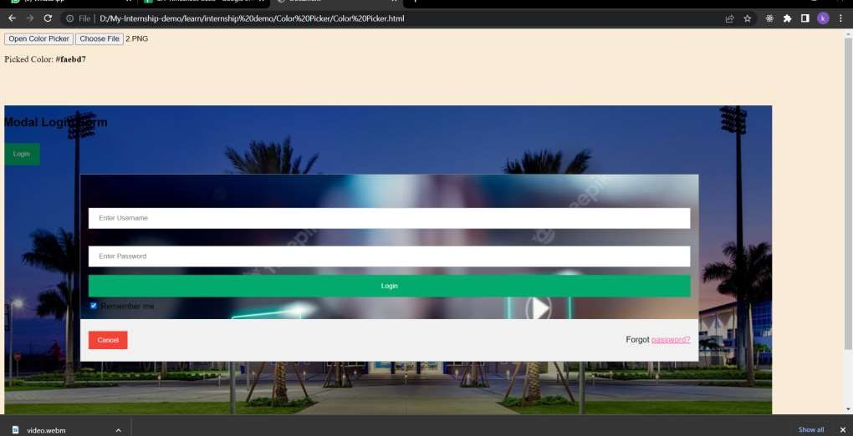

### ◤



using HTML,JAVASCRIPT

create demo DOM progress bar with setup and increment opreters

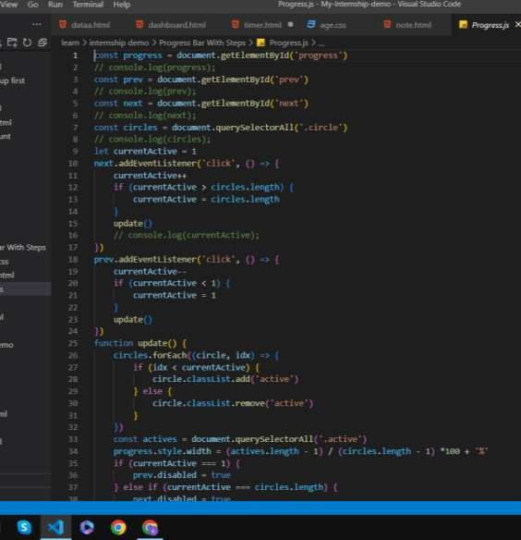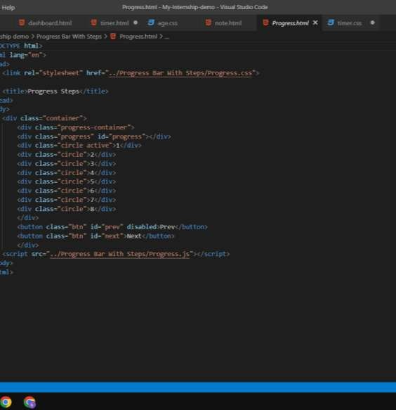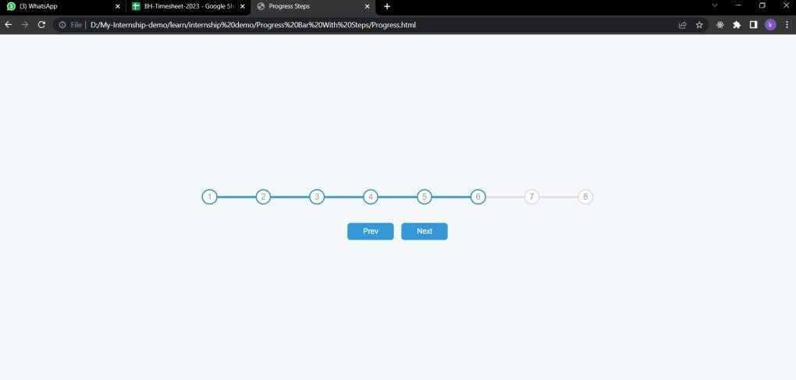

### ◤



using HTML,JAVASCRIPT

# create demo DOM age calculeter

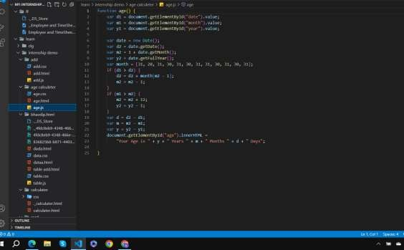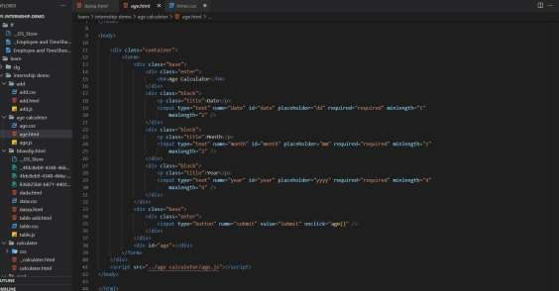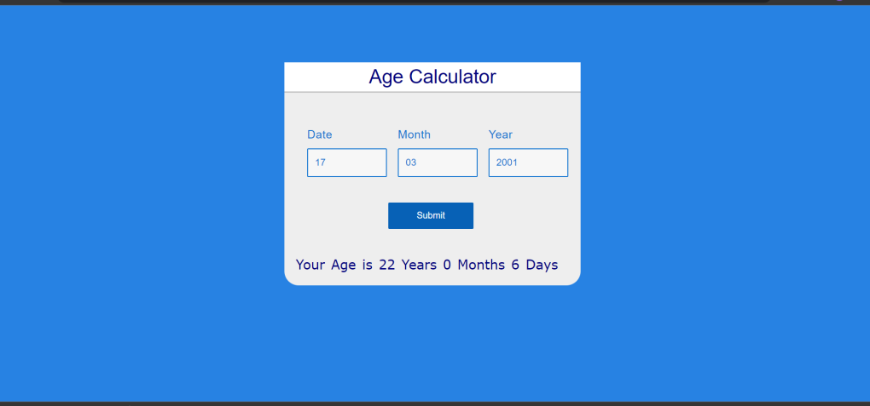

### ◤

◤



Thank you