**A Project Report on**

|  |  |
| --- | --- |
|  | **Semester-IV**  **2023**  **IT Project**  **ITCC14** |
|  |  |

**PHP (TASK BASED)**

Submitted as partial fulfillment of the requirement

For M.Sc**. IT - Semester IV**

Prepared for Subject: **IT Project** (**ITCC14**)

**Prepared By**

**Name of Student : Zalak S. Patel**

**Enrollment No.:21mscit22023**

**Exam No.:**



**Shri Maneklal M.Patel Institute of Sciences and Research**

**Kadi Sarva Vishwavidyalaya**

**Department of M.Sc.IT, Gandhinagar**

**ACKNOWLEDGMENT**

I am grateful to my internal guide ***Bhavesh Katariya*** for providing me valuable guidance for the **IT PROJECT** (ITCC14) and other domain related information.

I would like to express my endless thanks to ***JAY DARJIl(CEREBULB)***, for giving invaluable advice, direction, support and transferring knowledge throughout the project work.

Also my hearty gratitude to Head of Department, **Prof. (Dr.) B. R. Pandya** for giving me an opportunity for learning through the process of project work by which I can improve my technical skills along with practical exposure and its applicability in the industry.

**Name of Student: Zalak S. Patel Signature of Student:**

Enrollment No.: 21mscit22023



**Shri Maneklal M.Patel Institute of Sciences and Research**

**Kadi Sarva Vishwavidyalaya**

**Department of M.Sc.IT, Gandhinagar**

***INTERNAL PROJECT CERTIFICATE***

This is to certify that **ZALAK S.PATEL** having Enrollment No. **21mscit22023** was working for the M.Sc. IT department as project trainee from <<15-dec-2022>> to <<14-apr-2023>>. During the above period, we found him/her to be very sincere and hardworking. He / She has completed IT Project (ITCC14) on <<***PHP TASKS BASED>>*** satisfactorily under the guidance of guide.

We appreciate the enthusiasm & dedication towards work.

We wish him/her very best in all his future endeavors.

**Project Guide**

Mr. Bhavesh Katariya

Asst. Professor

M.Sc. (IT) Department.

**Prof. (Dr.) B. R. Pandya**

Head of Department, M.Sc. IT

01/01/2023



SHRI MANEKLAL M.PATEL INSTITUTE OF SCIENCE & RESEARCH

M.SC(INFORMATION TECHNOLOGY)

SEM-4

PROJECT REPORT: **PROJECT BASE**

COMPANY NAME :CEREBULB PVT.LTD LANGUAGE : **PHP**

STUDENT NAME: **Zalak S Patel**

ENROLLMENT NO: **21MSCIT22023**

INDEX

1. Create login form, navbar and footer
2. Create todo app
3. Create calculator
4. create demo calculator
5. create demo timer
6. create demo nevbar
7. create demo DOM array model with sorting serching filtering
8. create demo DOM age calculeter

TASKS:- Create login form, navbar and footer

USING HTML AND CSS

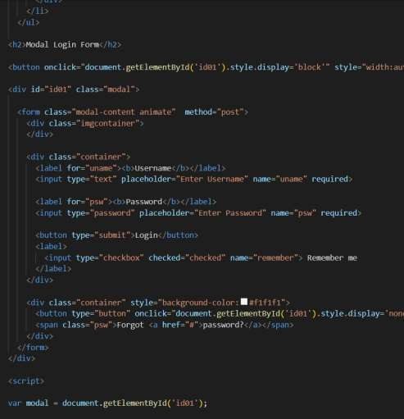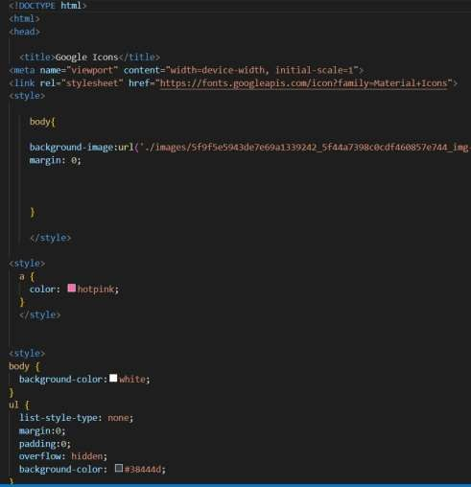

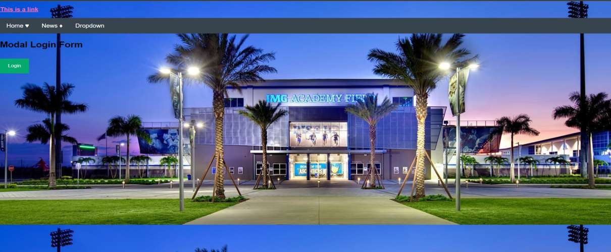

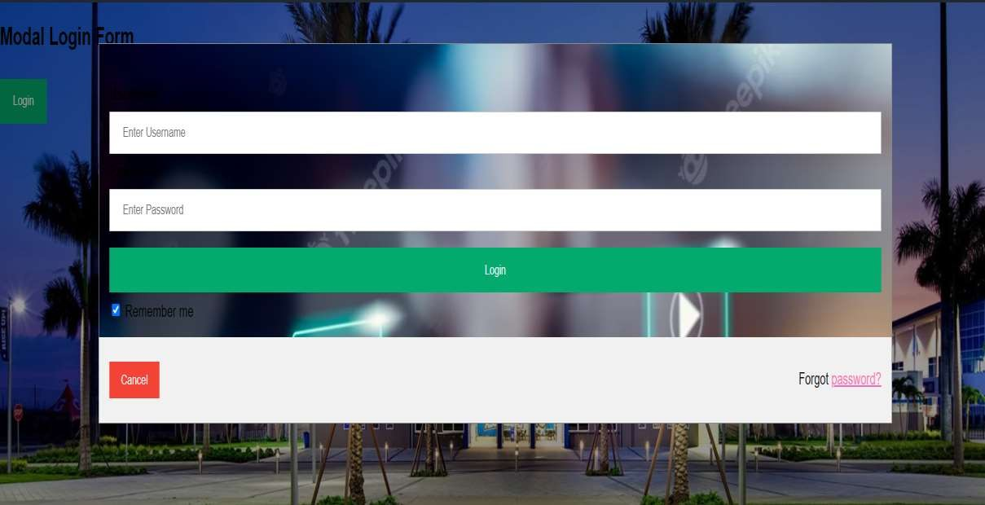

Create todo app

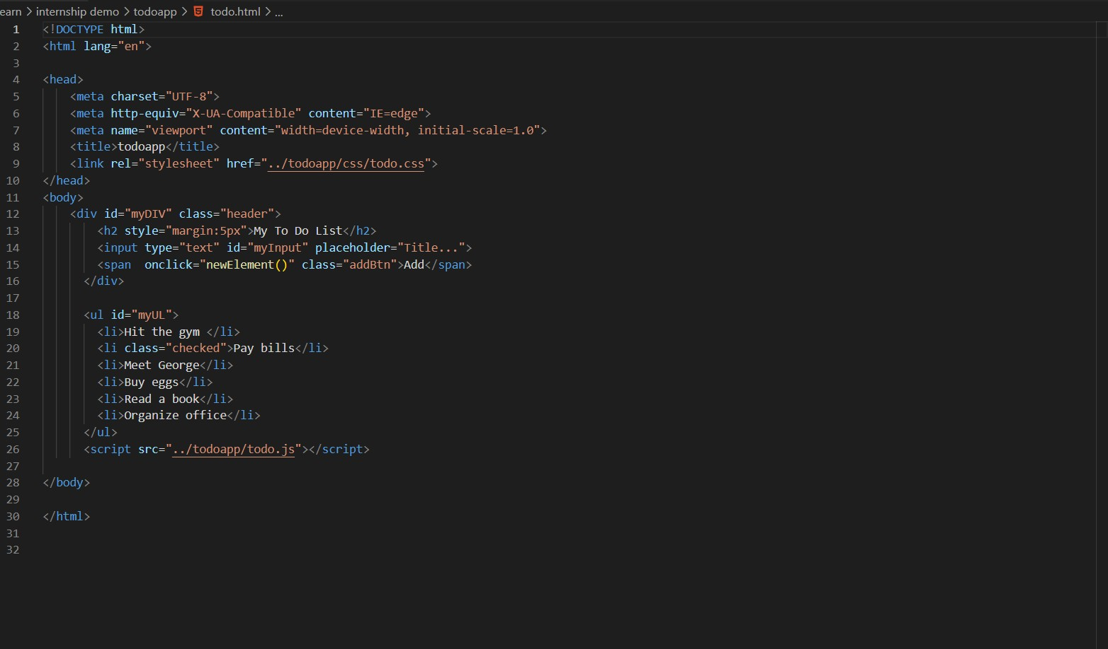using HTML CSS

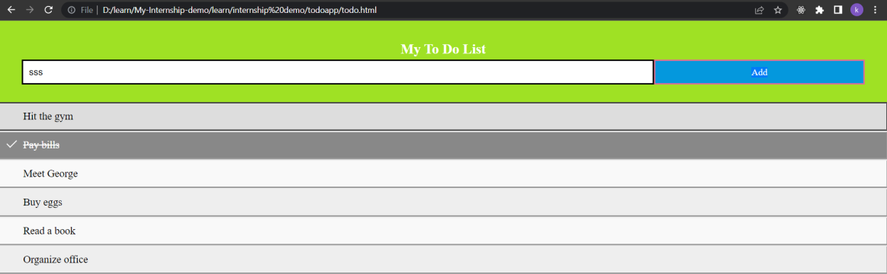

Create calculator

using HTML CSS

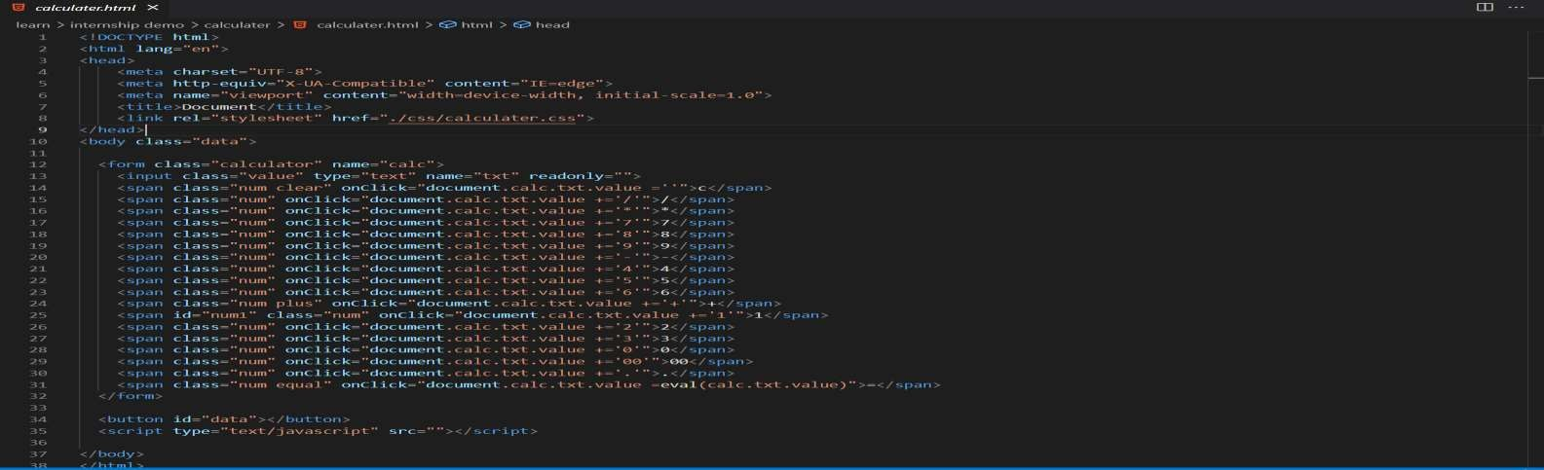

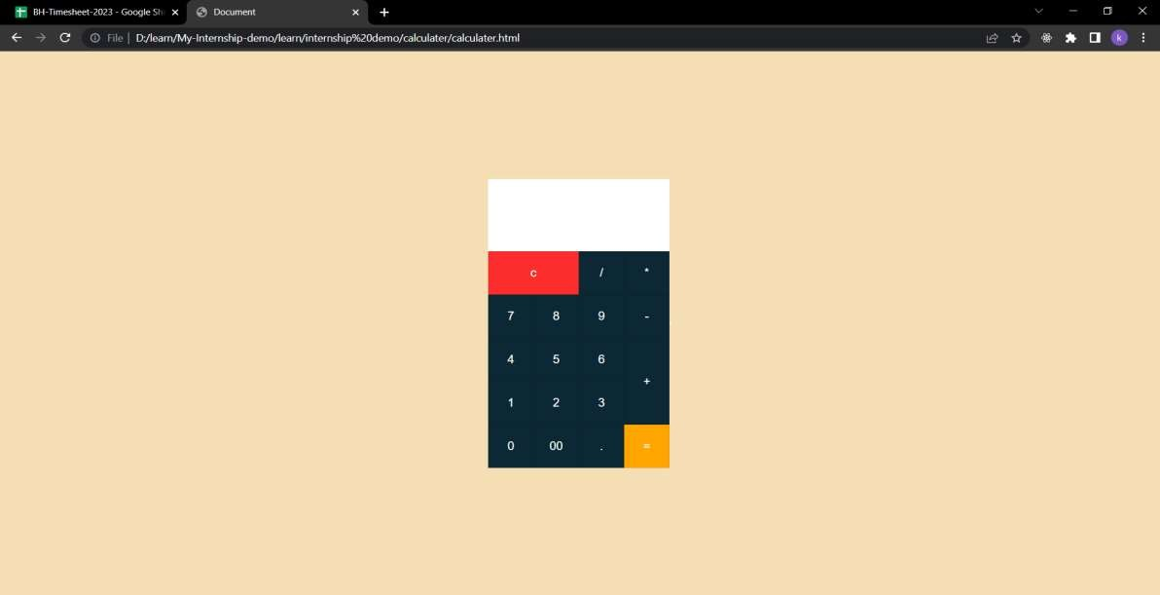

create demo calculator using Javascript

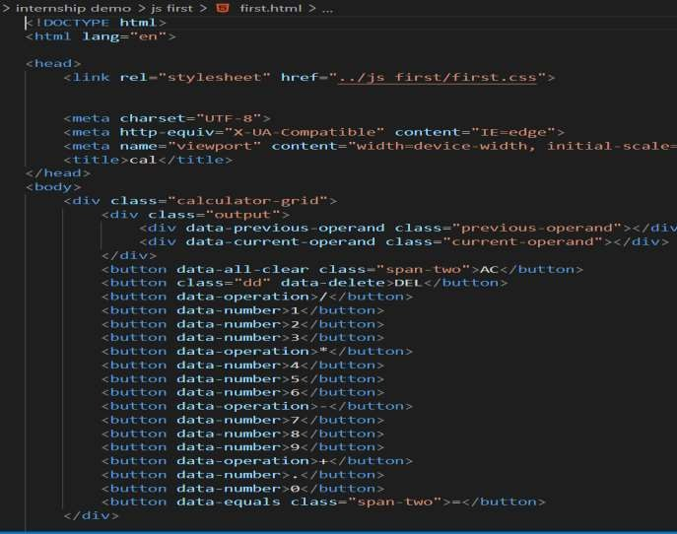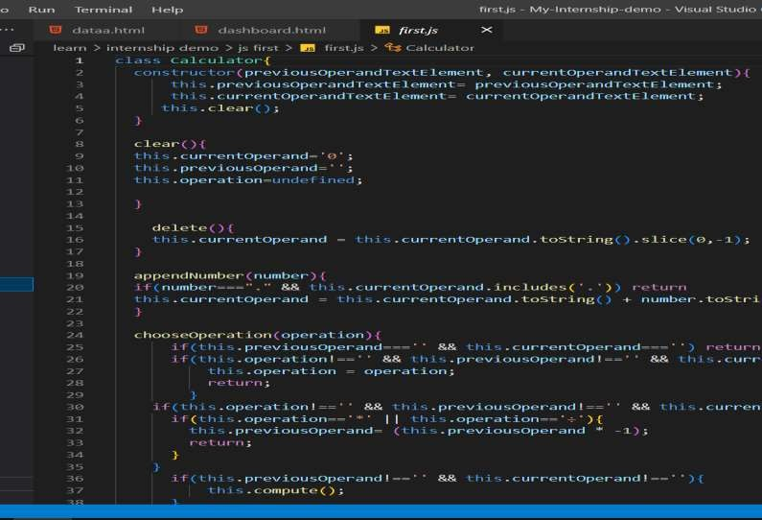

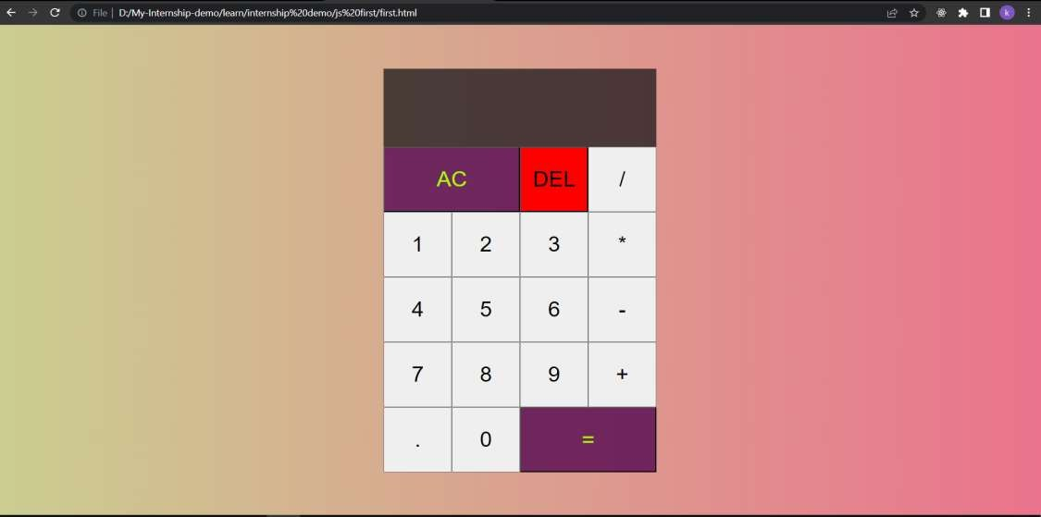

create demo timer using HTML,CSS,JS

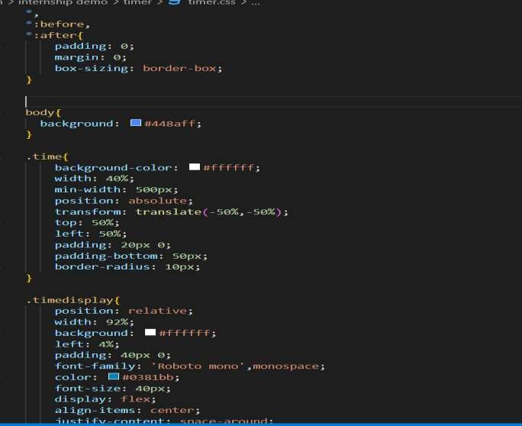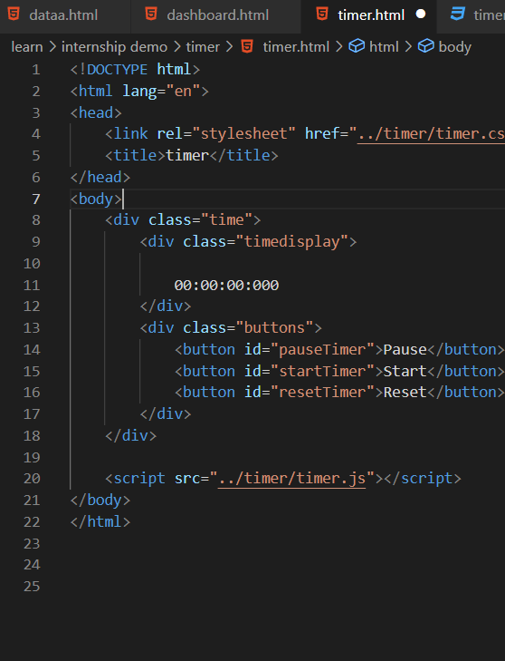

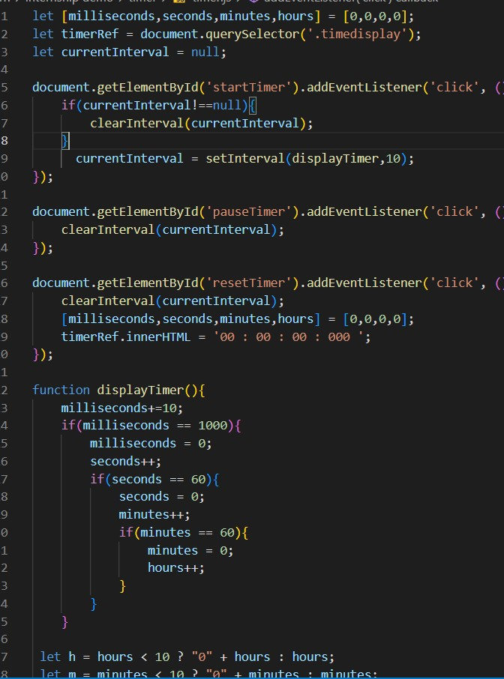 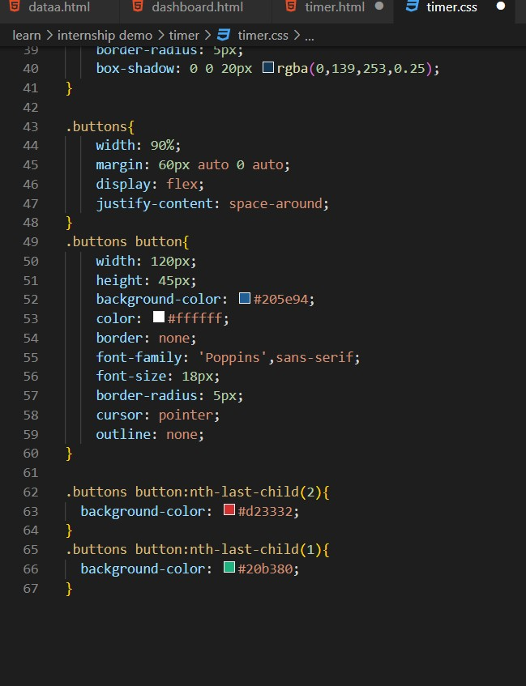

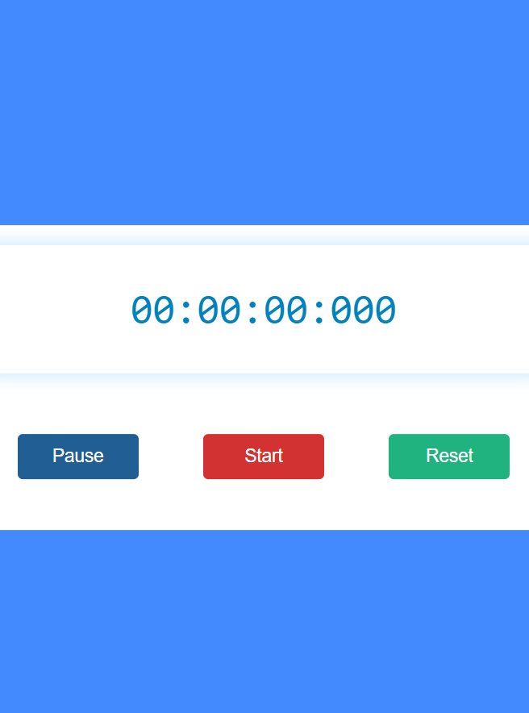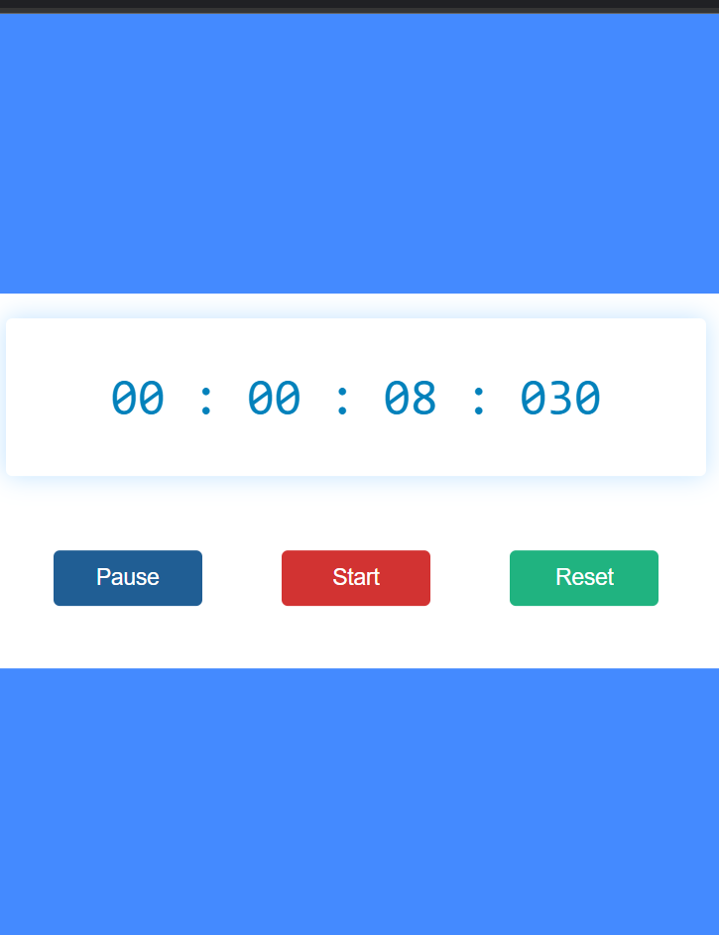

create demo tasks clock

using javascript

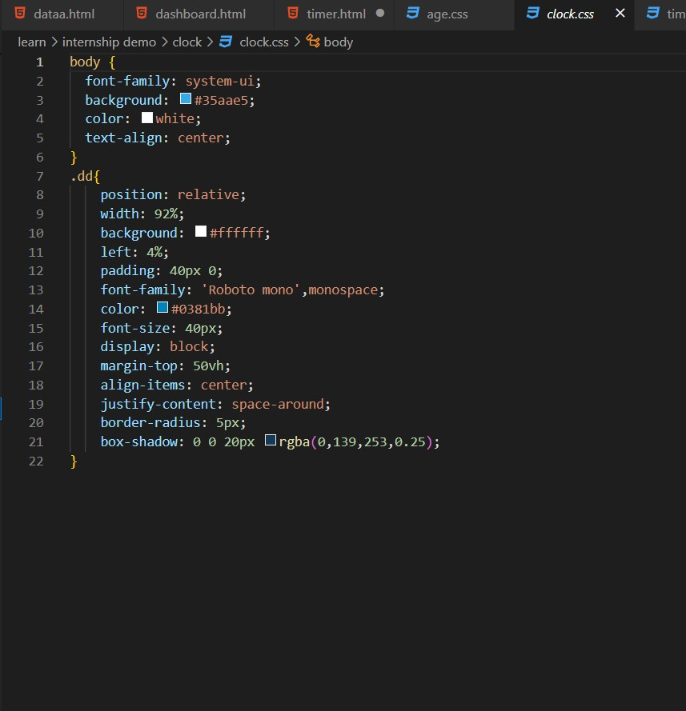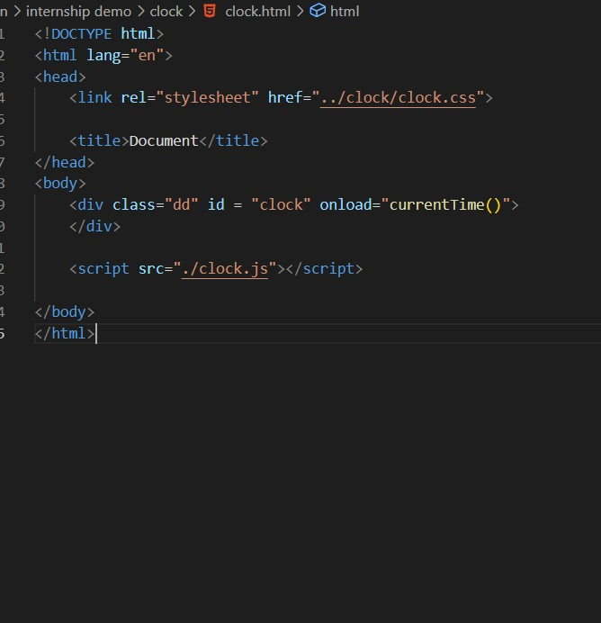

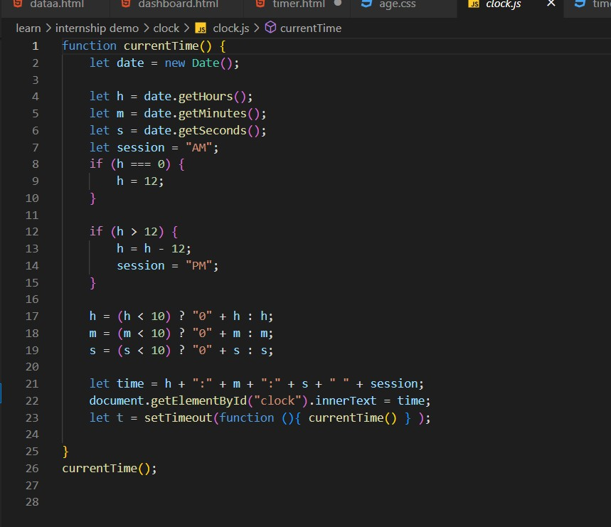



create demo nevbar using HTML,CSS

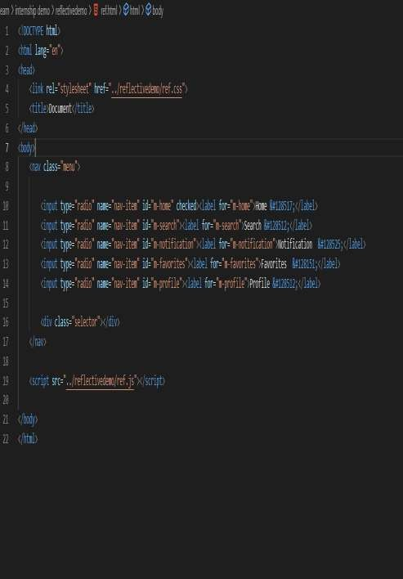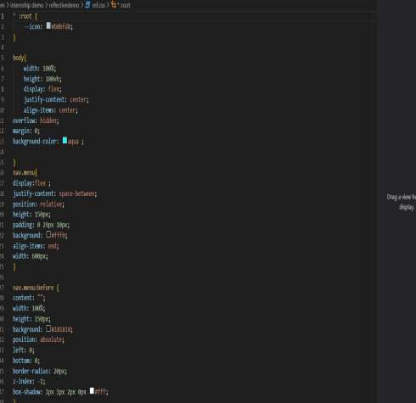

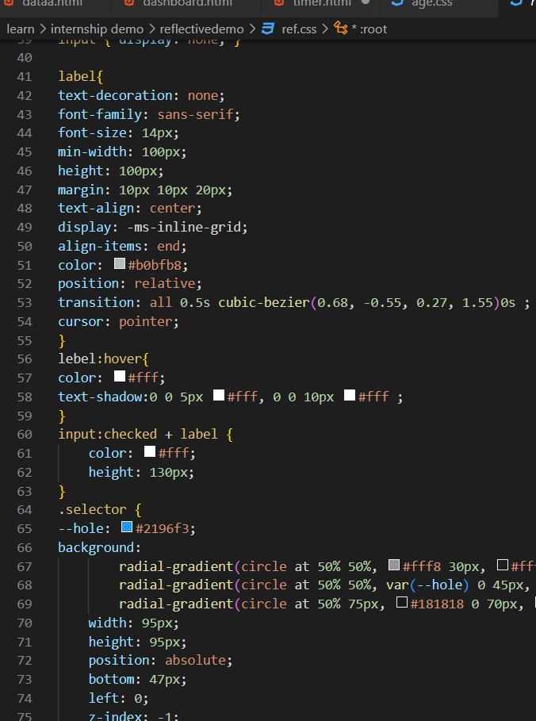 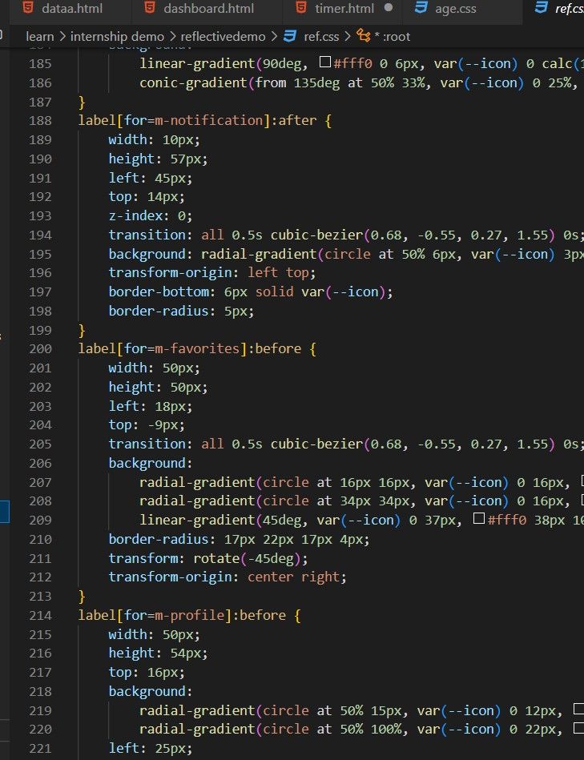

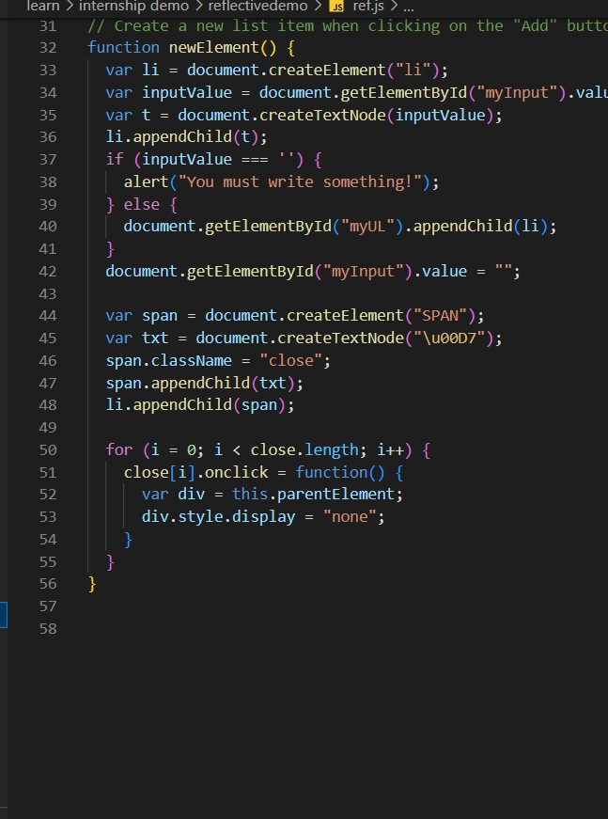 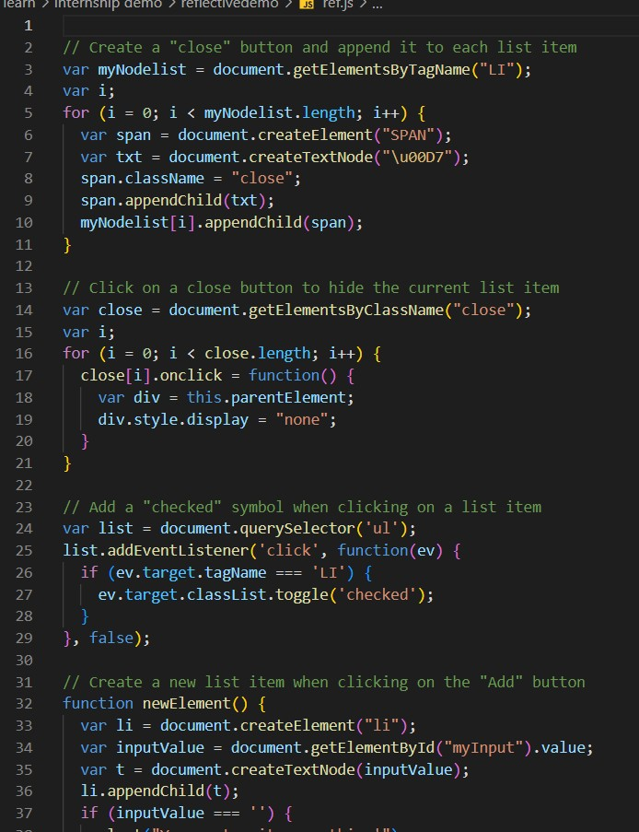

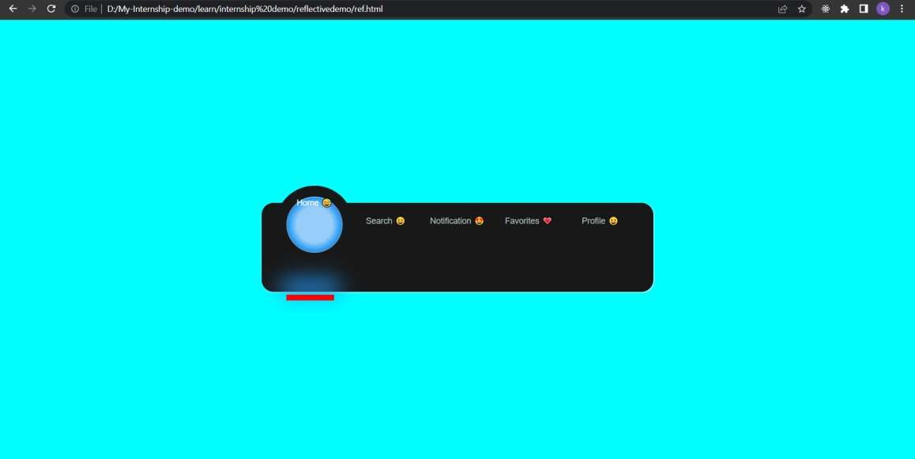

create demo DOM array model with sorting serching filtering

using API, HTML,CSS,JAVASCRIPT

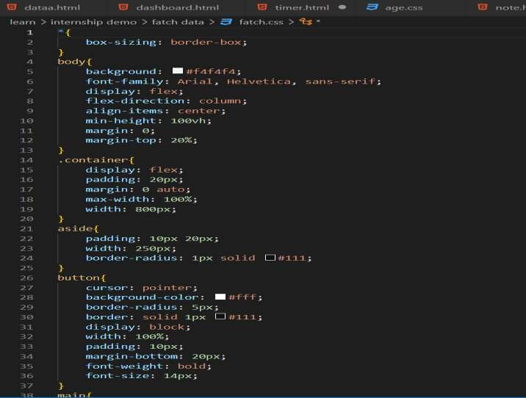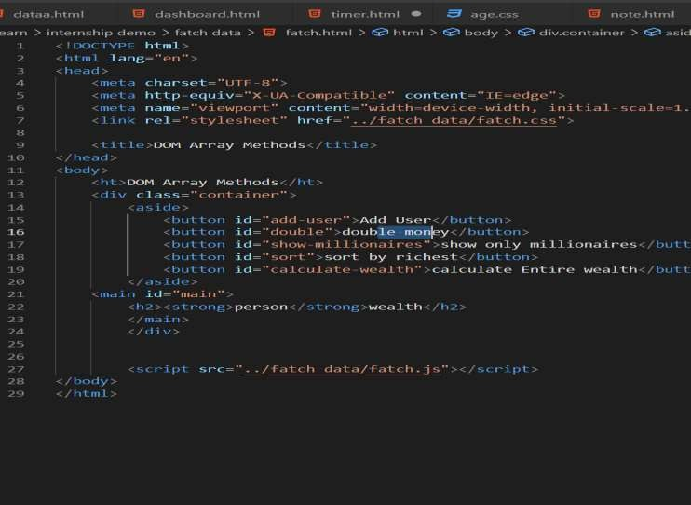

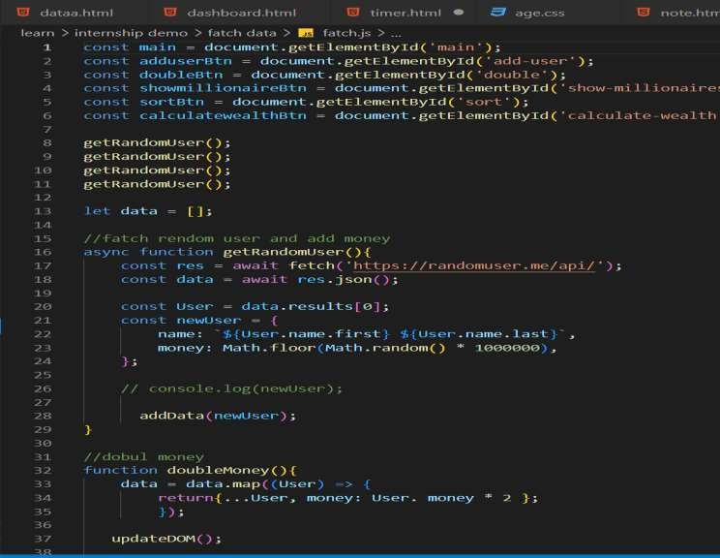 

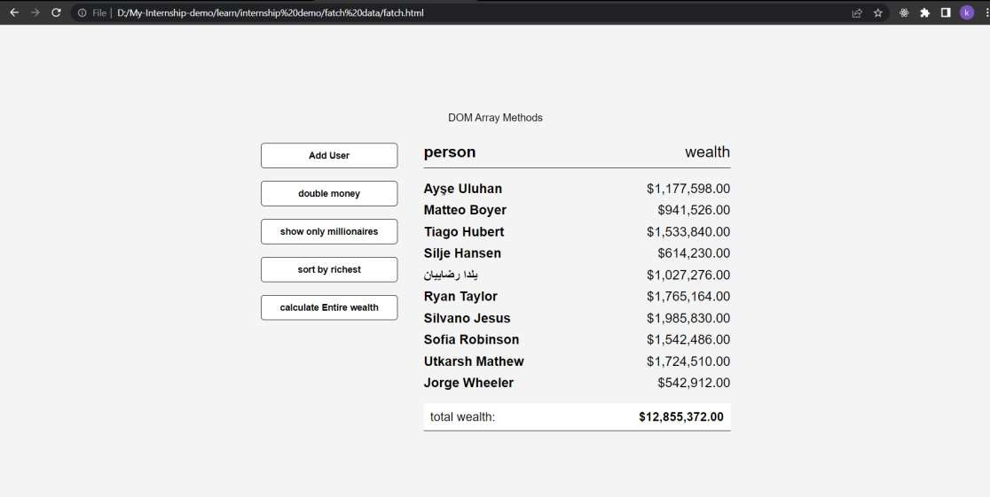

create demo DOM age calculeter using HTML,JAVASCRIPT

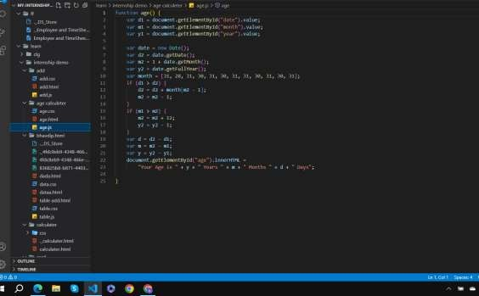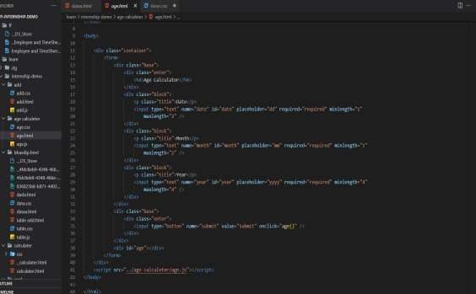

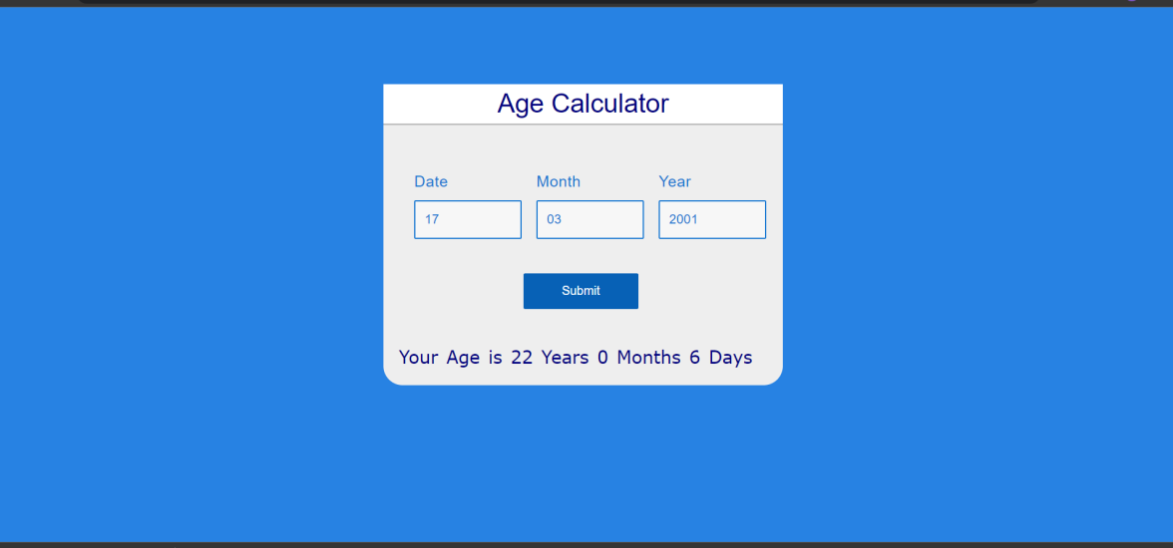

Thank you