**A Project Report on**

|  |  |
| --- | --- |
|  | **Semester-IV**  **2023**  **IT Project**  **ITCC14** |
|  |  |

**.NET (TASK BASED)**

Submitted as partial fulfillment of the requirement

For M.Sc**. IT - Semester IV**

Prepared for Subject: **IT Project** (**ITCC14**)

**Prepared By**

**Name of Student : Kanzariya Foram A.**

**Enrollment No.:21mscit22004**

**Exam No.:**



**Shri Maneklal M.Patel Institute of Sciences and Research**

**Kadi Sarva Vishwavidyalaya**

**Department of M.Sc.IT, Gandhinagar**

**ACKNOWLEDGMENT**

I am grateful to my internal guide ***Yagnesh vyash*** for providing me valuable guidance for the **IT PROJECT** (ITCC14) and other domain related information.

I would like to express my endless thanks to ***AMIT Patil(*BINARY REPUBLIK PVT.LTD*)***, for giving invaluable advice, direction, support and transferring knowledge throughout the project work.

Also my hearty gratitude to Head of Department, **Prof. (Dr.) B. R. Pandya** for giving me an opportunity for learning through the process of project work by which I can improve my technical skills along with practical exposure and its applicability in the industry.

**Name of Student: Kanzariya Foram A.. Signature of Student:**

Enrollment No.: 21mscit22004



**Shri Maneklal M.Patel Institute of Sciences and Research**

**Kadi Sarva Vishwavidyalaya**

**Department of M.Sc.IT, Gandhinagar**

***INTERNAL PROJECT CERTIFICATE***

This is to certify that **Kanzariya Foram A.** having Enrollment No. **21mscit22004** was working for the M.Sc. IT department as project trainee from <<15-dec-2022>> to <<14-apr-2023>>. During the above period, we found him/her to be very sincere and hardworking. He / She has completed IT Project (ITCC14) on <<***.net task based>>*** satisfactorily under the guidance of guide.

We appreciate the enthusiasm & dedication towards work.

We wish him/her very best in all his future endeavors.

**Project Guide**

Mr. Yagnesh vyash

Asst. Professor

M.Sc. (IT) Department.

**Prof. (Dr.) B. R. Pandya**

Head of Department, M.Sc. IT

01/01/2023

M.SC(INFORMATION TECHNOLOGY)

SEM-4

PROJECT REPORT: **TASK BASE**

COMPANY NAME : BINARY REPUBLIK PVT.LTD LANGUAGE : **.NET**

STUDENT NAME: **Kanzariya Foram A.**

ENROLLMENT NO: **21MSCIT22004**

INDEX

1. which is C# class and object
2. which is C# fibonacci series
3. which is C# abstract class
4. which is C# inheritance
5. which is C# polymorphism
6. Write a method that overloads the GetName() method by taking in a name and printing “Hello” with that name
7. Write a method that overloads the PerformAction() method with two arguments it could be numbers or strings. If both arguments are number then it should return Sum of both numbers.

If both arguments are strings then it should return concate of both string with space as separator. If there is no any arguments then it should print "Enter correct values“.

1. Registration form in Javascript with validation
2. Employee Details task with jQuery
3. Timesheet task with jQuery.

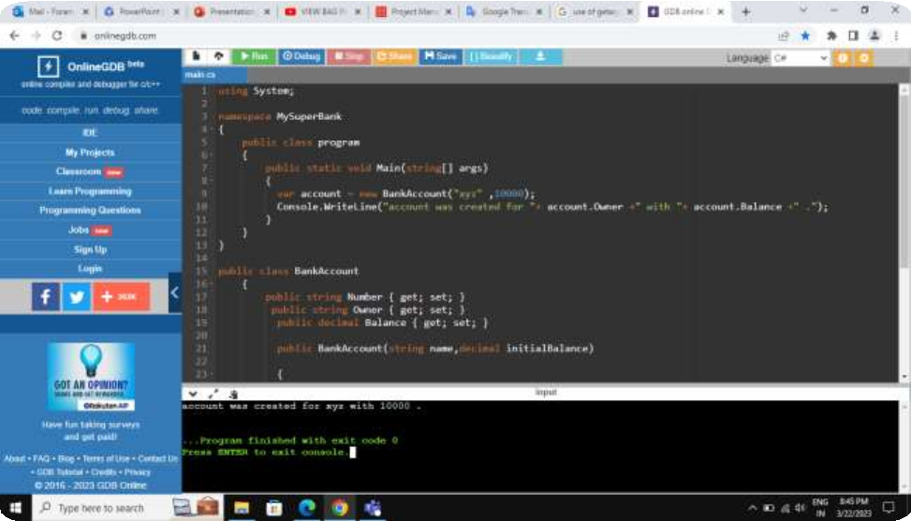

Task:1 which is C# class and object.

Task:2 which is C# fibonacci series.

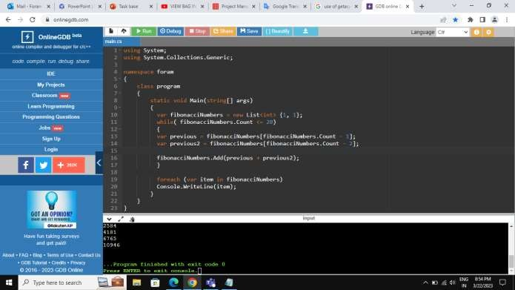

Task:3 which is C# abstract class.

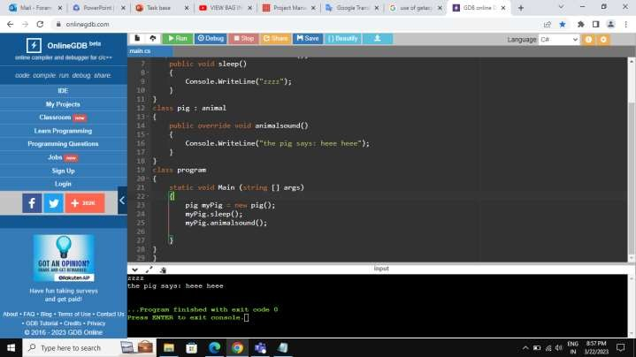

Task:4 which is C# inheritance.

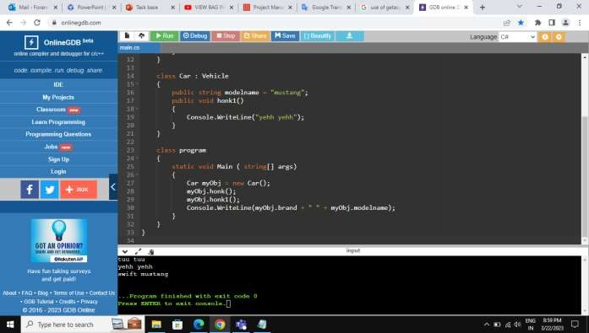

Task:5 which is C# polymorphism.

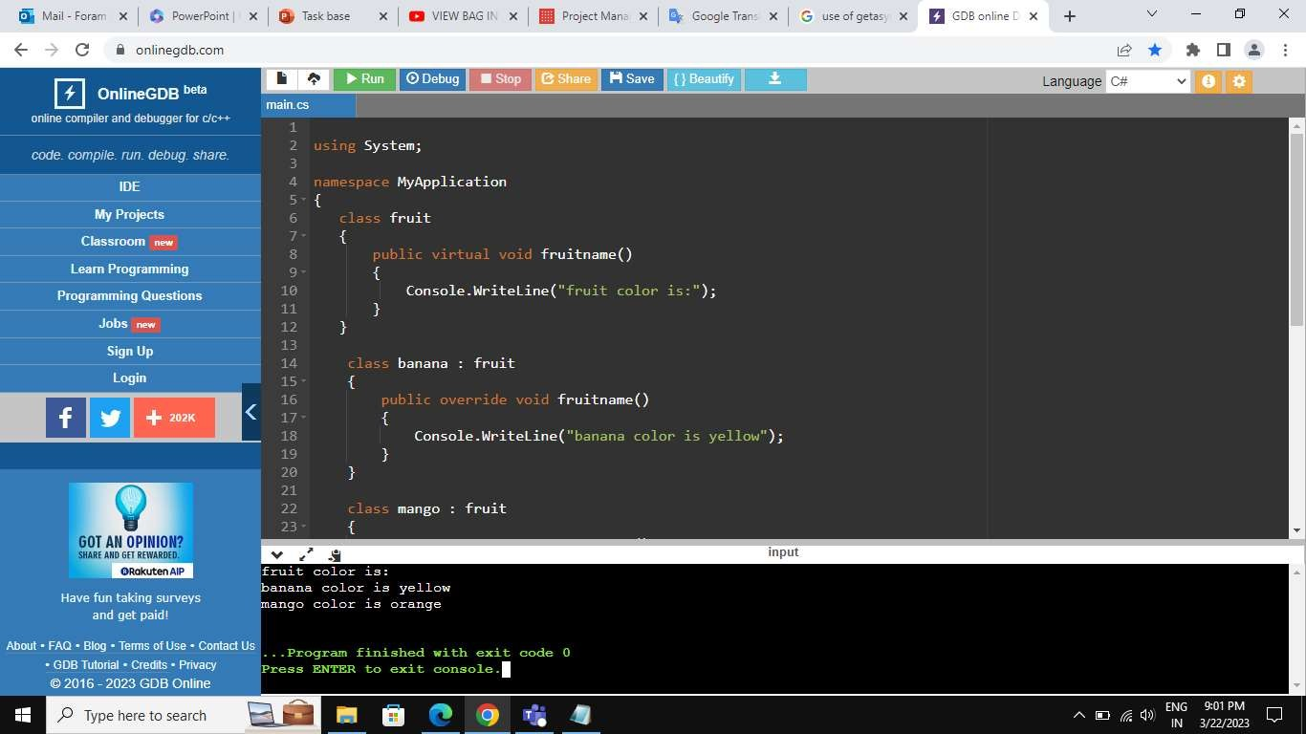

Task:6 Write a method that overloads the GetName() method by taking in a name and printing “Hello” with that name.

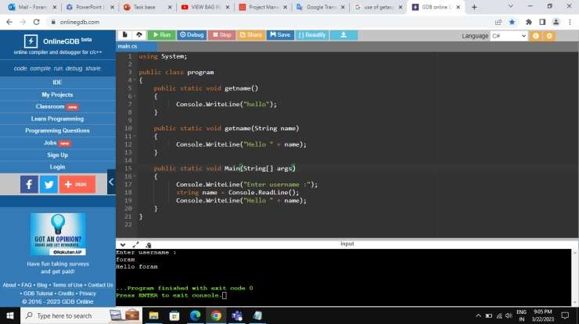

Task:7 Write a method that overloads the PerformAction() method with two arguments it could be numbers or strings.

If both arguments are number then it should return Sum of both numbers.

If both arguments are strings then it should return concate of both string with space as separator.

If there is no any arguments then it should print "Enter correct values".

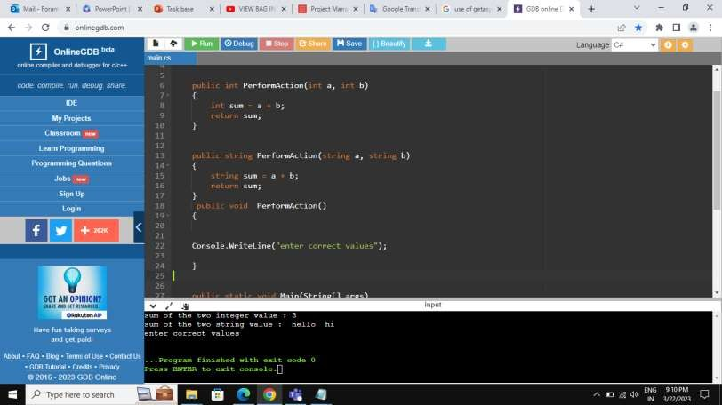

Task:8 Registration form in Javascript with validation.

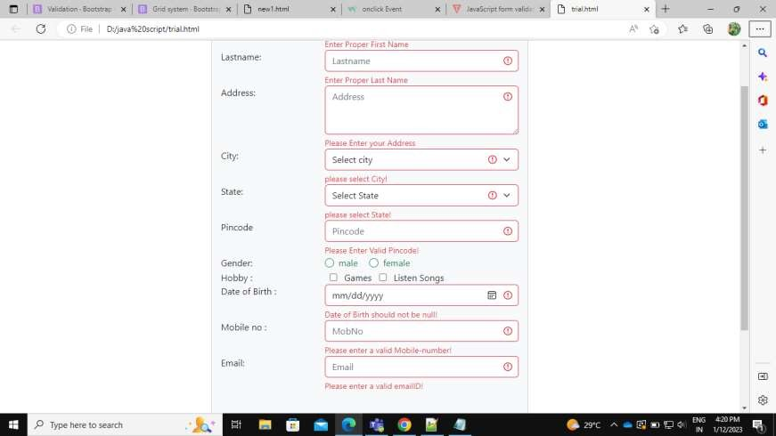

Task:9 Employee Details task with jQuery.

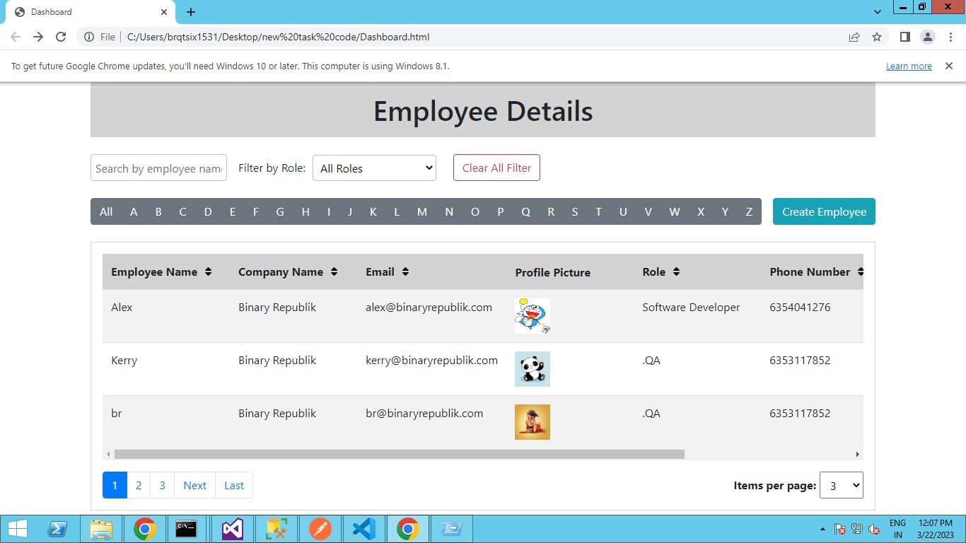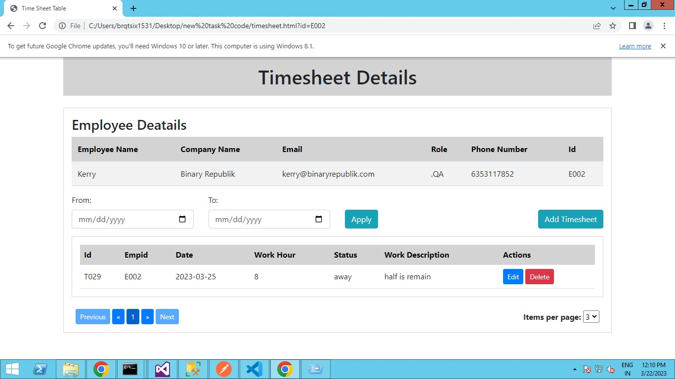

# Task:10 Timesheet task with jQuery.