 **DBMS Project**

*Prof. Name : P M Jat*

*Topic : Hotel Management*

*Group No. : G4_3*

Submissions :

1. Relational Schema Diagram
2. Minimal FD Set
3. BCNF Decomposing
4. DDL Script

Team Member details :

Name Student Id

Bhavesh Baraiya 202101241

Smeet Agrawal 202101237

Dhruvin Chaudhary 202101239

Rushang Parmar 202101240

1. Relational Schema Diagram :

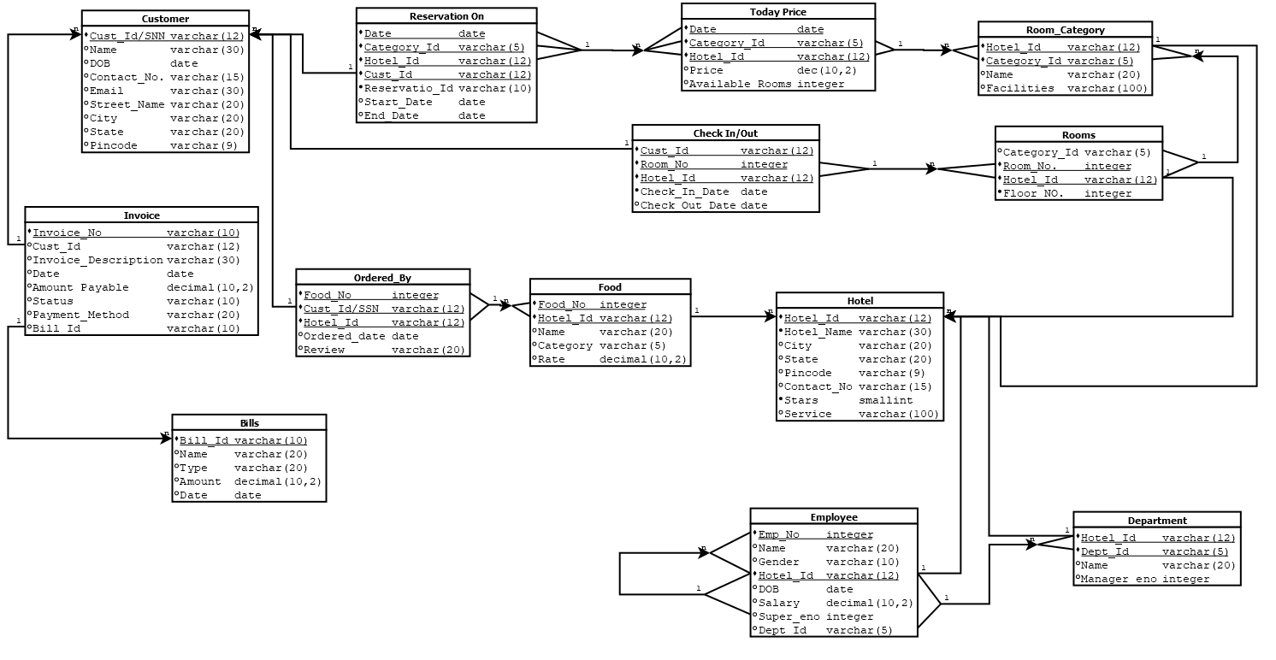

1. Minimal FD Set :

**Cust_Id/SNN 🡪 {Name ,DOB ,Contact_No ,Email ,City ,State ,Pin code}**

**{Date ,Category_Id ,Hotel_Id ,Cust_Id} 🡪 {Reservaion_Id ,Start_Date , End_Date}**

**{Reservation_Id ,Hotel_Id} 🡪 {Start_Date ,End_Date, Date ,Category_Id ,Cust_Id }**

**Invoice_No 🡪 {Customer_Id ,Invoice_Description ,Date ,Amount Payable ,Status , Payment_Method ,Bill_id}**

**Bill_Id 🡪 {Name ,Type ,Amount ,Date }**

**{Food_No ,Cust_Id ,Hotel_Id} 🡪 {Ordered_date ,Cust_Review}**

**{Food_No ,Hotel_id} 🡪 {Food_name ,Category ,Rate}**

**{ Food_name,Hotel_id} 🡪 { Food_No,Category ,Rate}**

**{Room_No , Hotel_Id} 🡪 {Category_id ,Floor No}**

**{Cust_Id ,Room_no ,Hotel_Id} 🡪 {Check_In_date ,Check_Out_date}**

**{Date ,Category_Id ,Hotel_id} 🡪 {Price ,Available Rooms}**

**{Hotel_Id ,Category_id} 🡪 {Category_Name ,Facilities}**

**Hotel_Id 🡪 {Hotel_Name , City , State , Pin code , Contact_No , Stars , Service}**

**{Hotel_id , Emp_No} 🡪 { Name , Gender , DOB , Salary , Super_eno , Dept_Id}**

**{Hotel_id , Dept_No } 🡪 { Name , Manager eno}**

1. Checking For BCNF(for every relation) :

*Customer :*

Cust_Id/SNN 🡪 {Name ,DOB ,Contact_No ,Email ,City ,State ,Pin code}

Key = { Cust_Id/SNN }

* Here every FDs have Key in left side so this relation is in BCNF.

*Reservation On :*

{Date ,Category_Id ,Hotel_Id ,Cust_Id} 🡪 {Reservaion_Id ,Start_Date , End_Date}

{Reservation_Id ,Hotel_Id} 🡪 {Start_Date ,End_Date , Date ,Category_Id ,Cust_Id }

Key ={Date ,Category_Id ,Hotel_Id ,Cust_Id} , {Reservation_Id ,Hotel_Id}.

* Here every FDs has one of the Key in left side so this relation is in BCNF.

*Invoice :*

Invoice_No 🡪 {Customer_Id ,Invoice_Description ,Date ,Amount Payable , Status , Payment_Method ,Bill_id}

Key = Invoice_No

* Here every FDs have Key in left side so this relation is in BCNF.

*Bill :*

Bill_Id 🡪 {Name ,Type ,Amount ,Date }

Key = Bill_Id

* Here every FDs have Key in left side so this relation is in BCNF.

*Ordered_By :*

{Food_No ,Cust_Id ,Hotel_Id} 🡪 {Ordered_date ,Cust_Review}

Key ={Food_No ,Cust_Id ,Hotel_Id}

* Here every FDs have Key in left side so this relation is in BCNF.

*Food :*

{Food_No ,Hotel_id} 🡪 {Food_name ,Category ,Rate}

**{ Food_name,Hotel_id} 🡪 { Food_No, Category ,Rate}**

Key = {{Food_No ,Hotel_id},**{ Food_name,Hotel_id}}**

* Here every FDs have Key in left side so this relation is in BCNF.

*Room :*

{Room_No , Hotel_Id} 🡪 {Category_id ,Floor No}

Key = {Room_No , Hotel_Id}

* Here every FDs have Key in left side so this relation is in BCNF.

*Check In/Out :*

{Cust_Id ,Room_no ,Hotel_Id} 🡪 {Check_In_date ,Check_Out_date}

Key ={Cust_Id ,Room_no ,Hotel_Id}

* Here every FDs have Key in left side so this relation is in BCNF.

*Today Price :*

{Date ,Category_Id ,Hotel_id} 🡪 {Price ,Available Rooms}

Key = {Date ,Category_Id ,Hotel_id}

* Here every FDs have Key in left side so this relation is in BCNF.

*Room Category :*

{Hotel_Id ,Category_id} 🡪 {Category_Name ,Facilities}

Key = {Hotel_Id ,Category_id}

* Here every FDs have Key in left side so this relation is in BCNF.

*Hotel :*

Hotel_Id 🡪 {Hotel_Name , City , State , Pin code , Contact_No , Stars , Service}

Key = Hotel_Id

* Here every FDs have Key in left side so this relation is in BCNF.

*Employee :*

{Hotel_id , Emp_No} 🡪 { Name , Gender , DOB , Salary , Super_eno , Dept_Id}

Key = {Hotel_id , Emp_No}

* Here every FDs have Key in left side so this relation is in BCNF.

*Department :*

{Hotel_id , Dept_No } 🡪 { Name , Manager eno}

Key = {Hotel_id , Dept_No }

* Here every FDs have Key in left side so this relation is in BCNF.

Q-4 DDL Script :

create schema Hotel_Management;

set search_path to Hotel_Management;

-- **************** Hotel *******************

Create table Hotel(

Hotel_ID varchar(12) primary key,

Hotel_Name varchar(30),

City varchar(20),

State varchar(12),

Pincode varchar(9),

Contact_No varchar(15),

Stars smallint not null,

Service varchar(100)

);

-- **************** Room Category **************

Create table Room_Category(

Hotel_ID varchar(12),

Category_ID varchar(5),

Name varchar(20),

Facilities varchar(100),

Primary key(Hotel_ID,Category_ID),

Foreign key (Hotel_ID) references Hotel(Hotel_ID) on delete cascade on update cascade

);

--*************** Room *******************

Create table Rooms(

Category_ID varchar(5),

Room_No integer,

Hotel_ID varchar(12),

Floor_No integer not null,

Primary key(Room_No,Hotel_ID),

Foreign key (Hotel_ID) references Hotel(Hotel_ID) on delete cascade on update cascade,

Foreign key (Category_ID,Hotel_ID) references Room_Category(Category_ID,Hotel_ID) on delete cascade on update cascade

);

-- **************** Today Price **************

create table Today_Price(

Date date,

Category_ID varchar(5),

Hotel_ID varchar(12),

Price decimal(10,2),

Available_Rooms integer,

Primary key(Date,Category_Id,Hotel_ID),

Foreign key(Category_ID,Hotel_ID) references Room_Category(Hotel_ID,Category_ID) on delete cascade on update cascade

);

-- ************* Customer *****************

create table Customer(

Cust_id varchar(12) primary key,

"Name" varchar(30),

DOB date,

Contact_No varchar(15),

Email varchar(30),

Street_Name varchar(20),

City varchar(20),

"State" varchar(20),

Pincode varchar(9)

);

-- ************** reservation On ****************

Create table Reservation_On(

"Date" date,

Category_ID varchar(5),

Hotel_ID varchar(12),

Cust_ID varchar(12),

Reservation_ID varchar(10) not null,

Start_Date date,

End_date date,

Primary key("Date",Category_ID,Hotel_ID,Cust_ID),

Foreign key("Date",Category_ID,Hotel_ID) references Today_Price(Date,Category_ID,Hotel_ID) on delete cascade on update cascade,

Foreign key (Cust_id) references Customer(Cust_id) on delete cascade on update cascade

);

-- ************** Check In/Out ****************

Create table check_in_out(

Cust_ID varchar(12),

Room_No integer,

Hotel_ID varchar(12),

Check_In_Date date,

Check_Out_Date date,

Primary key(Cust_id,Room_No,Hotel_ID),

Foreign key(Room_No,Hotel_ID) references Rooms(Room_No,Hotel_ID) on delete cascade on update cascade,

Foreign key (Cust_id) references Customer(Cust_id) on delete cascade on update cascade

);

-- ************** Department ****************

Create table Department(

Hotel_ID varchar(12),

Dept_ID varchar(5),

Name varchar(20),

Manager_eno integer,

Primary key(Hotel_ID,Dept_ID),

Foreign key (Hotel_ID) references Hotel(Hotel_ID) on delete cascade on update cascade

);

-- *************** Employee ***************

Create table Employee(

Hotel_ID varchar(12),

Emp_No integer,

"Name" varchar(20),

Gender varchar(10),

DOB date,

Salary decimal(10,2),

Super_eno integer,

Dept_ID varchar(5),

Primary key(Hotel_ID,Emp_NO),

Foreign key(Dept_ID,Hotel_ID) references Department(Dept_ID,Hotel_ID) on delete cascade on update cascade,

Foreign key(Super_eno,Hotel_ID) references Employee(Emp_No,Hotel_ID) on delete cascade on update cascade,

Foreign key(Hotel_ID) references Hotel(Hotel_ID) on delete cascade on update cascade

);

-- ************** Food ****************

Create table Food(

Food_No integer,

"Name" Varchar(20),

Hotel_ID varchar(12),

Category Varchar(5),

Rate decimal(10,2),

Primary key (Food_No,Hotel_ID),

Foreign key(Hotel_ID) references Hotel(Hotel_ID) on delete cascade on update cascade

);

-- ************** Ordered By ****************

Create table Ordered_By(

Food_NO integer,

Cust_ID varchar(12),

Hotel_ID varchar(12),

Ordered_date date,

Review varchar(20),

primary key(Food_NO,Cust_ID,Hotel_ID),

Foreign key (Cust_ID) references Customer(Cust_ID) on delete cascade on update cascade,

Foreign key(Food_No,Hotel_ID) references Food(Food_No,Hotel_ID)

);

-- ************** Bills ****************

Create table Bills(

Bill_ID varchar(10) primary key,

"Name" varchar(20),

Type varchar(20),

Amount decimal(10,2),

Date date

);

-- *************** Invoice ***************

Create table Invoice(

Invoice_No Varchar(10) Primary key,

Cust_id Varchar(12),

Invoice_Description Varchar(30),

"Date" date,

Amount_Payable decimal(10,2),

Status Varchar(10),

Payment_Method Varchar(20),

Bill_ID Varchar(10),

Foreign key (Cust_id) references Customer(Cust_id) on delete cascade on update cascade,

Foreign key (Bill_ID) references Bills(Bill_ID) on delete cascade on update cascade);