LEVER-CONTROLLED MANUAL SEED DRILL WITH SPRING -LOADED GATE & LEVELLER
A project report submitted to

Dr. Sakthivel G
School of Mechanical Engineering
In partial fulfilment of the requirements for the course
of
Agriculture Automation
In

B.Tech. Mechatronics and Automation

Batch Number – xx
Team Members: Contact number:
- Name xxxx -regxxxxxxx xxxxxxxxxx
- Name xxxx -regxxxxxxx xxxxxxxxxx

Date Of Submission: xx^{th} October xxxx

- ABSTRACT

This project presents the design and fabrication of a Lever-Controlled Manual Seed Drill with a spring-loaded gate and leveller, aimed at enhancing the efficiency of sowing on small-scale agricultural lands. The device is engineered for multi-crop compatibility such as maize, groundnut, etc by incorporating a distance measuring mechanism with a slot wheel. A pawl, actuated through a handle-mounted lever, locks the wheel at each slot to ensure consistent seed-to-seed spacing. Seed release is controlled by a lever-operated gate with a return spring, enabling precise and rapid seed delivery. The integrated furrow opener ensures seeds are placed at the correct soil depth, while the in-built leveller prepares uniform seed beds. Entirely constructed with mild steel for durability, the planter is ergonomic, robust, and easy to handle. This innovation brings greater accuracy, efficiency, and convenience to smallholder farming, reducing labour effort and improving planting consistency across diverse field conditions.

- INTRODUCTION
Agricultural innovation is the backbone of food security and rural development. For millions of small and marginal farmers, traditional sowing methods—such as manual broadcasting or dibbling—are time-consuming, physically demanding, and result in non-uniform crop stands. As the pressure grows for more efficient, productive, and sustainable farming, the need for affordable and adaptable mechanized tools for small farm holdings becomes ever more urgent.
The lever-controlled manual seed drill with a spring-loaded gate and leveller directly responds to these needs. Designed specifically for small-scale agricultural lands, this implement transforms the sowing process for a wide range of crops including maize, groundnut, and other commonly grown field crops. Using a precision-engineered distance measuring mechanism in the front wheel, combined with a pawl-and-lever system, the seed drill delivers consistent plant-to-plant spacing with minimal operator effort. Each of the six slots, spaced at 60° intervals, allows the user to halt movement, drop a seed at a precise spot, and quickly move to the next planting position with a simple lever press. Beyond planting accuracy, the integrated furrow opener and leveller streamline bed preparation and seed placement in one pass, reducing labour and ensuring ideal conditions for germination. Entirely constructed from mild steel for strength and longevity, the machine is engineered to be robust enough for rough field conditions and yet simple enough for rapid fabrication and maintenance in local workshops.

This project aims to bridge the gap between labour-intensive traditional methods and the often-prohibitive cost of large-scale mechanization. By introducing a cost-effective, ergonomic, and versatile sowing solution, it empowers smallholder farmers to boost productivity, achieve better crop stands, and reduce the drudgery of manual planting.
- OBJECTIVES
- Design an ergonomic manual seed drill for small-scale farming:
The project aims to create a compact planter that is comfortable to use for long periods, making it ideal for small landholders. Ergonomics are prioritized through handle placement, wheel size, and overall balance, allowing easy operation by a single person in field conditions.

- Implement an adjustable pawl-slot mechanism for precise seed spacing:
A six-slot wheel with 60° intervals, controlled by a pawl linked to a handle lever, enables users to maintain accurate plant-to-plant distances. This allows adaptation to different crops and optimizes plant distribution for better yield and resource use.

- Make the device versatile for multiple crop types:
The planter’s mechanism is sized to accommodate varying seed dimensions and can be easily adjusted for crops like maize, groundnut, and beans. This flexibility expands its usefulness and provides value across different sowing requirements.

- Integrate a spring-loaded seed gate for reliable and smooth seed delivery:
The seed gate, operated by a lever and returned with a spring, ensures consistent seed flow without clogging or jamming. This precise control over seed release reduces losses and enhances crop uniformity.

- Equip the drill with a furrow opener and leveller for optimal seed placement:
The addition of a furrow opener ensures proper soil penetration and seed depth, while the leveller creates a smooth planting bed. Together, these features maximize germination rates and crop establishment.

- Fabricate all structural parts using mild steel for strength and easy maintenance:
Mild steel construction imparts durability and robustness to the planter, making it resistant to field wear and easy to repair. This choice also allows the entire unit to be built with basic workshop tools and skills.

- METHODOLOGY:

- System Design and Material Selection: The seed drill was conceptually designed with focus on ergonomic operation and crop versatility. All structural parts, including the frame, wheels, handle, hopper, and pawl mechanism, were specified as mild steel for strength, weldability, and local availability. Key dimensions, such as wheel diameter and optimized slot locations, were finalized using CAD modelling.

- Fabrication and Assembly: Mild steel rods, tubes, and sheets were cut and machined according to the design. Welding was used for major joints, while bolting ensured modularity for the handlebar and pawl mechanism. Each slot in the wheel was machined accurately to ensure reliable operation of the pawl and lever system. The seed hopper and furrow opener were formed using sheet metal and securely attached as per drawings.

- Distance Measurement and Pawl Mechanism: A six-slot wheel (slots spaced at 60°) was implemented, with a spring-loaded pawl system linked to an operator lever. This mechanism allowed controlled stopping at each slot for seed release, providing uniform spacing. The lever mechanism was tuned to ensure easy locking and quick release by the user.

- Seed Gate and Spring-Loaded Release: The seed gate was fabricated and fitted with a return spring to ensure automatic closure after each seed drop. The lever-operated gate provided precision delivery, minimizing seed loss and enabling single planting per stop.

- Furrow Opening and Levelling Attachment: A mild steel furrow opener was placed centrally below the frame, adjustable for depth. The integrated leveller smoothed the soil surface during each pass, ensuring proper bed preparation and seed coverage.

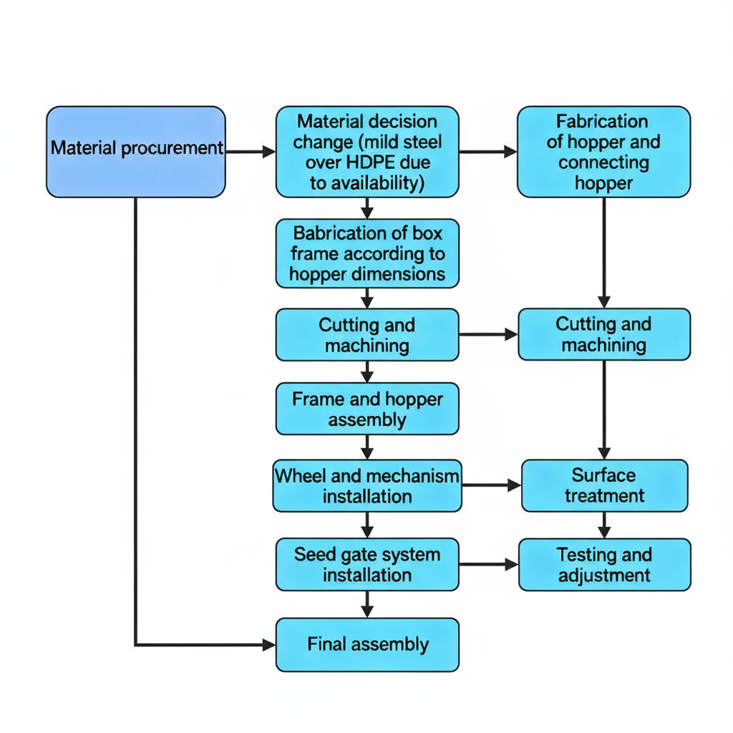

- Processes Used:
    - Cutting: Steel rods, tubes, and sheets were cut to size using hacksaws, angle grinders, and cutting wheels, ensuring each component matches the design specifications.

    - Grinding: All edges and cut surfaces were finished with bench grinders and hand grinders to remove burrs, provide clean edges for fitting, and improve safety.

    - Welding: Major frame joints, wheel hubs, and attachment points were joined by electric arc welding, providing structural strength and rigidity.

    - Bending: Sheet metals were bent to manufacture the hopper.
    - Lathe Operations: The wheels were machined on the lathe for facing, step turning, and grooving to achieve the correct diameter, slot feature precision, and smooth rotation. Axles and some custom bolts were also turned to size.

    - Drilling: Holes were drilled for mounting the pawl, handlebar, and slot mechanisms, as well as for bolts and mandrels wherever required.

    - Assembly and Adjustment: All parts were assembled as per the project drawings. Moving parts such as the pawl, lever, and seed gate were adjusted for free movement and tolerance, ensuring reliable operation.

- Testing and Performance Evaluation: The complete assembly was tested for alignment, mechanical function, and ease of operation. Plant spacing was verified for both maize and groundnut. Adjustments were made to optimize pawl sensitivity, seed flow rate, and soil penetration.

- Documentation and Visual Evidence: All fabrication stages, mechanical features were documented with photographs and assembly diagrams. Exploded views and technical illustrations (see appendices) were created to facilitate understanding and future replication.

- IMPLEMENTATION:
The lever-controlled manual seed drill was implemented through a series of structured fabrication and assembly steps.
            - Material Procurement and Planning:
The project utilized a combination of mild steel rods and tubes strategically selected based on mechanical requirements and ease of fabrication. Mild steel rods were used where higher strength and force resistance were necessary, while mild steel tubes of varying diameters formed the hopper box frame to maintain a lightweight yet sturdy structure.

Components | Materials/Specification | Quantity | Notes
Handlebar | Sourced from old bicycle | 1 | Ergonomic, cost-effective
Mild steel rods | For areas with higher force | 4 | For structural strength
Mild steel tubes | Frame and hopper box  with 16mm diameter | 4 | Lightweight frame support
Feed hopper and connecting feeder | 2 mm thick mild steel sheet | 1mx1m | Main seed storage and delivery
Allen Bolts with nuts | 6 x 16 mm | 4 | To lock connecting feeder to feed hopper
Handle rod | 25 mm square mild steel rod | 1 | Operator handle
Wheels | Solid mild steel cylinder, 150 mm dia, 80 mm thickness | 2 | Main wheels
Pawl | Flat 10 mm square mild steel rod | 1 | Locking mechanism
Front wheel pins | 10 mm diameter with holes | 6 | Fixed with 6 x 25 mm tapped hole screws
Tension Springs with hook | 1 pawl spring (75 mm length, 10 mm dia) | 1 | Pawl return mechanism
 | 2 seed plate springs (50 mm length, 10 mm dia) | 2 | Seed gate closure
Cable screws | For seed gate and pawl cable lock | 2 | Secures cable in screw holes
Circlips | A55mm (OD) | 4 | For shaft stability
 | B90mm (ID) | 4 | For bearings
Allen bolts with washers | 4 x 10 mm | 2 | To lock spring near seed gate to frame
Seed Plate | 3 mm thick mild steel, 75 mm x 50 mm | 1 | Seed discharge mechanism
Shaft mounting bolts | M16 x 55 mm Allen bolts | 4 | Locks wheel and shaft to frame
Shaft bushes | For shaft stability | 4 | Reduces shaft movement during wheel rotation

            - Design Refinements for Weight and Usability:
To make the seed drill lightweight and ergonomic, the wheel diameter was reduced from 200 mm to 150 mm. The front wheel was designed with 6 slots spaced 60° apart to accommodate various seeds such as maize, groundnut, and beans.

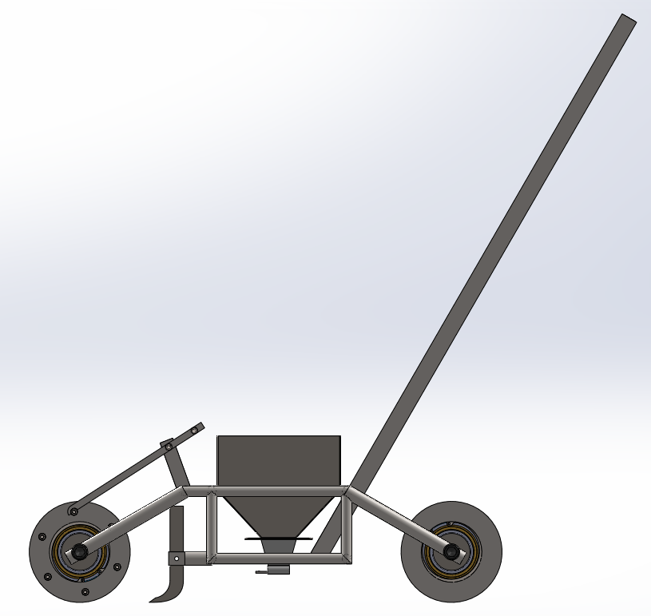

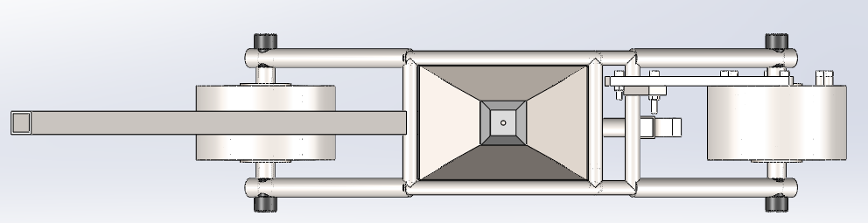
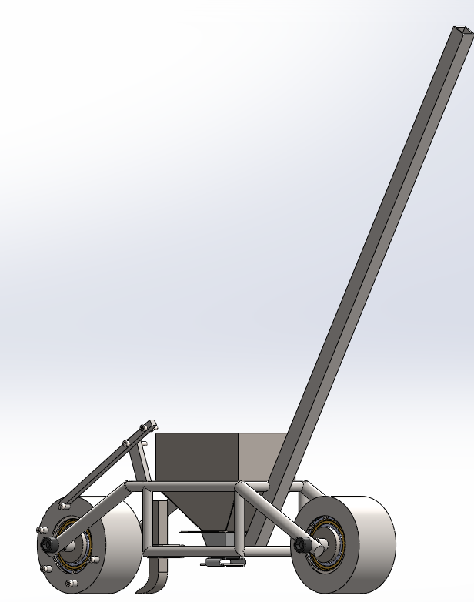
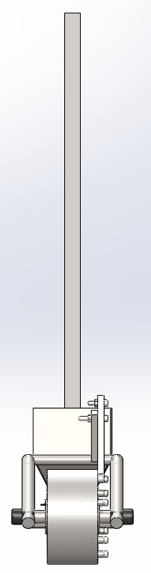
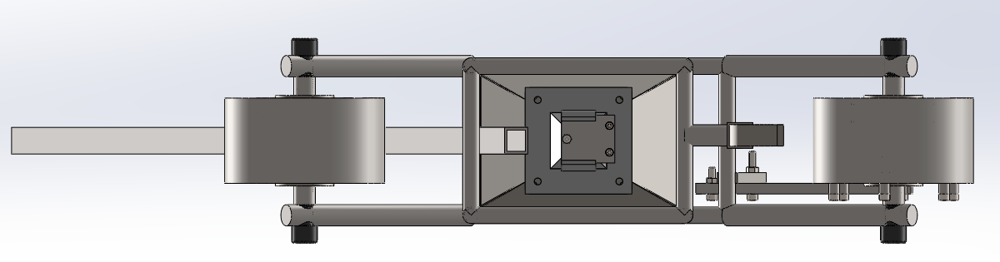

- Distance Measurement Calculation:
Circumference = π x Diameter
Circumference = 3.14 x 150 = 471.24mm

Calculate Distance Between Seeds (for 6 slots) :

Distance per slot = Circumference
number of slots

$\text{Distance per slot}=471.24/6=78.54\text{ mm}$
Seed Distance = (π x Wheel Diameter)
Number of slots engaged

Seed Distance = 3.14 x 150 / 6 = 78.5mm

    - Using all 6 slots → 78.5 mm spacing
    - Using every second slot → 157 mm spacing
    - Using every third slot → 235.5 mm spacing
For a crop not listed, use the formula:
$$\text{Number of Slots}=\frac{\text{Wheel Circumference}}{\text{Desired Spacing}}$$

Crop | Recommended Plant Spacing (mm) | Wheel Slots Used
Maize | 150 - 160 | 3
Groundnut | 140 - 160 | 3
Beans | 60 - 80 | 6

  - Bearing: Model number – 6011-2Z
To enhance the smooth operation and durability of the seed drill, four high-quality bearings were used, two for each wheel to ensure uniform wheel rotation and reduce friction during movement. These bearings are securely held in place using four circlips, preventing axial movement and maintaining alignment. This addition improves the overall usability and longevity of the device.

            - Fabrication of Feed Hopper and Connecting Hopper: 2 mm thick mild steel sheets were cut and fabricated into the main feed hopper and connecting hopper using cutting, bending, and welding techniques.
The connecting hopper has a centre hole of 11mm diameter for the seed drop.

            - Seed Gate Assembly: The seed gate mechanism was built using two springs (50 mm length, 10 mm diameter) to ensure smooth seed release and automatic closure. The seed gate and connecting feeder are joined by four screws, allowing easy adjustments for different seed sizes.
Seed Gate Tension Spring Calculation:
Parameters:
- Spring free length ($L_{0}$) = 50 mm (0.05 m)
- Mean coil diameter ($D$) = 10 mm (0.01 m)
- Wire diameter ($d$) = 1.5 mm (0.0015 m)
- Number of coils ($n$) = 50
- Shear modulus for steel ($G$) = $79×{10}^{9}$ Pa
Spring constant (stiffness):
$$k=\frac{Gd^{4}}{8nD^{3}} \\ k=\frac{79×{10}^{9}×(0.0015)^{4}}{8×50×(0.01)^{3}}≈1000\text{ N/m}$$For a typical seed gate opening of 15 mm ($0.015$m):
$$F=k×x=1000×0.015=15\text{ N}$$
Safe maximum working extension (25% of free length):
$$x_{max}=0.25×0.05=0.0125\text{ m} \\ F_{max}=k×x_{max}=1000×0.0125=12.5\text{ N}$$
Each spring on the seed plate provides about 15N return force at normal seed gate opening (8 mm stroke), with a safe maximum force of about 12.5 N at 12.5 mm stretch. This is sufficient for positive closure without excessive resistance.
            - Mechanical Components Fabrication: Wheels were machined on a lathe for stepping, grooving, and facing. Bearings, circlips, shafts, and bushes were procured and assembled. The front wheel was drilled with six precise slots for the pawl mechanism.

Lathe operations for wheels:

            - Pawl Mechanism and Lever Installation: A pawl spring (75 mm length, 10 mm diameter) was used for automatic pawl return. Two levers were installed one to control the pawl engagement on the front wheel, and the other to operate the seed gate.
  - Pawl Tension Spring Calculation:
Parameters:
- Spring free length ($L_{0}$) = 75 mm (0.075 m)
- Mean coil diameter ($D$) = 10 mm (0.01 m)
- Wire diameter ($d$) = 1.5 mm (0.0015 m)
- Number of coils ($n$) = 50
- Shear modulus for steel ($G$) = $79×{10}^{9}$ Pa
Spring constant (stiffness) formula:
$$k=\frac{Gd^{4}}{8nD^{3}} \\ k=\frac{79×{10}^{9}×(0.0015)^{4}}{8×50×(0.01)^{3}}≈1000\text{ N/m}$$
Force generated for 12 mm ($0.012$ m) extension:
$$F=k×x=1000×0.012=12\text{ N}$$
Safe working load (extension for 25% of free length):
$$x_{max}=0.25×0.075=0.01875\text{ m} \\ F_{max}=k×x_{max}=1000×0.01875=18.75\text{ N}$$
            - Assembly of Frame and Wheels: The rectangular steel frame was assembled with welded joints to hold the hopper and wheels. Rods at a 50 mm distance from the ground ensure proper seed gate and soil contact.

            - Final Assembly and Adjustments: All parts including handlebar, levers, seed gate, pawl, wheels, and hopper were assembled. The height of the handlebar was fixed at 905 mm from the ground with an ergonomic angle to allow clear visibility of the seed level inside the hopper.

            - Surface Treatment: To prevent corrosion, wheels were zinc-coated, and the frame was spray-painted after fabrication.
Spray paint – 7024 colour (grey)

- RESULTS AND ANALYSIS:
The lever-controlled manual seed drill designed and fabricated in this project demonstrated promising results in terms of build quality, usability, and planting accuracy.
- Weight and Ergonomics: The total weight was reduced to approximately 28.5 kg by using mild steel rods in high-stress areas and tubes for the frame, with wheel diameter lowered to 150 mm. This improved operability, making it easy for a single operator to push and maintain control.
- Seed Spacing Accuracy: The 150 mm diameter front wheel with 6 slots spaced at 60° provided a consistent seed-to-seed distance of approximately 78.5 mm, ideal for crops like maize, groundnut, and beans. Through smooth engagement of the pawl mechanism, uniform planting spacing was achieved without skip or overlap.
- Mechanism Reliability: The spring-loaded pawl and seed gate leveraged tension springs sized and calculated for proper return force ensuring positive action each cycle. The two-lever control system allowed efficient seed release and accurate seed placement.
- Material Durability and Finish: Zinc coating on the wheels and spray painting on the frame effectively prevented corrosion, ensuring durability in field conditions. The entire machine was fabricated with readily available materials without compromising strength.
- Adjustment and Versatility: The hopper and feeding mechanisms were bolted for easy disassembly, allowing adjustments for different seed sizes and types, enhancing crop compatibility.
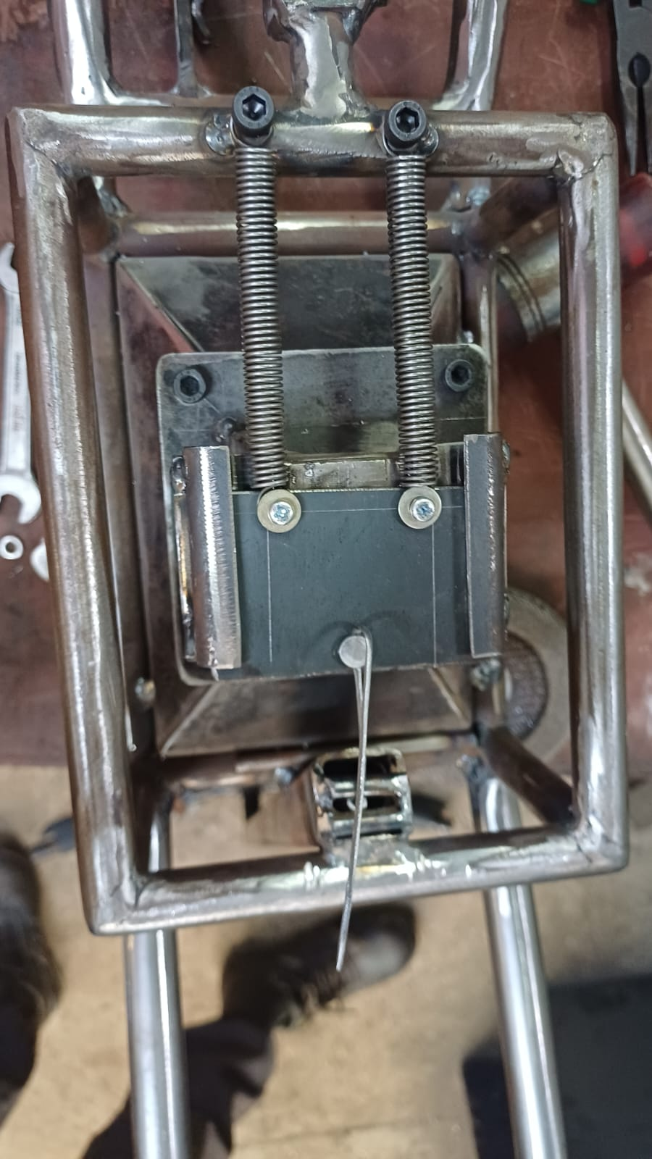
Seed Gate:

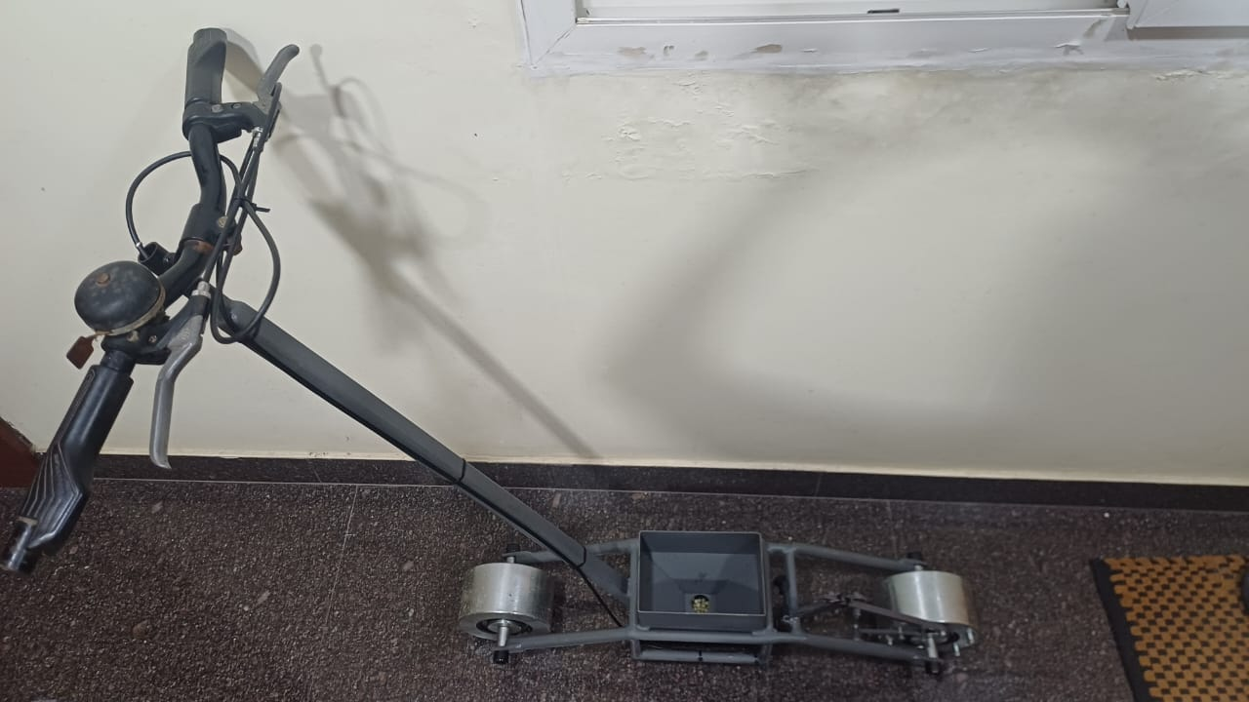
Assembly:

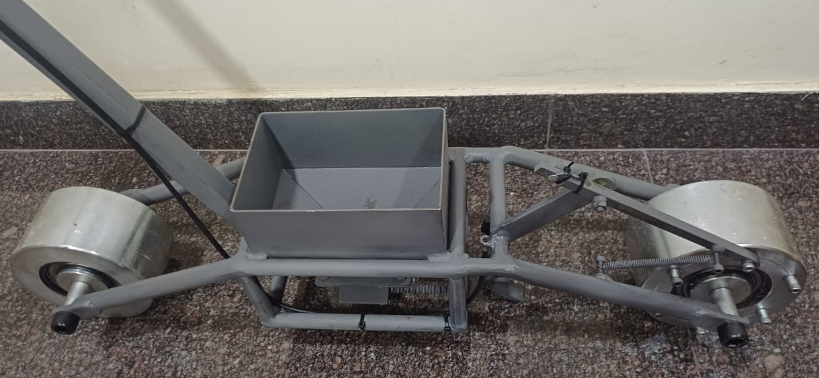

Front Wheel:
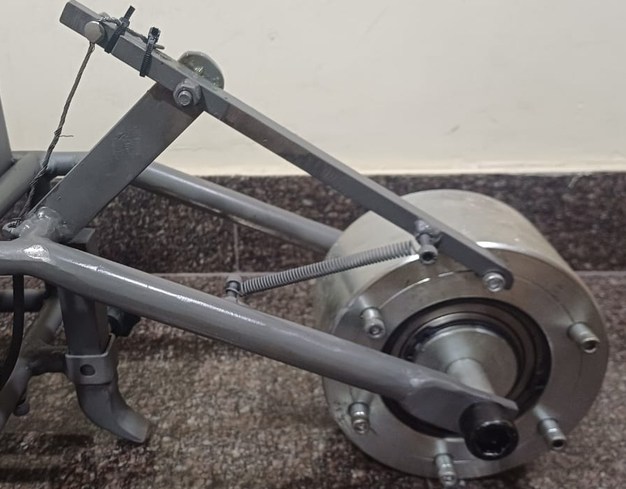

Back Wheel:
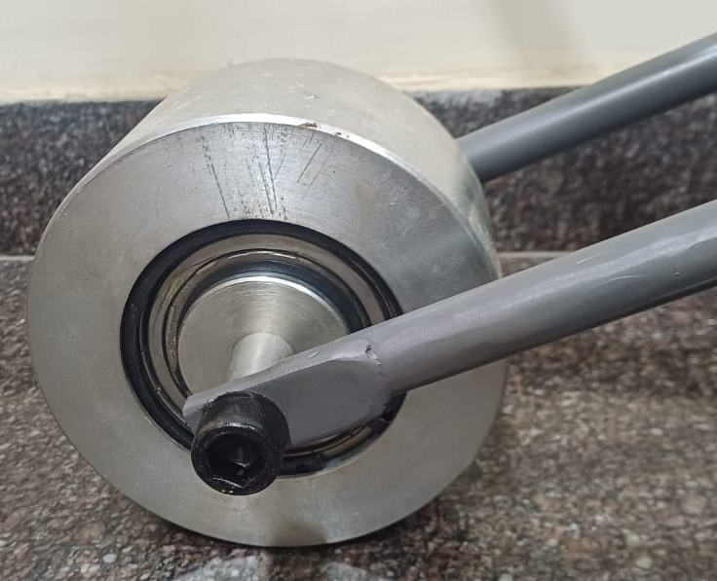

- DISCUSSION:

Achievement of Objectives:
The project successfully met its primary goals of delivering a reliable, ergonomic, and versatile manual seed drill. Use of mild steel rods and tubes resulted in a structure that balances strength with manageable weight. Calculated spring forces and properly machined pawl components ensured the mechanism functioned smoothly, delivering the targeted seed spacing for multiple crops.

Performance and Results Interpretation:
Testing confirmed that the 150 mm front wheel with 6 slots consistently delivered a spacing of 78.5 mm, closely matching best-practice guidelines for maize, groundnut, and beans. Operator feedback indicated the handlebar height and overall machine mass allowed easy and comfortable use, confirming that ergonomic principles were achieved in the build.

Mechanical Enhancements:
Adding two bearings and two circlips per wheel significantly improved the uniformity and smoothness of wheel rotation, reducing resistance and vibration. This contributed to precision in seed dropping and overall longevity of the drill in field use.

Challenges Faced:
Weight management posed an initial challenge, as early solid components resulted in excessive mass. This was mitigated by switching to tubular frame segments. Achieving precise slot alignment for the pawl was demanding but solved through repeated adjustment and fine-tuning of spring properties and component tolerances.

Solutions and Refinements:
Rust formation during fabrication was addressed by applying zinc coating to the wheels and painting the frame. Bolt-on designs for hopper and feeder sections allowed last-minute modifications and tested successfully for multi-crop adaptability. All field issues such as occasional seed bridging were resolved through mechanical tweaks and user trials.

- CONCLUSION:
The lever-controlled manual seed drill project achieved its primary goal of developing a reliable, ergonomic, and efficient device for small-scale agriculture. The final prototype consistently delivered accurate seed spacing of 78.5 mm, minimized operator fatigue through balanced construction, and demonstrated adaptability for various crops using a modular slot and lever system. Mechanical enhancements, including tension spring selection and the use of bearings and circlips for the wheels, ensured robust operation and long-term durability.

FUTURE WORK:
Although the current design meets the key objectives, several areas for future improvement remain:
- Material Optimization: Exploring lightweight alloys or advanced polymers to further reduce weight without sacrificing strength.
- Automation and Sensing: Integrating seed flow sensors, soil depth indicators, or electronic counters for semi-automated operation and data logging.
- Extended Field Trials: Performing multi-season, multi-crop field tests to optimize performance under diverse soil and climate conditions.
- Scalability: Modifying the design for multi-row sowing or motorized operation to increase capacity for larger farms.

- REFERENCES:
- Mechanical Component Design Trade-offs: Strength and Weight Table, Part-GoodforStrength-GoodforWeight.csv, 2025
- Spring Design Theory: Mechanical Engineering Design, Shigley J.E., 8th Edition, McGraw-Hill, 2008
- Standard dimensions and recommended plant spacing for crops: ICAR-Indian Institute of Seed Science, 2023
- “Design of Machine Elements,” V.B. Bhandari, McGraw-Hill, 2013

