INTRODUCTION :-

UNIX is an operating system which was first developed in the 1960s, and has been under constant development ever since. By operating system, we mean the suite of programs which make the computer work. It is a stable, multi-user, multi-tasking system for servers, desktops and laptops.

UNIX systems also have a graphical user interface (GUI) similar to Microsoft Windows which provides an easy to use environment

There are many different versions of UNIX, although they share common similarities. The most popular varieties of UNIX are Sun Solaris, GNU/Linux, and MacOS X.

Here in the School, we use Solaris on our servers and workstations, and Fedora Linux on the servers and desktop PCs.

The Unix operating system is a set of programs that act as a link between the computer and the user.

The computer programs that allocate the system resources and coordinate all the details of the computer's internals is called the **operating system** or the **kernel**.

Users communicate with the kernel through a program known as the **shell**. The shell is a command line interpreter; it translates commands entered by the user and converts them into a language that is understood by the kernel.

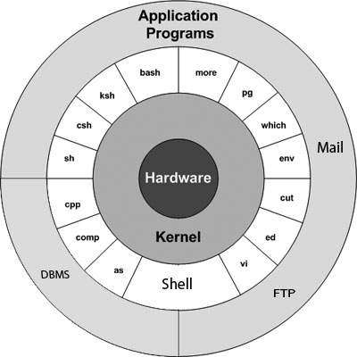

Directory structure

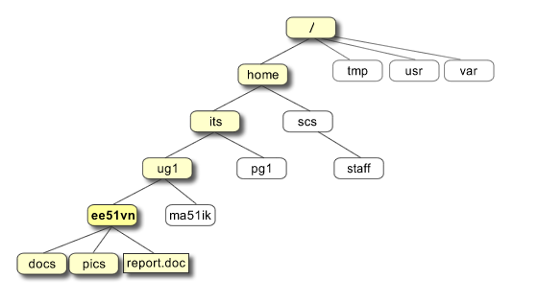

|  |
| --- |
| **/**  This is the root directory which should contain only the directories needed at the top level of the file structure |
| 2 | **/bin**  This is where the executable files are located. These files are available to all users |
| 3 | **/dev**  These are device drivers |
| 4 | **/etc**  Supervisor directory commands, configuration files, disk configuration files, valid user lists, groups, ethernet, hosts, where to send critical messages |
| 5 | **/lib**  Contains shared library files and sometimes other kernel-related files |
|  |  |
| 7 | **/home**  Contains the home directory for users and other accounts |

Ls

Mkdir

Ls –a

~

Pwd

Cd .

Cd ..

Rm file

Rmdir

cat

## File Access Modes

The permissions of a file are the first line of defense in the security of a Unix system. The basic building blocks of Unix permissions are the **read**, **write**, and **execute** permissions, which have been described below −

### **Read**

Grants the capability to read, i.e., view the contents of the file.

### **Write**

Grants the capability to modify, or remove the content of the file.

### **Execute**

User with execute permissions can run a file as a program.

* **Owner permissions** − The owner's permissions determine what actions the owner of the file can perform on the file.
* **Group permissions** − The group's permissions determine what actions a user, who is a member of the group that a file belongs to, can perform on the file.
* **Other (world) permissions** − The permissions for others indicate what action all other users can perform on the file.

A shell script is a computer program designed to be run by the Unix/Linux shell which could be one of the following:

* The Bourne Shell
* The C Shell
* The Korn Shell
* The GNU Bourne-Again Shell

A shell is a command-line interpreter and typical operations performed by shell scripts include file manipulation, program execution, and printing text.

i/o redirection > , >> form >> appends, <, <<

**Unix user management commands**

* useradd.
* userdel.
* usermod.
* passwd.

APPLICATIONS:-

Unix is there in all sort of applications and systems be it Android, iOS, PlayStation etc. UNIX or Linux based systems are driving most of the infrastructure you use.  Network management, telco, internet, banking, shipping, security, military, factory automation... I could go on and on listing field after field where UNIX and Linux based computers are deeply entrenched in production.