**Bhavesh Veeramachaneni**

**16233021**

**class id: 38**

**Assignment - 1**

**Introduction:**

Making the Logistic regression with SUV dataset.

**Objectives:**

* Import the SUV dataset
* Use logistic regression to predict whether a user buys the SUV or not
* Take the independent variables Age and Salary
* Build your model

**Approaches/Methods:**

* There are several approaches to classify like naive-bayes, random-forest, knn, decision-tree, svc.
* But we chose logistic regression.

**Workflow:**

* First, we load the the dataset using xlrd.open_workbook since it is a ‘.xls’ file.
* In deep learning it is a mandatory step to do feature scaling. Otherwise we don’t get appropriate results. So we make feature scaling.
* We create required tensorflow variables for the logistic regression.
* Logistic regression is sigmoid function applied to Linear regression.
* It’s a linear classifier.
* Pass each row of input data to train the model.
* Here we make 50 epochs and an epoch is training your model with full dataset once. Here we pass input data 50 times so 50 epochs.
* In each iteration you can see that loss decreases.
* We get y_pred values in probability.
* Its our choice on what percentage or probability to make classification.

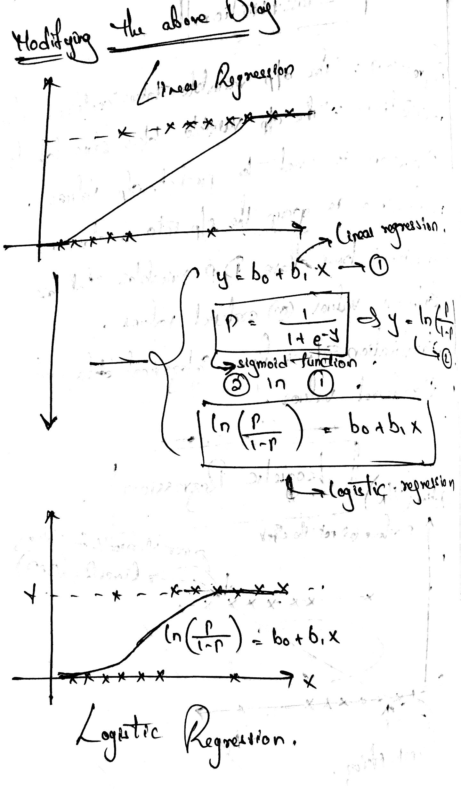

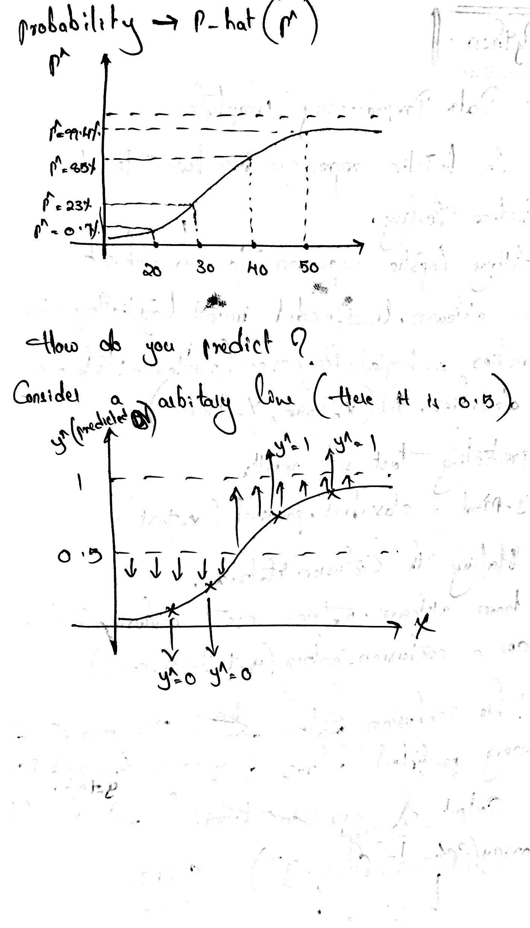

**Datasets:**

* My data is SUV dataset.
* Here we have customer name, age, salary and whether he is interested to buy or not.
* Independent variables: customer name, age, salary.
* Dependent variables: Interested or not (0 or 1).

**Evaluation:**

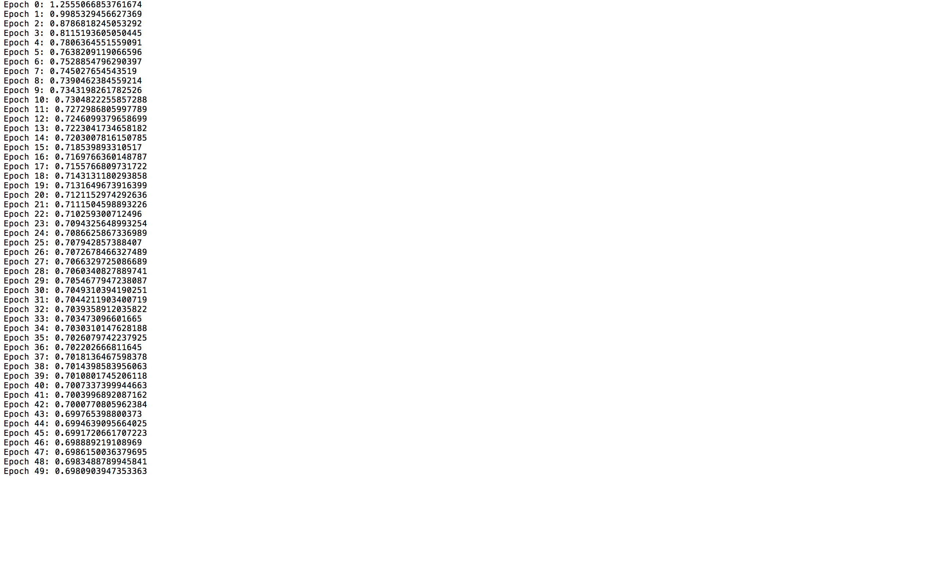

Here for each epoch you can see loss has been decreasing.

One way to evaluate is loss and accuracy.

**Conclusion:**

This is the output plot.

**2D plot:**

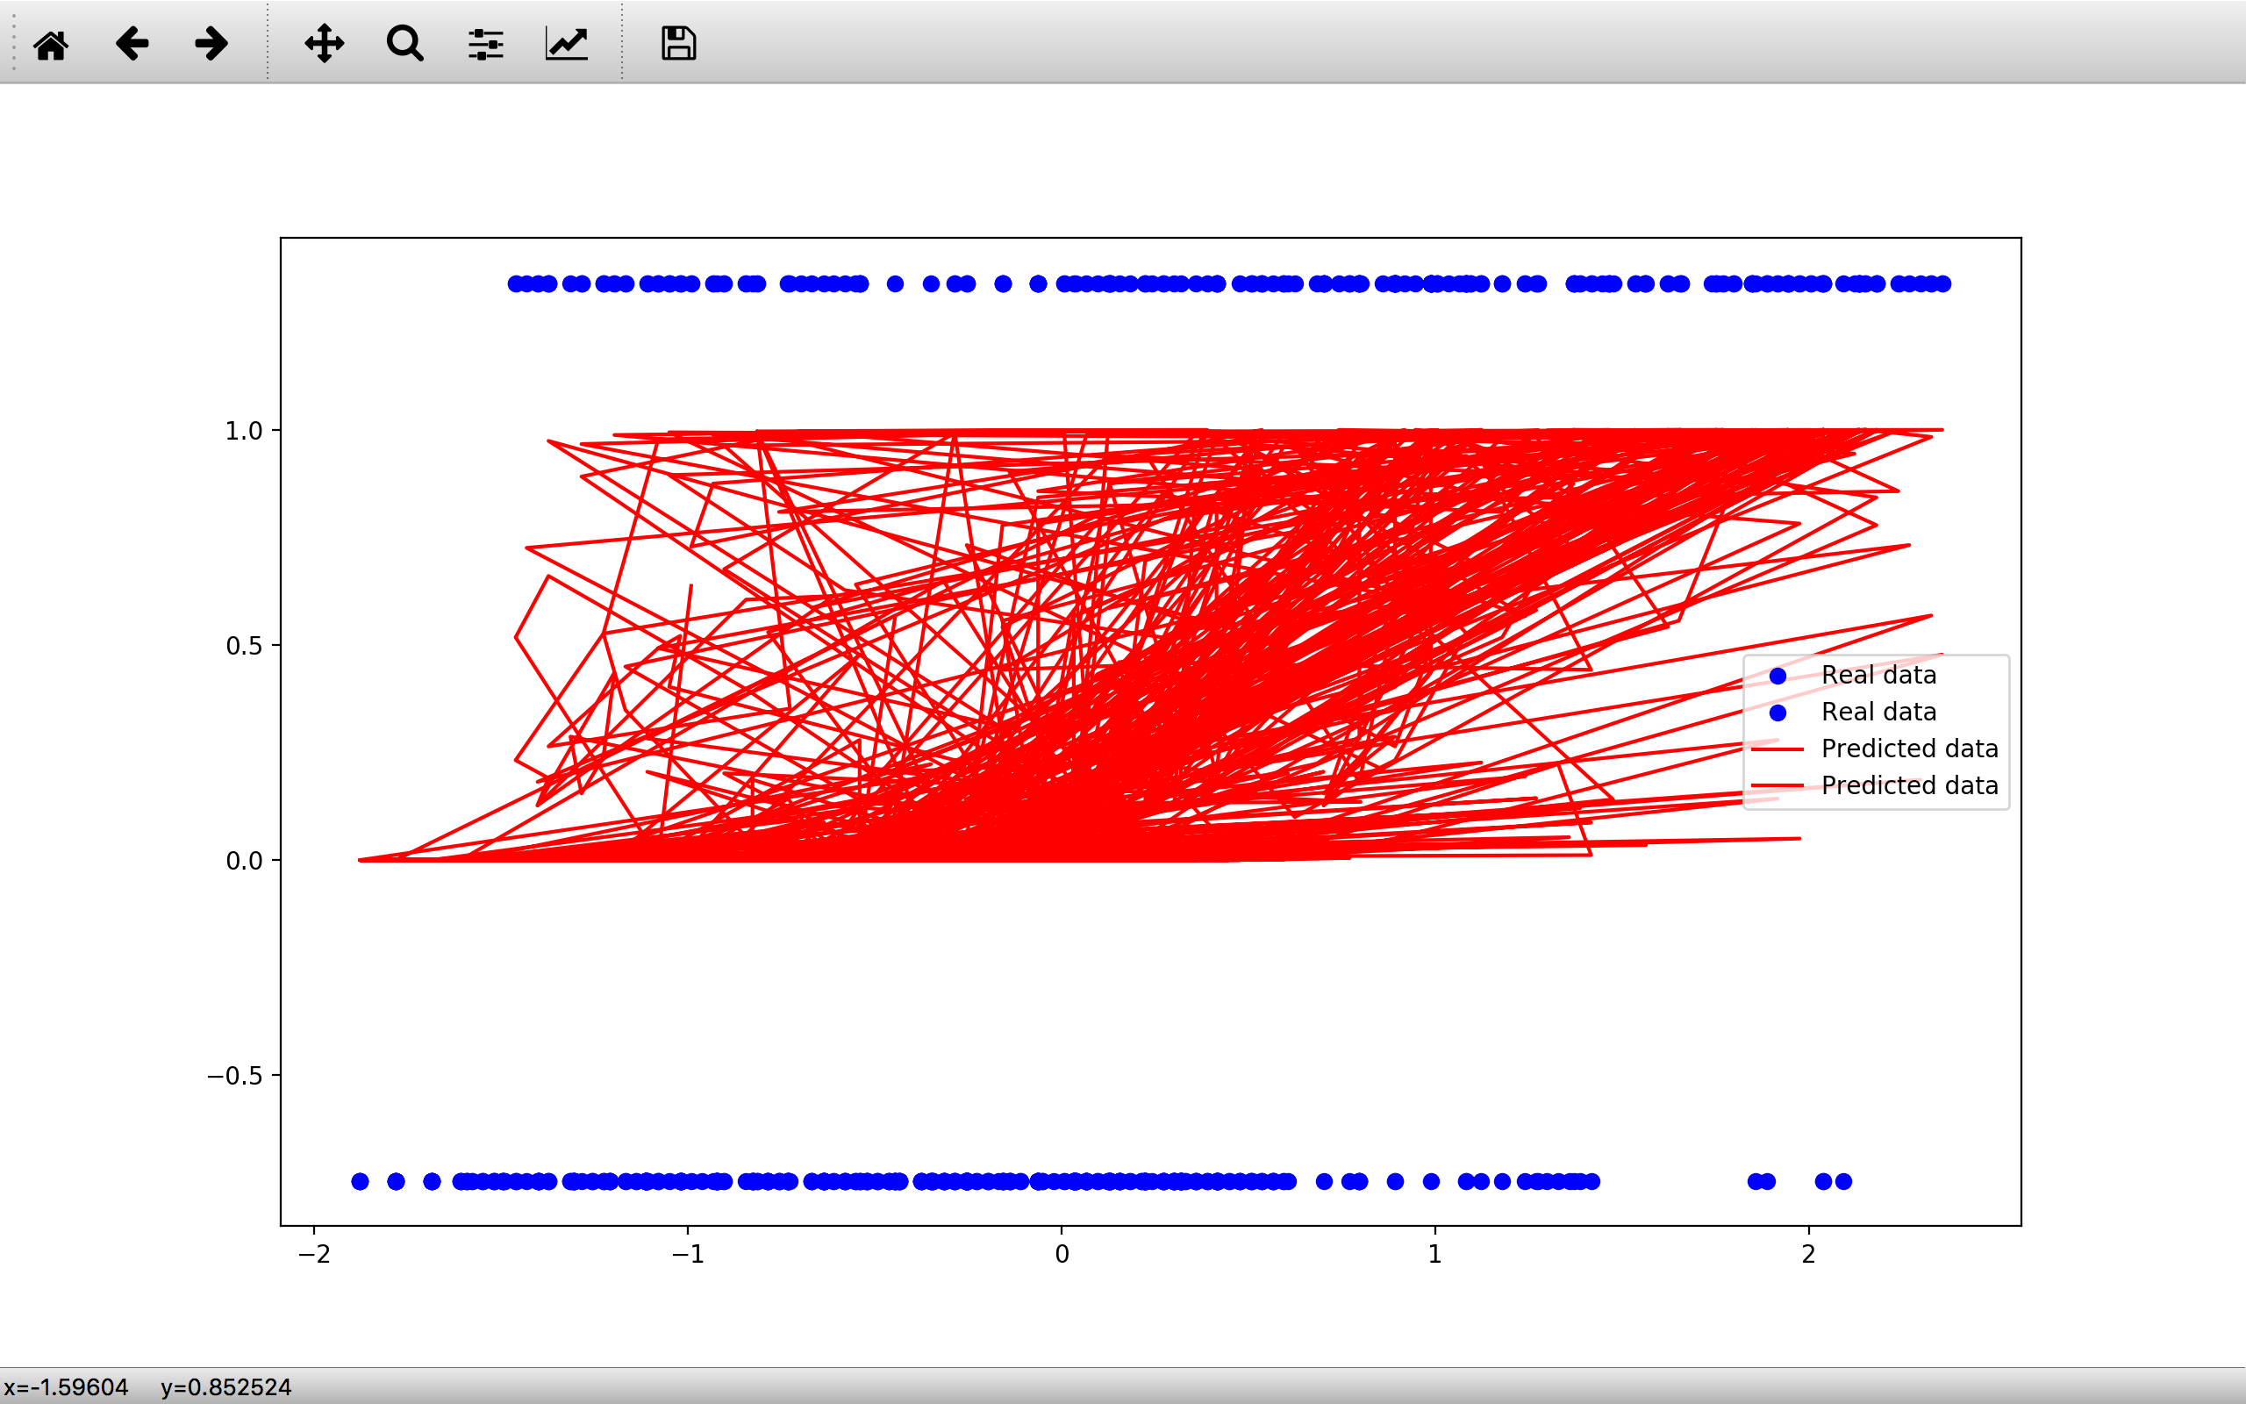

**3D plot:**

