**Day-2**

1. Python Program to Read a Number n And Print the Series “1+2+…..+n= “

sample:

Case 1:

Enter a number: 4

1 + 2 + 3 + 4 = 10

Case 2:

Enter a number: 5

1 + 2 + 3 + 4 + 5 = 15

2. Write a Python program to count the number of even and odd numbers from a series of numbers.

Sample numbers :

numbers = [1, 2, 3, 4, 5, 6, 7, 8, 9]

Expected Output :

Number of even numbers : 4

Number of odd numbers : 5

1. Write a Python program to create the multiplication table (from 1 to 10) of a number.

4.Given the triangle of consecutive odd numbers

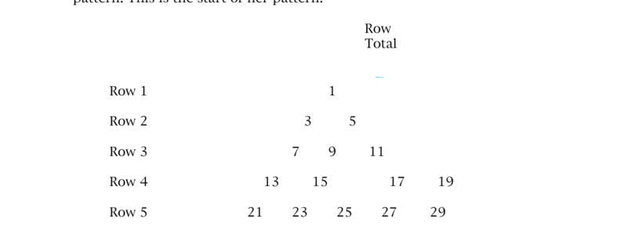

Above triangle is given Calculate Sum row wise

Example we call function :- row_sum_odd_numbers(2)

Result will be=3 + 5 = 8

if user give 4 then ur output is 13 + 15 + 17+ 19 = 64

5.Write python program to print the pattern given below

Note: Take input from user

1

2 2

3 3 3

4 4 4 4

5 5 5 5 5