1. Tableau Server has most of the functionality required to create data sources, dashboards and workbooks, but is still missing the ability to create and modify dashboard actions.
2. The Cluster and Forecast options in the Analytics pane are not available in Tableau Server/Online. At this time, these options are only available in Tableau Desktop.
3. With Tableau Server, you have a Username which is assigned a Site Role and a set of permissions. The functionality available to you depends on the Site Role and the permissions granted (usually by the Tableau Server Administrator).

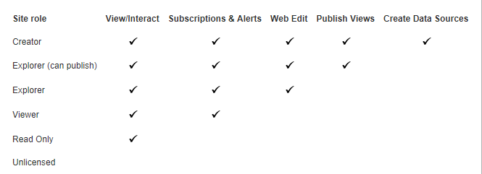

1. The mechanisms for saving and publishing are slightly different between Tableau Server/Online and Tableau Desktop, but the results are the same. With Tableau Desktop you can publish workbooks/dashboards/worksheets to Tableau Server/Online or you can save them as a packaged workbook (twbx). Packaged workbooks can be opened in Tableau Reader or Tableau Desktop. In Tableau Server you save your worksheets to projects and folders defined in Tableau Server or you can download and save them as a packaged workbook. (NOTE: Download and Save are permissions that are sometimes not granted to prevent unauthorized downloading of workbooks and data.)

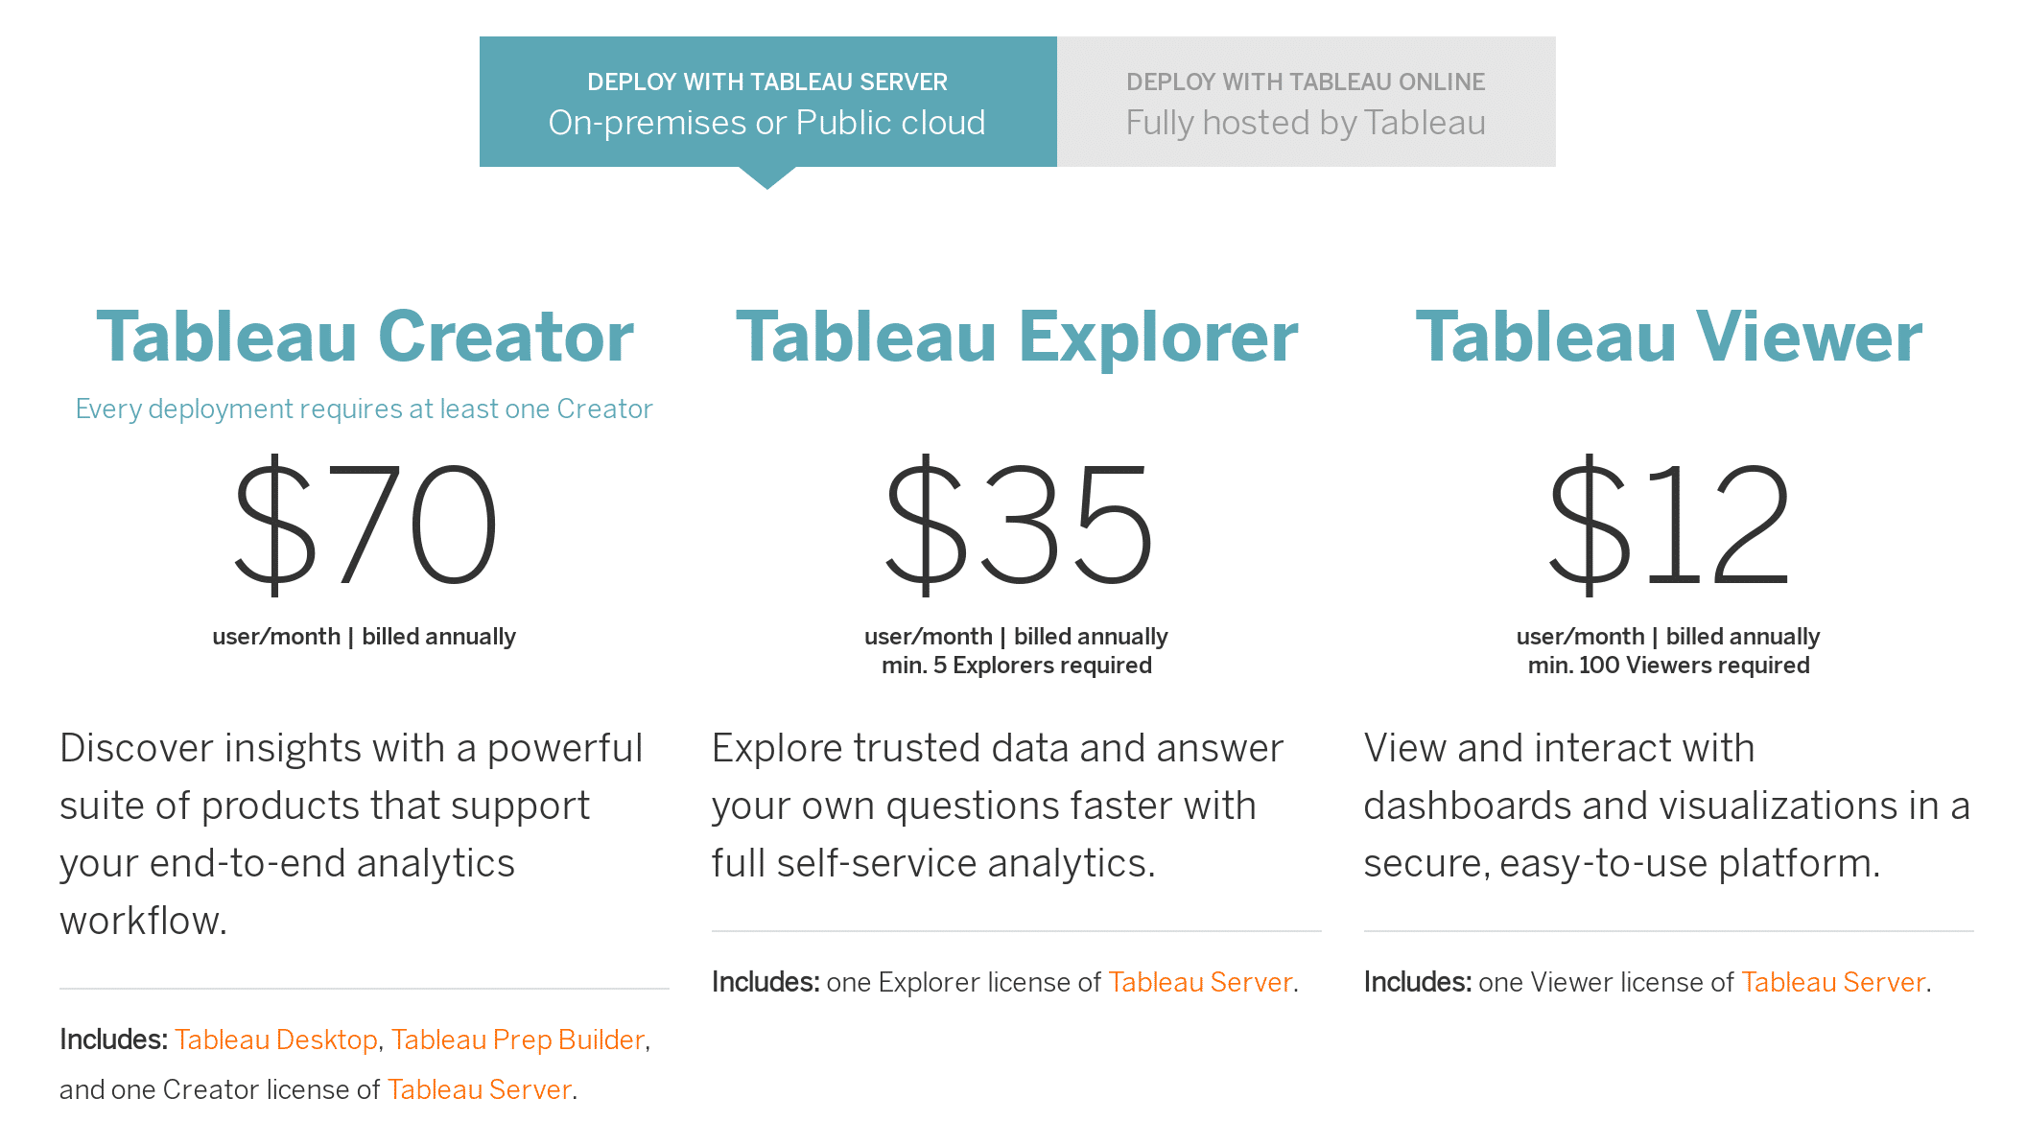

**Amazon Athena**

Interactive Analytics

AMAZON S3 and SQL only.

You are charged $5 per terabyte scanned by your queries.

**Amazon EMR**

Big Data Processing

Distributed computing for EC2 instances.

**Amazon Kinesis**

Real-time analytics

Can work with image data and audio data also.

**Amazon Quicksight**

Dashboards and visualizations

Can connect with EC2 instance and MongoDB

<https://aws.amazon.com/quicksight/pricing/?nc=sn&loc=4>