Game Design Document

Fill up the following document

1. Write the title of your project.

Jetpack Penguins

1. What is the goal of the game?

The goal of the game is for the players to try to get the rewards at the end of each level.

1. Write a brief story of your game.

There will be two players who will race across several terrains in

order to reach various other levels, Each level has a reward at the

end.

1. Which are the playing characters of this game?

* Playing characters are the ones who respond to the user based on the input from the user.
* Cars, monkeys, dinos, wizards, etc., are the playing characters in the game.

|  |  |  |
| --- | --- | --- |
| Number | Character Name | What can this character do? |
| 1 | Blue Penguin | It can fly using the key controls. |
| 2 |  |  |
| 3 |  |  |
| 4 |  |  |
| 5 |  |  |
| 6 |  |  |
| 7 |  |  |
| 8 |  |  |

1. Which are the Non-Playing Characters of this game?

* Non-Playing characters are the ones that don't have an action or behavior when the user interacts with the game.
* Hurdles, stones, bananas, coins, etc., are non-playing characters in the game.

|  |  |  |
| --- | --- | --- |
| Number | Character Name | What can this character do? |
| 1 | Red Penguin | It copies the movements of the blue penguin. |
| 2 | Obstacles | It reduces the life of the player. |
| 3 | Rewards | It increases the score of the player. |
| 4 |  |  |
| 5 |  |  |
| 6 |  |  |
| 7 |  |  |
| 8 |  |  |

Draw your imagination of this game. What does this game look like?

* Draw the game either on your computer or on paper.
* Add images of the game scenes to show each of the playing and non-playing characters at least once.

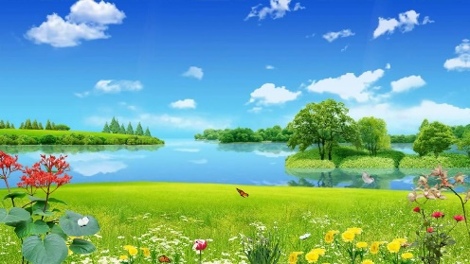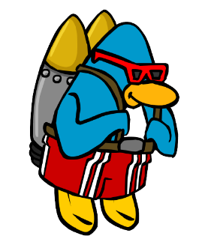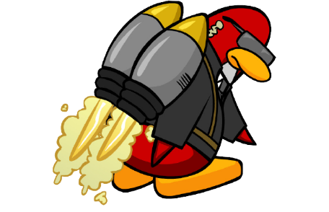

How do you plan to make your game engaging?

There will be feedback in which the players score will increase each time they touch a reward and once they pass a level, they get a message stating "Good job!". For each level they pass, the difficulty increases drastically. The background will move faster towards the player along with the obstacles too. The game will be made neither too hard nor too easy as there wont be way too many or too less obstacles.