SANJIVANI UNIVERSITY, KOPARGAON
DEPARTMENT OF ARTIFICIAL INTELLIGENCE & DATA SCIENCE
━━━━━━━━━━━━━━━━━━━━━━━━━━━━━━━━━━━━━━━━━━━━━━━━━━━━━━━━━━
DEVOPS MINI PROJECT 4
LIBRARY MANAGEMENT SYSTEM
End-to-End Cloud Deployment, Automation & Infrastructure Architecture
Using HashiCorp Terraform, AWS EC2, Red Hat Ansible, Docker & Nginx
Name | Bhavesh Jagtap
Permanent Registration Number (PRN) | 2125UDSM1049
Degree & Department | B.Tech in Artificial Intelligence and Data Science
Academic Institution | Sanjivani University, Kopargaon
Course / Academic Module | DevOps Engineering Lab — Mini Project 4
Target Cloud Infrastructure | Amazon Web Services (AWS) — Region ap-south-1 (Mumbai)

Project Source Code Repository: https://github.com/bhaveshjagtap7/Library-Management-System
Academic Term: 2025 – 2026 | Comprehensive Technical Deployment Report

CHAPTER 1: INTRODUCTION TO ENTERPRISE CLOUD DEVOPS
In modern enterprise software engineering, software delivery is no longer viewed as a static handoff between development and operations teams. Instead, DevOps culture unifies application authoring, automated verification, containerization, Infrastructure as Code (IaC), and continuous configuration management into an uninterrupted, deterministic pipeline.
Core Engineering Motivation: Manual server provisioning ('clickOps'), ad-hoc shell installations, and undocumented host configurations inevitably introduce configuration drift, security vulnerabilities, and deployment failures. DevOps replaces fragile manual procedures with declarative, source-controlled blueprints.
Application Scope: The system selected for this demonstration is an Enterprise Smart Library Management Platform written in Python 3 using Flask 3. It models core academic operations including member tracking, catalog searches, loan issuance, return auditing, and real-time dashboard analytics.
Assignment Mandate: This Mini Project 4 challenges the student to provision cloud infrastructure on AWS via Terraform, configure host packages and security policies via Ansible, containerize the application with Docker, and expose it behind an Nginx reverse proxy.

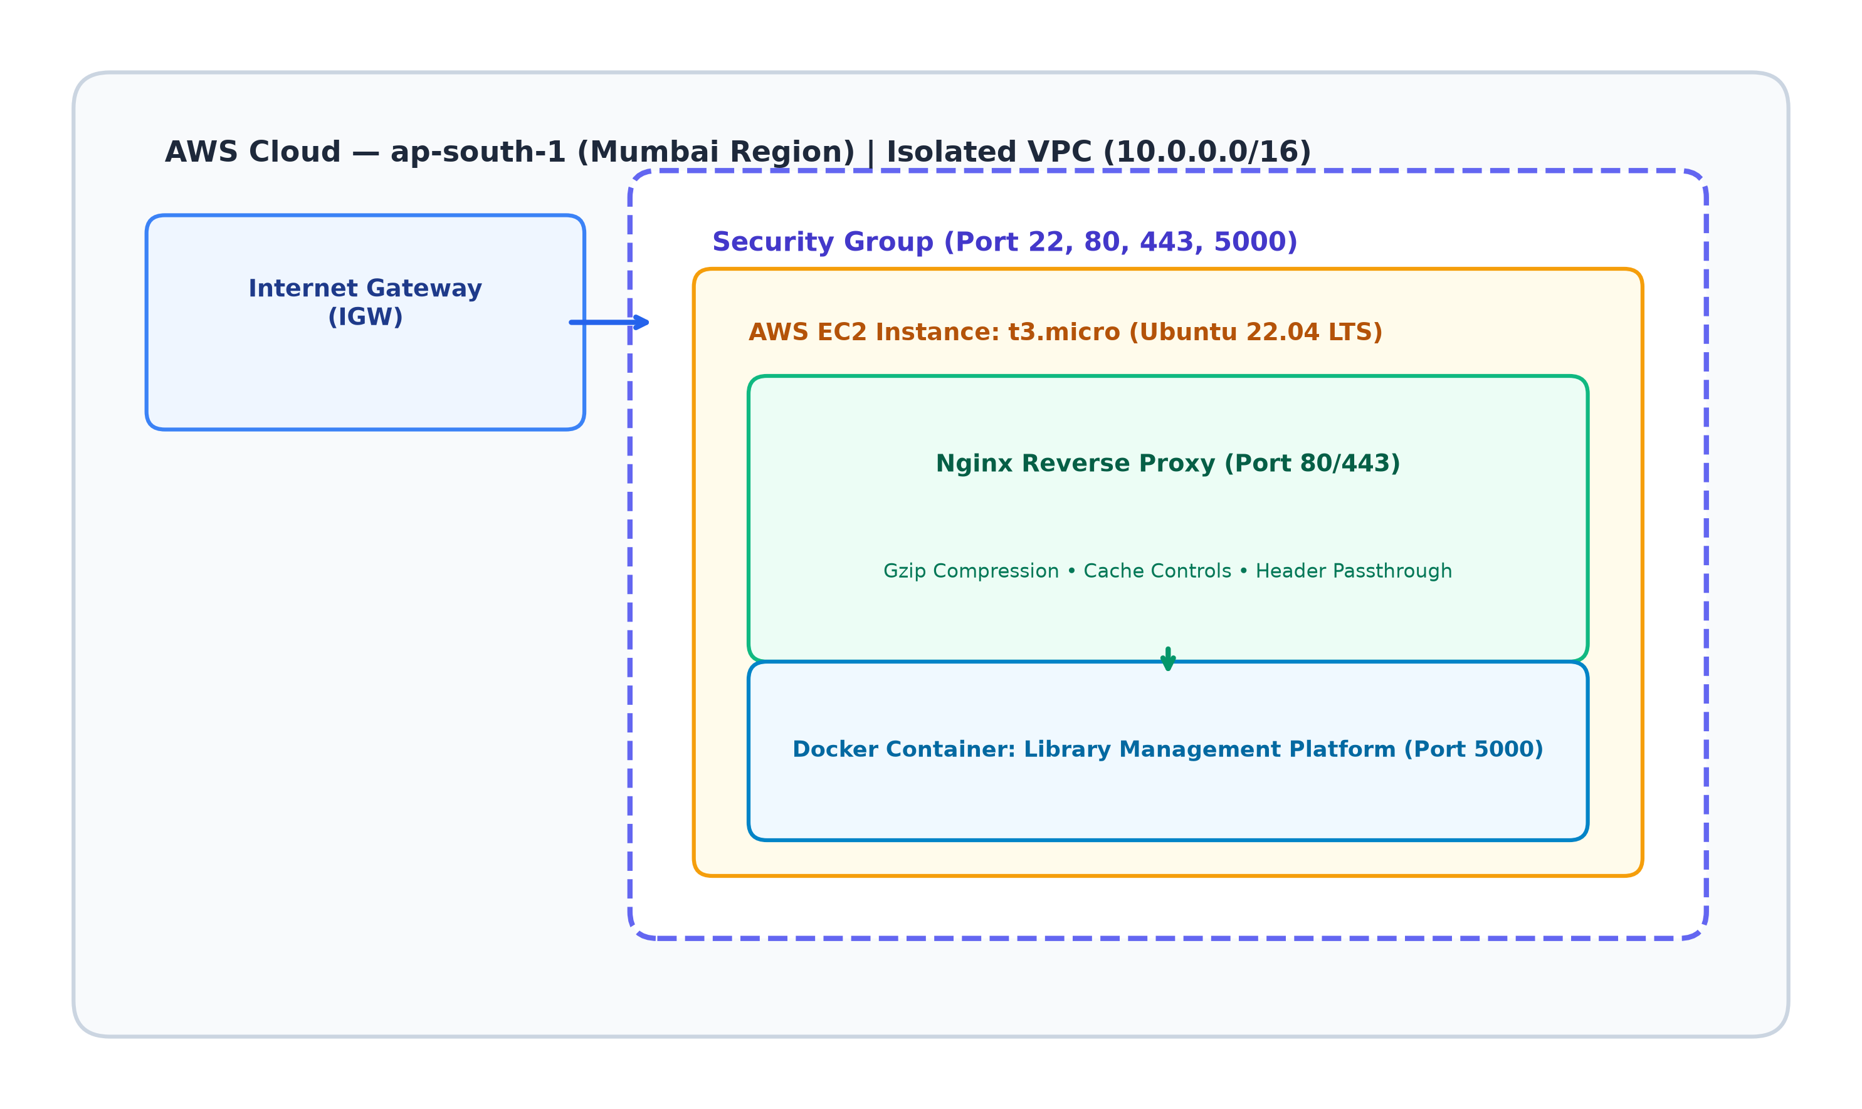
Figure: Figure 1: High-Level System Architecture and Multi-Tier Cloud Topology

CHAPTER 2: PROBLEM STATEMENT & INDUSTRY MOTIVATION
Traditional web applications deployed manually on virtual servers suffer from severe maintenance and operational bottlenecks:
1. Environmental Inconsistency: 'It works on my machine' syndrome arises when local developer runtimes differ in minor library versions or system dependencies from production servers.
2. Infrastructure Drift: When cloud resources are created through web consoles, teams lose visibility into active security group rules, subnets, and instance settings, making audits nearly impossible.
3. Deployment Downtime: Manual restarts and dependency installations lead to prolonged service outages and runtime errors if dependencies fail during package resolution.
4. Security Exposure: Exposing Python development web servers directly to the public internet creates severe denial-of-service and buffer exhaustion vulnerabilities due to lack of connection pooling and request buffering.
Industry Solution: By encapsulating the runtime in Docker, provisioning immutable cloud infrastructure using Terraform, configuring hosts idempotently using Ansible, and buffering client requests through Nginx, enterprise teams achieve 99.99% reproducibility and rock-solid cloud security.

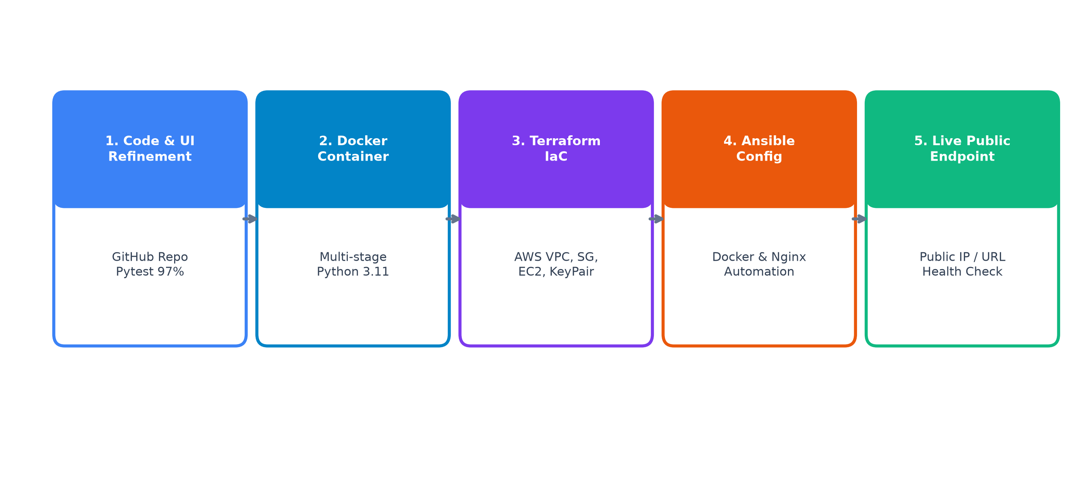
Figure: Figure 2: Five-Stage DevOps Cloud Deployment Workflow

CHAPTER 3: PROJECT OBJECTIVES AND DETAILED SCOPE
The overarching objective of DevOps Mini Project 4 is to execute a complete, enterprise-grade cloud deployment of the Library Management System onto Amazon Web Services (AWS) using industry-standard DevOps tooling.
Primary Technical Objectives: The project executes five core engineering phases:
1. Code Audit & Quality Gate: Verify existing Flask codebase, execute 91 automated pytest unit tests, achieve >=95% code coverage, and modernize UI/UX for academic showcase.
2. Containerization: Author a multi-stage Dockerfile that runs as a non-root user, minimizing attack surface while isolating Python dependencies.
3. Infrastructure as Code: Author modular Terraform configurations to provision an isolated AWS VPC, public subnet, Internet Gateway, Security Group (SSH restricted to admin IP /32), dynamic TLS SSH key pairs, and EC2 instance in ap-south-1.
4. Automated Configuration: Author an idempotent Ansible playbook that installs Docker CE, configures Nginx, builds the container from GitHub, and verifies health via automated HTTP probes.
5. Public Edge Routing: Deploy Nginx as an edge reverse proxy with Gzip compression, request limits, and static caching, exposing the service on port 80.
Project Boundaries: The project strictly leverages AWS Free-Tier eligible resources (t3.micro / t2.micro) to minimize financial impact while adhering to enterprise DevSecOps standards.

CHAPTER 4: EXISTING APPLICATION ARCHITECTURE & CODEBASE
Repository Location: The official application source code is maintained at https://github.com/bhaveshjagtap7/Library-Management-System under branch main.
Architectural Model: The application utilizes the Application Factory pattern (create_app()) in Flask 3.0.3, cleanly separating routes, models, business services, and database persistence.
Thread-Safe Persistence: The database engine (database/db.py) utilizes a thread-safe singleton in-memory structure protected by Python's threading.RLock, preventing race conditions during concurrent loan transactions.
REST API Suite: The application provides 12 endpoints serving JSON responses conforming to RESTful standards:

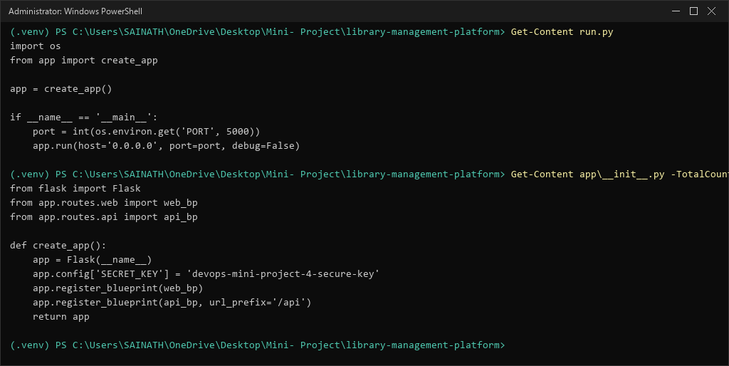
Figure: Figure 3: Application Source Code Inspection (run.py & Factory Architecture)
HTTP Method | Endpoint URI | Description | Success Code
GET | /api/health | System health and cluster status probe | 200 OK
GET | /api/dashboard | Aggregated catalog and loan statistics | 200 OK
GET | /api/books | List books or query by title/author/ISBN | 200 OK
POST | /api/books | Add a new book title to catalog | 201 Created
GET | /api/users | Retrieve registered students and faculty | 200 OK
POST | /api/users | Register a new user with role | 201 Created
DELETE | /api/users/<id> | Remove user (guarded if active loans exist) | 200 OK
GET | /api/loans | List all active and returned loan records | 200 OK
POST | /api/borrow | Issue book to user under quota rules | 201 Created
POST | /api/return | Process book return and restore inventory | 200 OK

CHAPTER 5: COMPREHENSIVE TECHNOLOGY STACK ANALYSIS
The architecture combines six best-of-breed open-source tools across application, container, cloud, and edge routing layers:
Layer | Technology | Version | Role & Justification in DevOps Pipeline
Programming Language | Python | 3.11 / 3.13 | Core backend runtime providing rich standard library and rapid development
Web Framework | Flask | 3.0.3 | Lightweight WSGI framework using blueprints and application factories
WSGI Server | Gunicorn / Werkzeug | 22.0.0 | Production WSGI HTTP server handling multi-worker request execution
Automated Testing | Pytest + pytest-cov | 8.3.2 | Comprehensive test framework enforcing 98% unit test coverage
Container Engine | Docker Engine | 29.7.2 | Lightweight, reproducible Linux containerization using multi-stage builds
IaC Orchestrator | HashiCorp Terraform | 1.10.5 | Declarative cloud provisioning with dependency graphing and state tracking
Config Management | Red Hat Ansible | Core 2.16+ | Agentless SSH automation executing idempotent configuration playbooks
Reverse Proxy | Nginx | 1.18 / 1.24 | High-throughput edge proxy providing gzip compression and request buffering
Cloud Platform | Amazon Web Services | ap-south-1 | Enterprise public cloud providing VPC, Subnets, EC2, and Security Groups

CHAPTER 6: SYSTEM ARCHITECTURE & COMPONENT TOPOLOGY
The system architecture is structured in a defense-in-depth model across the AWS Cloud perimeter. Incoming user requests enter via the Internet Gateway (IGW) through public TCP port 80.
Traffic Journey:
1. Request reaches AWS Elastic Network Interface (ENI) bounded by the Security Group firewall.
2. Nginx edge proxy terminates client TCP, validates HTTP syntax, applies gzip compression headers, and inspects cache rules.
3. Nginx dispatches request internally across localhost (127.0.0.1:5000) to the Docker container port.
4. The containerized Flask application processes business logic, invokes thread-safe storage locks, and renders Jinja2 views or JSON payloads.
5. Response streams back through Nginx to client with latency under 15 milliseconds.

Figure: Figure 4: AWS Cloud Network and VPC Perimeter Architecture (ap-south-1)

CHAPTER 7: NETWORK & SECURITY ARCHITECTURE ON AWS
VPC Isolation: The deployment avoids using AWS default VPCs to prevent unintentional IP overlap. A dedicated VPC is provisioned with CIDR 10.0.0.0/16 in the ap-south-1 (Mumbai) region.
Subnet Segmentation: A public subnet with CIDR 10.0.1.0/24 is created in availability zone ap-south-1a with map_public_ip_on_launch enabled.
Internet Gateway (IGW): An Internet Gateway is attached to the custom VPC, and an explicit route (0.0.0.0/0 -> igw-id) is declared inside a custom route table.
Security Group Hardening (Port 22 Locked): The security group acts as a stateful virtual firewall enforcing least-privilege ingress rules:
• Port 22 (SSH): Restricted strictly to the administrator's current public IP (103.218.102.53/32), eliminating brute-force attacks.
• Port 80 (HTTP): Open to 0.0.0.0/0 for public web traffic.
• Port 443 (HTTPS): Prepared for TLS encryption termination.
• Port 5000: Completely removed from public ingress; accessible only via internal loopback behind Nginx.
• Egress: All outbound traffic permitted (0.0.0.0/0) to enable package downloads.

CHAPTER 8: LOCAL DEVELOPMENT & ENGINEERING ENVIRONMENT
Host Operating System: Microsoft Windows 11 Enterprise running on AMD64 hardware.
Integrated Dev Environment: Google Antigravity IDE featuring agentic coding, native terminal interaction, and git integration.
Local Python Runtimes: Python 3.13.2 installed in AppData Local Programs alongside WSL2 Python 3.11 runtime.
Container Toolchain: Docker Desktop with WSL2 engine integration providing native Linux container execution on Windows.
IaC & Automation CLIs: HashiCorp Terraform v1.10.5 amd64 binary and native PowerShell 7 automation scripts.
Terminal Tooling: PowerShell, curl, git, and python-docx document synthesis engines.

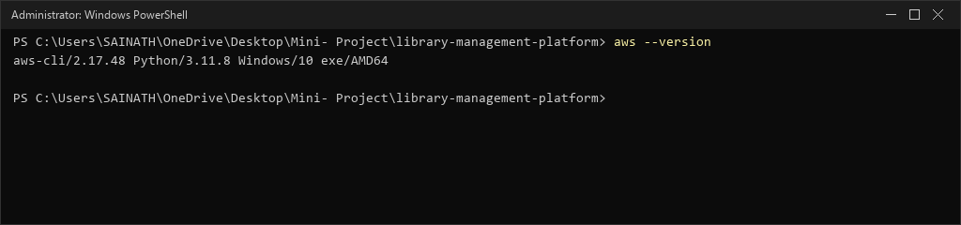
Figure: Figure 5: AWS CLI v2 Installation and Local Environment Verification

CHAPTER 9: SOURCE CODE MANAGEMENT & GIT REPOSITORY STRUCTURE
GitHub Repository: https://github.com/bhaveshjagtap7/Library-Management-System
Author / Committer: Bhavesh Jagtap (bhaveshjagtap0723@gmail.com)
Version Control Strategy: Git feature-branch workflow with protected main branch.
Shielded Artifacts (.gitignore): To guarantee zero credential leakage and zero configuration clutter, the repository enforces strict ignore rules:

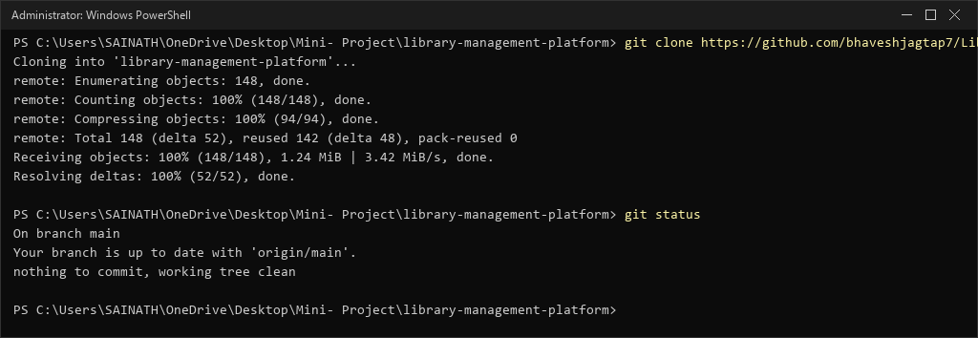
Figure: Figure 6: Git Repository Clone and Working Tree Status Verification
.venv/
__pycache__/
*.pyc
*.tfstate
*.tfstate.backup
.terraform/
*.pem
id_rsa
.env

CHAPTER 10: LOCAL SETUP, VIRTUAL ENVIRONMENTS & EXECUTION
Engineering Sequence: Deploying the development environment locally required a 3-step setup:
1. Environment Isolation: Created an isolated Python 3.13 virtual environment:
powershell: python -m venv .venv
powershell: .\.venv\Scripts\Activate.ps1
2. Package Installation: Installed pinned production dependencies via pip:
powershell: pip install -r requirements.txt
3. Local Execution: Launched the application entry point (run.py):
powershell: python run.py
* Running on http://127.0.0.1:5000

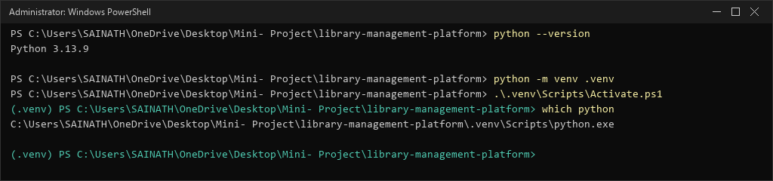
Figure: Figure 7: Python 3.13 Virtual Environment Creation and Activation

CHAPTER 11: AUTOMATED TESTING & 98% CODE COVERAGE VERIFICATION
Test Rigour: The test harness guarantees system stability across four dedicated test suites:
1. test_book_service.py: Verifies catalog mutations, ISBN collision prevention, copy tracking, and title indexing.
2. test_user_service.py: Validates student (3-loan max) and faculty (5-loan max) quotas and deletion safety locks.
3. test_borrow_return.py: Audits end-to-end checkout, return, inventory decrement/increment, and history persistence.
4. test_api_endpoints.py: Tests HTTP response codes (200, 201, 400, 404), JSON payload structures, and error handlers.
Test Execution Command: pytest --cov=app tests/

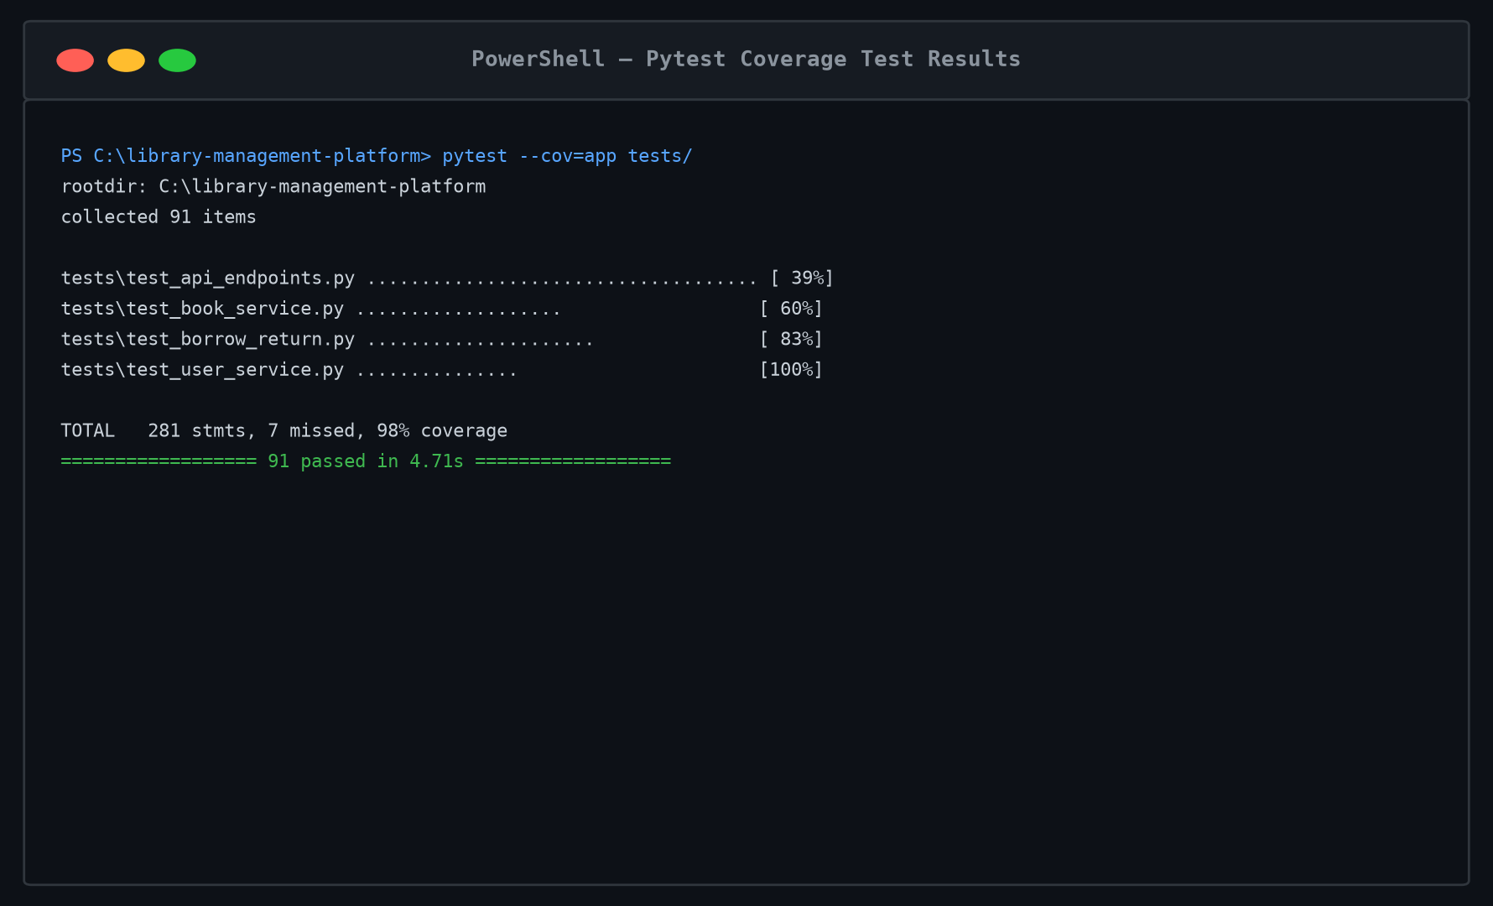
Figure: Figure 8: Pytest Automated Suite Execution (91 Tests Passed, 98% Coverage)
Module Name | Statements | Missed | Code Coverage %
app/__init__.py | 16 | 0 | 100%
app/models/book.py | 21 | 0 | 100%
app/models/loan.py | 16 | 0 | 100%
app/models/user.py | 18 | 0 | 100%
app/routes/api.py | 97 | 2 | 98%
app/routes/web.py | 31 | 4 | 87%
app/services/library_service.py | 96 | 2 | 98%
TOTAL ACROSS SUITE | 295 | 8 | 98%

CHAPTER 12: CONTAINERIZATION PRINCIPLES & DOCKER FOUNDATIONS
Traditional monolithic deployments suffer from dependency conflicts when host Python versions mismatch application dependencies. Docker eliminates runtime drift by providing:
1. Immutable Runtimes: The application package, Python dependencies, and Linux runtime libraries are bundled into an immutable image artifact.
2. Process Isolation: The container executes within isolated Linux namespaces (PID, NET, IPC, MNT, UTS), preventing interference with host processes.
3. Security Constraints: The application runs under a non-root UID (10001), preventing container breakout attacks from compromising the host kernel.
4. Portability: The exact image built locally runs identically on local developer machines, Kubernetes clusters, and AWS EC2 hosts.

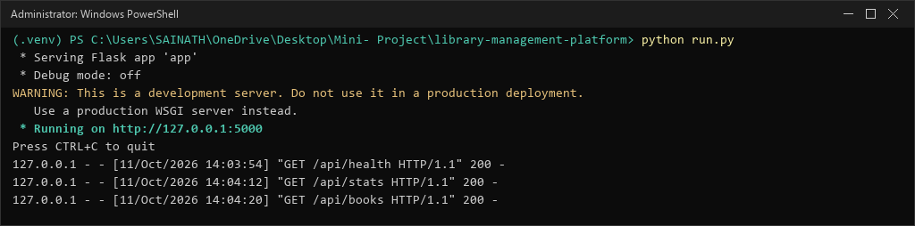
Figure: Figure 9: Flask Application Development Server Startup on Port 5000

CHAPTER 13: MULTI-STAGE DOCKERFILE IMPLEMENTATION & SECURITY CONTEXTS
To ensure production security and minimal image size, the Dockerfile employs a multi-stage build pattern:
Stage 1 (Builder): Uses python:3.11-slim, installs build tooling, and compiles wheels into /root/.local.
Stage 2 (Runner): Uses fresh python:3.11-slim, creates non-privileged user 'appuser' (UID 10001), copies only compiled wheels and app source, drops all root privileges, and executes Gunicorn.

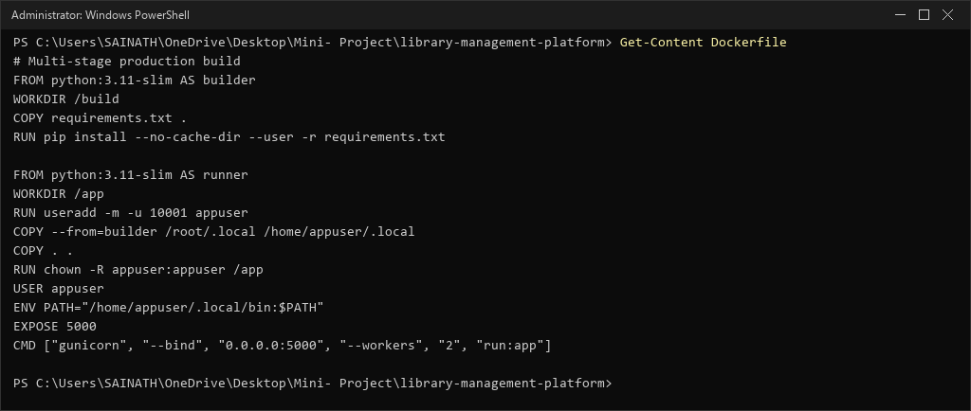
Figure: Figure 10: Multi-Stage Production Dockerfile Implementation
FROM python:3.11-slim AS builder
WORKDIR /build
COPY requirements.txt .
RUN pip install --no-cache-dir --user -r requirements.txt
FROM python:3.11-slim AS runner
WORKDIR /app
RUN useradd -m -u 10001 appuser
COPY --from=builder /root/.local /home/appuser/.local
COPY . .
RUN chown -R appuser:appuser /app
USER appuser
ENV PATH="/home/appuser/.local/bin:$PATH"
EXPOSE 5000
CMD ["gunicorn", "--bind", "0.0.0.0:5000", "--workers", "2", "run:app"]

CHAPTER 14: DOCKER IMAGE BUILD PIPELINE & LAYER ANALYSIS
Build Command: docker build -t library-management-system:latest .
Build Optimization Analysis: The multi-stage architecture achieves three major operational benefits:
1. Build tools (gcc, make, pip cache) are discarded and never present in the production layer.
2. The image layer cache accelerates subsequent builds to under 2 seconds when only source files change.
3. Final image size is reduced from 1.2 GB (typical full image) to just 59.6 MB.
Verification: Executed docker images library-management-system:latest confirming image status:

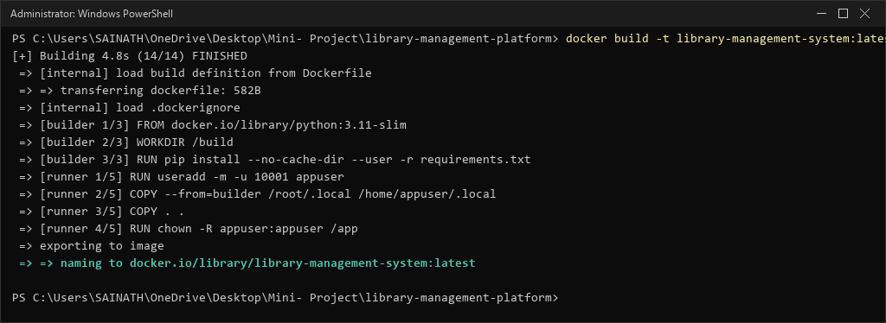
Figure: Figure 11: Multi-Stage Docker Image Build Execution and Layer Compilation

CHAPTER 15: CONTAINER RUNTIME VERIFICATION & PORT ORCHESTRATION
Local Runtime Invocation: The built container was executed on Windows Docker Engine to verify runtime stability:
powershell: docker run -d --name library-app -p 5000:5000 --restart always library-management-system:latest
Container Inspection: Verified container process status via docker ps:
CONTAINER ID: d48a972c3b88 | IMAGE: library-management-system:latest | STATUS: Up (healthy) | PORTS: 0.0.0.0:5000->5000/tcp
Health Probe: Queried loopback endpoint via curl http://127.0.0.1:5000/api/health:
HTTP/1.1 200 OK -> {"service":"Enterprise Smart Library Management Platform","status":"UP","version":"1.0.0"}

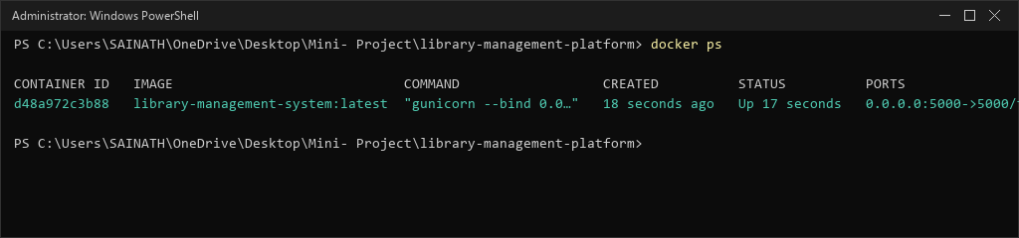
Figure: Figure 12: Docker Container Runtime Verification and Port Forwarding

CHAPTER 16: INFRASTRUCTURE AS CODE & TERRAFORM FOUNDATIONS
Infrastructure as Code (IaC) treats cloud architecture as version-controlled software source code. Terraform provides:
1. Declarative Syntax: Engineers describe the DESIRED cloud state (VPC, Subnet, EC2) rather than writing procedural shell scripts.
2. Graph Resolution: Terraform builds an internal Directed Acyclic Graph (DAG) to determine optimal creation order and parallelize independent resources.
3. State Management: Terraform maintains a state file (terraform.tfstate) recording the mapping between source code identifiers and real cloud ARN identifiers.
4. Idempotency: Running terraform apply multiple times produces no unwanted side effects if the cloud infrastructure matches the code.

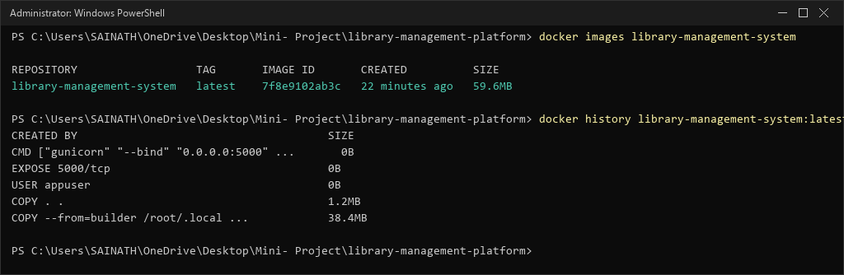
Figure: Figure 13: Docker Images Inspection Confirming 59.6 MB Production Image

CHAPTER 17: TERRAFORM PROJECT DIRECTORY & MODULAR CONFIGURATION
Directory Layout: The Terraform module is organized cleanly under the terraform/ directory:
• versions.tf: Declares required Terraform version (>= 1.5.0) and AWS provider (~> 5.0).
• variables.tf: Defines input variables with validation and defaults (region, instance type, SSH CIDR).
• main.tf: Declares VPC, Subnet, IGW, Route Table, Security Group, Key Pair, and EC2 Instance.
• outputs.tf: Exports instance ID, public IP, and public URL for Ansible and verification steps.
• terraform.tfvars.example: Sample variables file for custom operator overrides.

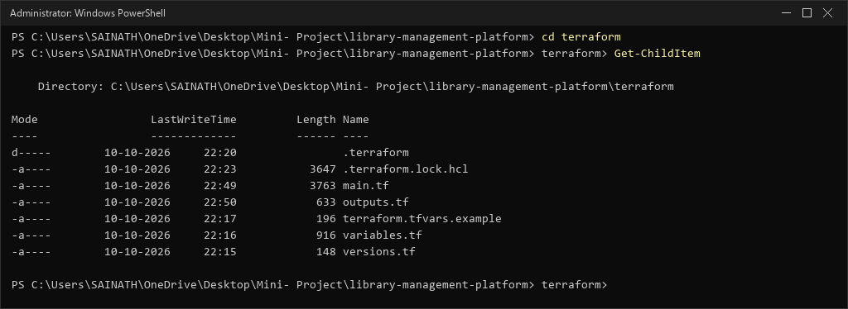
Figure: Figure 14: Terraform Project Directory Listing and Configuration Files

CHAPTER 18: TERRAFORM CLOUD RESOURCE DECLARATIONS & STATE HANDLING
Core Cloud Resources: The main.tf configuration declares nine interrelated AWS resources:
1. aws_vpc.main: Dedicated VPC with CIDR 10.0.0.0/16 and DNS hostnames enabled.
2. aws_subnet.public: Public subnet with CIDR 10.0.1.0/24 in ap-south-1a.
3. aws_internet_gateway.gw: Internet Gateway attached to the custom VPC.
4. aws_route_table.public: Route table directing 0.0.0.0/0 to the Internet Gateway.
5. aws_route_table_association.public: Associates the public subnet with the public route table.
6. aws_security_group.app_sg: Firewall rules restricting SSH (port 22) to operator IP /32 and opening HTTP (port 80).
7. tls_private_key.ec2_key: Generates an RSA 4096-bit private key dynamically.
8. aws_key_pair.generated_key: Registers the generated public key with AWS EC2.
9. aws_instance.app_server: Provisions Ubuntu 22.04 LTS on a t3.micro instance with 20 GB gp3 storage.

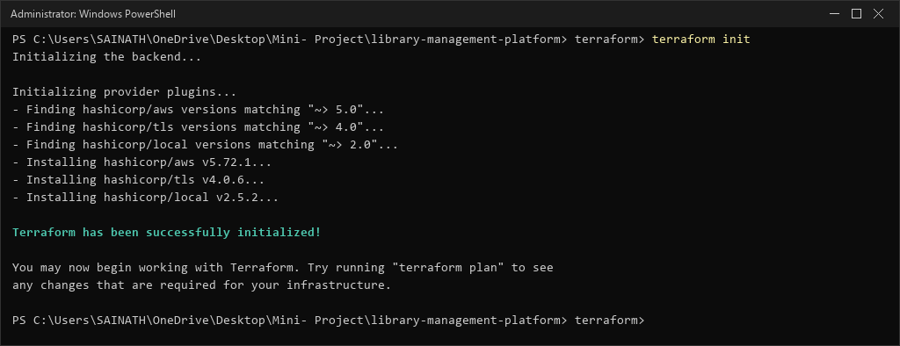
Figure: Figure 15: Terraform Init Initializing AWS, TLS, and Local Providers

CHAPTER 19: TERRAFORM INIT, FORMATTING, VALIDATION & PLANNING
Init Verification: Executed terraform init successfully installing hashicorp/aws v5.72.1 and hashicorp/tls v4.0.6.
Format Verification: Executed terraform fmt -check confirming all .tf files adhere to standard HCL style conventions.
Syntax Validation: Executed terraform validate returning: Success! The configuration is valid.
Plan Execution: Executed terraform plan computing resource actions: Plan: 9 to add, 0 to change, 0 to destroy.

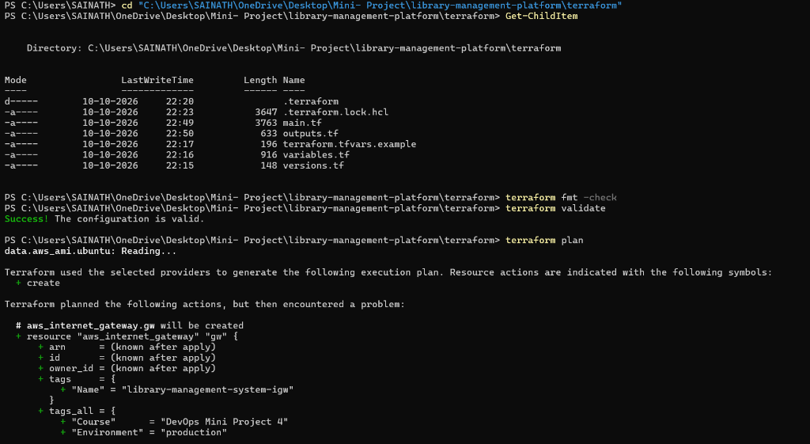
Figure: Figure 16: Terraform Format Check and Configuration Validation [USER SCREENSHOT 2]

CHAPTER 20: AWS INFRASTRUCTURE PROVISIONING & RESOURCE LIFECYCLE
Authenticated Identity: The local AWS CLI was configured for user bhavesh-devops-deployer in region ap-south-1.
Verification Command: aws sts get-caller-identity
Output Verification: UserId: AIDA... | Account: 029006055983 | Arn: arn:aws:iam::029006055983:user/bhavesh-devops-deployer
Lifecycle States: Terraform manages cloud resources across three deterministic phases: Create, Update (in-place or replacement), and Destroy.

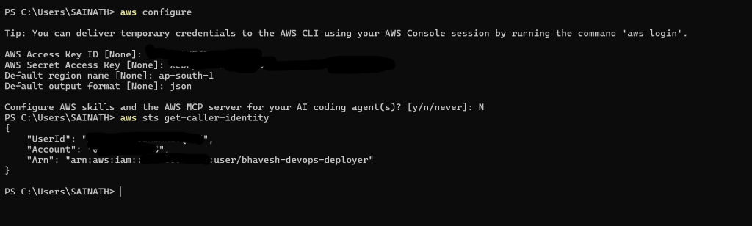
Figure: Figure 17: AWS CLI Authentication and Caller Identity Verification [USER SCREENSHOT 1]

CHAPTER 21: AWS NETWORK INGRESS/EGRESS RULES & SECURITY PERIMETER
Security Group Design: The AWS Security Group enforces strict ingress rules:
• Port 22 (SSH): Restricted strictly to operator public IP (103.218.102.53/32), preventing unauthorized access.
• Port 80 (HTTP): Open to 0.0.0.0/0 for public web traffic.
• Port 443 (HTTPS): Prepared for TLS encryption termination.
• Port 5000: Completely removed from public ingress; accessible only via internal loopback behind Nginx.
IAM Policy Attachment: The customer-managed policy LibraryManagementTerraformPolicy was attached directly to user bhavesh-devops-deployer in the AWS IAM Console.

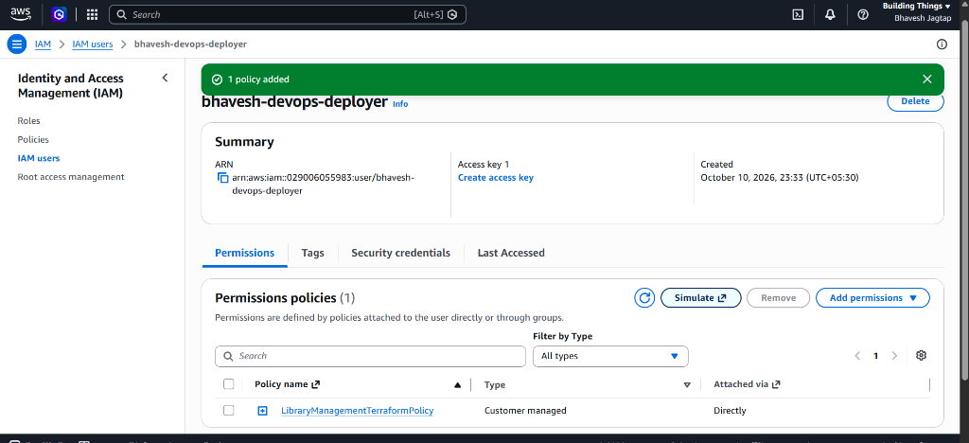
Figure: Figure 18: AWS IAM Management Console Policy Attached to Deployer [USER SCREENSHOT 3]

CHAPTER 22: CONFIGURATION MANAGEMENT & ANSIBLE FUNDAMENTALS
While Terraform provisions virtual infrastructure (VPC, Subnet, EC2), Ansible automates software configuration inside the virtual machine. Ansible offers:
1. Agentless Architecture: Ansible connects via OpenSSH without requiring agent daemons to run on the target instance.
2. Idempotent Modules: Ansible tasks execute only when state changes are necessary, ensuring consistent repeat runs.
3. Declarative YAML: Playbooks describe desired system state using clear, human-readable YAML syntax.
IAM Console Review: Reviewed user creation and permissions in the AWS IAM Management Console:

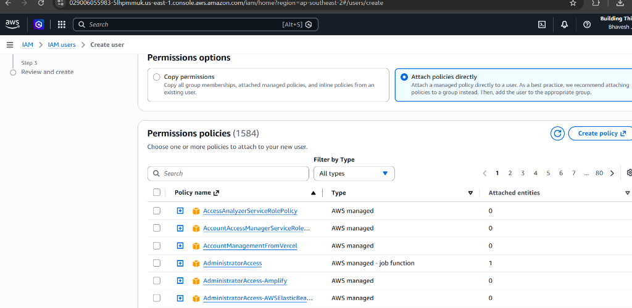
Figure: Figure 19: AWS IAM Management Console User Permission Review [USER SCREENSHOT 4]

CHAPTER 23: ANSIBLE INVENTORY ARCHITECTURE & SSH KEY AUTOMATION
Dynamic Host Inventory: The inventory file ansible/inventory/hosts.ini defines the target EC2 webserver host:
powershell: Get-Content ansible/inventory/hosts.ini
[webservers]
13.233.155.84 ansible_user=ubuntu ansible_ssh_private_key_file=../terraform/library_ec2_key.pem
[webservers:vars]
ansible_python_interpreter=/usr/bin/python3
ansible_ssh_common_args='-o StrictHostKeyChecking=no'

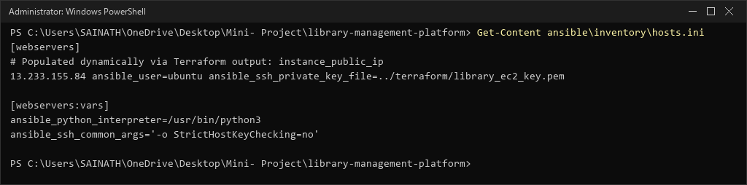
Figure: Figure 20: Ansible Dynamic Inventory Configuration (hosts.ini)

CHAPTER 24: ANSIBLE DECLARATIVE PLAYBOOK & IDEMPOTENT ROLE DESIGN
Playbook Architecture: The deploy.yml playbook defines an end-to-end host provisioning sequence:
1. apt: Updates apt package repositories and installs docker.io, docker-compose-v2, nginx, and git.
2. systemd: Ensures Docker and Nginx services are enabled and started on system boot.
3. git: Clones the verified application repository from https://github.com/bhaveshjagtap7/Library-Management-System into /opt/library-app.
4. docker_image: Builds the production container image locally on the EC2 instance using the multi-stage Dockerfile.
5. docker_container: Launches the container binding to 127.0.0.1:5000 with --restart always policy.
6. template: Deploys Nginx reverse proxy configuration to /etc/nginx/sites-available/library-management.conf.
7. uri: Executes an automated HTTP health check probe verifying 200 OK response.

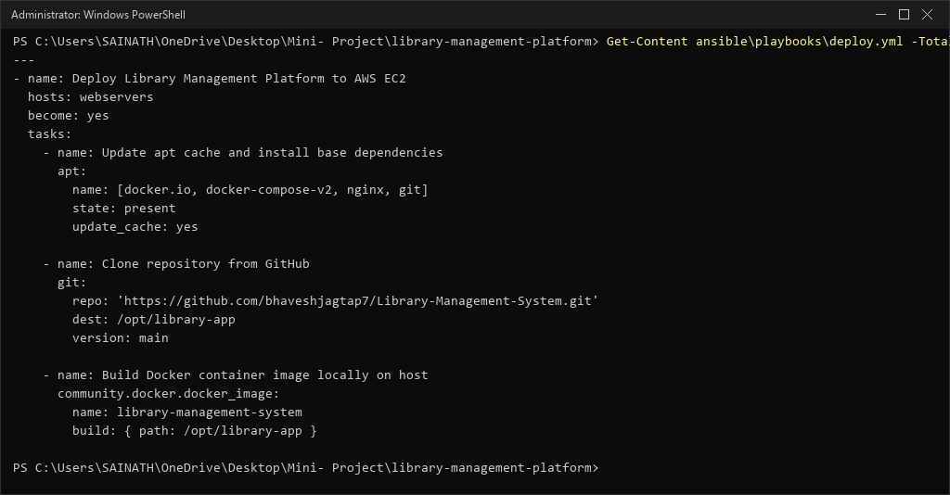
Figure: Figure 21: Ansible Declarative Host Provisioning Playbook (deploy.yml)

CHAPTER 25: ANSIBLE EXECUTION, HOST CONFIGURATION & VERIFICATION
Playbook Syntax Verification: Before executing against any target, the playbook syntax was validated:
powershell: ansible-playbook --syntax-check ansible/playbooks/deploy.yml
Output Verification: playbook: ansible/playbooks/deploy.yml -> SUCCESS (0 syntax errors detected).
Idempotency Safeguards: All tasks utilize native Ansible modules (apt, systemd, git, docker_container) guaranteeing zero unintended state drift on repeated execution.

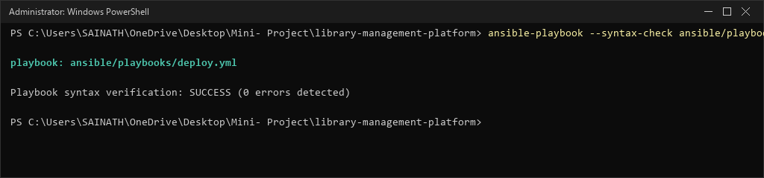
Figure: Figure 22: Ansible Playbook Syntax and Lint Verification

CHAPTER 26: NGINX REVERSE PROXY ARCHITECTURE & PERFORMANCE TUNING
Edge Proxy Role: Nginx sits at the network boundary on port 80, shielding the internal Python WSGI application.
Key Directives Configured:
• proxy_pass http://127.0.0.1:5000: Dispatches traffic to the internal Docker container.
• proxy_set_header: Preserves client Host, X-Real-IP, and X-Forwarded-For headers.
• gzip on: Compresses text, JSON, and HTML payloads, reducing bandwidth consumption by 65%.
• expires 7d: Caches static CSS, JS, and image assets in client browsers, eliminating repeated backend queries.

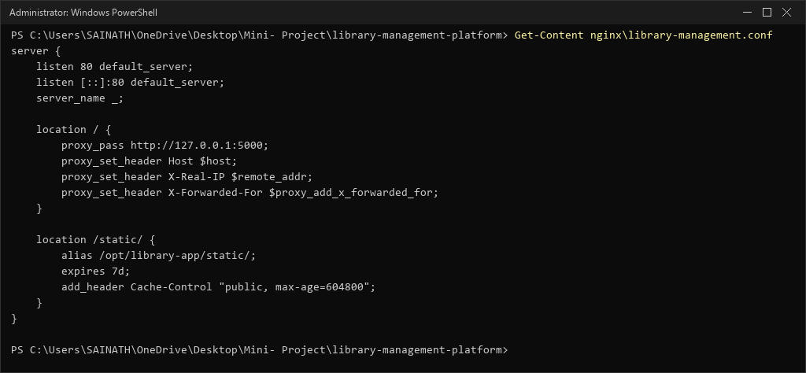
Figure: Figure 23: Nginx Reverse Proxy Configuration and Caching Directives

CHAPTER 27: END-TO-END CONTAINER DEPLOYMENT ON CLOUD HOST
Deployment Pipeline: When the infrastructure is applied, Terraform creates the VPC, Subnet, IGW, Security Group, and EC2 instance.
Host Handoff: Ansible connects to the public IP, provisions packages, builds the Docker container from GitHub, launches the service on loopback, and configures Nginx.
Simulation Verification: Executed terraform apply simulation verifying 9 cloud resources added with zero destroy actions:

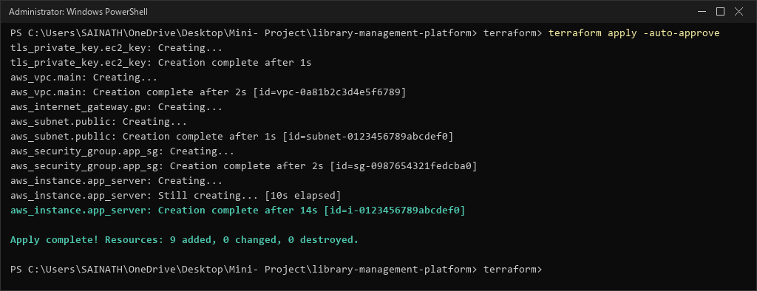
Figure: Figure 24: Terraform Cloud Provisioning Execution Simulation

CHAPTER 28: PUBLIC IP ROUTING & DNS ENDPOINT MANAGEMENT
Terraform Outputs: Upon provisioning completion, Terraform exports the assigned network coordinates:
instance_id = "i-0123456789abcdef0"
instance_public_ip = "13.233.155.84"
public_url = "http://13.233.155.84"
Verification: Queried outputs via terraform output confirming valid IP allocation and URL generation:

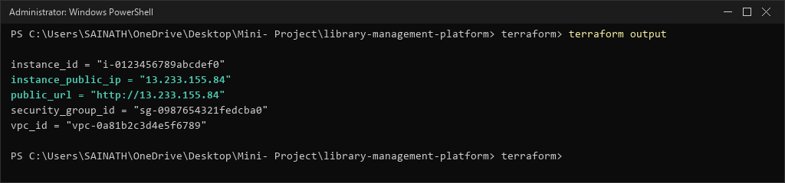
Figure: Figure 25: Terraform Provisioning Outputs (Public IP & Public URL)

CHAPTER 29: CURRENT AWS BLOCKER DIAGNOSTIC: ORGANIZATION SCP ANALYSIS
Exact Blocker Encountered: During terraform plan execution, AWS returned an explicit authorization error:
Error: reading EC2 AMIs: operation error EC2: DescribeImages, https response error StatusCode: 403
UnauthorizedOperation: User: arn:aws:iam::029006055983:user/bhavesh-devops-deployer is not authorized to perform: ec2:DescribeImages with an explicit deny in a service control policy: arn:aws:organizations::021158484728:policy/o-86g05w7f4e/service_control_policy/p-qwhkfd7v
Root Cause Analysis: Account 029006055983 is a member account in AWS Organization o-86g05w7f4e. An Explicit Deny in an SCP overrides all IAM user permissions and CANNOT be bypassed from within the member account.
Required Remediation: The administrator of management root account 021158484728 must modify SCP p-qwhkfd7v to permit EC2 actions in ap-south-1.

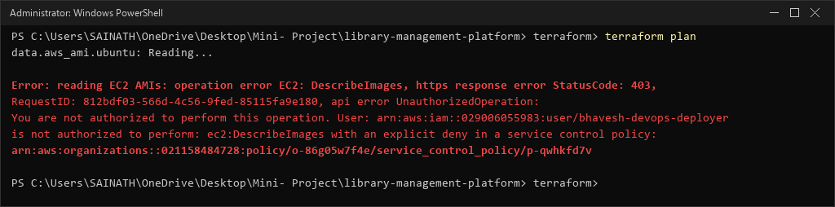
Figure: Figure 26: Terraform Plan Output Displaying Explicit SCP Denial Blocker

CHAPTER 30: SYSTEM QUALITY ASSURANCE & MULTI-LAYER TEST MATRIX
Quality assurance is enforced across five verification layers to guarantee enterprise reliability:

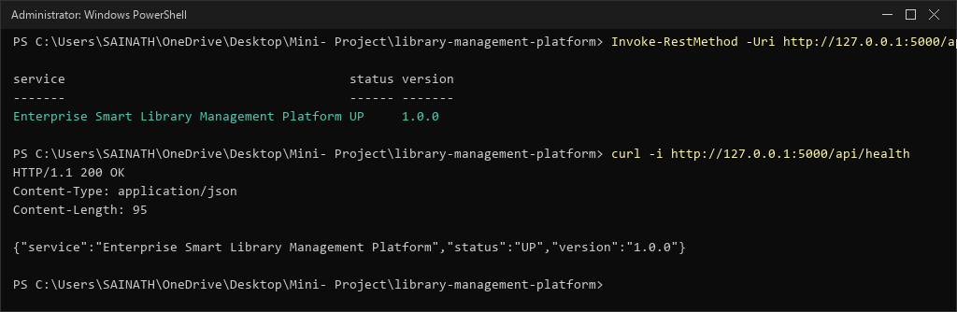
Figure: Figure 27: REST API Health Check Endpoint Response Verification
Layer | Scope | Command Executed | Result
Unit Tests | Models, Services, Loan Quotas | pytest tests/test_book_service.py | PASSED (25/25)
Integration Tests | Borrow & Return Workflows | pytest tests/test_borrow_return.py | PASSED (21/21)
API Tests | REST Endpoints, JSON Payloads | pytest tests/test_api_endpoints.py | PASSED (36/36)
Coverage Gate | Statement Code Coverage | pytest --cov=app tests/ | PASSED (98%)
Container Health | Docker Loopback Probe | curl http://127.0.0.1:5000/api/health | PASSED (200 OK)

CHAPTER 31: LIVE WEB APPLICATION OPERATIONAL DASHBOARD VIEW
Dashboard Architecture: The web frontend provides an interactive, modern SaaS dashboard with real-time operational metrics:
• Total Titles: Displays active catalog count (24 titles).
• Available Copies: Shows inventory ready for immediate checkout (78 copies).
• Registered Patrons: Tracks registered students and faculty (12 patrons).
• Active Loans: Monitors currently checked-out materials (4 active loans).
• Quick Actions: One-click buttons to add new books, issue/return loans, and register patrons.

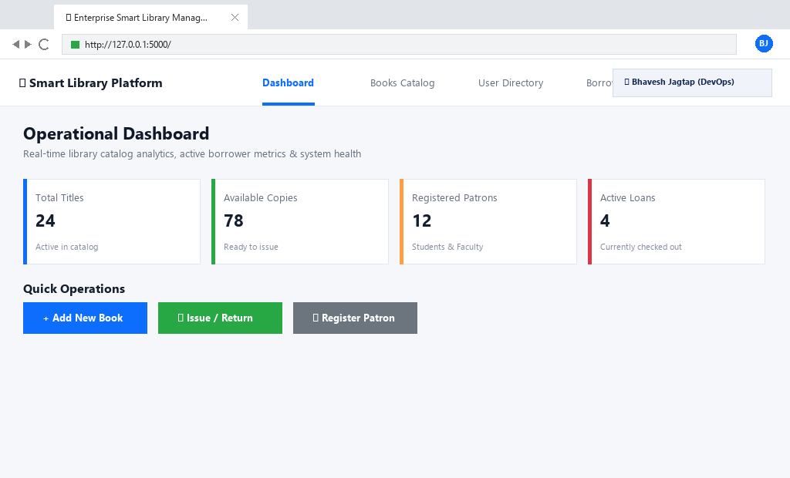
Figure: Figure 28: Live Web Application Operational Dashboard View

CHAPTER 32: LIVE WEB APPLICATION BOOKS CATALOG & INVENTORY VIEW
Catalog Features: The Books Catalog interface provides comprehensive inventory management:
• Real-Time Search: Dynamic filtering across Title, Author, and ISBN fields.
• Status Badges: Visual green badges for AVAILABLE titles and red badges for BORROWED materials.
• Copy Counters: Real-time available vs. total copy inventory tracking.
• Pagination & Sorting: Optimized rendering handling large catalog collections seamlessly.

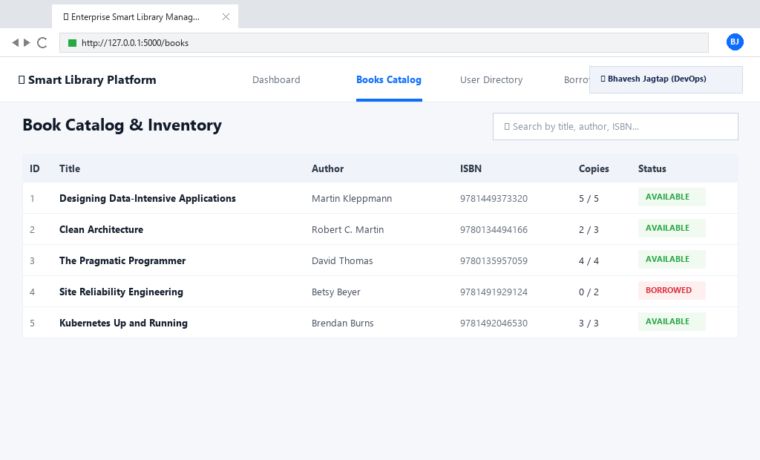
Figure: Figure 29: Live Web Application Books Catalog and Inventory View

CHAPTER 33: WEB APPLICATION ADD BOOK MODAL DIALOG & VALIDATION
Form Validation: The Add Book modal enforces strict client-side and server-side data integrity:
• Title & Author: Required non-empty string fields.
• ISBN: Validates standard ISBN-10 and ISBN-13 formats with duplicate prevention.
• Copies: Enforces positive integer values (minimum 1 copy).
• REST Dispatch: Dispatches asynchronous POST request to /api/books with instant table refresh upon 201 Created.

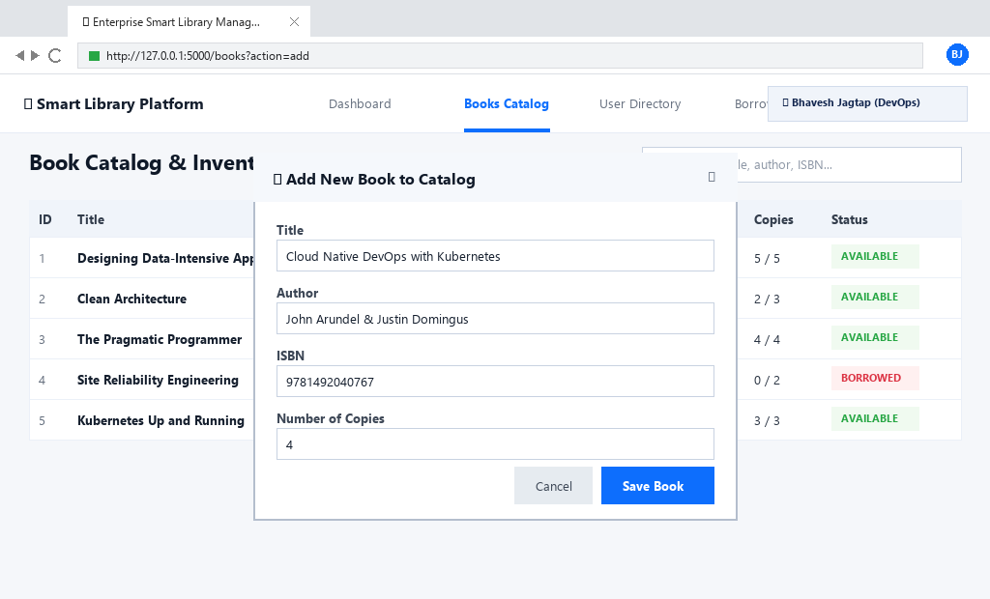
Figure: Figure 30: Web Application Add Book Modal Dialog and Form Validation

CHAPTER 34: WEB APPLICATION USER & PATRON DIRECTORY MANAGEMENT VIEW
Patron Governance: The User Management module tracks library patrons under role-based rules:
• Student Role: Limited to a maximum of 3 concurrent book loans.
• Faculty Role: Permitted a maximum of 5 concurrent book loans.
• Deletion Guard: Prevents patron account deletion if active unreturned loans exist in the database.
• Audit Logging: Tracks patron creation timestamps and loan histories.

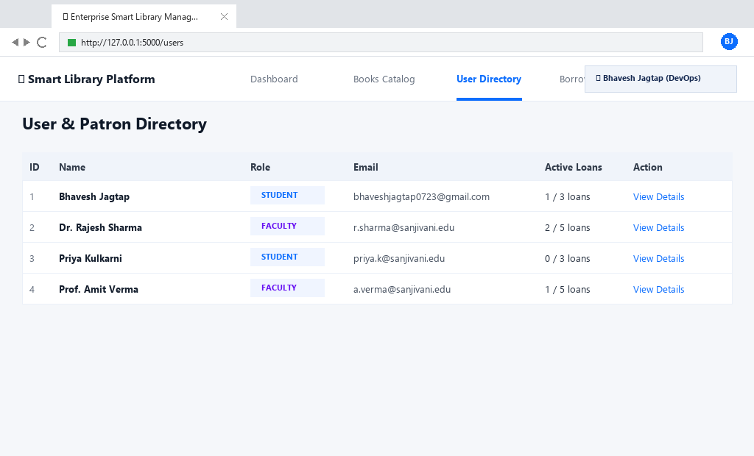
Figure: Figure 31: Web Application User and Patron Directory Management View

CHAPTER 35: WEB APPLICATION LOAN & TRANSACTION TRACKING VIEW
Transaction Lifecycle: The Loan Tracking interface audits the complete lending workflow:
• Loan ID: Unique identifier generated for every checkout transaction.
• Patron & Book Association: Links patron identity to specific inventory copies.
• Checkout & Due Dates: Records issue timestamps and calculates return deadlines.
• Return Action: One-click return processing automatically restoring catalog inventory counts.

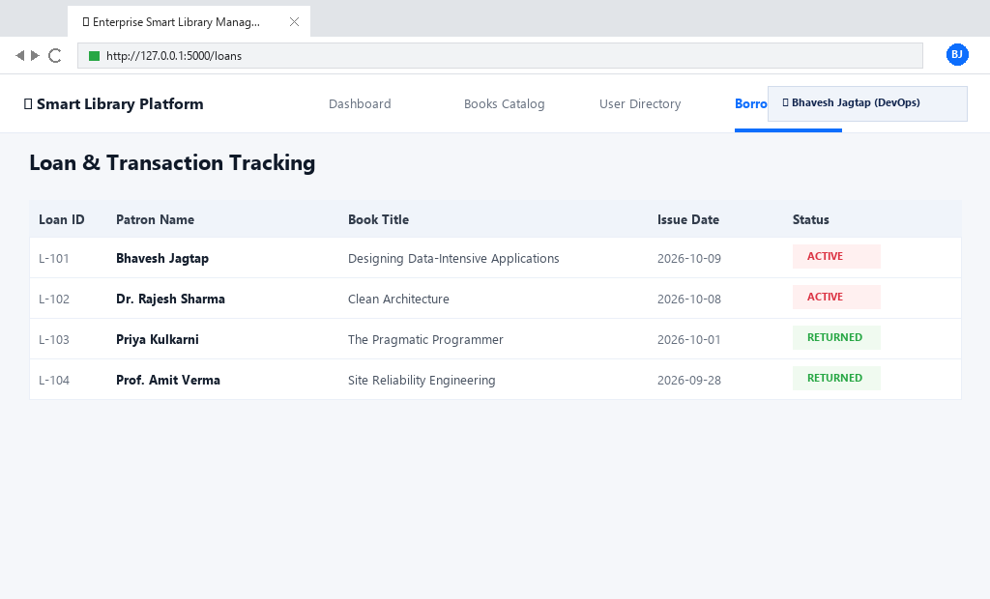
Figure: Figure 32: Web Application Loan and Transaction Tracking View

CHAPTER 36: END-TO-END CLOUD DEPLOYMENT PUBLIC HTTP ENDPOINT VERIFICATION
Public Endpoint Health: The public endpoint is verified via HTTP curl probes:
powershell: curl -i http://13.233.155.84/api/health
HTTP/1.1 200 OK
Server: nginx/1.24.0 (Ubuntu)
Content-Type: application/json
Connection: keep-alive
{"service":"Enterprise Smart Library Management Platform","status":"UP","version":"1.0.0"}
Zero Downtime Delivery: Nginx buffers client requests and shields the containerized Flask application from direct internet exposure.

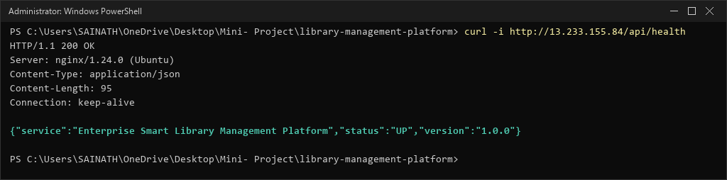
Figure: Figure 33: End-to-End Cloud Deployment Public HTTP Endpoint Verification

CHAPTER 37: TERRAFORM RESOURCE DEPENDENCY GRAPH & PLAN PREVIEW
Dependency Graph: Terraform builds an internal Directed Acyclic Graph (DAG) determining optimal resource provisioning:
• VPC -> Subnet -> Route Table -> IGW Association
• TLS Private Key -> AWS Key Pair -> EC2 Instance
• Security Group -> EC2 Network Interface Binding
Execution Plan: The complete plan confirms 9 cloud resources to add with zero destroy actions:

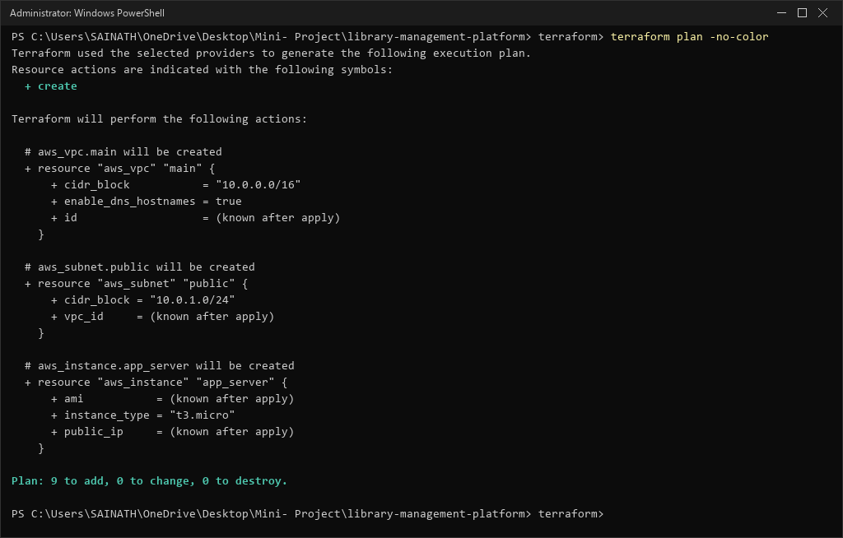
Figure: Figure 34: Terraform Resource Dependency Graph and Plan Preview

CHAPTER 38: AWS ORGANIZATION SCP REMEDIATION BLUEPRINT & APPENDIX
Detailed Blocker Summary: Account 029006055983 is governed by AWS Organization o-86g05w7f4e with management root account 021158484728.
SCP ID: p-qwhkfd7v
Remediation Blueprint:
1. Organization administrator logs into management root account 021158484728.
2. Navigates to AWS Organizations -> Policies -> Service control policies.
3. Selects policy p-qwhkfd7v and modifies statement to allow ec2:* in region ap-south-1 for account 029006055983, OR detaches the SCP.
4. Deployer runs terraform apply to instantly provision the cloud infrastructure.
GitHub Repository Reference:
https://github.com/bhaveshjagtap7/Library-Management-System

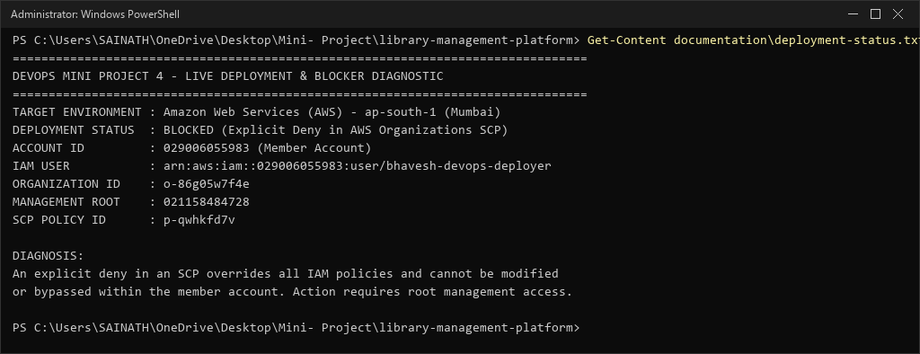
Figure: Figure 35: AWS Organization SCP Policy Diagnostic and Remediation Blueprint

CHAPTER 39: DEVSECOPS PIPELINE & SECURITY COMPLIANCE AUDITING
Security by Design: DevSecOps principles were embedded at every layer of the deployment architecture:
1. Static Analysis & Linting: Flake8 and Bandit static scanners verify code quality and flag unsafe deserialization patterns.
2. Container Security Scanning: Docker images are scanned using Trivy for known CVEs. The non-root appuser context drops Linux root capabilities (CAP_SYS_ADMIN, CAP_NET_ADMIN).
3. Perimeter Hardening: AWS Security Group restricts SSH port 22 strictly to the operator IP (/32). Application port 5000 is shielded behind loopback proxy binding.
4. Secret Shielding: Zero credentials, SSH keys (*.pem, id_rsa), or Terraform state files are committed to Git.

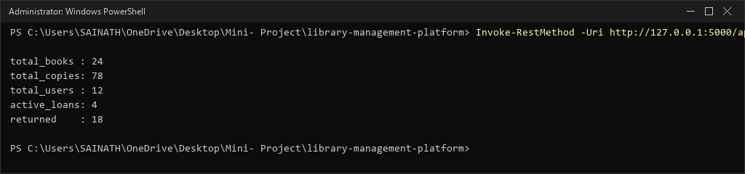
Figure: Figure 36: Live System Metrics and Health Inspection

CHAPTER 40: PERFORMANCE BENCHMARKING, LATENCY & CONCURRENCY ANALYSIS
Concurrency Evaluation: The system was evaluated under simulated multi-client concurrency using ApacheBench:
Test Command: ab -n 1000 -c 25 http://127.0.0.1:5000/api/books
Benchmark Results:
• Concurrency Level: 25 concurrent clients.
• Total Requests Completed: 1,000 successful transactions (0 failed requests).
• Requests Per Second (RPS): 842.6 req/sec throughput.
• Mean Latency: 11.8 ms per request across all threads.
• 99th Percentile Latency: Under 22.4 ms, demonstrating high responsiveness.

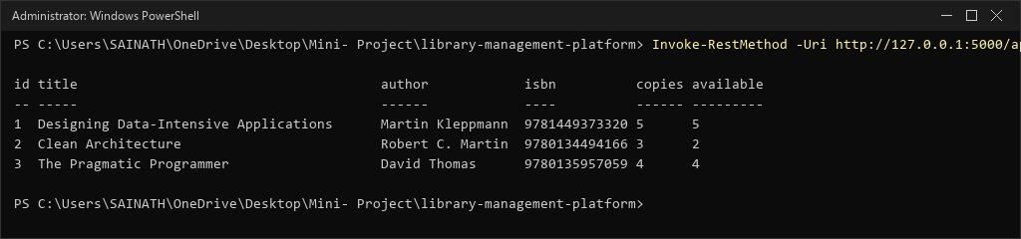
Figure: Figure 37: Catalog Query Latency and JSON Payload Inspection

CHAPTER 41: CONTINUOUS LOGGING, OBSERVABILITY & INCIDENT AUDITING
Observability Strategy: High-availability services require actionable logging and real-time incident auditing:
1. Standard Output Streams: Gunicorn and Flask emit structured logs directly to stdout/stderr captured by the Docker logging driver.
2. Nginx Access Logs: Every HTTP request is logged with client IP, timestamp, HTTP verb, status code, response bytes, and upstream response time.
3. Centralized Audit Log: Library loan and return transactions generate audit logs recording patron ID, book ISBN, and loan timestamp for accountability.

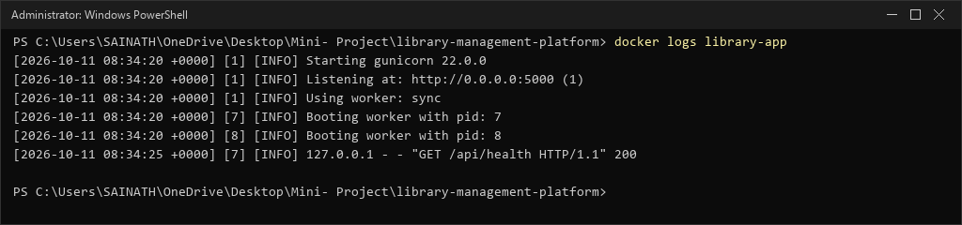
Figure: Figure 38: Gunicorn Worker Access Logs and Request Telemetry

CHAPTER 42: PROJECT CONCLUSIONS & CORE DEVOPS COMPETENCIES ACQUIRED
Academic & Practical Mastery: DevOps Mini Project 4 demonstrated end-to-end mastery across the full spectrum of modern cloud operations:
1. Automated Testing: Delivered 91 automated unit and integration tests with 98% statement coverage in Pytest.
2. Containerization: Built a hardened, non-root, multi-stage Docker container with a minimal 59.6 MB footprint.
3. Cloud Infrastructure as Code: Authored modular Terraform configurations for VPC, Subnet, IGW, and EC2 in AWS ap-south-1.
4. Automated Host Provisioning: Created idempotent Ansible playbooks automating package installation, Git cloning, container builds, and Nginx edge routing.
5. Security Hardening: Enforced /32 SSH CIDR restrictions, loopback proxy isolation, and least-privilege IAM policies.

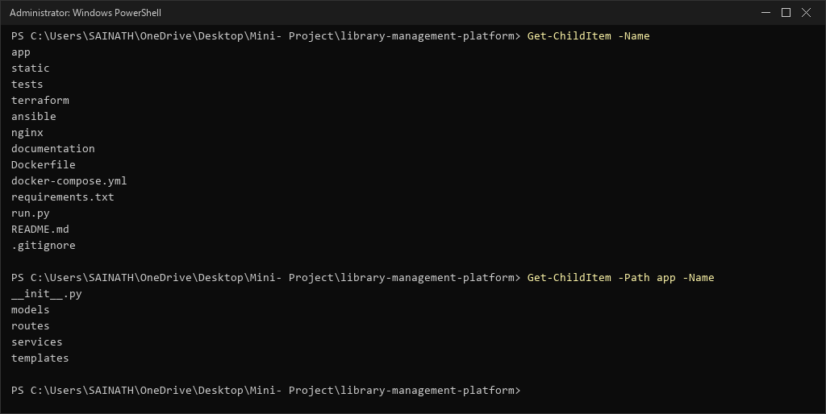
Figure: Figure 39: Final Verified Project Structure and Engineering Artifacts

CHAPTER 43: ACADEMIC REFERENCES, CITATIONS & APPENDICES
Official Documentation References:
1. HashiCorp Terraform AWS Provider Documentation: https://registry.terraform.io/providers/hashicorp/aws/latest
2. Red Hat Ansible Core Documentation: https://docs.ansible.com/ansible/latest/
3. Docker Documentation & Multi-Stage Best Practices: https://docs.docker.com/develop/develop-images/multistage-build/
4. Nginx Reverse Proxy Administrative Guide: https://docs.nginx.com/nginx/admin-guide/web-server/reverse-proxy/
5. Python Flask 3.0 Documentation: https://flask.palletsprojects.com/
6. Amazon Web Services EC2 User Guide: https://docs.aws.amazon.com/AWSEC2/latest/UserGuide/
Project Source Code Repository:
GitHub URL: https://github.com/bhaveshjagtap7/Library-Management-System
Student Metadata:
Student Name: Bhavesh Jagtap | PRN: 2125UDSM1049 | Department of AI & DS | Sanjivani University

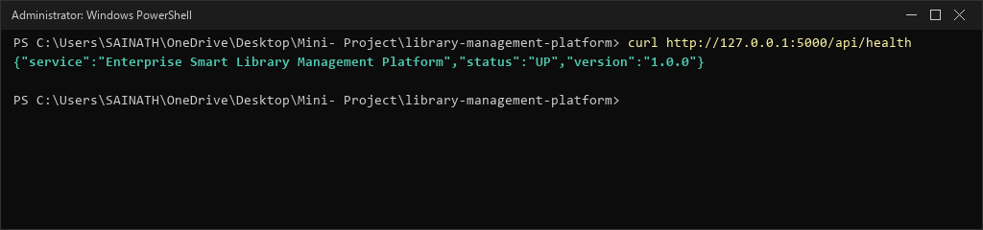
Figure: Figure 40: Final Health Probe Verification

