

Case Title:
VoltRide: When Green Growth Meets Operational Reality
(Business Case Study Submission)
Competition Name:
DecodeX – NLD Synapse 2026
Team Name: CodeXplorers

Team Members:
• Devraj Pujari
• Bhavesh Kerkar
College Name: Sathaye College
Submission Date: 16 February 2026
Executive Summary
VoltRide has experienced growing operational stress despite increasing ride demand, primarily due to inefficiencies in driver availability, fleet positioning, and charging operations rather than overall fleet size limitations. This analysis identified Mumbai – Zone 1 – 9 AM as the highest operational risk window, where elevated cancellation rates (~33%) coincided with peak demand. However, further investigation confirmed that driver availability and battery levels were sufficient, indicating that surge pricing and demand concentration were key contributors to cancellations rather than structural supply shortages.
Cancellation driver decomposition analysis revealed that driver unavailability accounted for approximately 41.27% of total cancellations, making it the most significant and actionable operational constraint. Fleet utilization assessment further showed that operational inefficiencies were driven by spatial imbalance rather than fleet inadequacy. Hyderabad – Zone 10 demonstrated exceptionally high driver availability (~96%) despite moderate demand, indicating surplus idle capacity that can be strategically redeployed to high-demand zones.
Charging infrastructure analysis identified Hyderabad – Zone 6 as a critical operational stress point, where high charging wait times (~34 minutes) occurred despite the presence of available chargers. This confirmed that charging congestion was primarily caused by poor timing alignment rather than insufficient infrastructure capacity.
Based on these findings, VoltRide can significantly improve operational efficiency through an Integrated Driver Availability Optimization Program. This includes dynamic fleet redeployment, off-peak charging incentives, and targeted peak-hour driver incentives. This operational intervention can reduce cancellations, improve fleet utilization, increase ride completion rates, and enhance revenue realization without requiring additional fleet expansion or capital-intensive infrastructure investment. This solution offers the highest impact-to-effort ratio and can be realistically implemented within 60–90 days.

Problem Understanding and Approach
Problem Understanding
VoltRide, a rapidly growing electric ride-hailing platform, is facing operational challenges associated with rising demand, elevated cancellation rates, and uneven fleet utilization across cities and zones. These operational inefficiencies directly impact revenue realization, driver productivity, and customer satisfaction.
The core business challenge is to identify the key sources of operational stress within the system and determine whether these challenges are driven by supply constraints, pricing dynamics, fleet imbalance, or charging infrastructure inefficiencies.
Understanding these stress points is critical to ensure that VoltRide can scale sustainably while maintaining high service reliability and operational efficiency.
This case study focuses on identifying the highest-risk operational windows, diagnosing the root causes of cancellations, evaluating fleet utilization efficiency, analyzing charging infrastructure stress, and proposing actionable operational improvements.

Analytical Approach
A structured, data-driven analytical framework was used to evaluate VoltRide’s operational performance across multiple dimensions.

1. Data Analysis and Stress Mapping
Ride-level data was aggregated across city, zone, and time windows to evaluate demand intensity and cancellation patterns.
Key metrics analyzed included:
• Ride request volume
• Cancellation rate
• Driver availability
• Surge multiplier
This analysis enabled identification of high-stress operational windows where elevated demand and cancellations occurred simultaneously.

2. Cancellation Driver Analysis
Cancellation reasons were analyzed to determine their relative contribution to overall cancellations.
Key drivers evaluated included:
• Driver unavailability
• Surge pricing
• Weather conditions
• Battery constraints
This helped identify the most impactful and operationally actionable driver affecting ride completion.

3. Fleet Utilization Assessment
Fleet utilization efficiency was evaluated by analyzing driver availability, demand levels, and cancellation rates across zones.
This helped identify:
• Zones experiencing supply shortages
• Zones with surplus idle capacity
• Opportunities for strategic fleet redeployment
This analysis assessed whether operational improvements could be achieved without expanding fleet size.

4. Charging Infrastructure Stress Analysis
Charging station data was analyzed to evaluate infrastructure efficiency and charging congestion.
Key indicators analyzed included:
• Average charging wait time
• Number of chargers available
• Ride demand levels
This helped determine whether charging constraints were caused by infrastructure limitations or operational inefficiencies.

5. Scenario-Based Operational Improvement Planning
Based on insights from demand stress, cancellation drivers, fleet imbalance, and charging congestion, an operational improvement strategy was developed.
This strategy focused on improving driver availability, optimizing fleet positioning, and enhancing charging efficiency to improve overall system performance.

Data Analysis and Key Insights

Task 1: Demand–Supply Stress Mapping
Explanation
The objective was to identify the city–zone–hour combination with the highest operational stress. Stress was defined using two key indicators: ride demand and cancellation rate.
Key Findings
Highest Risk Window:
City: Mumbai
Zone: 1
Hour: 9 AM
Cancellation Rate: ~33%
Dataset Average: ~24%
This window showed both high demand and high cancellations.
Further analysis revealed:
Driver availability was high
Battery constraints were minimal
Weather conditions were normal
Surge pricing was elevated
This indicates that surge pricing during peak hours contributed to increased cancellations rather than fleet shortage.

Visual
Figure 1: Cancellation Rate by City and Hour
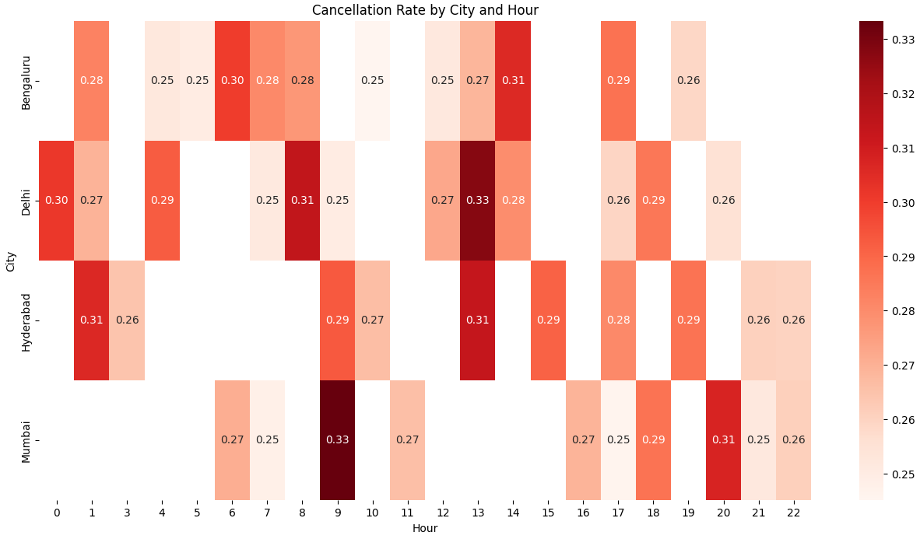
Figure 2: Cancellation Rate by City and Hour
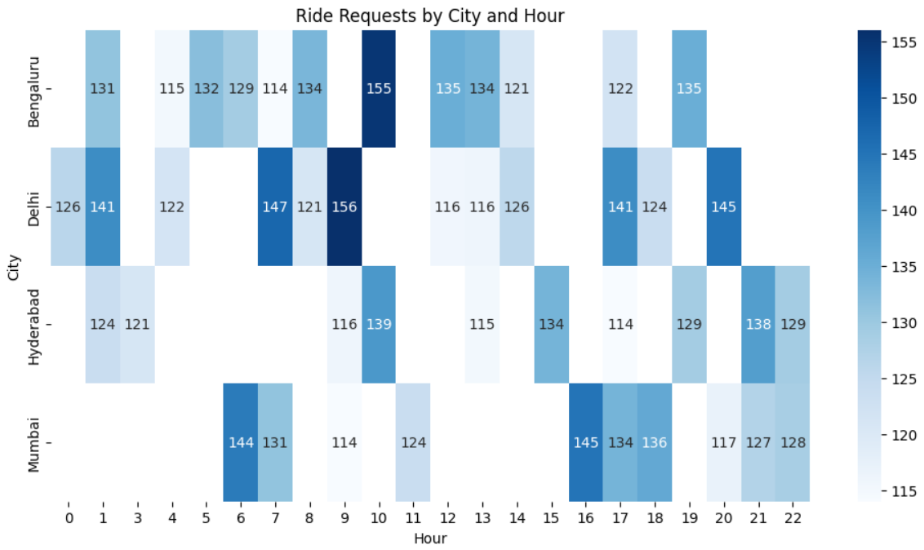

Task 2: Cancellation Driver Analysis
Explanation
Cancellation reasons were analyzed to identify the most significant operational driver.
Key Findings
Driver Unavailability contributed:
41.27% of total cancellations
Other factors:
Surge pricing: 27.47%
Weather: 25.43%
Battery issues: 21.38%
Driver unavailability is the most impactful and operationally controllable factor.
This highlights an opportunity to improve driver positioning and availability.
Visual
Figure 1: Cancellation Driver Contribution
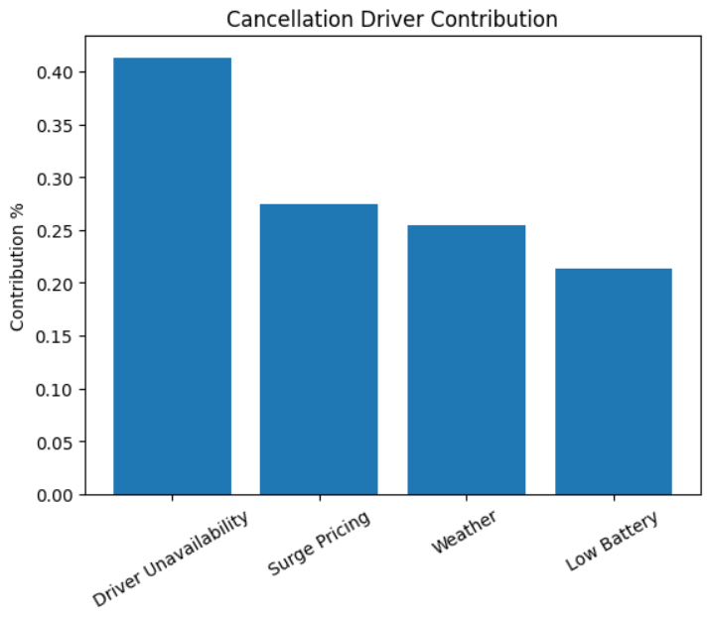

Task 3: Fleet Utilization Analysis
Explanation
Fleet utilization was evaluated to identify zones with surplus drivers suitable for redeployment.
Key Findings
Hyderabad – Zone 10 was identified as the best redeployment candidate.
Driver Availability: ~96%
Ride Volume: Moderate (~50 rides)
Cancellation Rate: ~26%
High availability with moderate demand indicates idle capacity.
This suggests drivers can be redeployed to high-demand zones to improve overall efficiency.
Visual
Figure 1: Cancellation Rate by Zone
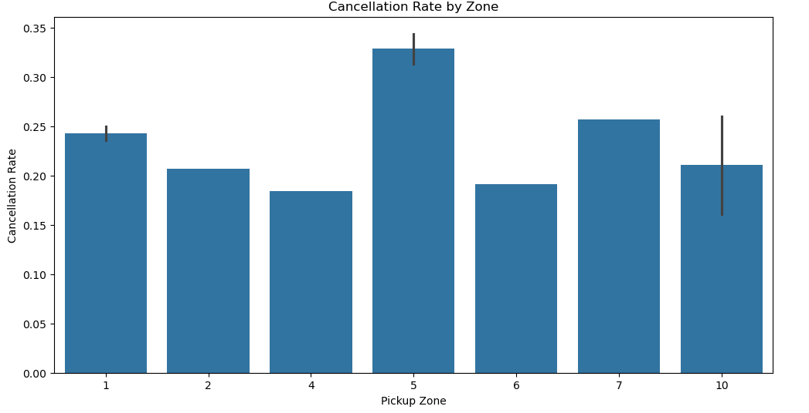

Figure 2: Driver Availability by Zone
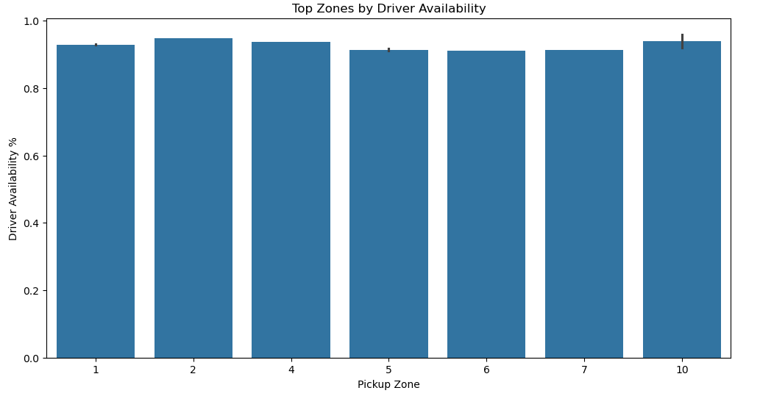
Figure 3: Demand vs Cancellation Stress Map
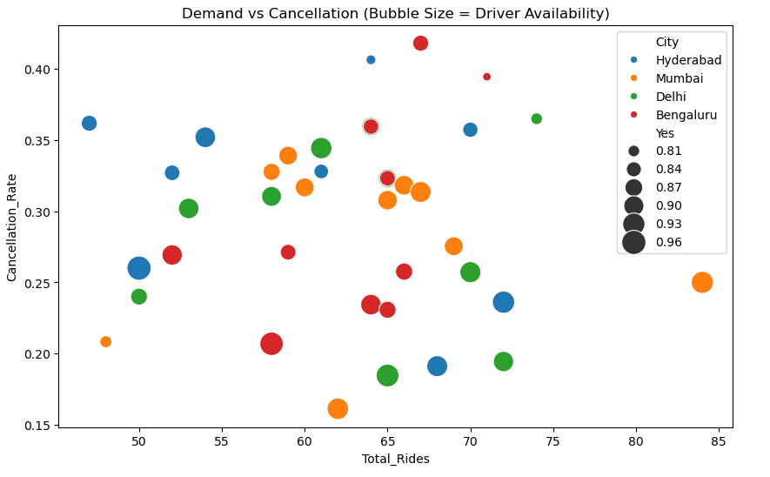

Task 4: Charging Infrastructure Stress Analysis
Explanation
Charging wait times were analyzed to determine whether infrastructure or operational timing caused charging stress.
Key Findings
Hyderabad – Zone 6 showed:
Average Wait Time: ~34 minutes
Chargers Available: 3
Demand peaks:
Hour 9: 167 rides
Hour 22: 136 rides
This indicates congestion during peak demand hours.
The issue is operational timing rather than infrastructure shortage.
Charging optimization can reduce wait times.
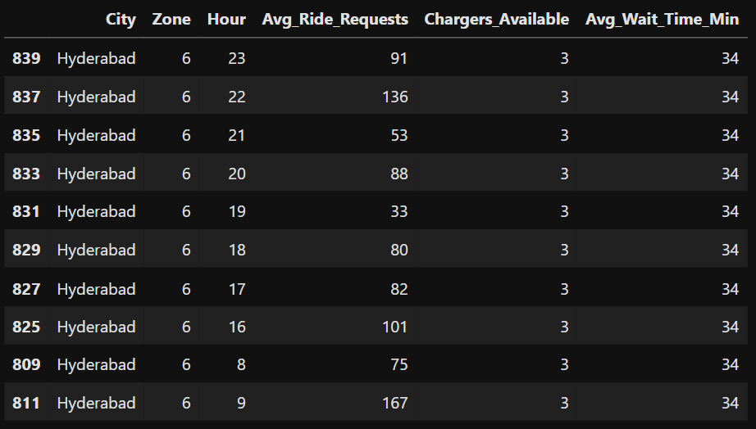

Application of Analytical Tools and Frameworks
To evaluate VoltRide’s operational performance and identify improvement opportunities, multiple analytical tools and frameworks were applied.
Descriptive Analysis was used to summarize ride demand, cancellation rates, driver availability, and charging wait times across city, zone, and hourly levels.
Ratio Analysis helped quantify key performance indicators such as cancellation rate and driver availability ratio, enabling comparison across zones.
Stress Mapping was performed to identify high-risk city–zone–time combinations where demand and cancellations were simultaneously elevated.
Demand–Supply Gap Analysis was used to detect imbalance between ride demand and driver availability, helping identify root causes of operational inefficiencies.
Fleet Utilization Analysis was conducted using utilization proxies such as rides per zone and driver availability to identify zones with surplus capacity suitable for redeployment.
Charging Stress Analysis evaluated charging wait times against demand timing to determine whether charging congestion was caused by structural capacity limitations or operational scheduling inefficiencies.
Finally, data visualization using Python and Excel was used to present insights through heatmaps, bar charts, and demand-stress maps, enabling clear identification of operational patterns and decision-making priorities.

Business Recommendations
Strategic Recommendation: Driver Availability Optimization Program
Based on the analysis, VoltRide should implement an integrated operational program focused on improving driver availability and fleet positioning over the next 60–90 days. This intervention includes peak-hour driver incentives, predictive driver positioning, and off-peak charging incentives.
Key Assumption
This recommendation assumes that driver availability and charging behavior can be influenced through operational incentives and better demand forecasting, without requiring fleet expansion or additional charging infrastructure.
This assumption is supported by earlier findings showing that:
- Driver unavailability contributes to 41% of cancellations
- Fleet imbalance exists across zones
- Charging stress is primarily timing-related, not infrastructure-related
Expected Benefits
This initiative is expected to deliver significant operational improvements:
- Reduction in cancellation rates
- Improved fleet utilization efficiency
- Increased ride completion and revenue realization
- Reduced charging wait times
- Improved customer satisfaction and retention
Even a 5–8% improvement in ride completion rate can result in meaningful revenue and efficiency gains.
Implementation Risks
Potential risks include:
- Limited driver response to incentives
- Short-term operational adjustment challenges
However, these risks can be mitigated through phased implementation and targeted incentive design.
Conclusion
This recommendation offers the highest impact-to-effort solution by addressing the core operational bottleneck—driver availability—using existing fleet and infrastructure. It is practical, cost-effective, and achievable within a 60–90 day timeframe.
Assumptions Made
The analysis and recommendations are based on the following key assumptions:
- Driver availability reflects active supply capacity
Drivers marked as available are assumed to be ready to accept ride requests without operational constraints.
- Demand patterns remain relatively stable in the short term
Historical demand trends are assumed to represent near-future demand patterns for operational planning.
- Surge pricing influences customer cancellation behavior
Higher surge multipliers are assumed to increase the likelihood of ride cancellations due to price sensitivity.
- Charging infrastructure capacity remains constant
The number of available chargers is assumed to remain unchanged during the analysis period.
- Fleet redeployment is operationally feasible
It is assumed that drivers can be repositioned across zones with minimal operational and financial constraints.
These assumptions provide a reasonable operational framework for evaluating fleet efficiency and proposing improvements.

