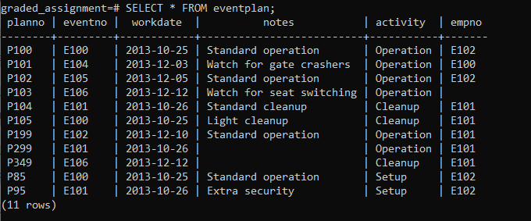

CREATE TABLE eventplan(

planno VARCHAR(8) NOT NULL,

eventno VARCHAR(8) NOT NULL,

workdate DATE NOT NULL,

notes VARCHAR(40),

activity VARCHAR(20) NOT NULL,

empno VARCHAR(8),

CONSTRAINT pkPlanNo PRIMARY KEY (planno),

CONSTRAINT fkEventNo FOREIGN KEY (eventno) REFERENCES eventrequest (eventno)

);