1. **Folder Structure:**

There are two apps in library management system one is form library itself and another is for admin_users login and signup.

1. **Run Tool:**

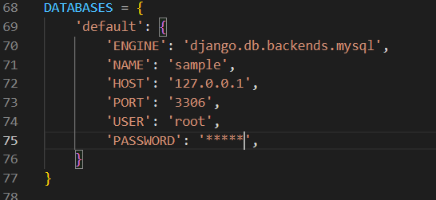

To Run this tool change settings for mysql database

“Name” : Database Name

“HOST” : MySQL ip

“PORT”: MySQL port number by default it is 3306

“USER” : username

“Password”: Password

1. **Library Templates:**

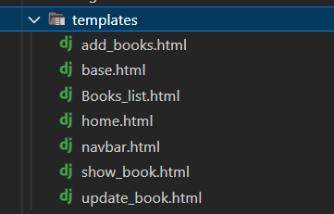

Each templates in library app are having self explanatory name.

1. 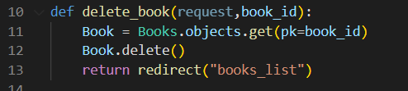**Views.py:**

Delete book function is called when someone wants to delete particular book. Here ISBN no. is used as primary key.

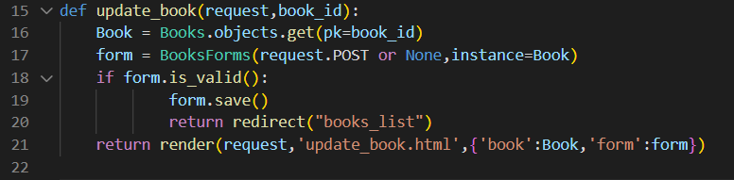

Update_book function is used to update any book. Here django’s modelform are used to create form.

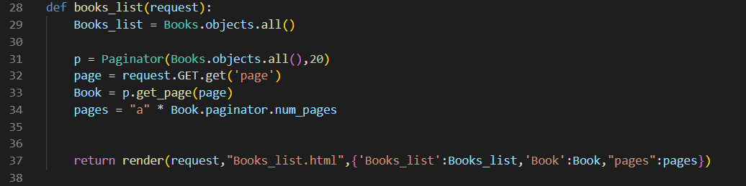

In books_list is used to list all the books available in the database here paginator is also used to show total of 20 records per page.