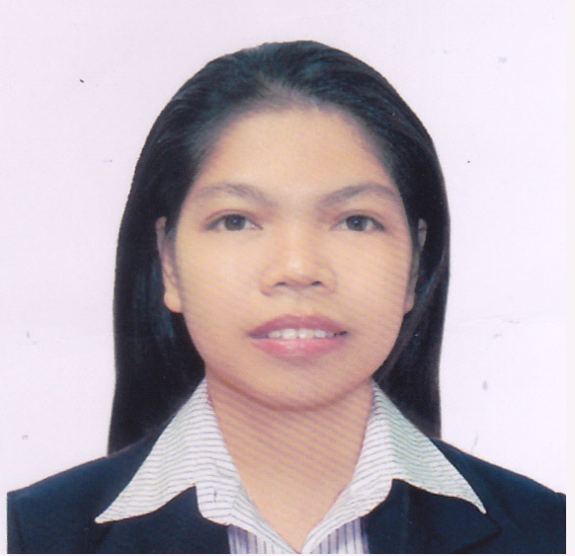

JOSEPHINE P. LAROA

BLK 10 LOT 22 PRIMAVEDA RESIDENCES PAG ASA 11 IMUS
Cavite, Philippines
Mobile No.: 09457847762
Email Add: jholaroa@yahoo.com.ph
Current Location: Philippines
Availability: I can start for work as soon as possible.

PERSONAL DATA
Age: | 34
Date of Birth: | May 9, 1986
Gender: | Female
Civil Status: | Single
Height: | 154 cm
Weight: | 50 kg
Nationality: | Filipino
Religion: | Roman Catholic
Permanent Address: | BLK 10 LOT 22 PRIMAVEDA RESIDENCES PAG ASA 11 IMUS CAVITE

WORK EXPERIENCE
I have been working for 12 year(s).

1. | Position: | HR OFFICER
1. | Duration: | October 08, 2008 TO June 2020 (close)
1. | Company: | MODELCOUP INTERNATIONAL INC.
1. | Company Industry: | MANPOWER
1. | Location | TEJERO ROSARIO CAVITE
1. | Department: | HR/ADMIN STAFF
1. | Job Description: | Handling Applicants inquiry, recruitment, Interviewed and giving exam to qualified applicants for various positions.  Deployment processing  Conduct training orientation to newly hire employees.  Prepares extensive Evaluation Reports of worker.  Responsible in monitoring manpower service to the client  Arranged Documentations of Clients and employees records.  Records keeping such as 201 files of employees.  Monitor daily timekeeping record/timekeeping of the employee  In charge in payroll preparation, releasing of salary on time thru bank transaction. Releasing of pay slip on time.  In charge in filling or preparation governments dues Phil Health, SSS, HDMF. Reporting monthly report such us medical report, BIR report, DOLE monthly report.  IN-charge in guidance and counseling of employees  Answering telephone calls, concern to client, Advertising Vacancies  Performs other related duties as may be required by the immediate superiors
2. | Position: | Part time Timekeeper
2. | Duration: | May 2013-August 2014
2. | Company: | Saint John BOSCO Faith Training Center
2. | Company Industry: | SCHOOL
2. | Location | NOVELETA Rosario Cavite
2. | Department: | ACCOUNTING
2. | Job Description: | In Charge in timekeeping, payroll preparation, releasing of student allowance
And bank processing.

3. | Position: | Production Operator
3. | Duration: | Jun 24, 2006 - Oct 10, 2007 (1.3 yrs)
3. | Company: | Macro Wiring Tech, Co. Inc.
3. | Company Industry: | Manufacturing
3. | Location | CEPZA Rosario Cavite
3. | Department: | Production
3. | JobDescription: | Perform production operation in wire harness assembly.

3. | Position: | HR COORDINATOR
3. | Duration:
3. | Company: | Chiyoda integre phils.
3. | Company Industry: | Manufacturing die cutting
3. | Location | CEPZA Rosario Cavite
3. | Department: | HR
3. | Job Description: | In charge in checking attendance, encoding output , proper grooming of employees and disciplinary action

EDUCATION
 | Highest Education
Education Level: | Bachelor's / College Degree
Education Field: | Others
Course: | Associate in Office Administration
School/University: | Saint Joseph College
Location: | Maasin City Southern Leyte
Date: | SY: Jun 2004 - Mar 2006

TRAININGS/SEMINARS
Date | Topic/Course Title
July 29 ,2015 | POWERMAX CONSUTING GROUP INC  ALL ABOUT PAYROLL AND WITHOLDING TAXES

OCTOBER 26, 2015 |  | PHILHEALTH  EMPOYERS FORUM

Capability

- With 12 years’ experience in HR ADMIN /ACCTG/FINANCE timekeeping and payroll processing. Government dues and employees benefits SSS PHILHEALTH HDMF AND BIR
- With good communication skills and ability to multi-task and manage assigned task well even under pressure and gives noteworthy results.
- Highly Dependable
- With experience in processing accounts payables both checks and cash payments

REFERENCES

Can be provide upon request.

________________
Applicant Signature

