**Assignment No: 3**

import pandas as pd

df = pd.read_csv("/content/sample_data/Housing.csv") # Replace with your actual dataset file

print(df.head())

**Output:** price area bedrooms bathrooms stories mainroad guestroom basement \

0 13300000 7420 4 2 3 yes no no

1 12250000 8960 4 4 4 yes no no

2 12250000 9960 3 2 2 yes no yes

3 12215000 7500 4 2 2 yes no yes

4 11410000 7420 4 1 2 yes yes yes

hotwaterheating airconditioning parking prefarea furnishingstatus

0 no yes 2 yes furnished

1 no yes 3 no furnished

2 no no 2 yes semi-furnished

3 no yes 3 yes furnished

4 no yes 2 no furnished

import pandas as pd

df = pd.read_csv("/content/sample_data/Housing.csv")

print(df.dtypes)

**Output:** price int64

area int64

bedrooms int64

bathrooms int64

stories int64

mainroad object

guestroom object

basement object

hotwaterheating object

airconditioning object

parking int64

prefarea object

furnishingstatus object

dtype: object

import pandas as pd

df = pd.read_csv("/content/sample_data/Housing.csv

# Count column types

num_categorical = df.select_dtypes(include=['object']).shape[1]

num_integer = df.select_dtypes(include=['int64']).shape[1]

num_float = df.select_dtypes(include=['float64']).shape[1]

# Display results

print(f"Number of Categorical Columns: {num_categorical}")

print(f"Number of Integer Columns: {num_integer}")

print(f"Number of Float Columns: {num_float}")

**Output:** Number of Categorical Columns: 7

Number of Integer Columns: 6

Number of Float Columns: 0

import pandas as pd

import numpy as np

import matplotlib.pyplot as plt

from sklearn.feature_selection import chi2

from sklearn.preprocessing import LabelEncoder

df = pd.read_csv("/content/sample_data/Housing.csv")

categorical_cols = df.select_dtypes(include=['object']).columns

encoder = LabelEncoder()

df_encoded = df.copy()

for col in categorical_cols:

df_encoded[col] = encoder.fit_transform(df[col])

X = df_encoded[categorical_cols] # Features

y = df_encoded.iloc[:, -1] # Target variable

chi_scores, p_values = chi2(X, y)

plt.figure(figsize=(10, 5))

plt.bar(categorical_cols, chi_scores, color='skyblue')

plt.xlabel("Categorical Features")

plt.ylabel("Chi-Square Score")

plt.title("Feature Importance Based on Chi-Square Test")

plt.xticks(rotation=45)

plt.show()

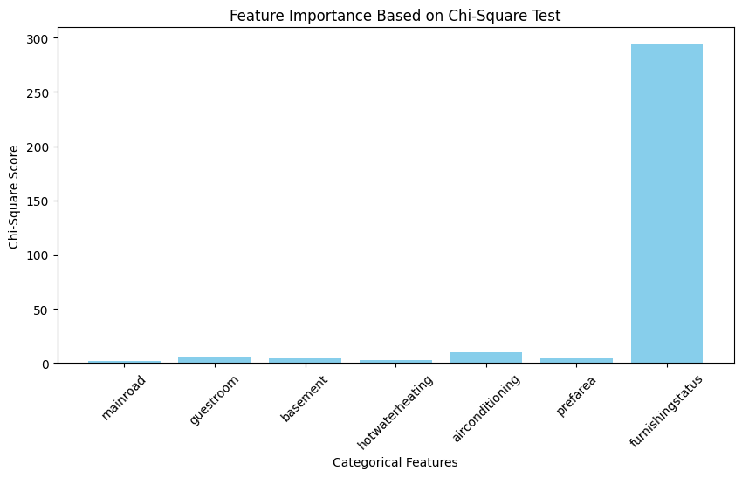

new_df=df.dropna()

new_df.isnull().sum()

**Output:** 0

price 0

area 0

bedrooms 0

bathrooms 0

stories 0

mainroad 0

guestroom 0

basement 0

hotwaterheating 0

airconditioning 0

parking 0

prefarea 0

furnishingstatus 0

dtype: int64

import pandas as pd

categorical_cols = df.select_dtypes(include=['object']).columns

df[categorical_cols] = df[categorical_cols].replace({'Yes': 1, 'No': 0})

df_encoded = pd.get_dummies(df, columns=categorical_cols, drop_first=True)

print(df_encoded.head().to_string(index=False))

import pandas as pd

from sklearn.model_selection import train_test_split

X = df.drop(columns=['price']) # Features (all columns except 'Price')

y = df['price'] # Target variable

X_train, X_test, y_train, y_test = train_test_split(X, y, test_size=0.2, random_state=42)

print("Training Features Shape:", X_train.shape)

print("Testing Features Shape:", X_test.shape)

print("Training Target Shape:", y_train.shape)

print("Testing Target Shape:", y_test.shape)

**Output:** Training Features Shape: (436, 12)

Testing Features Shape: (109, 12)

Training Target Shape: (436,)

Testing Target Shape: (109,)

import pandas as pd

import numpy as np

from sklearn.model_selection import train_test_split

from sklearn.preprocessing import StandardScaler

from sklearn.svm import SVR

from sklearn.metrics import mean_absolute_error, mean_squared_error, r2_score

# Preprocess data

X = pd.get_dummies(df.drop(columns=['price']), drop_first=True) # One-Hot Encoding

y = df['price']

X_train, X_test, y_train, y_test = train_test_split(X, y, test_size=0.2, random_state=42)

# Standardize features

scaler = StandardScaler()

X_train, X_test = scaler.fit_transform(X_train), scaler.transform(X_test)

# Train & predict with SVM

svm = SVR(kernel='rbf', C=100, gamma=0.1, epsilon=0.1)

svm.fit(X_train, y_train)

y_pred = svm.predict(X_test)

# Evaluate model

print(f"MAE: {mean_absolute_error(y_test, y_pred):.2f}, RMSE: {np.sqrt(mean_squared_error(y_test, y_pred)):.2f}, R²: {r2_score(y_test, y_pred):.2f}")

**Output:** MAE: 1762754.37, RMSE: 2358789.58, R²: -0.10

import pandas as pd

import numpy as np

from sklearn.model_selection import train_test_split

from sklearn.preprocessing import StandardScaler

from sklearn.ensemble import RandomForestRegressor

from sklearn.metrics import mean_absolute_error, mean_squared_error, r2_score

X = pd.get_dummies(df.drop(columns=['price']), drop_first=True) # One-Hot Encoding for categorical data

y = df['price']

X_train, X_test, y_train, y_test = train_test_split(X, y, test_size=0.2, random_state=42)

# Standardize features (optional for tree-based models, but good practice)

scaler = StandardScaler()

X_train, X_test = scaler.fit_transform(X_train), scaler.transform(X_test)

# Train & predict with Random Forest

rf = RandomForestRegressor(n_estimators=100, random_state=42)

rf.fit(X_train, y_train)

y_pred = rf.predict(X_test)

# Evaluate model

print(f"MAE: {mean_absolute_error(y_test, y_pred):.2f}, RMSE: {np.sqrt(mean_squared_error(y_test, y_pred)):.2f}, R²: {r2_score(y_test, y_pred):.2f}")

**Output:** MAE: 1021151.08, RMSE: 1399758.20, R²: 0.61

from sklearn.metrics import r2_score

rf = RandomForestRegressor(n_estimators=100, random_state=42)

rf.fit(X_train, y_train)

r2 = r2_score(y_test, rf.predict(X_test))

print(f"R² Score: {r2:.2f}")

**Output:** R² Score: 0.61

from sklearn.linear_model import LinearRegression

lr = LinearRegression()

lr.fit(X_train, y_train)

r2 = r2_score(y_test, lr.predict(X_test))

print(f"R² Score: {r2:.2f}")

**Output:** R² Score: 0.65

from sklearn.linear_model import Lasso

lasso = Lasso(alpha=0.1) # Adjust alpha for regularization strength

lasso.fit(X_train, y_train)

r2 = r2_score(y_test, lasso.predict(X_test))

print(f"R² Score: {r2:.2f}")

R² Score: 0.65