Week 1 — Linux for Servers (beyond the basics)
Theme: Turn "I know Linux commands" into "I can look after an Ubuntu server."
Time: Mon–Fri, 6–8 h/day (≈4 h learning, ≈3 h hands-on).
Sandbox: one Ubuntu 24.04 VM (2 vCPU / 4 GB / 40 GB + one extra 5 GB virtual disk for the LVM lab).
How to use this document: it is your master plan for the week. Work through the Day-wise plan top to bottom, do every lab, push each deliverable to submissions/week-N/ by 18:00, do the AI-assisted lab after the manual labs, and answer the quiz on Friday. The Sigzen SOPs you need are copied into this week's Materials/ folder.

Learning objectives
By Friday the trainee can:
- Start, stop, enable and inspect services with systemctl, and read their logs with journalctl and /var/log.
- Log in to a server with an SSH key only (password login disabled) and explain why.
- Use sudo correctly and explain the difference between root, a sudo user and a service user (e.g. the frappe user).
- Schedule a job with cron and prove it ran.
- Add a disk, extend a logical volume (LVM) and the filesystem without rebooting.
- Write a Bash script with variables, loops, functions and exit codes that backs up a folder and logs the result.
- Perform four Sigzen SOPs: SSH PEM key creation, Disk Cleanup, LVM Extend, Monitor Server Logs.
- Use an AI assistant to draft this week's artefacts, verify them with tools, explain every line, and keep an AI log with no secrets in prompts (AI-1).

Prerequisites (already known)
Navigation, ls/cd/cp/mv/rm, nano/vim, chmod/chown, users and groups, ps/top/kill, df/du, apt. If any of these are shaky, spend Day 1 morning on the Linux Foundation LFS101 refresher instead.

Day-wise plan
Day | Time | Tasks | Lab deliverable
Mon | 2 h | Set up the sandbox: install Ubuntu Server 24.04 in VirtualBox (or get the ESXi VM from the mentor), take a snapshot named clean. Read RHCSA guide Ch. 1 (SSH key auth) and Ch. 11 (services). | Lab 1.1
 | 2 h | systemctl — list units, status, start/stop/enable/disable, systemctl --failed; create your own small service.
 | 2 h | Read Sigzen Materials/SOP SSH_PEMKEY_CREATION.docx. Generate an SSH key pair on your laptop, copy the public key to the VM, disable password login, verify.
Tue | 2 h | Logs: /var/log/syslog, /var/log/auth.log, journalctl -u, -f, --since, -p err. Read RHCSA Ch. 12. | Lab 1.2
 | 2 h | Perform Materials/SOP Monitor_Server_Logs.docx on the VM. Find your own failed SSH login attempts in auth.log.
 | 2 h | sudo and /etc/sudoers.d/, visudo, su -, service users with no shell. Create a frappe-style user. Read RHCSA Ch. 3.
Wed | 2 h | cron: crontab -e, /etc/cron.d, crontab.guru; systemd timers (concept). Read RHCSA Ch. 7. | Lab 1.3
 | 2 h | Package management for servers: apt update/upgrade, apt list --upgradable, unattended-upgrades, holding a package, dpkg -l.
 | 2 h | Perform Materials/SOP Disk Cleanup.docx (apt clean/autoremove, du -sh * | sort -h, /tmp, old logs, journalctl --vacuum-size).
Thu | 3 h | Storage: lsblk, fdisk, mkfs, mount, /etc/fstab, then LVM (pvcreate, vgextend, lvextend, resize2fs). Read RHCSA Ch. 9–10. | Lab 1.4
 | 3 h | Perform Materials/SOP LVM EXTEND.docx: add a 5 GB virtual disk to the VM and extend the root LV by 5 GB live.
Fri | 3 h | Bash scripting: shebang, variables, $?, if, for, functions, set -euo pipefail, logging with date, tar, find -mtime. Run scripts through ShellCheck. | Lab 1.5
 | 1 h | Write the weekly summary in the Daily Log; complete the quiz. | Quiz
 | 1 h | Friday review with mentor (see Mentor check-in).

Materials
Books / docs (primary)
- RHCSA 9 student guide (Materials/rhcsa-9.0-student-guide.pdf): Ch. 1 (SSH keys), Ch. 3 (users/sudo), Ch. 7 (cron), Ch. 9–10 (storage, LVM), Ch. 11 (services/systemd), Ch. 12 (logs). ~3 h reading across the week. Note: the guide is Red Hat-based; Ubuntu uses `apt` instead of `dnf` and has no SELinux — skip those parts.
- The Linux Command Line (free book) — Part 4 "Writing Shell Scripts" (Ch. 24–36), read selectively on Friday.
- How to use systemctl (20 min)
- How to use journalctl (20 min)
- SSH keys on Ubuntu (15 min) · sshd_config reference (skim)
- Introduction to LVM (30 min)
- crontab.guru (tool) · ShellCheck (tool) · explainshell (tool)
- Google Shell Style Guide (skim, 15 min)
- Ubuntu Server docs (reference)
Videos (optional, Hindi/English)
- Linux For DevOps In One Shot (Hindi) — watch the sections on services, logs and cron only (~1 h).
- Users & groups (from the old intern sheet, 15 min)
- apt command crash course (15 min)
Stretch (optional)
- OverTheWire Bandit levels 0–15 — command-line puzzle game (1–2 h).
- Materials/RHCSA MOCK 3.pdf — attempt the storage and services questions.

Sigzen SOPs this week
Read | Perform | Path
✔ | ✔ | Materials/SOP SSH_PEMKEY_CREATION.docx
✔ | ✔ | Materials/SOP Monitor_Server_Logs.docx
✔ | ✔ | Materials/SOP Disk Cleanup.docx
✔ | ✔ | Materials/SOP LVM EXTEND.docx
✔ |  | Materials/SOP Create a Ubuntu VM.docx
✔ |  | Materials/SOP_Change-Ubuntu-Username-Hostname.docx
✔ |  | Materials/SOP_Sigzen-Template.docx — learn the SOP format; every lab write-up this program uses its section headings (Purpose, Scope, Procedure, Approval).

Labs (one per day — each has a deliverable)
Submit everything under submissions/week-1/ in the trainee's GitHub repo (created on Day 1 by the mentor, see Mentor Playbook).

Lab 1.1 (Mon) — Sandbox + SSH key-only login + your first service
- Install Ubuntu Server 24.04 in VirtualBox (bridged or NAT with port-forward 2222→22). Hostname trainee-vm. Snapshot clean.
- On your laptop: ssh-keygen -t ed25519 -C "yourname@sigzen". Copy the public key with ssh-copy-id.
Evidence — SSH password login disabled (Permission denied)
Evidence — Password authentication attempt failed: Permission denied (publickey)
Additional Evidence — SSH password login rejected (Permission denied)
- Edit /etc/ssh/sshd_config: PasswordAuthentication no, PermitRootLogin no. sudo systemctl restart ssh. Prove password login now fails.
- Create /etc/systemd/system/hello.service that runs /usr/local/bin/hello.sh (writes date to /var/log/hello.log every run). systemctl daemon-reload, enable --now, check status.
Deliverable: lab1.1.md containing (a) lsb_release -a output, (b) screenshot of a failed password login and a successful key login, (c) the hello.service file, (d) systemctl status hello output.

Lab 1.2 (Tue) — Log investigation + service user
- Perform SOP Monitor_Server_Logs step by step on the VM.
- Make 3 wrong-password SSH attempts from your laptop, then find them: sudo grep "Failed password" /var/log/auth.log and journalctl -u ssh --since "10 min ago".
- Break the hello service on purpose (typo in the script), find the error with journalctl -u hello -p err, fix it.
- Create user frappe with sudo adduser frappe, give it sudo via a file in /etc/sudoers.d/frappe (not by editing /etc/sudoers), and create a service user backupsvc with --shell /usr/sbin/nologin.
Evidence — /var/log/syslog output
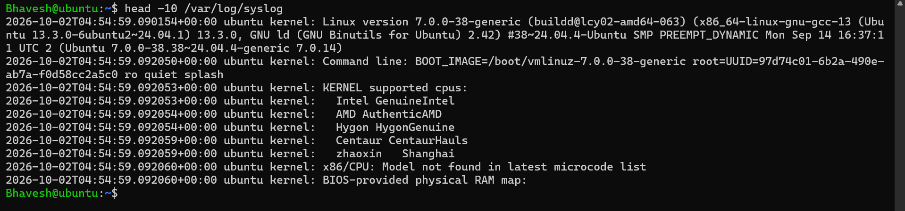
Evidence — /var/log/auth.log SSH authentication output
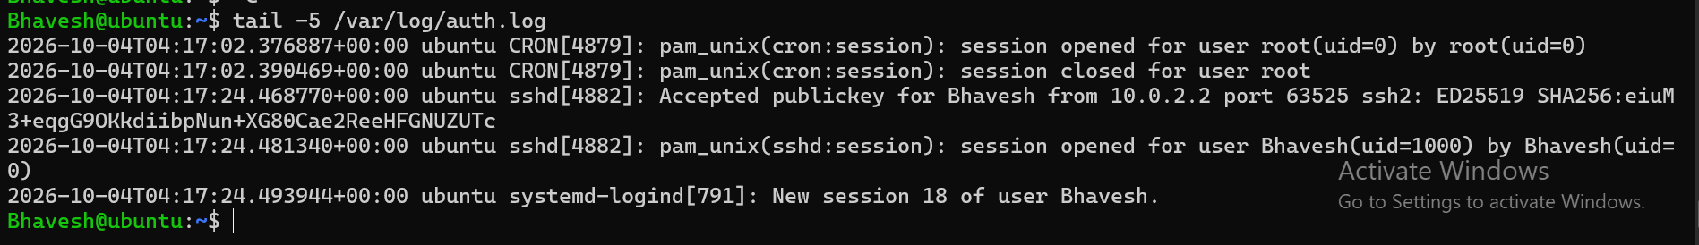
Evidence — journalctl -u ssh output
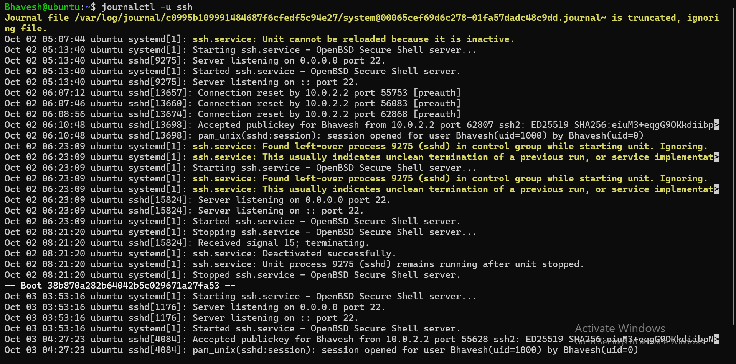
Evidence — journalctl -f live log monitoring
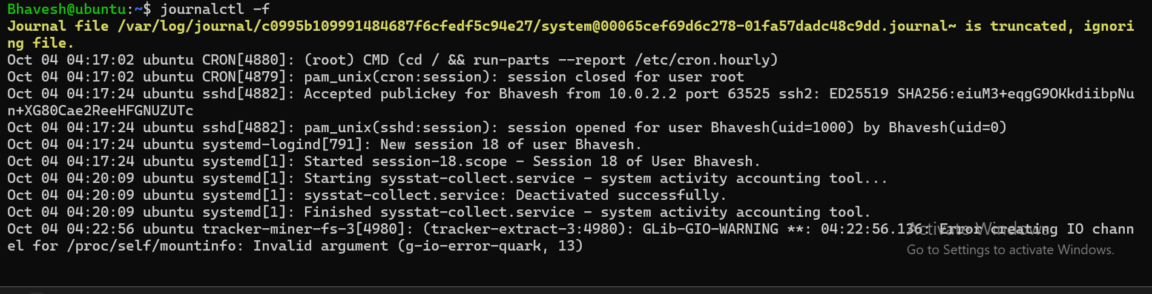
Evidence — Failed authentication entries found with grep
Evidence — frappe service user, sudoers configuration and validation
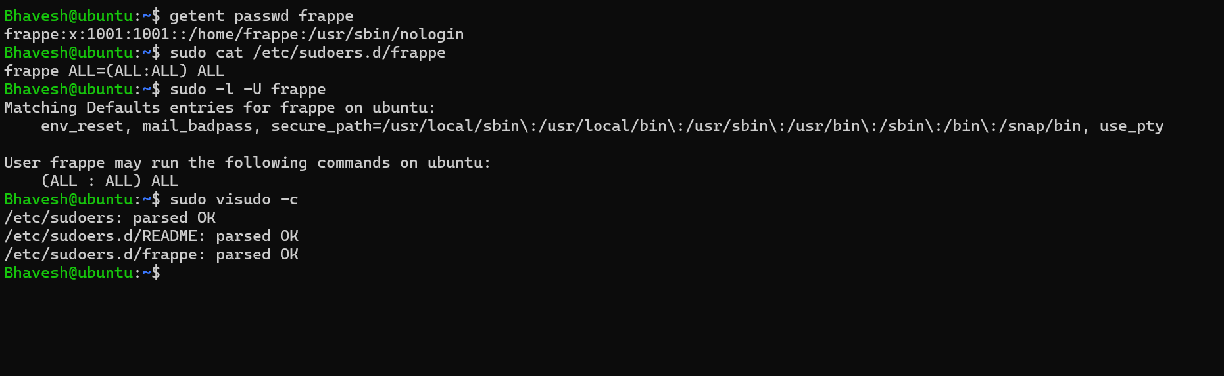
The evidence shows frappe configured with /usr/sbin/nologin, sudo access via /etc/sudoers.d/frappe, sudo permission verification, and successful sudoers syntax validation.
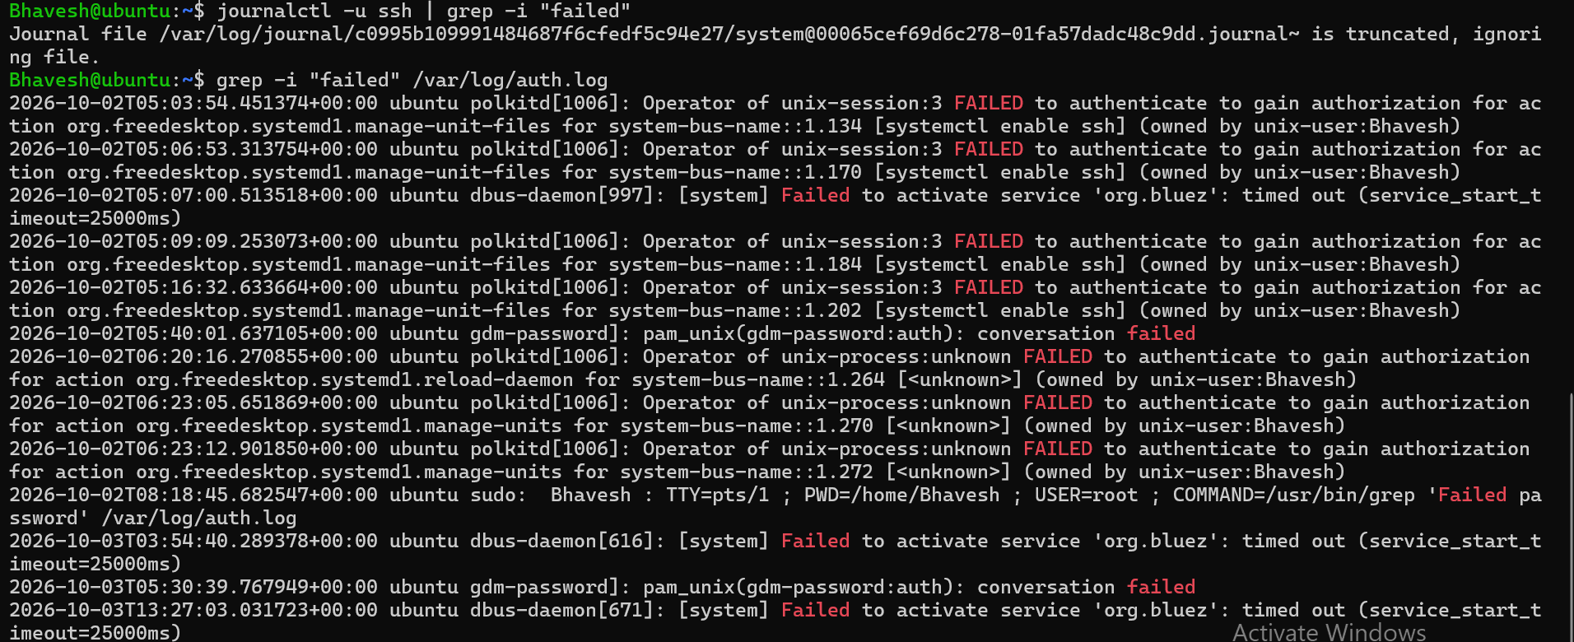
Deliverable: lab1.2.md with the grep/journalctl output showing your failed logins, the error line you found and how you fixed it, and id frappe, id backupsvc, sudo -l -U frappe outputs.

Lab 1.3 (Wed) — cron + disk cleanup
- Create a cron job for user frappe that appends date to /home/frappe/cron.log every 2 minutes. Wait 6 minutes, prove 3 lines exist. Then change it to run daily at 02:30 (the time Sigzen backups typically run).
- Fill the disk a little: fallocate -l 2G /tmp/bigfile, then perform SOP Disk Cleanup and show before/after df -h /.
- Run sudo journalctl --disk-usage, then sudo journalctl --vacuum-time=7d.
Deliverable: lab1.3.md with crontab -l for frappe, the cron.log lines, and df -h before/after cleanup. Include one sentence: "What would I NOT delete on a Sigzen production server?" (expected: sites/*/private/backups that are not yet copied to S3, /var/lib/mysql).

Lab 1.4 (Thu) — Add a disk and extend root with LVM (Sigzen SOP)
- Shut down the VM, add a 5 GB virtual disk, boot.
- lsblk to find it (e.g. /dev/sdb). sudo pvcreate /dev/sdb, sudo vgextend ubuntu-vg /dev/sdb, sudo lvextend -l +100%FREE /dev/ubuntu-vg/ubuntu-lv, sudo resize2fs /dev/ubuntu-vg/ubuntu-lv.
- Compare df -h / before and after. No reboot allowed.
Deliverable: lab1.4.md with lsblk, sudo vgs, sudo lvs, df -h / before and after, and a 5-line "Procedure" section written in the Sigzen SOP template style.

Lab 1.5 (Fri) — Backup script in Bash
Write /usr/local/bin/backup_dir.sh that:
- takes a source folder and a destination folder as arguments; exits with code 2 and a usage message if missing,
- creates dest/<foldername>-YYYYMMDD-HHMM.tar.gz,
- deletes archives older than 7 days in dest (find -mtime +7),
- writes one line per run to /var/log/backup_dir.log with date, size and OK/FAIL,
- uses set -euo pipefail and a function log(),
- passes ShellCheck with no warnings.
Schedule it in cron at 02:30 daily for /home/frappe.
Deliverable: the script file + shellcheck screenshot + 3 log lines (run it manually 3 times) + crontab -l.

AI-assisted lab — AI-1 — Script & explain (10 pts; see AI Track document, rules 1–7)
Do this after the manual labs of the week. Never paste secrets, client data or real server IPs.
- Ask an approved AI assistant to write a Bash backup script with the same requirements as Lab 1.5 (args, tar.gz with timestamp, delete > 7 days, log line, set -euo pipefail, a log() function). Do not paste your own script.
- Save it as backup_dir_ai.sh. Run shellcheck on it; run it 3 times against /home/frappe; diff -u backup_dir.sh backup_dir_ai.sh.
- In ai-log.md: tool, prompt, what you kept, what you changed, and at least two things the AI did differently or wrongly (e.g. unquoted variables, rm -rf on a computed path, missing mkdir -p).
Deliverable: backup_dir_ai.sh, ShellCheck output, the diff, ai-log.md. Mentor test: explain lines 1–15 of the AI script without notes.

Quiz — Week 1 (10 questions)
- What does systemctl enable nginx do that systemctl start nginx does not?
- Which file records SSH login attempts on Ubuntu?
- Give the journalctl command to show only errors from the ssh service since yesterday.
- Why does Sigzen disable password login on servers? Name the two sshd_config lines involved.
- What is the difference between su - and sudo -i?
- Write a cron expression for "every Sunday at 03:00".
- In LVM, put these in order from disk to filesystem: LV, PV, VG.
- After lvextend, why is df -h unchanged until you run resize2fs (ext4)?
- In Bash, what does set -euo pipefail protect you from? (three things)
- From SOP Disk Cleanup: name two locations that are safe to clean on a bench server and one that is NOT.
Pass mark: 7/10 — write your answers in submissions/week-N/quiz.md and send them to your mentor on Friday.

Rubric — Week 1 (100 points)
Item | Points | Evidence the mentor checks
Lab 1.1 sandbox + key-only SSH + custom service | 10 | Failed-password screenshot; hello.service file; systemctl status hello shows active
Lab 1.2 logs + users | 15 | grep/journalctl output; sudo -l -U frappe shows a rule; backupsvc has nologin
Lab 1.3 cron + disk cleanup | 15 | 3 cron.log lines; df -h before/after; correct "do not delete" answer
Lab 1.4 LVM extend (Sigzen SOP) | 20 | df -h / grew by ~5 GB; no reboot; procedure written in SOP style
Lab 1.5 backup script | 15 | Script runs; ShellCheck clean; 3 log lines; old-file deletion logic present
AI-assisted lab AI-1 | 10 | Artefact 4 · verification evidence 3 · explain-it test 3; ai-log.md has a non-empty 'wrong' column; no secrets in prompts
Quiz | 10 | Score ×1
Daily log + timesheet complete every day | 5 | 5 entries in the log; timesheet filled
Total | 100 | Record in Perfomance Sheet: Date = Friday, Comment = summary, Scored = total, Out of = 100, Week = 1

Evidence – Ubuntu Sandbox Setup
Screenshot showing the Ubuntu VM disk layout using the lsblk command.
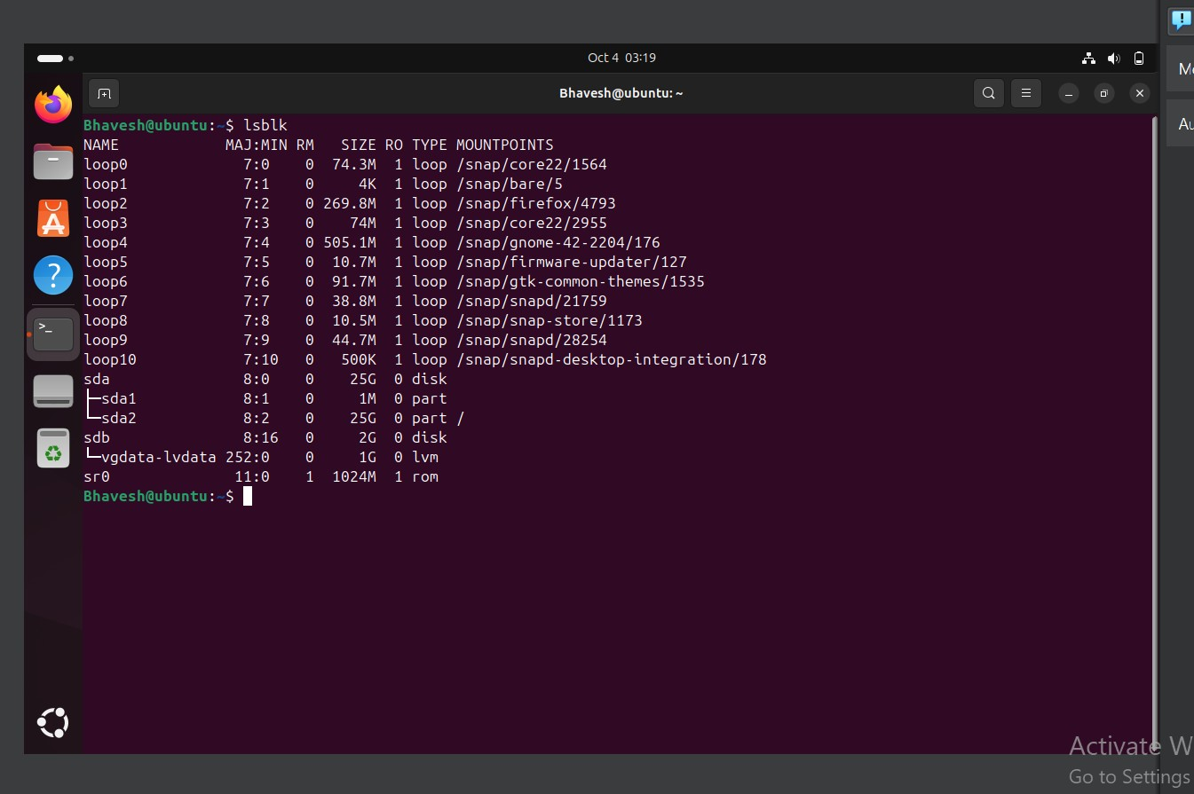

Evidence – systemctl Service Management
systemctl list-units --type=service – listing available service units.
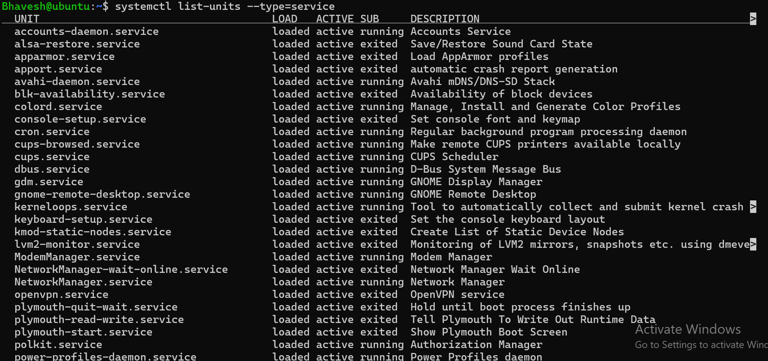
systemctl enable/restart ssh and systemctl --failed – verifying service configuration and that no failed units are present.
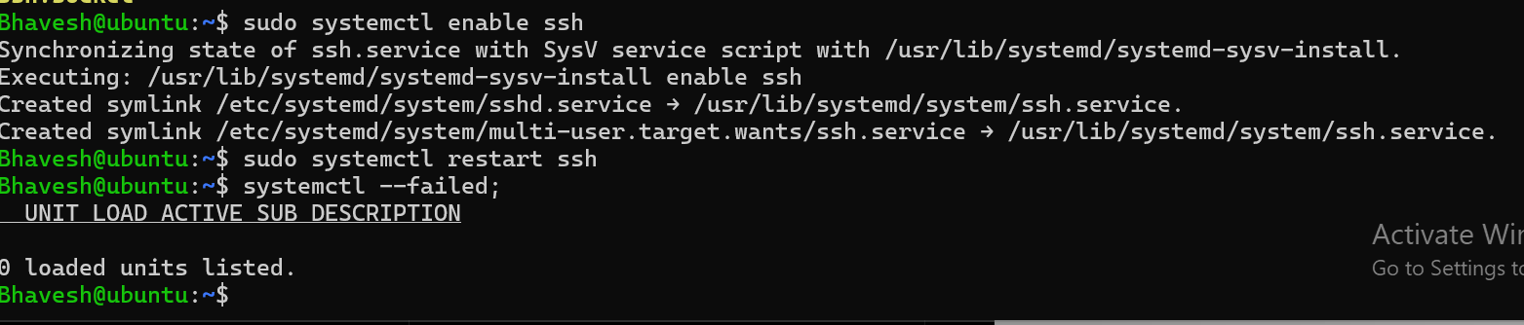
systemctl stop/start/status/disable ssh – demonstrating service control and checking the SSH service status.
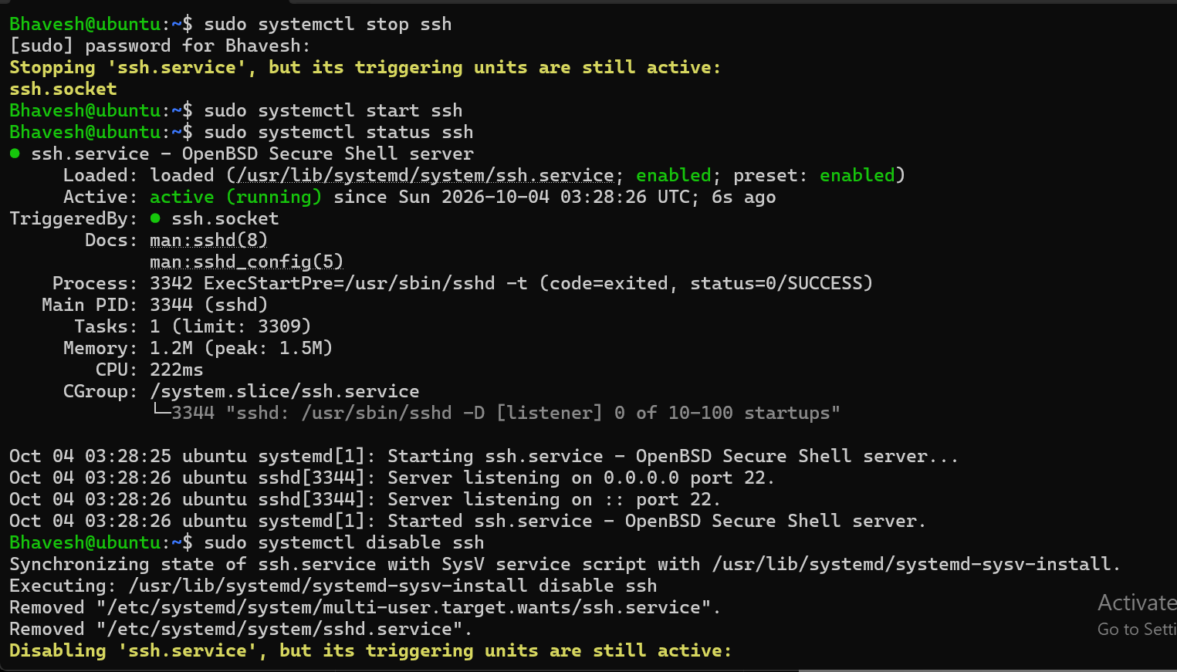

Evidence – Custom Backup Service
systemctl status backup.service – custom My Backup Service and journal output showing successful execution.
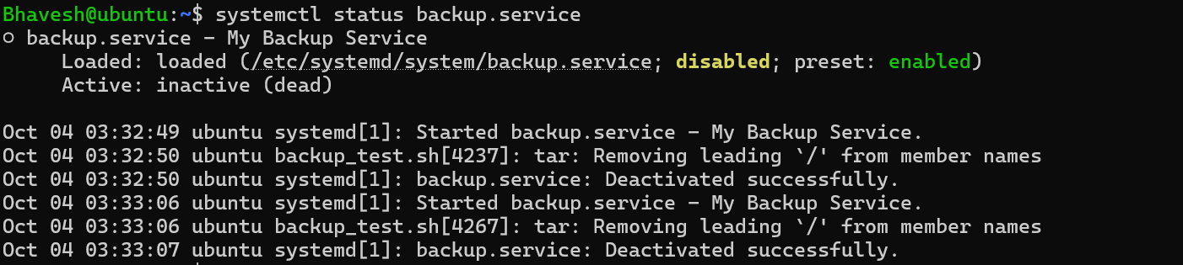

Evidence – SSH Key Authentication
Ubuntu VM ~/.ssh directory showing authorized_keys and the generated Ed25519 key pair.
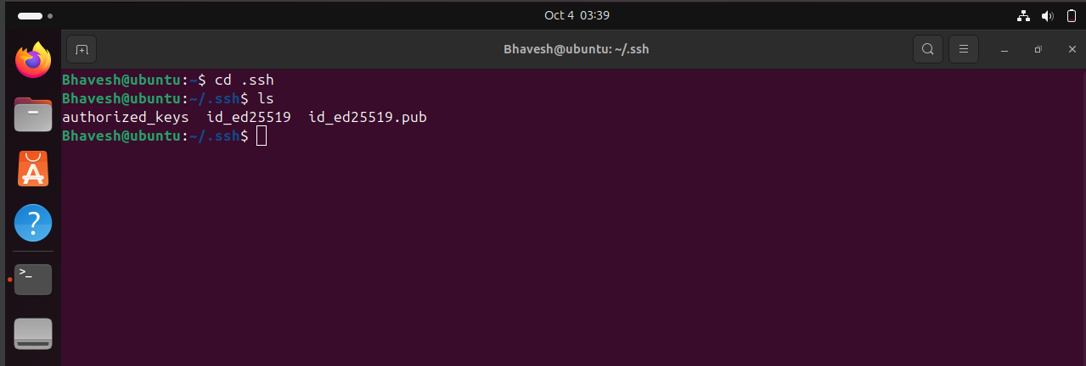
Successful SSH key-based login from Windows to the Ubuntu 24.04 VM using port 2222.
Evidence — Successful SSH key-based login from Windows to Ubuntu VM
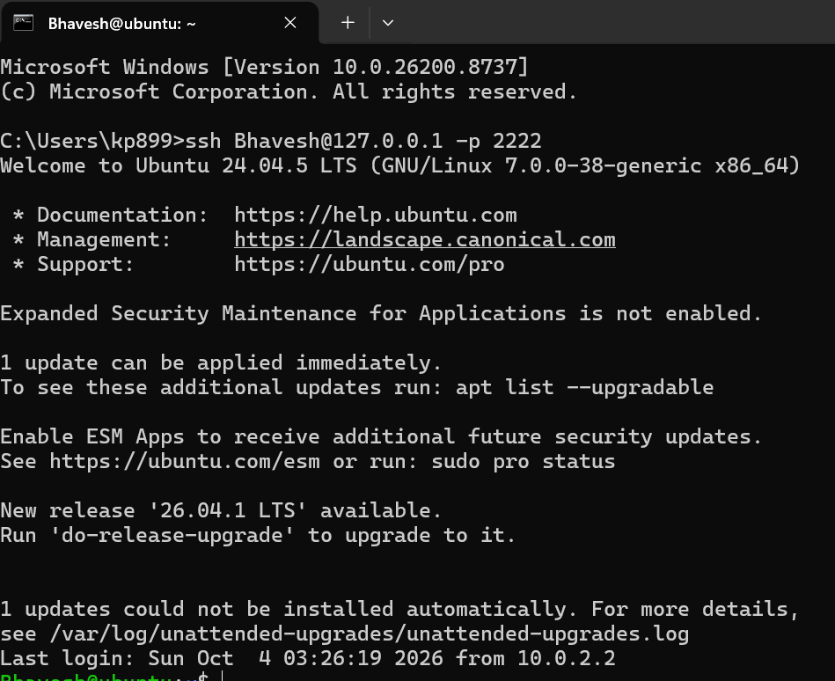

Evidence – Cron Job Configuration
Cron job configured to run the backup test script daily at 22:00. The screenshots show the crontab entry and verification using crontab -l.
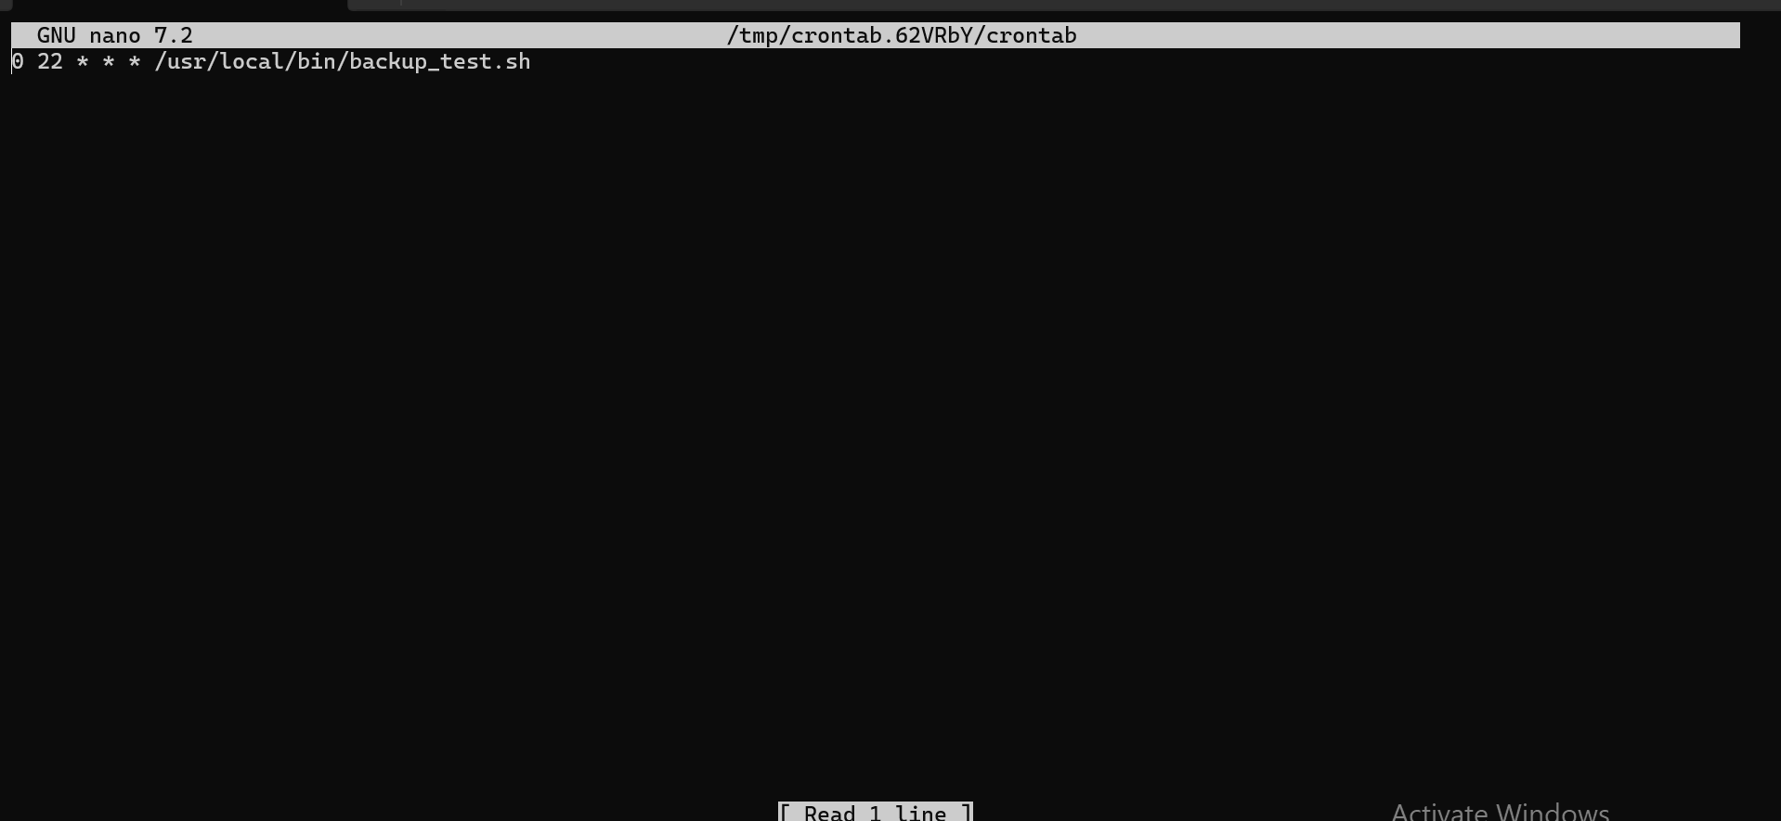
Cron editor showing: 0 22 * * * /usr/local/bin/backup_test.sh
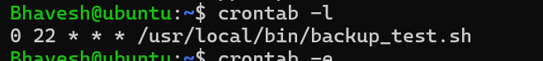
crontab -l confirming the scheduled backup job

Evidence – Unattended Upgrades
The unattended-upgrades service is enabled and currently active (running), confirming that Ubuntu's automatic security/update mechanism is configured.
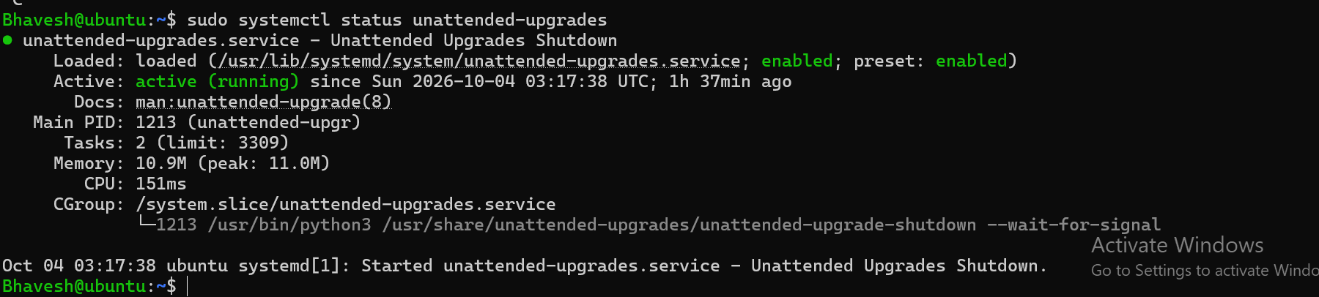
unattended-upgrades.service status showing enabled and active (running).

Evidence – Disk Cleanup SOP
Disk cleanup practice showing disk usage before cleanup, directory size inspection, APT cache cleanup, autoremove of unused packages, journal disk usage, and journal vacuuming.
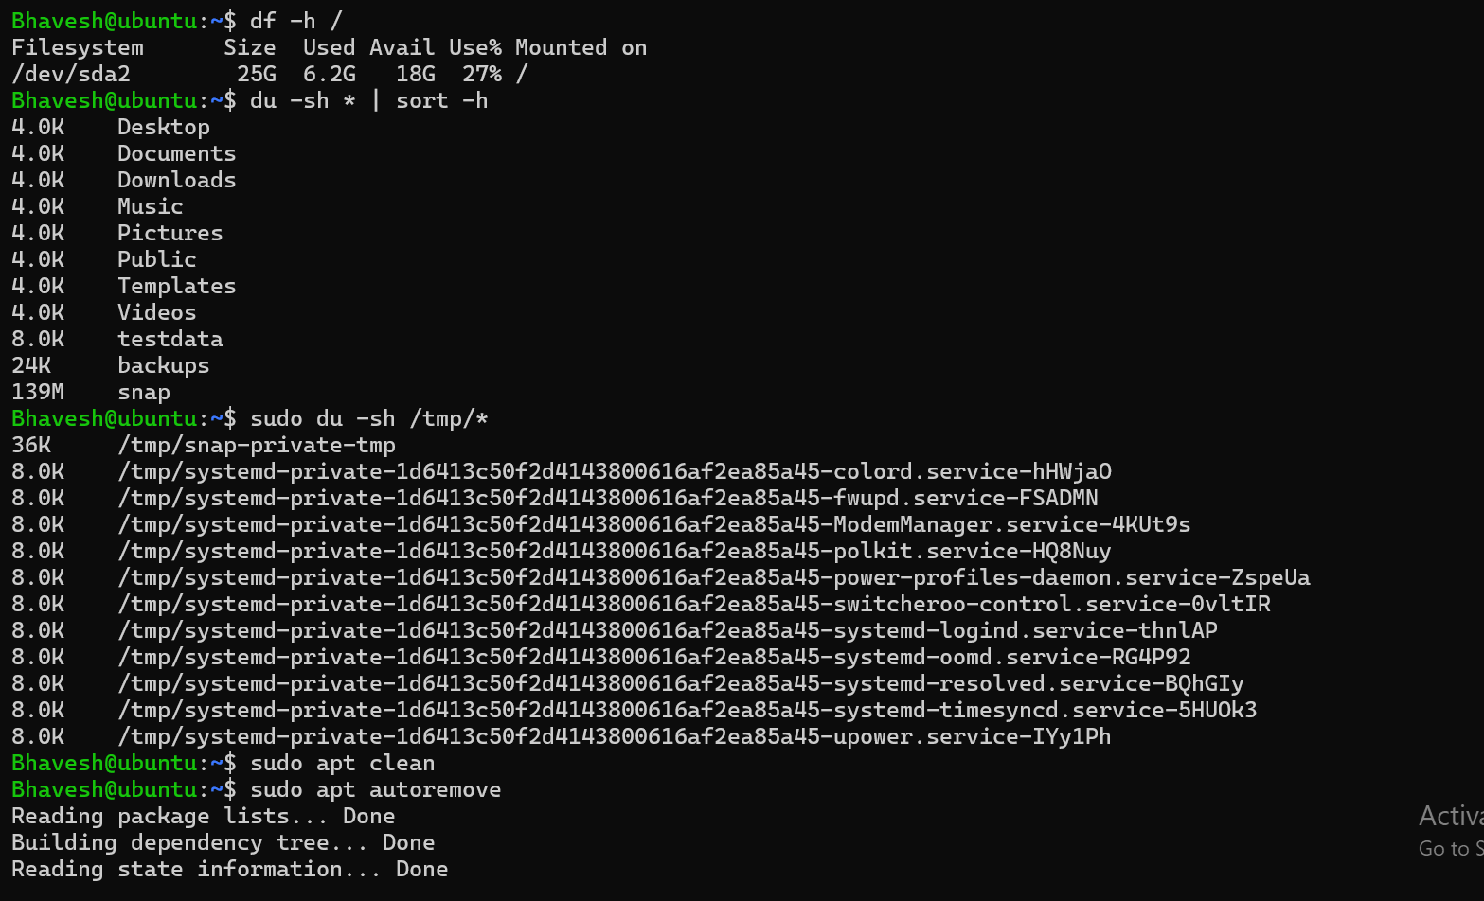
Disk cleanup commands: df -h /, du -sh * | sort -h, /tmp inspection, apt clean, and apt autoremove.
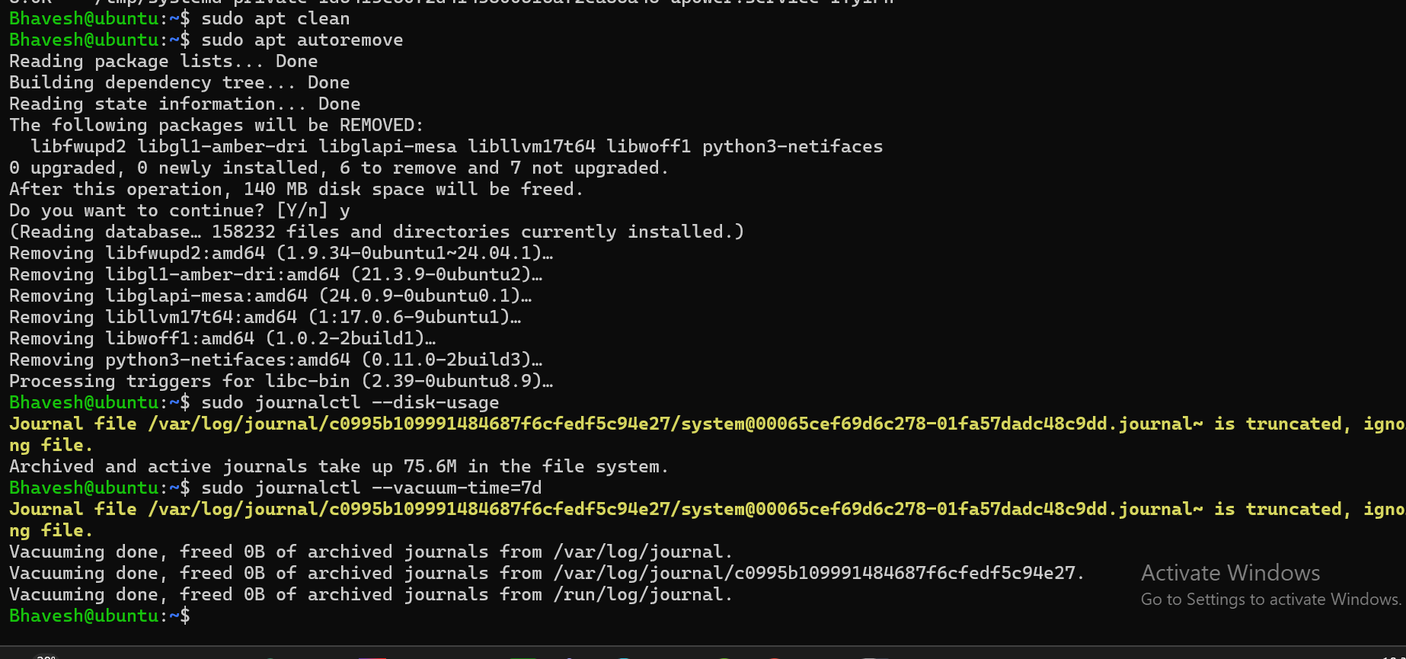
APT autoremove completed; journal disk usage checked and journalctl --vacuum-time=7d executed.

Evidence – LVM Storage Commands
LVM storage inspection showing the physical volume (PVS), volume group (VGS), logical volume (LVS), and block-device layout (lsblk).
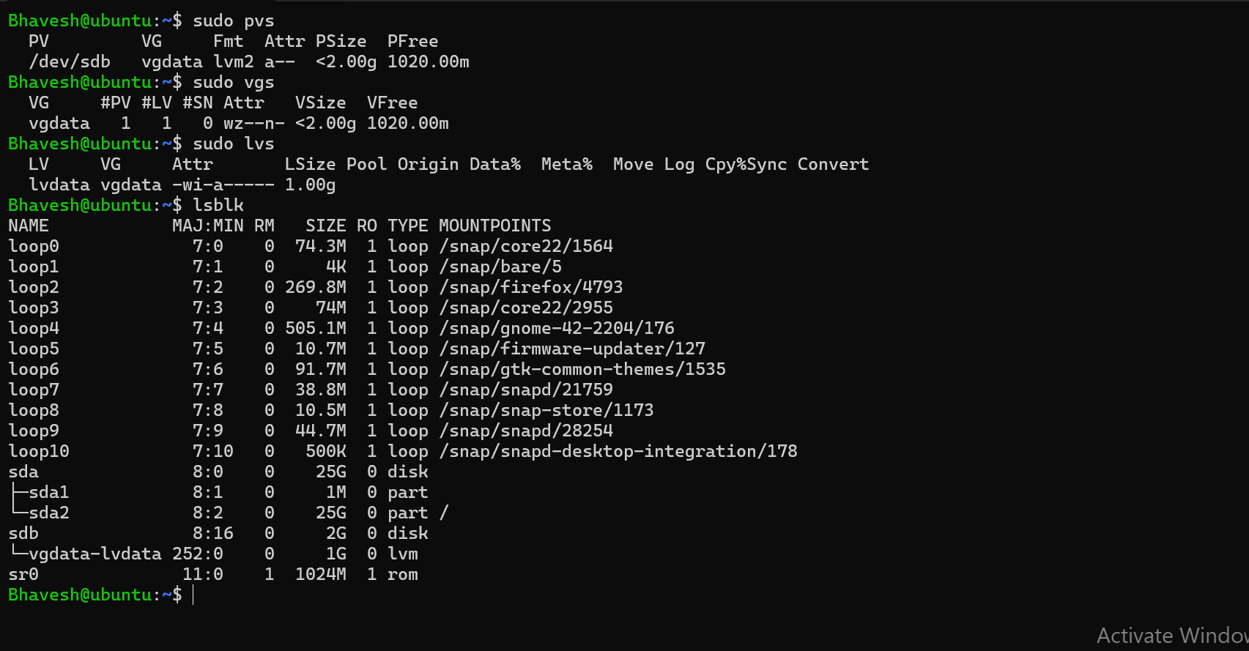
PVS, VGS, LVS and LSBLK output showing /dev/sdb, vgdata and the 1 GB logical volume.

Evidence – 5 GB Disk Added for LVM
lsblk output after adding the 5 GB virtual disk. The new disk is /dev/sdc, which is visible as a 5 GB disk and is ready for the LVM extension procedure.
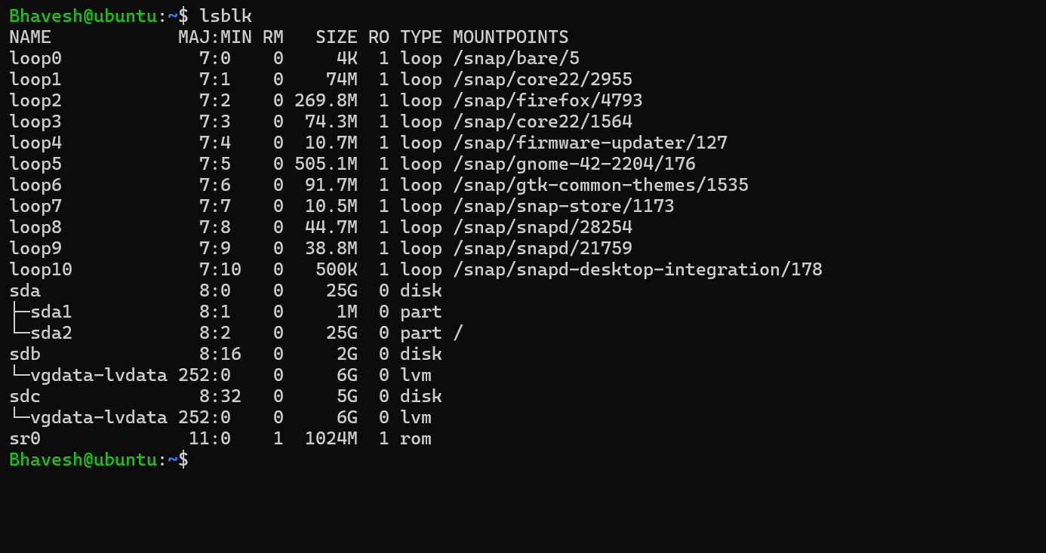
lsblk showing the newly added 5 GB /dev/sdc disk.

Evidence – Bash Disk Check Script
Bash disk-check script executed successfully. The script reports the current date, root filesystem usage, and home-directory disk usage.
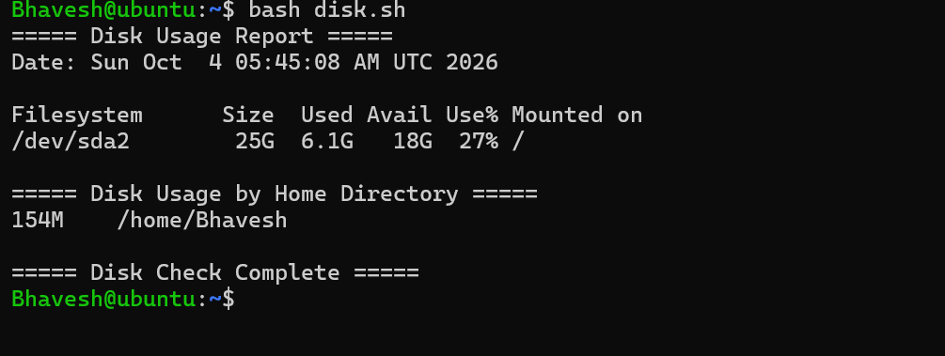
Successful execution of disk.sh showing disk usage and home-directory usage.

Week 1 Final – Bash Scripting Practice & Completion Checklist
Trainee: Bhavesh Rajput
Week: Week 1 – Linux for Servers

1. Bash Practice – `$?`
The `$?` variable shows the exit status of the last command. `0` normally means success; a non-zero value means the command failed.
Practical commands:
echo "Hello"
echo $?
ls /tmp
echo $?

2. Bash Practice – if Statement
The if statement is used to make a decision based on a condition.
#!/bin/bash
usage=$(df / | awk 'NR==2 {print $5}' | tr -d '%')
if [ "$usage" -ge 80 ]; then
echo "WARNING: Disk usage is ${usage}%"
else
echo "Disk usage is normal: ${usage}%"
fi

3. Bash Practice – for Loop
A for loop repeats a command for multiple values.
for file in /etc/*.conf; do echo "$file"; done

4. Bash Practice – Functions
A function groups reusable commands.
#!/bin/bash
show_disk() {
echo "Disk usage:"
df -h /
}
show_disk

5. Bash Practice – set -euo pipefail
This makes scripts safer: `-e` stops on command failure, `-u` detects unset variables, and `pipefail` makes a pipeline fail if a command inside it fails.
Command:
set -euo pipefail

6. Bash Practice – tar
tar is commonly used to create and extract archive files.
mkdir -p ~/backup_demo
echo "Backup test" > ~/backup_demo/test.txt
tar -czf ~/backup_demo.tar.gz -C ~/ backup_demo
tar -tzf ~/backup_demo.tar.gz

7. Bash Practice – find -mtime
find with `-mtime` can locate files based on modification age. The following safely searches the user's home directory for files modified more than 7 days ago.
find ~/ -type f -mtime +7 2>/dev/null

8. ShellCheck
ShellCheck is a static analysis tool that checks Bash scripts for common mistakes and possible improvements.
Install:
sudo apt update && sudo apt install shellcheck -y
Check the disk script:
shellcheck disk_check.sh

9. Final Week 1 Status
Area | Status | Notes
Ubuntu VM & Snapshot | Completed | VM created and clean snapshot taken.
SSH Key Authentication | Completed | Ed25519 key authentication verified.
Password SSH Login | Completed | Password authentication disabled.
systemd | Completed | Service practice completed.
Logs & Monitoring | Completed | auth.log/journalctl checks completed.
Users & sudoers | Completed | frappe sudoers configuration and verification completed.
Cron | Completed | Backup cron job configured.
Package Management | Completed | APT and unattended-upgrades practiced.
Disk Cleanup | Completed | APT and journal cleanup practiced.
Storage Basics | Completed | lsblk, fdisk, mount and fstab practiced.
LVM Practice | Completed | vgdata/lvdata extended using the added disk.
Bash Disk Script | Completed | Disk usage script created and executed.
Bash Topics | Added | Practice section added for $?, if, for, functions, set -euo pipefail, tar and find -mtime.
ShellCheck | To Verify | Run shellcheck on the final script.
Root LV Extension | Not Applicable to Current VM | Root is on /dev/sda2, not an LVM logical volume; do not modify blindly.
Important note: The practice LVM volume group `vgdata` was extended successfully. The VM root filesystem is on a normal partition rather than an LVM logical volume, so the Week 1 root-LV extension procedure cannot be performed on this current layout without changing the storage design.

