CDAC Mumbai DAC Forum & Mentor
Assessment

SOFTWARE REQUIREMENT SPECIFICATION FOR
Community Service Portal [16-06-2019]
CDAC, MUMBAI

Revision History:

Version. | DATE | Authored By | Reviewed By | REASON FOR CHANGE
00 | 30/06/2019 | Team-05 |  | 1st release

CDAC Mumbai DAC Forum & Mentor
Assessment

Table of Contents

- Introduction 1
Purpose 1
Document Conventions 1
Intended Audience and Reading Suggestions 1
Product Scope 2
References 3
- Overall Description 3
Product Perspective 3
Product Functions 3
User Classes and Characteristics 3
Operating Environment 3
Design and Implementation Constraints 3
User Documentation 4
Assumptions and Dependencies 4
- External Interface Requirements 4
User Interfaces 4
Hardware Interfaces 5
Software Interfaces 5
Communications Interfaces 5
- System Features 5
System Feature 1 5
System Feature 2 (and so on) 5
- Other Non-functional Requirements 6
Performance Requirements 6
Safety Requirements 7
Security Requirements 7
Software Quality Attributes 7
Business Rules 7
- Other Requirements 8
CDAC Mumbai DAC Forum & Mentor
Assessment
- Introduction

1.1: Purpose

Community Service Portal is a Web Application which provides an interface through which an public or citizen can Participant in an event organized by an Event Manager(NGO).
The proposed system reduces the effort of a Volunteer to search for places and events on
different websites or Internet where there a help, support or co-operation is needed, by simply login
into this website he/she can find their respective interested work.

1.2 Document Convention
Text: -Bold
Font-Size: - 14

Highlighting: - Times New Roman
Text: -Bold
Font-Size: - 12

Header
Text: - Simple
Font-Size: -10
Highlighting: - Times New Roman

Footer
Text: - Simple
Font-Size: -10
Highlighting: - Times New Roman

Intended Audience and Reading Suggestions:

This document is intended for developers, users, testers and project managers for the purpose
of understanding the design of system in terms of different perspectives.
Further, this document contains functionalities and characteristics of system along with the
working environment. It also includes other information related to system such as external
interface requirements, features and other non - functional requirements.

  - Product Scope

The main aim of our project is to make the community services easily known to people who are
willing to contribute their knowledge or any service with the rural people. The system allows the volunteer to easily login and register his/her name to the event that he/she is interested in. The event will be
organized by some NGO.

Overall Description

Product Perspective

Earlier for doing volunteering services it was quite difficult as the events were not known easily.
Where the events are going to take place were not known properly to people who were interested in doing social service. Through this website we came up with a solution that the events or NGO activities will be easily known to public.
The event updates will be given to the login user once he/she had participated in any of the event, so in near future if he/she wants to participate again then these notifications will be helpful for them to know about the events.

Product Functions

    - The volunteer will be able to see the available events
    - The NGOs will be adding the events
Administration can access both of the logins

Product Function
1.NGO Module
NGO registration
Event Management
2.Volunteer Module
Volunteer Registration
Selection of events
3. Admin Module
Verification of NGOs / Volunteers
Master Tables Management
CDAC Mumbai DAC Forum & Mentor
Assessment

User Classes and Characteristics Admin:
The Administrator will be able to access all the functionalities of the system. This person can approve newly registered NGOs and then only NGOs can create new events.
Admin will also have the authority to verify the volunteer interested in doing the social service. Once the volunteer is verified he/she can see the latest events updates uploaded by NGO’s. Admin can interact with both the NGO and volunteer login.

NGO:
Using this portal NGO can register themselves and create category wise events and can see the interested number of volunteers.

Volunteer:
Using this portal volunteer can register themselves, view the upcoming events and select any one of them as per his/her skills and interest.

Operating Environment

    - Hardware platform:
      - Processor – Above Pentium 4, with clock speed of 2.0 GHz
      - RAM – 1 GB or above
      - Hard Disk – Free disk space of above 1 GB
    - Software platform:
      - Front-end: HTML, CSS, Bootstrap, JSP
      - Back-end: MySQL , Spring
    - Supported tools:
      - Eclipse, MySQL Workbench

Design and Implementation Constraints

Constraints:
- User interface is only in English. No other language option is available
- User can log-in only with his assigned user-name and password
- Limited to HTTP/HTTPS
CDAC Mumbai DAC Forum & Mentor
Assessment

User Documentation

User documentation mainly comprises of Help menu of application. It will give all minute details about the project, if any user has any query about any module or functionality, one can refer it and see how to operate the application. This report is the complete documentation of our project. It gives complete details about the project, its functionality, users, software used, hardware requirement, environment and so on.

Assumptions and Dependencies

- Assumptions
  - There is an active internet connection with the system
  - The system has internet browser installed
  - Users know the English language, as the user interface will be provided in English.

- Dependencies:
There is a need of constant update event in portal after every event is successfully executed.
  - Active participation of volunteer is required.
- Active participation of NGOs enrolling the events is required

External Interface Requirements

User Interfaces

The main element is web-pages using HTML, bootstrap and JSP. Multiple interfaces are there like log-in pages, home pages of Volunteer, NGO, Admin, and also the Forum .Admin can see the events and can review the events and the participation from the volunteers status.
CDAC Mumbai DAC Forum & Mentor
Assessment

Hardware Interfaces

In the hardware interface, the system interacts with hardware given the processor is above P4 with clock speed of 2.0 GHz with 1 GB RAM and the Hard Disk with 1 GB free space in the memory. In future enhancements, it can be made responsive to be able to work with mobile devices as well.

Software Interfaces

In software interfaces, Spring, Hibernate is the back-end technology used along with MySQL Database. The front-end technologies include HTML, CSS, Bootstrap, JSP. Data will be communicated between these interfaces accordingly.

Communications Interfaces

The main communication interface for interacting with the System will be the web Browser.

System Features

Description

Earlier for doing volunteering services it was quite difficult as the events were not known easily.
Where the events are going to take place were not known properly to people who were interested in doing social service. Through this website we came up with a solution that the events or NGO activities will be easily known once User login is done.
The event updates will be given to the login user once he/she had participated in any of the event, so in near future if he/she wants to participate again then these notifications will be helpful for them to know about the events.

Functional Requirements

Registration

NGO

NGO registration would require the name of NGO, email, password, contact details.

Volunteer
Considering volunteer registration he/she needs to enter his basic details such as first name, last name, contact details, email, professional skillsets, passport photo

User Login

NGO:

Input: NGO after registering successfully will be able to login using username and password and can manage the events as per their requirement.

Output: Admin will verify and once done they can proceed with further process.

Volunteer:

Input: Volunteer after registering successfully will be able to login using username and password.

Output: Admin will verify and once done they can proceed with further process.

Select the event
The volunteer will be able to check the category of the event and as per his/her interest he can select the events.

Admin Dashboard

Here the admin will be able to keep the track of the volunteers registered and their validation and the events added and managed by the NGO along with the validation.

Logout
This option will be available for volunteer and NGO and they will be logged out after clicking on logout button.
- Performance Requirements
The system should store all the database records of each Volunteer, NGO and admin properly and the application should be available for use 24*7 through the server. Also, the application should be user friendly with a proper user interface which makes it easy for the user to understand. All the options should be present in properly accessible places for user convenience.

Safety Requirements
All login ids and passwords of the Volunteer, NGO and especially admin staff should be protected for privacy using whatever constraints required in the database or the application. In case any admin access account is hacked by any intruder, user id and passwords of all the
CDAC Mumbai DAC Forum & Mentor
Assessment

admin personnel should be changed and new passwords should be issued to all NGOs. NGO and volunteer records are to be backed up securely across database servers. In case database is hacked by someone and data is deleted a backup server should be present for such purpose.

Security Requirements
All passwords of the administrators should be protected for privacy using whatever constraints required in the database or the application. Transactions regarding NGO and volunteer records should be carried out properly. Only admin will have access rights to the NGO data according to the need for E.g.: -events and volunteer record and username, passwords. The database should be protected from attacks and unauthorized access. The interface should be protected from attacks. All passwords should be stored as a secure hash of the administrator password.

Software Quality Attributes 5.3.1Availability
The system should run on a variety of operating systems that support the JavaScript language. The system should run on a variety of hardware.

Accessibility
The software will be accessible to admin, NGO and volunteer.

Compatibility
The software will be compatible with multiple platforms.

Durability
The software will be tested for working with multiple users.

Effectiveness
The software will be made to handle operations effectively.

Maintainability
The system should be easy to maintain. There should be a clear separation between the interface and the business logic code. There should be a clear separation between the data access objects that map the database and the business logic code.
CDAC Mumbai DAC Forum & Mentor
Assessment

Other Requirements
- Appendix A: Glossary

- SRS: Software Requirement Specification
- GUI: Graphical User Interface
- P4: Pentium 4
- SQL: Structured Query Language
- HTML: Hyper Text Markup Language
- CSS: Cascading Style Sheet
CDAC Mumbai DAC Forum & Mentor
Assessment

Appendix B: Analysis Models

Use Case Diagram

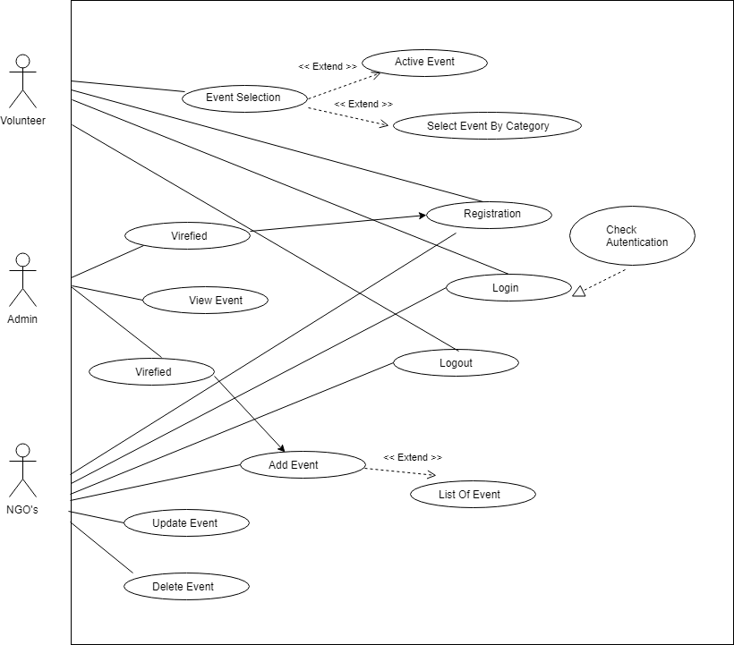
CDAC Mumbai DAC Forum & Mentor
Assessment

Class Diagram
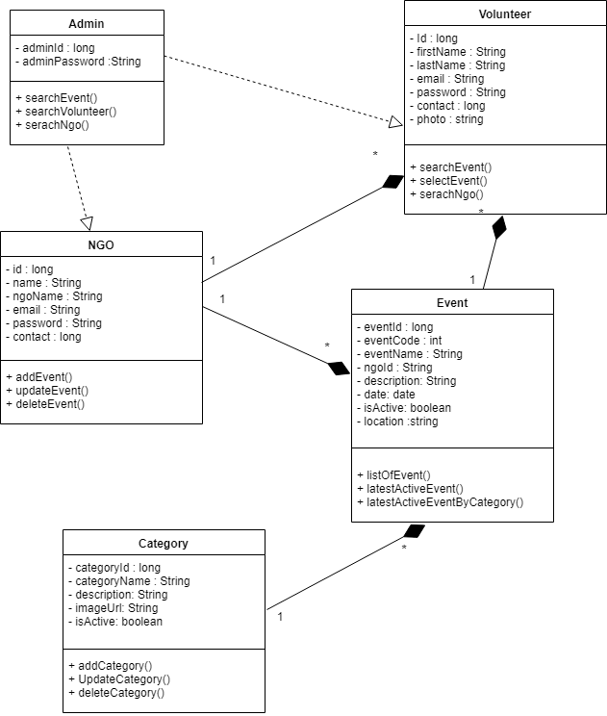

CDAC Mumbai DAC Forum & Mentor
Assessment

Activity Diagram 1:

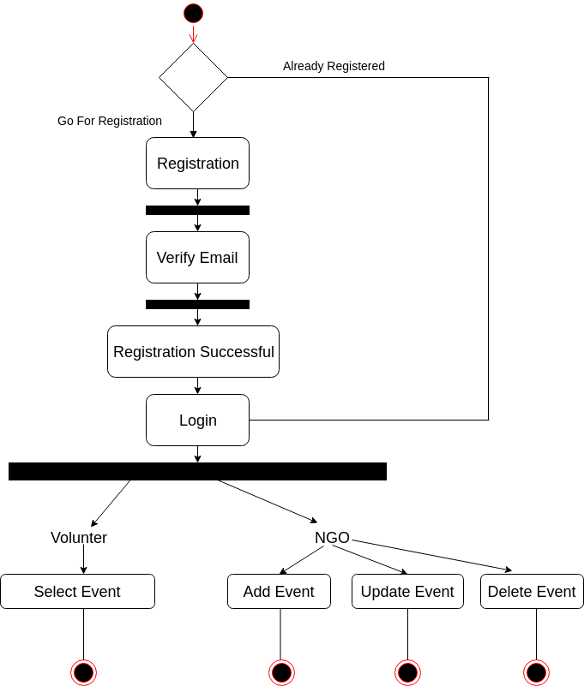

CDAC Mumbai DAC Forum & Mentor
Assessment

Sequence Diagram 1.1:

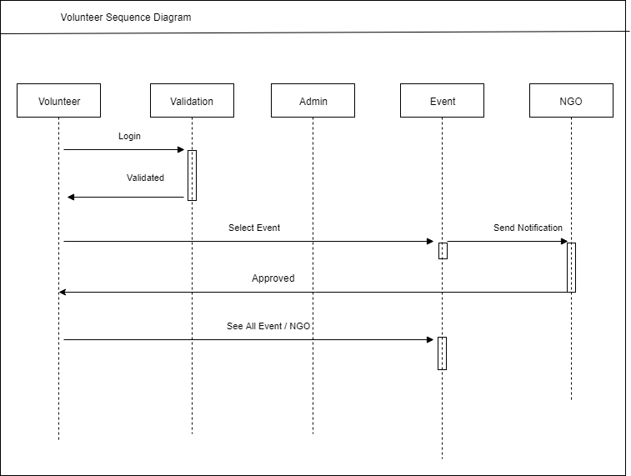

CDAC Mumbai DAC Forum & Mentor
Assessment

Sequence Diagram 1.2:

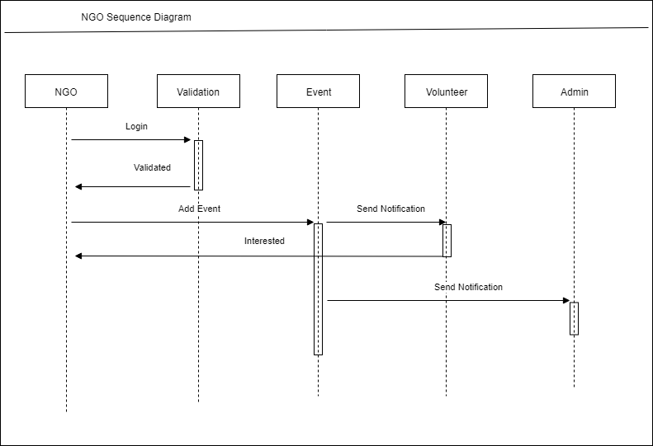
CDAC Mumbai DAC Forum & Mentor
Assessment

Sequence Diagram 1.3:

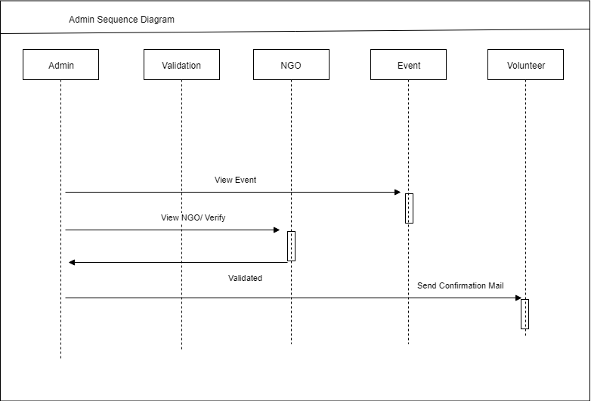
CDAC

