Smart Ambulance Alert and Tracking System: A Layered IoT Architecture for Fail-Safe Emergency Traffic Preemption
Team ResQtech
Team ID: AN006 | Problem Statement ID: SIH26133 | PS Category: Software/Hardware
Smart India Hackathon 2026
Abstract— Road traffic congestion remains one of the most significant, yet under-engineered, obstacles to timely emergency medical care in Indian cities. This report presents ResQtech, a Smart Ambulance Alert and Tracking System that couples onboard IoT hardware with a coordinated traffic-signal preemption network to reduce ambulance transit time while preserving traffic-system safety. The proposed architecture is organized into four functional layers — request and dispatch, encrypted data transmission, priority-based decryption and queuing, and route/signal coordination — supported by two purpose-built hardware units (an Ambulance Unit and a Traffic Signal Unit) that communicate directly over a LoRa radio link independent of cellular or internet connectivity. Message authenticity is enforced end-to-end using AES encryption combined with HMAC signatures, and the traffic-signal interface is designed around a physically isolated, fail-safe relay architecture so that any hardware or software failure defaults to normal, unmodified signal operation rather than an unsafe state. The system further incorporates a tiered offline-resilience scheme for the patient-facing application — falling back automatically from internet connectivity to an SMS gateway, and finally to a Bluetooth Low Energy mesh relay modeled on the open-source BitChat protocol — to maximize reachability in low-connectivity regions. This report details the system's software and hardware architecture, security model, routing algorithm, feasibility analysis, projected impact, and cost structure.
Keywords— Internet of Things, Ambulance Tracking, Traffic Signal Preemption, LoRa, ESP32, AES-HMAC Encryption, Fail-Safe Systems, Bluetooth Mesh, Smart City Infrastructure, Emergency Response

I. INTRODUCTION
India recorded over 1.6 lakh road accident fatalities annually in recent years, a figure that has trended upward from approximately 1.50 lakh deaths in 2016 to 1.68 lakh in 2022, according to the Ministry of Road Transport and Highways [1]. A substantial share of these deaths are considered preventable: established emergency-medicine consensus, echoed by World Health Organization guidance on trauma care, holds that timely intervention within the first hour following a critical injury — commonly termed the “golden hour” — meaningfully improves survival outcomes [2]. In practice, however, ambulances in Indian urban centers face the same congestion as all other road users, with response times frequently exceeding 25–35 minutes in metropolitan traffic, well beyond the golden-hour window.
This work addresses Smart India Hackathon Problem Statement SIH26133, concerning accessibility and quality of public healthcare services, through the specific lens of emergency transport delay. The stated theme — a smart system that tracks ambulances, controls traffic signals, alerts hospitals, and ultimately saves lives — frames two central engineering challenges that this report addresses directly: (i) the system must remain functional in areas with degraded or absent network connectivity, and (ii) any mechanism capable of automatically overriding public traffic infrastructure must be designed so that it cannot be exploited to cause unsafe signal states, while still providing meaningful automation benefit over a purely manual process.
II. EXISTING APPROACHES AND LIMITATIONS
Signal preemption for emergency vehicles is not a new concept; systems such as Opticom and GTT, deployed widely in North America, use optical or radio-frequency emitters to request priority at intersections through a standardized detector interface defined in the NEMA TS-2 traffic controller specification [3]. These systems, however, are typically deployed in environments with consistent power and network infrastructure and are not designed around a no-connectivity failure mode. In the Indian context, green-corridor arrangements are still predominantly manual, coordinated ad hoc by traffic police based on advance notice from hospitals or media coverage of VIP movement — an approach that does not scale to routine emergency traffic and is entirely dependent on human availability at the right place and time. ResQtech is designed to retrofit the same detector-input philosophy used by NEMA TS-2-compliant systems, while adding an offline-first communication layer and an explicit, hardware-enforced fail-safe boundary — both of which are necessary to make automated preemption viable and trustworthy in the Indian operating environment.
III. PROPOSED SYSTEM ARCHITECTURE
A. System Overview
The system is organized into four functional layers, illustrated in Fig. 1. Layer 1 handles emergency request intake and ambulance dispatch matching. Layer 2 governs encrypted transmission of trip data from the ambulance hardware unit to both the hospital and the traffic signal network. Layer 3 performs decryption, authentication, and priority-based queuing at the traffic-signal side. Layer 4 executes the routing algorithm that determines the ambulance's path and the corresponding sequence of signal preemptions along that path. A separate, LoRa-based hardware link connects the Ambulance Unit and Traffic Signal Unit directly, independent of the four software layers, to guarantee operation when no internet or cellular connectivity is available.

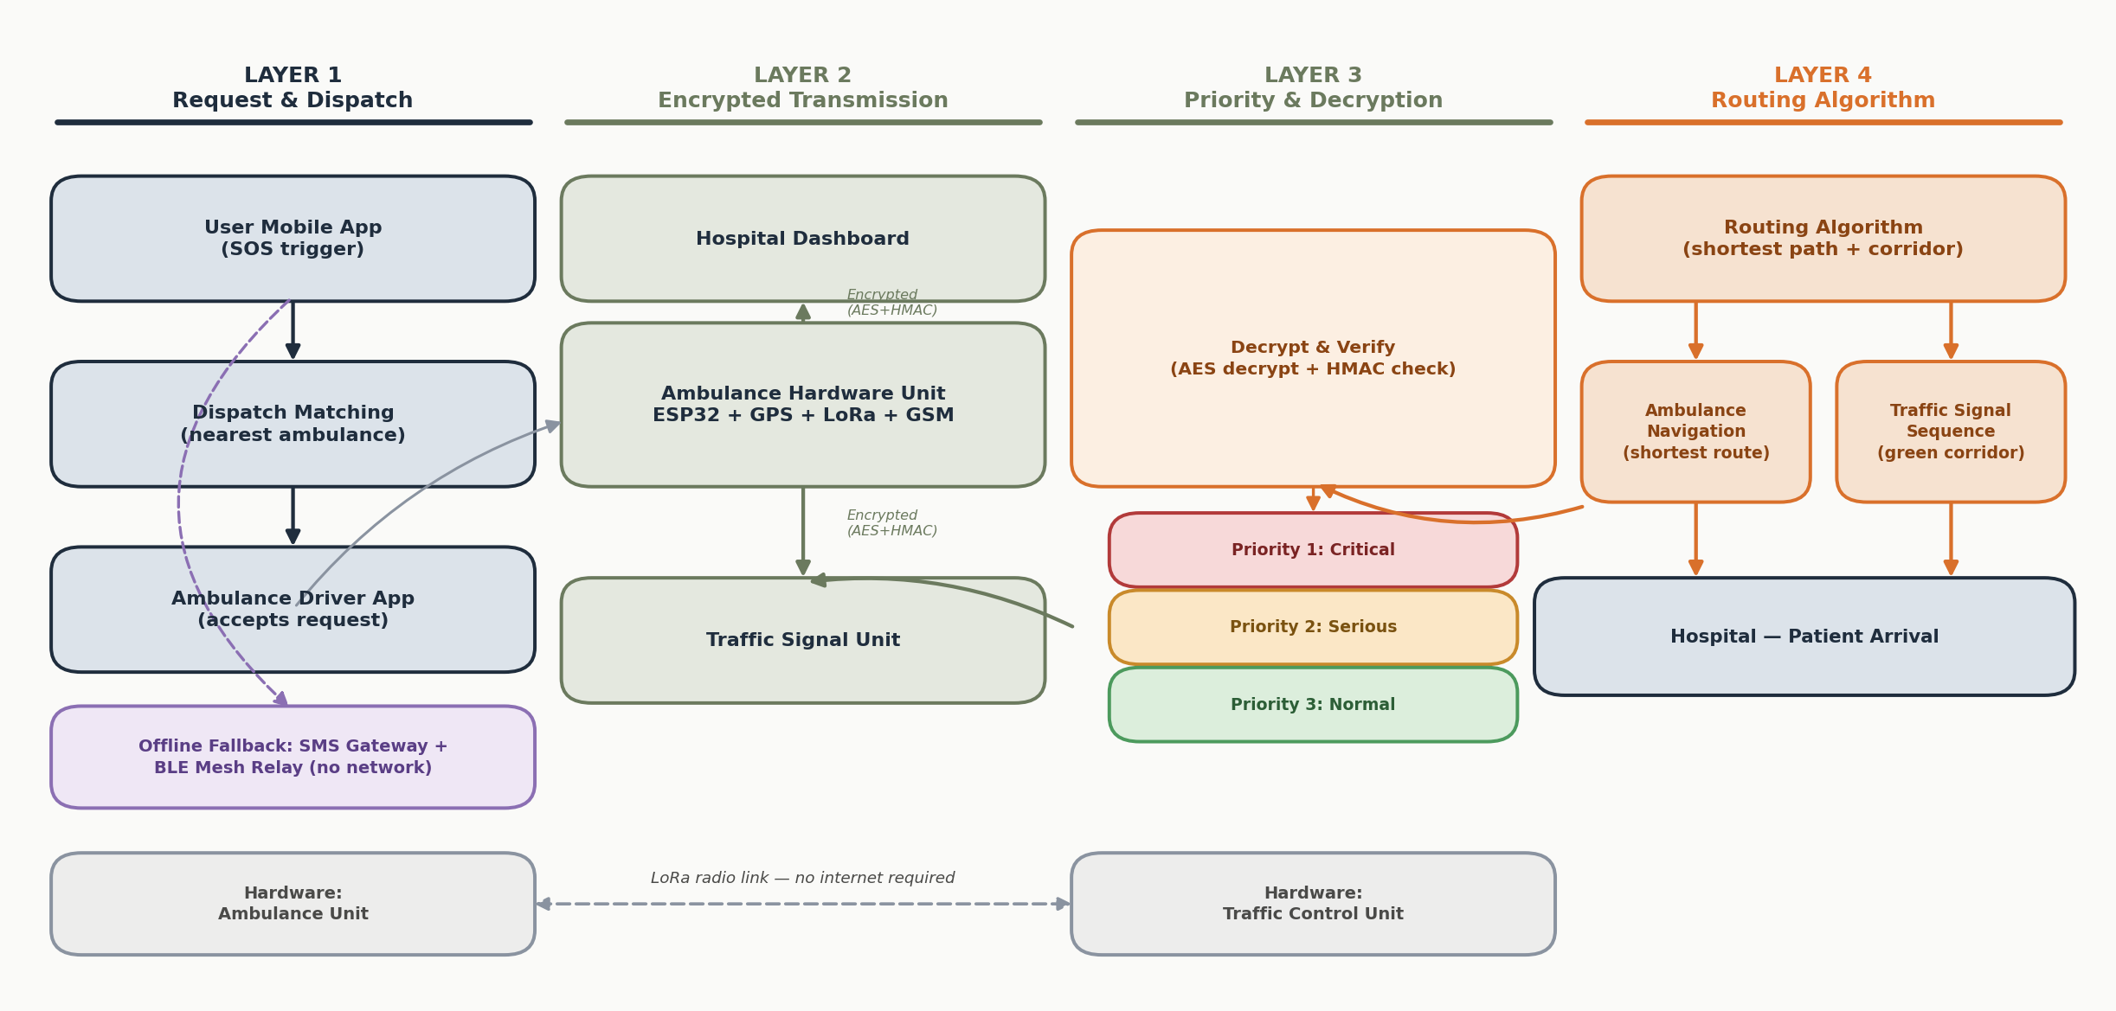
Fig. 1. Four-layer system architecture, from patient-initiated request through encrypted transmission, priority queuing, and green-corridor routing.

B. Layer 1 — Request and Dispatch
A patient or bystander initiates a request through the User role of the ResQtech application. The application immediately captures device GPS coordinates and a coarse emergency-type classification (e.g., cardiac, trauma, respiratory, obstetric, other), which is used downstream to derive an initial priority level. A dispatch-matching process identifies the nearest available ambulance and forwards the request to the Ambulance/Driver role, which may accept within a bounded response window before the request is offered to the next-nearest unit.
C. Layer 2 — Encrypted Data Transmission
Once a trip is accepted, the onboard Ambulance Hardware Unit begins periodic transmission of location, speed, and priority data. Each payload is encrypted using AES with a pre-shared key provisioned to the hardware at deployment time, and separately signed using HMAC computed over the plaintext payload with the same shared key. Both the ciphertext and signature are transmitted together, over cellular data to the Hospital Dashboard and, in parallel, over the direct LoRa link to the Traffic Signal Unit. The two destinations receive payloads scoped to their operational need: the traffic-signal path carries only location, route, and priority-level fields, while the hospital path additionally carries medical-profile information, consistent with a minimum-necessary-data-exposure principle.
D. Layer 3 — Priority Decryption and Queuing
On receipt, the Traffic Signal Unit first recomputes the HMAC over the received ciphertext using its own copy of the shared key and compares it against the transmitted signature. A mismatch causes the message to be discarded prior to decryption, preventing an attacker without knowledge of the key from injecting a valid-looking preemption request. Verified requests are decrypted and inserted into a three-tier priority queue — Critical, Serious, and Normal — so that when multiple ambulances converge on the same corridor, signal preemption is granted in order of medical urgency and estimated time of arrival rather than order of arrival at the signal.
E. Layer 4 — Routing and Traffic Algorithm
A routing process computes the shortest feasible path for the ambulance and, concurrently, determines the sequence and timing of signal preemptions required along that path. Rather than triggering each signal independently, adjacent Traffic Signal Units coordinate through the same LoRa channel to form a bounded-duration “green corridor”: each signal clears only briefly as the ambulance approaches and returns control to its normal cycle immediately afterward, which limits cross-traffic disruption and avoids holding any intersection open indefinitely.
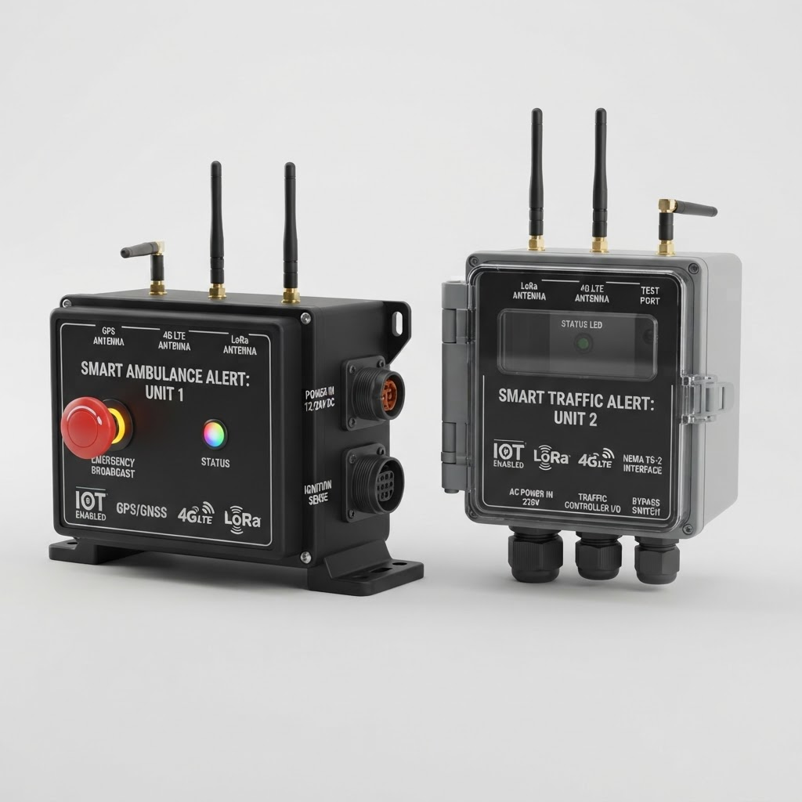
Fig. 2. Rendered hardware prototype — Ambulance Unit (left) with GPS/4G-LTE/LoRa antennas and emergency-broadcast button; Traffic Signal Unit (right) with LoRa/4G-LTE antennas and a NEMA TS-2 controller interface.
IV. HARDWARE DESIGN
A. Ambulance Unit
The Ambulance Unit is built around an ESP32 microcontroller interfaced with a u-blox NEO-M9N multi-constellation GNSS module for positioning, a LoRa transceiver (SX1276-class) for direct signal-network communication, and a 4G/LTE cellular module for cloud connectivity. Power is drawn from the vehicle's 12 V supply through an isolated flyback DC-DC converter with reverse-polarity protection and transient-voltage suppression to withstand automotive load-dump transients, backed by an 18650 Li-ion cell for continued operation if vehicle power is interrupted. A physical emergency-broadcast button, visible in Fig. 2, allows the crew to manually elevate broadcast priority.
B. Traffic Signal Unit
The Traffic Signal Unit receives LoRa broadcasts and interfaces with the existing traffic controller through its NEMA TS-2 detector input port, using an opto-isolated relay rather than a direct logic-level connection. This preserves galvanic isolation between the low-voltage ESP32 logic and the controller's own circuitry, and — critically — allows the unit to be installed as a non-invasive retrofit alongside existing signal infrastructure rather than requiring controller replacement.
C. Fail-Safe Isolation Architecture
Because this unit can influence live traffic infrastructure, its internal architecture deliberately separates safety-critical control from network-facing reporting, illustrated in Fig. 3. A dedicated safety controller performs LoRa reception, HMAC verification, and relay triggering, and has no WiFi or cellular hardware present on its board — it is not reachable over any network. A separate reporting controller handles the WiFi/4G uplink to the central control-room dashboard and is connected to the safety controller through a physically one-directional serial link (UART transmit routed to receive only, with no return conductor). Consequently, even a fully compromised reporting controller has no physical path by which to issue a command to the relay. The relay itself is a normally-de-energized Form-C device, so that loss of power or a firmware fault causes it to fall back to its rest position — normal, unmodified signal operation — rather than an indeterminate or “stuck-open” state. An external hardware watchdog forces a reset (and relay release) if the safety controller's main loop stops responding without a loss of power.
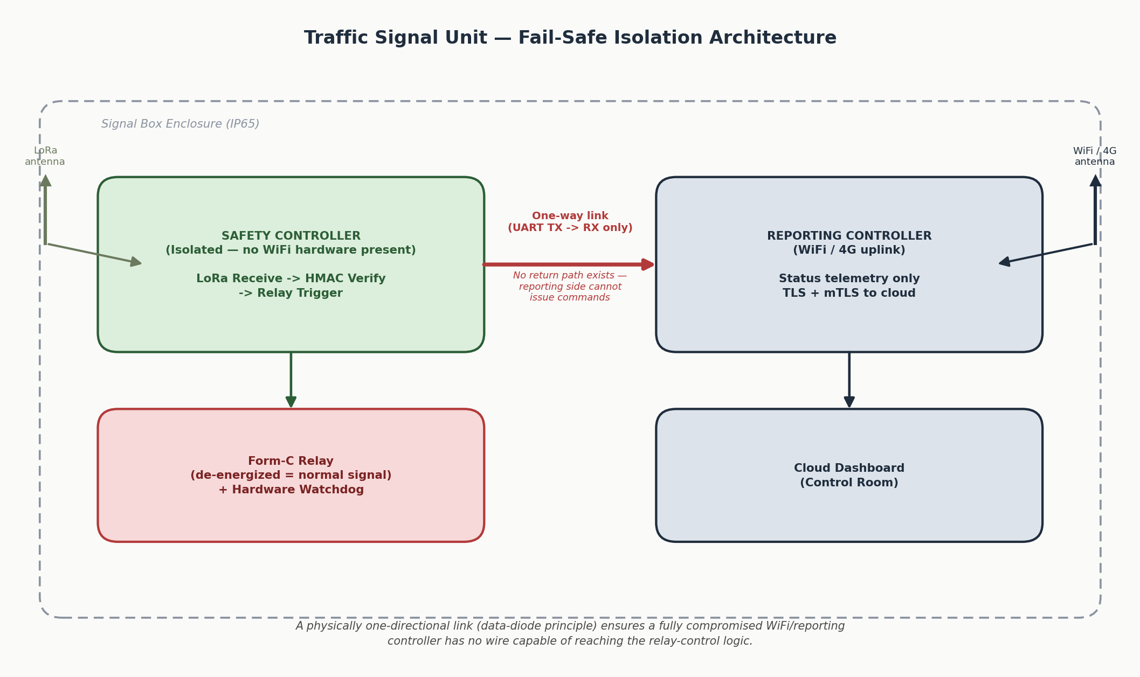
Fig. 3. Dual-controller fail-safe isolation architecture inside the Traffic Signal Unit.
D. Power and Environmental Hardening
The Traffic Signal Unit draws from existing 230 V AC signal-box supply through an isolated, surge-protected AC-DC module rated for outdoor temperature extremes, housed in an IP65-rated, UV-stabilized polycarbonate enclosure suitable for continuous pole-mounted outdoor deployment. Both units use SMA-connectorized antennas to allow field replacement without desoldering, and the LoRa RF path is laid out with physical separation from the cellular antenna and a dedicated ground plane to avoid receiver desensitization.
V. SOFTWARE ARCHITECTURE
The patient, driver, and hospital-facing interfaces are implemented as a single unified application with a role-based mode switcher, rather than three independently maintained codebases, to guarantee that all three perspectives observe a single, consistent source of truth for a given emergency request. All roles read from and write to a shared, real-time-synchronized data store; a request created in the User mode becomes visible to a matching Ambulance-mode client within the same update cycle, and subsequent status or location changes propagate to the Hospital mode without manual refresh. The Ambulance role's hardware-interaction logic is implemented behind a defined service interface so that the physical ESP32/LoRa hardware can be integrated later as a direct substitution for the software simulation used during development, without restructuring the application.
VI. OFFLINE RESILIENCE AND NO-NETWORK OPERATION
Two independent mechanisms provide continued operation in the absence of conventional connectivity, addressing the two distinct points in the system where connectivity may be unavailable.
A. Hardware-Level: Ambulance-to-Signal LoRa Link
As described in Section III, the Ambulance Unit and Traffic Signal Unit communicate directly over LoRa, independent of any cellular or internet infrastructure. This link is the primary channel for signal preemption and is unaffected by the availability of cellular service at either endpoint.
B. Application-Level: Tiered Patient-Request Fallback
The User-facing request path is more exposed to connectivity loss, since it depends on a personal mobile device rather than purpose-built radio hardware. The application therefore escalates automatically through three tiers. Under normal conditions, the request is written directly to the backend over standard internet connectivity. If no acknowledgment is received within a short timeout, the application falls back to an SMS gateway, transmitting a compact payload (emergency-type code, coordinates, and request identifier) over the cellular control channel, which typically remains available at substantially weaker signal strength than data service requires; a backend function parses the inbound SMS and reinserts it into the same request pipeline. If no cellular signal is available at all, the application falls back to a Bluetooth Low Energy mesh broadcast modeled on the protocol design of the open-source BitChat project [4], relaying the request peer-to-peer to any nearby device running the application until it reaches a node with connectivity, with store-and-forward behavior so that a message encountering no immediate peer is retained and retransmitted opportunistically rather than discarded.
VII. SECURITY ARCHITECTURE
A. Message Authentication
As described in Section III-C, every preemption-relevant message is both AES-encrypted and HMAC-signed using a pre-shared key. This combination addresses two distinct threats: encryption prevents an eavesdropper from reading intercepted location or medical data, while the HMAC signature prevents an attacker from forging a plausible-looking preemption request, since doing so requires possession of the shared key rather than merely the ability to transmit on the correct radio frequency.
B. Physical Isolation of Safety-Critical Control
Section IV-C's dual-controller design is treated as the primary security boundary for the traffic-signal interface, on the basis that a purely software-level separation on a single microcontroller cannot be assumed to hold against a genuine remote-code-execution exploit in the network stack. The one-directional hardware link between the reporting and safety controllers — a data-diode arrangement — ensures this boundary holds regardless of the sophistication of an attack mounted against the network-facing side.
C. Network-Layer Hardening
The reporting controller's WiFi/cellular path is independently hardened as a defense-in-depth measure, despite carrying no command authority: WPA3 with network segmentation isolates it from unrelated infrastructure; mutual TLS ensures the device and cloud endpoint each authenticate the other before exchanging data; ESP32 secure boot and signed over-the-air updates prevent unauthorized firmware from running; and default credentials and unused network services are disabled to reduce the exposed attack surface.
VIII. ROUTING AND PRIORITY ALGORITHM
Algorithm 1 summarizes the priority-queuing and corridor-formation logic executed collectively by Traffic Signal Units along an ambulance's route.
Algorithm 1: Priority Queue and Green-Corridor Formation
1: for each incoming verified request r do
2: priority(r) <- classify(r.emergencyType)
3: insert r into queue[priority(r)] ordered by ETA
4: end for
5: while queue is not empty do
6: r <- highest-priority, lowest-ETA request
7: compute shortest path P for r via routing graph
8: for each signal s in P, in travel order do
9: schedule short preemption window at s
10: timed to r's projected arrival at s
11: end for
12: mark r as in-service; remove from queue
13: end while

This scheme ensures that when multiple ambulances converge on a shared corridor — for example, a high-traffic arterial road — preemption is granted by medical urgency and arrival order rather than by which request happened to reach a given signal first, while each individual preemption window remains short and bounded to limit disruption to cross traffic.

IX. FEASIBILITY AND VIABILITY
Dimension | Assessment
Feasibility | Built on mature, low-cost, commercially available components (ESP32, u-blox GNSS, SX1276 LoRa); interfaces with existing signal infrastructure via the standard NEMA TS-2 detector port rather than requiring controller replacement.
Viability | Reduces projected ambulance transit time and the corresponding fraction of trips falling outside the golden-hour window; operates continuously without requiring manual signal operation; extensible to fire and disaster-response vehicles as a shared smart-city preemption layer.

X. PROJECTED IMPACT
The following figures are projections derived from established golden-hour and green-corridor research; they represent expected outcomes pending field-pilot validation rather than measured results from a live deployment.
Metric | Current | Projected
Ambulance response time | 25–35 min | 12–15 min
Golden-hour compliance | ~50% | ~80%+
Per-signal delay | 2–3 min | <30 sec

XI. COST ANALYSIS
Item | Prototype | Per-Unit (Scale)
Ambulance Unit | ₹3,500–4,000 | ₹3,500–5,000
Signal Box Unit | ₹3,000–3,500 | ₹3,000–4,500
Cloud/backend (monthly) | ≈₹0 (free tier) | ₹5,000–10,000

XII. CONCLUSION AND FUTURE SCOPE
This report has presented ResQtech, a four-layer IoT architecture for ambulance tracking and automated traffic-signal preemption, built around two central design commitments: continued operation without network connectivity, and a hardware-enforced fail-safe boundary that prevents automated signal control from degrading into an unsafe state. The system is deliberately scoped around components and interfaces already proven in adjacent domains — NEMA TS-2 detector inputs, LoRa long-range radio, AES/HMAC message authentication, and data-diode isolation patterns from critical-infrastructure security — rather than novel, unproven mechanisms, in the interest of realistic near-term deployability. Planned future work includes a supervised pilot deployment across a small number of intersections in partnership with a municipal traffic authority, empirical validation of the projected impact figures in Section X, native ESP32/Swift/Kotlin implementation of the BitChat-derived mesh relay, and extension of the signal-preemption layer to fire and disaster-response vehicles as shared smart-city infrastructure.

REFERENCES
[1] Ministry of Road Transport and Highways, Government of India, “Road Accidents in India,” annual report series.
[2] World Health Organization, guidance on emergency trauma care and the “golden hour” principle in prehospital emergency response.
[3] National Electrical Manufacturers Association, NEMA Standard TS 2, “Traffic Controller Assemblies with NTCIP Requirements.”
[4] permissionlesstech, “bitchat: decentralized peer-to-peer messaging over Bluetooth mesh,” GitHub repository, https://github.com/permissionlesstech/bitchat.
[5] Espressif Systems, ESP32 Series technical documentation and datasheet.
[6] Semtech Corporation, SX1276/77/78/79 LoRa transceiver datasheet.
[7] u-blox, NEO-M9N GNSS module data sheet.
[8] Smart India Hackathon 2026, Problem Statement SIH26133 — “Accessibility and quality of public healthcare services, particularly in rural and underserved areas.”

