Table 1: Summary of Iteration count, displacement and Residual values at each iteration

|  |  |  |
| --- | --- | --- |
| **Table of Iterations** | | |
| **Iteration count** | **dstep i (cm)** | **||Rstepi||(N)** |
| 0 | 6.67x10-3 | 20000 |
| 1 | 1.333x10-2 | 6600 |
| 2 | 1.553x10-2 | 4356 |
| 3 | 1.6985x10-2 | 2874.96 |
| 4 | 1.7944x10-2 | 1897.13 |
| 5 | 1.857637x10-2 | 1252.1026 |
| 6 | 1.89937x10-2 | 826.426 |
| 7 | 1.9269x10-2 | 545.62 |

**Solution 3:**

**Modified Newton Raphson Method:**

**Step#1:**

Number of Iterations required for a converged displacement value=**1**

Displacement and Residual after each iteration:

|  |  |  |
| --- | --- | --- |
| **Iteration** | **Displacement (cm)** | **Residual (N)** |
| 1 | 0.006667 | 0 |

**Step #2**

Table of Displacement and Residual values at each iteration count.

|  |  |  |
| --- | --- | --- |
| **Iteration #** | **di(cm)** | **Residual (N)** |
| 1 | 0.013333333 | 6600 |
| 2 | 0.015533333 | 4356 |
| 3 | 0.016985333 | 2874.96 |
| 4 | 0.017943653 | 1897.474 |
| 5 | 0.018576145 | 1252.333 |
| 6 | 0.018993589 | 826.5395 |
| 7 | 0.019269102 | 545.5161 |
| 8 | 0.019450941 | 360.0406 |
| 9 | 0.019570954 | 237.6268 |
| 10 | 0.019650163 | 156.8337 |
| 11 | 0.019702441 | 103.5102 |
| 12 | 0.019736944 | 68.31675 |
| 13 | 0.019759717 | 45.08906 |
| 14 | 0.019774746 | 29.75878 |
| 15 | 0.019784666 | 19.64079 |
| 16 | 0.019791213 | 12.96292 |
| 17 | 0.019795534 | 8.55553 |
| 18 | 0.019798386 | 5.64665 |
| 19 | 0.019800268 | 3.726789 |
| 20 | 0.01980151 | 2.459681 |
| 21 | 0.01980233 | 1.623389 |
| 22 | 0.019802871 | 1.071437 |
| 23 | 0.019803228 | 0.707148 |
| 24 | 0.019803464 | 0.466718 |
| 25 | 0.01980362 | 0.308034 |
| 26 | 0.019803722 | 0.203302 |
| 27 | 0.01980379 | 0.13418 |
| 28 | 0.019803835 | 0.088558 |
| 29 | 0.019803864 | 0.058449 |
| 30 | 0.019803884 | 0.038576 |
| 31 | 0.019803897 | 0.02546 |
| 32 | 0.019803905 | 0.016804 |
| 33 | 0.019803911 | 0.01109 |
| 34 | 0.019803914 | 0.00732 |
| 35 | 0.019803917 | 0.004831 |
| 36 | 0.019803918 | 0.003188 |
| 37 | 0.01980392 | 0.002104 |
| 38 | 0.01980392 | 0.001389 |
| 39 | 0.019803921 | 0.000917 |
| 40 | 0.019803921 | 0.000605 |
| 41 | 0.019803921 | 0.000399 |
| 42 | 0.019803921 | 0.000264 |
| 43 | 0.019803921 | 0.000174 |
| 44 | 0.019803921 | 0.000115 |
| 45 | 0.019803921 | 7.58E-05 |
| 46 | 0.019803922 | 5.00E-05 |
| 47 | 0.019803922 | 3.30E-05 |
| 48 | 0.019803922 | 2.18E-05 |
| 49 | 0.019803922 | 1.44E-05 |
| 50 | 0.019803922 | 9.49E-06 |
| 51 | 0.019803922 | 6.26E-06 |
| 52 | 0.019803922 | 4.13E-06 |
| 53 | 0.019803922 | 2.73E-06 |
| 54 | 0.019803922 | 1.80E-06 |
| 55 | 0.019803922 | 1.19E-06 |
| 56 | 0.019803922 | 7.84E-07 |
| 57 | 0.019803922 | 5.18E-07 |
| 58 | 0.019803922 | 3.42E-07 |
| 59 | 0.019803922 | 2.25E-07 |
| 60 | 0.019803922 | 1.49E-07 |
| 61 | 0.019803922 | 9.82E-08 |
| 62 | 0.019803922 | 6.48E-08 |
| 63 | 0.019803922 | 4.28E-08 |
| 64 | 0.019803922 | 2.82E-08 |
| 65 | 0.019803922 | 1.86E-08 |
| 66 | 0.019803922 | 1.23E-08 |
| 67 | 0.019803922 | 8.12E-09 |
| 68 | 0.019803922 | 5.36E-09 |

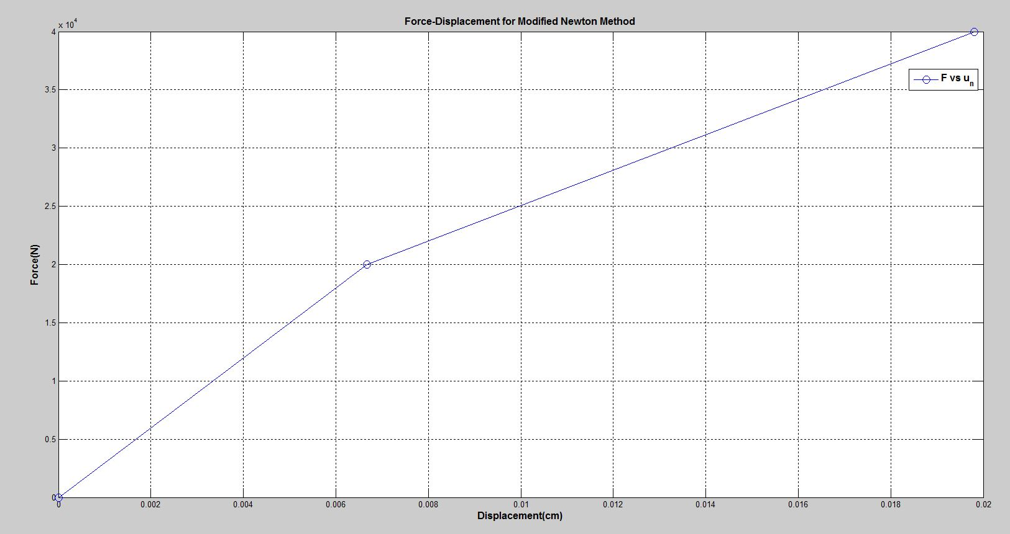

**Newton-Raphson Method**

**Step#1:**

Number of Iterations required for a converged displacement value=**1**

Displacement and Residual after each iteration:

|  |  |  |
| --- | --- | --- |
| **Iteration** | **Displacement (cm)** | **Residual (N)** |
| 1 | 0.006667 | 0 |

**Step #2**

Table of Displacement and Residual values at each iteration count.

|  |  |  |
| --- | --- | --- |
| **Iteration** | **Displacement (cm)** | **Residual (N)** |
| 1 | 0.013333 | 6600 |
| 2 | 0.019804 | 0 |

