BUIDCO
Project Monitoring Dashboard
Application Testing & Audit Documentation
Report generated: 28/9/2026, 5:28:39 pm
Testing performed: 28/9/2026, 5:27:35 pm — 28/9/2026, 5:28:38 pm
Environment: local BUIDCO stack (Vite dev server + Node/Express API + local PostgreSQL). No deployed or production environment was used at any point.
Tester account: demo_md (role: MD) — a seeded demonstration account.
Summary of test scenarios
Test Case ID | Test Scenario | Screenshots | Status
TC-01 | Create New Projects Through Input Sheet | 12 | Pass
TC-02 | CRUD Testing for Existing Projects | 10 | Pass
TC-04 | Import Projects Through Excel Sheet | 8 | Pass
TC-05 | Testing Data Cleanup and Post-Test Verification | 3 | Pass
Each scenario below is documented in the Standard Documentation Format: the fifteen numbered fields, in order, from Test Case ID through to Cleanup Confirmation.
Data protection statement
- All testing was performed against a local development database. No production data was read, modified or deleted.
- Every record created for testing was named with the "ZZ-AUDIT" prefix so test data is distinguishable from genuine project data at a glance.
- No pre-existing project was edited or deleted. The Create, Update, Delete and expiry scenarios operated only on records created by the test run itself.
- Each deletion was targeted by record id from a registry written at creation time, and re-checked the test-data tag immediately before deleting — so no genuine record could be removed by a name-pattern sweep.
- After testing, every temporary record was removed and the dashboard KPI values were confirmed to match their pre-test baseline exactly (see TC-05).

TC-01 — Create New Projects Through Input Sheet
Test status: Pass
1. Test Case ID
TC-01
2. Test Scenario
Create New Projects Through Input Sheet
3. Objective
Verify that new projects can be created through the Input Sheet and that the Projects section and the dashboard KPIs / status counts update correctly.
4. Pre-Conditions
- Local BUIDCO stack running (Vite dev server + API + local Postgres).
- Signed in as demo_md (role MD) — a seeded demo account, not a real user.
- No project named with the ZZ-AUDIT test prefix exists before the run (verified in step 2).
5. Test Data
- ZZ-AUDIT-S1-01 Test Water Supply Scheme — City: Testpur, Contract Type: Work Contract, Execution Status: Not Started, Contractor: Test Contractor Alpha (dummy)
- ZZ-AUDIT-S1-02 Test Drainage Network — City: Testpur, Contract Type: Work Contract, Execution Status: In Progress, Contractor: Test Contractor Beta (dummy)
- ZZ-AUDIT-S1-03 Test Sewerage Package — City: Testpur, Contract Type: Service Contract, Execution Status: Completed, Contractor: Test Contractor Gamma (dummy)
6. Steps Performed
1. Signed in as demo_md (MD) on the local application.
2. Opened the Overview dashboard and recorded every KPI tile value before any change.
3. Opened Projects and searched for "ZZ-AUDIT" to confirm no test data existed beforehand (0 rows).
4. Created test project 1 of 3 through the Input Sheet form: "ZZ-AUDIT-S1-01 Test Water Supply Scheme".
5. Created test project 2 of 3 through the Input Sheet form: "ZZ-AUDIT-S1-02 Test Drainage Network".
6. Created test project 3 of 3 through the Input Sheet form: "ZZ-AUDIT-S1-03 Test Sewerage Package".
7. Re-opened the Projects section and confirmed all three test projects are listed.
8. Returned to the Overview dashboard and re-read every KPI tile value.
7. Before Testing — Screenshots
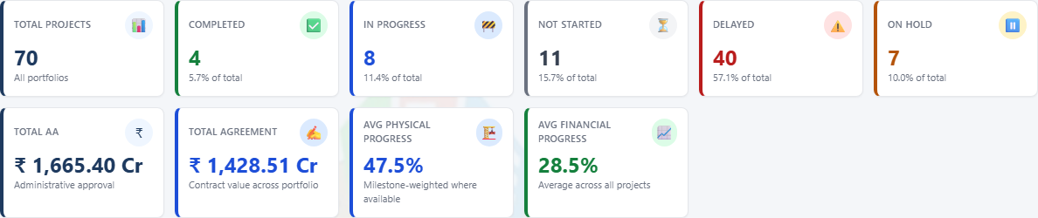
Figure 1 · [Before] Overview dashboard KPI tiles before creating any test project. (captured 28/9/2026, 5:27:38 pm)
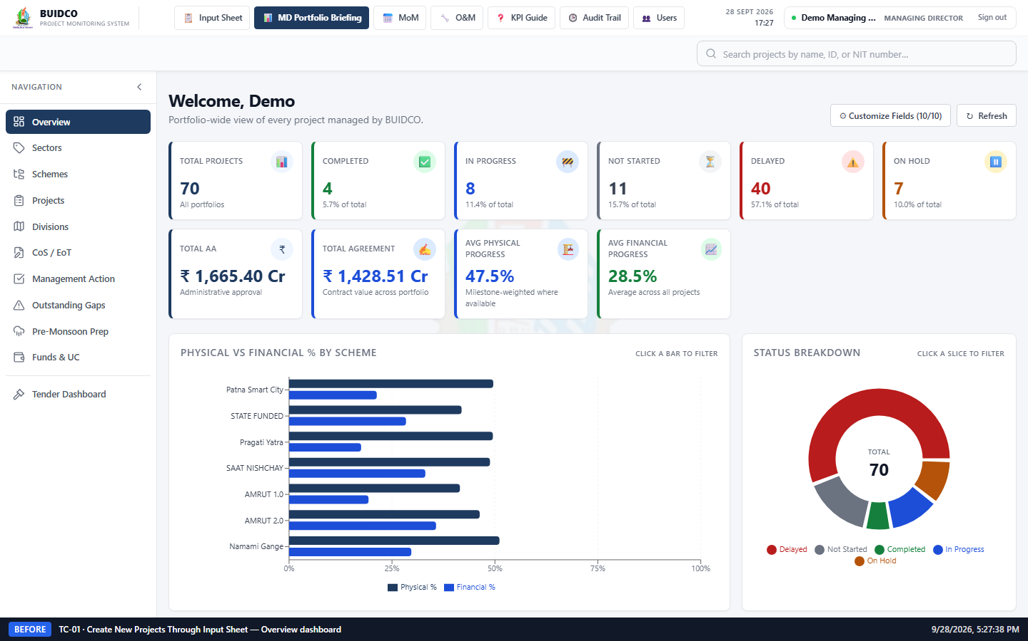
Figure 2 · [Before] Full Overview dashboard before the test projects were created. (captured 28/9/2026, 5:27:38 pm)
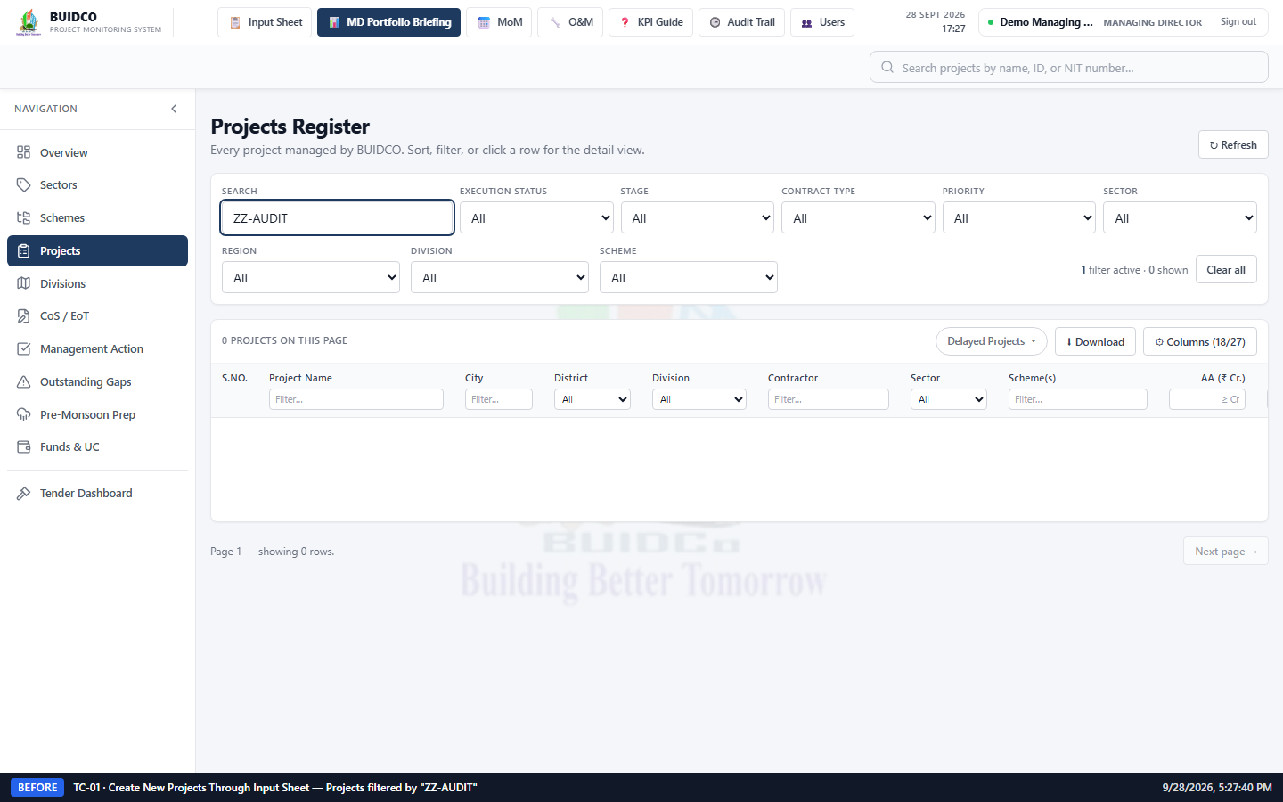
Figure 3 · [Before] Projects section filtered by "ZZ-AUDIT" before creation — no test records exist. (captured 28/9/2026, 5:27:41 pm)
8. Action / Change Performed
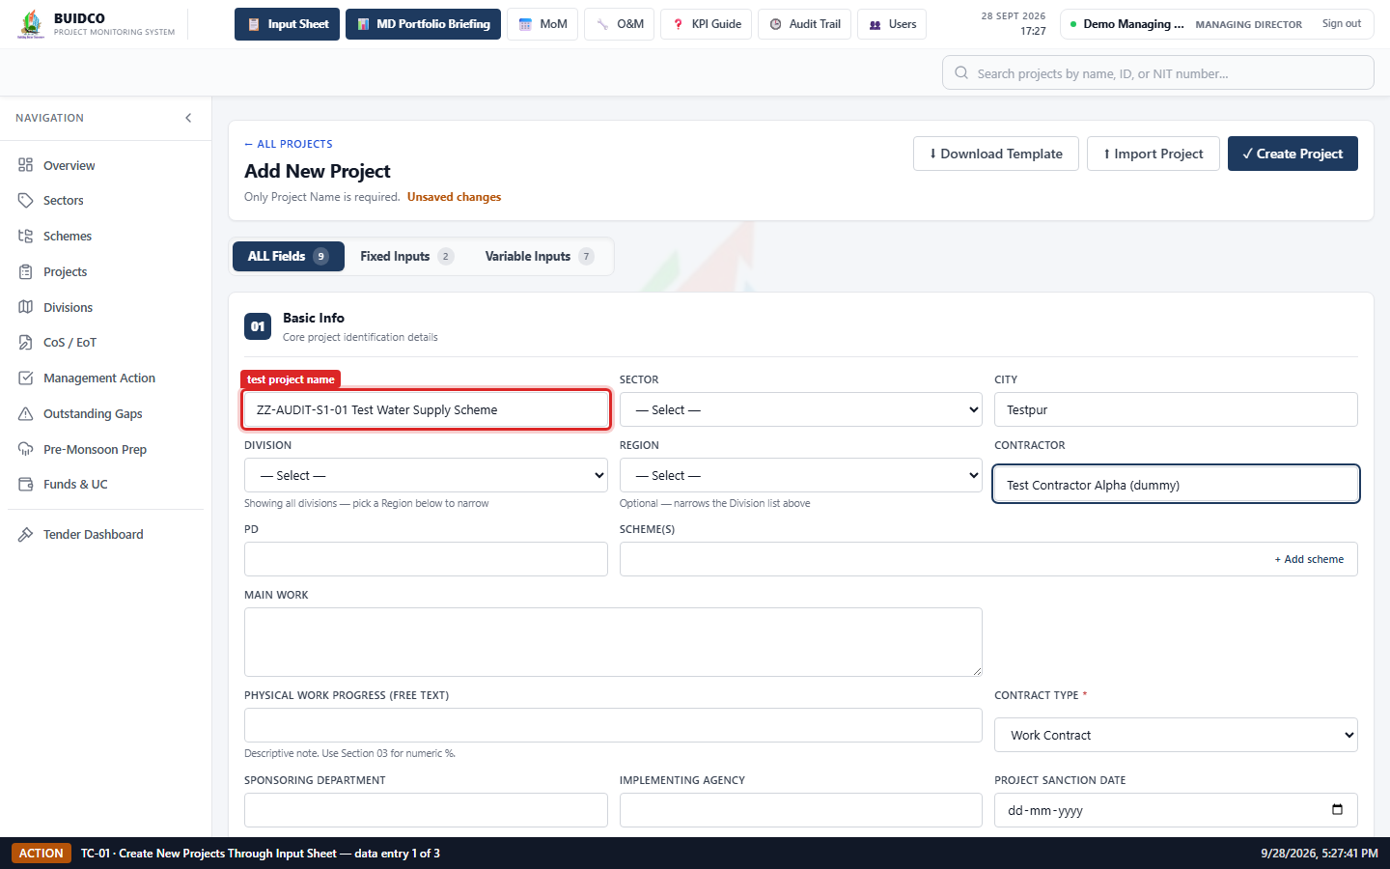
Figure 4 · [Action] Input Sheet data entry for test project 1: "ZZ-AUDIT-S1-01 Test Water Supply Scheme" (Execution Status: Not Started). (captured 28/9/2026, 5:27:42 pm)
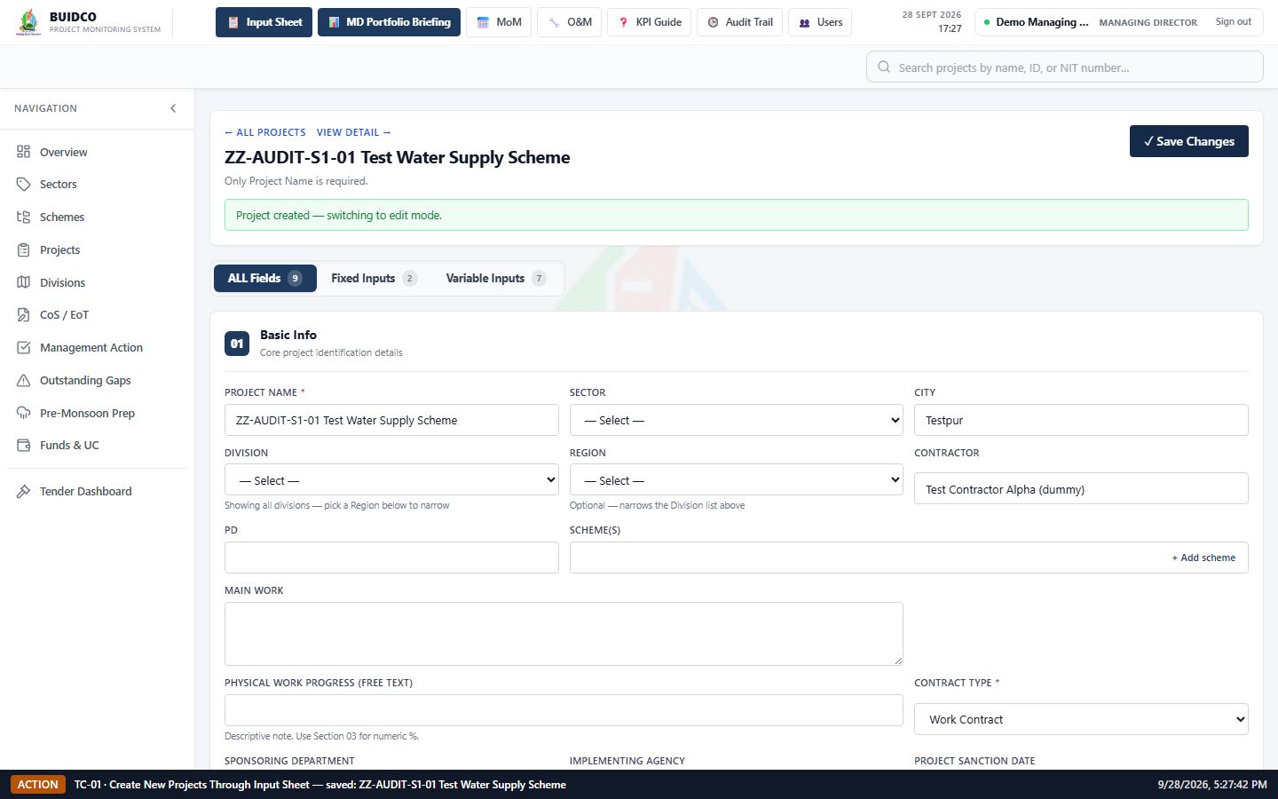
Figure 5 · [Action] Confirmation after saving test project 1 — the form switched to edit mode on the new record. (captured 28/9/2026, 5:27:42 pm)
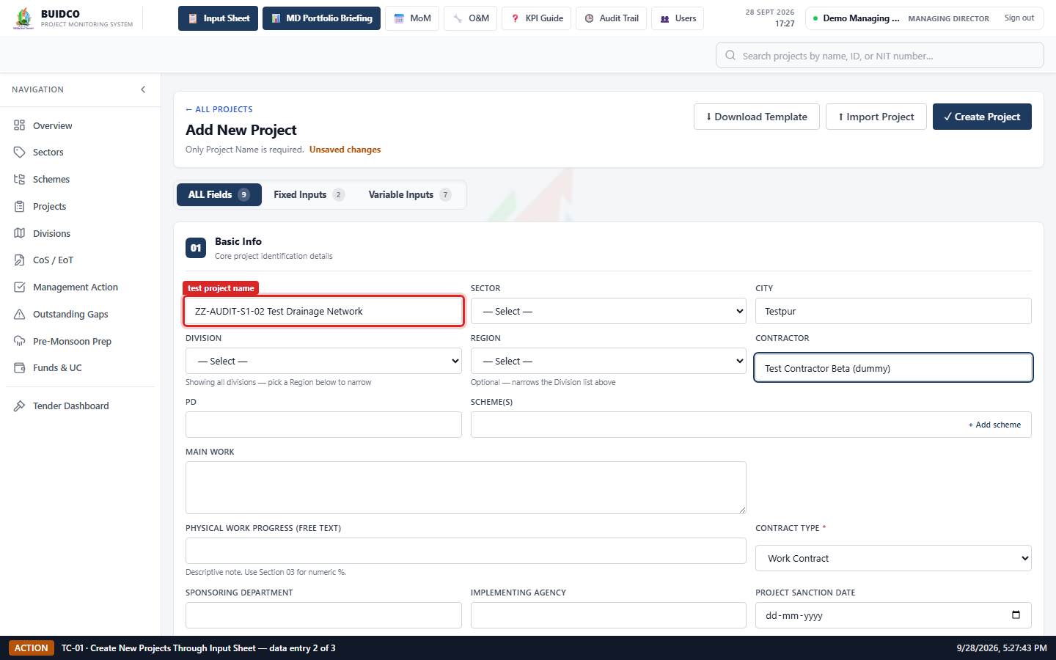
Figure 6 · [Action] Input Sheet data entry for test project 2: "ZZ-AUDIT-S1-02 Test Drainage Network" (Execution Status: In Progress). (captured 28/9/2026, 5:27:43 pm)
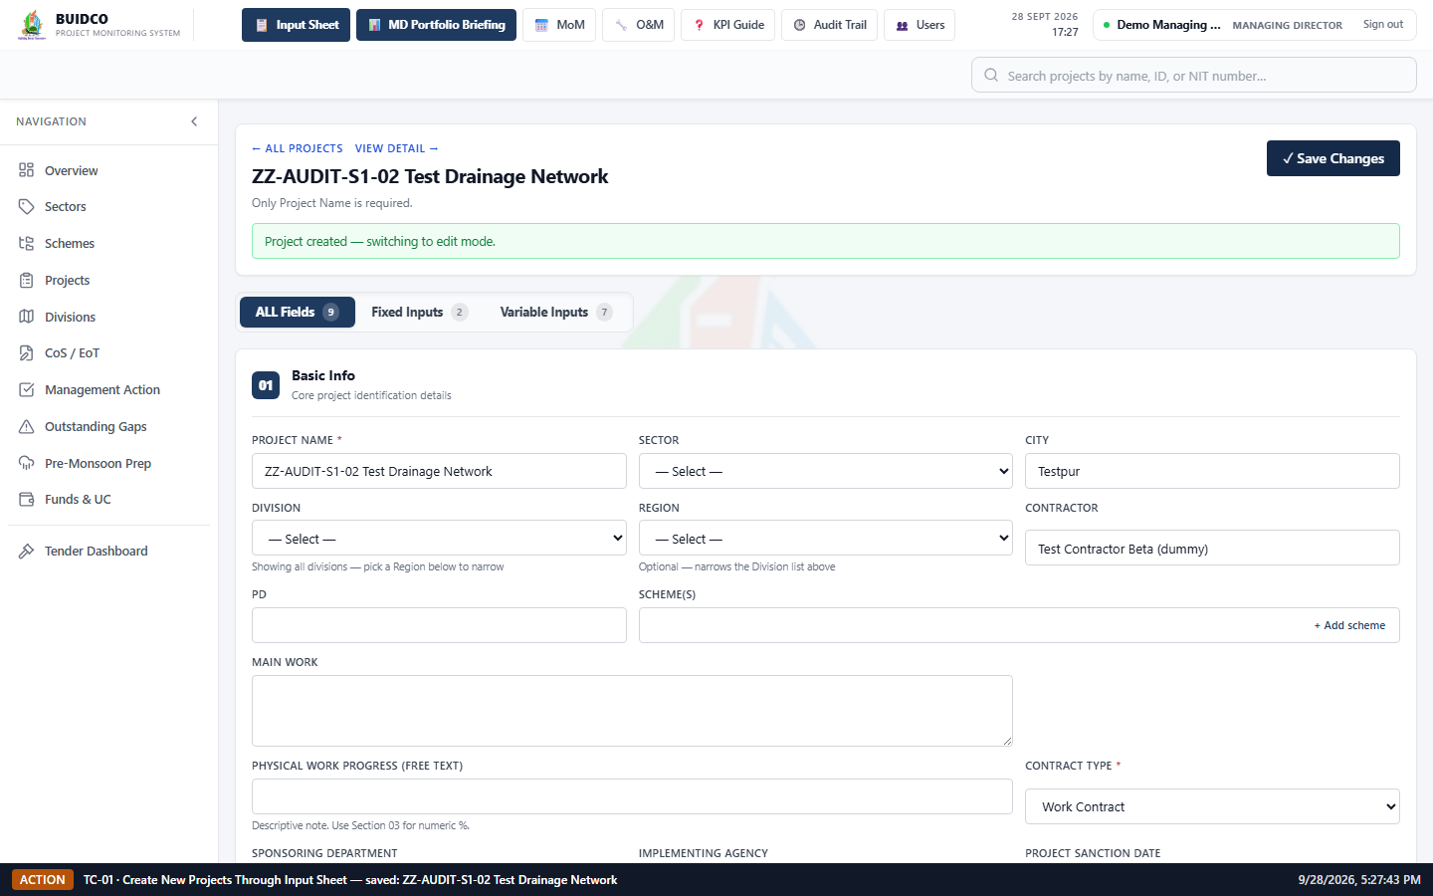
Figure 7 · [Action] Confirmation after saving test project 2 — the form switched to edit mode on the new record. (captured 28/9/2026, 5:27:44 pm)
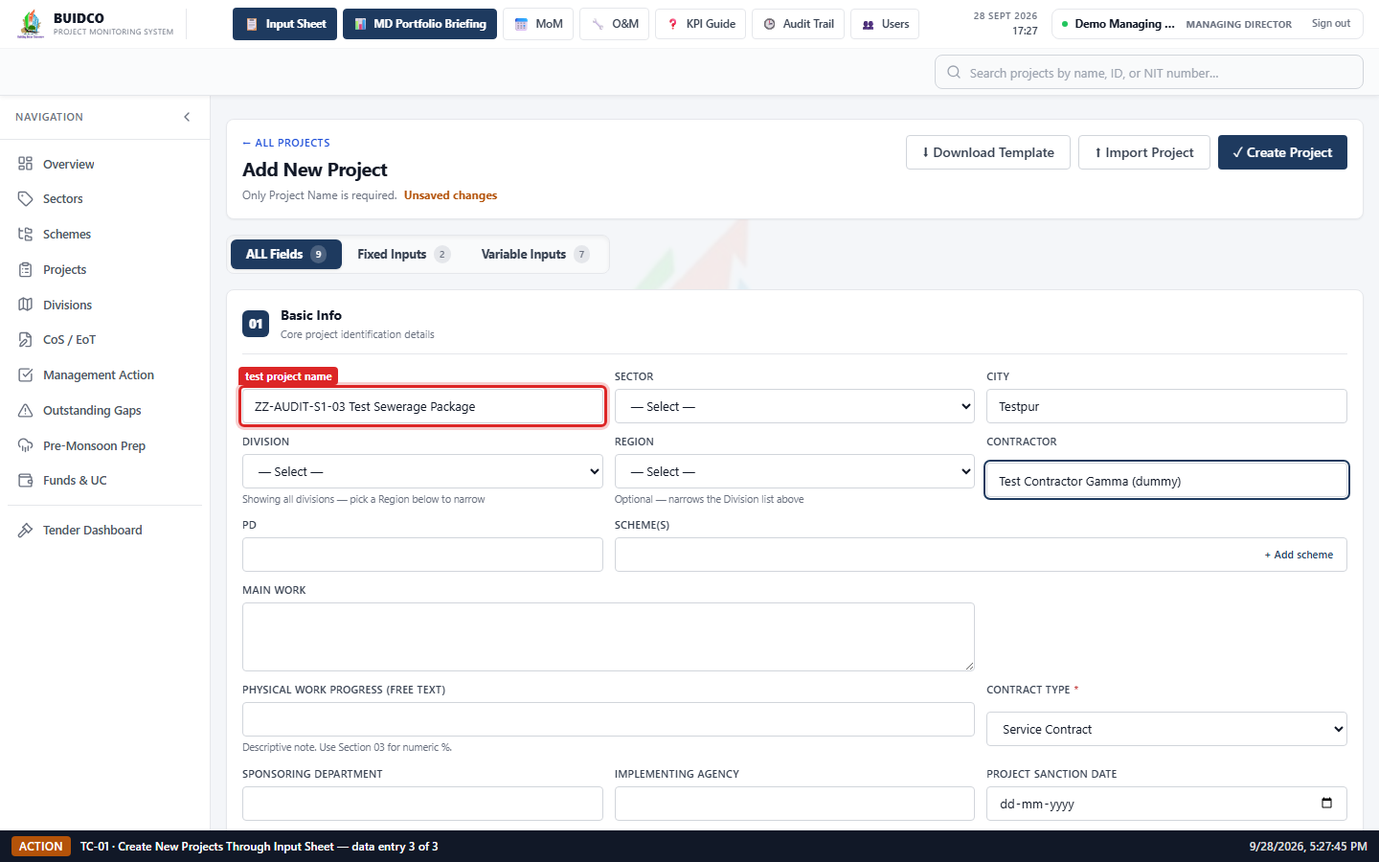
Figure 8 · [Action] Input Sheet data entry for test project 3: "ZZ-AUDIT-S1-03 Test Sewerage Package" (Execution Status: Completed). (captured 28/9/2026, 5:27:45 pm)
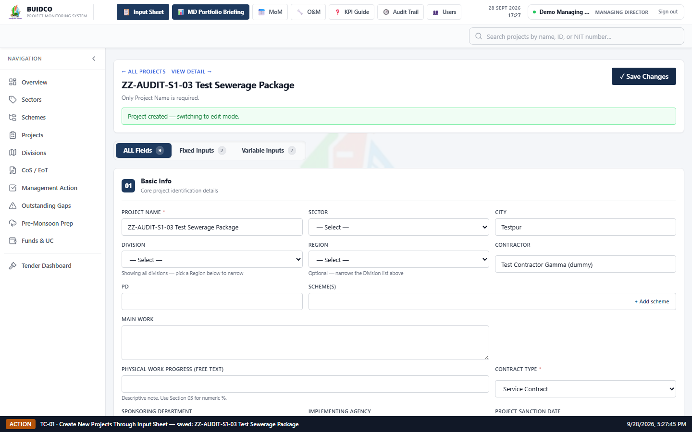
Figure 9 · [Action] Confirmation after saving test project 3 — the form switched to edit mode on the new record. (captured 28/9/2026, 5:27:45 pm)
9. After Testing — Screenshots
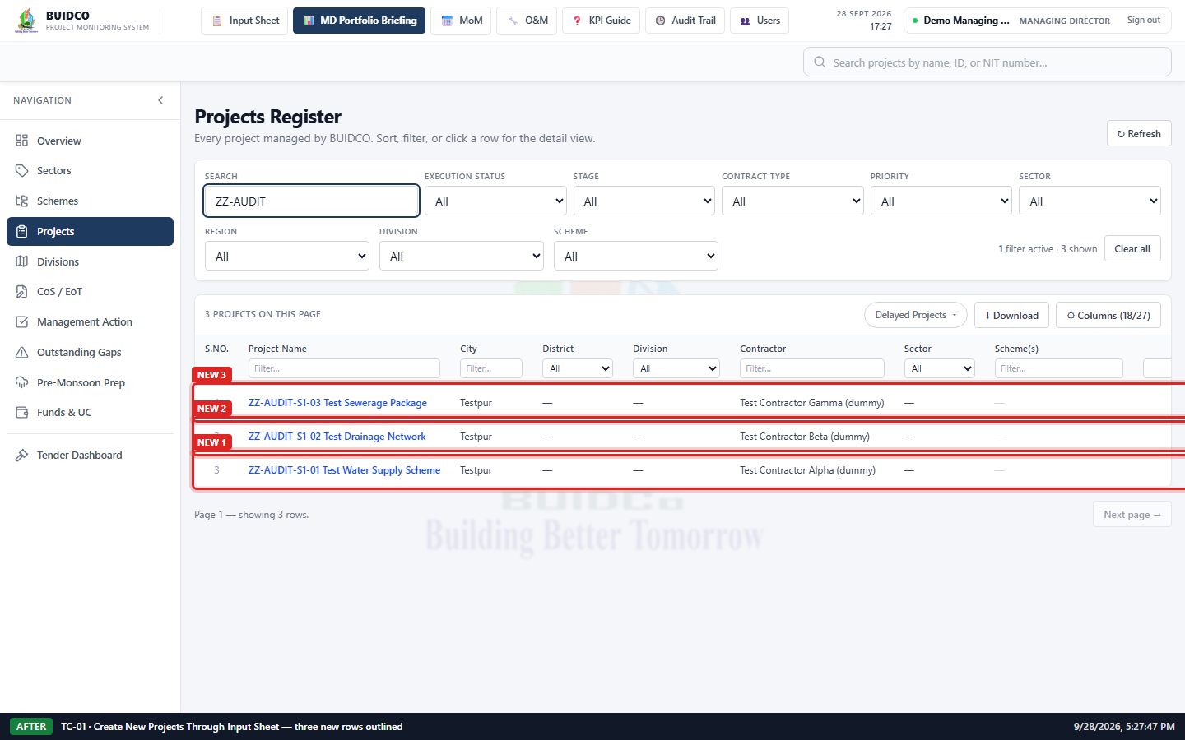
Figure 10 · [After] Projects section filtered by "ZZ-AUDIT" after creation — all three test projects present and outlined. (captured 28/9/2026, 5:27:47 pm)
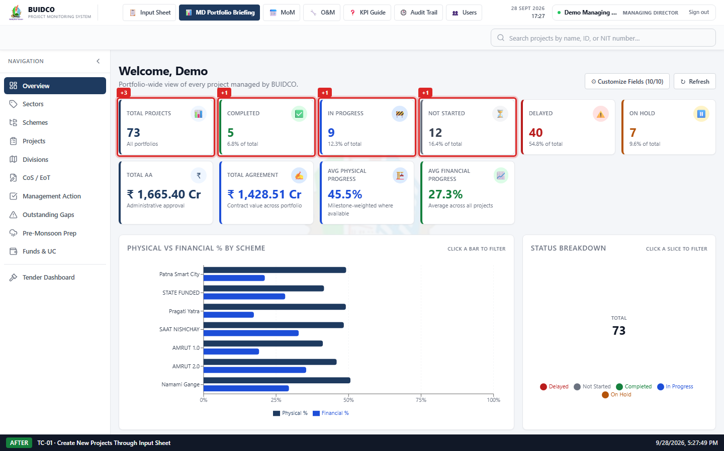
Figure 11 · [After] Overview KPI tiles after creation — every tile that changed is outlined with its delta. (captured 28/9/2026, 5:27:49 pm)
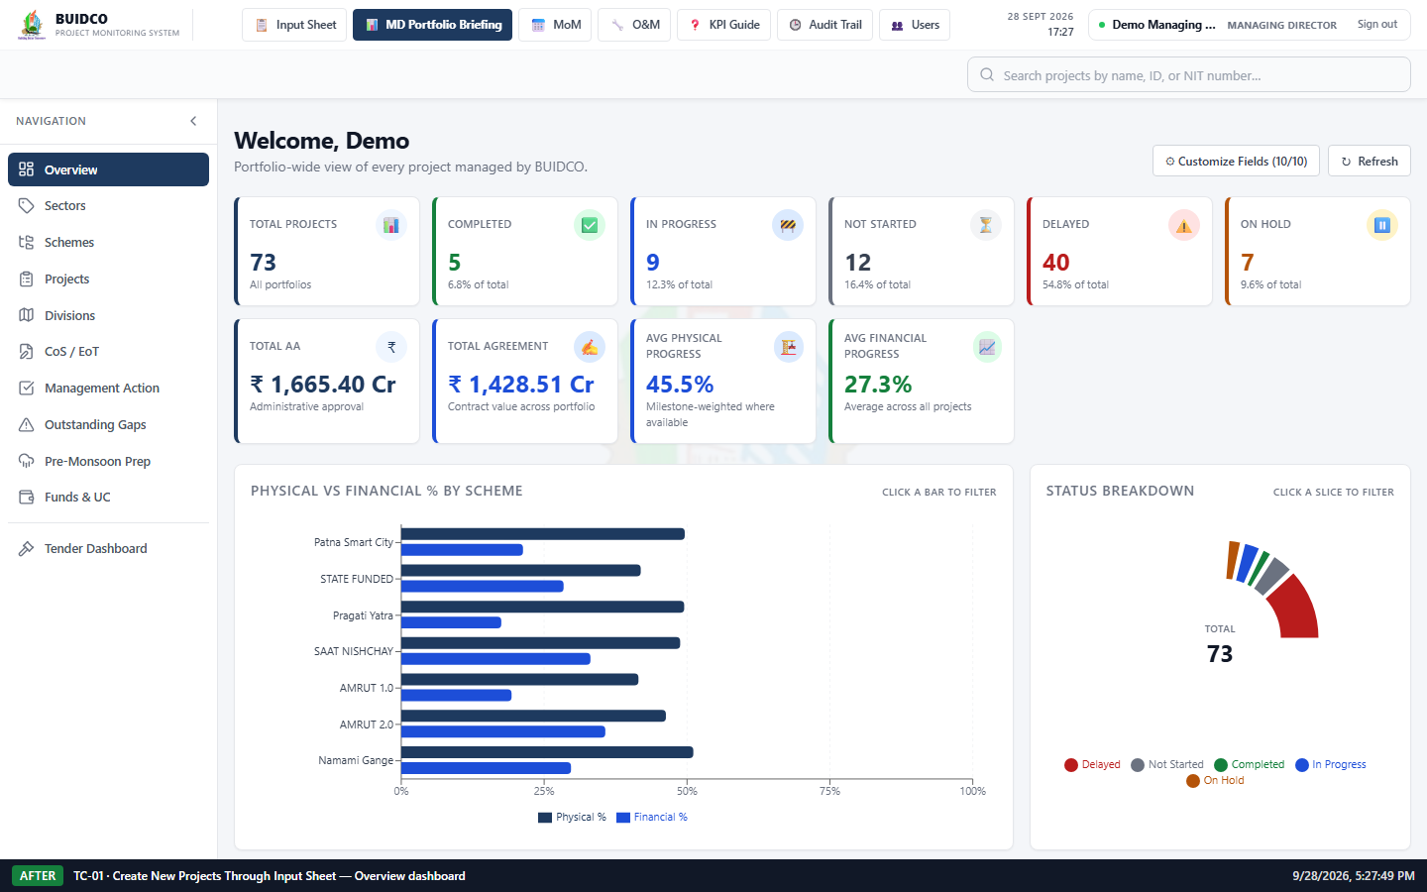
Figure 12 · [After] Full Overview dashboard after the three test projects were created. (captured 28/9/2026, 5:27:50 pm)
10. Highlighted Changes
Every screenshot above carries a caption bar with the scenario, phase and capture time, and each changed element is outlined in red with a label.
- Projects section: new row "ZZ-AUDIT-S1-01 Test Water Supply Scheme" is displayed.
- Projects section: new row "ZZ-AUDIT-S1-02 Test Drainage Network" is displayed.
- Projects section: new row "ZZ-AUDIT-S1-03 Test Sewerage Package" is displayed.
- KPI tile "Not Started" increased from 11 to 12.
- KPI tile "In Progress" increased from 8 to 9.
- KPI tile "Completed" increased from 4 to 5.
- KPI tile "Total Projects" increased from 70 to 73.
- Aggregate tile "Avg Physical Progress" recalculated from 47.5% to 45.5%.
- Aggregate tile "Avg Financial Progress" recalculated from 28.5% to 27.3%.
Overview KPI values — before vs after creating 3 test projects
KPI tile | Before | After | Actual change | Expected change
Total Projects | 70 | 73 | +3 | 3
Completed | 4 | 5 | +1 | 1
In Progress | 8 | 9 | +1 | 1
Not Started | 11 | 12 | +1 | 1
Delayed | 40 | 40 | 0 | 0
On Hold | 7 | 7 | 0 | 0
Total AA | ₹ 1,665.40 Cr | ₹ 1,665.40 Cr | no change | aggregate — expected to recalculate
Total Agreement | ₹ 1,428.51 Cr | ₹ 1,428.51 Cr | no change | aggregate — expected to recalculate
Avg Physical Progress | 47.5% | 45.5% | recalculated | aggregate — expected to recalculate
Avg Financial Progress | 28.5% | 27.3% | recalculated | aggregate — expected to recalculate
Shaded rows are the values that changed.
Test projects created, with the status the application stored
# | Project name | Execution status entered | Status stored by application
1 | ZZ-AUDIT-S1-01 Test Water Supply Scheme | Not Started | Not Started
2 | ZZ-AUDIT-S1-02 Test Drainage Network | In Progress | In Progress
3 | ZZ-AUDIT-S1-03 Test Sewerage Package | Completed | Completed
11. Expected Result
- All three test projects are saved and listed in the Projects section.
- Total Projects increases by exactly 3; each status count increases in line with the status the application stored for each new project.
- No unrelated project-count tile changes.
- The portfolio average tiles recalculate to include the new projects (they are averages over all projects, so they are expected to move).
12. Actual Result
- KPI "Not Started": 11 → 12 (change of +1, as expected).
- KPI "In Progress": 8 → 9 (change of +1, as expected).
- KPI "Completed": 4 → 5 (change of +1, as expected).
- KPI "Total Projects": 70 → 73 (change of +3, as expected).
- Every project-count tile unrelated to the new projects held its previous value, so no unrelated count was disturbed.
- Aggregate tile "Avg Physical Progress": 47.5% → 45.5% — recalculated to include the three new projects.
- Aggregate tile "Avg Financial Progress": 28.5% → 27.3% — recalculated to include the three new projects.
- All three test projects appear in the Projects section with the entered details.
13. Test Status
Pass
14. Remarks / Observations
- Execution Status was entered as Not Started / In Progress / Completed. The application derives the stored status from the project dates as well as the entered value, so the KPI deltas were checked against the stored status read back from the API.
- The Avg Physical/Financial Progress tiles are averages across every project. The three test projects were created at 0% progress, so these averages fall — correct behaviour for an average, not a defect, and they return to baseline once the test data is removed (see TC-05).
15. Cleanup Confirmation
- The three test projects remain in place for Scenario 2 evidence and are removed by the cleanup step (TC-05) at the end of the run.

TC-02 — CRUD Testing for Existing Projects
Test status: Pass
1. Test Case ID
TC-02
2. Test Scenario
CRUD Testing for Existing Projects
3. Objective
Verify that a project supports Create, Read, Update and Delete operations, that updates are reflected throughout the application, and that no genuine project data is affected.
4. Pre-Conditions
- Local BUIDCO stack running; signed in as demo_md (role MD).
- CRUD is exercised against a purpose-created test record, never against an existing project, because the scenario ends in a delete.
5. Test Data
- ZZ-AUDIT-S2-01 Test CRUD Project — created as City: Testpur, Contractor: Test Contractor Delta (dummy), Contract Type: Work Contract, Execution Status: Not Started, Physical Progress: 10%
- Update applies — City: Testnagar, Contractor: Test Contractor Delta REVISED (dummy), Execution Status: In Progress, Physical Progress: 45%
6. Steps Performed
1. CREATE — saved a new test project "ZZ-AUDIT-S2-01 Test CRUD Project" through the Input Sheet.
2. READ — opened the project profile and verified the stored details are displayed.
3. UPDATE — changed City, Contractor, Execution Status and Physical Progress %, then saved.
4. DELETE — used the row Delete action and accepted the confirmation prompt.
7. Before Testing — Screenshots
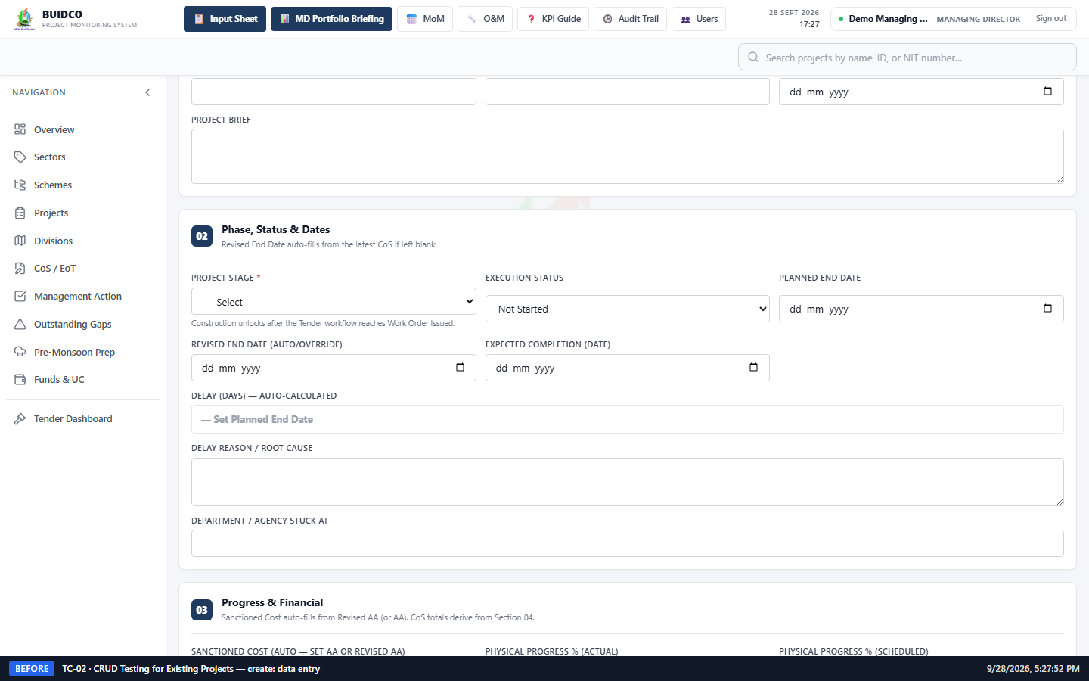
Figure 13 · [Before] CREATE — Input Sheet filled with the test project's original values. (captured 28/9/2026, 5:27:53 pm)
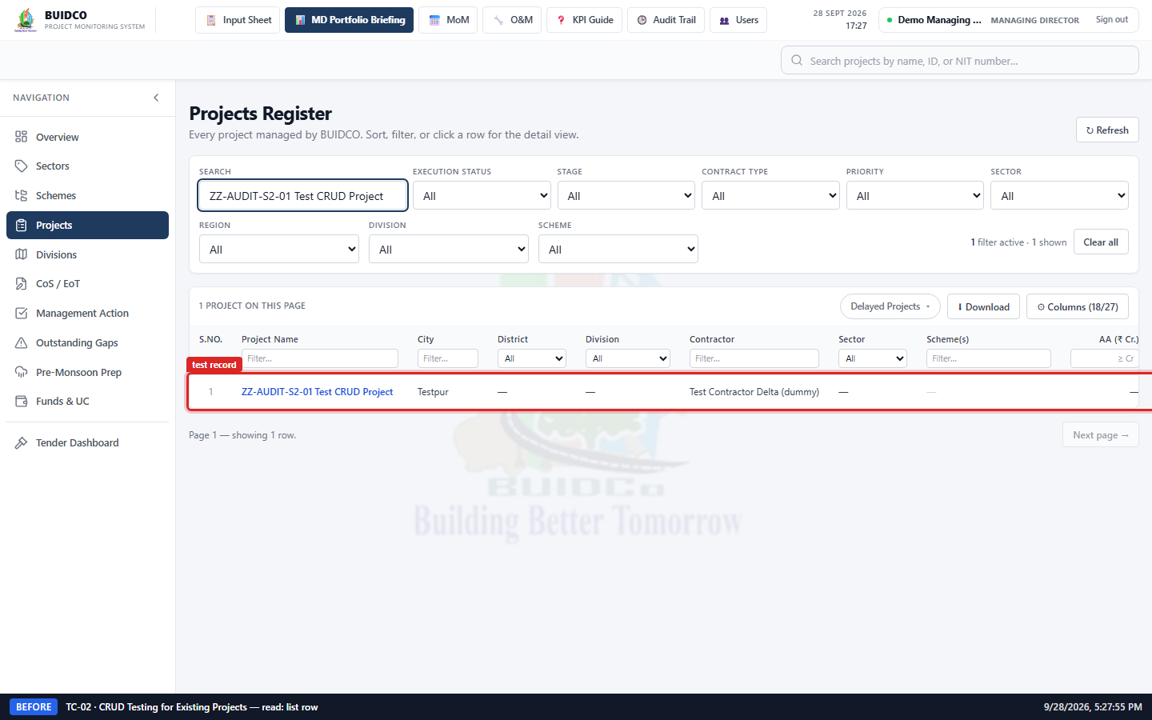
Figure 14 · [Before] READ — the new record listed in the Projects section with its original values. (captured 28/9/2026, 5:27:55 pm)
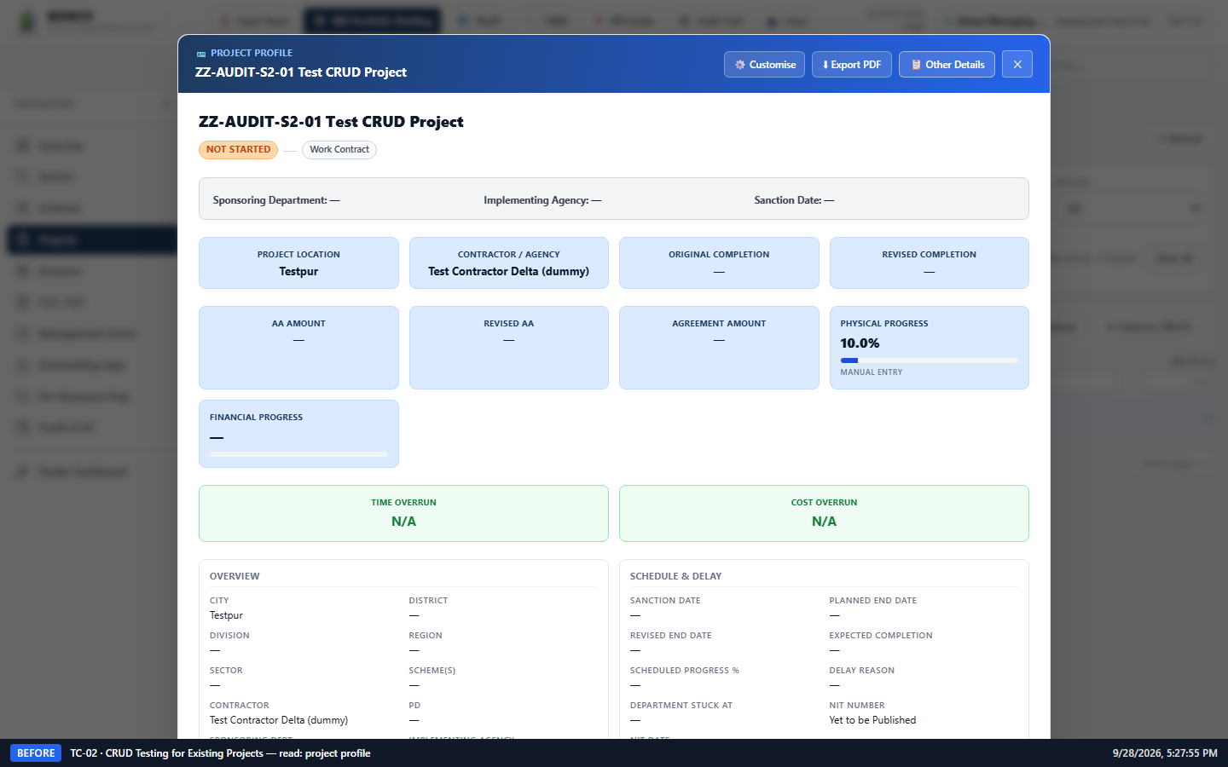
Figure 15 · [Before] READ — project profile showing the record as created, before any modification. (captured 28/9/2026, 5:27:56 pm)
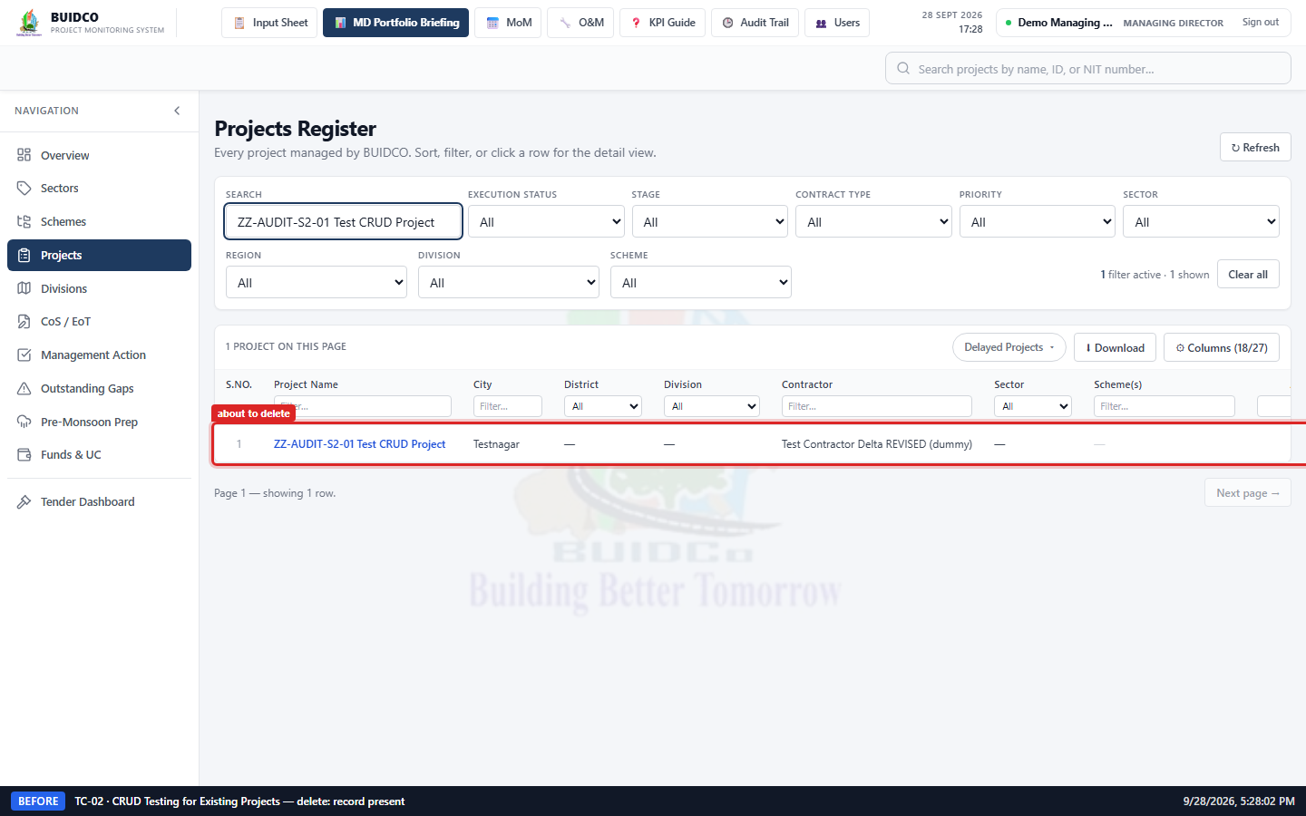
Figure 16 · [Before] DELETE — the test record still listed, immediately before deletion. (captured 28/9/2026, 5:28:02 pm)
8. Action / Change Performed
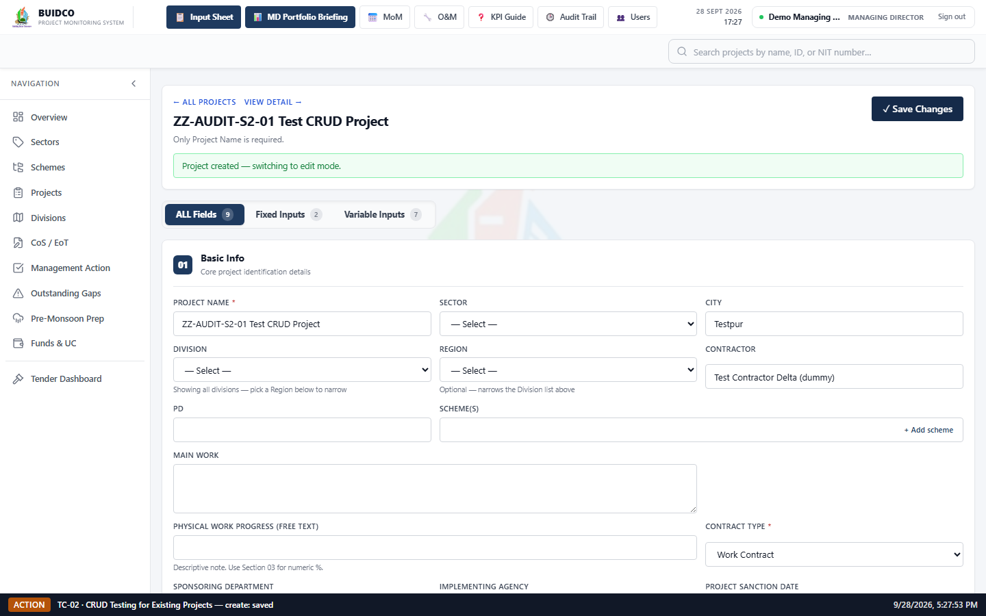
Figure 17 · [Action] CREATE — the record saved and the form switched into edit mode on the new project. (captured 28/9/2026, 5:27:53 pm)
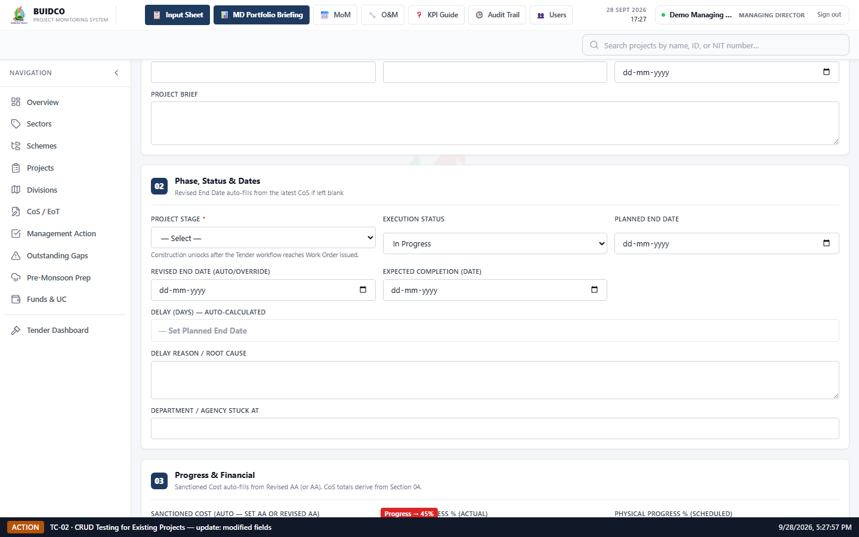
Figure 18 · [Action] UPDATE — the four modified fields before saving (City, Contractor, Execution Status, Physical Progress %). (captured 28/9/2026, 5:27:57 pm)
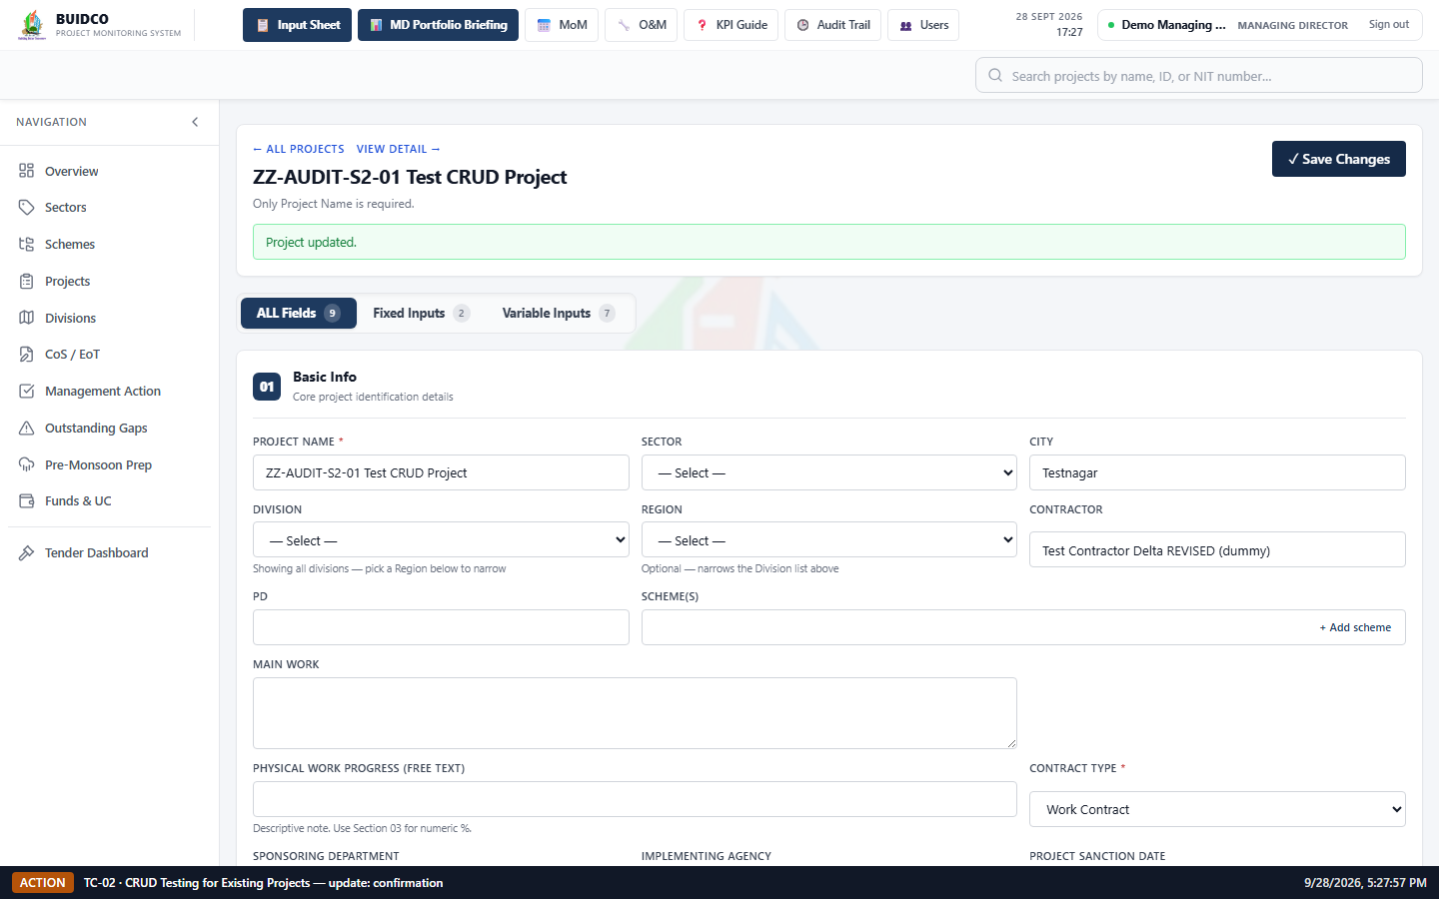
Figure 19 · [Action] UPDATE — the application confirmed "Project updated." (captured 28/9/2026, 5:27:58 pm)
9. After Testing — Screenshots
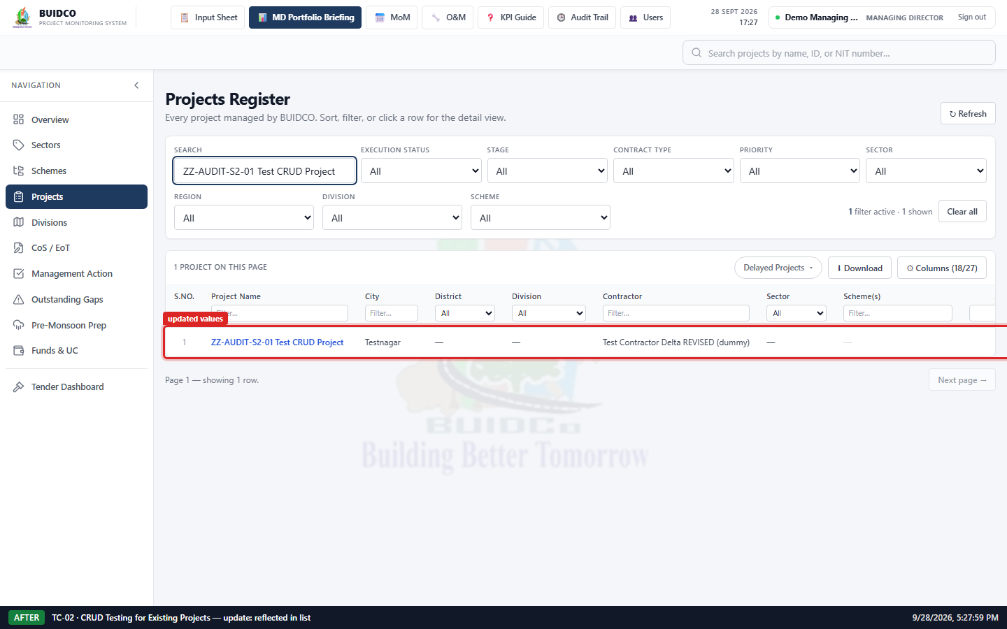
Figure 20 · [After] UPDATE — the Projects section now shows the revised values (City "Testnagar"). (captured 28/9/2026, 5:28:00 pm)
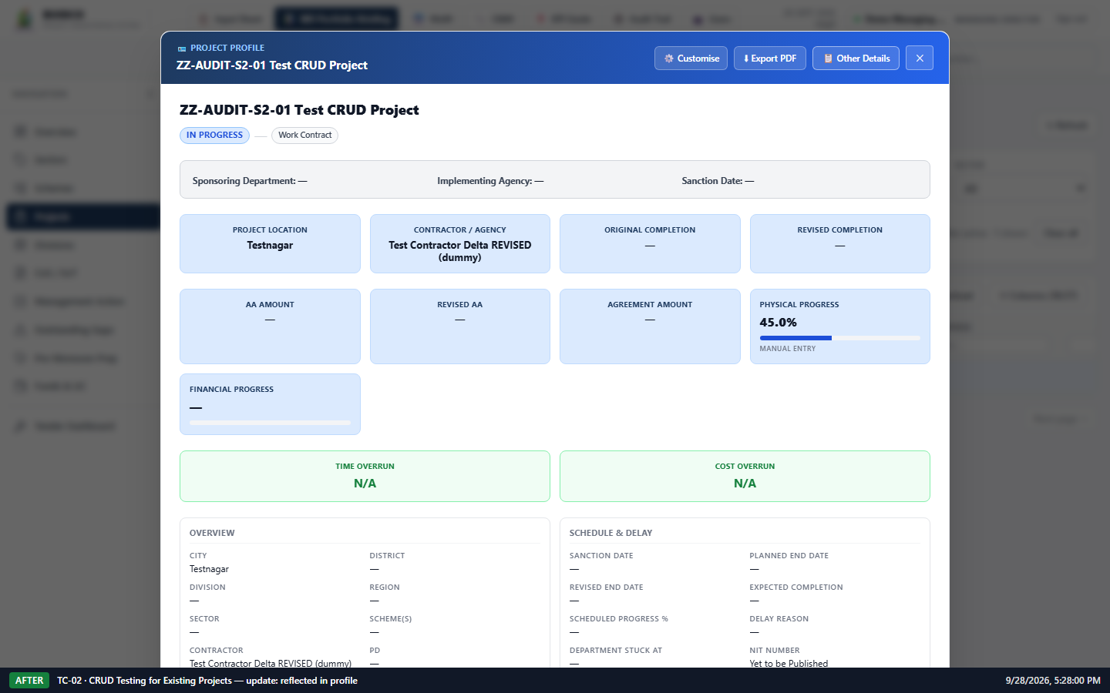
Figure 21 · [After] UPDATE — the project profile reflects the same revised values as the list. (captured 28/9/2026, 5:28:00 pm)
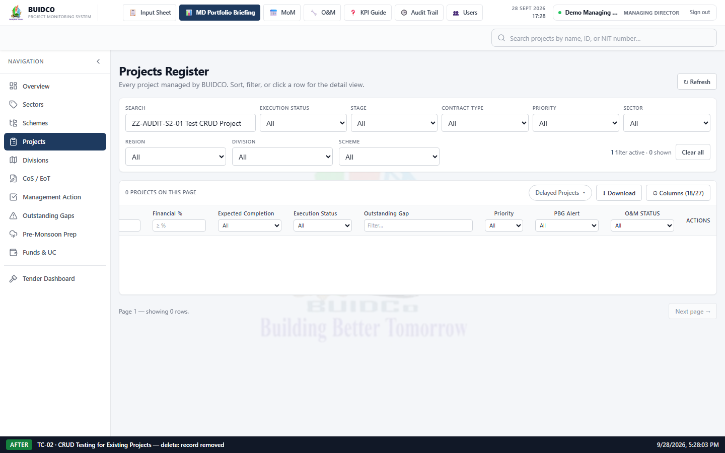
Figure 22 · [After] DELETE — the record is gone from the Projects section. (captured 28/9/2026, 5:28:03 pm)
10. Highlighted Changes
Every screenshot above carries a caption bar with the scenario, phase and capture time, and each changed element is outlined in red with a label.
- New record "ZZ-AUDIT-S2-01 Test CRUD Project" created.
- City changed from "Testpur" to "Testnagar".
- Contractor changed from "Test Contractor Delta (dummy)" to "Test Contractor Delta REVISED (dummy)".
- Execution Status changed from "Not Started" to "In Progress"; Physical Progress from 10% to 45%.
- Record removed from the Projects section.
Field-level Before vs After for the Update operation
Field | Before update | After update | Reflected in list + profile
City | Testpur | Testnagar | Yes
Contractor | Test Contractor Delta (dummy) | Test Contractor Delta REVISED (dummy) | Yes
Execution Status | Not Started | In Progress | Yes
Physical Progress % | 10% | 45% | Yes
Shaded rows are the values that changed.
11. Expected Result
- CREATE — a new project is saved with the entered values.
- READ — the stored values are displayed in the list and the project profile.
- UPDATE — modified values are saved and reflected consistently in the Input Sheet, the Projects list and the project profile.
- DELETE — the record is removed after an explicit confirmation and is no longer retrievable.
- No existing/genuine project is modified or deleted at any point.
12. Actual Result
- READ — the project profile and the API both return the values entered at creation (City: Testpur, Contractor: Test Contractor Delta (dummy)).
- UPDATE — the revised values were saved and appear identically in the Input Sheet, the Projects list and the project profile.
- DELETE — the application asked for confirmation first: "Delete "ZZ-AUDIT-S2-01 Test CRUD Project"? This permanently removes the project and all of its linked data (milestones, CoS/EoT, photos, etc.). This cannot be undone."
- DELETE — the record is removed from the list and the API returns 404 for its id.
13. Test Status
Pass
14. Remarks / Observations
- Every operation was performed through the application UI. The delete is guarded by a confirmation prompt that names the project and states that the action cannot be undone.
- Only the purpose-created test record was touched. No pre-existing project was opened for editing at any point in this scenario.
15. Cleanup Confirmation
- The test record used for this scenario was deleted as part of the Delete step — nothing is left behind by TC-02.

TC-04 — Import Projects Through Excel Sheet
Test status: Pass
1. Test Case ID
TC-04
2. Test Scenario
Import Projects Through Excel Sheet
3. Objective
Verify that projects can be imported from an Excel file and are correctly reflected in the application's Projects section and dashboard counts.
4. Pre-Conditions
- Local BUIDCO stack running; signed in as demo_md (role MD).
- The import workbook is generated from the application's own Download Template, so the column headers are exactly the ones the importer expects.
- No ZZ-AUDIT-S4 record exists before the import.
5. Test Data
- Project Name: ZZ-AUDIT-S4-01 Test Imported Park Upgrade, City: Testganj, Contractor: Test Importer One (dummy), Contract Type: Work Contract, Execution Status: Not Started, Physical Progress % (Actual): 0
- Project Name: ZZ-AUDIT-S4-02 Test Imported Road Resurfacing, City: Testganj, Contractor: Test Importer Two (dummy), Contract Type: Work Contract, Execution Status: In Progress, Physical Progress % (Actual): 35
- Project Name: ZZ-AUDIT-S4-03 Test Imported Pump House, City: Testganj, Contractor: Test Importer Three (dummy), Contract Type: Service Contract, Execution Status: In Progress, Physical Progress % (Actual): 60
6. Steps Performed
1. Prepared an Excel file with 3 dummy project rows, built from the application's Download Template (ZZ-AUDIT-import-test-projects.xlsx).
2. Confirmed the Projects section contains none of the rows about to be imported.
3. Uploaded the Excel file; the dialog validated every row and reported 3 projects ready to import.
4. Ran the import and the application confirmed the records were created.
5. Compared every imported field shown in the Projects section against the value in the Excel source file.
7. Before Testing — Screenshots
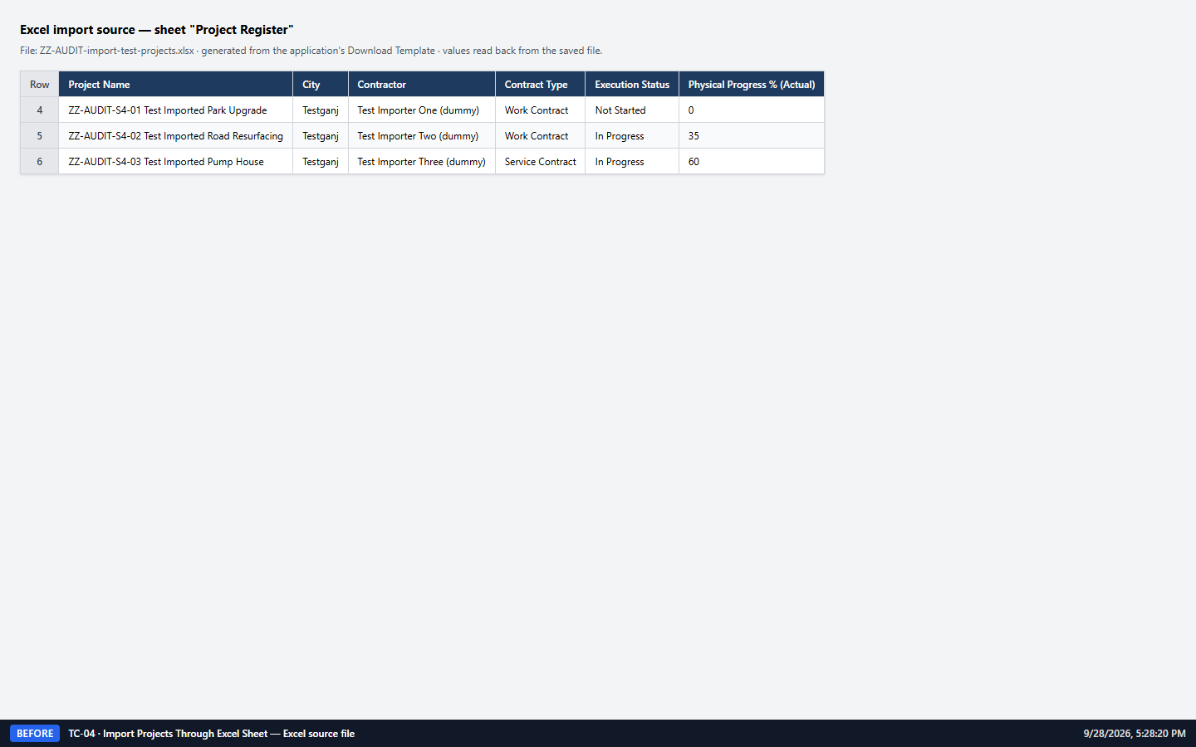
Figure 29 · [Before] Excel source data — the 3 dummy rows in ZZ-AUDIT-import-test-projects.xlsx, read back from the generated file. (captured 28/9/2026, 5:28:21 pm)
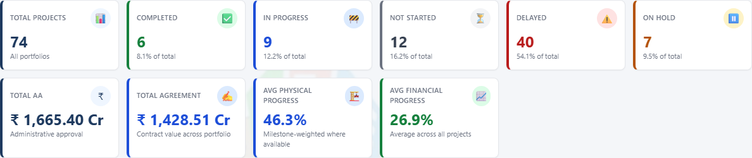
Figure 30 · [Before] Overview KPI tiles before the Excel import. (captured 28/9/2026, 5:28:22 pm)
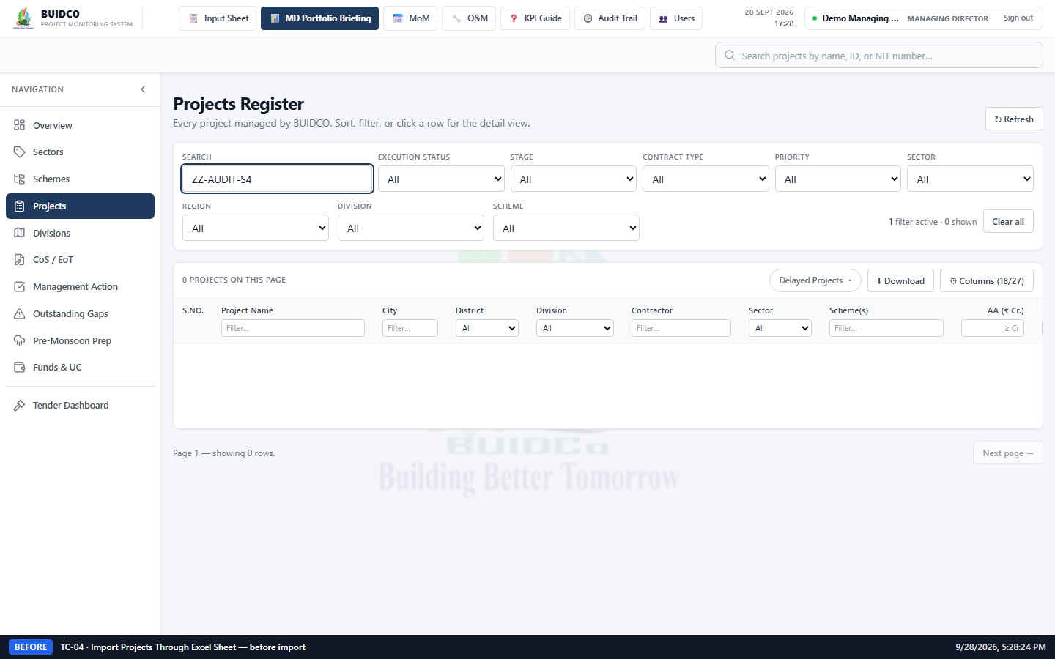
Figure 31 · [Before] Projects section filtered by "ZZ-AUDIT-S4" before the import — no records. (captured 28/9/2026, 5:28:24 pm)
8. Action / Change Performed
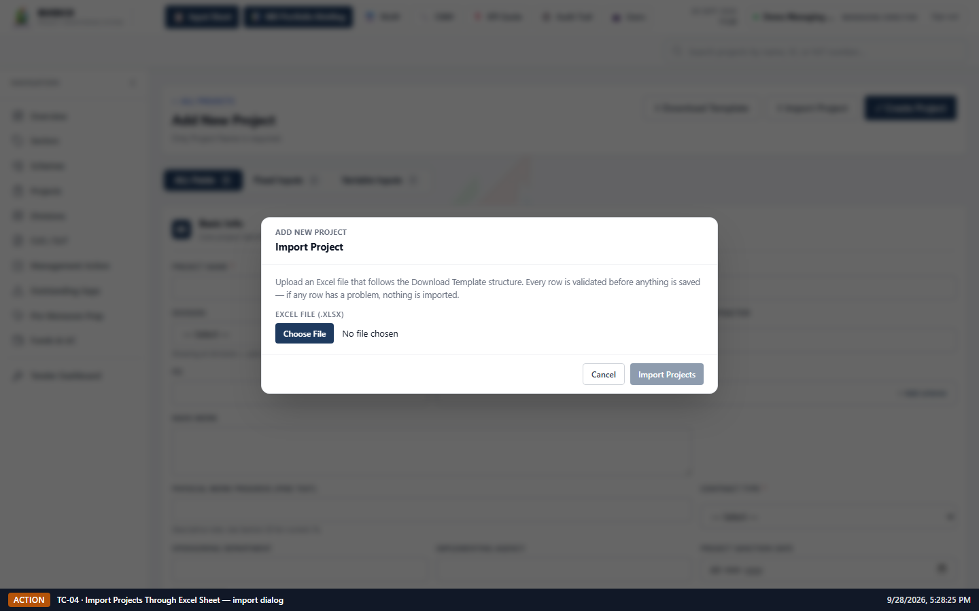
Figure 32 · [Action] The Import Project dialog, before a file is chosen. (captured 28/9/2026, 5:28:25 pm)
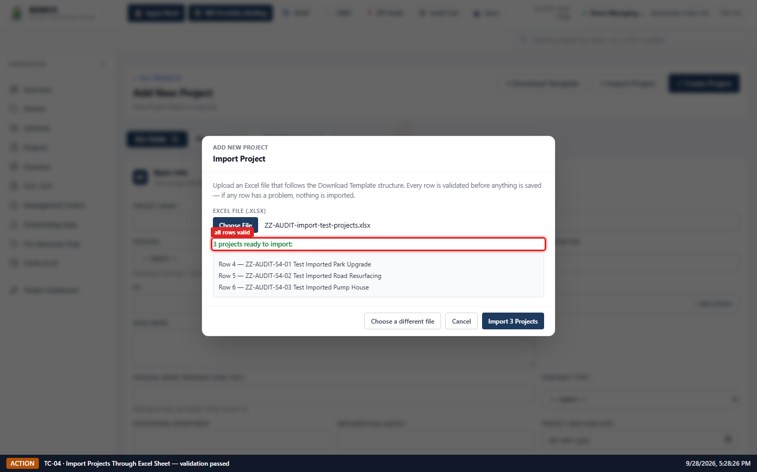
Figure 33 · [Action] Validation result — all 3 rows parsed with no errors and are listed ready to import. (captured 28/9/2026, 5:28:26 pm)
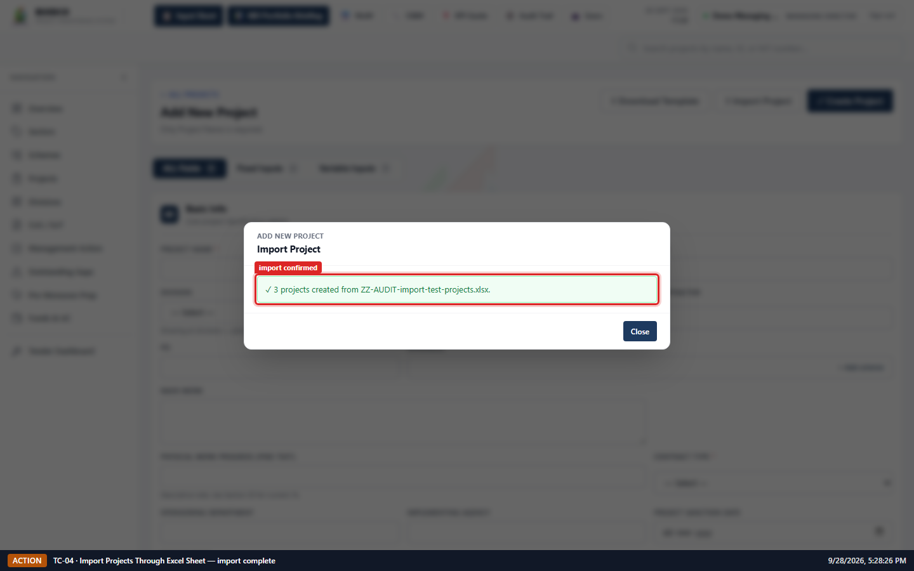
Figure 34 · [Action] Import confirmation — 3 projects created from the Excel file. (captured 28/9/2026, 5:28:27 pm)
9. After Testing — Screenshots
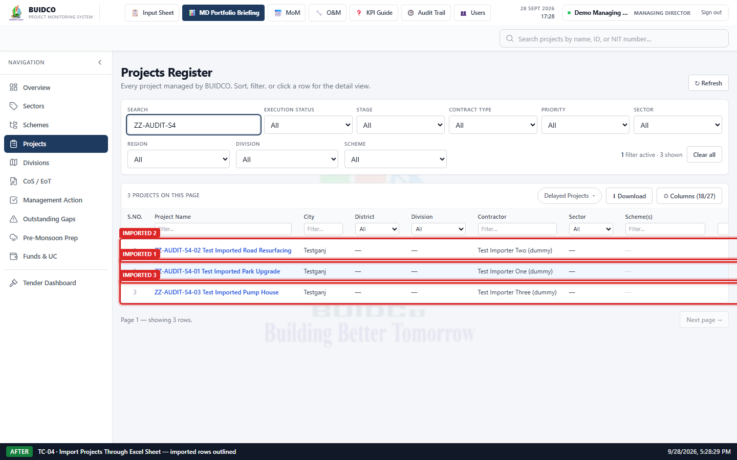
Figure 35 · [After] Projects section after the import — all 3 imported records are listed and outlined. (captured 28/9/2026, 5:28:29 pm)
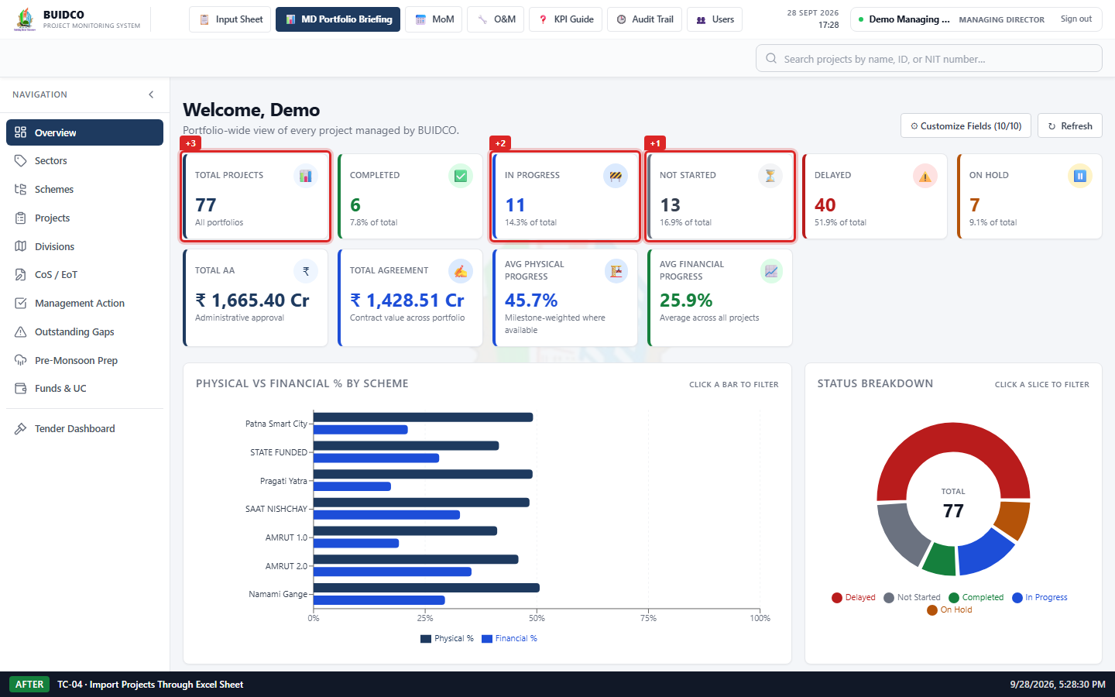
Figure 36 · [After] Overview KPI tiles after the import — every tile that moved is outlined with its delta. (captured 28/9/2026, 5:28:30 pm)
10. Highlighted Changes
Every screenshot above carries a caption bar with the scenario, phase and capture time, and each changed element is outlined in red with a label.
- KPI tile "Total Projects" increased from 74 to 77.
- KPI tile "Not Started" increased from 12 to 13.
- KPI tile "In Progress" increased from 9 to 11.
- Projects section: imported row "ZZ-AUDIT-S4-01 Test Imported Park Upgrade" is displayed.
- Projects section: imported row "ZZ-AUDIT-S4-02 Test Imported Road Resurfacing" is displayed.
- Projects section: imported row "ZZ-AUDIT-S4-03 Test Imported Pump House" is displayed.
Excel source value vs value displayed in the application
Imported project | Excel column | Excel value | Shown in application | Result
S4-01 Test Imported Park Upgrade | Project Name | ZZ-AUDIT-S4-01 Test Imported Park Upgrade | ZZ-AUDIT-S4-01 Test Imported Park Upgrade | Match
S4-01 Test Imported Park Upgrade | City | Testganj | Testganj | Match
S4-01 Test Imported Park Upgrade | Contractor | Test Importer One (dummy) | Test Importer One (dummy) | Match
S4-01 Test Imported Park Upgrade | Execution Status | Not Started | NOT STARTED | Match
S4-02 Test Imported Road Resurfacing | Project Name | ZZ-AUDIT-S4-02 Test Imported Road Resurfacing | ZZ-AUDIT-S4-02 Test Imported Road Resurfacing | Match
S4-02 Test Imported Road Resurfacing | City | Testganj | Testganj | Match
S4-02 Test Imported Road Resurfacing | Contractor | Test Importer Two (dummy) | Test Importer Two (dummy) | Match
S4-02 Test Imported Road Resurfacing | Execution Status | In Progress | IN PROGRESS | Match
S4-03 Test Imported Pump House | Project Name | ZZ-AUDIT-S4-03 Test Imported Pump House | ZZ-AUDIT-S4-03 Test Imported Pump House | Match
S4-03 Test Imported Pump House | City | Testganj | Testganj | Match
S4-03 Test Imported Pump House | Contractor | Test Importer Three (dummy) | Test Importer Three (dummy) | Match
S4-03 Test Imported Pump House | Execution Status | In Progress | IN PROGRESS | Match
Overview KPI values — before vs after the Excel import
KPI tile | Before import | After import | Expected change
Total Projects | 74 | 77 | +3
Completed | 6 | 6 | —
In Progress | 9 | 11 | +2
Not Started | 12 | 13 | +1
Delayed | 40 | 40 | —
On Hold | 7 | 7 | —
Total AA | ₹ 1,665.40 Cr | ₹ 1,665.40 Cr | —
Total Agreement | ₹ 1,428.51 Cr | ₹ 1,428.51 Cr | —
Avg Physical Progress | 46.3% | 45.7% | —
Avg Financial Progress | 26.9% | 25.9% | —
Shaded rows are the values that changed.
11. Expected Result
- All 3 rows in the Excel file are validated and imported.
- Each imported project appears in the Projects section with exactly the values from the Excel file.
- Total Projects increases by 3 and the status counts increase in line with the imported Execution Status values.
12. Actual Result
- KPI "Total Projects": 74 → 77 (change of +3, as expected).
- KPI "Not Started": 12 → 13 (change of +1, as expected).
- KPI "In Progress": 9 → 11 (change of +2, as expected).
- The dialog validated all 3 rows with no errors and reported them created.
- Every compared field (Project Name, City, Contractor, Execution Status) matches the Excel source exactly — 12 field comparisons, 0 mismatches.
13. Test Status
Pass
14. Remarks / Observations
- The importer validates the whole file before writing anything — a single bad row aborts the batch — so a partial import cannot leave half a spreadsheet behind.
15. Cleanup Confirmation
- The three imported test projects are removed by the cleanup step (TC-05) at the end of the run.
- The temporary Excel file is kept with the evidence at audit-evidence/files/ZZ-AUDIT-import-test-projects.xlsx and is removed with the rest of the working artifacts once the report is signed off.

TC-05 — Testing Data Cleanup and Post-Test Verification
Test status: Pass
1. Test Case ID
TC-05
2. Test Scenario
Testing Data Cleanup and Post-Test Verification
3. Objective
Remove every temporary record created during this testing session and verify that the application is left in the same valid operational state as before testing.
4. Pre-Conditions
- Scenarios TC-01 to TC-04 have completed and registered 7 test project(s) for removal.
- No production/real project is listed in the removal registry.
5. Test Data
- ZZ-AUDIT-S1-01 Test Water Supply Scheme (created by TC-01 via Input Sheet UI)
- ZZ-AUDIT-S1-02 Test Drainage Network (created by TC-01 via Input Sheet UI)
- ZZ-AUDIT-S1-03 Test Sewerage Package (created by TC-01 via Input Sheet UI)
- ZZ-AUDIT-S3-01 Test O&M and PBG Expiry (created by TC-03 via API (test fixture))
- ZZ-AUDIT-S4-02 Test Imported Road Resurfacing (created by TC-04 via Excel import)
- ZZ-AUDIT-S4-01 Test Imported Park Upgrade (created by TC-04 via Excel import)
- ZZ-AUDIT-S4-03 Test Imported Pump House (created by TC-04 via Excel import)
6. Steps Performed
1. Searched the Projects section for "ZZ-AUDIT" — 7 test record(s) present before cleanup.
2. Deleted 7 registered test project(s); each delete re-checked that the record still carried the ZZ-AUDIT tag before removing it.
3. Queried the API directly for any remaining tagged record — none found.
7. Before Testing — Screenshots
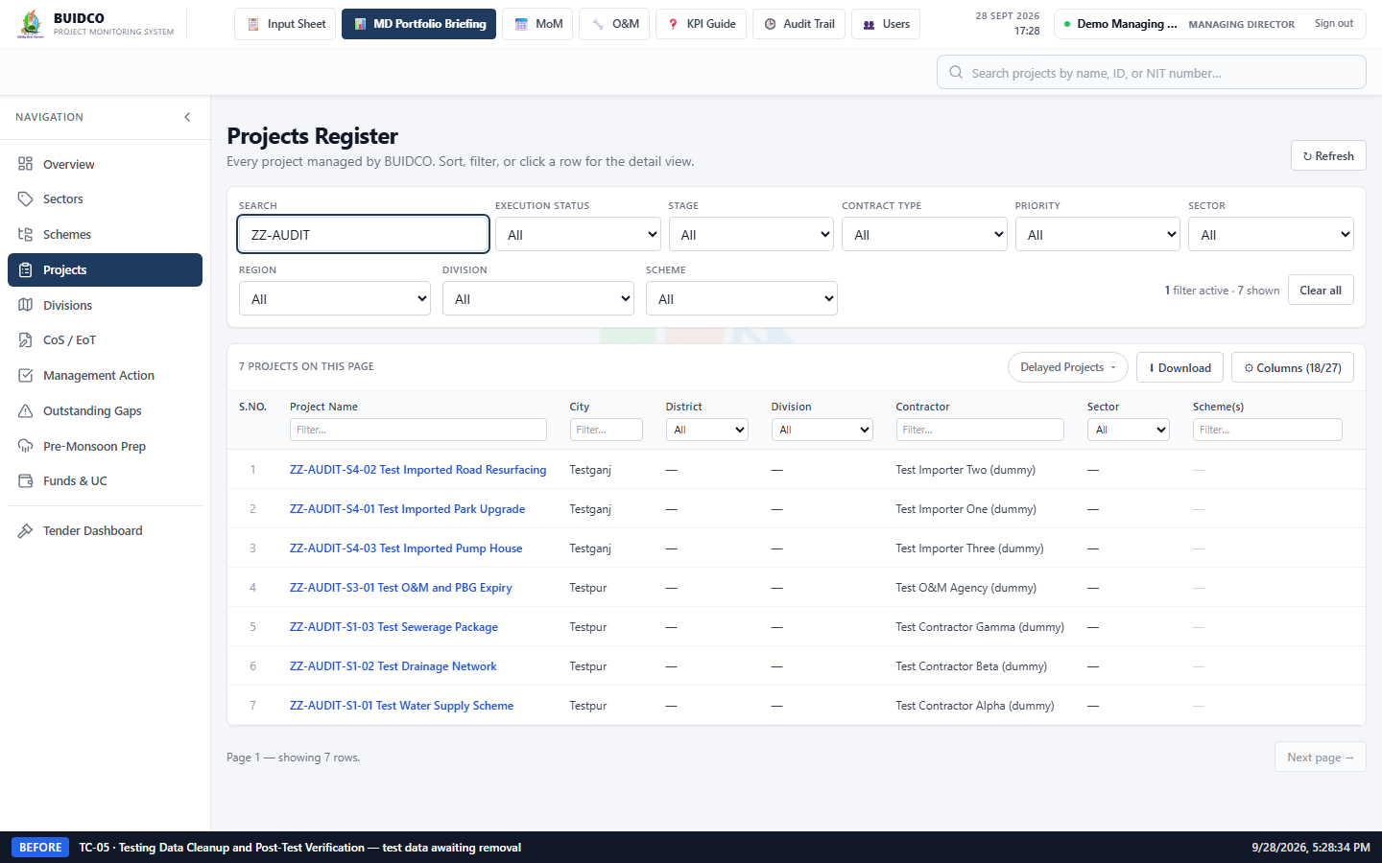
Figure 37 · [Before] All ZZ-AUDIT test records still present, immediately before cleanup. (captured 28/9/2026, 5:28:34 pm)
8. Action / Change Performed
Covered by the Before/After evidence below.
9. After Testing — Screenshots
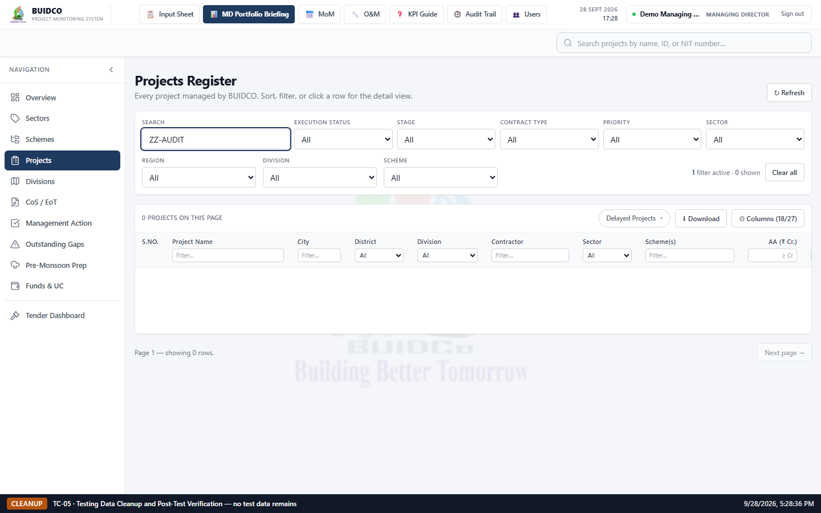
Figure 38 · [Cleanup] Projects section searched for "ZZ-AUDIT" after cleanup — no test records remain. (captured 28/9/2026, 5:28:37 pm)
Figure 39 · [Cleanup] Overview KPI tiles after cleanup — counts are back to the values recorded before testing began. (captured 28/9/2026, 5:28:38 pm)
10. Highlighted Changes
Every screenshot above carries a caption bar with the scenario, phase and capture time, and each changed element is outlined in red with a label.
- All test rows removed from the Projects section.
- KPI counts returned to their pre-test baseline values.
Test records removed
Project name | Created by | Created via | Cleanup result
ZZ-AUDIT-S1-01 Test Water Supply Scheme | TC-01 | Input Sheet UI | deleted
ZZ-AUDIT-S1-02 Test Drainage Network | TC-01 | Input Sheet UI | deleted
ZZ-AUDIT-S1-03 Test Sewerage Package | TC-01 | Input Sheet UI | deleted
ZZ-AUDIT-S3-01 Test O&M and PBG Expiry | TC-03 | API (test fixture) | deleted
ZZ-AUDIT-S4-02 Test Imported Road Resurfacing | TC-04 | Excel import | deleted
ZZ-AUDIT-S4-01 Test Imported Park Upgrade | TC-04 | Excel import | deleted
ZZ-AUDIT-S4-03 Test Imported Pump House | TC-04 | Excel import | deleted
Pre-test baseline vs post-cleanup KPI values
KPI tile | Before testing | After cleanup | Result
Total Projects | 70 | 70 | Restored
Completed | 4 | 4 | Restored
In Progress | 8 | 8 | Restored
Not Started | 11 | 11 | Restored
Delayed | 40 | 40 | Restored
On Hold | 7 | 7 | Restored
Total AA | ₹ 1,665.40 Cr | ₹ 1,665.40 Cr | Restored
Total Agreement | ₹ 1,428.51 Cr | ₹ 1,428.51 Cr | Restored
Avg Physical Progress | 47.5% | 47.5% | Restored
Avg Financial Progress | 28.5% | 28.5% | Restored
11. Expected Result
- All temporary test records created during this session are removed.
- No production/existing project data is modified or deleted.
- Project counts and KPI tiles return to their pre-test values.
12. Actual Result
- Every project-count KPI tile returned to exactly its pre-test value.
- 7 test project(s) deleted.
- A direct API search for "ZZ-AUDIT" returns no records.
- The Projects section shows no "ZZ-AUDIT" rows.
13. Test Status
Pass
14. Remarks / Observations
- Only records created by this testing session were deleted. Each deletion was id-targeted from the registry written at creation time and guarded by a re-check of the test-data tag, so no existing project could be removed by a name-pattern sweep.
- The demo_md account and the seeded demo accounts are pre-existing application data and were left untouched.
15. Cleanup Confirmation
- 7 temporary test project(s) removed.
- Temporary Excel test file retained under audit-evidence/files for evidence, and removable with the documented cleanup command.
- No existing/production application data was modified or deleted.

Final Audit Evidence
This document provides evidence that:
- The application was tested using the four defined functional scenarios — project creation through the Input Sheet, CRUD on a project, O&M and PBG expiry handling, and Excel import.
- Testing was performed entirely with controlled test data on a local environment.
- Existing application data and functionality were protected throughout, and were verified unchanged after testing.
- Changes were verified through Before and After screenshots, with the changed element outlined in every image.
- KPIs, project statuses, CRUD operations, expiry conditions and the import function were each exercised and verified.
- All temporary testing records were removed after the evidence was captured, and the dashboard returned to its exact pre-test values.
Overall result
Test Case ID | Scenario | Status
TC-01 | Create New Projects Through Input Sheet | Pass
TC-02 | CRUD Testing for Existing Projects | Pass
TC-04 | Import Projects Through Excel Sheet | Pass
TC-05 | Testing Data Cleanup and Post-Test Verification | Pass
All test scenarios completed successfully. No functional defect was found.
Observations raised for review
The following scenarios passed their functional checks but raised a point worth reviewing. Neither is a data fault; both describe the application behaving as written.
- TC-03: once the PBG expiry date has passed, the PBG Alert column renders an em dash, the same as a project that has no PBG recorded at all (PbgAlertCell returns "—" for days < 0). The O&M column, by contrast, shows an explicit red "Expired Nd ago". An expired PBG is therefore visible in the O&M-style treatment but not in the PBG column. This is the component behaving as written rather than a data fault, but it is worth review: a lapsed PBG is arguably more urgent than one expiring next week, and it is currently indistinguishable from "no PBG on record" in that column.
Reproducibility
Every screenshot and figure in this report was produced by an automated run, not assembled by hand. To reproduce it, from the frontend/ directory:
npm run audit
npm run audit:report
The specs live in frontend/e2e/audit/ and the raw evidence (screenshots, per-scenario JSON, the generated Excel import file) is written to frontend/audit-evidence/.

