|  |  |  |  |
| --- | --- | --- | --- |
|  | **Prepared By / Last Updated By** | **Reviewed By** | **Approved By** |
| **Name** | Prashant Singh Shoeran  Bhavesh Tyagi  Ghufran Khan  Sharad Sirohi  Mohd. Azam |  |  |
| **Role** |  |  |  |
| **Signature** |  |  |  |
| **Date** | 22/04/2019 |  |  |

 **Credit Card Onboarding**

**Business Requirements Document**

**V1.0**

**Table of Contents**

**1.0** **Introduction** **3**

**1.1** **Purpose of this document** **3**

**1.2** **Project Overview** **3**

1.2.1 Objectives 3

**1.3** **Intended Audience** **3**

**2.0** **Process Architecture** **4**

**3.0** **High Level Business Requirements** **5**

**4.0** **Detailed Business Requirements** **5**

**4.1** **Functional Requirements** **5**

**5.0** **References** **10**

**5.1** **Table 1.0** **10**

**5.2** **Table 2.0** **10**

**5.3** **Table 3.0** **11**

**5.4** **Table 4.0** **11**

**6.0** **Terms and conditions** **12**

**7.0** **Change Log** **12**

# 1.0 Introduction

## 1.1 Purpose of this document

This document is aimed at:

* Providing the necessary inputs to the detailed requirements gathering phase and further on for the SDLC processes.
* This document also serves to establish the traceability between the Business Objectives and the requirements identified in the proposed solution and how they satisfy the stated objectives.
* Provide expectation traceability in terms of the requirements and the user expectation
* Serves as a formal template for documenting the Business Requirements which also includes statutory and regulatory requirements.

The purpose of this document is to systematically capture the requirements of the project and the system to be developed. The document also captures the Functional requirements and serves as an input for the scope of project.

## 1.2 Project Overview

The Customer experience becomes imperative in any touch point with the bank. To have a seamless experience while the Customer applies for a Credit Card, right from the time of applying and all the way till approval, and customer notification, is the predominant objective behind the need to have an online Credit Card Onboarding application.

### This proposed application will provide quick response to the customer as compared to the traditional way. This will significantly save tremendous amount of time for the customers as well as the credit card underwriters/approvers.

### 1.2.1 Objectives

Below are the objectives that shall be fulfilled post the execution of this project:

• Members fill the credit card application form.

• Members give the answers for some questions for verification.

• Procurement of member’s applications for validation.

• Generation of the verification status message.

## 1.3 Intended Audience

* Interns/Project Team
* Mentors and SME’s
* Delivery assurance/excellence group

# 2.0 Process Architecture

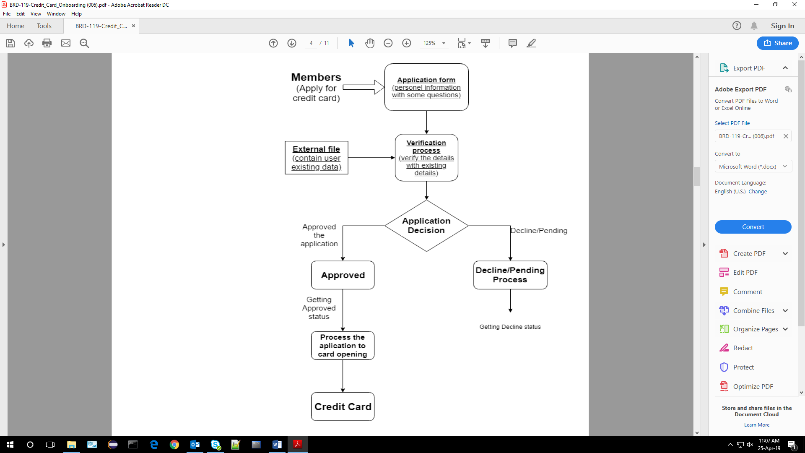

# 3.0 High Level Business Requirements

Note - Primary focus is to complete developing the critical requirements (highlighted in Yellow) and then to proceed with the remaining requirements.

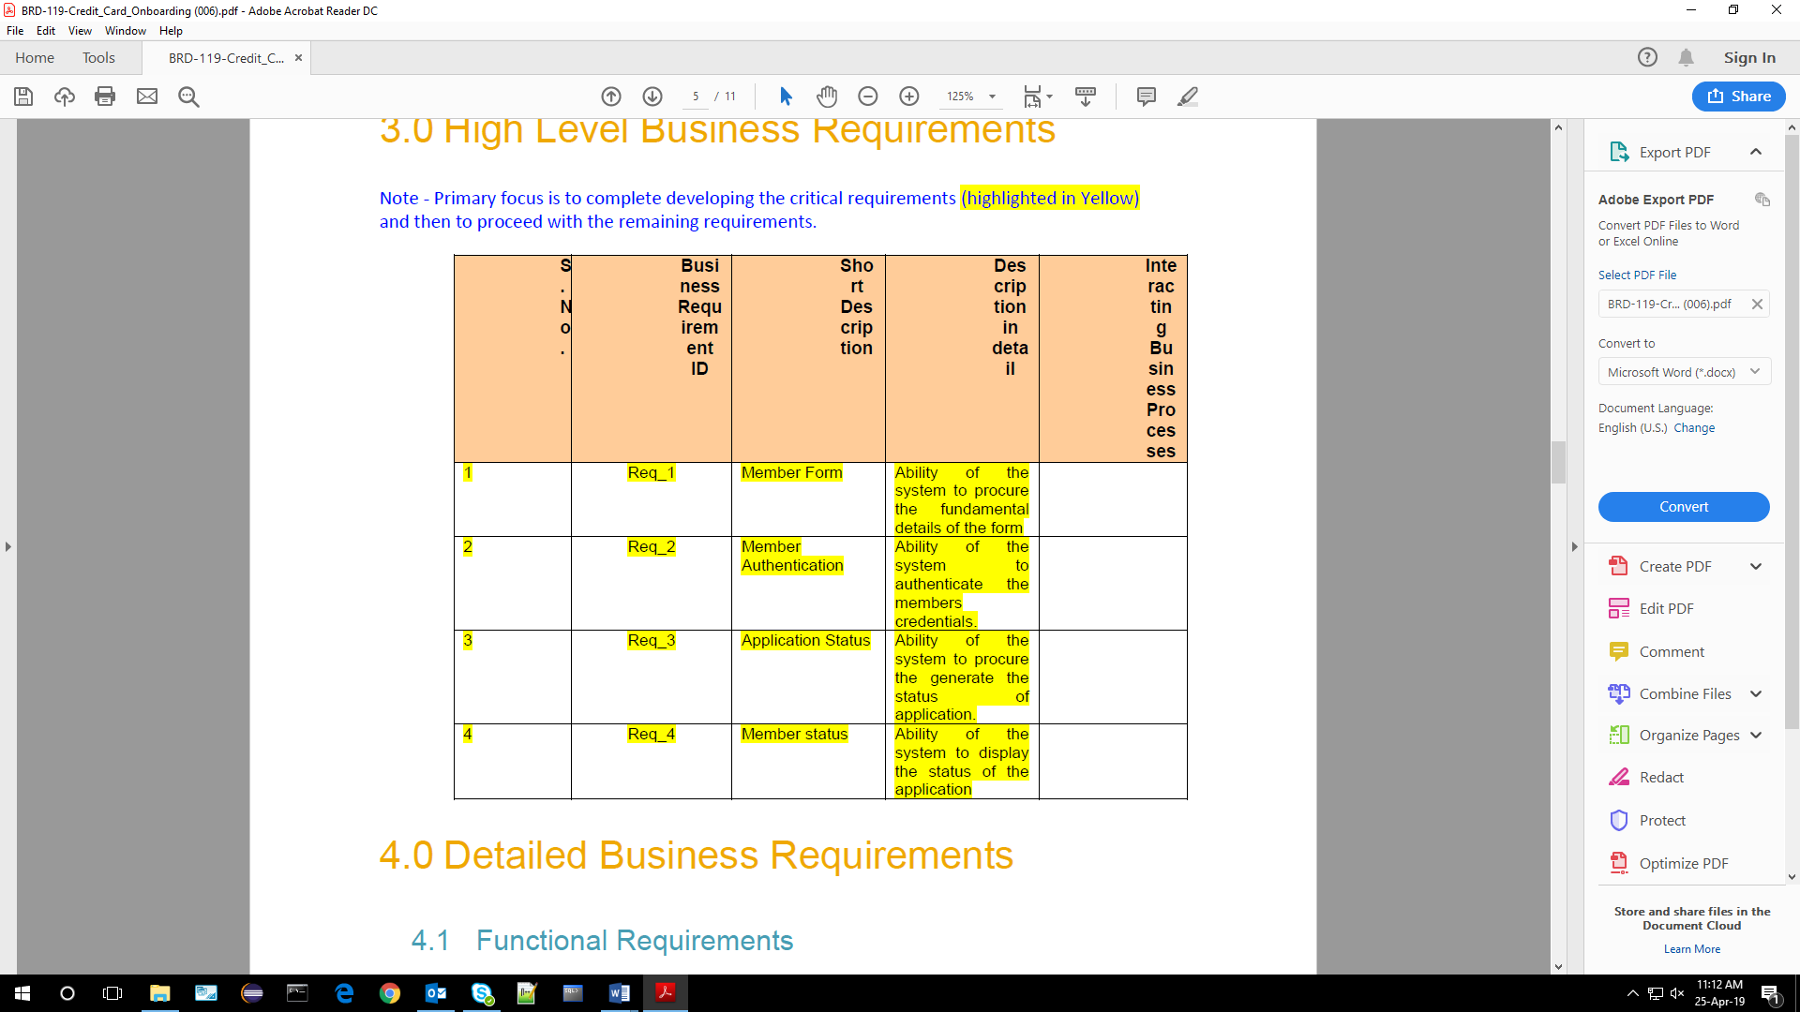

# 4.0 Detailed Business Requirements

## 4.1 Functional Requirements

The functional requirements are projected below, for each of the high level requirements called out in the earlier section

Additionally, the following elements are captured for each business requirement in the table provided below:-

* Req. Type = (F Core Functionality, E Exception, UI User Interface, R Reporting)

** Priority of Requirement = (1=Base Functionality, 2=Advanced Functionality,

3=Additional Opportunities)

** Originator = (Name of the business process of the system/ department or function name in the customer organization)

The Requirements in this document are prioritized as follows:

|  |  |  |
| --- | --- | --- |
| **Value** | **Rating** | **Description** |
| 1 | Critical | This requirement is critical to the success of the project. The project will not be possible without this requirement. |
| 2 | High | This requirement is high priority, but the project can be implemented at a bare minimum without this requirement. |
| 3 | Medium | This requirement is somewhat important, as it provides some value but the project can proceed without it. |
| 4 | Low | This is a low priority requirement, or a “nice to have” feature, if time and cost allow it. |
| 5 | Future | This requirement is out of scope for this project, and has been included here for a possible future release. |

|  |  |  |  |  |  |  |  |
| --- | --- | --- | --- | --- | --- | --- | --- |
| **Req. #** | **Rationale Categorization** | **Business Requirement** | **Req.**  **Type**  **\*** | **Priority \*\*** | **Originator**  **\*\*\*** | **BR Traced to Business**  **Requirement / Use case ID** | **Remarks** |
| 1.01 | Member Form | When the member clicks on the form link, it should re-direct to credit card application form. | UI | Critical | NA | REQ-1 |  |
| 1.02 | Member Form | Member needs to fill some of the basic attributes/fields as mentioned below in requirement: First Name, Last Name, Age, Gender, Contact Number, UID number with questions for verification process. | UI | Critical | NA | REQ-1 | Please refer  Table 1.0 under References section |
| 1.03 | Member Form | Clicking ‘Submit’ should validate the datatype constraints for each field | F | Critical | NA | REQ-1 |  |
| 1.04 | Member Form | Member failing to provide information on the mandatory fields be provided with an alert message – ‘Please update the highlighted mandatory field(s).’ Also, highlight the missed out field in red | E | Medium | NA | REQ-1 |  |

|  |  |  |  |  |  |  |  |  |
| --- | --- | --- | --- | --- | --- | --- | --- | --- |
| **Req. #** | **Rationale Categorization** | **Business Requirement** | **Req.**  **Type**  **\*** | **Priority \*\*** | **Originator**  **\*\*\*** | **BR Traced to Business**  **Requirement / Use case ID** | **Remarks** | |
| 1.05 | Member Form | Post-successful field level validation. | F | Critical | NA | REQ-1 |  |  |
| 2.01 | Member Authentication | Member able to click ‘Submit’ button, after keying in mandatory fields in the form. | F | Medium | NA | REQ-2 |  |  |
| 2.02 | Member Authentication | After clicking on the button the verification process is start. | F | Critical | NA | REQ-2 |  |  |
| 2.03 | Member Authentication | Verify the verification answers enter in the application form with existing details. | F | Critical | NA | REQ-2 |  |  |
| 3.01 | Application Status | Form answers match with the existing details then provide the message – ‘Details verified successfully done’. | F | Critical | NA | REQ-3 |  |  |
| 3.02 | Application Status | After getting success message make set verified flag to true. | F | Critical | NA | REQ-3 |  | |
| 3.03 | Application Status | User can redirect to success page and getting processing details and card link | F | Critical | NA | REQ-3 |  | |

|  |  |  |  |  |  |  |  |
| --- | --- | --- | --- | --- | --- | --- | --- |
| **Req. #** | **Rationale Categorization** | **Business Requirement** | **Req.**  **Type**  **\*** | **Priority \*\*** | **Originator**  **\*\*\*** | **BR Traced to Business**  **Requirement / Use case ID** | **Remarks** |
| 3.04 | Application Status | Form answers does not match with the existing details then provide the message – ‘Please provide the correct details’. | F | Critical | NA | REQ-3 |  |
| 3.05 | Application Status | After getting decline message make set verified flag to false. | F | Critical | NA | REQ-3 |  |
| 4.01 | Member Status | Get the Application request details based on the User ID and display the status. | UI | Critical | NA | REQ-4 | Please refer  Table 2.0 under References section |

# 5.0 References

## 5.1 Table 1.0

|  |  |  |  |  |
| --- | --- | --- | --- | --- |
| **Field**  **Name** | **Field Type** | **Data Type** | **Mandatory** | **Possible Values** |
| First Name | Text(50) | Alphabetic | Yes |  |
| Last Name | Text(50) | Alphabetic | Yes |  |
| Age | Numeric(2) | Numeric | Yes |  |
| Gender | Drop Down | NA |  | Male, Female |
| Contact Number | Text(10) | Numeric | Yes |  |
| Verified | Boolean |  | Yes |  |
| UID Number | Numeric(20) | Numeric | Yes |  |
| Password | Text(15) | Alphanumeric | Yes |  |

## 5.2 Table 2.0

|  |  |  |  |  |
| --- | --- | --- | --- | --- |
| **Field Name** | **Field Type** | **Data Type** | **Mandato ry** | **Possibl e**  **Values** |
| UID Number | Numeric(20) | Numeric | Yes |  |
| Application ID | Numeric(20) | Numeric | Yes |  |
| Application Date | Text(10) | Alphanumeric | Yes |  |
| Status | Drop Down | NA | Yes | Submitted  Accepted  Rejected |

# 6.0 Terms and conditions

Interns shall be solely responsible for all its acts and omissions under this program. Interns will comply at all times with all applicable laws. Interns shall not use Cognizant’s name, logo and trademark in any promotional materials or other communications with third parties without the prior written consent of Cognizant. Any materials used by interns in relation to program will not infringe the copyrights, trademarks, patents, trade secrets or other intellectual property rights, privacy or similar rights of any person or entity. Interns agrees not to post, draw, make, display any content that is threatening, libelous, obscene, defamatory, abusive, pornographic, or advocates/encourages any conduct that could constitute a criminal offence or give rise to any civil liability. Cognizant its associates’ personal details including but not limited to name, address, contact number shall not be shared or forwarded to any third party, without prior written consent of Cognizant, its associates. All intellectual property provided by Cognizant as part of program shall be owned exclusively by Cognizant. Intern shall indemnify, defend and indemnify Cognizant its associates, officers, directors from and against any claims, demands, loss, damage, liability, causes of action, judgments, or costs and expenses of every nature (including attorney’s fees and expenses) incurred by Cognizant based on any claim that any breach of terms and conditions of this program.

# 7.0 Change Log

|  |  |  |  |  |
| --- | --- | --- | --- | --- |
| **Version Number** | **Changes Made** | | | |
| V1.0.0 | Initial baseline created on <dd-Mon-yy> by <Name of Author> | | | |
| Vx.y.z | <Please refer the configuration control tool / change item status form if the details of changes are maintained separately. If not, the template given below needs to be followed> | | | |
| **Section No.** | **Changed By** | **Effective Date** | **Changes Effected** |
|  |  |  |  |