PROJECT REPORT
INVENTORY MANAGEMENT SYSTEM
A Python Desktop Application using Tkinter and MySQL

Submitted by:
Jinali Jain 1262243057
Diya Chordiya 1262242873
Diya Kumari 1262242970
Bhavika Rane 1262242228
Vanshika Agarwal 1262242242
Submitted to
Faculty Name: Prof. Gauri Bilaye
Department: TY B.TECH. CSE AIDS F
Academic Year: 2024-2028

ACKNOWLEDGEMENT
We would like to express our sincere gratitude to our faculty guide and department for providing guidance and the opportunity to develop this project. We also acknowledge the documentation and learning resources that helped us understand Python programming, GUI development, database connectivity and data visualization. This project helped us apply these concepts in a practical inventory-management application.

ABSTRACT
The Inventory Management System is a Python-based desktop application designed to organize product information and support routine inventory operations. The application provides a graphical user interface built with Tkinter. Its backend connects to a MySQL database and supports product management, stock updates, sales and purchase recording, low-stock detection, dashboard statistics, and CSV import/export. Matplotlib is used to display charts within the desktop interface, while Pandas supports tabular data processing and CSV handling. The project also includes a synchronization mechanism that checks for changes in MySQL and the inventory CSV file. The main objective is to make inventory information easier to maintain, search and review.

TABLE OF CONTENTS
1. Introduction
2. Problem Statement
3. Objectives
4. Scope of the Project
5. Tools and Technologies
6. System Requirements
7. System Design and Architecture
8. Database Design
9. Implementation
10. Functionalities of the System
11. Testing and Validation
12. Advantages and Limitations
13. Future Enhancements
14. Conclusion
15. References

1. INTRODUCTION
Inventory management is the process of maintaining records of products, monitoring available quantities and tracking stock movement. When product information is maintained manually, it can become difficult to search records, identify products that need replenishment and review sales or purchase activity. A computerized system can make these tasks more organized.
The Inventory Management System developed for this project is a desktop application written in Python. It uses Tkinter for the interface and MySQL for storing inventory and transaction data. The application also uses CSV files to support data exchange and Matplotlib to present selected information as charts.

2. PROBLEM STATEMENT
Maintaining product details, quantities, sales and purchases manually can be time-consuming and may lead to outdated records or difficulty locating low-stock products. The problem addressed by this project is to provide a simple desktop application where inventory records and related transactions can be managed in a centralized database and reviewed through a graphical interface.

3. OBJECTIVES
- To provide a graphical interface for managing product details.
- To store inventory, sales and purchase records in a MySQL database.
- To support adding, viewing, updating and deleting product records.
- To record sales and purchases and update stock quantities accordingly.
- To identify products whose quantities are at or below their reorder levels.
- To display inventory summaries and charts on a dashboard.
- To support importing and exporting inventory data using CSV files.
- To check for changes in MySQL and the inventory CSV file and refresh the interface when needed.

4. SCOPE OF THE PROJECT
The system is intended for basic inventory-management tasks in a small store, lab, or similar setting. It supports product records, stock quantities, transaction recording, low-stock review, dashboard summaries and CSV data exchange. The current implementation is a desktop application and uses a local MySQL connection configured through environment variables or a local password file.
The application does not claim to provide enterprise resource planning, multi-branch inventory, user-role management, cloud hosting or automated supplier ordering.

5. TOOLS AND TECHNOLOGIES
Technology | Purpose | Use in the Project
Python | Programming language | Implements the application logic and event handling.
Tkinter / ttk | GUI development | Creates the window, tabs, forms, buttons, labels and tables.
MySQL | Database management | Stores inventory, sales and purchase records.
mysql.connector | Database connectivity | Connects Python functions to MySQL.
Pandas | Tabular data handling | Processes inventory data and supports CSV operations.
CSV | Data exchange | Imports and exports inventory records.
Matplotlib | Data visualization | Displays dashboard charts inside the Tkinter window.

6. SYSTEM REQUIREMENTS

6.1 Hardware Requirements
- A desktop or laptop computer.
- Sufficient memory and storage to run Python, MySQL and the application.
- A keyboard and pointing device for user interaction.

6.2 Software Requirements
- Windows, Linux or macOS with a compatible Python installation.
- Python 3 with the packages used by the project.
- MySQL Server.
- A code editor or terminal such as Visual Studio Code (optional for running the program).
Python dependencies used by the supplied code include mysql-connector-python, pandas and matplotlib. Tkinter is included with many standard Python installations, although some Linux installations may require a separate Tkinter package.

7. SYSTEM DESIGN AND ARCHITECTURE

7.1 Architecture
The system follows a simple two-layer application structure. The frontend is implemented in main.py and handles user interaction. The backend is implemented in backend.py and handles database operations, inventory rules, transaction processing, CSV synchronization and data retrieval. MySQL stores the records. The frontend calls backend functions and refreshes the displayed data after successful operations.
Typical operation flow:
- The user enters data or clicks a button in the Tkinter interface.
- The relevant function in main.py validates the input and calls a backend function.
- The backend executes the required database or CSV operation.
- The backend returns a success flag and a message or data.
- The frontend displays a message and refreshes the inventory or dashboard where appropriate.

7.2 Main Interface Sections
Dashboard: Shows summary cards for total products, units in stock, inventory value, low-stock products, today's sales and today's purchases. It also displays charts and a low-stock table.
Inventory: Provides product input fields, add/update/delete actions, search, and a table of product records.
Sales & Purchases: Allows a user to enter a product ID and quantity and record a sale or purchase.
CSV controls: The footer provides manual refresh, CSV import, inventory CSV export and exit controls.

8. DATABASE DESIGN
The backend initializes the inventory database and creates the tables if they do not already exist. The supplied code defines three main tables.
Table | Important fields | Purpose
inventory | Product_ID, Product_Name, Category, Price, Quantity, Reorder_Level, SKU | Stores current product and stock information.
sales | Sale_ID, Product_ID, Product_Name, Quantity, Unit_Price, Total_Amount, Sale_Date | Stores sales transactions.
purchases | Purchase_ID, Product_ID, Product_Name, Quantity, Unit_Price, Total_Amount, Purchase_Date | Stores purchase transactions.
Product_ID is an auto-incrementing primary key in the inventory table. Sale_ID and Purchase_ID are auto-incrementing primary keys in their respective transaction tables. Prices and transaction totals use decimal database types to support monetary values. The SKU field can store an additional product identifier and is optional in the required CSV column set.

9. IMPLEMENTATION

9.1 Backend: backend.py
Database configuration: Reads the database host, username and database name from environment variables, with local defaults. The password is read from the INVENTORY_DB_PASSWORD environment variable or db_password.txt. This avoids hard-coding the password directly in the source file.
get_connection(): Creates and returns a MySQL connection using the configured settings.
initialize_database(): Creates the database and required tables if necessary. On first initialization, it can load products from inventory.csv into an empty inventory table and preserve a backup of the original CSV.
Inventory retrieval and synchronization: Functions such as _fetch_inventory(), _write_csv(), sync_inventory_to_csv() and sync_check() retrieve data, write the inventory CSV, and detect changes made in the application or outside it.
import_csv_to_db(): Reads and validates inventory.csv. It checks required columns and numeric values, detects duplicate identifiers, and applies changes within a database transaction. The code includes safeguards against importing an empty CSV over an existing inventory.
add_product(): Adds a new product record to inventory.
update_product(): Updates existing product details.
update_stock(): Changes a product's stock quantity.
delete_product(): Deletes a product from inventory.
get_low_stock(): Returns products whose quantity is less than or equal to the reorder level.
record_sale(): Records a sale and handles the corresponding reduction in available stock.
record_purchase(): Records a purchase and handles the corresponding increase in available stock.
Dashboard and chart data: Functions such as get_dashboard_kpis(), get_sales_data() and get_purchase_data() provide summary and transaction data for the GUI.
CSV import/export: import_csv_file() and export_inventory_csv() support selecting a CSV file to import and saving inventory records to a chosen CSV file.

9.2 Frontend: main.py
Imports: Imports Tkinter widgets, dialogs, Matplotlib components and the backend module.
InventoryApp class: Groups the GUI setup and event-handling methods.
__init__(): Sets the window title and dimensions, initializes the interface, refreshes data and schedules automatic synchronization.
setup_style() and setup_ui(): Configure widget appearance and create the tabs, buttons and status area.
setup_dashboard(): Builds the dashboard KPI cards, chart area and low-stock table.
refresh_dashboard(): Requests KPI, inventory, low-stock and sales data from the backend, then displays the values and charts.
setup_inventory(): Builds the product form, search box and inventory table.
get_form_values(): Reads and validates product name, category, price, quantity and reorder level. It rejects an empty product name and negative numeric values.
add_product(), update_product(), delete_product(): Connect the GUI buttons to the matching backend operations and show success, warning or error messages.
setup_transactions(), make_sale(), make_purchase(): Provide fields for product ID and quantity and call the backend transaction functions.
import_csv() and export_csv(): Use file dialogs to select a CSV for import or choose where to save exported inventory.
refresh_all() and auto_sync(): Refresh inventory and dashboard data and check periodically for external changes.

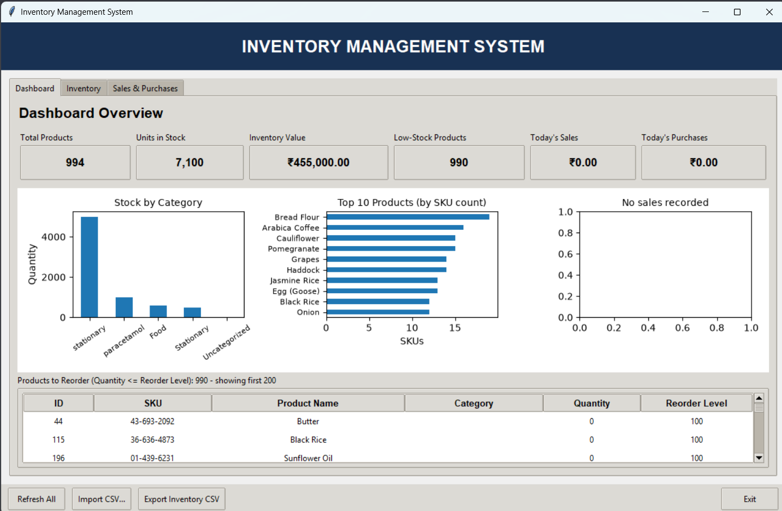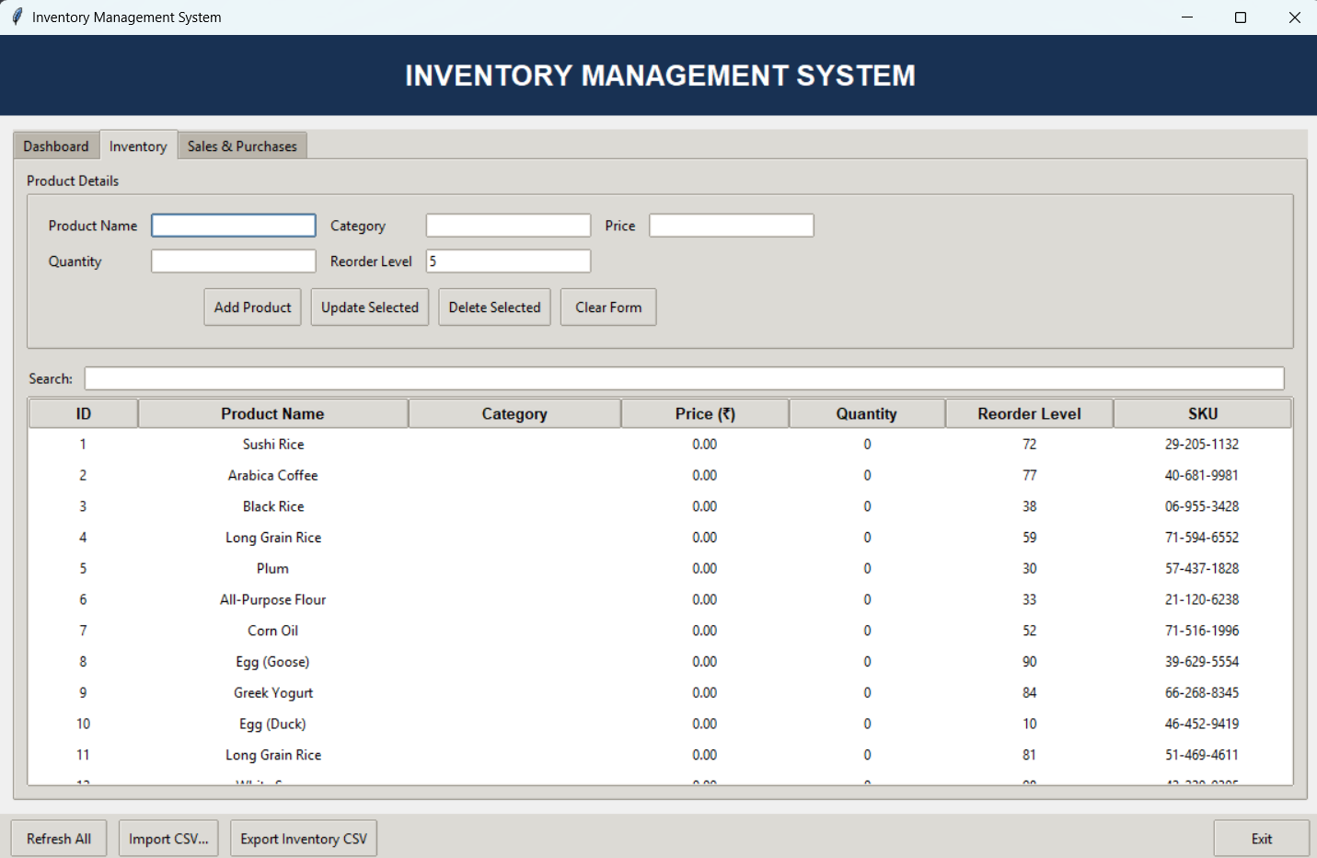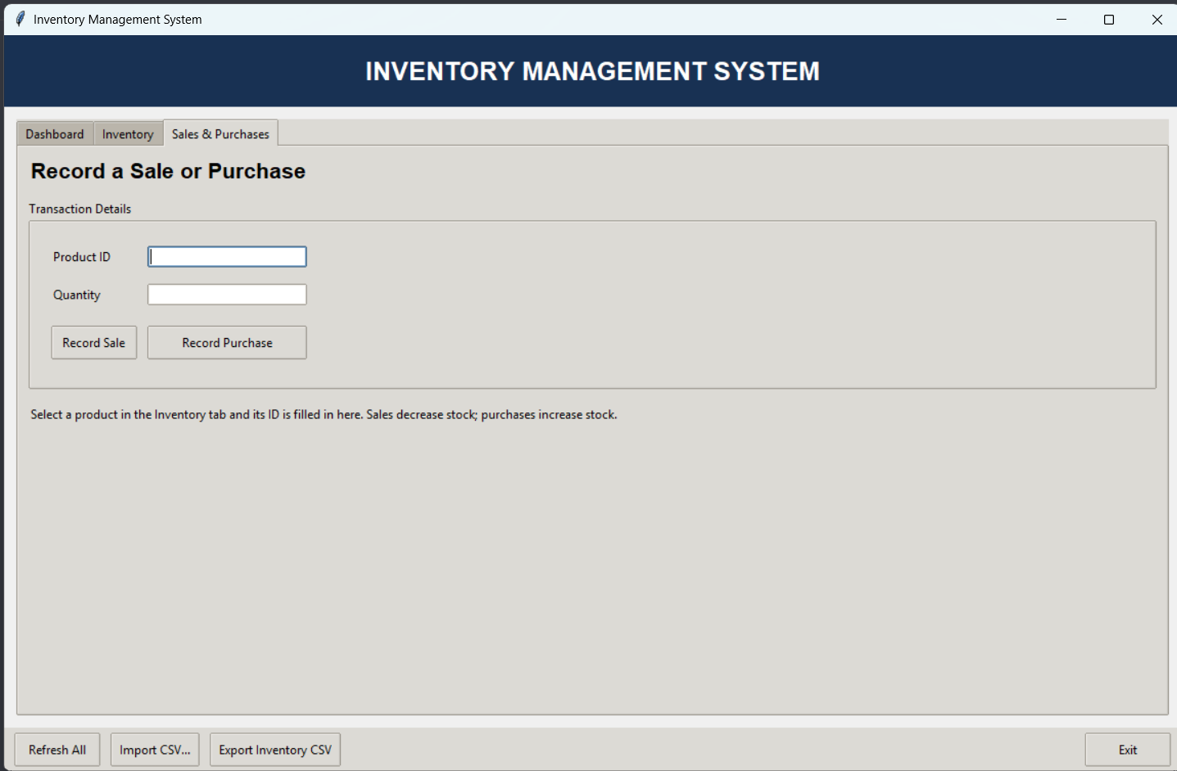

9.3 Low-Stock Logic
A product is considered low in stock when its current Quantity is less than or equal to its Reorder_Level. For example, if Quantity is 4 and Reorder_Level is 5, the product appears in the products-to-reorder list. If Quantity is 8 and Reorder_Level is 5, it does not meet the low-stock condition.

9.4 Inventory Value
Inventory value represents the combined value of available stock. The usual calculation is to multiply the price of each product by its quantity and add the results for all products.
Inventory Value = Σ (Product Price × Available Quantity)

9.5 Automatic Synchronization
The frontend schedules auto_sync() using Tkinter's after() method with AUTO_SYNC_MS = 3000. This means the application checks approximately every three seconds. The backend's sync_check() compares the CSV file's modification time and a MySQL table signature to detect changes, and the GUI refreshes its inventory and dashboard when changes are detected.

10. FUNCTIONALITIES OF THE SYSTEM
- Add new product details to the inventory.
- View and search product records.
- Update product information and stock quantities.
- Delete a selected product after confirmation.
- Record sales and reduce available stock.
- Record purchases and increase available stock.
- Identify products that have reached their reorder levels.
- Display dashboard KPI cards and charts.
- Import inventory data from a selected CSV file.
- Export inventory records to a selected CSV file.
- Automatically check for data changes and refresh the interface.

11. TESTING AND VALIDATION
The following are recommended functional test cases for validating the application. They are test plans, not claims that formal testing has already been completed. Record the actual result after running each test in your environment.
Test ID | Test case | Expected result | Actual result
T01 | Add a product with valid details | Product is stored and shown in the inventory table. | To be filled
T02 | Submit a blank product name | Validation message is displayed. | To be filled
T03 | Enter a negative price or quantity | Input is rejected with a validation message. | To be filled
T04 | Update a selected product | The selected product details are updated. | To be filled
T05 | Delete a selected product and confirm | The product is removed from the inventory. | To be filled
T06 | Record a sale | Sale is recorded and stock decreases. | To be filled
T07 | Record a purchase | Purchase is recorded and stock increases. | To be filled
T08 | Set quantity at or below reorder level | Product appears in the low-stock list. | To be filled
T09 | Export inventory to CSV | A CSV file is created at the selected location. | To be filled
T10 | Run with MySQL unavailable or incorrect credentials | The application displays a startup/database error. | To be filled
Note: CSV import/synchronization should be tested carefully using a backup because the synchronization logic can update, insert or delete inventory records to match the CSV contents.

12. ADVANTAGES AND LIMITATIONS

12.1 Advantages
- Provides a graphical interface instead of requiring users to enter SQL queries.
- Keeps inventory and transaction records in a structured MySQL database.
- Supports searching and common product-management operations.
- Helps identify low-stock products using reorder levels.
- Presents key figures and charts on a dashboard.
- Supports CSV import/export for spreadsheet use and data exchange.
- Separates frontend code from backend logic.

12.2 Limitations
- The current version is a desktop application rather than a web or mobile application.
- The supplied code does not include a full user login and role-based permission system.
- The database connection must be configured on the computer where the application runs.
- CSV synchronization requires care because an imported file can modify the database inventory.
- The report does not claim verified performance results or formal testing outcomes; these must be recorded after testing.

13. FUTURE ENHANCEMENTS
- Add user authentication and role-based access for administrators and staff.
- Add barcode or QR-code scanning for product identification.
- Provide printable invoices and transaction reports.
- Add supplier details and purchase-order management.
- Create scheduled backups and a clearer recovery workflow.
- Add date-range filters and more detailed sales/purchase reports.
- Provide a web-based or cloud-connected version for access from multiple devices.

14. CONCLUSION
The Inventory Management System demonstrates how Python, Tkinter, MySQL, Pandas, CSV and Matplotlib can be combined to build a desktop application for routine inventory tasks. The application provides product management, stock updates, sales and purchase recording, low-stock identification, dashboard summaries, charts and CSV data exchange. The separation between main.py and backend.py makes the application structure easier to understand and maintain. After completing and documenting functional tests, the system can be further improved with authentication, reporting and backup features.

15. REFERENCES
- Python Documentation — https://docs.python.org/3/
- Tkinter Documentation — https://docs.python.org/3/library/tkinter.html
- MySQL Connector/Python Developer Guide — https://dev.mysql.com/doc/connector-python/en/
- Pandas Documentation — https://pandas.pydata.org/docs/
- Matplotlib Documentation — https://matplotlib.org/stable/

APPENDIX A: HOW TO RUN THE PROJECT
- Install Python and MySQL Server.
- Install the required Python packages, for example: pip install mysql-connector-python pandas matplotlib.
- Configure the database connection settings. The backend reads the password from INVENTORY_DB_PASSWORD or a db_password.txt file beside backend.py.
- Ensure the MySQL user has permission to create the database and tables, or create/configure the database with suitable permissions.
- Keep main.py and backend.py in the same project folder.
- Open a terminal in that folder and run: python main.py.
If startup fails, check that MySQL is running, the username and password are correct, the required packages are installed, and the configured MySQL account has the required permissions.

APPENDIX B: IMPORTANT FUNCTIONS FOR VIVA
Function / Component | Explanation for viva
get_connection() | Connects Python to MySQL.
initialize_database() | Creates the database and required tables and handles first-run CSV initialization.
add_product() | Adds a product to inventory.
update_product() | Changes product details.
update_stock() | Changes available quantity.
delete_product() | Removes a product record.
get_low_stock() | Finds products at or below the reorder level.
record_sale() | Records a sale and reduces stock.
record_purchase() | Records a purchase and increases stock.
get_dashboard_kpis() | Returns values displayed in the dashboard cards.
sync_check() | Checks for changes in MySQL or the inventory CSV and supports synchronization.
InventoryApp | Contains the Tkinter interface and event-handling methods.
auto_sync() | Schedules periodic synchronization checks approximately every three seconds.

