1. Employee
   1. CREATE TABLE command as follows
   2. 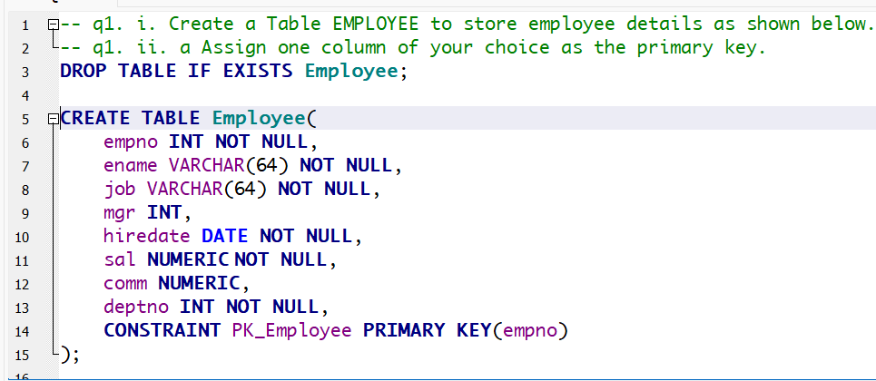a. Primary Key is **empno**

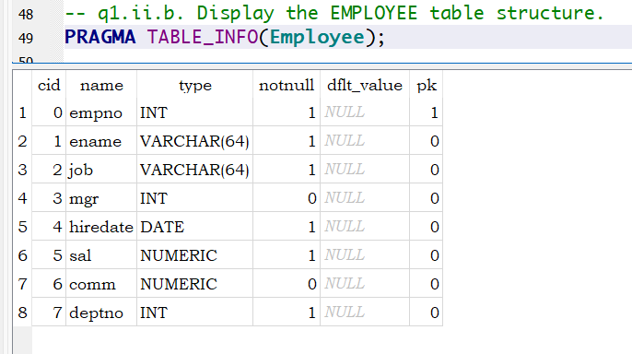b. I used sqlite browser for windows, PRAGMA is the command for this one. However, there are alternate ways to do this using Schema command.

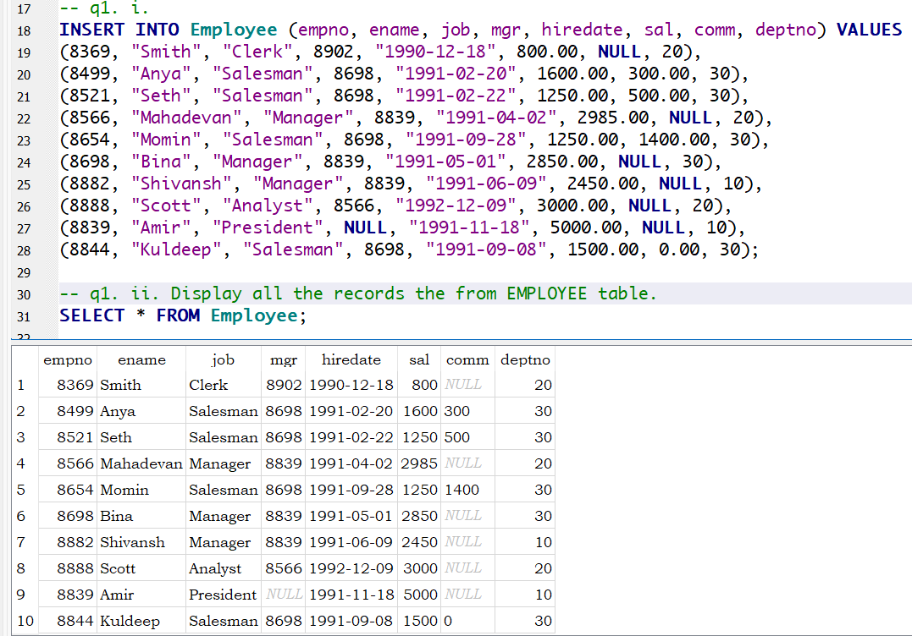c. SELECT * FROM Employee;

d. SELECT ename, sal FROM Employee WHERE sal >= 2200;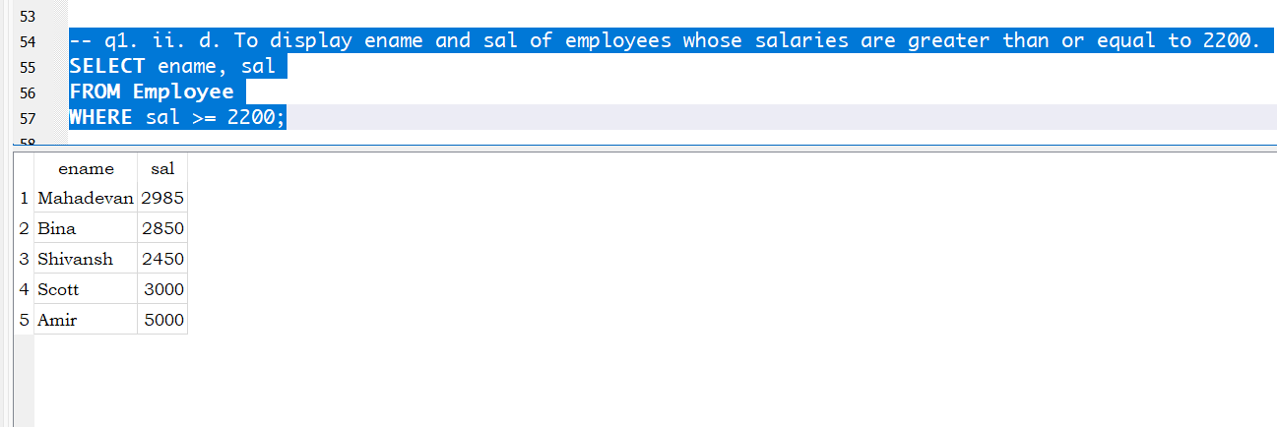

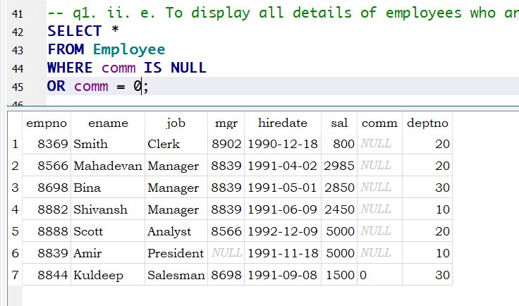e. SELECT * FROM Employee WHERE comm IS NULL OR comm = 0;

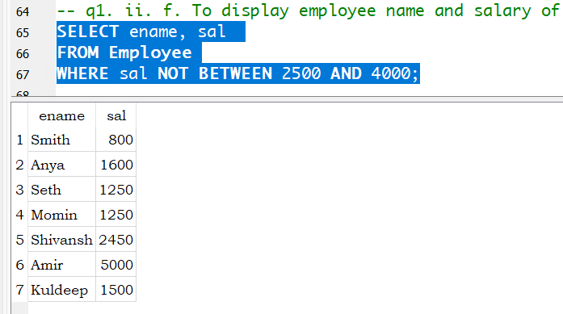f. SELECT ename, sal FROM Employee WHERE sal NOT BETWEEN 2500 AND 4000;

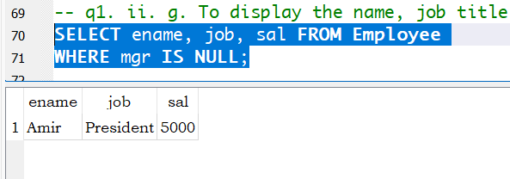g. SELECT ename, job, sal FROM Employee WHERE mgr IS NULL;

h. SELECT ename FROM Employee WHERE ename LIKE "__a%";

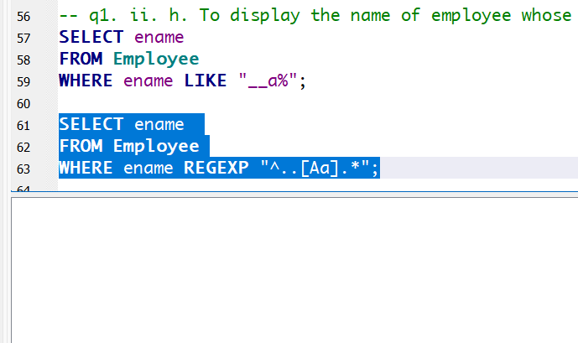SELECT ename FROM Employee WHERE ename REGEXP "^..[Aa].*";

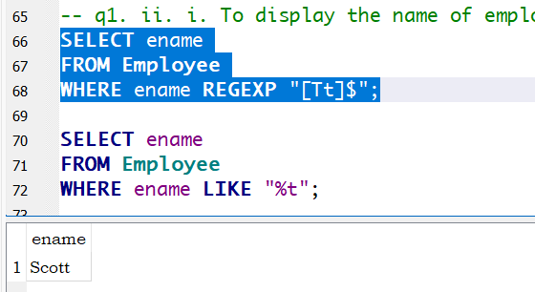i. SELECT ename FROM Employee WHERE ename REGEXP "[Tt]$";  
SELECT ename FROM Employee WHERE ename LIKE "%t";

j. SELECT ename FROM Employee WHERE ename LIKE "m_l%";

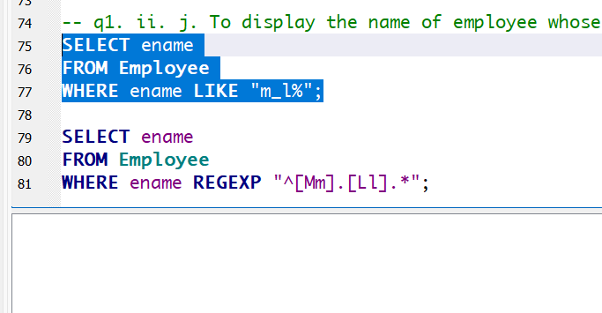 SELECT ename FROM Employee WHERE ename REGEXP "^[Mm].[Ll].*";

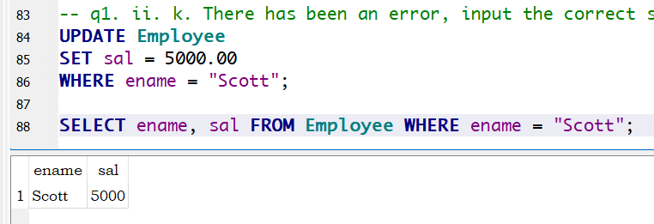k. UPDATE Employee SET sal = 5000.00 WHERE ename = "Scott";

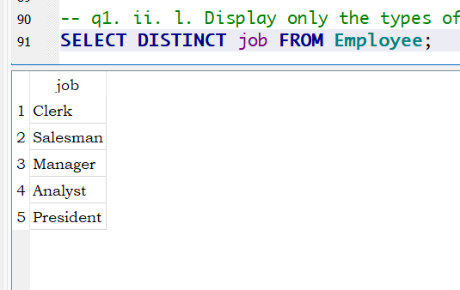l. SELECT DISTINCT job FROM Employee;

i.   
-- Student

DROP TABLE IF EXISTS Student;

CREATE TABLE Student (

StdID INT NOT NULL,

Fname VARCHAR(64) NOT NULL,

Lname VARCHAR(64),

Credits INT NOT NULL,

Dept VARCHAR(32) NOT NULL,

Gender VARCHAR(1) NOT NULL,

CONSTRAINT PK_Student PRIMARY KEY(StdID)

);

INSERT INTO Student (StdID, Fname, Lname, Credits, Dept, Gender) VALUES

(100, "Mary", "Cooper", 6000, "Drama", "F"),

(101, "Mike", "Carpen", 5000, "Maths", "M"),

(102, "Ryan", "Smith", 10000, "Drama", "M"),

(103, "Tom", "Randall", 4800, "Maths", "M"),

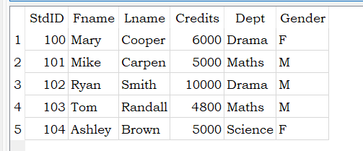(104, "Ashley", "Brown", 5000, "Science", "F");

-- Project

DROP TABLE IF EXISTS Project;

CREATE TABLE Project (

ProjectID INT NOT NULL,

ProjectName VARCHAR(64),

StdID INT NOT NULL,

CONSTRAINT PK_Project PRIMARY KEY(ProjectID)

);

INSERT INTO Project (ProjectID, StdID, ProjectName) VALUES

(1, 100, "Shakespeare"),

(2, 100, "Greek Tragedy"),

(3, 100, "Disaster"),

(4, 101, "Trigonometry"),

(5, 102, "Wizard of Oz"),

(6, 102,"Creative Dramatics"),

(7, 102, "Modern Art"),

(8, 106, "Natural Language Processing"),

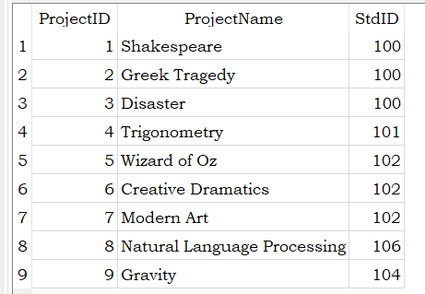(9, 104, "Gravity");

ii.

a.

SELECT Student.Fname, Student.Lname, Project.ProjectName

FROM Student JOIN Project

ON Student.StdID = Project.StdID

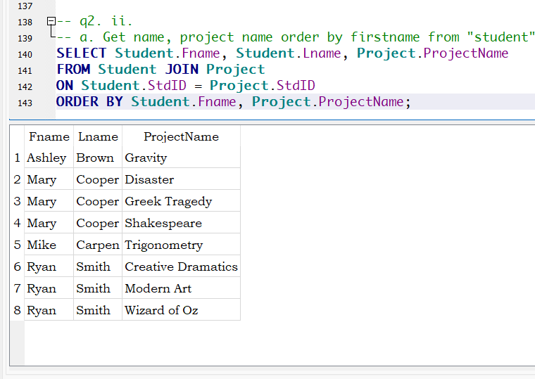ORDER BY Student.Fname, Project.ProjectName;

b.

SELECT Student.Fname, Student.Lname, Project.ProjectName

FROM Student LEFT JOIN Project

ON Student.StdID = Project.StdID

WHERE ProjectName IS NULL

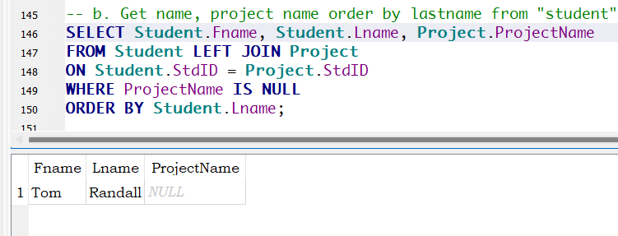ORDER BY Student.Lname;

c. SELECT Project.ProjectName

FROM Project LEFT JOIN Student

ON Student.StdID = Project.StdID

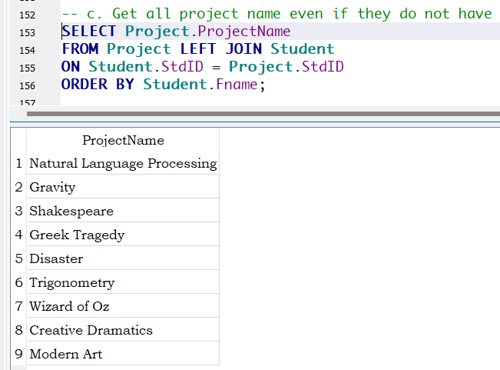ORDER BY Student.Fname;

d. SELECT Student.Fname, Student.Lname, Student.Credits, Student.Dept, Student.Gender, Project.ProjectName

FROM Project LEFT JOIN Student ON Student.StdID = Project.StdID   
UNION

SELECT Student.Fname, Student.Lname, Student.Credits, Student.Dept, Student.Gender, Project.ProjectName

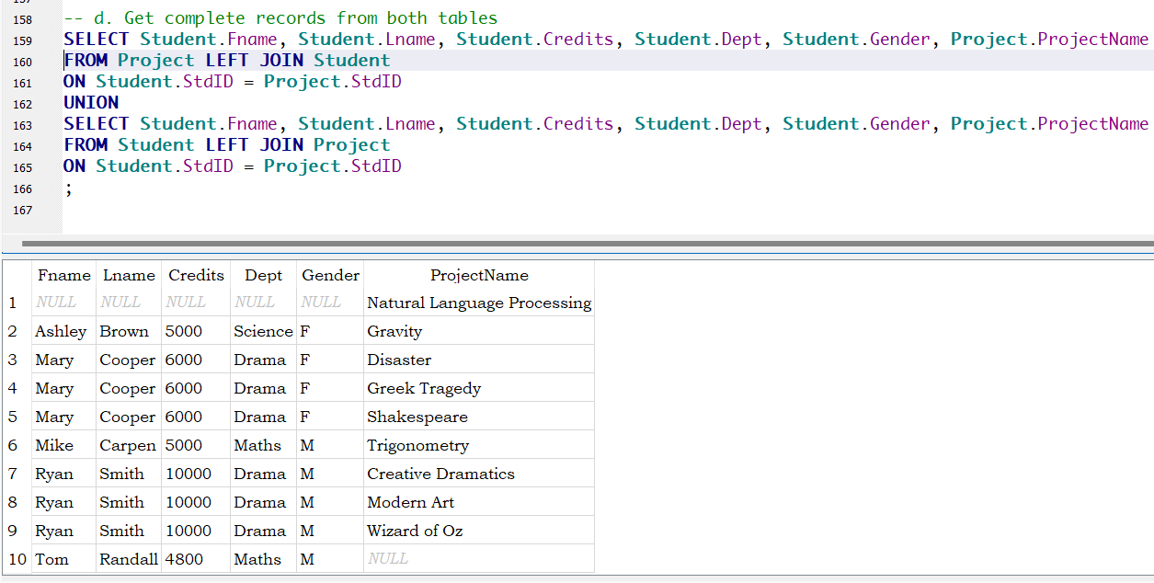FROM Student LEFT JOIN Project ON Student.StdID = Project.StdID;

3.

* Student (ID, NAME, SUBJECT, AVERAGE, DIV, CREDITS)
* Teacher (SUBJECT, PNAME)

1. a. Display the student, professor name and the subject.

SELECT Student.NAME, Student.SUBJECT, Teacher.PNAME

FROM Student JOIN Teacher

ON Student.SUBJECT = Teacher.SUBJECT;

b. Display all the student and professor name who are offering subjects Maths and Science.

SELECT Student.NAME, Teacher.PNAME

FROM Teacher LEFT JOIN Student

ON Teacher.SUBJECT = Student.SUBJECT

WHERE Teacher.SUBJECT IN (“Maths”, “Science”);

c. Correct the following query if you find any errors.

Select NAME from Student where CREDITS = **NULL**; (NULL All Uppercase)

Select NAME, CREDITS From Student where CREDITS BETWEEN 10 AND 20; (No error)