**A PROJECT REPORT ON**

Task Management CRM

**SUBMITTED TO:**

**Geetanjali Group of Colleges**

**FRONT END**

HTML, CSS, Js,Bootstrap

**BACK END**

Laravel

**AFFILIATED BY**

Saurashtra University

**ACADEMIC YEAR**

2024-2025

**PROJECT GUIDE:**

**Prof . Harsh Joshi**

**PREPARED BY**

**Bhavik Sapariya**

**Acknowledgement**

* First and foremost, we are sincerely thankful to Saurashtra University for giving us the opportunity to work on this project as part of our curriculum.
* We extend our gratitude to Geetanjali Group Of Colleges for providing us with the resources and environment needed to develop our project.
* We are particularly grateful to our Head of Department, Prof. Brijesh Shah
  + for their constant support and guidance throughout the project.
* We would like to express our deepest appreciation to our project guide, Harsh Joshi, who guided us through the analysis and development phases of our project, providing invaluable advice and support.
* We are also thankful to all well-wishers and friends who supported us during the project development.

Yours Faithfully**,  
Bhavik Sapariya**

**Preface**

* In the 21st century, technology plays a crucial role in everyday life,enhancing the speed and efficiency of work. As part of our MSC-IT program, which combines both practical and theoretical learning, this project serves as an essential component to bridge academic knowledge with real-world application.
* The project,undertaken in the 1st semester at Geetanjali Group Of Colleges, affiliated with Saurashtra University, Rajkot, is a reflection of our understanding and skills gained throughout our coursework.
* A Task Management CRM combines the functionalities of customer relationship management (CRM) with task and project management tools. It is designed to help businesses manage customer interactions, sales processes, and the internal tasks or project
* I have gone through and study necessary information, which is collected and presented in this report. I am trying my best in this project.I have taken almost care that are information provided in the project is true and project is in a smooth running condition and error free.

**Index**

|  |  |  |
| --- | --- | --- |
| **SR.NO** | **TOPICNAME** | **PAGENO.** |
| 1 | Project Profile | 1 |
| 2 | Project Requirement | 2 |
| 3 | Technology Requirement | 3 |
| 4 | Data Flow Diagram | 4 |
| 5 | E-R Diagram | 5 |
| 6 | SDLC | 6 |
| 7 | Data Dictionary | 9 |
| 8 | Test Case | 12 |
| 9 | Screen Shots | 13 |
| 10 | Future Enhancement | 23 |
| 11 | Limitation | 24 |
| 12 | Webliography | 25 |

**Project Profile**

* **Project Title:** Task Management CRM
* **Development Software:** Visual Studio Code
* **Front End:** HTML, CSS, JavaScript, Bootstrap
* **Back End:** Laravel
* **Academic Year:** 2024-2025
* **Developed By:** Bhavik Sapariya
* **Submitted To:** Geetanjali Group Of Colleges
* **Documentation Tool:** Microsoft Word
* **Operating System:** Windows 11

**Project Requirement**

* **Processor:** Intel Core i3 or higher
* **RAM:** 4 GB or more
* **Hard Disk:** 500 GB or more

**Technology Requirement**

* **Platform:** Laravel
* **Operating System:** Windows 11 / macOS / Linux
* **Front End Tools:** HTML, CSS, JavaScript,Bootstrap
* **Back End Tools:** laravel
* **Additional Libraries:** Bootstrap, FontAwsome
* **Editing Tool:** Visual Studio Code
* **Browser:** Google Chrome, Mozilla Firefox, or any modern browser

**Data Flow Diagram**

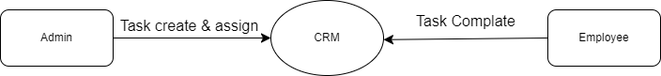

**E-R Diagram**

* An entity Relationship Diagram (ERD) is a data modeling technique that graphically illustrates an information system’s entities and the relationship between those entities . An ERD is a conceptual and representation model of data used to represent the entity from work infrastructure .
* Admin Side :-

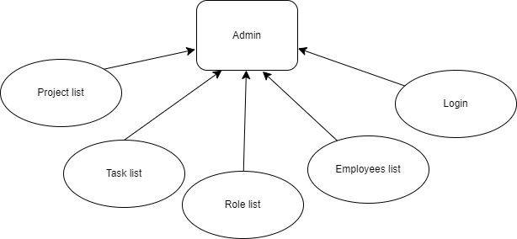

* Employee Side (Other Role):-

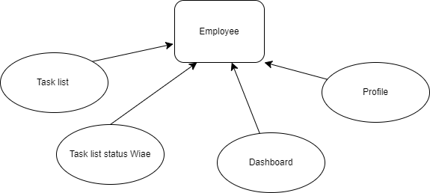

**System Development Lifecycle:**

**Initiation Phase**

* Identify the need for a Car Rental Management System based on market research and customer requirements.
* Define project scope, objectives, and stakeholders involved.
* Conduct a feasibility study to assess the technical and operational viability.

**Planning Phase**

* Develop a detailed project plan outlining tasks, timelines, resources, and budget.
* Identify deliverables and milestones for each phase of the project.
* Conduct risk analysis and develop a risk management plan.

**Analysis Phase**

* Gather requirements from stakeholders (car rental owners, managers, and users).
* Document functional and non-functional requirements.
* Create use cases, user stories, and wireframes to visualize the system.

**Design Phase**

* Design the database schema and application architecture.
* Choose technologies and frameworks for development.

**Development Phase**

* Implement the system with Laravel and MySQL.
* Use front-end technologies such as HTML, CSS, and JavaScript for user interfaces.

**Testing Phase**

* Conduct rigorous testing to ensure functionality, performance, and security.
* Address and fix identified issues.

**Deployment Phase**

* Deploy the Car Rental Management System on a live server.
* Train end users and provide documentation.

**Data Dictionary**

**TABLES**

* **users**
* **roles**
* **categories (project)**
* **tasks**

**Users Table**

|  |  |  |
| --- | --- | --- |
| **Field Name** | **Data Type** | **Constraints** |
| id | bigint(20) | Primary Key, NOT NULL |
| name | varchar(255) | NOT NULL |
| email | varchar(255) | NOT NULL |
| password | varchar(255) | NOT NULL |
| role_id | bigint | Foreign Key NOT NULL |
| created_at | timestamp | - |
| updated_at | timestamp | - |

**RolesTable**

|  |  |  |
| --- | --- | --- |
| **Field Name** | **Data Type** | **Constraints** |
| id | bigint(20) | Primary Key, NOT NULL |
| name | varchar(255) | NOT NULL |
| created_at | timestamp | - |
| updated_at | timestamp | - |

**Categories Table**

|  |  |  |
| --- | --- | --- |
| **Field Name** | **Data Type** | **Constraints** |
| id | bigint(20) | Primary Key, NOT NULL |
| booking_name | Varchar(5) | NOT NULL |
| user_id | bigint(20) | Foreign Key |
| created_at | timestamp | - |
| updated_at | timestamp | - |

**Tasks Table**

|  |  |  |
| --- | --- | --- |
| **Field Name** | **Data Type** | **Constraints** |
| id | bigint(20) | Primary Key, NOT NULL |
| title | varchar(255) | NOT NULL |
| description | text | NOT NULL |
| completed | Tiny int(1) | NOT NULL (0) |
| due_date | date | - |
| completed_at | date | - |
| category_id | bigint | Foreign Key |
| user_id | bigint | Foreign Key |
| assign_to_ser_id | bigint | Foreign Key |
| assign_date | date | - |
| created_at | timestamp | - |
| updated_at | timestamp | - |

**Test Cases**

|  |  |  |  |
| --- | --- | --- | --- |
| **Test Case** | **Description** | **Expected Output** | **Result** |
| Login | Validate username and password inputs | Redirect to dashboard or error | Pass |
| Add Category | Insert a new category | Category is added to the database | Pass |
| Add User | Make a user created | User created | Pass |
| Update User | Modify user profile details | Updated information is saved | Pass |

**Screen Shots**

**Login Page**

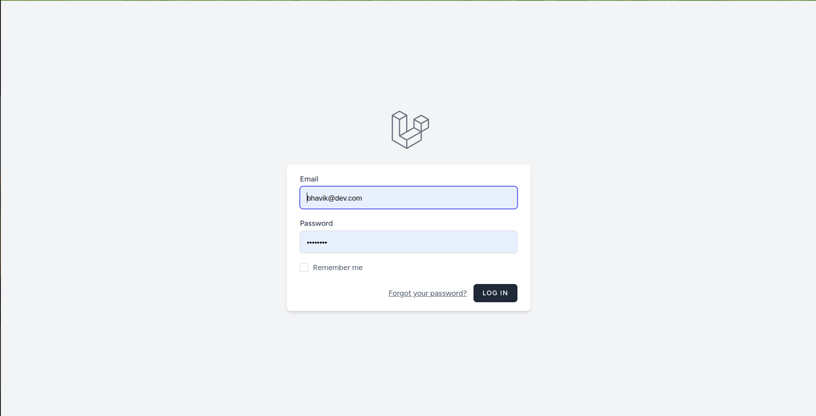

* This is Login page of CRM.
* User can Login

**Admin Dashboard Page**

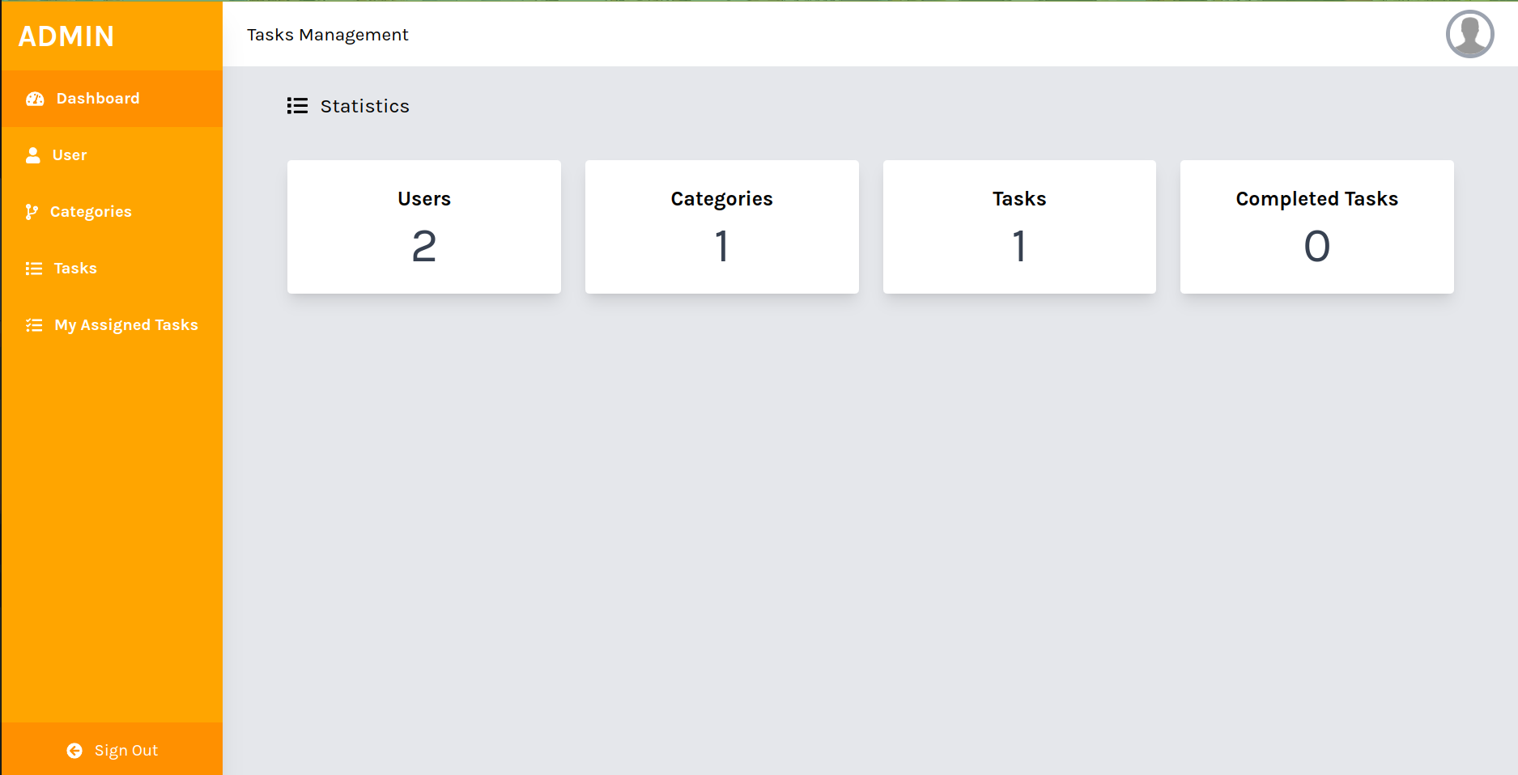

* Admin can login and see their Dashboard
* Admin can see cont of user category and Task

**Admin User List Page**

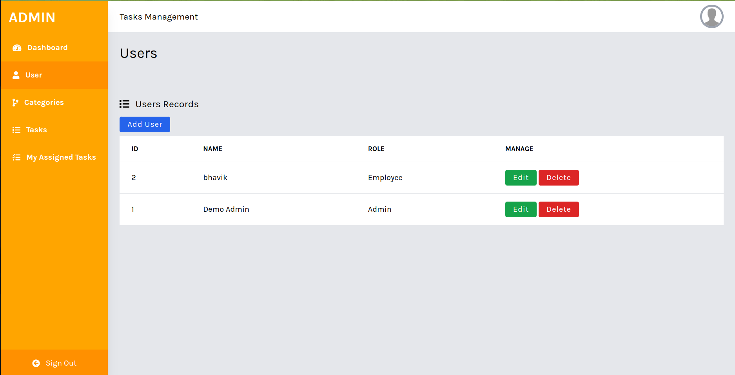

* This is user listing page.
* Admin Can see how many user in that system.

**Admin Category Page**

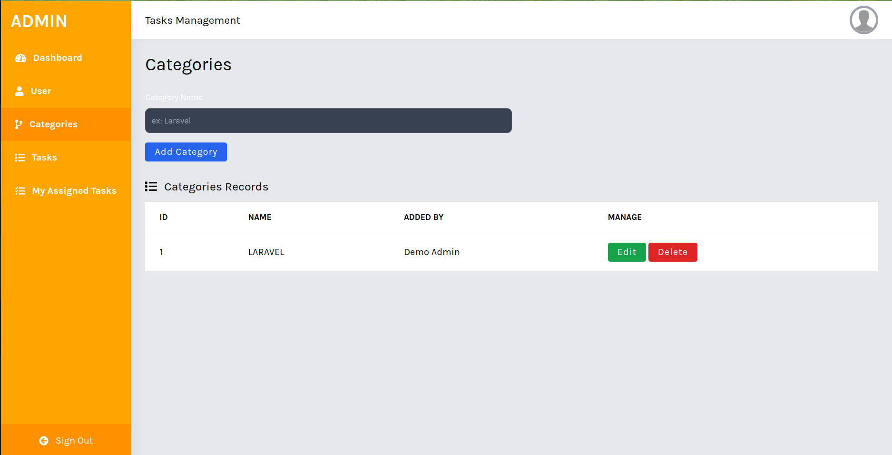

* Admin create category of tasks.
* Admin also perform CURD operation in category module.

**Admin Edit Category**

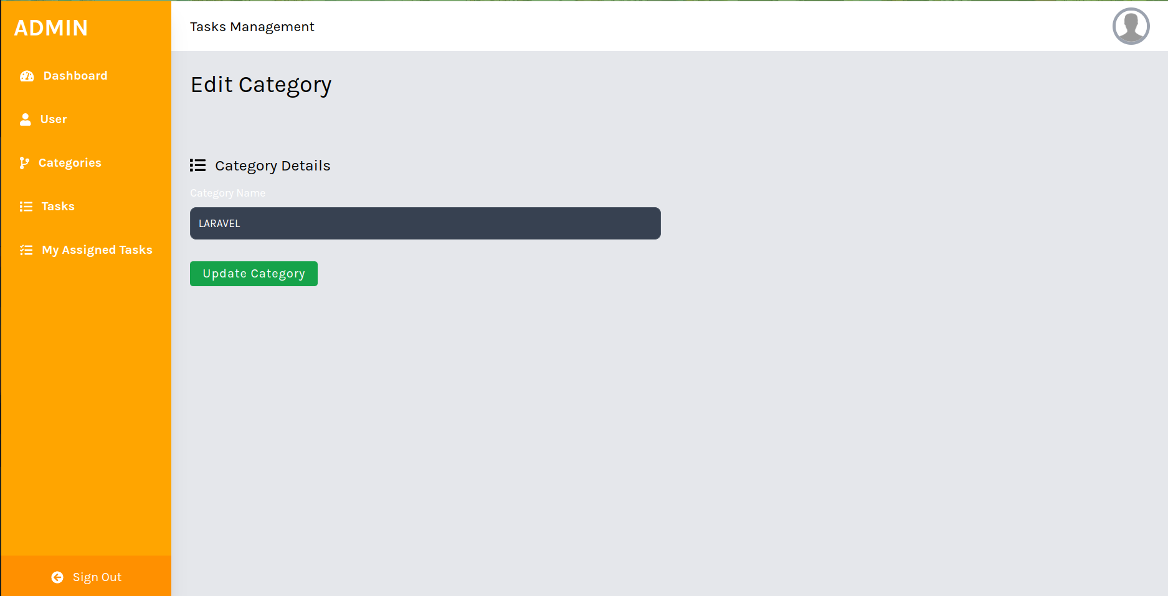

* **This is admin edit category Form (page).**
* **Admin can edit Categoy as well.**

**Admin Role Page**

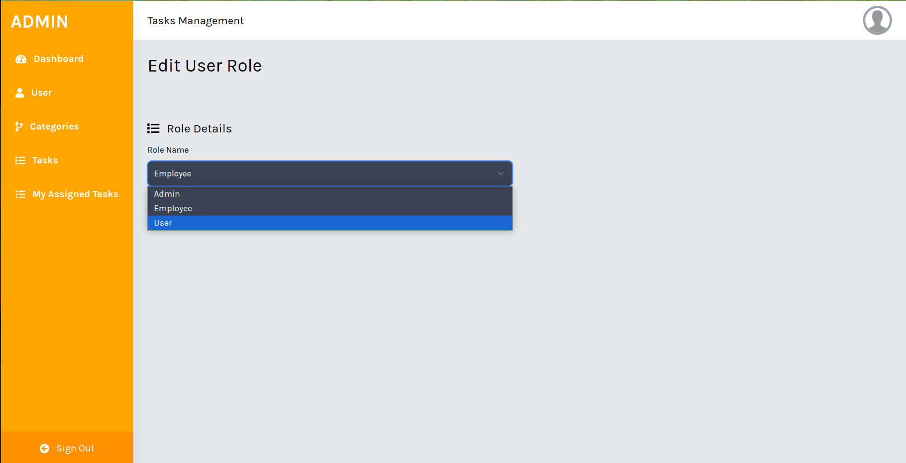

* **This page is used to edit role of users.**
* **Now we have static role user, employee, admin etc.**

**Admin Task List Page**

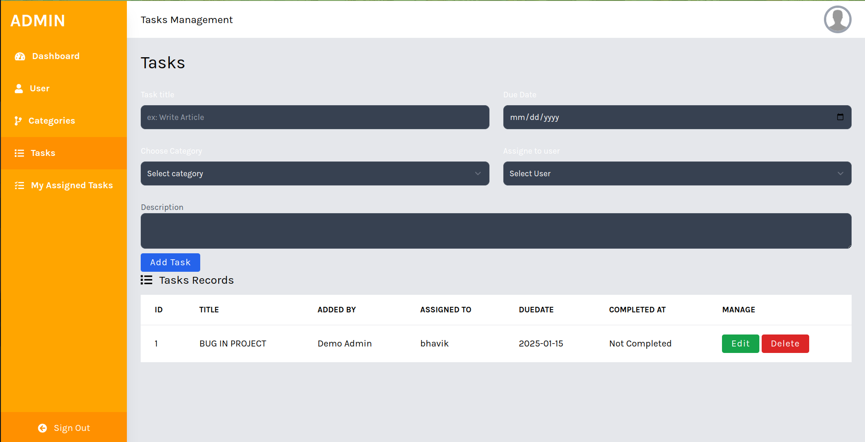

* **This page is used for insert,update and delete Task.**
* **Admin can add and assign task to their employee or user.**
* **Admin can delete Task.**

**Employee Dashboard**

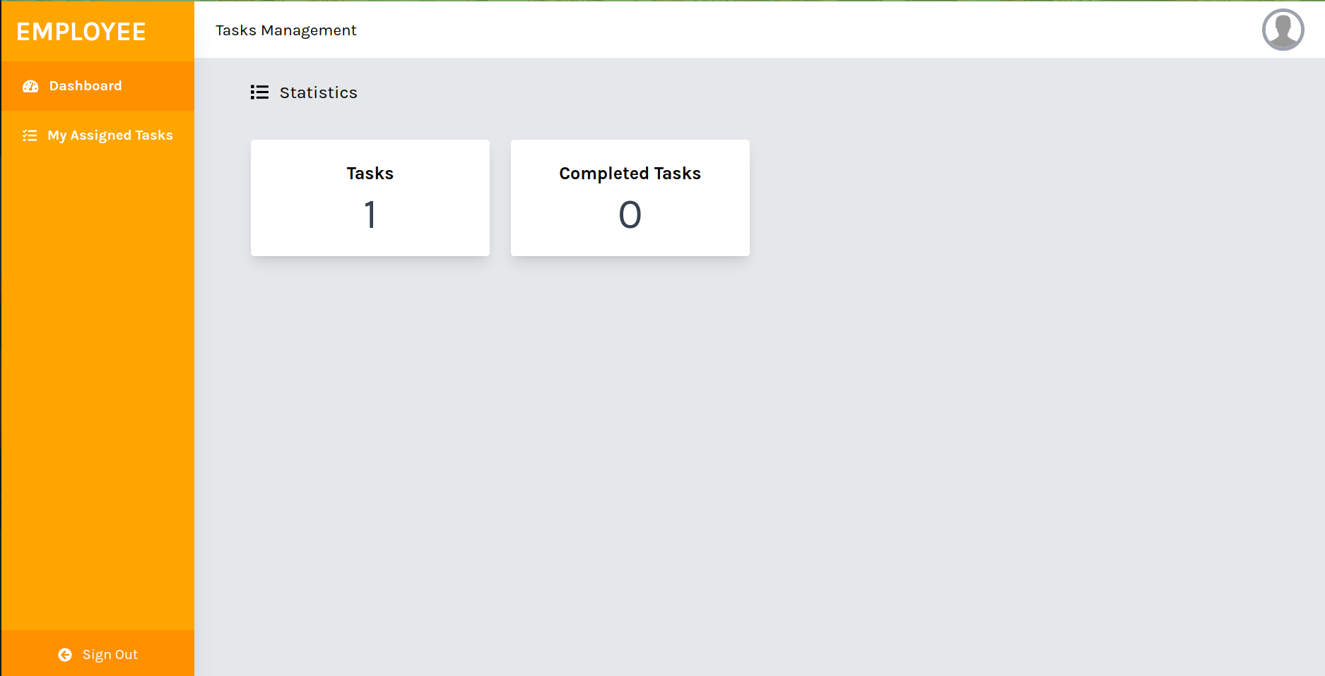

* **Employee can see their Task and Completed Task.**
* **Employee see their total no of tasks.**

**Employee Task View Page**

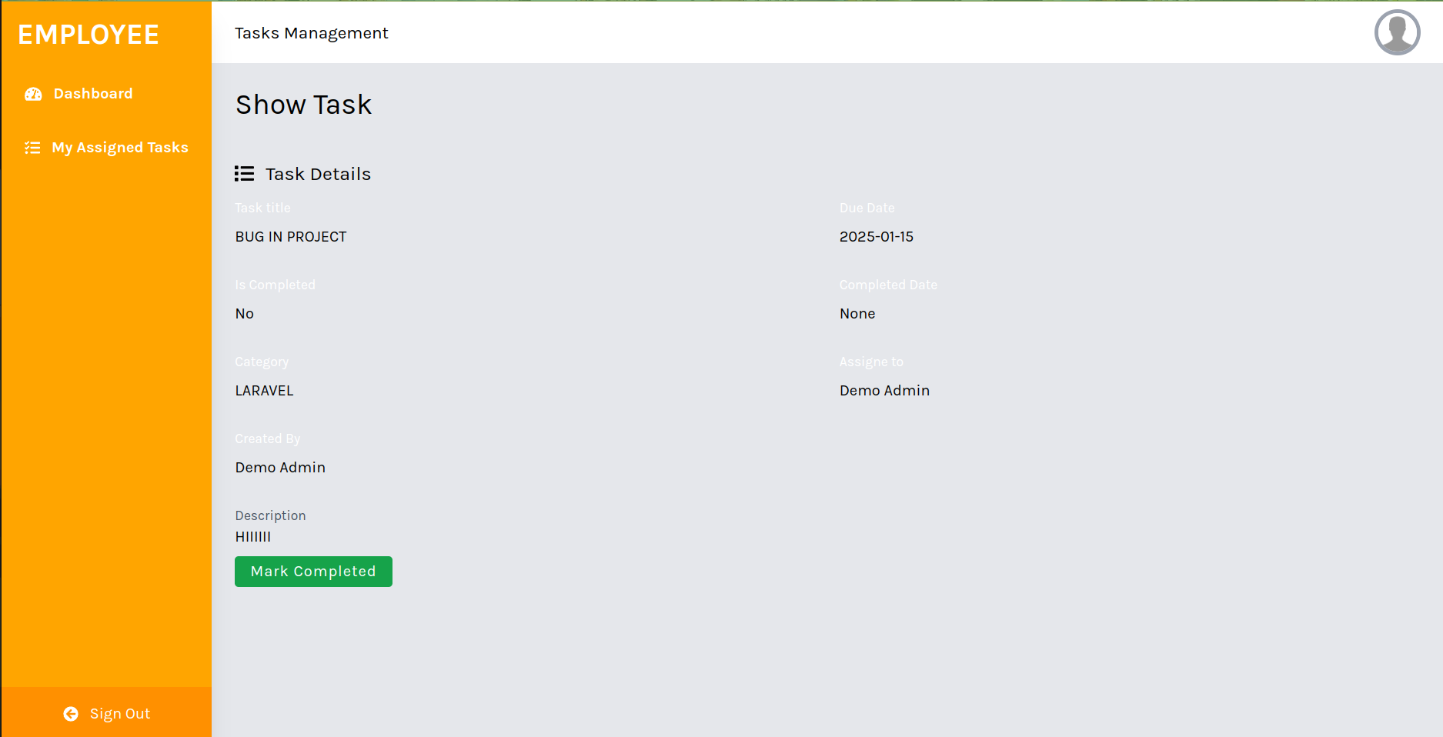

* **Employee Can see Their Task Description etc.**
* **Employee also change status if task was Completed.**

**Employee Assign Task List**

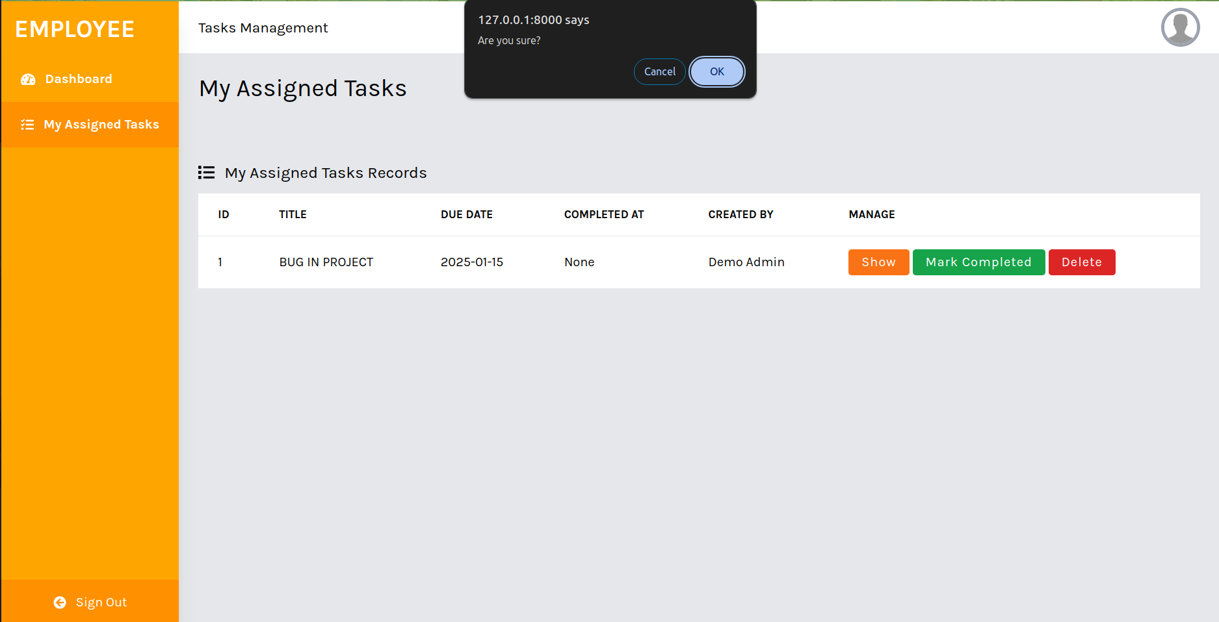

* **This page is used to see Assign Task assign By admin.**
* **Employee Also Can Delete Task.**

**Future Enhancement**

* + Add support for online payments.
  + Implement advanced search and filtering options for cars.
  + Integrate analytics to track user activity and log.
  + Develop a mobile app for easier access.

**Limitations:**

* Limited functionality for managing complex workflows.
* No integration with payment gateways.
* Manual refresh required for some features.

**Webliography**

* + Bootstrap · The most popular HTML, CSS, and JS library in the world. (getbootstrap.com)
  + W3Schools Online Web Tutorials
  + [GeeksforGeeks](https://www.geeksforgeeks.org/)
  + [Laravel Documentation](https://laravel.com/docs/)