A PROJECT REPORT ON
“CHAINSHIELD TRANSPORTATION SYSTEM”
Real-Time Disruption Prediction & Route Optimisation for Logistics
Submitted in Fulfillment of the Requirement
for Completion of Semester – 3 in
Master of Computer Application (MCA)
Academic Year 2026-27
To
LJ INSTITUTE OF COMPUTER APPLICATION
Affiliated to LJK University
Guided By:  Prof. Dhaval Shah | Prepared By: (Group No. 59)  Bhavik A. Visani (D51 - 25004401110170)  Diya Shah (D36 - 25003401110017)  Shruti Somani (D42 - 25004401110259)

DECLARATION
We, the undersigned students of Group No. 59, Master of Computer Application (MCA) Semester 3 at LJ Institute of Computer Application (affiliated to LJK University), hereby declare that the project entitled “ChainShield Transportation System” is our own original work, carried out under the guidance of Prof. Dhaval Shah, and has not been submitted, in whole or in part, for the award of any other degree, diploma, or certificate to this or any other institute or university.
We further declare that all the information, technical concepts, and design decisions presented in this report have been gathered, analysed, and implemented by us to the best of our understanding, and that any reference material used has been duly acknowledged in the Bibliography.

Date: __________________ | Place: Ahmedabad

Bhavik A. Visani (D51)
Diya Shah (D36)
Shruti Somani (D42)

CERTIFICATE
This is to certify that the project entitled “ChainShield Transportation System”, submitted for MCA Semester 3, has been carried out by Bhavik A. Visani (D51), Diya Shah (D36), and Shruti Somani (D42) of Group No. 59, under my guidance and supervision.
The work presented in this report is a bona fide record of the project carried out by the above-named students and, to the best of my knowledge, has not been submitted elsewhere for the award of any degree or diploma.
I wish them success in their future endeavours.

_______________________________  Prof. Dhaval Shah  Project Guide | _______________________________  Head of Department / Director  LJ Institute of Computer Application

PREFACE
Global trade today moves through supply chains of extraordinary scale and complexity — millions of shipments crossing ports, highways, railways, and air corridors every single day. The same forces that make this scale possible also make it fragile: a single storm, a congested port, or a mishandled hazardous cargo shipment can ripple into delays that cost businesses time, money, and customer trust. Historically, these disruptions have been discovered only after the fact, when a delivery has already slipped past its promised window.
This project, ChainShield Transportation System, was conceived to address exactly that gap. Rather than treating disruption management as a reactive, after-the-event exercise, ChainShield continuously evaluates every active shipment against a weighted risk model, flags the ones heading toward trouble, and proposes concrete rerouting alternatives before the delay materialises.
The idea came from a practical observation: most logistics teams still learn about a delay only after it has happened. We set out to build ChainShield as a lean, self-hostable product — Python (Flask), SQLite, server-rendered Jinja2/Bootstrap templates and Docker — that any logistics company can run on its own server without paid services or a complex cloud setup, while still delivering real-time risk scoring, route recommendations and alerts.
This report documents the problem definition, requirement analysis, system design, implementation, and testing of the ChainShield Transportation System, prepared as part of the curriculum prescribed for MCA Semester 3 at LJ Institute of Computer Application.

ACKNOWLEDGEMENT
We would like to express our sincere gratitude to everyone who supported us through the course of this project.
First and foremost, we thank LJK University and LJ Institute of Computer Application for providing us the opportunity and the academic environment to undertake this project as part of our MCA Semester 3 curriculum.
We are deeply grateful to our project guide, Prof. Dhaval Shah, for his valuable guidance, constructive feedback, and constant encouragement throughout the planning, design, and documentation of this project. His inputs have been instrumental in shaping the direction of ChainShield Transportation System.
We also extend our thanks to the Director and faculty of LJ Institute of Computer Application for their support, and to our classmates and peers who offered helpful suggestions during discussions on this project.
Finally, we thank our families for their patience and encouragement throughout this endeavour.

Thank you,
Bhavik A. Visani, Diya Shah, Shruti Somani
Group No. 59, MCA Semester 3

INDEX
Sr. | Particulars | Page No
1 | Introduction  1) Problem Definition  2) Objective of the New System  3) Core Components  4) Project Profile  5) Need of the New System  6) Scope of the New System  7) Advantages and Limitations of the Proposed System  8) Proposed Time Line Chart  9) Targeted User | 7
2 | Requirement Determination and Analysis  1) Requirement Determination  2) Requirement Specification | 12
3 | System Design  1) Use Case Diagram  2) Data Dictionary  3) User Interface Design  4) Report Design | 14
4 | Development  1) Coding Standards  2) Implementation Details  3) Output Screens | 22
5 | Testing  1) Test Cases | 36
6 | Proposed Enhancement | 41
7 | Conclusion | 42
8 | Bibliography | 43

1. INTRODUCTION

1.1 Problem Definition
Logistics operators run hundreds of shipments at once across road, rail, sea and air, and every one of them is exposed to weather, congestion at hubs and ports, customs holds, breakdowns and other operational bottlenecks. In most companies these disruptions are noticed only after a delivery date has already slipped.
In practice, logistics managers rely on manual tracking and reactive escalation: a disruption becomes visible only once a customer or downstream partner reports a missed delivery. By that point, the shipment is already late, alternate routing options have narrowed, and the cost of recovery — expedited freight, penalty clauses, damaged customer trust — has multiplied. There is no continuously running system that scores every active shipment's risk in real time and proposes a corrective route before the delay actually happens.

1.2 Objective of the New System
- Continuously analyse multifaceted transit data (weather, route congestion, cargo sensitivity, historic delay patterns) for every active shipment.
- Preemptively detect and flag potential disruptions before delivery timelines are compromised, using a composite, weighted risk-scoring model.
- Automatically generate optimised route-adjustment recommendations (hold, reroute via an alternate hub, or switch transport mode) the moment a shipment crosses a risk threshold.
- Notify the right stakeholder — manager, then the assigned field operator — the instant a decision is made, closing the loop between detection and execution.
- Provide role-based dashboards so admins, managers, and field operators (captains, pilots, drivers, loco pilots) each see only what is relevant to their responsibilities.
- Keep the system self-contained, inexpensive to run, and simple to demonstrate, using an open-source Python/Flask stack packaged with Docker.

1.3 Core Components
- Risk Engine — scores every active shipment on a recurring schedule using a 4-factor weighted model (weather severity, route congestion, cargo sensitivity, historic delay probability).
- Disruption Manager — converts a MEDIUM-or-higher risk score into a formal disruption record, escalates it to HIGH if the risk keeps rising, and triggers ranked route-solution generation.
- Route Solver — builds hold, hub-reroute and mode-switch alternatives using great-circle distances between hubs, and ranks them by a weighted score of residual risk, extra time and extra cost (₹).
- Notification & Chat Module — pushes real-time alerts over Flask-SocketIO to admins, managers and the assigned field operator, and supports direct messaging between users.
- Admin Panel & Reports — manages users, logistics hubs and cargo types, keeps an activity audit log, and provides reports with date-range filters and CSV export.
- AI Assistant — a conversational assistant (Google Gemini API, with an offline fallback engine) that answers natural-language questions using live shipment and disruption data.
- Live Map — a Leaflet.js visualisation of shipment positions, routes, hubs and shaded disruption zones that refreshes automatically after every risk scan.

1.4 Project Profile
Project Title | ChainShield Transportation System
Domain | Logistics & Supply Chain Management — Real-time disruption prediction and route optimisation
Project Description | A system that continuously scores active shipments for disruption risk and instantly proposes optimised route adjustments before delays cascade, with role-based dashboards for admins, managers, and field operators.
Front End | HTML5, CSS3, Bootstrap 5, Jinja2 templating, JavaScript, Leaflet.js, Chart.js
Back End | Python (Flask), Flask-SQLAlchemy, SQLite
Other Tools | Flask-Login, Flask-SocketIO, APScheduler, Flask-WTF, Google Gemini API, OpenWeatherMap API, Docker
Guide | Prof. Dhaval Shah
Submitted To | LJ Institute of Computer Application (LJK University)

1.5 Need of the New System
- Manual, reactive monitoring means disruptions surface only after a customer complaint or missed SLA — by then recovery options are limited and costly.
- Existing tracking dashboards typically show where a shipment IS, not what is about to go wrong with it — there is a visibility gap between tracking and prediction.
- Weather, congestion, cargo-type, and historical-delay signals sit in silos; no single continuously-running process fuses them into one actionable risk score per shipment.
- Rerouting decisions are usually ad hoc, based on a manager's personal experience, rather than a systematic comparison of ranked options with quantified cost, time, and risk trade-offs.
- Field operators (drivers, captains, pilots) often learn about a rerouting decision late — over phone or radio — introducing further delay and communication error.

1.6 Scope of the New System
Included in this project:
- Interval-based risk scoring for every active shipment (near-real-time).
- Automatic disruption creation once a shipment crosses a risk threshold, with ranked reroute/hold solutions.
- Manager dashboard for reviewing and resolving disruptions.
- Field operator dashboard for status updates and receiving resolution notifications.
- Admin panel for user, hub, and cargo-type management, plus an audit log.
- Shipment management (create, edit, delete) for managers and admins, with server-side validation.
- Reports with date-range filters and CSV export (disruption summary, resolution time, shipment risk, audit log).
- An AI assistant (Gemini, with an offline fallback) for natural-language questions about shipment data.
- Live map visualisation of shipments and disruption zones.
- A demo/simulation mode — simulated shipment movement, a one-click “Trigger demo disruption” action and a reset command — for showing the system without live production data.
Outside the scope of the current version:
- Integration with live carrier/GPS hardware feeds (simulated positions are used instead).
- Payment, billing, or contractual/SLA enforcement modules.
- Multi-tenant support for multiple independent companies.

1.7 Advantages and Limitations of the Proposed System
Advantages:
- Shifts the organisation from reactive to preemptive disruption handling.
- Quantifies risk with a transparent, weighted scoring formula instead of gut feeling.
- Cuts the time between “risk detected” and “operator notified” to seconds.
- Role-based views reduce information overload for each type of user.
- Runs on a lightweight Flask + SQLite stack, containerised with Docker, so it is cheap to host and easy to demonstrate on any machine.
Limitations:
- Near-real-time, not instantaneous — performance depends on the scheduler interval (60 seconds by default).
- Weather and route-congestion signals rely on external APIs, or a simulated fallback, rather than certified logistics-grade data feeds.
- SQLite suits a single-server deployment but would need to be replaced by PostgreSQL/MySQL for large multi-branch production load.
- The AI assistant's answers are only as reliable as the underlying Gemini model and the data exposed to it — it is a convenience feature, not a system of record.

1.8 Proposed Time Line Chart
The project was planned across the semester using the phased schedule below (Fig 1.1). Table 1.1 records the milestones actually achieved, taken from the project's version-control history and document records.
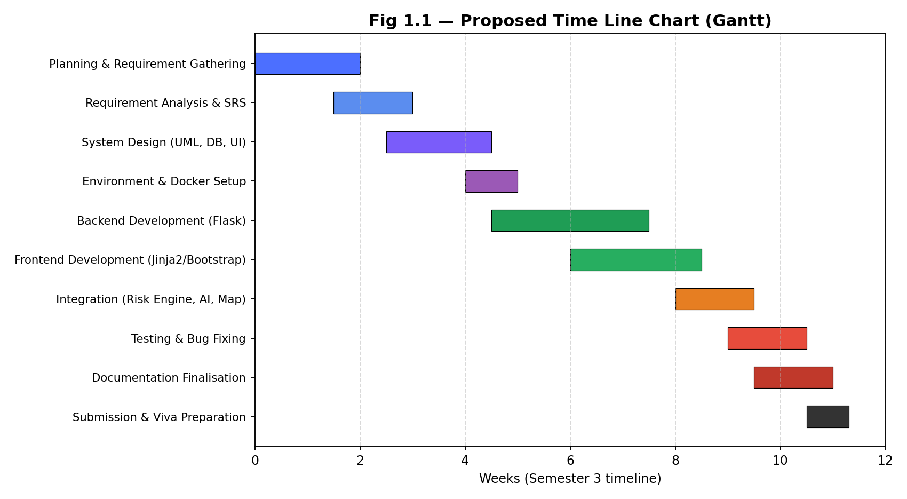
Fig 1.1 — Proposed Time Line Chart
Table 1.1 — Actual Progress Against the Plan
Milestone | Completed On | Status
Problem analysis and technology stack decision | 13 Aug 2026 | Done
Project report — requirements and system design | 15–19 Aug 2026 | Done
Development environment and Docker setup | 16 Aug 2026 | Done
Authentication and base user interface | 16–25 Aug 2026 | Done
SRS document and first presentation | 25 Aug 2026 | Done
Risk engine scan loop, route solver, disruption module, admin panel | 7–8 Sep 2026 | Done
Shipment CRUD, live map, dashboards and charts, real-time notifications, chat, AI assistant | 9–16 Sep 2026 | Done
Reports and CSV export, cargo/hub/user management, demo mode | 17–20 Sep 2026 | Done
Testing (101 automated checks) and Docker deployment verification | 21–22 Sep 2026 | Done
Premium UI redesign — responsive layout, light/dark themes, animations | 22–24 Sep 2026 | Done
Final documentation (report, SRS, presentation) | 24–25 Sep 2026 | Done
Final submission and viva | As per university schedule | Pending

1.9 Targeted User
- Logistics / Supply Chain Manager — the primary decision-maker who reviews and resolves disruptions.
- Field Operators — Captain, Pilot, Driver, and Loco Pilot — who execute the resolved route.
- System Administrator — manages users, hubs, cargo types, and system configuration.
- Indirectly, end customers and downstream partners who benefit from fewer missed deliveries.

2. REQUIREMENT DETERMINATION AND ANALYSIS

2.1 Requirement Determination
Requirements for ChainShield Transportation System were determined through group discussion, study of how logistics operators track shipments today (manual follow-ups, spreadsheets and phone calls), and analysis of the roles involved — administrators, operations managers and field operators (drivers, loco pilots, pilots and ship captains).
The group broke the problem down into what a supply-chain manager needs to see, what a field operator needs to act on, and what an administrator needs to configure — and cross-checked each requirement against the objective of catching disruptions before they cascade, rather than after.
Key requirements identified through this process:
- All users (admin, manager, field operator) must authenticate before accessing the system.
- The system must continuously evaluate risk for every active shipment without manual triggering.
- A disruption must be created automatically once a shipment's risk score reaches MEDIUM (≥ 50), and escalated if it rises to HIGH (≥ 70).
- The system must propose at least three ranked route-solution alternatives per disruption (hold, reroute via a hub, mode switch, or continue).
- Field operators must be notified in-app the moment a manager resolves a disruption in their favour.
- Admins must be able to manage users, hubs, and cargo types, and view an audit trail of system activity.
- The system must be demonstrable without live production data, via a simulated/demo disruption trigger.

2.2 Requirement Specification
Functional Requirements:
- User registration, login, and role-based access control (Admin, Manager, Field Operator).
- Shipment create, read, update and delete (managers and admins), with field operators seeing only their assigned shipments.
- Continuous, scheduled risk scoring of all active shipments.
- Automatic disruption detection and alerting once a risk threshold is crossed.
- Generation of ranked route-solution alternatives (hold, hub reroute, mode switch, continue) with cost, time, and residual-risk trade-offs.
- Real-time in-app notification delivery (Socket.IO) to managers and the assigned field operator on detection, escalation and resolution of a disruption.
- Direct messaging (chat) between users.
- Admin CRUD operations for users, logistics hubs, and cargo types.
- Activity audit log for all administrative and disruption-resolution actions.
- AI assistant for natural-language queries about the supply chain.
- Reports with date-range filter and CSV export.
- Live map rendering of shipment positions and disruption zones.
- A one-click demo-mode trigger for presentation purposes.
Non-Functional Requirements:
- Performance — risk scores must refresh at least once every 60 seconds.
- Usability — each role sees a dashboard tailored to its responsibilities; the interface is responsive from phone to desktop, offers light and dark themes, and respects the reduced-motion accessibility setting.
- Portability — the system must run identically on any machine via Docker, without manual environment setup.
- Reliability — database writes must be transactional; the background scheduler must recover gracefully from a failed run.
- Security — passwords must be hashed (never stored in plain text); sessions managed via Flask-Login; all forms CSRF-protected; admin rights cannot be self-assigned at registration.
- Maintainability — code must be organised into modular Flask blueprints so features can be extended independently.
Platform / Hardware & Software Requirements:
Operating System | Windows 11 / any OS supporting Docker
Backend Language | Python 3.10
Web Framework | Flask, Flask-SQLAlchemy, Flask-Login, Flask-SocketIO, Flask-WTF, APScheduler
Database | SQLite
Containerisation | Docker, Docker Compose (Gunicorn + eventlet worker)
Front-End Tools | HTML5, CSS3, Bootstrap 5, Bootstrap Icons, Inter font, Jinja2, JavaScript, Leaflet.js, Chart.js, Socket.IO client
External APIs | Google Gemini API, OpenWeatherMap API
Documentation Tool | Microsoft Word 2021

3. SYSTEM DESIGN

3.1 Use Case Diagram
The diagram below shows the use cases of the three human actors — Admin, Manager and Field Operator — and the Background Scheduler (a timer system actor) within the ChainShield Transportation System boundary. The Manager is a specialisation of the Field Operator and inherits its use cases (login, status update, live map and chat); the scheduler’s automated “Score Risk & Detect Disruption” use case includes “Receive Real-time Notifications”.
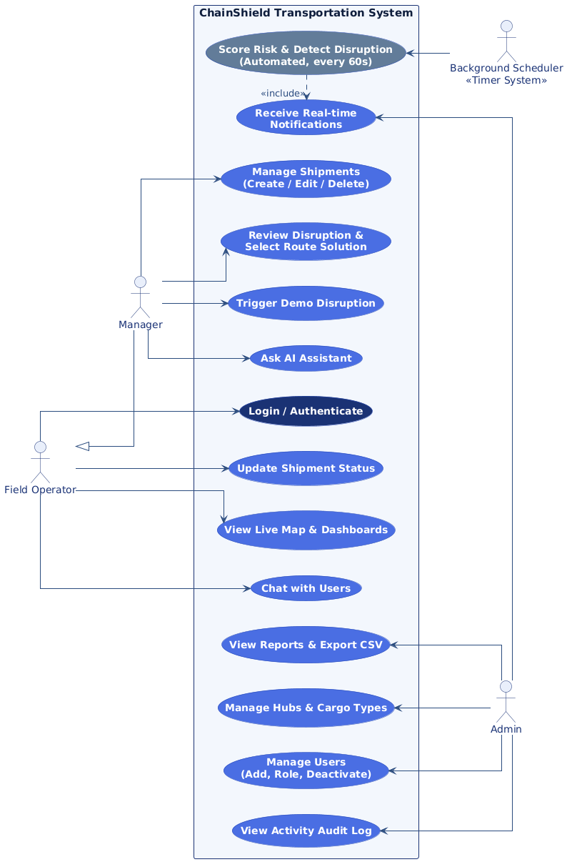
Fig 3.1 — Use Case Diagram
System Architecture:
The system follows a layered architecture: a Flask + Jinja2 + Bootstrap presentation layer (with Leaflet.js and Chart.js) talking to the server over HTTP and WebSockets, core services (Risk Engine, Route Solver, Notifications/Chat, AI Assistant, Admin & Reports) in the middle, a Flask-SQLAlchemy data access layer, and a SQLite database at the base — the entire stack packaged inside a Docker container.
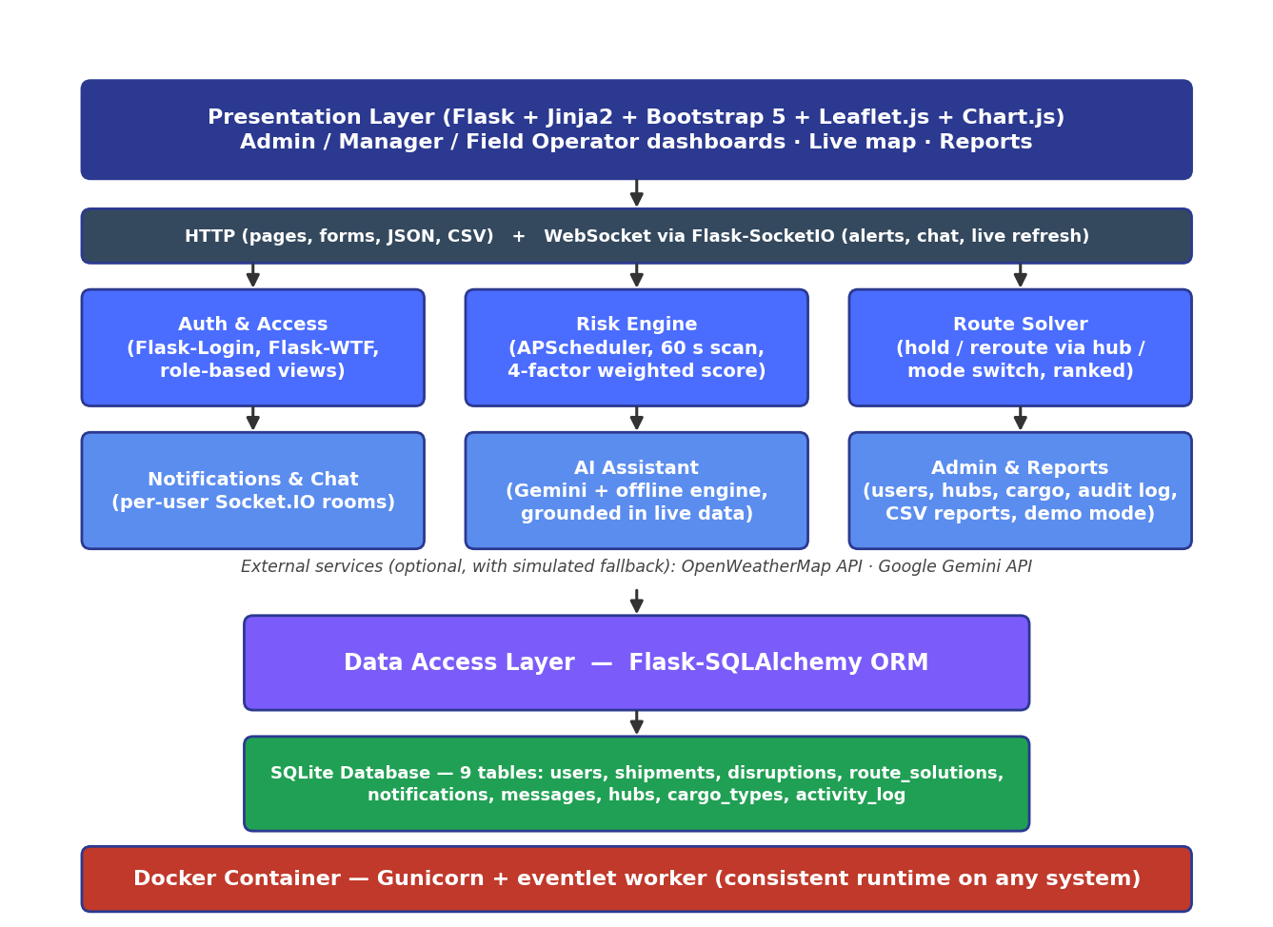
Fig 3.2 — ChainShield System Architecture

3.2 Data Dictionary
Database: chainshield (SQLite, file instance/chainshield.db) — 9 tables, one for each model class in app/models.py.
1. users — Login accounts and roles of every system user
Column Name | Data Type | Constraints | Description
id | INTEGER | PRIMARY KEY, AUTOINCREMENT | Unique user identifier
name | VARCHAR(100) | NOT NULL | Full name
email | VARCHAR(100) | NOT NULL, UNIQUE, INDEX | Login email address
password_hash | VARCHAR(255) | NOT NULL | Werkzeug-hashed password (never plain text)
role | VARCHAR(20) | NOT NULL, DEFAULT 'manager' | admin / manager / captain / pilot / driver / loco_pilot
phone | VARCHAR(20) | NULL | Contact number
is_active | BOOLEAN | NOT NULL, DEFAULT 1 | 0 = deactivated by an admin; cannot log in
created_at | DATETIME | DEFAULT current UTC time | Account creation time
2. hubs — Master data of logistics hubs used for routing and rerouting
Column Name | Data Type | Constraints | Description
id | INTEGER | PRIMARY KEY, AUTOINCREMENT | Unique hub identifier
name | VARCHAR(100) | NOT NULL | Hub name, e.g. Mumbai Port Hub
location | VARCHAR(150) | NULL | City / state of the hub
lat | FLOAT | NULL | Latitude (map marker, detour distance)
lng | FLOAT | NULL | Longitude (map marker, detour distance)
3. cargo_types — Master data of cargo categories and their risk sensitivity
Column Name | Data Type | Constraints | Description
id | INTEGER | PRIMARY KEY, AUTOINCREMENT | Unique cargo type identifier
name | VARCHAR(50) | NOT NULL, UNIQUE | e.g. Hazardous, Perishable, Electronics, General
sensitivity_weight | FLOAT | DEFAULT 0.5 | 0.0 – 1.0; × 100 gives the cargo factor of the risk score
4. shipments — Every shipment with its live position and current risk
Column Name | Data Type | Constraints | Description
id | INTEGER | PRIMARY KEY, AUTOINCREMENT | Unique shipment identifier
tracking_no | VARCHAR(30) | NOT NULL, UNIQUE | Tracking number (auto-generated CS-xxxx if blank)
origin | VARCHAR(100) | NULL | Origin city
destination | VARCHAR(100) | NULL | Destination city
cargo_type_id | INTEGER | FOREIGN KEY → cargo_types.id | Type of cargo carried
transport_mode | VARCHAR(20) | NULL | Road / Rail / Sea / Air
status | VARCHAR(20) | DEFAULT 'In-transit' | In-transit / Delayed / On-hold / Delivered
current_lat | FLOAT | NULL | Current latitude (simulated movement)
current_lng | FLOAT | NULL | Current longitude (simulated movement)
risk_score | FLOAT | DEFAULT 0.0 | Composite risk score 0 – 100 from the last scan
risk_level | VARCHAR(15) | DEFAULT 'LOW' | LOW / AT-RISK / MEDIUM / HIGH
cargo_value | FLOAT | DEFAULT 0.0 | Declared cargo value in ₹ (value-at-risk reports)
assigned_operator_id | INTEGER | FOREIGN KEY → users.id | Field operator responsible for the shipment
hub_id | INTEGER | FOREIGN KEY → hubs.id | Origin hub
created_at | DATETIME | DEFAULT current UTC time | Shipment creation time
5. disruptions — Disruptions detected by the risk engine for a shipment
Column Name | Data Type | Constraints | Description
id | INTEGER | PRIMARY KEY, AUTOINCREMENT | Unique disruption identifier
shipment_id | INTEGER | NOT NULL, FOREIGN KEY → shipments.id | Affected shipment
type | VARCHAR(30) | NULL | Dominant factor: Weather / Congestion / Cargo / History
severity | VARCHAR(15) | NULL | MEDIUM or HIGH (escalated as risk rises)
risk_score | FLOAT | NULL | Risk score at detection / last escalation
status | VARCHAR(15) | DEFAULT 'Open' | Open / Resolved
detected_at | DATETIME | DEFAULT current UTC time | When the disruption was detected
resolved_at | DATETIME | NULL | When a route decision was applied
resolved_by | INTEGER | FOREIGN KEY → users.id, NULL | Manager / admin who resolved it
6. route_solutions — Ranked route options generated for each disruption
Column Name | Data Type | Constraints | Description
id | INTEGER | PRIMARY KEY, AUTOINCREMENT | Unique solution identifier
disruption_id | INTEGER | NOT NULL, FOREIGN KEY → disruptions.id (cascade delete) | Parent disruption
option_no | INTEGER | NOT NULL | Rank; 1 = recommended
description | TEXT | NULL | e.g. Reroute via Jaipur Hub (+77 km detour)
extra_time_hours | FLOAT | NULL | Additional transit time in hours
extra_cost | FLOAT | NULL | Additional cost in ₹
risk_score | FLOAT | NULL | Residual risk if this option is chosen
selected | BOOLEAN | DEFAULT 0 | 1 = option applied by the manager
7. notifications — In-app alerts delivered to individual users
Column Name | Data Type | Constraints | Description
id | INTEGER | PRIMARY KEY, AUTOINCREMENT | Unique notification identifier
user_id | INTEGER | NOT NULL, FOREIGN KEY → users.id | Recipient
message | VARCHAR(255) | NOT NULL | Alert text
is_read | BOOLEAN | DEFAULT 0 | 1 = marked as read
created_at | DATETIME | DEFAULT current UTC time | When the alert was created
8. messages — Direct chat messages between two users
Column Name | Data Type | Constraints | Description
id | INTEGER | PRIMARY KEY, AUTOINCREMENT | Unique message identifier
sender_id | INTEGER | NOT NULL, FOREIGN KEY → users.id | User who sent the message
receiver_id | INTEGER | NOT NULL, FOREIGN KEY → users.id | User who receives the message
chat_id | VARCHAR(10) | NULL | Conversation key 'lowerId-higherId', e.g. 2-5
content | TEXT | NOT NULL | Message text
sent_at | DATETIME | DEFAULT current UTC time | When the message was sent
9. activity_log — Audit trail of logins, admin actions and disruption decisions
Column Name | Data Type | Constraints | Description
id | INTEGER | PRIMARY KEY, AUTOINCREMENT | Unique log entry identifier
user_id | INTEGER | FOREIGN KEY → users.id, NULL | User who performed the action
action | VARCHAR(255) | NOT NULL | Description of the action
timestamp | DATETIME | DEFAULT current UTC time | When the action happened
Relationships: users 1 : N shipments (assigned_operator_id); cargo_types 1 : N shipments; hubs 1 : N shipments; shipments 1 : N disruptions; disruptions 1 : N route_solutions (deleted together with their disruption); users 1 : N notifications, messages (as sender and as receiver), activity_log entries and resolved disruptions.

3.3 User Interface Design
The interface is built with server-rendered Jinja2 templates on Bootstrap 5, extended with a custom design system (app/static/css/style.css). Every signed-in page shares one application shell: a collapsible dark sidebar for navigation with live counts, and a translucent top bar with the theme switch, a notification dropdown and the account menu. The implemented screens are listed below; screenshots are given in Section 4.3.
- Landing, Login and Register — split-screen pages with an animated route illustration; admin rights can only be granted by an existing admin.
- Admin Dashboard — KPI cards (users, shipments, disruptions, cargo value at risk), four live Chart.js charts and recent activity.
- Operations Dashboard — for managers and field operators: KPIs, charts, a risk watchlist and open disruptions for the shipments they can see.
- Live Map — Leaflet map of shipments coloured by risk, hubs, planned routes and shaded disruption zones; refreshes after every scan.
- Disruptions — each open disruption with its ranked route options (time, cost, residual risk) and a one-click “Apply selected option”.
- Shipments — searchable list, detail page with mini-map and disruption history, and a validated create/edit form.
- Admin Panel — tabs for Users, Shipments, Base Cities (hubs), Cargo Types, Reports, System Config and Activity Log.
- Chat, Notifications and AI Assistant — real-time direct messages, a notification feed, and a chat-style assistant with suggested questions.
UI/UX design principles applied across all screens:
- Design system — Inter typeface, an indigo and teal brand palette, soft elevation and 16 px rounded cards; risk levels always use the same colours (green LOW, amber AT-RISK, orange MEDIUM, red HIGH).
- Light and dark themes — switchable from the top bar, defaulting to the operating-system setting and remembered per browser; charts and map tiles adapt to the active theme.
- Motion — buttons lift, press and ripple; forms show a spinner while submitting; content fades up as it scrolls into view; KPI numbers count up; new alerts ring the bell and slide in as toasts. Motion is disabled automatically for users who prefer reduced motion.
- Responsive layout — the sidebar collapses to icons on desktop and becomes a slide-in drawer on phones; grids stack and tables scroll horizontally, so no page scrolls sideways at 390 px width.
- Offline-safe assets — Bootstrap, Bootstrap Icons, the Inter font, Leaflet, Chart.js and the Socket.IO client are bundled locally, so the interface works without internet (except map tiles).

3.4 Report Design
The Reports module (available to admins and managers) shows the following reports on-screen, filtered by a selected date range; the reports marked CSV can be exported and opened directly in Excel:
- Disruption Summary Report (CSV) — count of disruptions by dominant factor and severity, with each disruption's detection time, resolution time, decision-maker and chosen option.
- Shipment Risk Report (CSV) — current risk score, level, status, cargo value and operator for every shipment.
- Resolution Time Report — average time from disruption detection to a route decision, per manager/admin.
- Activity Audit Log (CSV) — a chronological record of logins, administrative actions, shipment changes and disruption resolutions, for accountability.

4. DEVELOPMENT

4.1 Coding Standards
The following coding standards were followed throughout development. For each standard, the reason it was adopted and where it can be seen in the code are given:
- PEP 8 style for all Python code. Consistent 4-space indentation, snake_case functions and PascalCase classes let all three members read each other's code without friction. Example: compute_risk_score() and class RouteSolution in app/services and app/models.py.
- Application factory pattern. create_app() in app/__init__.py builds the app from a named configuration, so development, testing and production (Docker) run the same code with different settings and tests get a fresh app each time.
- Modular blueprint structure. Seven blueprints (main, auth, shipments, disruptions, notifications, chat, assistant) each own one URL prefix, so a feature can be changed or tested in isolation. Example: app/blueprints/shipments/routes.py serves everything under /shipments.
- Business logic separated from routes (service layer). Routes only read the request and render a page; scoring, routing, weather, notifications, statistics and the AI assistant live in app/services/. The same risk engine is therefore reused by the scheduler, the ‘Scan now’ button and the CLI command flask scan-risk.
- Single source of configuration; no hard-coded secrets. Risk weights, scan interval and model names live in app/config.py; API keys and the database URL are read from a .env file that is excluded from Git and Docker. Changing a weight or key never requires a code change.
- ORM models instead of raw SQL. All nine tables are Python classes in app/models.py. Queries are parameterised by SQLAlchemy, which prevents SQL injection, and the database can be switched from SQLite to PostgreSQL by changing DATABASE_URL only.
- Server-side validation. Every form is validated with Flask-WTF before anything is saved (e.g. ShipmentForm in app/forms.py rejects origin = destination and out-of-range values), because browser-side checks can be bypassed.
- Security by default. Passwords are stored only as Werkzeug hashes (User.set_password), every form and AJAX call carries a CSRF token, role decorators (admin_required, manager_required) guard each route, and Jinja2 auto-escapes output against XSS.
- Template inheritance and reusable macros. base.html defines the sidebar, top bar and scripts once; each page only fills its content block. Repeated UI pieces (risk badge, KPI tile, form field) are macros in _macros.html, so a design change is made in one place.
- Meaningful names and documented logic. Descriptive names (risk_level, extra_time_hours, assigned_operator_id) make the code self-explaining; docstrings and comments are added where the logic is not obvious — the risk formula, route ranking and scheduler set-up.
- Consistent UTC timestamps. All times are stored in UTC (datetime.utcnow) and the scheduler runs in UTC, avoiding time-zone bugs; times are formatted for display only in the templates.
- Version control and reproducible builds. Git with descriptive commit messages records every feature; dependency versions are pinned in requirements.txt and the Dockerfile uses the same Python 3.10, so the application behaves identically on every machine.

4.2 Implementation Details
Risk Engine (app/services/risk_engine.py)
- APScheduler runs a scan every 60 seconds (configurable). Each in-transit shipment is scored: score = 0.40 × weather + 0.25 × congestion + 0.20 × cargo sensitivity + 0.15 × lane history (each 0–100).
- Thresholds: ≥ 70 HIGH, ≥ 50 MEDIUM, ≥ 30 AT-RISK, otherwise LOW. AT-RISK shipments are watched; a disruption is opened at MEDIUM and escalated (with re-planned options) if the shipment reaches HIGH.
- Weather comes from OpenWeatherMap when a key is configured; otherwise a simulated signal is used (mostly calm, with an occasional storm). Lane history grows with disruptions on the same origin–destination lane in the last 90 days.
- In demo mode each scan also moves shipments towards their destination hub, marking them Delivered on arrival.
Route Solver (app/services/route_solver.py)
- Candidates: hold at the nearest hub, continue (baseline), reroute via the two hubs with the smallest detour (haversine distance), and a mode switch for the remaining leg (e.g. Road → Rail).
- Each option gets extra time, extra cost (₹, from per-km mode rates) and residual risk, and is ranked by 0.60 × risk + 0.25 × normalised time + 0.15 × normalised cost — option 1 is the recommendation.
Real-time Layer (Flask-SocketIO)
- Every logged-in browser joins a personal room (user_<id>). Notifications and chat messages are stored in the database and pushed to the right room; broadcast events (shipments_updated, disruption_new) make the live map, dashboards and charts refresh themselves without polling.
AI Assistant (app/services/assistant.py)
- The question and a snapshot of live data the user is allowed to see (shipments, risk, open disruptions and their ranked options) are sent to Google Gemini. Without a key or internet, a rule-based offline engine answers from the same data, so the feature always works in a demonstration.
User Interface (app/templates/, app/static/)
- One base template provides the application shell (sidebar, top bar, toasts); pages extend it and reuse Jinja macros for risk pills, status pills, KPI tiles and form fields.
- A single stylesheet defines colour tokens as CSS variables for both themes; main.js handles theme switching, the sidebar, ripples, scroll-reveal, count-up numbers, the notification dropdown and live Socket.IO toasts.
Security and Deployment
- Werkzeug password hashing, Flask-Login sessions, CSRF protection on every form and AJAX call, role checks on every route, account deactivation, and no self-registration as admin.
- Docker image on Python 3.10 served by Gunicorn with an eventlet worker (real WebSockets); the SQLite file is persisted through a volume and secrets are supplied through a .env file that is never committed.

4.3 Output Screens
The screenshots below were captured from the running application with demo data (the live-map captures use a simplified country-outline basemap; in normal use the map shows OpenStreetMap tiles).
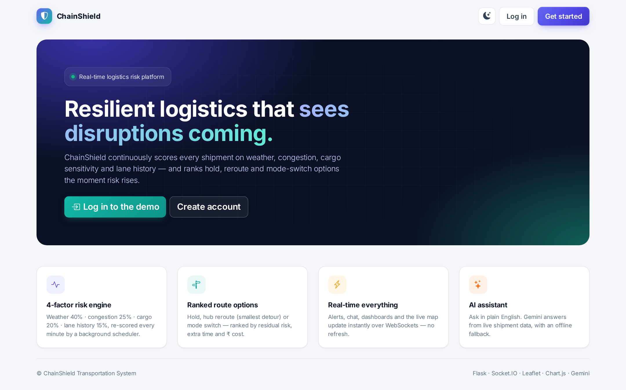
Fig 4.1 — Landing Page
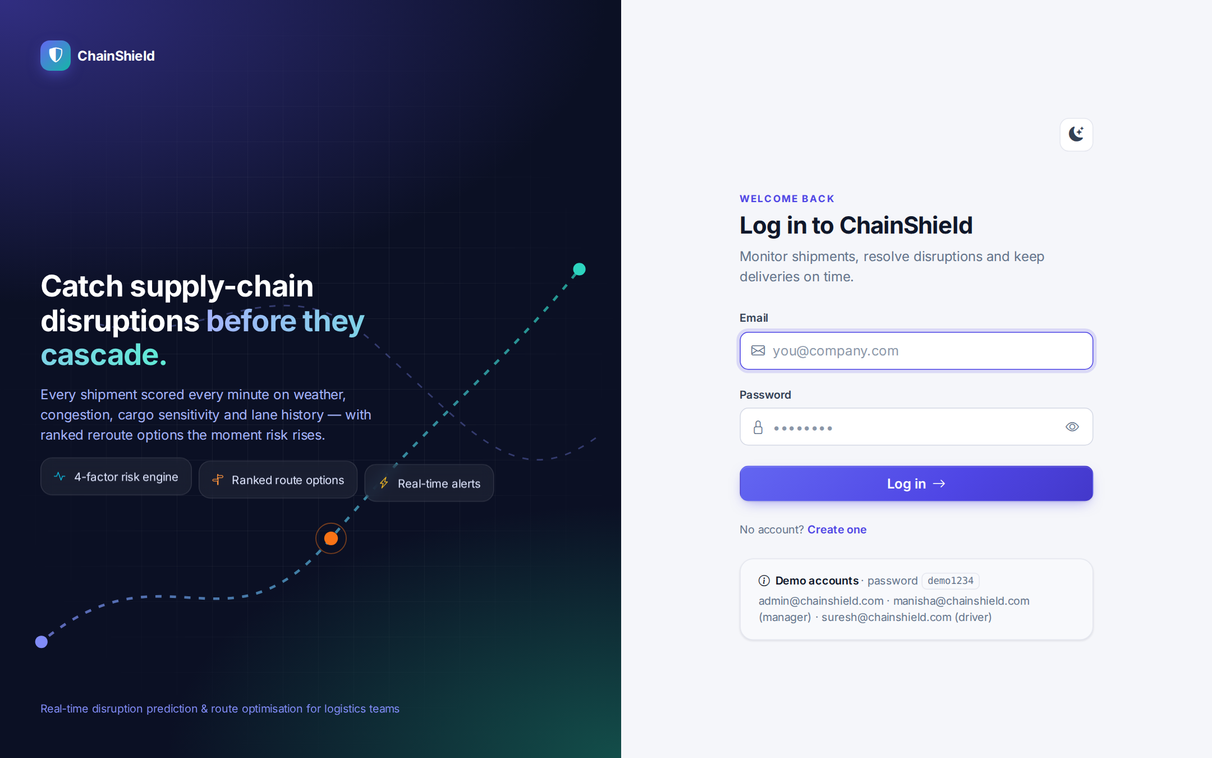
Fig 4.2 — Login Screen
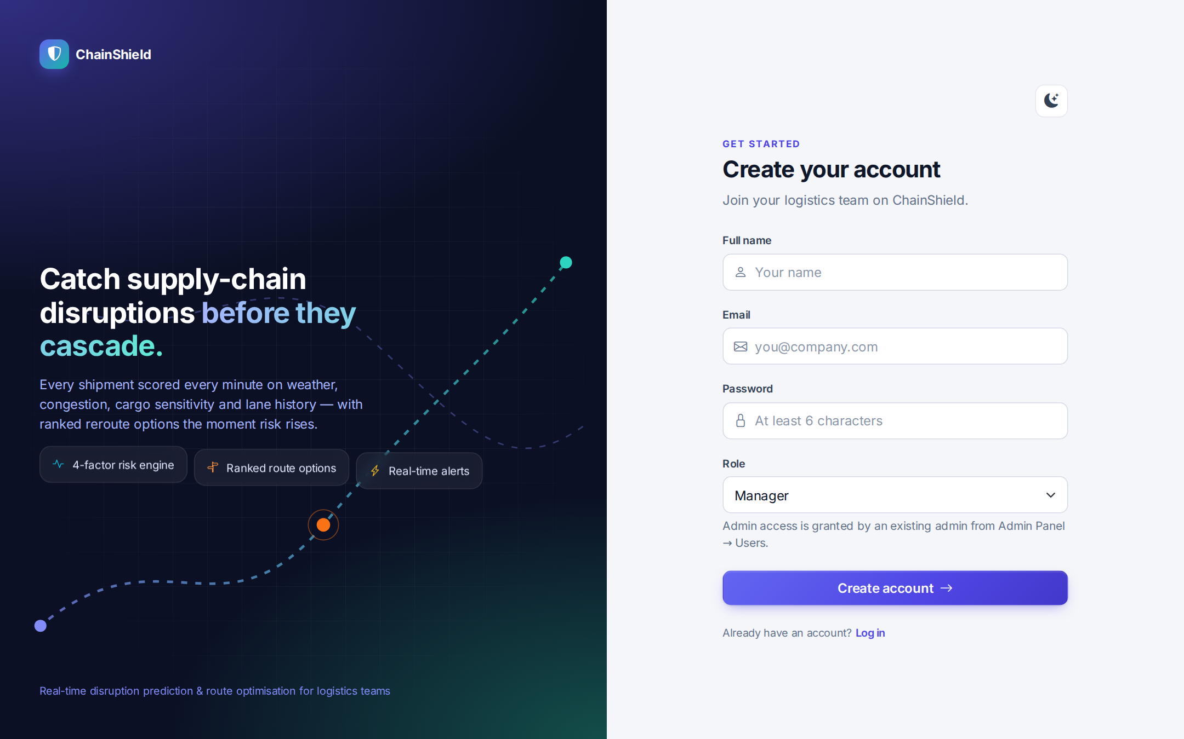
Fig 4.3 — Registration Screen
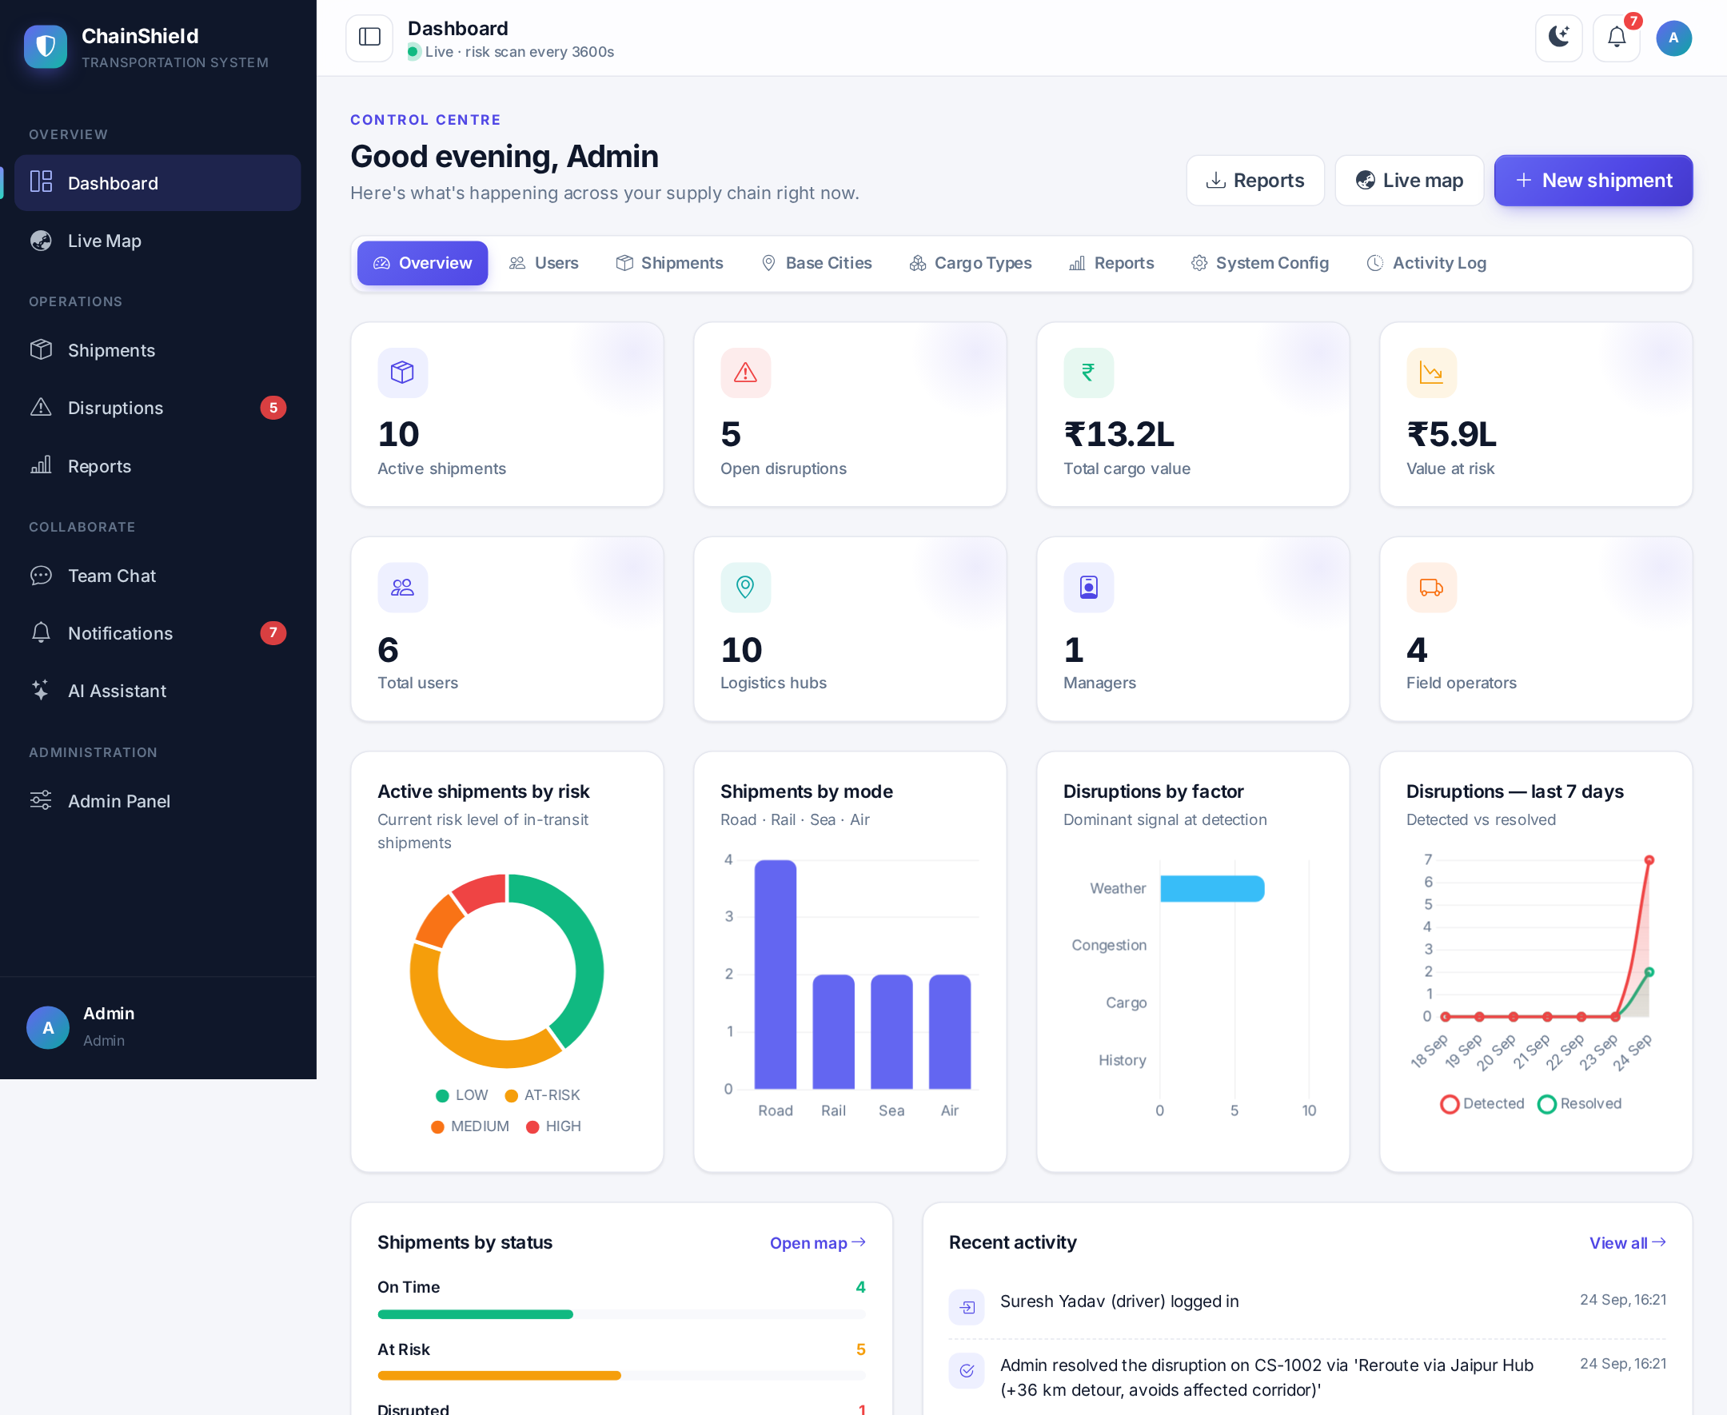
Fig 4.4 — Admin Dashboard with Live Charts
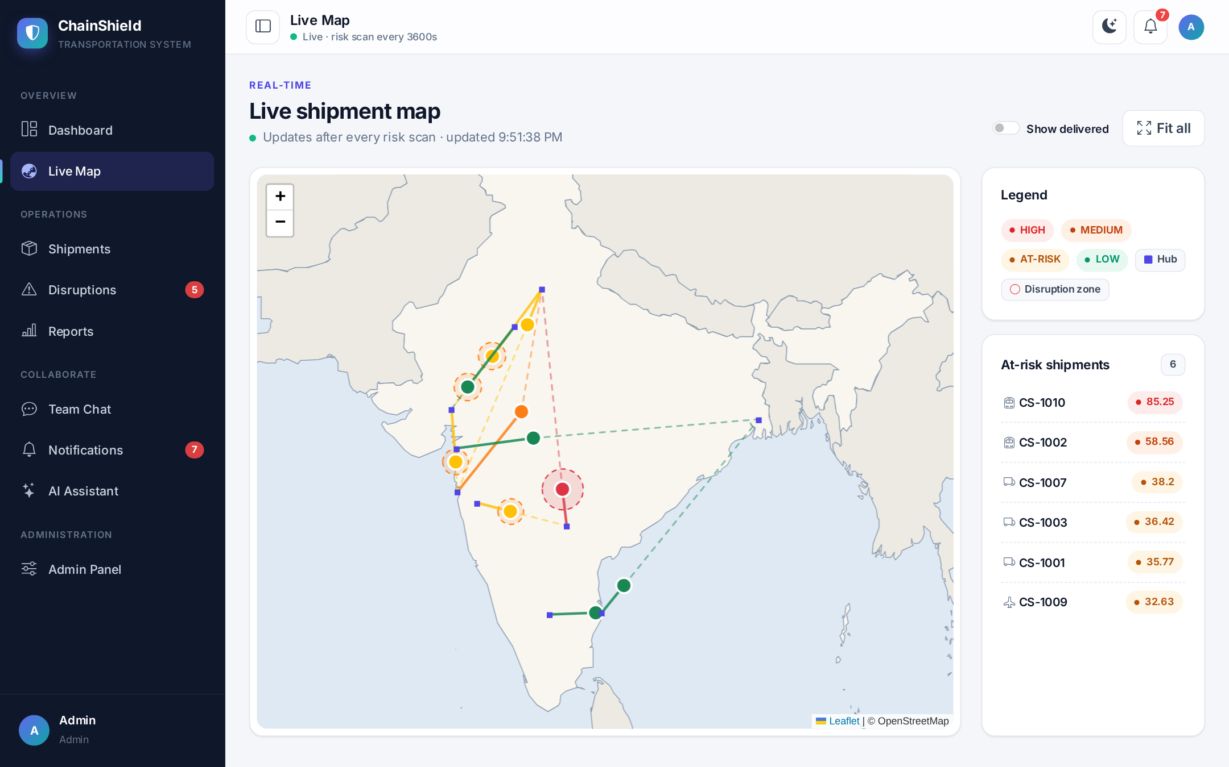
Fig 4.5 — Live Shipment Map with Disruption Zones
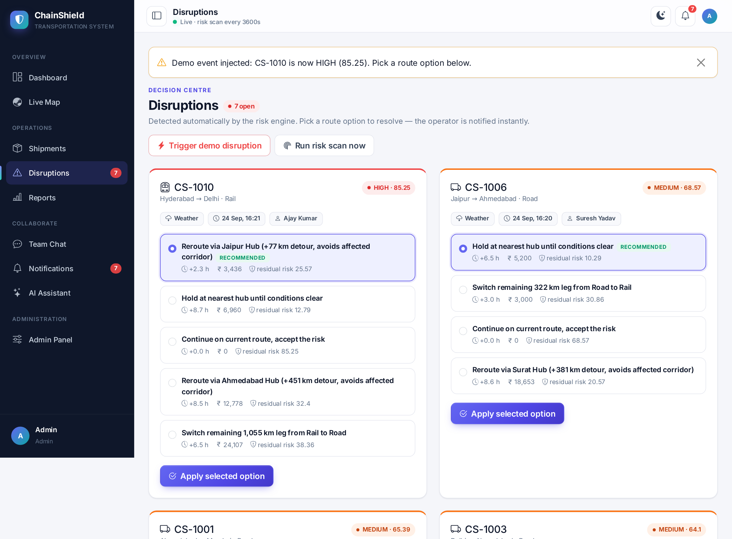
Fig 4.6 — Disruptions with Ranked Route Options
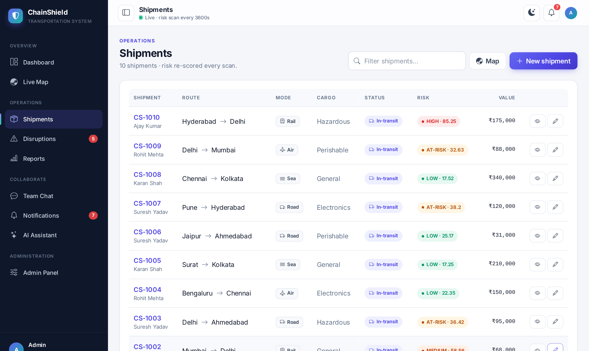
Fig 4.7 — Shipment List
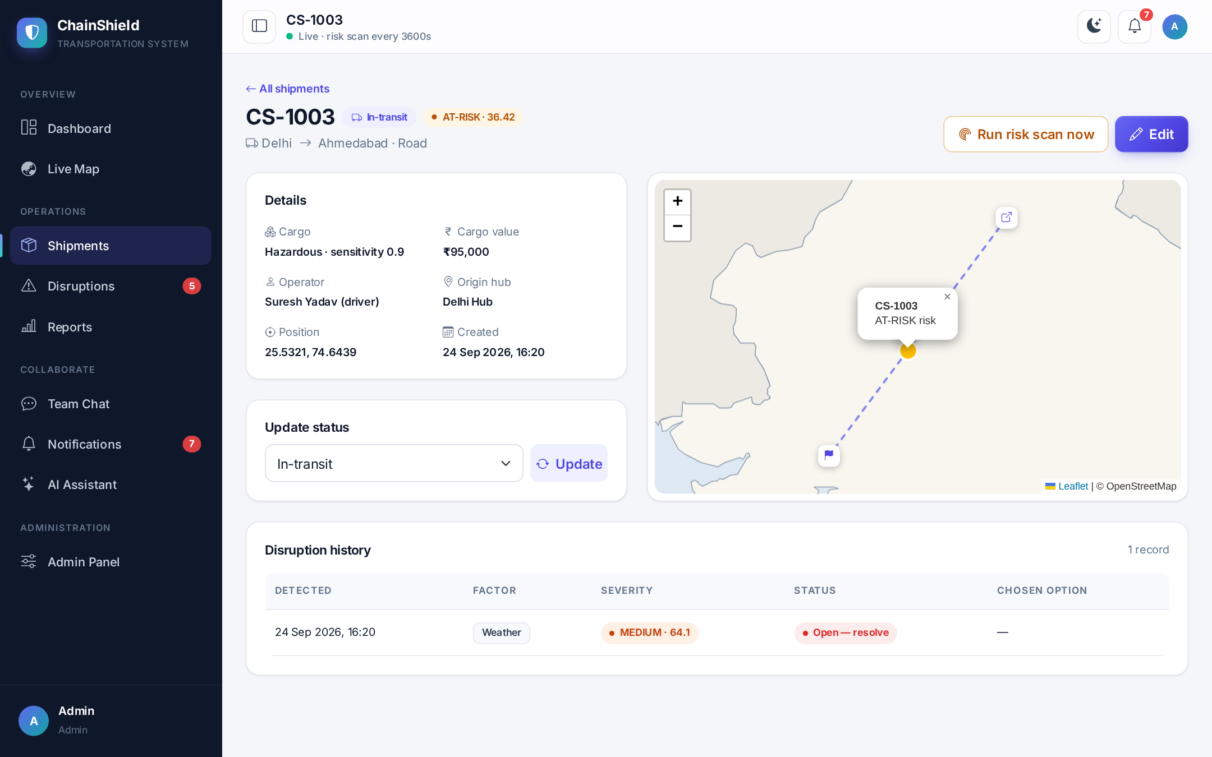
Fig 4.8 — Shipment Detail with Mini-map and History
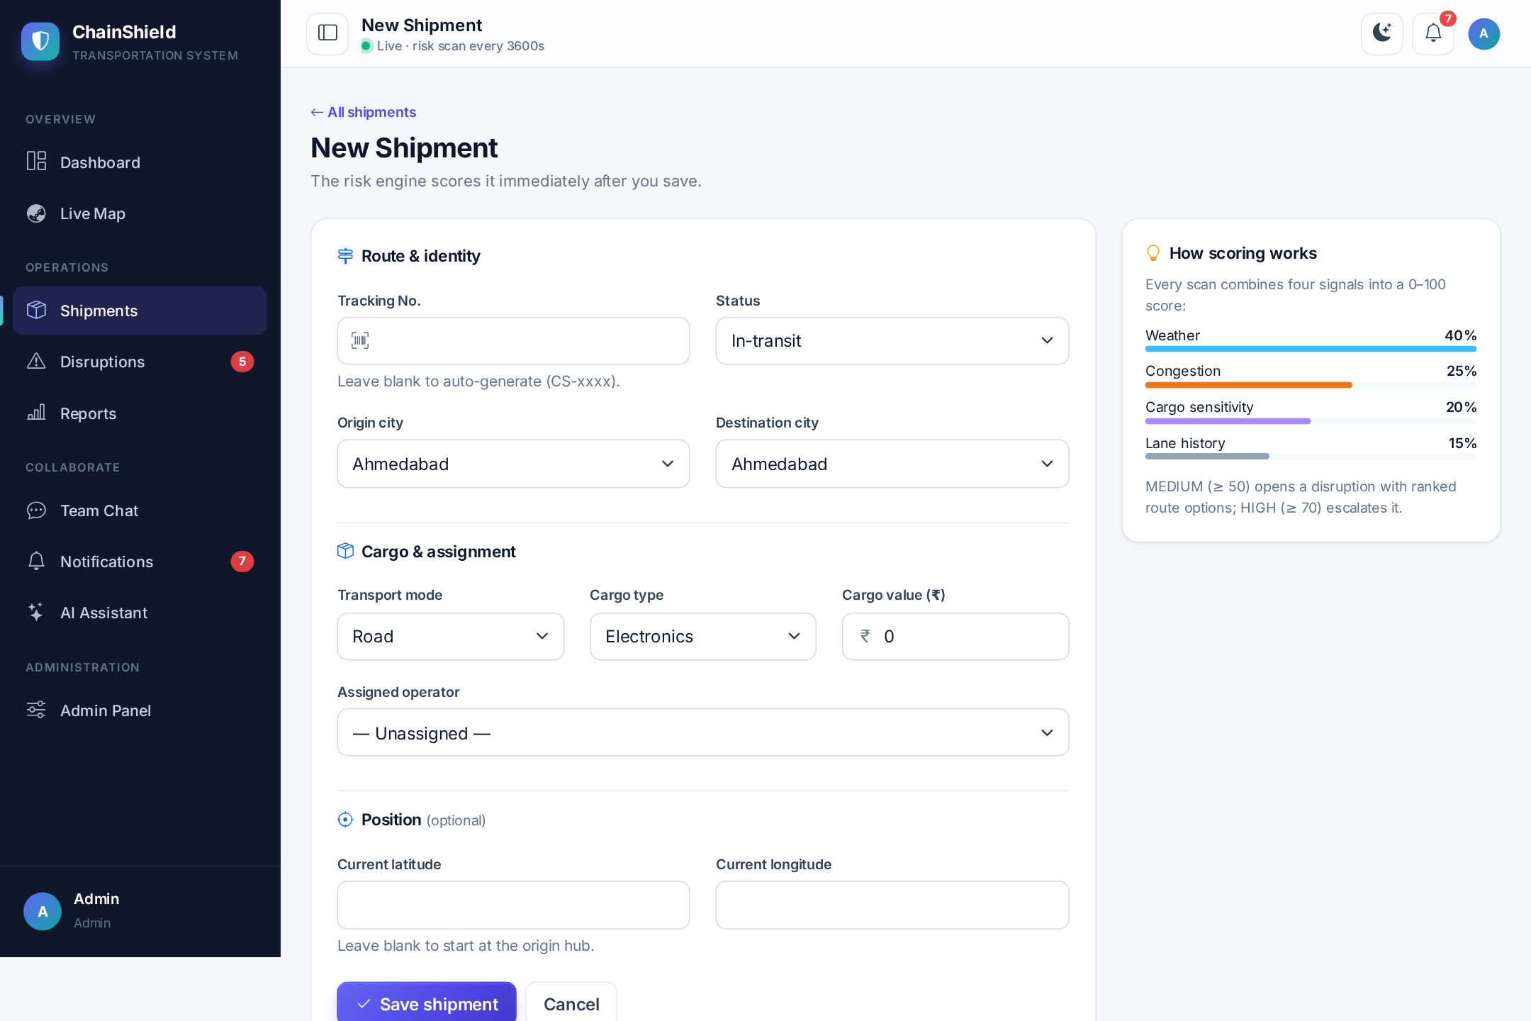
Fig 4.9 — Create Shipment Form
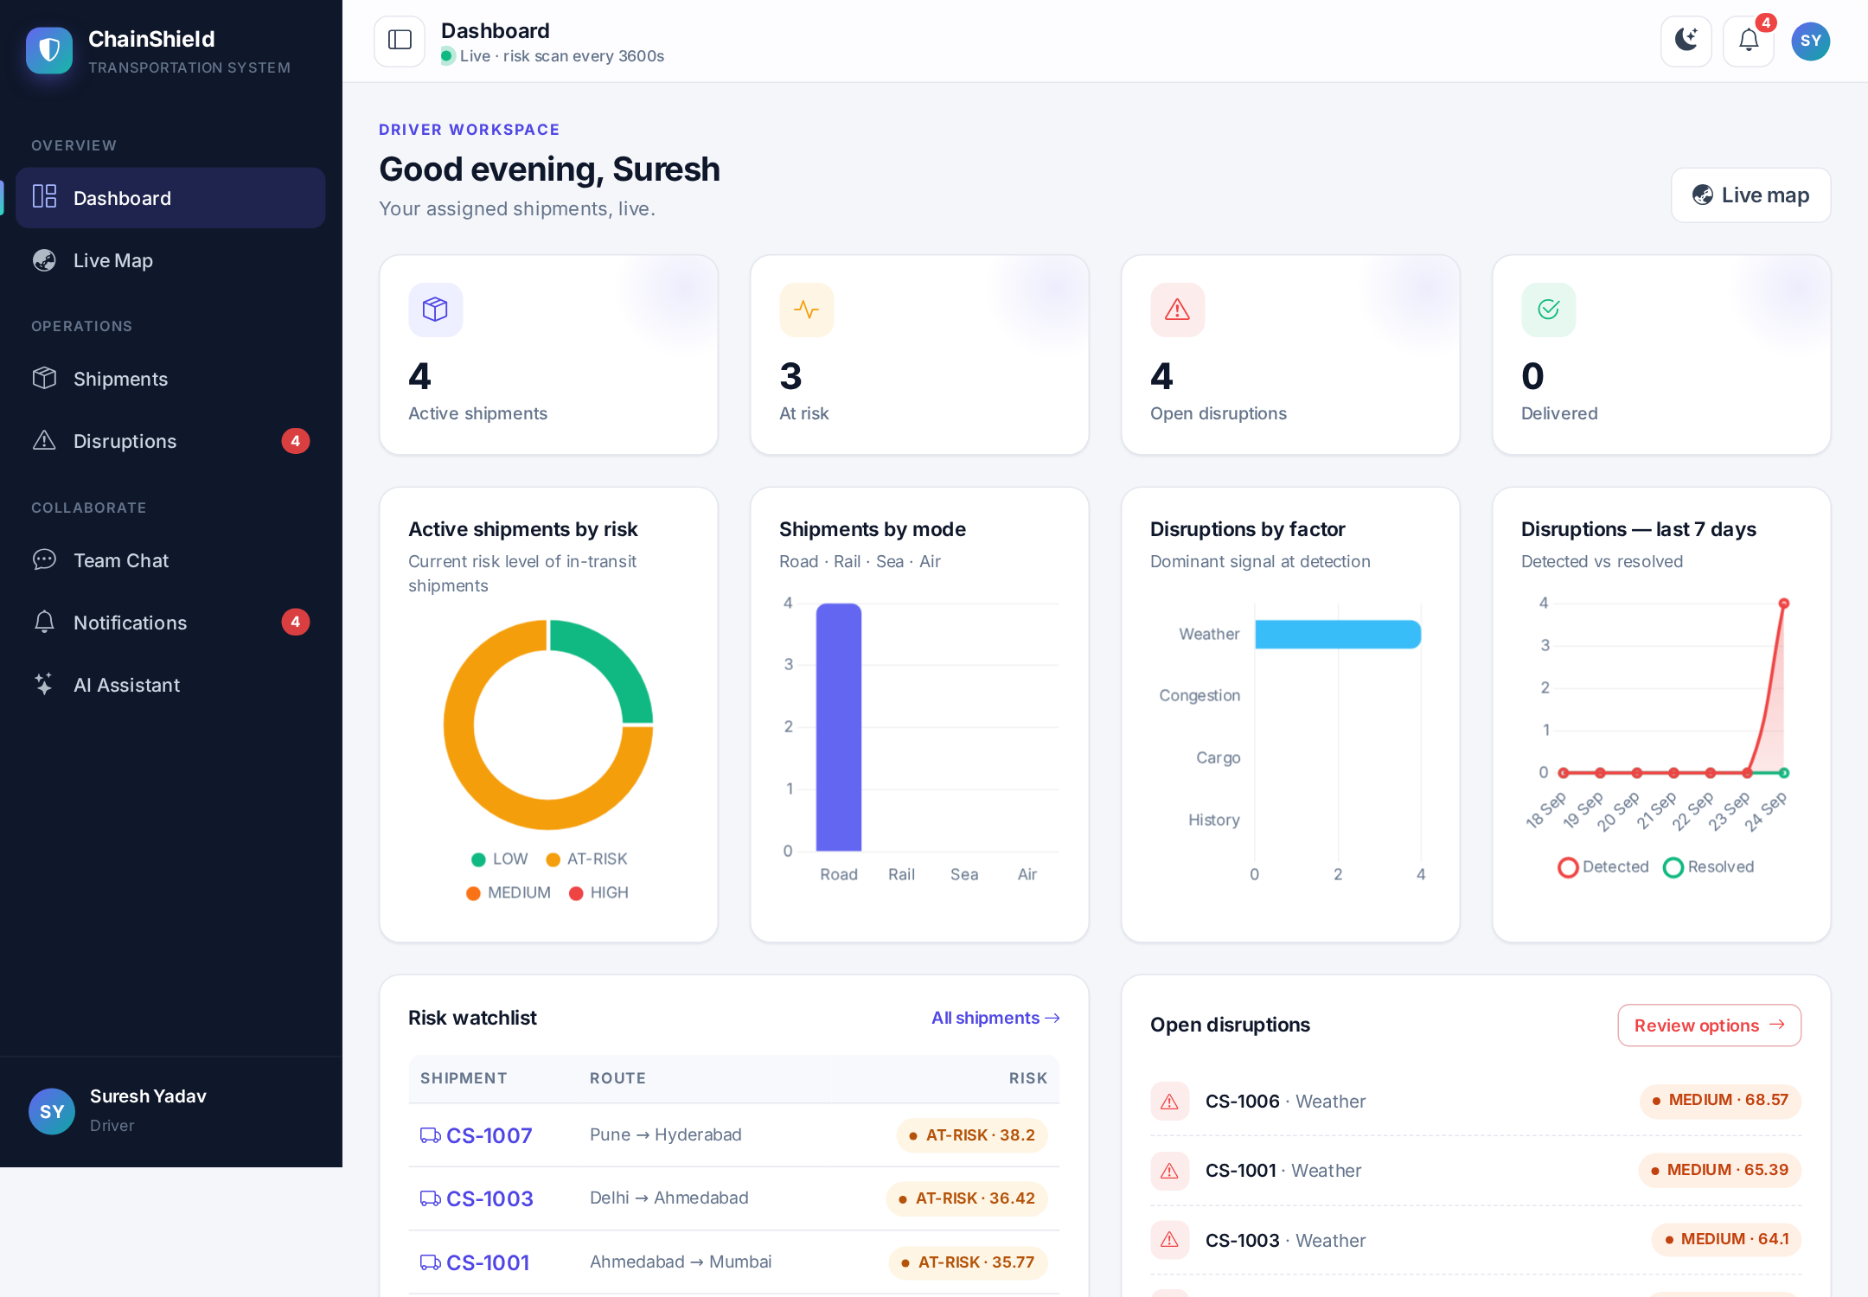
Fig 4.10 — Field Operator (Driver) Dashboard
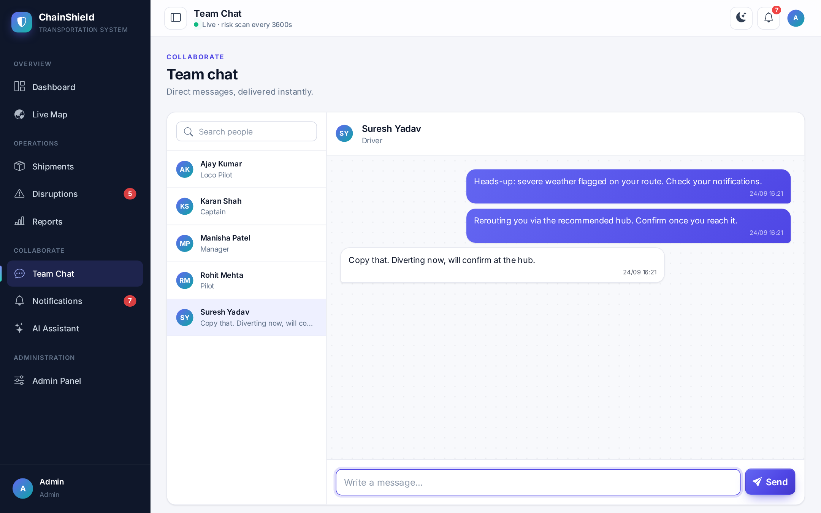
Fig 4.11 — Real-time Team Chat
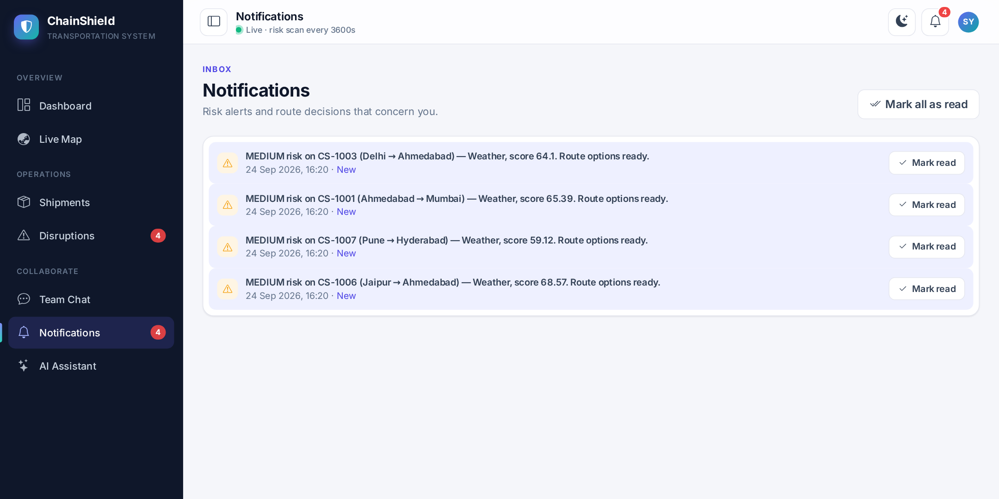
Fig 4.12 — Notification Feed
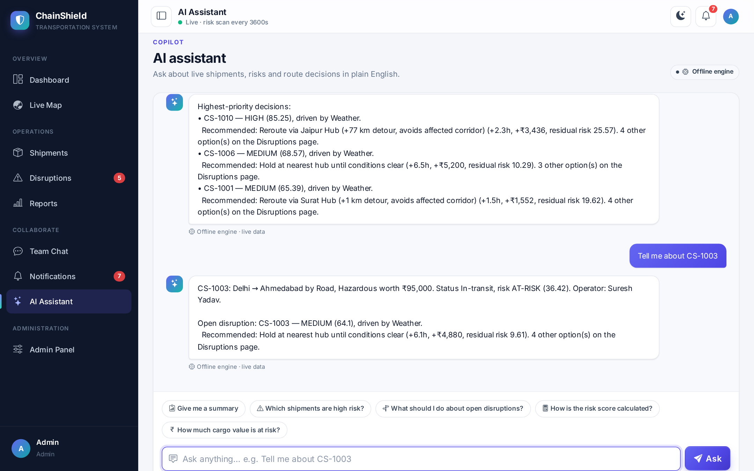
Fig 4.13 — AI Assistant with Suggested Questions
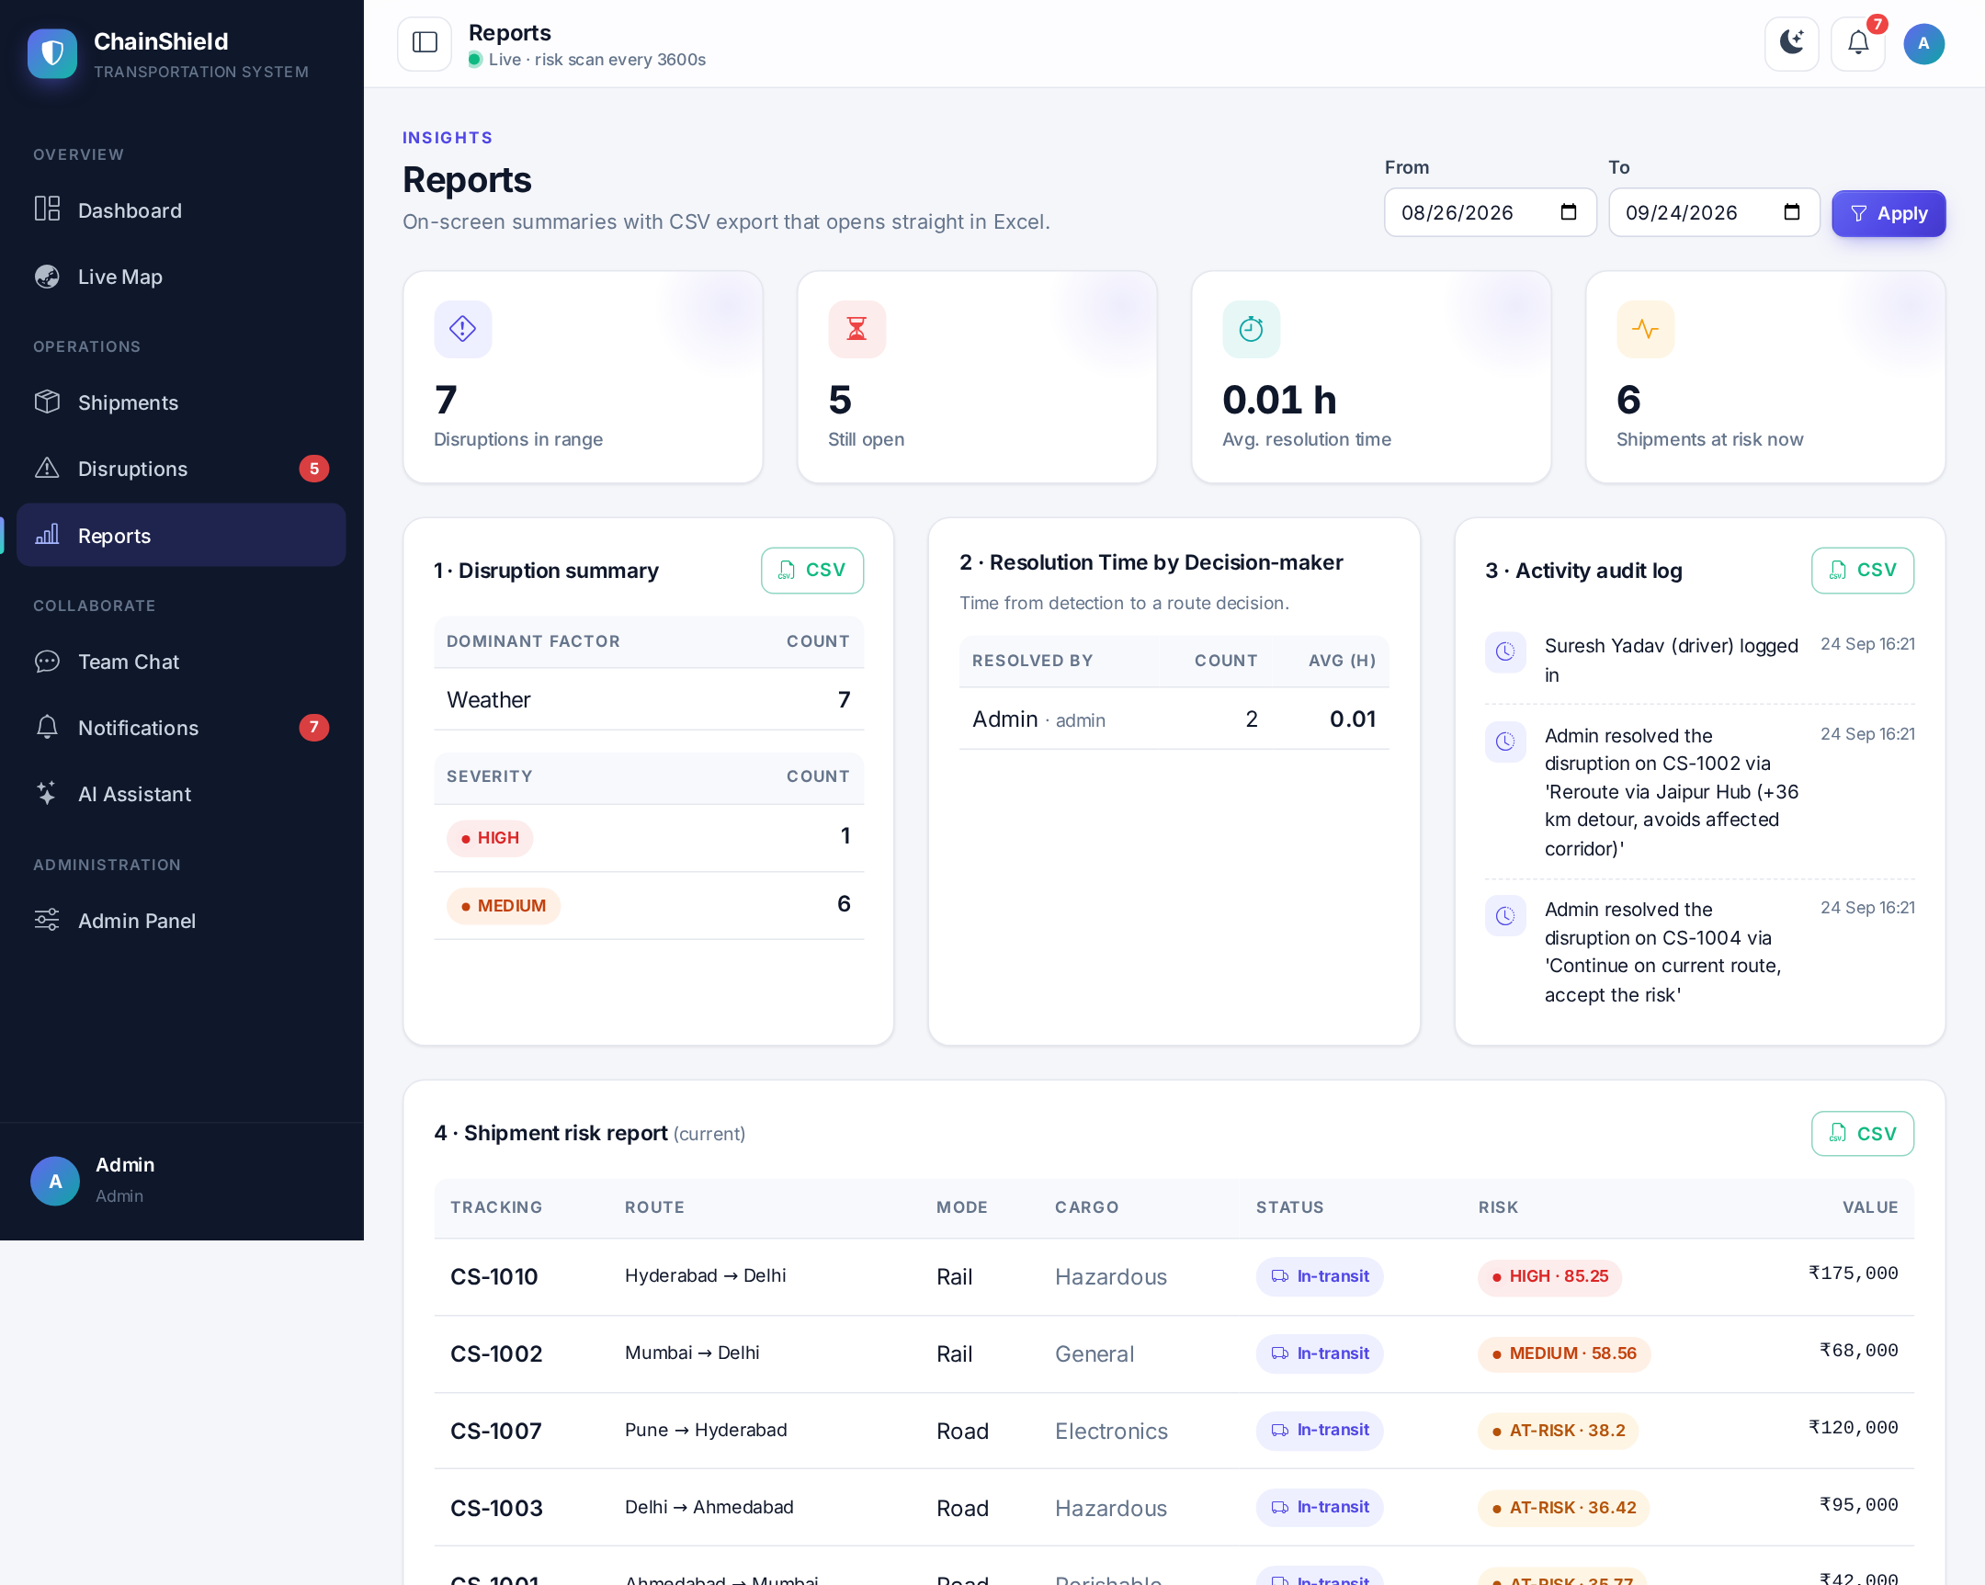
Fig 4.14 — Reports with CSV Export
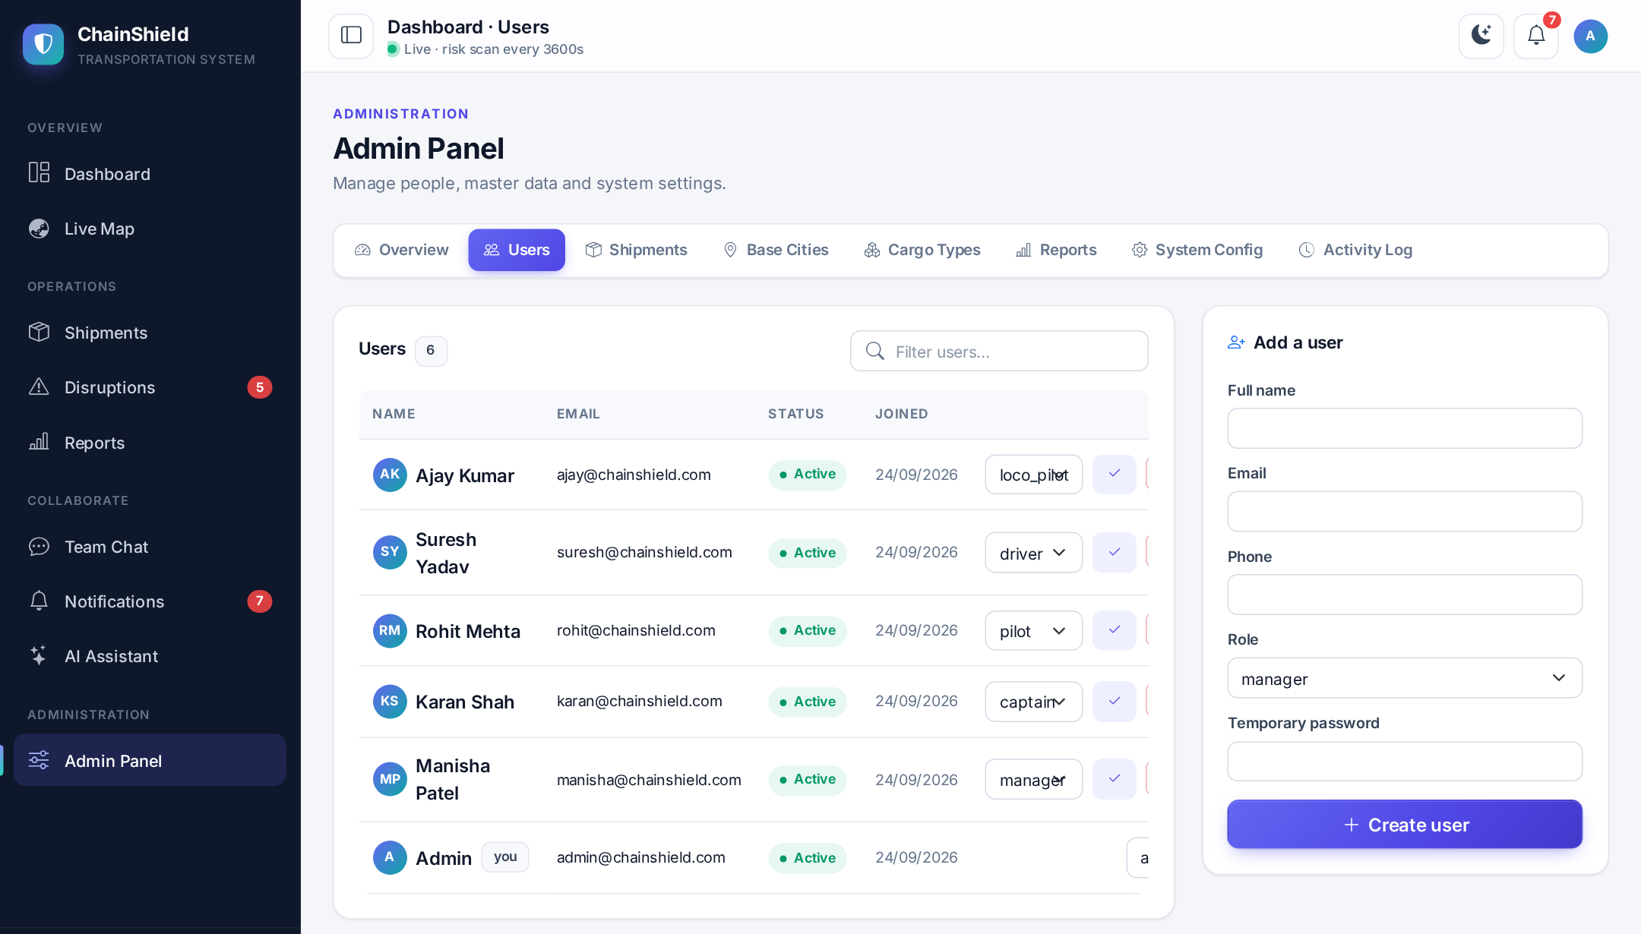
Fig 4.15 — Admin — User Management
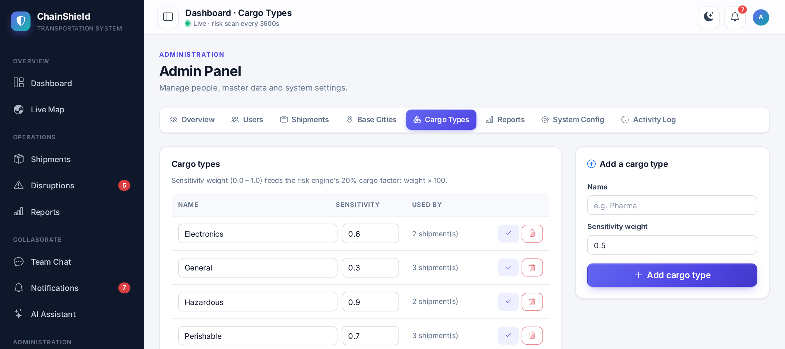
Fig 4.16 — Admin — Cargo Types
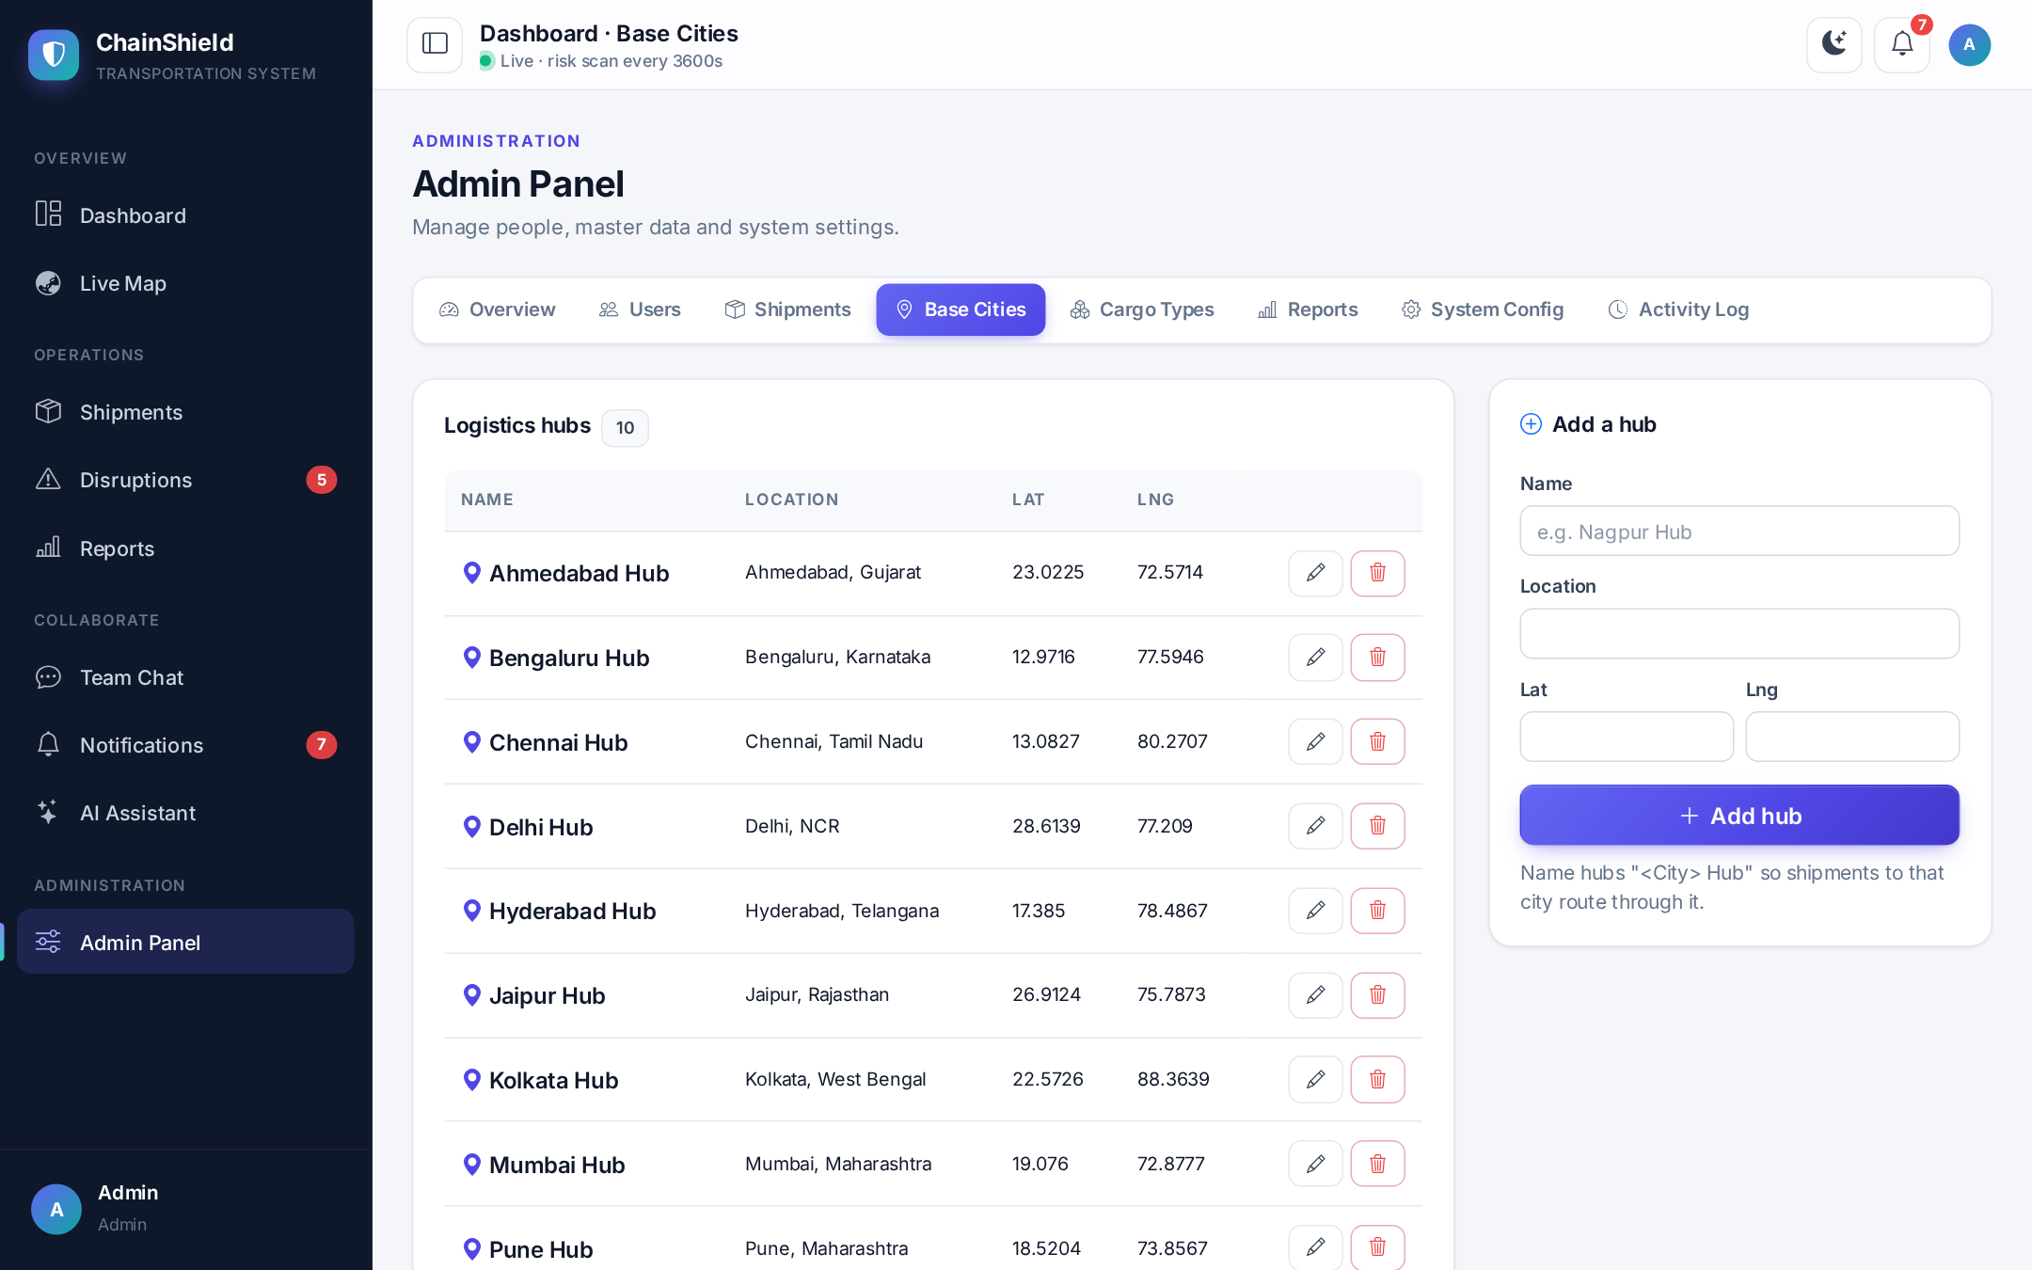
Fig 4.17 — Admin — Logistics Hubs
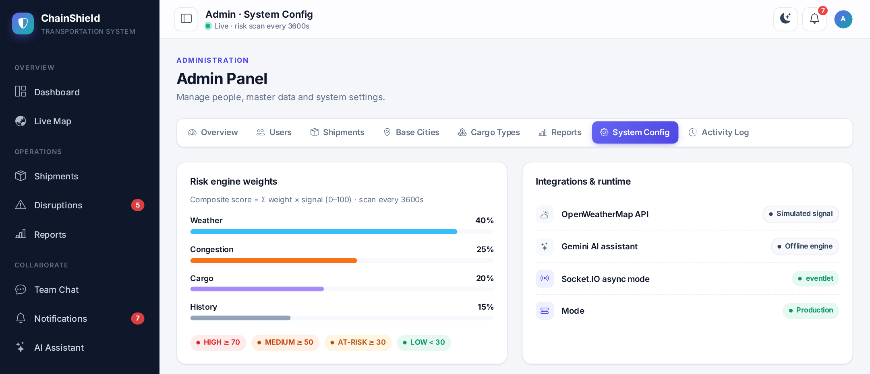
Fig 4.18 — Admin — System Configuration
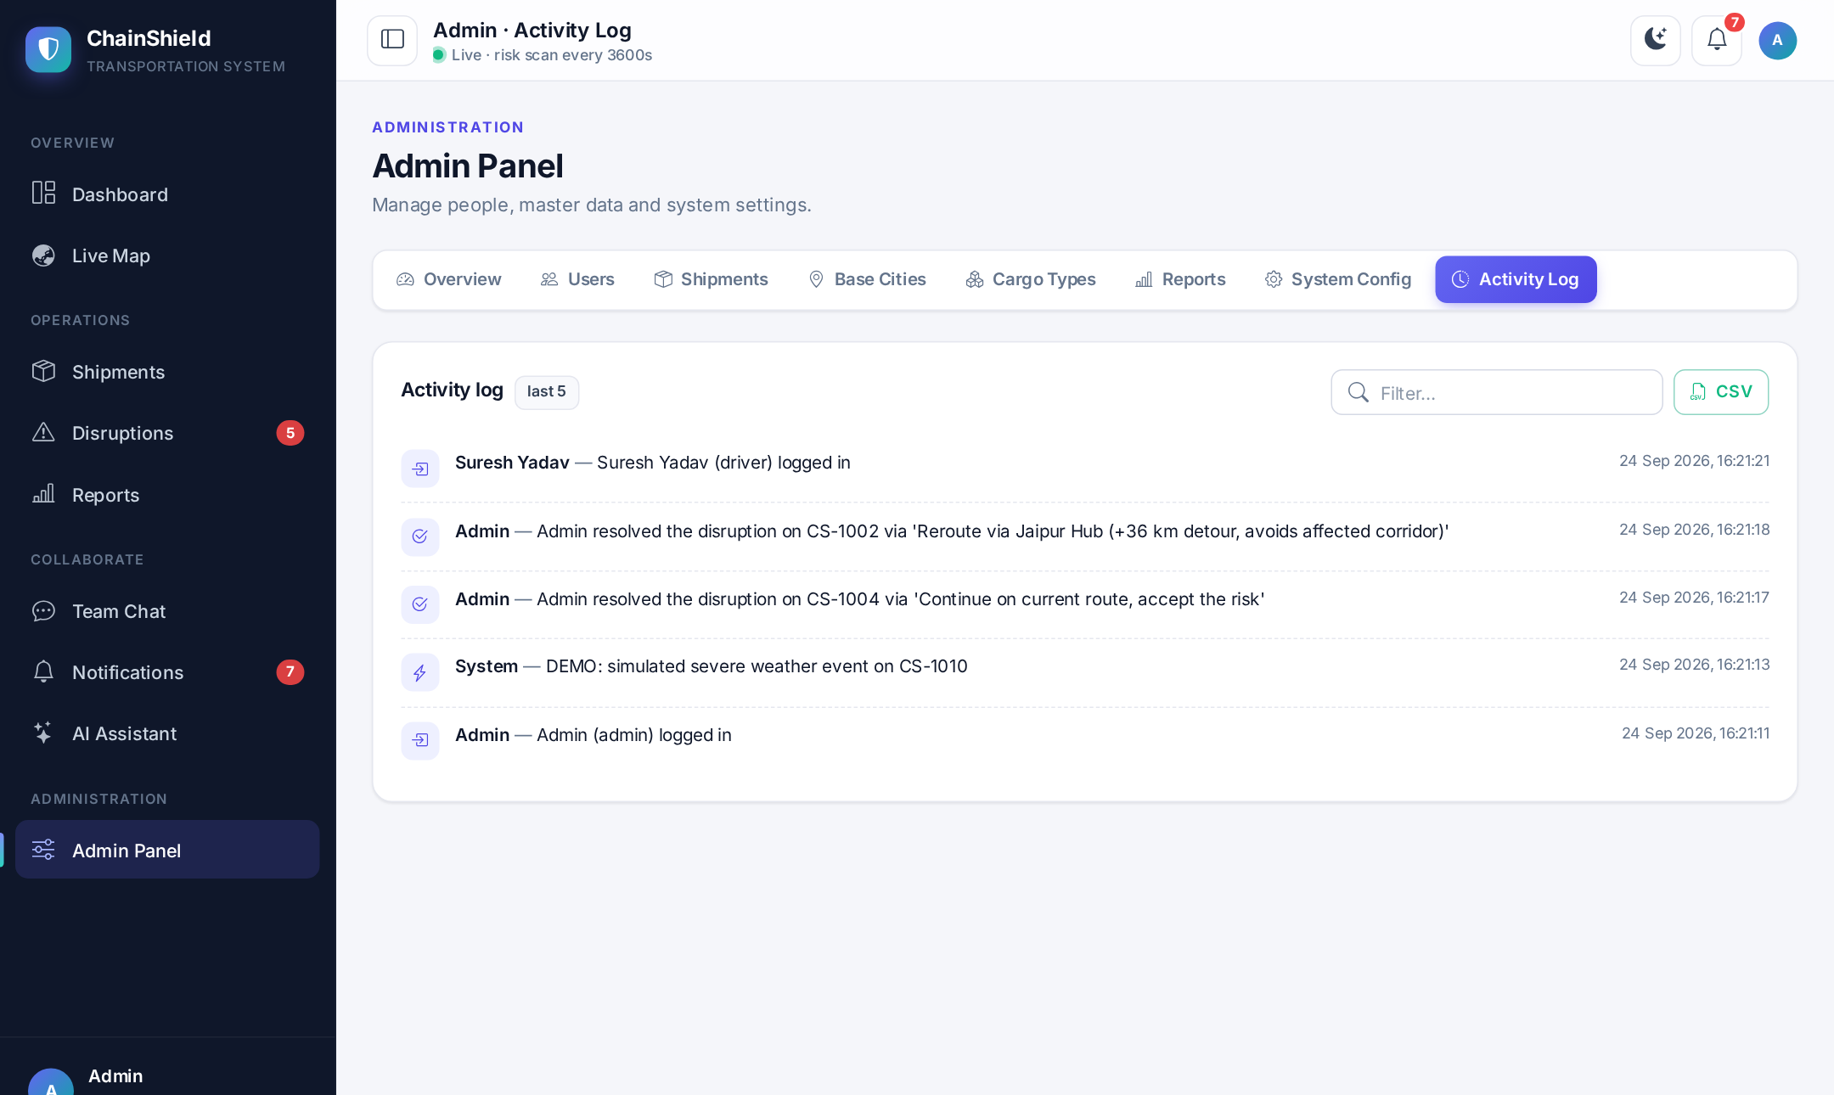
Fig 4.19 — Admin — Activity Audit Log
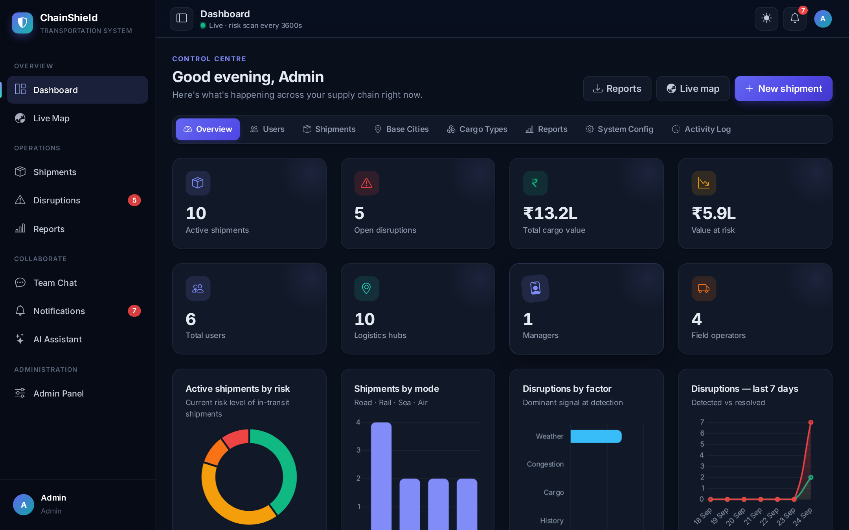
Fig 4.20 — Dark Theme — Admin Dashboard
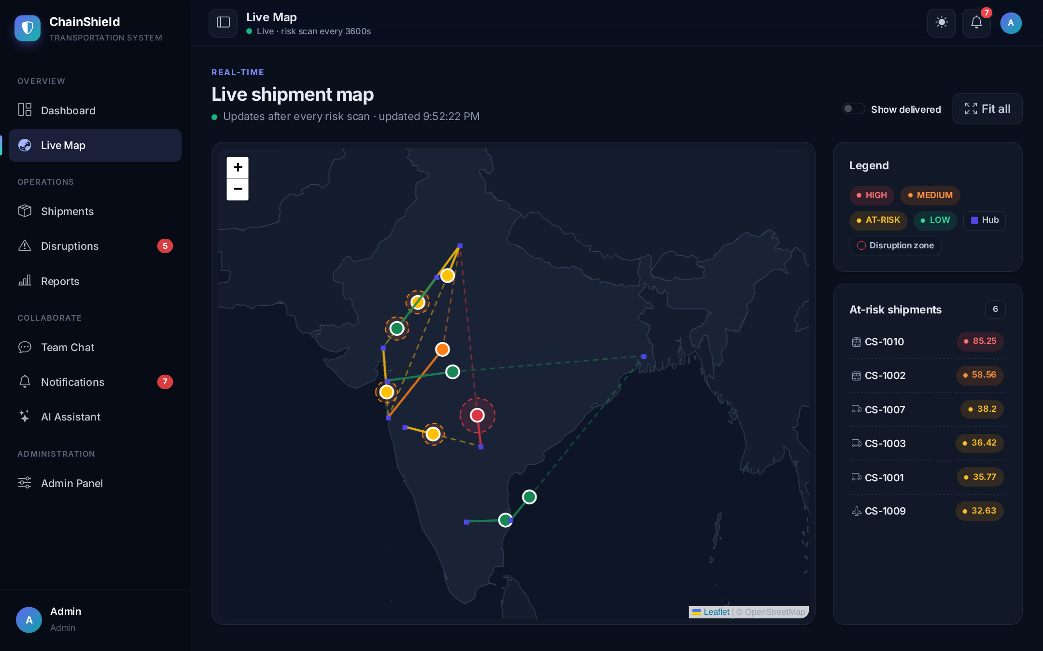
Fig 4.21 — Dark Theme — Live Map
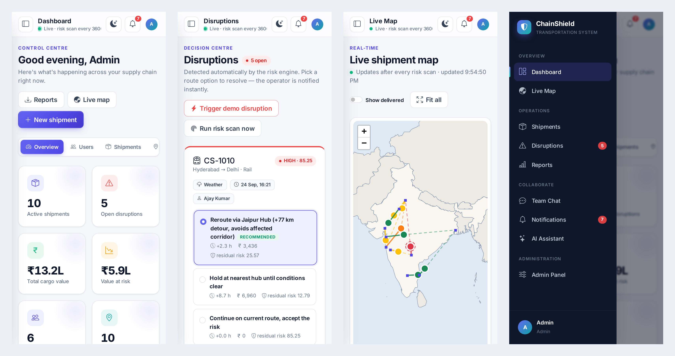
Fig 4.22 — Mobile Views — Dashboard, Disruptions, Live Map and Navigation Drawer

5. TESTING

5.1 Test Cases
Testing combined an automated test script (101 checks run through Flask's test client and the Socket.IO test client, covering every route, role restriction, the risk and route-solver logic, real-time events, chat, the assistant, reports and admin CRUD), manual testing of each screen in the browser, and a Docker deployment test. Representative test cases and their results are listed below.
Test Case 1 — User Login
Test ID | TC001
Description | Verify that a registered user can log in with correct credentials.
Pre-conditions | User account exists in the database.
Test Data | email = manisha@chainshield.com, password = demo1234
Expected Result | User is authenticated and redirected to their role-specific dashboard.
Status | Pass

Test Case 2 — Risk Score Calculation
Test ID | TC002
Description | Verify the risk engine correctly computes a composite score from the 4 weighted factors.
Pre-conditions | Risk weights configured as 0.40 / 0.25 / 0.20 / 0.15.
Test Data | Weather=80, Congestion=60, Cargo=50, History=40
Expected Result | Composite score = 0.40×80 + 0.25×60 + 0.20×50 + 0.15×40 = 63 (MEDIUM)
Status | Pass

Test Case 3 — Automatic Disruption Creation and Escalation
Test ID | TC003
Description | Verify a disruption is auto-created when a shipment's score reaches MEDIUM (≥ 50) and escalated when it reaches HIGH (≥ 70).
Pre-conditions | Scheduler running; an in-transit shipment with no open disruption.
Test Data | Scan 1: weather = congestion = 70 (MEDIUM); Scan 2: weather = congestion = 100 (HIGH)
Expected Result | One disruption is opened at MEDIUM with ≥ 3 ranked route solutions and alerts are sent; on scan 2 the same disruption is escalated to HIGH, its options re-planned and an “ESCALATED” notification sent.
Status | Pass

Test Case 4 — Route Solution Selection & Notification
Test ID | TC004
Description | Verify that resolving a disruption notifies the assigned field operator instantly.
Pre-conditions | An open disruption with ranked route solutions exists; manager is logged in.
Test Data | Manager selects Option 1 (recommended), e.g. “Reroute via Jaipur Hub”
Expected Result | Disruption status becomes Resolved; the operator receives a live notification and toast; the action appears in the audit log.
Status | Pass

Test Case 5 — Admin CRUD (Cargo Type)
Test ID | TC005
Description | Verify admin can add, edit, and delete a cargo type.
Pre-conditions | Admin is logged in.
Test Data | name = 'Pharma', sensitivity_weight = 0.9 → edited to 0.85; weight 1.5 attempted
Expected Result | Cargo type is saved, edited and deleted; weight outside 0.0–1.0 is rejected; deleting a cargo type used by shipments is blocked.
Status | Pass

Test Case 6 — Docker Container Startup
Test ID | TC006
Description | Verify the application starts correctly inside a Docker container with no manual configuration.
Pre-conditions | Docker Desktop installed on Windows 11.
Test Data | docker compose up --build
Expected Result | Image builds; Gunicorn starts with the eventlet worker on port 5000; the app, database and scheduler run and the site is reachable at http://localhost:5000.
Status | Pass

Test Case 7 — Role-Based Access Control
Test ID | TC007
Description | Verify field operators cannot reach admin/manager functions and only see their own shipments.
Pre-conditions | Driver account with 3 assigned Road shipments.
Test Data | GET /dashboard/users, /shipments/new, /reports; view another operator's shipment
Expected Result | 403 Forbidden for admin/manager pages; 404 for other operators' shipments; live map lists only the driver's 3 shipments.
Status | Pass

Test Case 8 — Real-time Chat Delivery
Test ID | TC008
Description | Verify a chat message is stored and delivered live to the recipient.
Pre-conditions | Admin and driver both logged in (two browsers).
Test Data | Admin sends “Hold CS-1001 at Surat” to the driver
Expected Result | Message saved; driver's open socket receives it instantly; it appears in both chat histories; empty messages are rejected.
Status | Pass

Test Case 9 — AI Assistant with Fallback
Test ID | TC009
Description | Verify the assistant answers from live data, and still answers when Gemini is unavailable.
Pre-conditions | Shipments and open disruptions exist.
Test Data | “Give me a summary”, “Tell me about CS-1003”, with a valid key and with an invalid key
Expected Result | Gemini answer with a valid key; with an invalid key the offline engine answers from the same data within seconds.
Status | Pass

Test Case 10 — Reports and CSV Export
Test ID | TC010
Description | Verify reports render and export correctly for managers, with a working date filter.
Pre-conditions | Manager logged in; disruptions and activity exist.
Test Data | /reports, /reports/disruptions.csv, ?from=2020-01-01&to=2020-01-02
Expected Result | Page shows 4 reports; CSV downloads open in Excel with resolution time column; out-of-range filter returns only the header row; drivers get 403.
Status | Pass

Test Case 11 — User Deactivation
Test ID | TC011
Description | Verify a deactivated user can no longer log in and an open session is ended.
Pre-conditions | Admin logged in; target user has an active session.
Test Data | Admin clicks Deactivate on the user
Expected Result | Login is refused with a message; the user's open session is logged out on the next request; admin cannot deactivate themself.
Status | Pass

Test Case 12 — Demo Disruption Trigger
Test ID | TC012
Description | Verify the demo trigger creates a live HIGH disruption instantly.
Pre-conditions | Manager logged in; at least one in-transit shipment.
Test Data | Click “Trigger demo disruption”
Expected Result | A HIGH disruption with ranked options appears immediately, a shaded zone is drawn on the live map, and alerts are pushed.
Status | Pass

Test Case 13 — Responsive Layout and Themes
Test ID | TC013
Description | Verify the interface works on phones and that theme and sidebar preferences persist.
Pre-conditions | Browser at 390 × 844 (phone) and 1440 × 900 (desktop).
Test Data | Open 8 main pages on a phone; toggle dark mode; collapse the sidebar and navigate
Expected Result | No page scrolls sideways on the phone; the navigation drawer opens and closes; the chosen theme and collapsed sidebar are remembered across pages.
Status | Pass

6. PROPOSED ENHANCEMENT
The following enhancements are identified as valuable future work, beyond the scope of the current MCA Semester 3 submission:
- Integration with real GPS/telematics hardware feeds in place of simulated shipment positions.
- Migration from SQLite to PostgreSQL to support multi-node, production-scale deployment.
- A predictive machine-learning model, trained on historical disruption data, to augment or replace the current weighted-heuristic risk formula.
- A companion mobile application for field operators, for on-the-go status updates and notifications.
- Multi-tenant support so multiple independent logistics companies can use isolated instances of the platform.
- Additional notification channels — SMS and WhatsApp — alongside in-app alerts.
- Integration with public customs and port-authority APIs for verified, real-time congestion data.
- Improve the AI assistant — better prompts, conversation memory and suggested actions from its answers.
- PDF export of reports and scheduled e-mail delivery of the daily risk summary.
- Installable Progressive Web App for field operators, with push notifications on their phones.

7. CONCLUSION
The ChainShield Transportation System addresses a well-defined, real-world problem: the tendency of supply-chain disruptions to be discovered only after delivery timelines are already compromised. By continuously scoring every active shipment against a transparent, weighted risk model, and by pairing every detected disruption with concrete, ranked route-solution alternatives, the system moves logistics management from a reactive posture to a preemptive one.
ChainShield was built from scratch as a self-contained Python (Flask) and SQLite application, containerised with Docker so that it runs identically on any server. This makes it practical for a logistics company to deploy it on its own infrastructure, connect its own weather and AI keys, and start monitoring its shipments immediately.
Group 59 translated the requirement analysis and system design in this report into a working, tested application: a scheduled risk engine, automatic disruption detection with escalation, a multi-objective route solver, a live map, role-based dashboards, real-time notifications and chat, a Gemini-powered assistant, reports with CSV export, a full admin panel and a responsive interface with light and dark themes — verified by 101 automated checks, visual checks on desktop and phone, and a Docker deployment test. It shows how a modest, open-source technology stack can meaningfully address a difficult operational problem in logistics.

8. BIBLIOGRAPHY

Books Referred
- Flask Web Development — Miguel Grinberg, O'Reilly Media
- Python Crash Course — Eric Matthes, No Starch Press
- Fundamentals of Database Systems — Ramez Elmasri & Shamkant B. Navathe, Pearson
- Software Engineering — Ian Sommerville, Pearson

Websites Referred
- https://flask.palletsprojects.com/
- https://docs.python.org/3/
- https://www.sqlite.org/docs.html
- https://docs.docker.com/
- https://getbootstrap.com/docs/5.3/
- https://leafletjs.com/reference.html
- https://developer.mozilla.org/
- https://ai.google.dev/gemini-api/docs
- https://openweathermap.org/api
- https://flask-socketio.readthedocs.io/
- https://www.chartjs.org/docs/
- https://apscheduler.readthedocs.io/
- https://www.geeksforgeeks.org/

