SOFTWARE REQUIREMENTS SPECIFICATION
“ CHAINSHIELD TRANSPORTATION SYSTEM ”
Resilient Logistics & Dynamic Supply Chain Optimization
Prepared as per IEEE 830 SRS guidelines
MCA Semester 3, Academic Year 2026-27
To
LJ INSTITUTE OF COMPUTER APPLICATION
Affiliated to LJK University
Guided By:  Prof. Dhaval Shah | Prepared By: (Group No. 59)  Bhavik A. Visani (D51 / 25004401110170)  Diya Shah (D36 / 25003401110017)  Shruti Somani (D42 / 25004401110259)

INDEX
Sr. | Particulars | Page No
1 | Introduction  1) Purpose  2) Document Scope  3) Definitions, Acronyms & Abbreviations  4) References  5) Overview | 3
2 | Overall Description  1) Product Perspective  2) Product Functions  3) User Classes & Characteristics  4) Operating Environment  5) Design & Implementation Constraints  6) Assumptions & Dependencies | 5
3 | System Architecture & Use Cases | 7
4 | Specific Requirements — Functional | 9
5 | External Interface Requirements  1) User Interfaces  2) Hardware Interfaces  3) Software Interfaces  4) Communication Interfaces | 14
6 | Non-Functional Requirements  1) Performance  2) Security  3) Reliability  4) Usability  5) Portability  6) Maintainability | 15
7 | Data Requirements | 16
8 | Appendix — Traceability & Bibliography | 17

1. INTRODUCTION

1.1 Purpose
This Software Requirements Specification (SRS) defines the functional and non-functional requirements of the ChainShield Transportation System, a project developed by Group No. 59 for MCA Semester 3 at LJ Institute of Computer Application. It is intended to give the project guide, examiners, and the development team a single, unambiguous reference for what the system must do before implementation proceeds, following the structure recommended by IEEE Standard 830.

1.2 Document Scope
This document covers the ChainShield Transportation System rebuild — a Flask, SQLite, and Docker-based application that continuously scores active shipments for disruption risk and proposes optimised route adjustments. It does not cover the original FastAPI/React ChainShield prototype built for an earlier solution-building initiative, which remains a separate, already-deployed codebase and is not part of this specification.

1.3 Definitions, Acronyms & Abbreviations
Term | Meaning
SRS | Software Requirements Specification
FR | Functional Requirement
NFR | Non-Functional Requirement
Disruption | A shipment event whose composite risk score has crossed the AT-RISK threshold (≥ 30)
Risk Engine | The scheduled service that computes a 0-100 composite risk score for each active shipment
Route Solution | A ranked reroute/hold alternative generated for an open disruption
Field Operator | A user with role captain, pilot, driver, or loco_pilot who executes shipments
ORM | Object-Relational Mapper (Flask-SQLAlchemy)

1.4 References
- MCA Semester 3 Project Documentation — ChainShield_MCA_Sem3_Documentation.docx (Group 59, 2026)
- IEEE Std 830-1998 — IEEE Recommended Practice for Software Requirements Specifications
- Flask Documentation — https://flask.palletsprojects.com/
- SQLite Documentation — https://www.sqlite.org/docs.html

1.5 Overview
Section 2 describes the product at a high level — its perspective, functions, users, and constraints. Section 3 summarises the system architecture and use cases. Section 4 lists detailed functional requirements, each with a unique identifier for traceability. Section 5 covers external interfaces, Section 6 covers non-functional requirements, Section 7 defines the data requirements, and Section 8 provides a requirements traceability summary and bibliography.

2. OVERALL DESCRIPTION

2.1 Product Perspective
ChainShield Transportation System is a new, self-contained web application — it is not a component of, or dependent on, any other system. It is built as a single Flask application following the app-factory and blueprint patterns, backed by a local SQLite database, and packaged with Docker for portable deployment. It optionally integrates with two external services — the OpenWeatherMap API for live weather signals and the Google Gemini API for its AI assistant — both of which degrade gracefully to simulated data when unavailable, so the system remains fully demonstrable offline.

2.2 Product Functions
- Role-based user registration, authentication, and session management
- Continuous, scheduled disruption-risk scoring for every active shipment
- Automatic disruption detection and ranked route-solution generation
- In-app notification delivery and direct messaging between users
- Administrative management of users, logistics hubs, and cargo types, with an audit log
- A natural-language AI assistant for supply-chain queries
- A live map visualisation of shipments and disruption zones

2.3 User Classes and Characteristics
User Class | Technical Expertise | Primary Use
Admin | Moderate — comfortable with web forms and configuration | User, hub, and cargo-type management; audit review
Manager | Low to moderate — a logistics professional, not a technical user | Monitoring risk, resolving disruptions, choosing routes
Field Operator | Low — expects a simple, mobile-friendly interface | Viewing assigned shipments, updating status, receiving alerts

2.4 Operating Environment
- Server: any OS that supports Docker (Windows, Linux, macOS) running Python 3.10+
- Client: any modern desktop or mobile web browser (Chrome, Edge, Firefox, Safari)
- Database: SQLite, file-based, persisted via a Docker volume
- Deployment: Docker container exposing the application on port 5000

2.5 Design and Implementation Constraints
- Must use Python and Flask, per the confirmed academic technology stack
- Must remain fully independent of the original FastAPI/React ChainShield prototype — no shared code or database
- Must run without requiring paid API keys — external APIs are optional with simulated fallbacks
- Must be containerisable with a single Dockerfile and docker-compose.yml, with no manual server configuration

2.6 Assumptions and Dependencies
- It is assumed the host machine has Docker Desktop (or an equivalent Docker engine) installed for containerised deployment
- It is assumed shipment position and weather data may be simulated for demonstration, in the absence of live GPS/telematics hardware
- The system depends on Flask, Flask-SQLAlchemy, Flask-Login, Flask-SocketIO, Flask-WTF, and APScheduler, as listed in requirements.txt

3. SYSTEM ARCHITECTURE & USE CASES
The system follows a layered architecture: a Flask + Jinja2 + Bootstrap presentation layer, core services (Risk Engine, Route Solver, Notifications/Chat, AI Assistant, Admin Services) in the middle, a Flask-SQLAlchemy data access layer, and a SQLite database at the base — the entire stack packaged inside a Docker container.
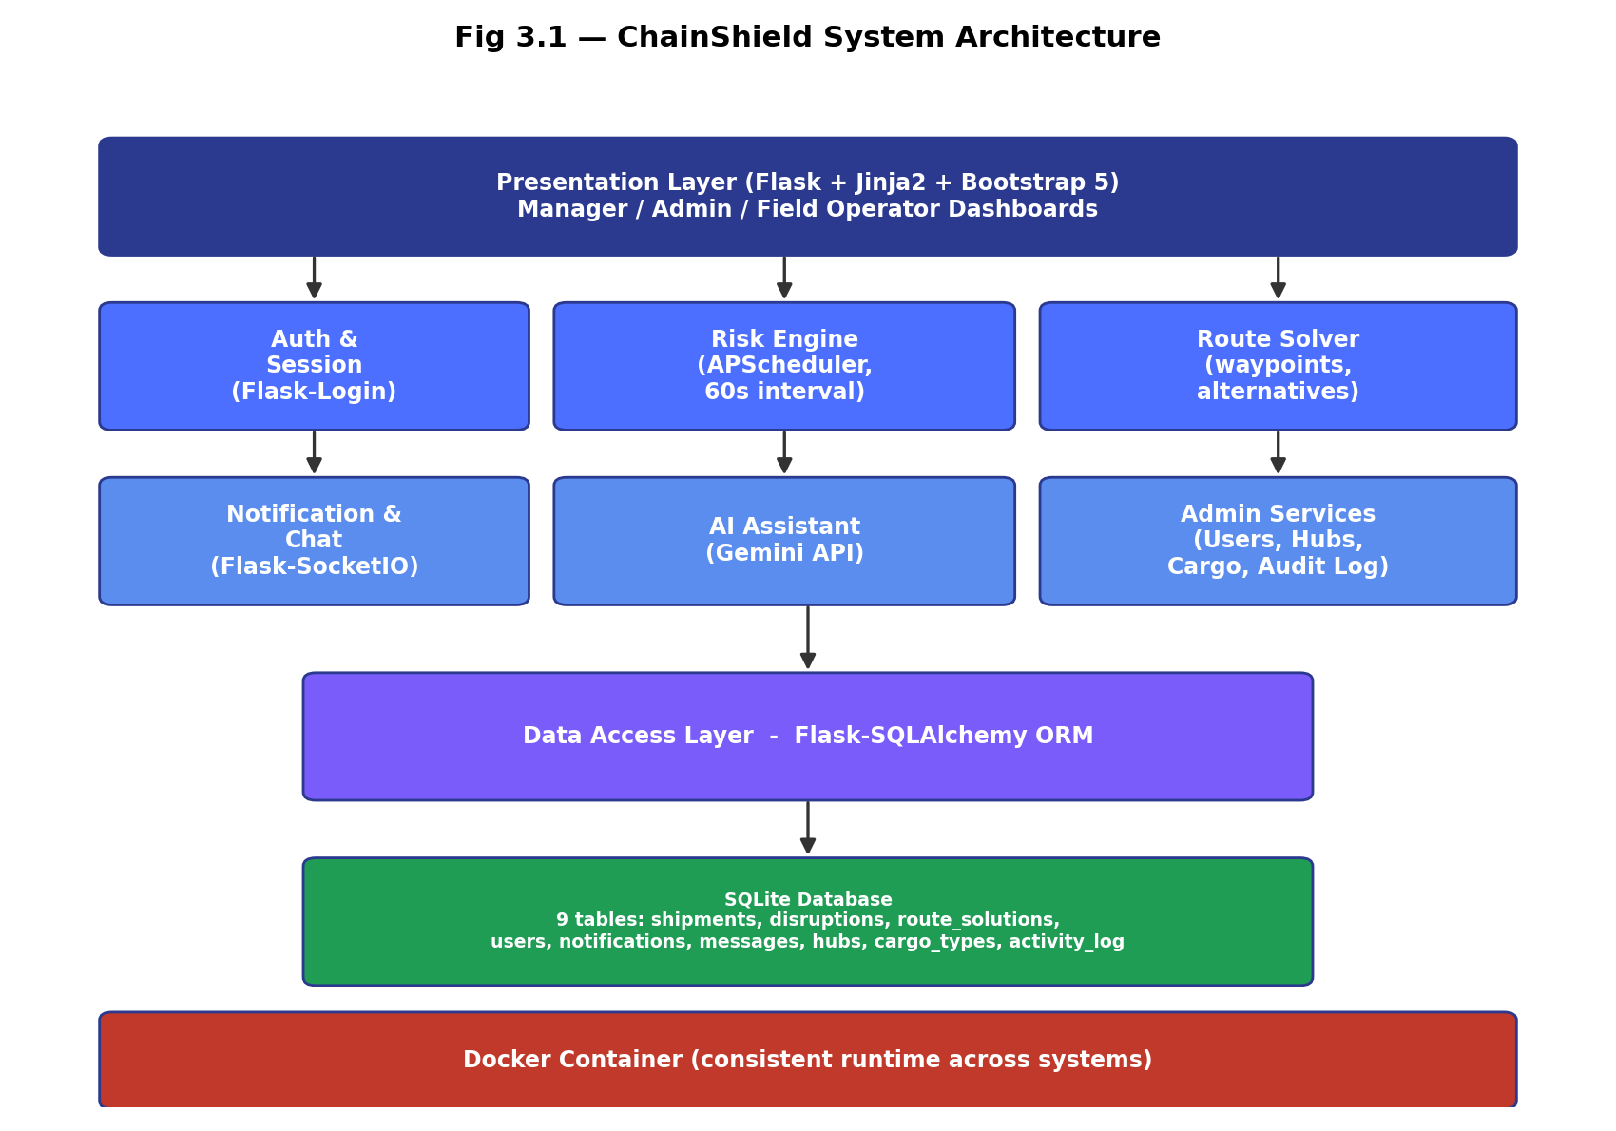
Fig 3.1 — ChainShield System Architecture
Three actors interact with the system — Admin, Manager, and Field Operator — each restricted to the use cases relevant to their role, as summarised below.
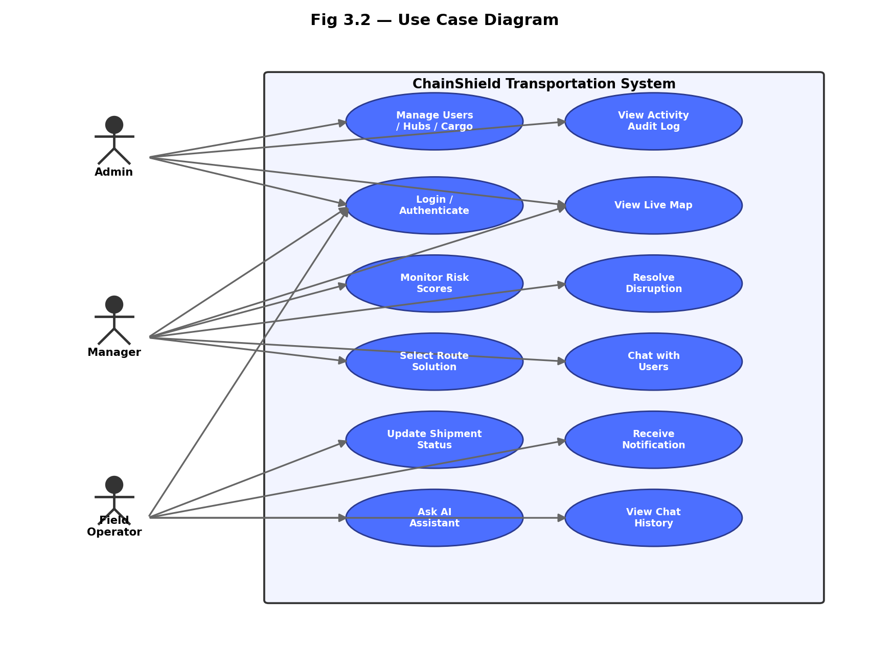
Fig 3.2 — Use Case Diagram

4. SPECIFIC REQUIREMENTS — FUNCTIONAL
Each functional requirement below is uniquely identified (FR-n) for traceability against test cases and the implementation. Requirements are grouped by the module that implements them.

4.1 Authentication & Access Control
FR-1 User Registration
FR-1 | User Registration
Description | Allow a new user to create an account with a name, email, password, and role.
Input | Name, email, password, role (admin / manager / captain / pilot / driver / loco_pilot)
Processing | Validate the email is not already registered; hash the password with Werkzeug; persist the new User row.
Output | New account created; user redirected to the login page with a confirmation message.

FR-2 User Login
FR-2 | User Login
Description | Authenticate a registered user by email and password.
Input | Email, password
Processing | Look up the user by email; verify the password hash; on success, start a Flask-Login session.
Output | User is logged in and redirected to their role-specific dashboard; on failure, an error message is shown.

FR-3 User Logout
FR-3 | User Logout
Description | End the current user's authenticated session.
Input | Authenticated session
Processing | Clear the Flask-Login session.
Output | User is redirected to the login page.

FR-4 Role-Based Access Control
FR-4 | Role-Based Access Control
Description | Restrict each dashboard and admin action to the appropriate user role.
Input | Current user's role, requested route
Processing | Check the requesting user's role against the route's required role before rendering the page or performing the action.
Output | Authorised users see the page; unauthorised users are redirected or denied.

4.2 Risk Engine
FR-5 Risk Score Calculation
FR-5 | Risk Score Calculation
Description | Compute a composite 0-100 risk score for a shipment from four weighted signals.
Input | Weather severity, route congestion, cargo sensitivity, historic delay probability (each 0-100)
Processing | score = 0.40×weather + 0.25×congestion + 0.20×cargo + 0.15×history, rounded to 2 decimals.
Output | A composite risk_score and a risk_level classification (LOW / AT-RISK / MEDIUM / HIGH) stored on the shipment.

FR-6 Scheduled Risk Scanning
FR-6 | Scheduled Risk Scanning
Description | Automatically re-score every active shipment on a fixed interval.
Input | All shipments with status 'In-transit' or 'At-risk'; interval from RISK_SCAN_INTERVAL_SECONDS (default 60s)
Processing | APScheduler triggers a scan job that recalculates each shipment's risk score (FR-5) and updates its risk_level.
Output | Updated risk scores across all active shipments; disruptions are created where thresholds are crossed (FR-7).

4.3 Disruption Management
FR-7 Automatic Disruption Detection
FR-7 | Automatic Disruption Detection
Description | Create a disruption record automatically when a shipment's risk score crosses the HIGH threshold (≥ 70).
Input | Shipment risk_score, risk_level
Processing | If risk_score ≥ 70 and no open disruption exists for the shipment, create a new Disruption row and trigger route-solution generation (FR-8).
Output | A new open disruption; a notification queued for the responsible manager.

FR-8 Route Solution Generation
FR-8 | Route Solution Generation
Description | Generate two ranked route alternatives for an open disruption.
Input | Disruption's shipment, origin/destination hubs, current risk factors
Processing | Compute at least two candidate options (e.g. reroute via an alternate hub, or hold in place), each with estimated extra time, extra cost, and residual risk.
Output | Two RouteSolution rows linked to the disruption, ranked by residual risk.

FR-9 Disruption Resolution
FR-9 | Disruption Resolution
Description | Allow a manager to select a route solution and resolve the disruption.
Input | Manager's selected route_solution_id
Processing | Mark the chosen RouteSolution as selected; set the disruption's status to Resolved and resolved_by/resolved_at; queue a notification for the assigned field operator.
Output | Disruption closed; field operator notified of the chosen route (FR-10).

4.4 Notifications & Communication
FR-10 In-App Notification Delivery
FR-10 | In-App Notification Delivery
Description | Deliver real-time in-app alerts to a specific user.
Input | Target user_id, message text
Processing | Persist a Notification row and push it over Flask-SocketIO to the target user's active session, if connected.
Output | Notification appears in the recipient's notification feed immediately, or on next login if offline.

FR-11 Direct Messaging (Chat)
FR-11 | Direct Messaging
Description | Allow two authenticated users to exchange direct messages.
Input | Sender, receiver, message content
Processing | Persist a Message row; push it to the receiver's session via Flask-SocketIO if connected.
Output | Message appears in both users' chat history.

4.5 Administration
FR-12 Manage Users
FR-12 | Manage Users
Description | Allow an admin to create, update, or deactivate user accounts.
Input | User details (name, email, role, phone)
Processing | Validate and persist changes to the User table; log the action to the activity log (FR-15).
Output | User list reflects the change; an audit entry is recorded.

FR-13 Manage Logistics Hubs
FR-13 | Manage Logistics Hubs
Description | Allow an admin to create, update, or delete hub master data.
Input | Hub name, location, latitude, longitude
Processing | Validate and persist changes to the Hub table.
Output | Hub list updated; hubs available for shipment origin/destination selection.

FR-14 Manage Cargo Types
FR-14 | Manage Cargo Types
Description | Allow an admin to create, update, or delete cargo-type master data, including its sensitivity weight.
Input | Cargo type name, sensitivity_weight (0.0-1.0)
Processing | Validate and persist changes to the CargoType table.
Output | Cargo type list updated; used as an input to FR-5 risk scoring.

FR-15 Activity Audit Log
FR-15 | Activity Audit Log
Description | Record administrative and disruption-resolution actions for accountability.
Input | Acting user, action description, timestamp
Processing | Append an ActivityLog row whenever an admin or manager performs a tracked action.
Output | A chronological, filterable audit trail viewable by admins.

4.6 AI Assistant & Live Map
FR-16 AI Assistant Query Handling
FR-16 | AI Assistant Query Handling
Description | Answer a user's natural-language question about the supply chain.
Input | User's free-text question
Processing | Forward the question, plus relevant shipment/disruption context, to the Google Gemini API; on failure or missing API key, return a graceful fallback message.
Output | A natural-language answer displayed in the assistant panel.

FR-17 Live Map Visualisation
FR-17 | Live Map Visualisation
Description | Display shipment positions and active disruption zones on an interactive map.
Input | All active shipments' current_lat/current_lng; open disruptions
Processing | Render a Leaflet.js map with markers coloured by risk_level and shaded zones for disruption areas.
Output | An interactive map visible on the manager dashboard.

FR-18 Demo / Simulation Mode
FR-18 | Demo / Simulation Mode
Description | Let a user trigger a simulated disruption for demonstration purposes.
Input | A 'Trigger Demo Disruption' action
Processing | Force a sample shipment's risk_score above the HIGH threshold, invoking FR-7 and FR-8 immediately.
Output | A live disruption appears on the map and in the alerts panel, without waiting for the next scheduled scan.

5. EXTERNAL INTERFACE REQUIREMENTS

5.1 User Interfaces
- Server-rendered Jinja2 templates styled with Bootstrap 5, sharing a common base layout (navbar, flash messages, footer).
- Role-specific dashboards: Manager (map, KPIs, alerts), Admin (users/hubs/cargo/audit log), Field Operator (assigned shipment, status update, notifications).
- A disruption-resolution modal presenting ranked route solutions with time/cost/risk for each.
- Responsive layout supporting desktop and tablet breakpoints via Bootstrap's grid system.

5.2 Hardware Interfaces
- None required directly — the system runs on standard server hardware capable of hosting a Docker container.
- Shipment position data is simulated in this academic build in place of live GPS/telematics hardware (see Section 2.6).

5.3 Software Interfaces
Interface | Purpose | Fallback if Unavailable
OpenWeatherMap API | Supplies live weather severity for the risk engine (FR-5) | Simulated weather severity value (random, bounded)
Google Gemini API | Powers the AI assistant's natural-language answers (FR-16) | Graceful fallback message; assistant panel remains usable
SQLite | Primary data store, accessed via Flask-SQLAlchemy ORM | Not applicable — core dependency

5.4 Communication Interfaces
- HTTP/HTTPS for all standard page requests and form submissions.
- WebSocket (via Flask-SocketIO) for real-time notification and chat delivery.
- Outbound HTTPS calls to OpenWeatherMap and Gemini APIs when API keys are configured.

6. NON-FUNCTIONAL REQUIREMENTS
ID | Category | Requirement
NFR-1 | Performance | Risk scores must refresh for all active shipments at least once every 60 seconds (configurable via RISK_SCAN_INTERVAL_SECONDS).
NFR-2 | Security | Passwords must be hashed with Werkzeug's generate_password_hash — never stored or logged in plain text. All state-changing forms must include CSRF protection (Flask-WTF).
NFR-3 | Reliability | Database writes must be transactional; a failed scheduled scan must not corrupt existing shipment data and must be retried on the next interval.
NFR-4 | Usability | Each user role must see only the navigation and actions relevant to it; core workflows (login, view alerts, resolve disruption) must be completable within 3 clicks from the dashboard.
NFR-5 | Portability | The application must run identically on any Docker-supported host via `docker compose up --build`, with no manual environment configuration beyond a .env file.
NFR-6 | Maintainability | Code must be organised into independent Flask blueprints and a services/ package, so a feature (e.g. Route Solver) can be modified without touching unrelated modules.
NFR-7 | Availability | The background scheduler and web server must both run inside the same container lifecycle, restarting together on failure (Docker `restart: unless-stopped`).
NFR-8 | Scalability (future) | While SQLite suits this academic single-node build, the ORM-based data layer must allow migration to PostgreSQL/MySQL without rewriting business logic (see Proposed Enhancements, main documentation).

7. DATA REQUIREMENTS
The system persists nine entities in SQLite via the Flask-SQLAlchemy ORM. The core entities directly referenced by the functional requirements in Section 4 are detailed below; supporting entities (notifications, messages, hubs, cargo_types, activity_log) follow the same structure documented in the main project report.
users
Column Name | Data Type | Description
id | INTEGER (PK) | Unique user identifier
name / email | VARCHAR | Identity fields; email is unique
password_hash | VARCHAR(255) | Werkzeug-hashed password (FR-1, NFR-2)
role | VARCHAR(20) | admin / manager / captain / pilot / driver / loco_pilot (FR-4)

shipments
Column Name | Data Type | Description
tracking_no | VARCHAR(30) | Human-readable tracking number
risk_score / risk_level | FLOAT / VARCHAR | Output of FR-5 / FR-6
current_lat / current_lng | FLOAT | Position used by FR-17 live map
assigned_operator_id | INTEGER (FK) | Field operator responsible (FR-9, FR-10)

disruptions / route_solutions
Column Name | Data Type | Description
disruptions.risk_score / severity / status | mixed | Output of FR-7
route_solutions.extra_time_hours / extra_cost / risk_score | FLOAT | Output of FR-8, input to FR-9
route_solutions.selected | BOOLEAN | Set by FR-9 disruption resolution

8. APPENDIX — TRACEABILITY & BIBLIOGRAPHY

8.1 Requirements Traceability Summary
Maps each functional requirement to the codebase module that implements it, for use during testing (see main documentation, Section 5).
Requirement | Implementing Module | Priority
FR-1 to FR-4 | app/blueprints/auth/ | High — implemented
FR-5, FR-6 | app/services/risk_engine.py | High — scoring formula implemented
FR-7, FR-8, FR-9 | app/blueprints/disruptions/, app/services/route_solver.py | High — planned next phase
FR-10, FR-11 | app/blueprints/notifications/, app/blueprints/chat/ | Medium — planned
FR-12 to FR-15 | app/blueprints/admin/ | Medium — planned
FR-16 | app/blueprints/assistant/, app/services/ (Gemini integration) | Low — planned
FR-17 | Front-end (Leaflet.js) + app/blueprints/shipments/ | Medium — planned
FR-18 | app/blueprints/disruptions/ (demo trigger) | Low — planned

8.2 Bibliography
- IEEE Std 830-1998 — IEEE Recommended Practice for Software Requirements Specifications
- Flask Web Development — Miguel Grinberg, O'Reilly Media
- Fundamentals of Database Systems — Ramez Elmasri & Shamkant B. Navathe, Pearson
- https://flask.palletsprojects.com/
- https://docs.docker.com/
- https://www.sqlite.org/docs.html

