SOFTWARE REQUIREMENTS SPECIFICATION
“ CHAINSHIELD TRANSPORTATION SYSTEM ”
Real-Time Disruption Prediction & Route Optimisation for Logistics
Prepared as per IEEE 830 SRS guidelines
MCA Semester 3, Academic Year 2026-27
To
LJ INSTITUTE OF COMPUTER APPLICATION
Affiliated to LJK University
Guided By:  Prof. Dhaval Shah | Prepared By: (Group No. 59)  Bhavik A. Visani (D51 / 25004401110170)  Diya Shah (D36 / 25003401110017)  Shruti Somani (D42 / 25004401110259)

INDEX
Sr. | Particulars | Page No
1 | Introduction  1) Purpose  2) Document Scope  3) Definitions, Acronyms & Abbreviations  4) References  5) Overview | 3
2 | Overall Description  1) Product Perspective  2) Product Functions  3) User Classes & Characteristics  4) Operating Environment  5) Design & Implementation Constraints  6) Assumptions & Dependencies | 5
3 | System Architecture & Use Cases | 7
4 | Specific Requirements — Functional | 9
5 | External Interface Requirements  1) User Interfaces  2) Hardware Interfaces  3) Software Interfaces  4) Communication Interfaces | 16
6 | Non-Functional Requirements  1) Performance  2) Security  3) Reliability  4) Usability  5) Portability  6) Maintainability | 17
7 | Data Requirements | 18
8 | Appendix — Traceability & Bibliography | 19

1. INTRODUCTION

1.1 Purpose
This Software Requirements Specification (SRS) defines the functional and non-functional requirements of the ChainShield Transportation System, a project developed by Group No. 59 for MCA Semester 3 at LJ Institute of Computer Application. It gives the project guide, examiners, and the development team a single, unambiguous reference for what the system does, following the structure recommended by IEEE Standard 830. This revision (v2) reflects the completed implementation; Section 8 traces every requirement to its code module and test case.

1.2 Document Scope
This document covers the ChainShield Transportation System — a Flask, SQLite, and Docker-based application that continuously scores active shipments for disruption risk and proposes optimised route adjustments. It is intended to be deployable by any logistics company on its own server.

1.3 Definitions, Acronyms & Abbreviations
Term | Meaning
SRS | Software Requirements Specification
FR | Functional Requirement
NFR | Non-Functional Requirement
Disruption | A shipment event whose composite risk score has reached MEDIUM (≥ 50); it is escalated if the score reaches HIGH (≥ 70). AT-RISK (≥ 30) shipments are flagged and watched.
Risk Engine | The scheduled service that computes a 0-100 composite risk score for each active shipment
Route Solution | A ranked alternative (hold, hub reroute, mode switch, or continue) generated for an open disruption; option 1 is the recommendation
Field Operator | A user with role captain, pilot, driver, or loco_pilot who executes shipments
ORM | Object-Relational Mapper (Flask-SQLAlchemy)

1.4 References
- MCA Semester 3 Project Documentation — ChainShield_MCA_Sem3_Documentation.docx (Group 59, 2026)
- IEEE Std 830-1998 — IEEE Recommended Practice for Software Requirements Specifications
- Flask Documentation — https://flask.palletsprojects.com/
- SQLite Documentation — https://www.sqlite.org/docs.html
- Flask-SocketIO Documentation — https://flask-socketio.readthedocs.io/

1.5 Overview
Section 2 describes the product at a high level — its perspective, functions, users, and constraints. Section 3 summarises the system architecture and use cases. Section 4 lists detailed functional requirements, each with a unique identifier for traceability. Section 5 covers external interfaces, Section 6 covers non-functional requirements, Section 7 defines the data requirements, and Section 8 provides a requirements traceability summary and bibliography.

2. OVERALL DESCRIPTION

2.1 Product Perspective
ChainShield Transportation System is a new, self-contained web application — it is not a component of, or dependent on, any other system. It is built as a single Flask application following the app-factory and blueprint patterns, backed by a local SQLite database, and packaged with Docker for portable deployment. It optionally integrates with two external services — the OpenWeatherMap API for live weather signals and the Google Gemini API for its AI assistant — both of which degrade gracefully to simulated data when unavailable, so the system remains fully demonstrable offline.

2.2 Product Functions
- Role-based user registration, authentication, and session management
- Shipment management (create, view, edit, delete) with role-scoped visibility
- Continuous, scheduled disruption-risk scoring for every active shipment
- Automatic disruption detection, escalation, and ranked route-solution generation
- Real-time in-app notification delivery and direct messaging between users
- Administrative management of users, logistics hubs, and cargo types, with an audit log
- A natural-language AI assistant for supply-chain queries
- A live map visualisation of shipments and disruption zones
- Reports with date-range filters and CSV export
- A demo / simulation mode for presentations without live data

2.3 User Classes and Characteristics
User Class | Technical Expertise | Primary Use
Admin | Moderate — comfortable with web forms and configuration | User, hub, and cargo-type management; reports; audit review; system configuration
Manager | Low to moderate — a logistics professional, not a technical user | Managing shipments, monitoring risk, resolving disruptions, reports
Field Operator | Low — expects a simple, mobile-friendly interface | Viewing assigned shipments, updating status, receiving alerts, chat

2.4 Operating Environment
- Server: any OS that supports Docker (Windows, Linux, macOS) running Python 3.10+
- Client: any modern desktop or mobile web browser (Chrome, Edge, Firefox, Safari)
- Database: SQLite, file-based, persisted via a Docker volume
- Deployment: Docker container exposing the application on port 5000

2.5 Design and Implementation Constraints
- Must use Python and Flask, for a lightweight, easily self-hosted stack
- Must be deployable by any logistics company on its own server as a single Docker container, with no mandatory paid services
- Must run without requiring paid API keys — external APIs are optional with simulated fallbacks
- Must be containerisable with a single Dockerfile and docker-compose.yml, with no manual server configuration

2.6 Assumptions and Dependencies
- It is assumed the host machine has Docker Desktop (or an equivalent Docker engine) installed for containerised deployment
- It is assumed shipment position and weather data may be simulated for demonstration, in the absence of live GPS/telematics hardware
- The system depends on Flask, Flask-SQLAlchemy, Flask-Login, Flask-SocketIO, Flask-WTF, and APScheduler, as listed in requirements.txt

3. SYSTEM ARCHITECTURE & USE CASES
The system follows a layered architecture: a Flask + Jinja2 + Bootstrap presentation layer (with Leaflet.js and Chart.js) talking to the server over HTTP and WebSockets, core services (Risk Engine, Route Solver, Notifications/Chat, AI Assistant, Admin & Reports) in the middle, a Flask-SQLAlchemy data access layer, and a SQLite database at the base — the entire stack packaged inside a Docker container.
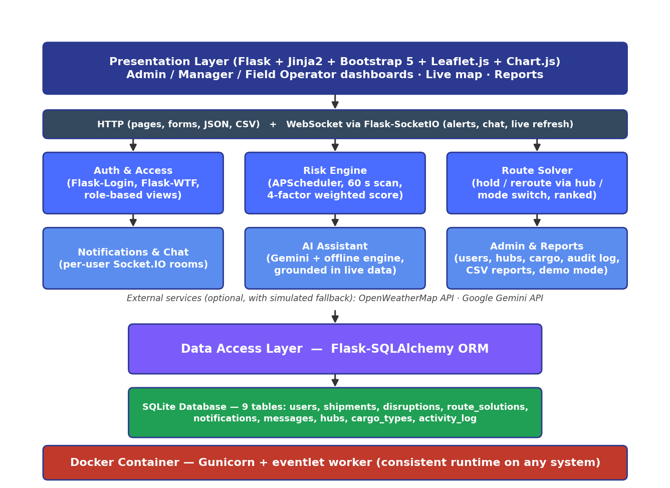
Fig 3.1 — ChainShield System Architecture
Three human actors — Admin, Manager and Field Operator — and one system actor, the Background Scheduler, interact with ChainShield. The Manager generalises the Field Operator and inherits its use cases; automated risk scoring includes real-time notification delivery, as summarised below.
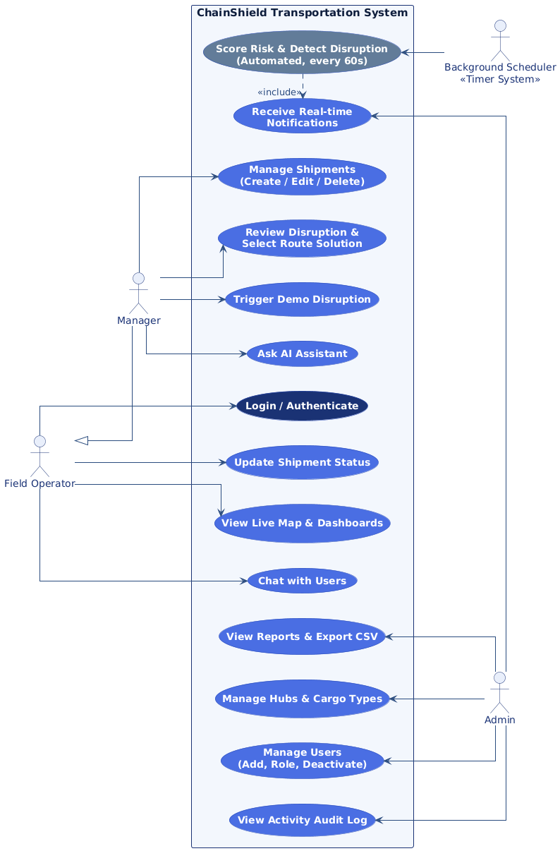
Fig 3.2 — Use Case Diagram

4. SPECIFIC REQUIREMENTS — FUNCTIONAL
Each functional requirement below is uniquely identified (FR-n) for traceability against test cases and the implementation. Requirements are grouped by the module that implements them.

4.1 Authentication & Access Control
FR-1 User Registration
FR-1 | User Registration
Description | Allow a new user to create an account with a name, email, password, and role.
Input | Name, email, password (6+ characters), role (manager / captain / pilot / driver / loco_pilot)
Processing | Validate the email is not already registered and the role is allowed (admin cannot be self-assigned — an existing admin grants it); hash the password with Werkzeug; persist the new User row.
Output | New account created; user redirected to the login page with a confirmation message.

FR-2 User Login
FR-2 | User Login
Description | Authenticate a registered user by email and password.
Input | Email, password
Processing | Look up the user by email; verify the password hash and that the account is active; on success, start a Flask-Login session and write an audit-log entry.
Output | User is logged in and redirected to their role-specific dashboard; on failure, an error message is shown.

FR-3 User Logout
FR-3 | User Logout
Description | End the current user's authenticated session.
Input | Authenticated session
Processing | Clear the Flask-Login session.
Output | User is redirected to the login page.

FR-4 Role-Based Access Control
FR-4 | Role-Based Access Control
Description | Restrict each dashboard and admin action to the appropriate user role.
Input | Current user's role, requested route
Processing | Check the requesting user's role on every route (admin-only, manager-or-admin, or assigned operator); field operators only ever see their own shipments and disruptions.
Output | Authorised users see the page; unauthorised users receive 403 Forbidden (or 404 for records outside their scope).

4.2 Risk Engine
FR-5 Risk Score Calculation
FR-5 | Risk Score Calculation
Description | Compute a composite 0-100 risk score for a shipment from four weighted signals.
Input | Weather severity, route congestion, cargo sensitivity, historic delay probability (each 0-100)
Processing | score = 0.40×weather + 0.25×congestion + 0.20×cargo + 0.15×history, rounded to 2 decimals.
Output | A composite risk_score and a risk_level classification (LOW / AT-RISK / MEDIUM / HIGH) stored on the shipment.

FR-6 Scheduled Risk Scanning
FR-6 | Scheduled Risk Scanning
Description | Automatically re-score every active shipment on a fixed interval.
Input | All shipments with status 'In-transit'; interval from RISK_SCAN_INTERVAL_SECONDS (default 60 s)
Processing | APScheduler triggers a scan job that (in demo mode) moves each shipment toward its destination hub, recalculates its risk score (FR-5) and updates its risk_level; shipments reaching the destination are marked Delivered.
Output | Updated risk scores across all active shipments; disruptions created or escalated (FR-7); a live 'shipments_updated' event refreshes every open map and dashboard.

4.3 Disruption Management
FR-7 Automatic Disruption Detection
FR-7 | Automatic Disruption Detection
Description | Create a disruption record automatically when a shipment's risk score reaches MEDIUM (≥ 50), and escalate it when the score reaches HIGH (≥ 70).
Input | Shipment risk_score, risk_level
Processing | If risk_level is MEDIUM or HIGH and no open disruption exists, create a Disruption (dominant factor = highest of the four signals) and trigger FR-8. If one is open and the level has risen, escalate its severity and re-plan its route solutions.
Output | A new or escalated open disruption; real-time notifications to all admins, managers and the assigned field operator.

FR-8 Route Solution Generation
FR-8 | Route Solution Generation
Description | Generate ranked route alternatives for an open disruption.
Input | Disruption's shipment, current position, origin/destination hubs, transport mode, risk score
Processing | Build candidates — hold at the nearest hub, continue, reroute via the two hubs with the smallest haversine detour, and a mode switch for the remaining leg — each with extra time, extra cost (₹) and residual risk. Rank by 0.60 × risk + 0.25 × normalised time + 0.15 × normalised cost.
Output | Three to five RouteSolution rows linked to the disruption; option 1 is marked Recommended.

FR-9 Disruption Resolution
FR-9 | Disruption Resolution
Description | Allow a manager to select a route solution and resolve the disruption.
Input | Manager's selected option_no
Processing | Mark the chosen RouteSolution as selected; set the disruption to Resolved with resolved_by/resolved_at; put the shipment On-hold if a hold option was chosen; log the decision; notify the assigned field operator.
Output | Disruption closed; field operator notified of the chosen route (FR-10).

4.4 Notifications & Communication
FR-10 In-App Notification Delivery
FR-10 | In-App Notification Delivery
Description | Deliver real-time in-app alerts to a specific user.
Input | Target user_id, message text
Processing | Persist a Notification row and push it over Flask-SocketIO to the recipient's personal room (user_<id>); the navbar bell count and a pop-up update instantly.
Output | Notification appears in the recipient's notification feed immediately, or on next login if offline.

FR-11 Direct Messaging (Chat)
FR-11 | Direct Messaging
Description | Allow two authenticated users to exchange direct messages.
Input | Sender, receiver, message content
Processing | Validate the message (non-empty, ≤ 2000 characters); persist a Message row; push it over Flask-SocketIO to both participants' rooms.
Output | Message appears in both users' chat history.

4.5 Administration
FR-12 Manage Users
FR-12 | Manage Users
Description | Allow an admin to create users, change their role, and deactivate or re-activate accounts.
Input | User details (name, email, role, phone, temporary password)
Processing | Validate and persist changes to the User table; a deactivated user cannot log in and any open session ends on the next request; an admin cannot deactivate themself; log the action (FR-15).
Output | User list reflects the change; an audit entry is recorded.

FR-13 Manage Logistics Hubs
FR-13 | Manage Logistics Hubs
Description | Allow an admin to create, update, or delete hub master data.
Input | Hub name, location, latitude, longitude
Processing | Validate and persist changes to the Hub table; deletion is blocked while any shipment uses the hub.
Output | Hub list updated; hubs available for shipment origin/destination selection.

FR-14 Manage Cargo Types
FR-14 | Manage Cargo Types
Description | Allow an admin to create, update, or delete cargo-type master data, including its sensitivity weight.
Input | Cargo type name, sensitivity_weight (0.0-1.0)
Processing | Validate the name is unique and the weight is between 0.0 and 1.0; persist changes to the CargoType table; deletion is blocked while any shipment uses the cargo type.
Output | Cargo type list updated; used as an input to FR-5 risk scoring.

FR-15 Activity Audit Log
FR-15 | Activity Audit Log
Description | Record administrative and disruption-resolution actions for accountability.
Input | Acting user, action description, timestamp
Processing | Append an ActivityLog row whenever an admin or manager performs a tracked action.
Output | A chronological audit trail viewable by admins, filterable by date in Reports and exportable as CSV (FR-20).

4.6 AI Assistant & Live Map
FR-16 AI Assistant Query Handling
FR-16 | AI Assistant Query Handling
Description | Answer a user's natural-language question about the supply chain.
Input | User's free-text question
Processing | Send the question, recent conversation and a snapshot of live data the user may see (shipments, risk, open disruptions and their ranked options) to Google Gemini; if no key is configured or the call fails, a rule-based offline engine answers from the same data.
Output | A natural-language answer in the assistant panel, labelled with its source (Gemini or offline engine).

FR-17 Live Map Visualisation
FR-17 | Live Map Visualisation
Description | Display shipment positions and active disruption zones on an interactive map.
Input | All active shipments' current_lat/current_lng; open disruptions
Processing | Render a Leaflet.js map with markers coloured by risk_level, hubs, planned routes, and shaded circular zones around open disruptions sized by severity; refresh on every Socket.IO update.
Output | An interactive Live Map page available to every role (field operators see only their shipments).

FR-18 Demo / Simulation Mode
FR-18 | Demo / Simulation Mode
Description | Let a user trigger a simulated disruption for demonstration purposes.
Input | A 'Trigger demo disruption' action (admin / manager); `flask reset-demo` to restore demo data
Processing | Inject a severe weather and congestion event (both 100) on an in-transit shipment, preferring a calm one, and run it through FR-5, FR-7 and FR-8 immediately.
Output | A live HIGH disruption with ranked options appears on the Disruptions page and the map, with real-time alerts, without waiting for the next scheduled scan.

4.7 Shipment Management & Reports
FR-19 Shipment Management
FR-19 | Shipment Management
Description | Allow managers and admins to create, view, edit and delete shipments; let the assigned operator update status.
Input | Tracking no. (optional, auto CS-xxxx), origin, destination, mode, cargo type, value (₹), status, operator, position
Processing | Validate with Flask-WTF (origin ≠ destination, unique tracking no., valid ranges); default the position to the origin hub; run an initial risk scan; deleting a shipment also removes its disruption history.
Output | Shipment saved with an initial risk level; list, detail page (mini-map, disruption history) and live map update.

FR-20 Reports & CSV Export
FR-20 | Reports & CSV Export
Description | Provide on-screen reports and CSV downloads for managers and admins.
Input | Report type, date range (from / to)
Processing | Aggregate disruptions by dominant factor and severity; compute resolution time (detection → decision) per decision-maker; list current shipment risk and the audit log; stream CSV with a UTF-8 BOM so Excel opens it correctly.
Output | Reports page with four reports; CSV files for disruptions, shipment risk and the activity log.

5. EXTERNAL INTERFACE REQUIREMENTS

5.1 User Interfaces
- Server-rendered Jinja2 templates on Bootstrap 5 with a custom design system (Inter typeface, indigo/teal palette, consistent risk colours) and one application shell: a collapsible sidebar with live counts and a top bar with theme switch, notification dropdown and account menu.
- Role-specific dashboards: Admin (KPIs, four live charts, activity, tabs for Users / Shipments / Base Cities / Cargo Types / Reports / Config / Activity Log) and an operations dashboard for managers and field operators (KPIs, charts, risk watchlist, open disruptions).
- A Disruptions page presenting each open disruption with its ranked route solutions (time / cost / risk) and a one-click “Apply selected option”, plus Live Map, Chat, Notifications, AI Assistant and Reports pages.
- Responsive layout from 390 px phones to wide desktops (sidebar becomes a slide-in drawer on phones); light and dark themes remembered per browser; animated feedback on every interaction (ripples, loading states, toasts, scroll reveal) that is switched off for users who prefer reduced motion. Front-end libraries and fonts are bundled locally so the interface works without internet (except map tiles).

5.2 Hardware Interfaces
- None required directly — the system runs on standard server hardware capable of hosting a Docker container.
- Shipment position data is simulated in the current version in place of live GPS/telematics hardware (see Section 2.6).

5.3 Software Interfaces
Interface | Purpose | Fallback if Unavailable
OpenWeatherMap API | Supplies live weather severity for the risk engine (FR-5) | Simulated weather severity (mostly calm, occasional storm)
Google Gemini API | Powers the AI assistant's natural-language answers (FR-16) | Offline rule-based engine answers from the same live data; panel remains fully usable
SQLite | Primary data store, accessed via Flask-SQLAlchemy ORM | Not applicable — core dependency

5.4 Communication Interfaces
- HTTP/HTTPS for all standard page requests and form submissions.
- WebSocket (via Flask-SocketIO) for real-time notification and chat delivery.
- Outbound HTTPS calls to OpenWeatherMap and Gemini APIs when API keys are configured.

6. NON-FUNCTIONAL REQUIREMENTS
ID | Category | Requirement
NFR-1 | Performance | Risk scores must refresh for all active shipments at least once every 60 seconds (configurable via RISK_SCAN_INTERVAL_SECONDS).
NFR-2 | Security | Passwords must be hashed with Werkzeug's generate_password_hash — never stored or logged in plain text. All state-changing forms must include CSRF protection (Flask-WTF).
NFR-3 | Reliability | Database writes must be transactional; a failed scheduled scan must not corrupt existing shipment data and must be retried on the next interval.
NFR-4 | Usability | Each user role sees only the navigation and actions relevant to it; core workflows (login, view alerts, resolve disruption) take at most 3 clicks from the dashboard; every page works at 390 px width without sideways scrolling and supports light and dark themes.
NFR-5 | Portability | The application must run identically on any Docker-supported host via `docker compose up --build`, with no manual environment configuration beyond a .env file.
NFR-6 | Maintainability | Code must be organised into independent Flask blueprints and a services/ package, so a feature (e.g. Route Solver) can be modified without touching unrelated modules.
NFR-7 | Availability | The background scheduler and web server must both run inside the same container lifecycle, restarting together on failure (Docker `restart: unless-stopped`).
NFR-8 | Scalability (future) | While SQLite suits a single-server deployment, the ORM-based data layer must allow migration to PostgreSQL/MySQL without rewriting business logic (see Proposed Enhancements, main documentation).

7. DATA REQUIREMENTS
The system persists nine tables in SQLite through the Flask-SQLAlchemy ORM — one for each model class in app/models.py. Each table is summarised below with its keys and the functional requirements that read or write it; complete column definitions (data types, constraints and descriptions) are given in §3.2 Data Dictionary of the project report.
Table summary
Table | Keys | Purpose | Used by
users | PK id; UNIQUE email | Accounts, roles, active flag | FR-1 – FR-4, FR-12
hubs | PK id | Logistics hub master data | FR-8, FR-13, FR-17
cargo_types | PK id; UNIQUE name | Cargo categories and sensitivity weight | FR-5, FR-14
shipments | PK id; UNIQUE tracking_no; FK cargo_type_id, assigned_operator_id, hub_id | Shipments, live position, risk score and level | FR-5, FR-6, FR-17, FR-19
disruptions | PK id; FK shipment_id, resolved_by | Detected disruptions and their lifecycle | FR-7, FR-9, FR-20
route_solutions | PK id; FK disruption_id (cascade delete) | Ranked route options per disruption | FR-8, FR-9
notifications | PK id; FK user_id | In-app alerts per user | FR-10
messages | PK id; FK sender_id, receiver_id | Direct chat messages | FR-11
activity_log | PK id; FK user_id | Audit trail of actions | FR-15, FR-20

8. APPENDIX — TRACEABILITY & BIBLIOGRAPHY

8.1 Requirements Traceability Summary
Maps each functional requirement to the codebase module that implements it and the test case that verifies it (test cases are in Section 5 of the main project report).
Requirement | Implementing Module | Status / Test
FR-1 to FR-4 | app/blueprints/auth/, role checks in every blueprint | Implemented — TC001, TC007
FR-5, FR-6 | app/services/risk_engine.py, APScheduler job in app/__init__.py | Implemented — TC002, TC003
FR-7, FR-8, FR-9 | app/services/risk_engine.py, app/services/route_solver.py, app/blueprints/disruptions/ | Implemented — TC003, TC004
FR-10, FR-11 | app/services/notifier.py, app/sockets.py, app/blueprints/notifications/, app/blueprints/chat/ | Implemented — TC004, TC008
FR-12 to FR-15 | app/blueprints/main/ (admin tabs), ActivityLog model | Implemented — TC005, TC011
FR-16 | app/services/assistant.py, app/blueprints/assistant/ | Implemented — TC009
FR-17 | app/blueprints/shipments/ (live map + JSON feed), Leaflet.js | Implemented — TC012
FR-18 | trigger_demo_disruption() in risk_engine.py; flask reset-demo | Implemented — TC012
FR-19 | app/blueprints/shipments/, app/forms.py | Implemented — automated CRUD checks
FR-20 | Reports routes in app/blueprints/main/ | Implemented — TC010

8.2 Bibliography
- IEEE Std 830-1998 — IEEE Recommended Practice for Software Requirements Specifications
- Flask Web Development — Miguel Grinberg, O'Reilly Media
- Fundamentals of Database Systems — Ramez Elmasri & Shamkant B. Navathe, Pearson
- https://flask.palletsprojects.com/
- https://docs.docker.com/
- https://www.sqlite.org/docs.html
- https://flask-socketio.readthedocs.io/
- https://leafletjs.com/reference.html
- https://ai.google.dev/gemini-api/docs

