SOFTWARE REQUIREMENTS SPECIFICATION
“ CHAINSHIELD TRANSPORTATION SYSTEM ”
Resilient Logistics & Dynamic Supply Chain Optimization
Prepared as per IEEE 830 SRS guidelines
MCA Semester 3, Academic Year 2026-27
To
LJ INSTITUTE OF COMPUTER APPLICATION
Affiliated to LJK University
Guided By:  Prof. Dhaval Shah | Prepared By: (Group No. 59)  Bhavik A. Visani (D51 / 25004401110170)  Diya Shah (D36 / 25003401110017)  Shruti Somani (D42 / 25004401110259)

INDEX
Sr. | Particulars | Page No
1 | Introduction  1) Purpose  2) Document Scope  3) Definitions, Acronyms & Abbreviations  4) References  5) Overview | 3
2 | Overall Description  1) Product Perspective  2) Product Functions  3) User Classes & Characteristics  4) Operating Environment  5) Design & Implementation Constraints  6) Assumptions & Dependencies | 5
3 | System Architecture & Use Cases | 7
4 | Specific Requirements — Functional | 9
5 | External Interface Requirements  1) User Interfaces  2) Hardware Interfaces  3) Software Interfaces  4) Communication Interfaces | 16
6 | Non-Functional Requirements  1) Performance  2) Security  3) Reliability  4) Usability  5) Portability  6) Maintainability | 17
7 | Data Requirements | 18
8 | Appendix — Traceability & Bibliography | 19

1. INTRODUCTION

1.1 Purpose
This Software Requirements Specification (SRS) defines the functional and non-functional requirements of the ChainShield Transportation System, a project developed by Group No. 59 for MCA Semester 3 at LJ Institute of Computer Application. It gives the project guide, examiners, and the development team a single, unambiguous reference for what the system does, following the structure recommended by IEEE Standard 830. This revision (v2) reflects the completed implementation; Section 8 traces every requirement to its code module and test case.

1.2 Document Scope
This document covers the ChainShield Transportation System rebuild — a Flask, SQLite, and Docker-based application that continuously scores active shipments for disruption risk and proposes optimised route adjustments. It does not cover the original FastAPI/React ChainShield prototype built for an earlier solution-building initiative, which remains a separate, already-deployed codebase and is not part of this specification.

1.3 Definitions, Acronyms & Abbreviations
Term | Meaning
SRS | Software Requirements Specification
FR | Functional Requirement
NFR | Non-Functional Requirement
Disruption | A shipment event whose composite risk score has reached MEDIUM (≥ 50); it is escalated if the score reaches HIGH (≥ 70). AT-RISK (≥ 30) shipments are flagged and watched.
Risk Engine | The scheduled service that computes a 0-100 composite risk score for each active shipment
Route Solution | A ranked alternative (hold, hub reroute, mode switch, or continue) generated for an open disruption; option 1 is the recommendation
Field Operator | A user with role captain, pilot, driver, or loco_pilot who executes shipments
ORM | Object-Relational Mapper (Flask-SQLAlchemy)

1.4 References
- MCA Semester 3 Project Documentation — ChainShield_MCA_Sem3_Documentation.docx (Group 59, 2026)
- IEEE Std 830-1998 — IEEE Recommended Practice for Software Requirements Specifications
- Flask Documentation — https://flask.palletsprojects.com/
- SQLite Documentation — https://www.sqlite.org/docs.html
- Flask-SocketIO Documentation — https://flask-socketio.readthedocs.io/

1.5 Overview
Section 2 describes the product at a high level — its perspective, functions, users, and constraints. Section 3 summarises the system architecture and use cases. Section 4 lists detailed functional requirements, each with a unique identifier for traceability. Section 5 covers external interfaces, Section 6 covers non-functional requirements, Section 7 defines the data requirements, and Section 8 provides a requirements traceability summary and bibliography.

2. OVERALL DESCRIPTION

2.1 Product Perspective
ChainShield Transportation System is a new, self-contained web application — it is not a component of, or dependent on, any other system. It is built as a single Flask application following the app-factory and blueprint patterns, backed by a local SQLite database, and packaged with Docker for portable deployment. It optionally integrates with two external services — the OpenWeatherMap API for live weather signals and the Google Gemini API for its AI assistant — both of which degrade gracefully to simulated data when unavailable, so the system remains fully demonstrable offline.

2.2 Product Functions
- Role-based user registration, authentication, and session management
- Shipment management (create, view, edit, delete) with role-scoped visibility
- Continuous, scheduled disruption-risk scoring for every active shipment
- Automatic disruption detection, escalation, and ranked route-solution generation
- Real-time in-app notification delivery and direct messaging between users
- Administrative management of users, logistics hubs, and cargo types, with an audit log
- A natural-language AI assistant for supply-chain queries
- A live map visualisation of shipments and disruption zones
- Reports with date-range filters and CSV export
- A demo / simulation mode for presentations without live data

2.3 User Classes and Characteristics
User Class | Technical Expertise | Primary Use
Admin | Moderate — comfortable with web forms and configuration | User, hub, and cargo-type management; reports; audit review; system configuration
Manager | Low to moderate — a logistics professional, not a technical user | Managing shipments, monitoring risk, resolving disruptions, reports
Field Operator | Low — expects a simple, mobile-friendly interface | Viewing assigned shipments, updating status, receiving alerts, chat

2.4 Operating Environment
- Server: any OS that supports Docker (Windows, Linux, macOS) running Python 3.10+
- Client: any modern desktop or mobile web browser (Chrome, Edge, Firefox, Safari)
- Database: SQLite, file-based, persisted via a Docker volume
- Deployment: Docker container exposing the application on port 5000

2.5 Design and Implementation Constraints
- Must use Python and Flask, per the confirmed academic technology stack
- Must remain fully independent of the original FastAPI/React ChainShield prototype — no shared code or database
- Must run without requiring paid API keys — external APIs are optional with simulated fallbacks
- Must be containerisable with a single Dockerfile and docker-compose.yml, with no manual server configuration

2.6 Assumptions and Dependencies
- It is assumed the host machine has Docker Desktop (or an equivalent Docker engine) installed for containerised deployment
- It is assumed shipment position and weather data may be simulated for demonstration, in the absence of live GPS/telematics hardware
- The system depends on Flask, Flask-SQLAlchemy, Flask-Login, Flask-SocketIO, Flask-WTF, and APScheduler, as listed in requirements.txt

3. SYSTEM ARCHITECTURE & USE CASES
The system follows a layered architecture: a Flask + Jinja2 + Bootstrap presentation layer (with Leaflet.js and Chart.js) talking to the server over HTTP and WebSockets, core services (Risk Engine, Route Solver, Notifications/Chat, AI Assistant, Admin & Reports) in the middle, a Flask-SQLAlchemy data access layer, and a SQLite database at the base — the entire stack packaged inside a Docker container.
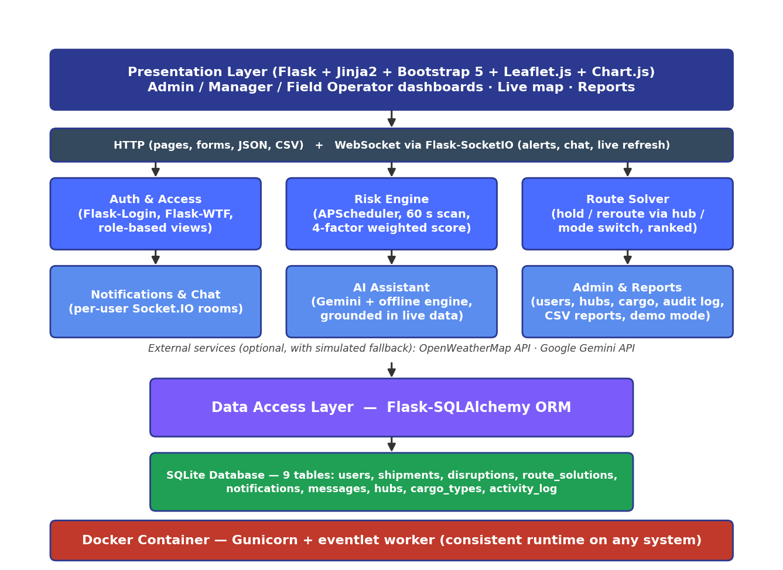
Fig 3.1 — ChainShield System Architecture
Three actors interact with the system — Admin, Manager, and Field Operator — each restricted to the use cases relevant to their role; a background scheduler scores risk automatically, as summarised below.
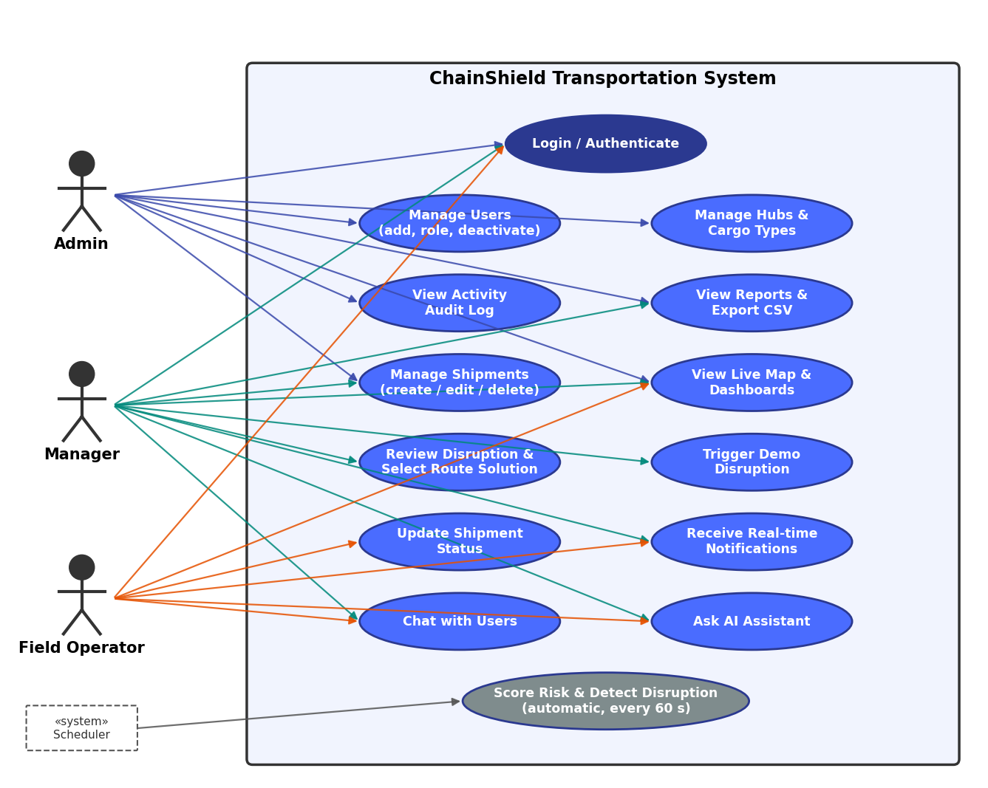
Fig 3.2 — Use Case Diagram

4. SPECIFIC REQUIREMENTS — FUNCTIONAL
Each functional requirement below is uniquely identified (FR-n) for traceability against test cases and the implementation. Requirements are grouped by the module that implements them.

4.1 Authentication & Access Control
FR-1 User Registration
FR-1 | User Registration
Description | Allow a new user to create an account with a name, email, password, and role.
Input | Name, email, password (6+ characters), role (manager / captain / pilot / driver / loco_pilot)
Processing | Validate the email is not already registered and the role is allowed (admin cannot be self-assigned — an existing admin grants it); hash the password with Werkzeug; persist the new User row.
Output | New account created; user redirected to the login page with a confirmation message.

FR-2 User Login
FR-2 | User Login
Description | Authenticate a registered user by email and password.
Input | Email, password
Processing | Look up the user by email; verify the password hash and that the account is active; on success, start a Flask-Login session and write an audit-log entry.
Output | User is logged in and redirected to their role-specific dashboard; on failure, an error message is shown.

FR-3 User Logout
FR-3 | User Logout
Description | End the current user's authenticated session.
Input | Authenticated session
Processing | Clear the Flask-Login session.
Output | User is redirected to the login page.

FR-4 Role-Based Access Control
FR-4 | Role-Based Access Control
Description | Restrict each dashboard and admin action to the appropriate user role.
Input | Current user's role, requested route
Processing | Check the requesting user's role on every route (admin-only, manager-or-admin, or assigned operator); field operators only ever see their own shipments and disruptions.
Output | Authorised users see the page; unauthorised users receive 403 Forbidden (or 404 for records outside their scope).

4.2 Risk Engine
FR-5 Risk Score Calculation
FR-5 | Risk Score Calculation
Description | Compute a composite 0-100 risk score for a shipment from four weighted signals.
Input | Weather severity, route congestion, cargo sensitivity, historic delay probability (each 0-100)
Processing | score = 0.40×weather + 0.25×congestion + 0.20×cargo + 0.15×history, rounded to 2 decimals.
Output | A composite risk_score and a risk_level classification (LOW / AT-RISK / MEDIUM / HIGH) stored on the shipment.

FR-6 Scheduled Risk Scanning
FR-6 | Scheduled Risk Scanning
Description | Automatically re-score every active shipment on a fixed interval.
Input | All shipments with status 'In-transit'; interval from RISK_SCAN_INTERVAL_SECONDS (default 60 s)
Processing | APScheduler triggers a scan job that (in demo mode) moves each shipment toward its destination hub, recalculates its risk score (FR-5) and updates its risk_level; shipments reaching the destination are marked Delivered.
Output | Updated risk scores across all active shipments; disruptions created or escalated (FR-7); a live 'shipments_updated' event refreshes every open map and dashboard.

4.3 Disruption Management
FR-7 Automatic Disruption Detection
FR-7 | Automatic Disruption Detection
Description | Create a disruption record automatically when a shipment's risk score reaches MEDIUM (≥ 50), and escalate it when the score reaches HIGH (≥ 70).
Input | Shipment risk_score, risk_level
Processing | If risk_level is MEDIUM or HIGH and no open disruption exists, create a Disruption (dominant factor = highest of the four signals) and trigger FR-8. If one is open and the level has risen, escalate its severity and re-plan its route solutions.
Output | A new or escalated open disruption; real-time notifications to all admins, managers and the assigned field operator.

FR-8 Route Solution Generation
FR-8 | Route Solution Generation
Description | Generate ranked route alternatives for an open disruption.
Input | Disruption's shipment, current position, origin/destination hubs, transport mode, risk score
Processing | Build candidates — hold at the nearest hub, continue, reroute via the two hubs with the smallest haversine detour, and a mode switch for the remaining leg — each with extra time, extra cost (₹) and residual risk. Rank by 0.60 × risk + 0.25 × normalised time + 0.15 × normalised cost.
Output | Three to five RouteSolution rows linked to the disruption; option 1 is marked Recommended.

FR-9 Disruption Resolution
FR-9 | Disruption Resolution
Description | Allow a manager to select a route solution and resolve the disruption.
Input | Manager's selected option_no
Processing | Mark the chosen RouteSolution as selected; set the disruption to Resolved with resolved_by/resolved_at; put the shipment On-hold if a hold option was chosen; log the decision; notify the assigned field operator.
Output | Disruption closed; field operator notified of the chosen route (FR-10).

4.4 Notifications & Communication
FR-10 In-App Notification Delivery
FR-10 | In-App Notification Delivery
Description | Deliver real-time in-app alerts to a specific user.
Input | Target user_id, message text
Processing | Persist a Notification row and push it over Flask-SocketIO to the recipient's personal room (user_<id>); the navbar bell count and a pop-up update instantly.
Output | Notification appears in the recipient's notification feed immediately, or on next login if offline.

FR-11 Direct Messaging (Chat)
FR-11 | Direct Messaging
Description | Allow two authenticated users to exchange direct messages.
Input | Sender, receiver, message content
Processing | Validate the message (non-empty, ≤ 2000 characters); persist a Message row; push it over Flask-SocketIO to both participants' rooms.
Output | Message appears in both users' chat history.

4.5 Administration
FR-12 Manage Users
FR-12 | Manage Users
Description | Allow an admin to create users, change their role, and deactivate or re-activate accounts.
Input | User details (name, email, role, phone, temporary password)
Processing | Validate and persist changes to the User table; a deactivated user cannot log in and any open session ends on the next request; an admin cannot deactivate themself; log the action (FR-15).
Output | User list reflects the change; an audit entry is recorded.

FR-13 Manage Logistics Hubs
FR-13 | Manage Logistics Hubs
Description | Allow an admin to create, update, or delete hub master data.
Input | Hub name, location, latitude, longitude
Processing | Validate and persist changes to the Hub table; deletion is blocked while any shipment uses the hub.
Output | Hub list updated; hubs available for shipment origin/destination selection.

FR-14 Manage Cargo Types
FR-14 | Manage Cargo Types
Description | Allow an admin to create, update, or delete cargo-type master data, including its sensitivity weight.
Input | Cargo type name, sensitivity_weight (0.0-1.0)
Processing | Validate the name is unique and the weight is between 0.0 and 1.0; persist changes to the CargoType table; deletion is blocked while any shipment uses the cargo type.
Output | Cargo type list updated; used as an input to FR-5 risk scoring.

FR-15 Activity Audit Log
FR-15 | Activity Audit Log
Description | Record administrative and disruption-resolution actions for accountability.
Input | Acting user, action description, timestamp
Processing | Append an ActivityLog row whenever an admin or manager performs a tracked action.
Output | A chronological audit trail viewable by admins, filterable by date in Reports and exportable as CSV (FR-20).

4.6 AI Assistant & Live Map
FR-16 AI Assistant Query Handling
FR-16 | AI Assistant Query Handling
Description | Answer a user's natural-language question about the supply chain.
Input | User's free-text question
Processing | Send the question, recent conversation and a snapshot of live data the user may see (shipments, risk, open disruptions and their ranked options) to Google Gemini; if no key is configured or the call fails, a rule-based offline engine answers from the same data.
Output | A natural-language answer in the assistant panel, labelled with its source (Gemini or offline engine).

FR-17 Live Map Visualisation
FR-17 | Live Map Visualisation
Description | Display shipment positions and active disruption zones on an interactive map.
Input | All active shipments' current_lat/current_lng; open disruptions
Processing | Render a Leaflet.js map with markers coloured by risk_level, hubs, planned routes, and shaded circular zones around open disruptions sized by severity; refresh on every Socket.IO update.
Output | An interactive Live Map page available to every role (field operators see only their shipments).

FR-18 Demo / Simulation Mode
FR-18 | Demo / Simulation Mode
Description | Let a user trigger a simulated disruption for demonstration purposes.
Input | A 'Trigger demo disruption' action (admin / manager); `flask reset-demo` to restore demo data
Processing | Inject a severe weather and congestion event (both 100) on an in-transit shipment, preferring a calm one, and run it through FR-5, FR-7 and FR-8 immediately.
Output | A live HIGH disruption with ranked options appears on the Disruptions page and the map, with real-time alerts, without waiting for the next scheduled scan.

4.7 Shipment Management & Reports
FR-19 Shipment Management
FR-19 | Shipment Management
Description | Allow managers and admins to create, view, edit and delete shipments; let the assigned operator update status.
Input | Tracking no. (optional, auto CS-xxxx), origin, destination, mode, cargo type, value (₹), status, operator, position
Processing | Validate with Flask-WTF (origin ≠ destination, unique tracking no., valid ranges); default the position to the origin hub; run an initial risk scan; deleting a shipment also removes its disruption history.
Output | Shipment saved with an initial risk level; list, detail page (mini-map, disruption history) and live map update.

FR-20 Reports & CSV Export
FR-20 | Reports & CSV Export
Description | Provide on-screen reports and CSV downloads for managers and admins.
Input | Report type, date range (from / to)
Processing | Aggregate disruptions by dominant factor and severity; compute resolution time (detection → decision) per decision-maker; list current shipment risk and the audit log; stream CSV with a UTF-8 BOM so Excel opens it correctly.
Output | Reports page with four reports; CSV files for disruptions, shipment risk and the activity log.

5. EXTERNAL INTERFACE REQUIREMENTS

5.1 User Interfaces
- Server-rendered Jinja2 templates on Bootstrap 5 with a custom design system (Inter typeface, indigo/teal palette, consistent risk colours) and one application shell: a collapsible sidebar with live counts and a top bar with theme switch, notification dropdown and account menu.
- Role-specific dashboards: Admin (KPIs, four live charts, activity, tabs for Users / Shipments / Base Cities / Cargo Types / Reports / Config / Activity Log) and an operations dashboard for managers and field operators (KPIs, charts, risk watchlist, open disruptions).
- A Disruptions page presenting each open disruption with its ranked route solutions (time / cost / risk) and a one-click “Apply selected option”, plus Live Map, Chat, Notifications, AI Assistant and Reports pages.
- Responsive layout from 390 px phones to wide desktops (sidebar becomes a slide-in drawer on phones); light and dark themes remembered per browser; animated feedback on every interaction (ripples, loading states, toasts, scroll reveal) that is switched off for users who prefer reduced motion. Front-end libraries and fonts are bundled locally so the interface works without internet (except map tiles).

5.2 Hardware Interfaces
- None required directly — the system runs on standard server hardware capable of hosting a Docker container.
- Shipment position data is simulated in this academic build in place of live GPS/telematics hardware (see Section 2.6).

5.3 Software Interfaces
Interface | Purpose | Fallback if Unavailable
OpenWeatherMap API | Supplies live weather severity for the risk engine (FR-5) | Simulated weather severity (mostly calm, occasional storm)
Google Gemini API | Powers the AI assistant's natural-language answers (FR-16) | Offline rule-based engine answers from the same live data; panel remains fully usable
SQLite | Primary data store, accessed via Flask-SQLAlchemy ORM | Not applicable — core dependency

5.4 Communication Interfaces
- HTTP/HTTPS for all standard page requests and form submissions.
- WebSocket (via Flask-SocketIO) for real-time notification and chat delivery.
- Outbound HTTPS calls to OpenWeatherMap and Gemini APIs when API keys are configured.

6. NON-FUNCTIONAL REQUIREMENTS
ID | Category | Requirement
NFR-1 | Performance | Risk scores must refresh for all active shipments at least once every 60 seconds (configurable via RISK_SCAN_INTERVAL_SECONDS).
NFR-2 | Security | Passwords must be hashed with Werkzeug's generate_password_hash — never stored or logged in plain text. All state-changing forms must include CSRF protection (Flask-WTF).
NFR-3 | Reliability | Database writes must be transactional; a failed scheduled scan must not corrupt existing shipment data and must be retried on the next interval.
NFR-4 | Usability | Each user role sees only the navigation and actions relevant to it; core workflows (login, view alerts, resolve disruption) take at most 3 clicks from the dashboard; every page works at 390 px width without sideways scrolling and supports light and dark themes.
NFR-5 | Portability | The application must run identically on any Docker-supported host via `docker compose up --build`, with no manual environment configuration beyond a .env file.
NFR-6 | Maintainability | Code must be organised into independent Flask blueprints and a services/ package, so a feature (e.g. Route Solver) can be modified without touching unrelated modules.
NFR-7 | Availability | The background scheduler and web server must both run inside the same container lifecycle, restarting together on failure (Docker `restart: unless-stopped`).
NFR-8 | Scalability (future) | While SQLite suits this academic single-node build, the ORM-based data layer must allow migration to PostgreSQL/MySQL without rewriting business logic (see Proposed Enhancements, main documentation).

7. DATA REQUIREMENTS
The system persists nine entities in SQLite via the Flask-SQLAlchemy ORM. The core entities directly referenced by the functional requirements in Section 4 are detailed below; supporting entities (notifications, messages, hubs, cargo_types, activity_log) follow the same structure documented in the main project report.
users
Column Name | Data Type | Description
id | INTEGER (PK) | Unique user identifier
name / email | VARCHAR | Identity fields; email is unique
password_hash | VARCHAR(255) | Werkzeug-hashed password (FR-1, NFR-2)
role | VARCHAR(20) | admin / manager / captain / pilot / driver / loco_pilot (FR-4)
is_active | BOOLEAN | False = deactivated by an admin (FR-12)

shipments
Column Name | Data Type | Description
tracking_no | VARCHAR(30) | Human-readable tracking number (FR-19)
status | VARCHAR(20) | In-transit / Delayed / On-hold / Delivered
risk_score / risk_level | FLOAT / VARCHAR | Output of FR-5 / FR-6 (LOW / AT-RISK / MEDIUM / HIGH)
current_lat / current_lng | FLOAT | Position used by FR-6 movement and FR-17 live map
cargo_value | FLOAT | Declared value in INR (reports, value at risk)
assigned_operator_id | INTEGER (FK) | Field operator responsible (FR-4, FR-9, FR-10)

disruptions / route_solutions
Column Name | Data Type | Description
disruptions.risk_score / severity / status | mixed | Output of FR-7
route_solutions.extra_time_hours / extra_cost / risk_score | FLOAT | Output of FR-8, input to FR-9
route_solutions.selected | BOOLEAN | Set by FR-9 disruption resolution

8. APPENDIX — TRACEABILITY & BIBLIOGRAPHY

8.1 Requirements Traceability Summary
Maps each functional requirement to the codebase module that implements it and the test case that verifies it (test cases are in Section 5 of the main project report).
Requirement | Implementing Module | Status / Test
FR-1 to FR-4 | app/blueprints/auth/, role checks in every blueprint | Implemented — TC001, TC007
FR-5, FR-6 | app/services/risk_engine.py, APScheduler job in app/__init__.py | Implemented — TC002, TC003
FR-7, FR-8, FR-9 | app/services/risk_engine.py, app/services/route_solver.py, app/blueprints/disruptions/ | Implemented — TC003, TC004
FR-10, FR-11 | app/services/notifier.py, app/sockets.py, app/blueprints/notifications/, app/blueprints/chat/ | Implemented — TC004, TC008
FR-12 to FR-15 | app/blueprints/main/ (admin tabs), ActivityLog model | Implemented — TC005, TC011
FR-16 | app/services/assistant.py, app/blueprints/assistant/ | Implemented — TC009
FR-17 | app/blueprints/shipments/ (live map + JSON feed), Leaflet.js | Implemented — TC012
FR-18 | trigger_demo_disruption() in risk_engine.py; flask reset-demo | Implemented — TC012
FR-19 | app/blueprints/shipments/, app/forms.py | Implemented — automated CRUD checks
FR-20 | Reports routes in app/blueprints/main/ | Implemented — TC010

8.2 Bibliography
- IEEE Std 830-1998 — IEEE Recommended Practice for Software Requirements Specifications
- Flask Web Development — Miguel Grinberg, O'Reilly Media
- Fundamentals of Database Systems — Ramez Elmasri & Shamkant B. Navathe, Pearson
- https://flask.palletsprojects.com/
- https://docs.docker.com/
- https://www.sqlite.org/docs.html
- https://flask-socketio.readthedocs.io/
- https://leafletjs.com/reference.html
- https://ai.google.dev/gemini-api/docs

