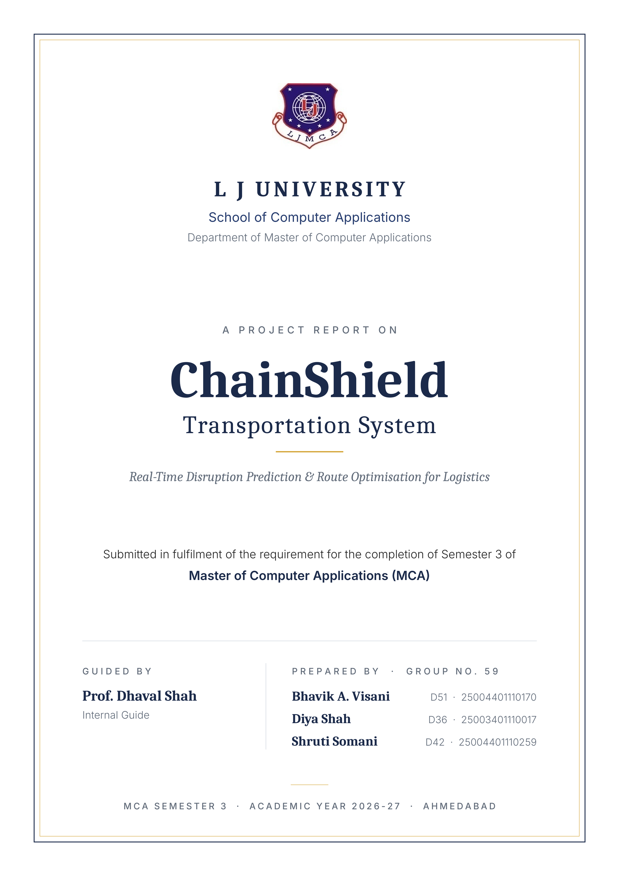

DECLARATION
We, the undersigned students of Group No. 59, Master of Computer Applications (MCA) Semester 3 at the School of Computer Applications, L J University, hereby declare that the project entitled “ChainShield Transportation System” is our own original work, carried out under the guidance of Prof. Dhaval Shah, and has not been submitted, in whole or in part, for the award of any other degree, diploma, or certificate to this or any other institute or university.
We further declare that all the information, technical concepts, and design decisions presented in this report have been gathered, analysed, and implemented by us to the best of our understanding, and that any reference material used has been duly acknowledged in the Bibliography.

Date: __________________ | Place: Ahmedabad

Bhavik A. Visani (D51) ____________________
Diya Shah (D36) ____________________
Shruti Somani (D42) ____________________

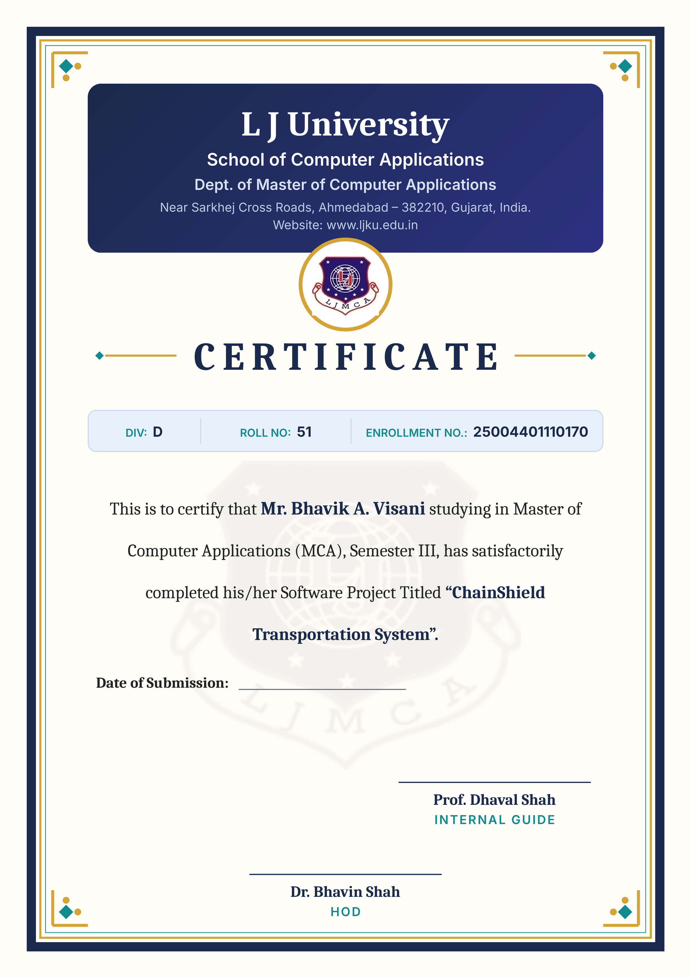

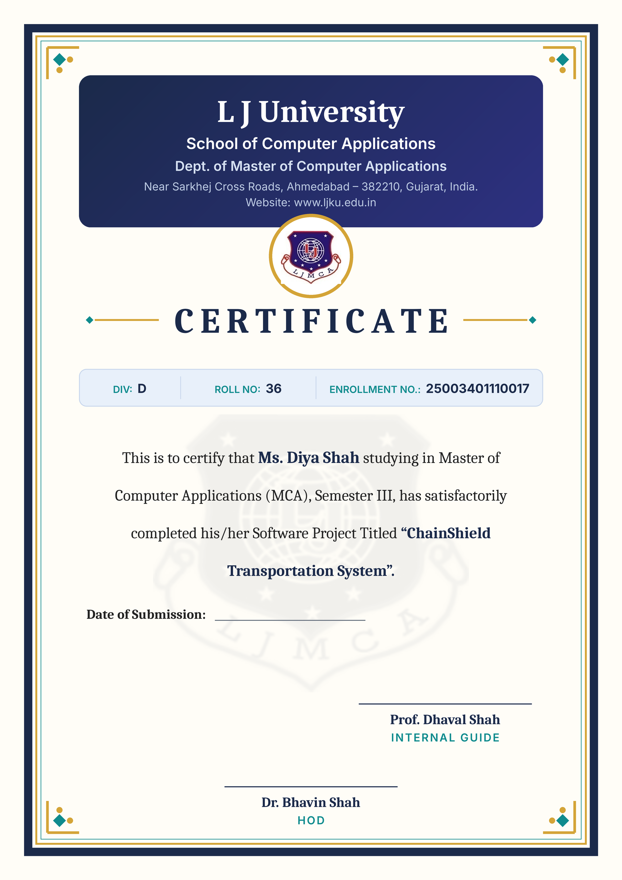

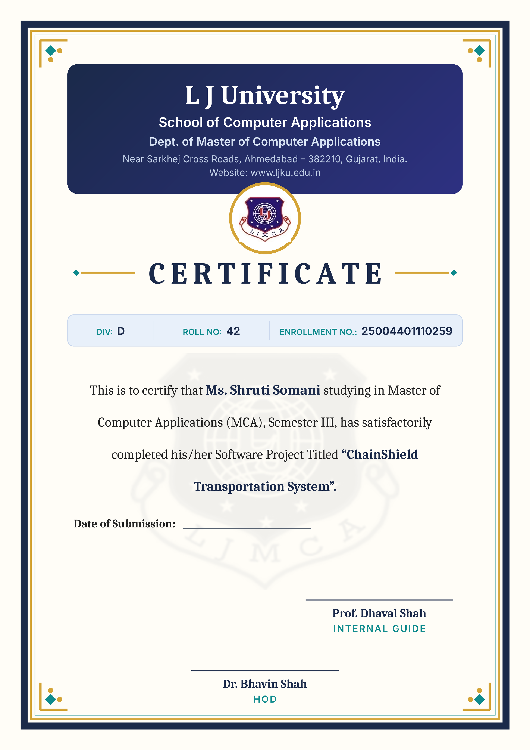

PREFACE
Global trade today moves through supply chains of extraordinary scale and complexity — millions of shipments crossing ports, highways, railways, and air corridors every single day. The same forces that make this scale possible also make it fragile: a single storm, a congested port, or a mishandled hazardous cargo shipment can ripple into delays that cost businesses time, money, and customer trust. Historically, these disruptions have been discovered only after the fact, when a delivery has already slipped past its promised window.
This project, ChainShield Transportation System, was conceived to address exactly that gap. Rather than treating disruption management as a reactive, after-the-event exercise, ChainShield continuously evaluates every active shipment against a weighted risk model, flags the ones heading toward trouble, and proposes concrete rerouting alternatives before the delay materialises.
The idea came from a practical observation: most logistics teams still learn about a delay only after it has happened. We set out to build ChainShield as a lean, self-hostable product — Python (Flask), SQLite, server-rendered Jinja2/Bootstrap templates and Docker — that any logistics company can run on its own server without paid services or a complex cloud setup, while still delivering real-time risk scoring, route recommendations and alerts.
This report documents the problem definition, requirement analysis, system design, implementation, and testing of the ChainShield Transportation System, prepared as part of the curriculum prescribed for MCA Semester 3 at the School of Computer Applications, L J University.

ACKNOWLEDGEMENT
We would like to express our sincere gratitude to everyone who supported us through the course of this project.
First and foremost, we thank L J University and its School of Computer Applications for providing us the opportunity and the academic environment to undertake this project as part of our MCA Semester 3 curriculum.
We are deeply grateful to our project guide, Prof. Dhaval Shah, for his valuable guidance, constructive feedback, and constant encouragement throughout the planning, design, and documentation of this project. His inputs have been instrumental in shaping the direction of ChainShield Transportation System.
We also extend our thanks to the Head of Department and faculty of the School of Computer Applications for their support, and to our classmates and peers who offered helpful suggestions during discussions on this project.
Finally, we thank our families for their patience and encouragement throughout this endeavour.

Thank you,
Bhavik A. Visani, Diya Shah, Shruti Somani
Group No. 59, MCA Semester 3

INDEX
Sr. No. | Particulars | Page No.
1 | Introduction | 9
 | 1.1 Problem Definition | 9
 | 1.2 Objective of the New System | 9
 | 1.3 Core Components, Modules and Features | 10
 | 1.4 Project Profile | 13
 | 1.5 Need of the New System | 13
 | 1.6 Scope of the New System | 14
 | 1.7 Advantages and Limitations of the Proposed System | 16
 | 1.8 Proposed Time Line Chart | 16
 | 1.9 Targeted Users | 18
2 | Requirement Determination and Analysis | 20
 | 2.1 Requirement Determination | 20
 | 2.2 Requirement Specification | 20
3 | System Design | 23
 | 3.1 Use Case Diagram | 23
 | 3.2 Data Dictionary | 26
 | 3.3 User Interface Design | 33
 | 3.4 Report Design | 37
4 | Development | 40
 | 4.1 Coding Standards | 40
 | 4.2 Implementation Details | 44
 | 4.3 Output Screens | 46
5 | Testing | 54
 | 5.1 Test Cases | 54
6 | Proposed Enhancement | 58
7 | Conclusion | 59
8 | Bibliography | 60

1. INTRODUCTION

1.1 Problem Definition
Logistics companies move hundreds of shipments at the same time across road, rail, sea and air. Every one of these shipments is exposed to risks that are outside the company's control — heavy rain and storms, congestion at hubs and ports, customs holds, vehicle breakdowns and the special handling needs of sensitive cargo such as perishable or hazardous goods.
In most companies these disruptions are noticed only after a delivery date has already slipped. Managers depend on manual tracking — phone calls to drivers, spreadsheets and e-mail — and learn about a problem only when a customer or a downstream partner reports a missed delivery. By that time the shipment is already late, the alternate routes that were available earlier have narrowed, and the cost of recovery (express freight, penalty clauses and lost customer trust) has multiplied.
The core problem, therefore, is the absence of a continuously running system that scores the disruption risk of every active shipment, warns the right people before the delay actually happens, and recommends a corrective route with its time, cost and risk trade-offs clearly stated. ChainShield Transportation System is designed to fill exactly this gap.

1.2 Objective of the New System
The main objective of ChainShield is to move logistics operations from a reactive way of working to a preemptive one. The specific objectives of the new system are described below.
• Continuous risk analysis — to analyse weather, route congestion, cargo sensitivity and historic delay data for every active shipment on a fixed schedule, without anyone having to start the check manually.
• Early disruption detection — to detect and flag a potential disruption before the delivery timeline is compromised, using a transparent, weighted risk-scoring formula.
• Optimised route recommendations — to automatically generate ranked alternatives (hold at a hub, reroute through another hub, or switch the transport mode) the moment a shipment crosses the risk threshold.
• Instant communication — to notify managers and the assigned field operator in real time when a disruption is detected, escalated or resolved, closing the gap between decision and execution.
• Role-based working — to give administrators, managers and field operators (drivers, loco pilots, pilots and captains) their own dashboards containing only the information relevant to their work.
• Low-cost deployment — to keep the system self-contained and inexpensive, built on an open-source Python/Flask stack and packaged with Docker so that any logistics company can run it on its own server.

1.3 Core Components, Modules and Features

Core Components
ChainShield is made up of seven major components. Each component is implemented as a separate module so that it can be developed and tested independently.
• Risk Engine — a scheduled background job that scores every active shipment every 60 seconds using a four-factor weighted model (weather severity, route congestion, cargo sensitivity and historic delay probability) and classifies it as LOW, AT-RISK, MEDIUM or HIGH.
• Disruption Manager — converts a MEDIUM-or-higher risk score into a formal disruption record, escalates it to HIGH if the risk keeps rising, and asks the route solver for alternatives.
• Route Solver — builds hold, hub-reroute and mode-switch alternatives using great-circle distances between hubs, and ranks them by a weighted score of residual risk, extra time and extra cost in rupees.
• Notification and Chat Module — pushes real-time alerts over Flask-SocketIO to admins, managers and the assigned field operator, and lets users send direct messages to each other.
• Admin Panel and Reports — manages users, logistics hubs and cargo types, keeps an activity audit log, and produces reports with date-range filters and CSV export.
• AI Assistant — a conversational assistant based on the Google Gemini API, with an offline fallback engine, that answers natural-language questions using live shipment and disruption data.
• Live Map — a Leaflet.js map of shipment positions, planned routes, hubs and shaded disruption zones that refreshes automatically after every risk scan. Sea shipments follow the shortest route over real shipping lanes to any port in the world.

Modules of the System
In the code, the seven components are divided into eleven functional modules. Table 1.1 lists each module with its main functions, the users who work with it and where it is implemented.
Table 1.1 — Modules of ChainShield
Module | Main Functions | Users | Implemented In
Authentication and User Management | Registration, login and logout, password hashing, role assignment, activation and deactivation of accounts | All users (roles set by Admin) | auth blueprint, Flask-Login
Shipment Management | Create, view, edit and delete shipments, automatic tracking number, operator assignment, status update | Manager, Admin; operators update status | shipments blueprint, Flask-WTF
Risk Engine | Four-factor risk score every 60 seconds, LOW / AT-RISK / MEDIUM / HIGH levels, simulated movement | Scheduler (system actor) | services/risk_engine.py, APScheduler
Disruption Management | Opens a disruption at MEDIUM, escalates at HIGH, Scan now, demo trigger, resolution with a chosen option | Manager, Admin; operators view their own | disruptions blueprint
Route Solver | Hold, continue, two hub reroutes and a mode switch, each with extra time, extra cost and residual risk, ranked | Used by Disruption Management | services/route_solver.py
Notifications | Stores and pushes alerts to each user's personal room, unread count, mark as read | All users | notifications blueprint, Flask-SocketIO
Chat | One-to-one messages delivered live | All users | chat blueprint, Flask-SocketIO
AI Assistant | Answers questions on the live data the user may see, Gemini with an offline engine | All users | assistant blueprint, Google Gemini API
Live Map | Shipment positions, travelled and remaining route, shortest sea routes, hubs, disruption zones | All users (operators see their own) | Leaflet.js, services/sea_route.py (searoute)
Dashboards and Reports | KPI cards, value at risk, four charts, risk watch-list, four reports with date filter and CSV export | Dashboards: all; Reports: Manager, Admin | main blueprint, Chart.js
Admin Panel | Users, hubs, cargo types, system configuration and the activity audit log | Admin | main blueprint (/dashboard)

Key Features
The main features that a user sees in ChainShield are listed below.
• Six user roles (Admin, Manager, Driver, Loco Pilot, Pilot, Captain) with role-based dashboards; field operators see only their own shipments.
• Automatic risk scoring of every in-transit shipment every 60 seconds with a transparent four-factor weighted formula.
• Automatic disruption creation at MEDIUM risk and escalation at HIGH, with the route options re-planned.
• Ranked route options showing extra time, extra cost in rupees and residual risk, applied by the manager with one click.
• Real-time alerts and a notification bell over WebSockets, so the operator receives a decision within seconds.
• One-to-one live chat between admins, managers and field operators.
• Live map with risk-coloured markers, travelled and remaining route, shortest sea routes over real shipping lanes and shaded disruption zones.
• AI assistant that answers questions on live data using Google Gemini, with an offline engine as fallback.
• Dashboards with KPI cards, value at risk, four Chart.js charts and a risk watch-list.
• Four reports with a date-range filter and CSV export.
• Admin panel for users and roles, account deactivation, hubs, cargo types, configuration and the activity audit log.
• Demo mode with simulated movement, a one-click demo disruption and a reset command.
• Responsive interface for phone and desktop, with light and dark themes.
• Docker packaging, with the live version hosted on the Render cloud platform.

1.4 Project Profile
The project profile below gives a one-page summary of the project, the team that developed it and the technologies used.
Table 1.2 — Project Profile
Particulars | Details
Project Title | ChainShield Transportation System
Project Group | Group No. 59
Team Members | Bhavik A. Visani (Roll No. D51, Enrollment No. 25004401110170)  Diya Shah (Roll No. D36, Enrollment No. 25003401110017)  Shruti Somani (Roll No. D42, Enrollment No. 25004401110259)
Project Guide | Prof. Dhaval Shah
Domain | Logistics & Supply Chain Management — real-time disruption prediction and route optimisation
Project Description | A web-based system that continuously scores active shipments for disruption risk, opens disruptions automatically, recommends ranked route alternatives and notifies the responsible people in real time, with role-based dashboards for admins, managers and field operators.
Front End | HTML5, CSS3, Bootstrap 5, Jinja2 templates, JavaScript, Leaflet.js, Chart.js
Back End | Python 3.10, Flask, Flask-SQLAlchemy
Database | SQLite
Other Tools & APIs | Flask-Login, Flask-SocketIO, Flask-WTF, APScheduler, Google Gemini API, OpenWeatherMap API, searoute (shortest sea routes), Docker, Git / GitHub
Platform | Windows 11 / any operating system that supports Docker
Live Application | https://chainshield.onrender.com/ (hosted on Render)
Duration | August 2026 – November 2026 (Semester 3)
Submitted To | School of Computer Applications, L J University
Academic Year | 2026-27

1.5 Need of the New System
A study of how logistics teams currently track their shipments showed several weaknesses in the existing, largely manual process. These weaknesses create the need for the new system.
• Reactive monitoring — disruptions surface only after a customer complaint or a missed delivery commitment, when recovery options are already limited and expensive.
• Tracking without prediction — existing tracking screens show where a shipment is, but not what is about to go wrong with it. There is a clear gap between tracking and prediction.
• Signals in silos — weather, congestion, cargo type and past delay information sit in different places, and no single process combines them into one actionable risk score per shipment.
• Ad hoc rerouting — rerouting decisions depend on a manager's personal experience instead of a systematic comparison of options with their time, cost and risk clearly quantified.
• Slow communication — field operators usually learn about a rerouting decision late, over a phone call or radio, which adds further delay and the chance of miscommunication.
• No audit trail — there is no reliable record of who took which decision and when, which makes review and accountability difficult.
• Costly specialised tools — commercial supply-chain visibility platforms are expensive and complex to set up for small and medium logistics companies.
Table 1.4 maps each of these needs to the way ChainShield meets it, the users who benefit and the technology used.
Table 1.4 — Needs Mapped to Features, Users and Technology
Need | How ChainShield Meets It | Users Who Benefit | Technology Used
Reactive monitoring | Scores every in-transit shipment every 60 seconds and opens a disruption at MEDIUM risk, before the delay happens | Manager, Admin | APScheduler, risk engine (Python)
Tracking without prediction | Shows the risk level and score next to the position on the shipment list, dashboard and live map | Manager, Field Operator | Leaflet.js, Chart.js
Signals in silos | Combines weather, congestion, cargo sensitivity and lane history into one weighted score | Manager | OpenWeatherMap API, SQLAlchemy
Ad hoc rerouting | Ranks hold, hub reroute, mode switch and continue by residual risk, extra time and extra cost | Manager, Admin | Route solver, haversine formula
Slow communication | Pushes the decision to the operator instantly and offers live one-to-one chat | Field Operator, Manager | Flask-SocketIO (WebSockets)
No audit trail | Logs logins, admin changes and every disruption decision with user and time; CSV export | Admin, company management | activity_log table, CSV reports
Costly specialised tools | Open-source stack in one Docker container, hosted on Render | Logistics company, Admin | Flask, SQLite, Docker, Render

1.6 Scope of the New System
The scope defines what the current version of ChainShield covers and what is intentionally left for future versions.

Included in the scope
• Interval-based (near-real-time) risk scoring of every active shipment.
• Automatic creation of a disruption when a shipment crosses the risk threshold, with ranked reroute and hold solutions.
• A manager dashboard for reviewing and resolving disruptions, and a field-operator dashboard for status updates and resolution notifications.
• An admin panel for managing users, hubs and cargo types, along with an activity audit log.
• Shipment management (create, view, edit and delete) with server-side validation.
• Reports with date-range filters and CSV export — disruption summary, resolution time, shipment risk and audit log.
• An AI assistant for natural-language questions about shipment data, and a live map of shipments and disruption zones.
• A demo mode — simulated shipment movement, a one-click “Trigger demo disruption” action and a reset command — so the system can be demonstrated without live production data.

Outside the scope of the current version
• Integration with live carrier GPS or telematics hardware (simulated positions are used instead).
• Live traffic, port or customs congestion feeds (congestion is simulated for each transport mode).
• Turn-by-turn navigation or routing on the actual road and rail network (distances are great-circle).
• A native Android or iOS mobile app (the web interface is responsive instead).
• A tracking portal for customers or consignees.
• SMS, e-mail or WhatsApp alerts (notifications are in-app only).
• Machine-learning prediction of delays (a transparent weighted formula is used instead).
• Payment, billing and contractual SLA-enforcement modules.
• Multi-tenant support for several independent companies on one installation.
• A multi-language interface (the system is in English only).

1.7 Advantages and Limitations of the Proposed System

Advantages
• Preemptive handling — the organisation reacts to a risk before it becomes a delay, instead of after the delivery has been missed.
• Transparent scoring — risk is measured with a clear, weighted formula that anyone can verify, instead of by gut feeling.
• Faster response — the time between “risk detected” and “operator notified” is reduced to a few seconds.
• Less information overload — role-based views show each user only what is relevant to their job.
• Cheap and portable — the lightweight Flask and SQLite stack runs inside a single Docker container, so it is inexpensive to host and easy to set up on any machine.

Limitations
• Near-real-time, not instantaneous — freshness depends on the scheduler interval, which is 60 seconds by default.
• Data quality — weather comes from the OpenWeatherMap API when a key is set (otherwise it is simulated), and congestion is simulated for each transport mode; neither is a certified logistics-grade data feed.
• Straight-line distances — detours and remaining legs are measured as great-circle (haversine) distances, not along the real road or rail network.
• Advisory route decisions — a chosen reroute or mode switch is recorded and sent to the operator as an instruction; the map keeps showing the planned route.
• Single-server database — SQLite suits one server; a large multi-branch deployment would need PostgreSQL or MySQL.
• AI answers are advisory — the assistant is only as reliable as the Gemini model and the data given to it; it is a convenience feature, not a system of record.

1.8 Proposed Time Line Chart
The project was planned phase-wise across the semester, from August to November 2026. In the chart below each month is divided into four weeks (W1 – W4) and the shaded cells show the weeks in which each phase is carried out. Documentation runs in parallel with every other phase, from requirement gathering until final submission.
Fig 1.1 — Proposed Time Line Chart (Aug – Nov 2026)
Sr. | Phase | Aug 2026 |  |  |  | Sep 2026 |  |  |  | Oct 2026 |  |  |  | Nov 2026
Sr. | Phase | W1 | W2 | W3 | W4 | W1 | W2 | W3 | W4 | W1 | W2 | W3 | W4 | W1 | W2 | W3 | W4
1 | Requirement Gathering (R.G.)
2 | Requirement Analysis & SRS
3 | System Design (Use Case, DB, UI)
4 | Environment & Docker Setup
5 | Coding / Development
6 | UI Enhancement (Themes, Mobile)
7 | Testing
8 | Implementation / Deployment
9 | Documentation
10 | Final Review, Submission & Viva
Note: W1 = days 1–7, W2 = 8–14, W3 = 15–21, W4 = 22 to month-end. Shaded cells show the weeks in which each phase is carried out.
Table 1.3 records the milestones actually achieved against this plan, taken from the project's version-control history and document records.
Table 1.3 — Actual Progress Against the Plan
Milestone | Completed On | Status
Requirement gathering, problem analysis and technology stack decision | 13 Aug 2026 | Done
Requirement analysis and system design in the project report | 15 – 19 Aug 2026 | Done
Development environment and Docker setup | 16 Aug 2026 | Done
Authentication and base user interface | 16 – 25 Aug 2026 | Done
SRS document and first presentation | 25 Aug 2026 | Done
Risk engine scan loop, route solver, disruption module, admin panel | 7 – 8 Sep 2026 | Done
Shipment CRUD, live map, dashboards, charts, real-time notifications | 9 – 16 Sep 2026 | Done
Reports with CSV export, cargo/hub/user management, demo mode | 17 – 20 Sep 2026 | Done
Testing and Docker deployment verification | 21 – 22 Sep 2026 | Done
UI enhancement — responsive layout, light/dark themes, animations | 22 – 24 Sep 2026 | Done
Final documentation revised as per guide's review | 30 Sep 2026 | Done
Cloud deployment on Render (https://chainshield.onrender.com/) | 15 Oct 2026 | Done
Automated test script (159 checks) added to the code repository | 24 Oct 2026 | Done
Final submission and viva | As per university schedule | Pending

1.9 Targeted Users
ChainShield is designed for the people who plan, supervise and carry out the movement of goods inside a logistics company. Each type of user has a different responsibility, and the system gives each of them a separate, role-based view. The targeted users are described in detail below.

1. System Administrator
The administrator is the person responsible for setting up and maintaining the system for the whole company — usually a member of the IT or operations-support team. The administrator creates user accounts and assigns their roles, activates or deactivates accounts, maintains the master data of logistics hubs (base cities) and cargo types along with their sensitivity weights, and reviews the system configuration such as the risk weights and API integrations. The administrator also has access to every report and to the complete activity audit log, which records logins, administrative changes and disruption decisions. Because the administrator also inherits all the rights of a manager, he or she can step in to resolve a disruption when needed. Only an existing administrator can create another administrator — admin rights can never be self-assigned at registration.

2. Logistics / Supply Chain Manager
The manager is the primary decision-maker and the main user of ChainShield. Managers create and update shipments, assign each shipment to a field operator, and watch the dashboard, the risk watch-list and the live map to see which shipments are heading towards trouble. When the risk engine opens a disruption, the manager receives an instant alert, compares the ranked route options (with their extra time, extra cost and residual risk) and applies the most suitable one with a single click. Managers can also ask the AI assistant questions such as “Which shipments are at high risk?”, view and export reports for a chosen date range, trigger a demo disruption during presentations, and chat directly with field operators. For the manager, the system replaces phone calls and spreadsheets with a single, data-driven control screen.

3. Field Operators — Driver, Loco Pilot, Pilot and Captain
Field operators are the people who physically move the cargo: truck drivers for road shipments, loco pilots for rail, pilots for air cargo and ship captains for sea freight. They are usually on the move and need a simple, mobile-friendly view. After logging in, a field operator sees only the shipments assigned to him or her, their current risk level and position on the live map. Operators update the status of a shipment (In-transit, Delayed, On-hold or Delivered), and the moment a manager resolves a disruption on their shipment they receive a real-time notification describing the new route or the hold instruction. They can also chat directly with their manager or the admin to clarify instructions. This removes the delay and confusion of passing instructions over the phone or radio.

4. Background Scheduler (System Actor)
Although it is not a human user, the background scheduler is an important actor of the system. It wakes up every 60 seconds, recalculates the risk score of every in-transit shipment, opens or escalates disruptions, asks the route solver for alternatives and triggers the notifications — all without any human action.

5. Indirect Beneficiaries
End customers, consignees and downstream business partners do not log in to ChainShield, but they benefit directly from fewer missed deliveries and more reliable delivery estimates. Company management also benefits from the reports on disruption frequency, resolution time and value at risk, which support planning and performance review.
Table 1.5 — Targeted Users and Their Access
User | Main Responsibilities | Access in ChainShield
Administrator | System set-up, users, master data, audit | Full access — admin panel, all reports, audit log, plus all manager functions
Manager | Shipment planning, disruption decisions | Shipments CRUD, disruptions, route decisions, reports, AI assistant, chat, live map
Field Operator (Driver / Loco Pilot / Pilot / Captain) | Moving the cargo, status updates | Own assigned shipments only, status update, notifications, chat, live map, AI assistant
Scheduler (system) | Automatic risk scanning | Risk engine, disruption creation, route generation, alerts

2. REQUIREMENT DETERMINATION AND ANALYSIS

2.1 Requirement Determination
The requirements of ChainShield Transportation System were determined through group discussion, a study of how logistics operators track shipments today (manual follow-ups, spreadsheets and phone calls), and an analysis of the roles involved — administrators, operations managers and field operators (drivers, loco pilots, pilots and ship captains).
The group divided the problem into three questions: what a supply-chain manager needs to see, what a field operator needs to act on, and what an administrator needs to configure. Each requirement was then checked against the main objective of catching disruptions before they cascade, rather than after. The key requirements identified through this process are:
1. All users (admin, manager and field operator) must log in before they can access the system.
2. The system must continuously evaluate the risk of every active shipment without anyone triggering it manually.
3. A disruption must be created automatically when a shipment's risk score reaches MEDIUM (≥ 50), and escalated when it rises to HIGH (≥ 70).
4. The system must propose at least three ranked route alternatives for every disruption (hold, reroute through a hub, mode switch or continue).
5. Field operators must be notified in the application the moment a manager resolves a disruption on their shipment.
6. Administrators must be able to manage users, hubs and cargo types, and view an audit trail of system activity.
7. The system must be demonstrable without live production data, through a simulated demo-disruption trigger.

2.2 Requirement Specification

Functional Requirements
Functional requirements describe what the system must do:
1. User registration, login and role-based access control (Admin, Manager, Field Operator).
2. Create, view, update and delete shipments (managers and admins); field operators see only their assigned shipments.
3. Continuous, scheduled risk scoring of all active shipments.
4. Automatic disruption detection and alerting once a risk threshold is crossed.
5. Generation of ranked route alternatives (hold, hub reroute, mode switch, continue) with cost, time and residual-risk trade-offs.
6. Real-time in-app notifications (Socket.IO) to managers and the assigned field operator on detection, escalation and resolution of a disruption.
7. Direct messaging (chat) between users.
8. Admin CRUD operations for users, logistics hubs and cargo types.
9. Activity audit log of all administrative and disruption-resolution actions.
10. AI assistant for natural-language questions about the supply chain.
11. Reports with a date-range filter and CSV export.
12. Live map of shipment positions and disruption zones.
13. A one-click demo-mode trigger for presentations.

Non-Functional Requirements
Non-functional requirements describe how well the system must perform:
• Performance — risk scores must be refreshed at least once every 60 seconds.
• Usability — each role sees a dashboard tailored to its work; the interface is responsive from phone to desktop, offers light and dark themes and respects the reduced-motion accessibility setting.
• Portability — the system must run identically on any machine through Docker, without manual environment setup.
• Reliability — database writes must be transactional, and the background scheduler must recover gracefully from a failed run.
• Security — passwords are stored only as hashes; sessions are managed by Flask-Login; all forms are CSRF-protected; admin rights cannot be self-assigned at registration.
• Maintainability — code is organised into modular Flask blueprints so features can be extended independently.

Hardware and Software Requirements
Table 2.1 — Hardware and Software Requirements
Component | Specification
Processor / RAM | Intel i3 or equivalent / minimum 4 GB RAM (8 GB recommended)
Operating System | Windows 11 / any operating system supporting Docker
Backend Language | Python 3.10
Web Framework | Flask, Flask-SQLAlchemy, Flask-Login, Flask-SocketIO, Flask-WTF, APScheduler
Database | SQLite
Containerisation | Docker, Docker Compose (Gunicorn + eventlet worker)
Front-End Tools | HTML5, CSS3, Bootstrap 5, Bootstrap Icons, Jinja2, JavaScript, Leaflet.js, Chart.js
External APIs | Google Gemini API, OpenWeatherMap API
Browser | Google Chrome / Microsoft Edge / Mozilla Firefox (latest)
Documentation Tool | Microsoft Word 2021, Microsoft PowerPoint 2021

3. SYSTEM DESIGN

3.1 Use Case Diagram
The use case diagram (Fig 3.1) shows what each actor can do inside the boundary of ChainShield Transportation System. The primary actors — Field Operator, Manager and Admin — are drawn on the left, together with the abstract actor User; the secondary actor, the Scheduler, is drawn on the right. Each actor is joined only to the use cases it starts, every association is a straight line, and no two lines cross.
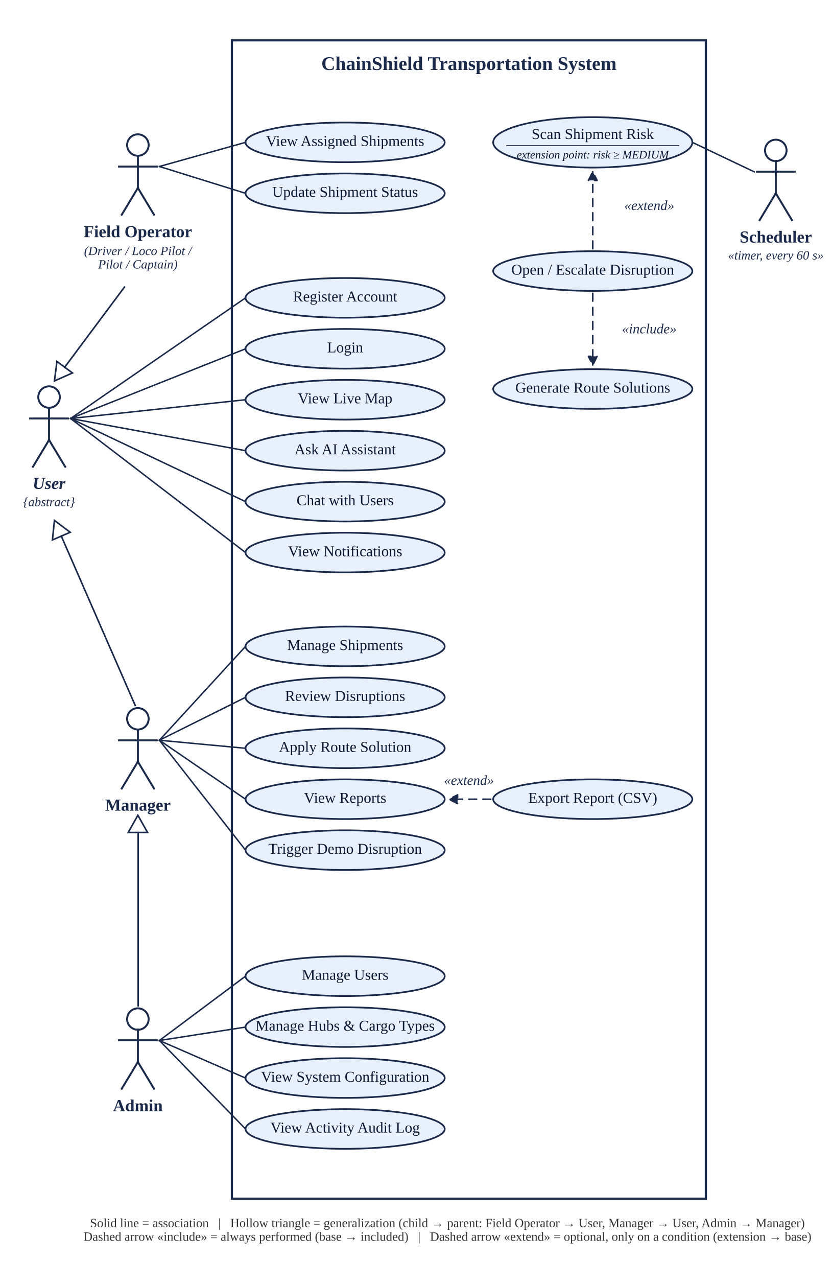
Fig 3.1 — Use Case Diagram

Actors
• User {abstract} — any person who has an account. It is never used on its own; it only holds the use cases that every role shares: Register Account, Login, View Live Map, Ask AI Assistant, Chat with Users and View Notifications.
• Field Operator (driver, loco pilot, pilot or captain) — views the shipments assigned to him or her and updates their status.
• Manager — manages shipments, reviews disruptions, applies a route solution, views reports and can trigger a demo disruption.
• Admin — manages users, hubs and cargo types, views the system configuration and the activity audit log.
• Scheduler — a time-triggered secondary actor (APScheduler, every 60 seconds) that starts Scan Shipment Risk without any human action.

Generalization
Generalization (a solid line with a hollow triangle pointing to the parent) means the child actor inherits every use case of the parent. Field Operator and Manager are both specialised Users, so both inherit the six common use cases without drawing six extra lines for each of them. Admin is a specialised Manager, so the Admin inherits all Manager use cases and, through the Manager, all User use cases as well. A Manager is not a kind of Field Operator, so there is no generalization between those two actors.

Example of «include»
“Open / Escalate Disruption” «include» “Generate Route Solutions”. An include relationship means the included use case is always performed as a mandatory part of the base use case, and the dashed arrow points from the base use case to the included one. Whenever a disruption is opened or escalated, the route solver always generates the ranked hold, reroute, mode-switch and continue options — a disruption is never created without them.

Example of «extend»
An extend relationship means the extending use case is optional and runs only when a condition is true, and the dashed arrow points from the extending use case to the base use case. The diagram has two examples. “Open / Escalate Disruption” «extend» “Scan Shipment Risk”: every scan scores the shipments, but a disruption is opened only at the extension point risk ≥ MEDIUM (score 50 or more). “Export Report (CSV)” «extend» “View Reports”: a manager normally just views a report on screen, and only if he or she clicks Export CSV is the report also downloaded as a CSV file.

System Architecture
The system follows a layered architecture (Fig 3.2): a Flask + Jinja2 + Bootstrap presentation layer (with Leaflet.js and Chart.js) talks to the server over HTTP and WebSockets; core services (Risk Engine, Route Solver, Notifications/Chat, AI Assistant, Admin and Reports) form the middle layer; a Flask-SQLAlchemy data-access layer sits below them; and a SQLite database forms the base. The entire stack is packaged inside one Docker container.
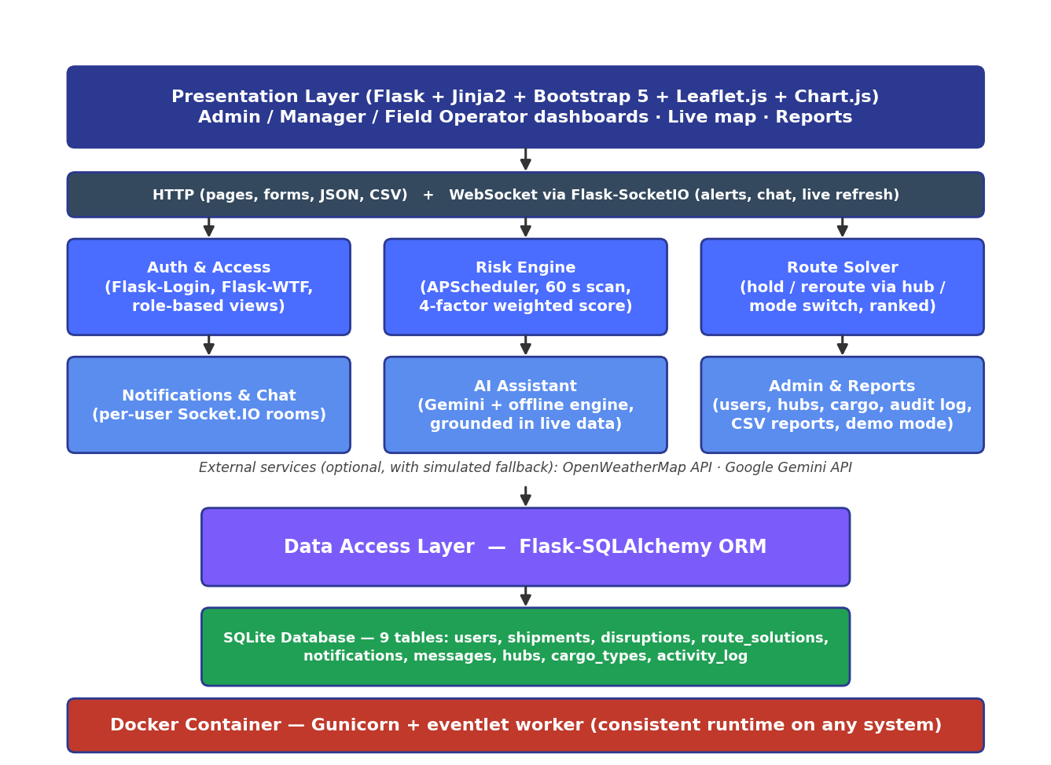
Fig 3.2 — ChainShield System Architecture

3.2 Data Dictionary
The database of ChainShield is named chainshield and is stored in the SQLite file instance/chainshield.db. It contains nine tables, one for each model class in app/models.py. For every table, the data dictionary below gives its name, description, primary key and foreign keys, followed by each field with its data type, size, constraint and description. The last column shows the sample data of one record (id = 1) taken from the demo database.
Conventions used in the tables: every primary key is an INTEGER that SQLite generates automatically; NULL means the field is optional; DEFAULT values are filled in by the application when a new record is saved; a size is given only for VARCHAR fields, and “—” means the type has no size; all dates and times are stored in UTC.

1. Table: users
Description: Stores the login account, role and status of every person who uses the system.
Primary Key: id Foreign Key(s): None
Table 3.1 — users
Sr. No. | Field Name | Data Type | Size | Constraint | Description | Sample Data (id = 1)
1 | id | INTEGER | — | PRIMARY KEY | Unique user identifier, generated automatically | 1
2 | name | VARCHAR | 100 | NOT NULL | Full name of the user | Admin
3 | email | VARCHAR | 100 | NOT NULL, UNIQUE | Login e-mail address (indexed for fast login) | admin@chainshield.com
4 | password_hash | VARCHAR | 255 | NOT NULL | Werkzeug (scrypt) hash of the password; the plain password is never stored | scrypt:32768:8:1$jCqB…
5 | role | VARCHAR | 20 | NOT NULL, DEFAULT 'manager' | admin / manager / captain / pilot / driver / loco_pilot | admin
6 | phone | VARCHAR | 20 | NULL | Contact number (optional) | NULL
7 | is_active | BOOLEAN | — | NOT NULL, DEFAULT 1 | 1 = active; 0 = deactivated by an admin and cannot log in | 1
8 | created_at | DATETIME | — | DEFAULT current date-time (UTC) | Date and time the account was created | 2026-08-25 03:48:26

2. Table: hubs
Description: Master data of logistics hubs (base cities) used for plotting, rerouting and holding shipments.
Primary Key: id Foreign Key(s): None
Table 3.2 — hubs
Sr. No. | Field Name | Data Type | Size | Constraint | Description | Sample Data (id = 1)
1 | id | INTEGER | — | PRIMARY KEY | Unique hub identifier, generated automatically | 1
2 | name | VARCHAR | 100 | NOT NULL | Name of the hub | Ahmedabad Hub
3 | location | VARCHAR | 150 | NULL | City and state of the hub | Ahmedabad, Gujarat
4 | lat | FLOAT | — | NULL | Latitude, used for the map marker and detour distance | 23.0225
5 | lng | FLOAT | — | NULL | Longitude, used for the map marker and detour distance | 72.5714

3. Table: cargo_types
Description: Master data of cargo categories and how sensitive each one is to disruption.
Primary Key: id Foreign Key(s): None
Table 3.3 — cargo_types
Sr. No. | Field Name | Data Type | Size | Constraint | Description | Sample Data (id = 1)
1 | id | INTEGER | — | PRIMARY KEY | Unique cargo type identifier, generated automatically | 1
2 | name | VARCHAR | 50 | NOT NULL, UNIQUE | Cargo category name | General
3 | sensitivity_weight | FLOAT | — | DEFAULT 0.5, range 0.0 – 1.0 | Sensitivity of the cargo; × 100 gives the cargo factor of the risk score | 0.3

4. Table: shipments
Description: Every shipment with its route, cargo, assigned operator, live position and current risk.
Primary Key: id Foreign Key(s): cargo_type_id → cargo_types(id), assigned_operator_id → users(id), hub_id → hubs(id)
Table 3.4 — shipments
Sr. No. | Field Name | Data Type | Size | Constraint | Description | Sample Data (id = 1)
1 | id | INTEGER | — | PRIMARY KEY | Unique shipment identifier, generated automatically | 1
2 | tracking_no | VARCHAR | 30 | NOT NULL, UNIQUE | Tracking number (auto-generated as CS-xxxx if left blank) | CS-1001
3 | origin | VARCHAR | 100 | NULL | Origin city | Ahmedabad
4 | destination | VARCHAR | 100 | NULL | Destination city | Mumbai
5 | cargo_type_id | INTEGER | — | FOREIGN KEY → cargo_types(id), NULL | Type of cargo carried | 2 (Perishable)
6 | transport_mode | VARCHAR | 20 | NULL | Road / Rail / Sea / Air | Road
7 | status | VARCHAR | 20 | DEFAULT 'In-transit' | In-transit / Delayed / On-hold / Delivered | In-transit
8 | current_lat | FLOAT | — | NULL | Current latitude (simulated movement) | 22.30
9 | current_lng | FLOAT | — | NULL | Current longitude (simulated movement) | 72.62
10 | risk_score | FLOAT | — | DEFAULT 0.0, range 0 – 100 | Composite risk score from the last scan | 0.0
11 | risk_level | VARCHAR | 15 | DEFAULT 'LOW' | LOW / AT-RISK / MEDIUM / HIGH | LOW
12 | cargo_value | FLOAT | — | DEFAULT 0.0 | Declared cargo value in ₹ (used for value at risk) | 42000.00
13 | assigned_operator_id | INTEGER | — | FOREIGN KEY → users(id), NULL | Field operator responsible for the shipment | 8 (Suresh Yadav, driver)
14 | hub_id | INTEGER | — | FOREIGN KEY → hubs(id), NULL | Origin hub of the shipment | 1 (Ahmedabad Hub)
15 | created_at | DATETIME | — | DEFAULT current date-time (UTC) | Date and time the shipment was created | 2026-09-07 06:24:35

5. Table: disruptions
Description: Disruptions opened automatically by the risk engine when a shipment reaches MEDIUM risk.
Primary Key: id Foreign Key(s): shipment_id → shipments(id), resolved_by → users(id)
Table 3.5 — disruptions
Sr. No. | Field Name | Data Type | Size | Constraint | Description | Sample Data (id = 1)
1 | id | INTEGER | — | PRIMARY KEY | Unique disruption identifier, generated automatically | 1
2 | shipment_id | INTEGER | — | NOT NULL, FOREIGN KEY → shipments(id) | Affected shipment | 3 (CS-1003)
3 | type | VARCHAR | 30 | NULL | Dominant factor: Weather / Congestion / Cargo / History | Cargo
4 | severity | VARCHAR | 15 | NULL | MEDIUM or HIGH (escalated as the risk rises) | HIGH
5 | risk_score | FLOAT | — | NULL | Risk score at detection or at the last escalation | 79.69
6 | status | VARCHAR | 15 | DEFAULT 'Open' | Open / Resolved | Resolved
7 | detected_at | DATETIME | — | DEFAULT current date-time (UTC) | Date and time the disruption was detected | 2026-10-10 20:06:57
8 | resolved_at | DATETIME | — | NULL | Date and time a route decision was applied | 2026-10-11 05:45:02
9 | resolved_by | INTEGER | — | FOREIGN KEY → users(id), NULL | Manager or admin who resolved it | 1 (Admin)

6. Table: route_solutions
Description: Ranked route options generated by the route solver for each disruption.
Primary Key: id Foreign Key(s): disruption_id → disruptions(id)
Table 3.6 — route_solutions
Sr. No. | Field Name | Data Type | Size | Constraint | Description | Sample Data (id = 1)
1 | id | INTEGER | — | PRIMARY KEY | Unique solution identifier, generated automatically | 1
2 | disruption_id | INTEGER | — | NOT NULL, FOREIGN KEY → disruptions(id), deleted with its disruption | Parent disruption | 1
3 | option_no | INTEGER | — | NOT NULL | Rank of the option; 1 = recommended | 1
4 | description | TEXT | — | NULL | Readable description of the option | Reroute via Jaipur Hub (+0 km detour, avoids affected corridor)
5 | extra_time_hours | FLOAT | — | NULL | Additional transit time in hours | 1.5
6 | extra_cost | FLOAT | — | NULL | Additional cost in ₹ | 1501.22
7 | risk_score | FLOAT | — | NULL | Residual risk if this option is chosen | 23.91
8 | selected | BOOLEAN | — | DEFAULT 0 | 1 = option applied by the manager | 0

7. Table: notifications
Description: In-app alerts delivered to individual users in real time.
Primary Key: id Foreign Key(s): user_id → users(id)
Table 3.7 — notifications
Sr. No. | Field Name | Data Type | Size | Constraint | Description | Sample Data (id = 1)
1 | id | INTEGER | — | PRIMARY KEY | Unique notification identifier, generated automatically | 1
2 | user_id | INTEGER | — | NOT NULL, FOREIGN KEY → users(id) | Recipient of the alert | 1 (Admin)
3 | message | VARCHAR | 255 | NOT NULL | Alert text | MEDIUM risk on CS-1003 (Delhi → Ahmedabad) — Cargo, score 56.53. Route options ready.
4 | is_read | BOOLEAN | — | DEFAULT 0 | 1 = marked as read | 0
5 | created_at | DATETIME | — | DEFAULT current date-time (UTC) | Date and time the alert was created | 2026-10-10 20:06:57

8. Table: messages
Description: Direct chat messages exchanged between two users.
Primary Key: id Foreign Key(s): sender_id → users(id), receiver_id → users(id)
Table 3.8 — messages
Sr. No. | Field Name | Data Type | Size | Constraint | Description | Sample Data (id = 1)
1 | id | INTEGER | — | PRIMARY KEY | Unique message identifier, generated automatically | 1
2 | sender_id | INTEGER | — | NOT NULL, FOREIGN KEY → users(id) | User who sent the message | 8 (Suresh Yadav)
3 | receiver_id | INTEGER | — | NOT NULL, FOREIGN KEY → users(id) | User who receives the message | 1 (Admin)
4 | chat_id | VARCHAR | 10 | NULL | Conversation key in the form 'lowerId-higherId' | 1-8
5 | content | TEXT | — | NOT NULL | Message text | Hello
6 | sent_at | DATETIME | — | DEFAULT current date-time (UTC) | Date and time the message was sent | 2026-09-24 13:22:49

9. Table: activity_log
Description: Audit trail of logins, administrative actions and disruption decisions.
Primary Key: id Foreign Key(s): user_id → users(id)
Table 3.9 — activity_log
Sr. No. | Field Name | Data Type | Size | Constraint | Description | Sample Data (id = 1)
1 | id | INTEGER | — | PRIMARY KEY | Unique log entry identifier, generated automatically | 1
2 | user_id | INTEGER | — | FOREIGN KEY → users(id), NULL | User who performed the action | 1 (Admin)
3 | action | VARCHAR | 255 | NOT NULL | Description of the action | Admin resolved the disruption on CS-1002 via 'Hold at current hub until conditions clear'
4 | timestamp | DATETIME | — | DEFAULT current date-time (UTC) | Date and time the action happened | 2026-09-07 07:15:49

Relationships
users 1 : N shipments (assigned_operator_id); cargo_types 1 : N shipments; hubs 1 : N shipments; shipments 1 : N disruptions; disruptions 1 : N route_solutions (deleted together with their disruption); users 1 : N notifications, messages (as sender and as receiver), activity_log entries and resolved disruptions (resolved_by).

3.3 User Interface Design
The user interface is built with server-rendered Jinja2 templates on Bootstrap 5, extended with a custom design system (app/static/css/style.css). Every signed-in page shares one application shell: a collapsible dark sidebar for navigation with live counts, and a top bar with the theme switch, a notification bell and the account menu. The design principles applied to every screen are:
• Consistent design system — Inter typeface, an indigo and teal colour palette, soft shadows and rounded cards. Risk levels always use the same colours: green for LOW, amber for AT-RISK, orange for MEDIUM and red for HIGH.
• Light and dark themes — switchable from the top bar, defaulting to the operating-system setting; charts and map tiles adapt to the active theme.
• Responsive layout — the sidebar collapses to icons on desktop and becomes a slide-in drawer on phones, so no page scrolls sideways even at a 390-pixel phone width.
• Feedback and motion — buttons show a spinner while a form is submitting, KPI numbers count up and new alerts slide in as toasts; motion is switched off automatically for users who prefer reduced motion.

Admin Panel Design
The admin panel is the control centre of the system and is available only to administrators. It is organised as tabs — Overview, Users, Shipments, Base Cities (hubs), Cargo Types, Reports, System Config and Activity Log — so that every administrative task is one click away. The screenshots below show the main screens of the admin panel.
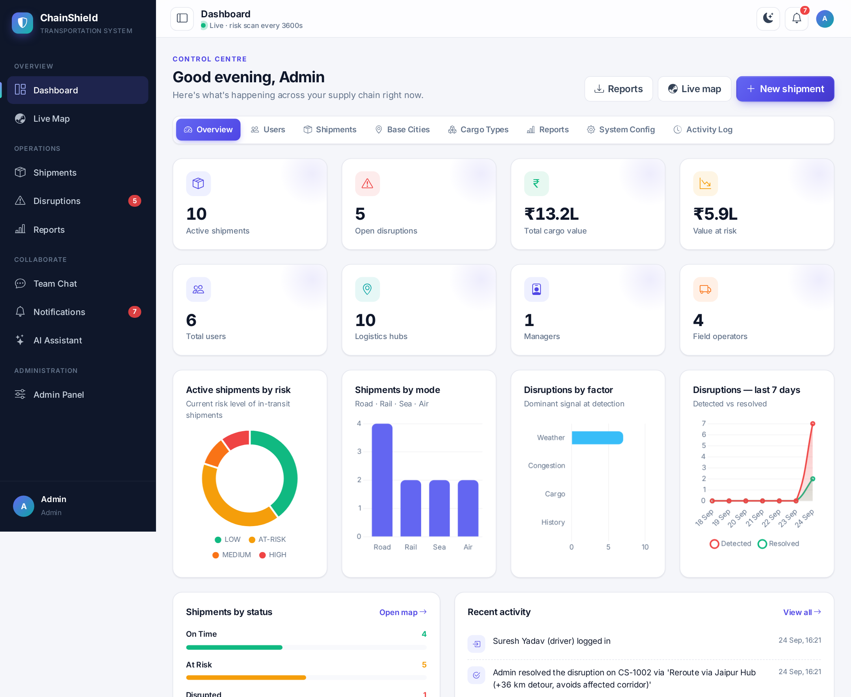
Fig 3.3 — Admin Panel: Overview Dashboard
The overview dashboard shows KPI cards for active shipments, open disruptions, cargo value at risk and total users, four live Chart.js charts (shipments by risk, by transport mode, disruptions by factor and disruptions over the last 7 days) and the recent activity feed. All figures refresh automatically after every risk scan.
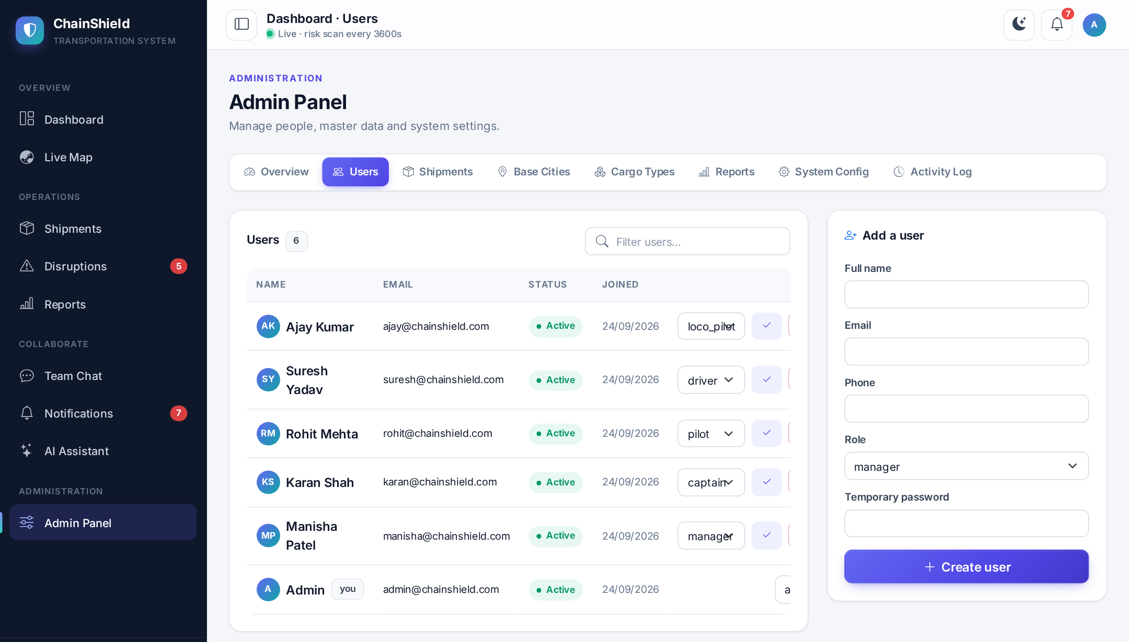
Fig 3.4 — Admin Panel: User Management
The Users tab lists every account with its role and status. The admin can create a new user with a temporary password, change a role, and activate or deactivate an account; a deactivated user is logged out immediately.
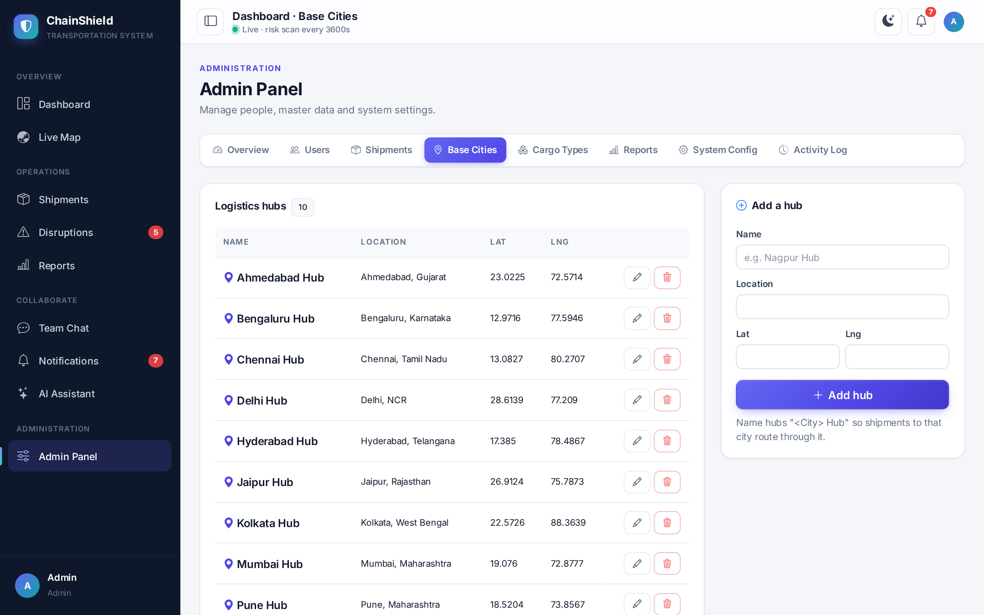
Fig 3.5 — Admin Panel: Logistics Hubs (Base Cities)
The Base Cities tab maintains the hubs used by the route solver. Each hub has a name, a location and latitude/longitude, which are used to plot the hub on the map and to calculate detour distances.
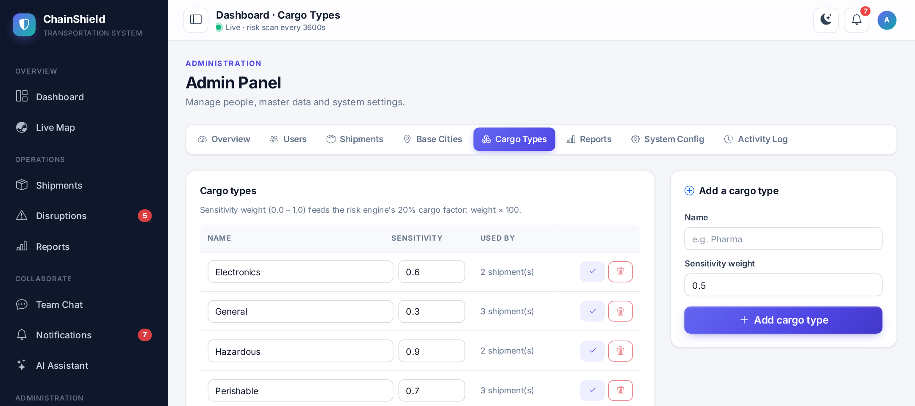
Fig 3.6 — Admin Panel: Cargo Types
The Cargo Types tab maintains the cargo categories and their sensitivity weight between 0.0 and 1.0. A weight outside this range is rejected by server-side validation.
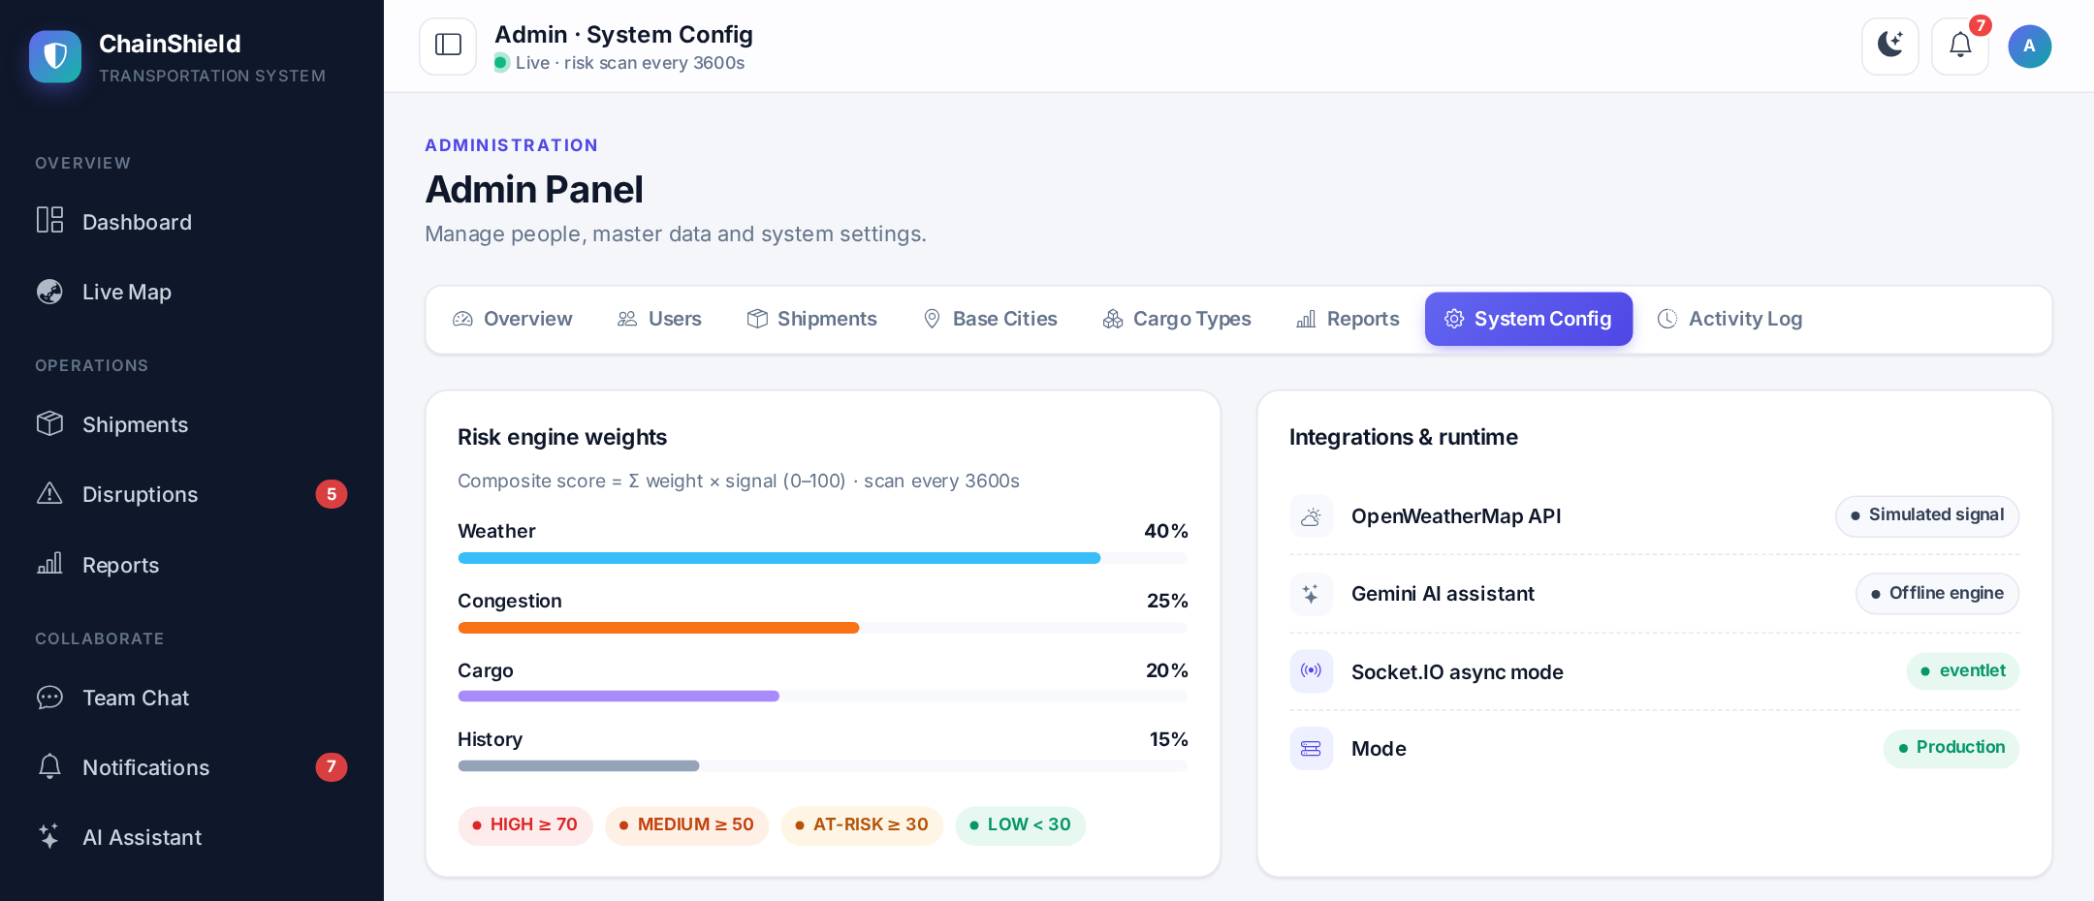
Fig 3.7 — Admin Panel: System Configuration
The System Config tab shows the current risk-engine weights and thresholds, and the status of each integration (OpenWeatherMap, Gemini AI, Socket.IO and demo mode).
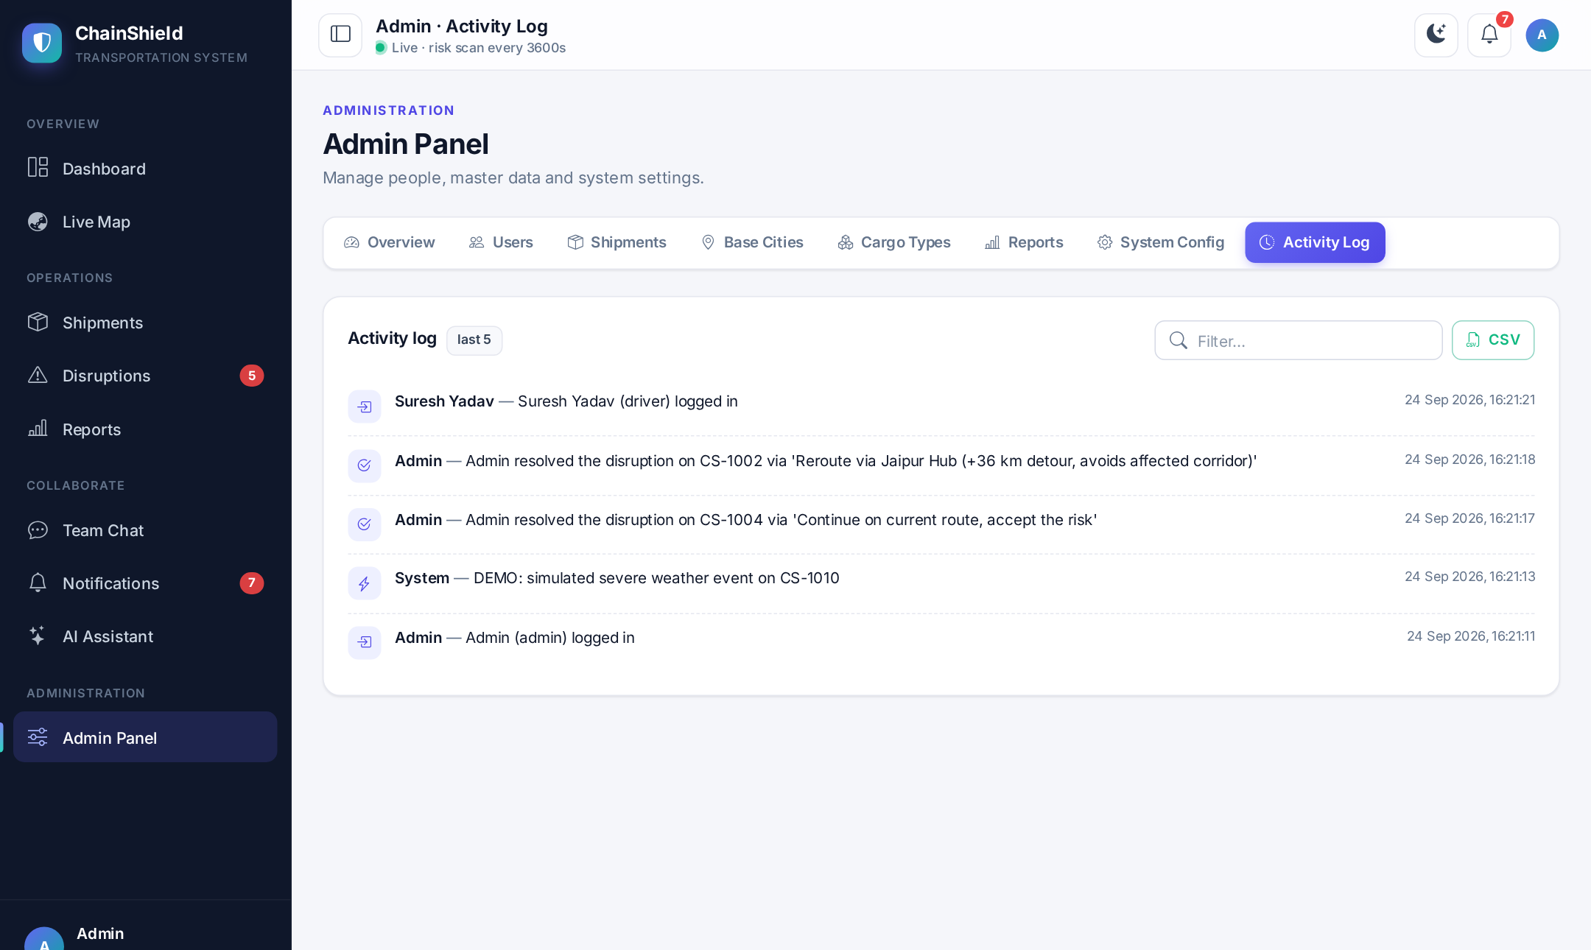
Fig 3.8 — Admin Panel: Activity Audit Log
The Activity Log tab is a searchable, time-ordered record of logins, administrative changes and disruption decisions, which provides accountability for every action taken in the system.

3.4 Report Design
The Reports module is available to administrators and managers. All reports are shown on one screen (Fig 3.9) and are filtered by a From – To date range at the top of the page. Three of the reports can be exported as CSV files that open directly in Microsoft Excel. The design of the reports screen is shown below, followed by the layout of each report.
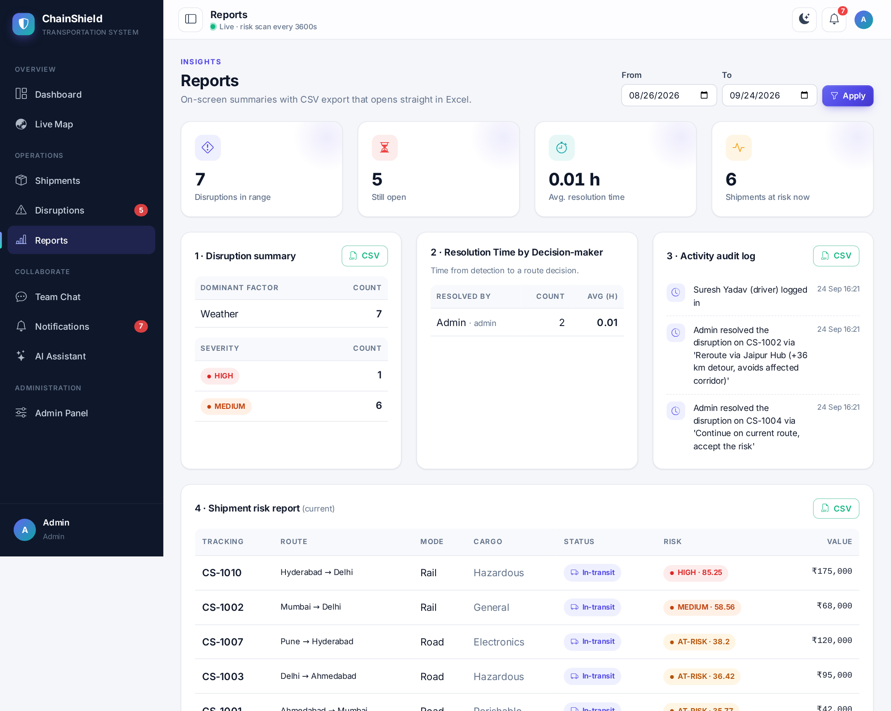
Fig 3.9 — Report Design: Reports Screen with Date Filter and CSV Export

Report 1 — Disruption Summary Report (CSV)
On screen this report shows the number of disruptions by dominant factor and by severity for the selected period. The CSV export lists every disruption with its decision details, so management can see which factors cause most disruptions and how each one was handled. Its layout is:
Table 3.10 — Layout of Disruption Summary Report
Column | Description | Sample Value
ID | Disruption number | 1
Shipment | Tracking number | CS-1003
Dominant Factor | Weather / Congestion / Cargo / History | Cargo
Severity | MEDIUM or HIGH | HIGH
Risk Score | Score at detection or last escalation | 79.69
Status | Open / Resolved | Resolved
Detected (UTC) | Detection date and time | 2026-10-10 20:06
Resolved (UTC) | Decision date and time | 2026-10-11 05:45
Resolution Time (h) | Hours from detection to decision | 9.63
Resolved By | Manager / admin | Admin
Chosen Option | Route option applied | Reroute via Surat Hub (+370 km detour, avoids affected corridor)

Report 2 — Resolution Time by Decision-maker
This on-screen report shows, for each manager or admin, how many disruptions were resolved in the period and the average time taken from detection to a route decision. It measures how quickly the team responds to risk.
Table 3.11 — Layout of Resolution Time Report (sample rows)
Resolved By | Count | Average Time (hours)
Manisha Patel | 4 | 0.61
Admin | 2 | 1.12

Report 3 — Activity Audit Log (CSV)
A chronological record of logins, administrative actions, shipment changes and disruption resolutions for the selected period, used for accountability and review.
Table 3.12 — Layout of Activity Audit Log Report (sample row)
Timestamp (UTC) | User | Action
2026-09-07 07:15:49 | Admin | Admin resolved the disruption on CS-1002 via 'Hold at current hub until conditions clear'

Report 4 — Shipment Risk Report (CSV)
This report lists the current risk of every shipment, so a manager can see at a glance which shipments, and how much cargo value, are at risk right now. Its layout is:
Table 3.13 — Layout of Shipment Risk Report
Column | Description | Sample Value
Tracking No | Shipment tracking number | CS-1004
Origin / Destination | Route of the shipment | Bengaluru / Chennai
Mode | Road / Rail / Sea / Air | Air
Cargo Type | Cargo category | Electronics
Status | Current shipment status | In-transit
Risk Level / Score | Result of the last scan | MEDIUM / 53.20
Cargo Value (INR) | Declared value | 150000
Operator | Assigned field operator | Rohit Mehta
Latitude / Longitude | Current position | 13.08 / 80.27

4. DEVELOPMENT

4.1 Coding Standards
The following coding standards were followed throughout the development of ChainShield. For every standard, a short explanation, an example, and a screenshot of the actual source code where the standard is applied are given.

1. PEP 8 Naming, Type Hints and Docstrings
All Python code follows PEP 8: 4-space indentation, snake_case for functions and variables, PascalCase for classes and UPPER_CASE for constants. Functions carry type hints and a docstring, so every member of the group can read and review another member's code without explanation.
Example: compute_risk_score() and classify_risk() in app/services/risk_engine.py; the constant ALERT_LEVELS; the class RouteSolution in app/models.py.
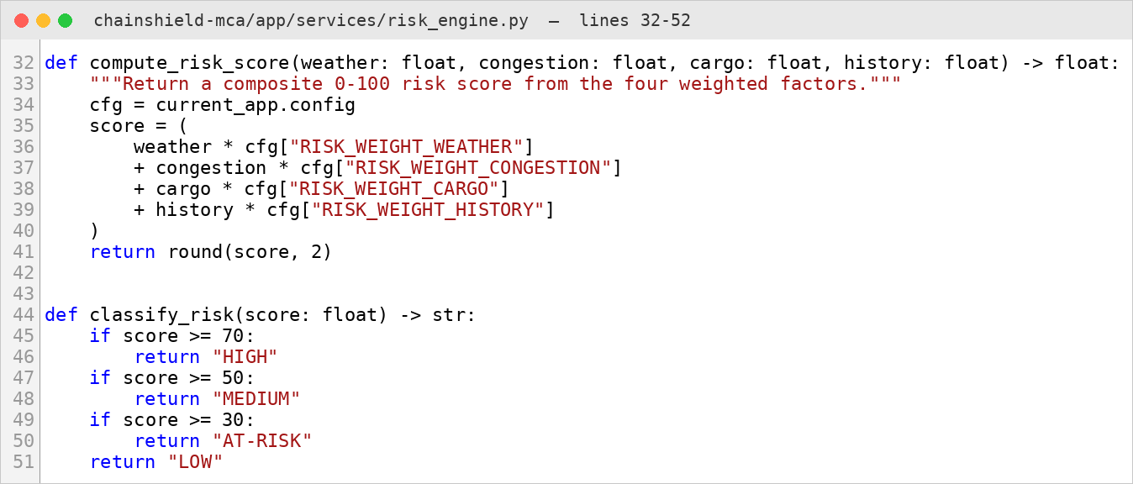
Fig 4.1 — Naming, type hints and docstring in the risk engine

2. Application Factory Pattern
The Flask application is never created at import time; create_app() builds it from a named configuration (development, testing or production). This lets the same code run on a laptop, inside the automated tests and inside Docker, each with its own settings.
Example: create_app("testing") gives the test suite a fresh in-memory database, while Docker calls create_app("production").
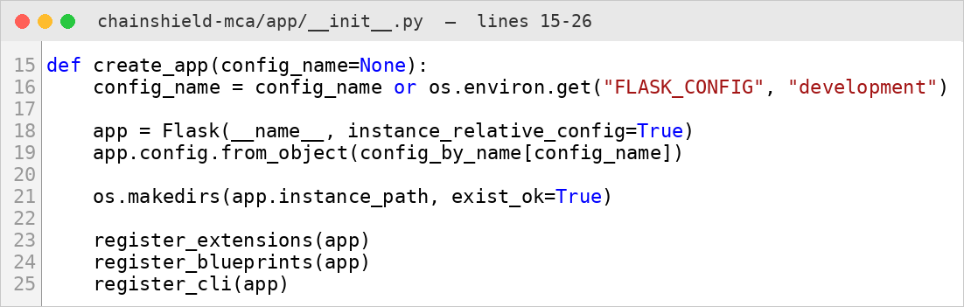
Fig 4.2 — create_app() in app/__init__.py

3. Modular Blueprint Structure
Each feature lives in its own Flask blueprint with its own URL prefix, routes and templates. A feature can therefore be changed, tested or disabled without touching the others.
Example: shipments_bp serves everything under /shipments, disruptions_bp under /disruptions and chat_bp under /chat.
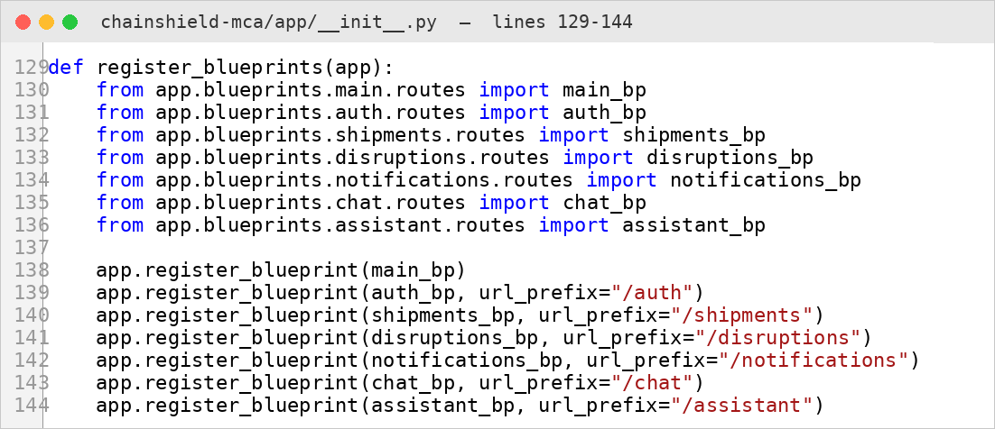
Fig 4.3 — Blueprint registration in app/__init__.py

4. Single Source of Configuration — No Hard-coded Secrets
Risk weights, the scan interval and model names are defined once in app/config.py; API keys and the secret key are read from a .env file. The .env file is excluded from Git and Docker, so no password or key is ever committed to the repository.
Example: RISK_WEIGHT_WEATHER = 0.40 is read by the risk engine; GEMINI_API_KEY = os.environ.get("GEMINI_API_KEY", "").
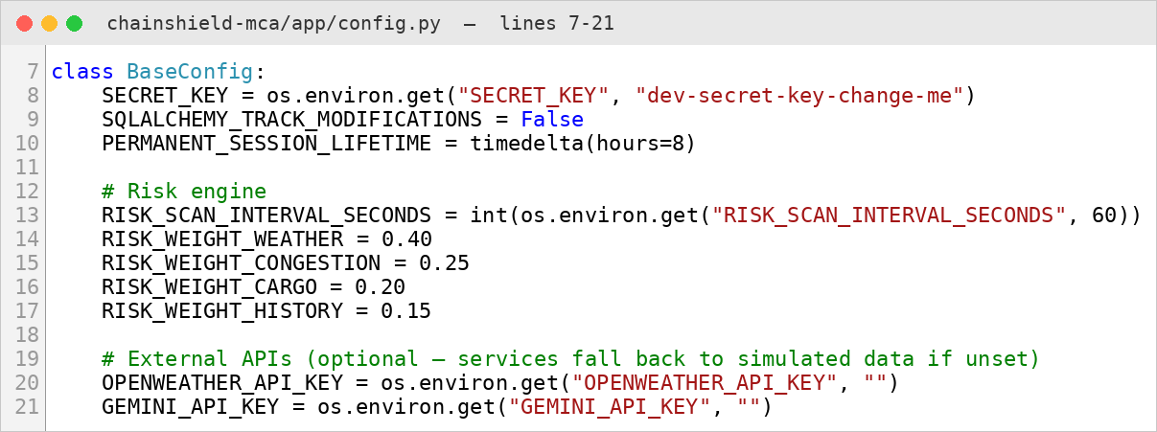
Fig 4.4 — Centralised settings in app/config.py

5. ORM Models Instead of Raw SQL
All nine tables are Python classes in app/models.py, and every query goes through Flask-SQLAlchemy. Queries are parameterised automatically, which prevents SQL injection, and the database can be moved to PostgreSQL by changing only DATABASE_URL.
Example: User.query.filter_by(email=form.email.data).first() instead of a hand-written SELECT statement.
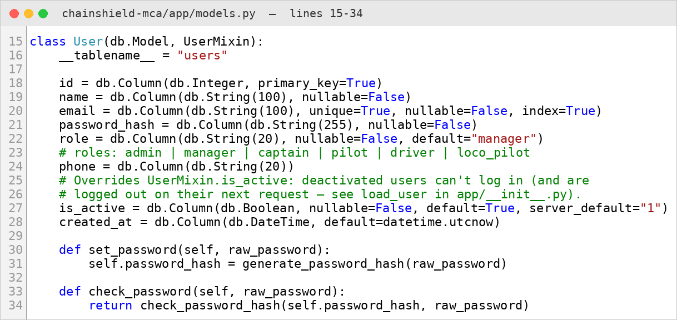
Fig 4.5 — The User model with password hashing helpers

6. Server-side Form Validation
Every form is validated on the server with Flask-WTF before anything is saved, because browser-side checks can be bypassed. Business rules that span two fields are written in a validate() method of the form class.
Example: ShipmentForm rejects a shipment whose destination equals its origin and any latitude outside −90 to 90.
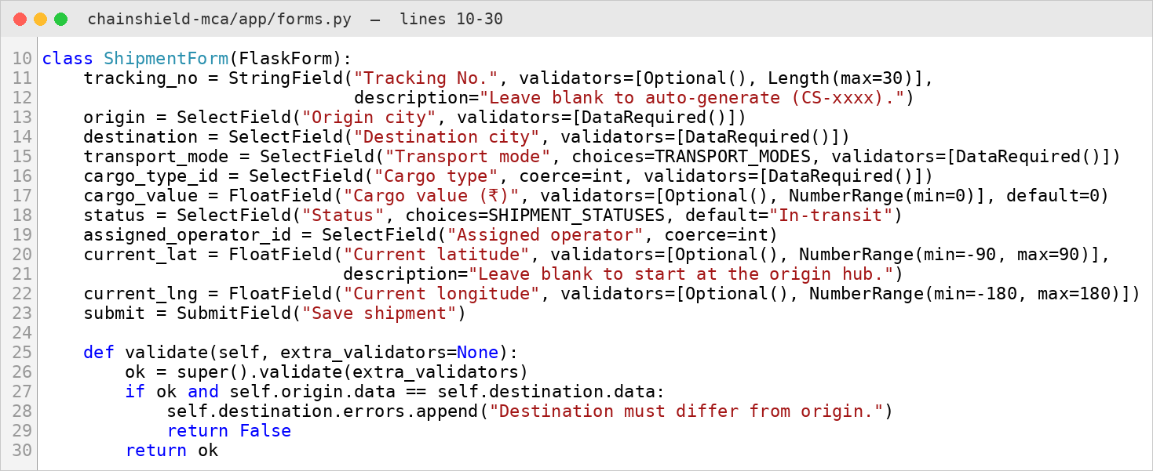
Fig 4.6 — ShipmentForm in app/forms.py

7. Security by Default — Role Decorators
Access rules are written once as decorators and placed on top of each route, so no page can forget its permission check. Together with CSRF tokens on every form, Werkzeug password hashing and Jinja2 auto-escaping, this protects against the common web attacks.
Example: @manager_required on /shipments/new returns 403 Forbidden to drivers, pilots, captains and loco pilots.
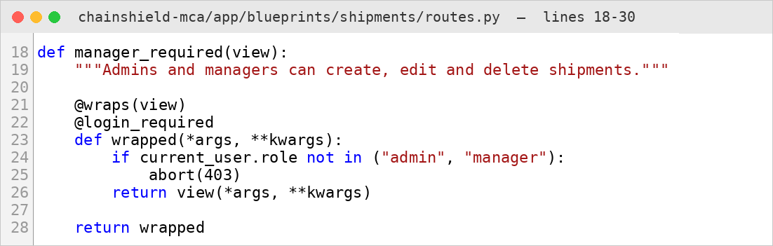
Fig 4.7 — manager_required decorator in the shipments blueprint

8. Template Inheritance and Reusable Macros
base.html defines the sidebar, top bar and scripts once, and every page only fills its content block. Repeated interface pieces are Jinja2 macros, so a design change is made in exactly one place.
Example: {{ risk_badge(s.risk_level, s.risk_score) }} draws the same coloured risk pill on the dashboard, shipment list and map pop-ups.
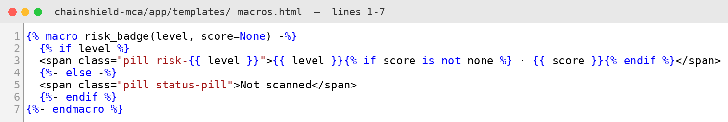
Fig 4.8 — risk_badge macro in app/templates/_macros.html

9. Version Control and Pinned Dependencies
Git records every feature with a descriptive commit message, and every library version is pinned in requirements.txt. The Dockerfile installs exactly these versions on Python 3.10, so the application behaves identically on every machine.
Example: Commit “Add admin CRUD, reports with CSV export, demo mode and map zones”; Flask==3.0.3 in requirements.txt.
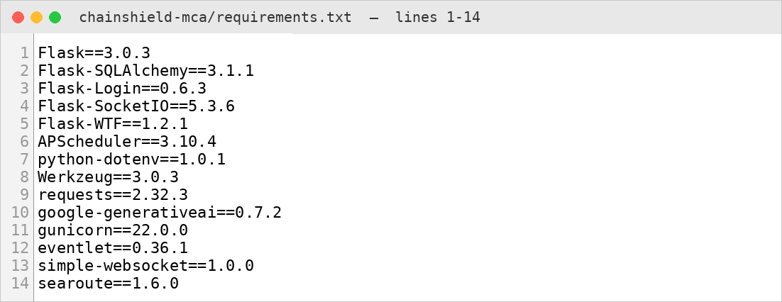
Fig 4.9 — Pinned dependencies in requirements.txt

4.2 Implementation Details

Risk Engine (app/services/risk_engine.py)
APScheduler runs a scan every 60 seconds (configurable). Each in-transit shipment is scored with the formula: score = 0.40 × weather + 0.25 × congestion + 0.20 × cargo sensitivity + 0.15 × lane history, where each factor is on a scale of 0 – 100. A score of 70 or more is HIGH, 50 or more is MEDIUM, 30 or more is AT-RISK and anything lower is LOW. AT-RISK shipments are only watched; a disruption is opened at MEDIUM and escalated, with re-planned options, if the shipment reaches HIGH. Weather comes from OpenWeatherMap when an API key is configured; otherwise a simulated signal is used. Congestion is simulated for each transport mode, with an occasional severe jam. Lane history grows with disruptions on the same origin–destination lane in the last 90 days. In demo mode each scan also moves shipments towards their destination hub, marking them Delivered on arrival.

Route Solver (app/services/route_solver.py)
For each disruption the solver builds these candidates: hold at the nearest hub, continue on the current route (baseline), reroute through the two hubs with the smallest detour (using the haversine great-circle distance), and a mode switch for the remaining leg (for example Road → Rail). Each option receives an extra time, an extra cost (₹, from per-kilometre mode rates) and a residual risk, and is ranked by 0.60 × risk + 0.25 × normalised time + 0.15 × normalised cost. Option 1 is the recommendation.

Sea Routing (app/services/sea_route.py)
Sea shipments move and are drawn along the shortest route over water. The open-source searoute library runs a shortest-path (Dijkstra) search over Eurostat's MARNET global network of shipping lanes, straits and canals, so a ship from Mumbai to Sydney goes round Sri Lanka and along the south coast of Australia instead of crossing land, and one to Rotterdam goes through the Suez Canal. It works for any hub in the world without an internet connection, and each route is cached per origin and destination. Road, rail and air shipments keep the straight line between hubs.

Real-time Layer (Flask-SocketIO)
Every logged-in browser joins a personal room (user_<id>). Notifications and chat messages are saved in the database and pushed to the right room; broadcast events such as shipments_updated and disruption_new make the live map, dashboards and charts refresh themselves without polling.

AI Assistant (app/services/assistant.py)
The user's question and a snapshot of the live data that the user is allowed to see (shipments, risk, open disruptions and their ranked options) are sent to Google Gemini. Without a key or an internet connection, a rule-based offline engine answers from the same data, so the feature always works during a demonstration.

Security and Deployment
Passwords are hashed with Werkzeug, sessions are handled by Flask-Login, every form and AJAX call carries a CSRF token, every route checks the user's role, accounts can be deactivated, and nobody can register as admin. The application is packaged as a Docker image on Python 3.10 served by Gunicorn with an eventlet worker (for real WebSockets); the SQLite file is persisted through a Docker volume and secrets are supplied through a .env file that is never committed. The live version of the application is hosted on the Render cloud platform and can be opened at https://chainshield.onrender.com/. On Render's free plan the service sleeps when it is idle and starts again from the demo data after a restart.

4.3 Output Screens
The screenshots below were captured from the running application with demo data. The admin panel screens are shown in Section 3.3 and the reports screen in Section 3.4.
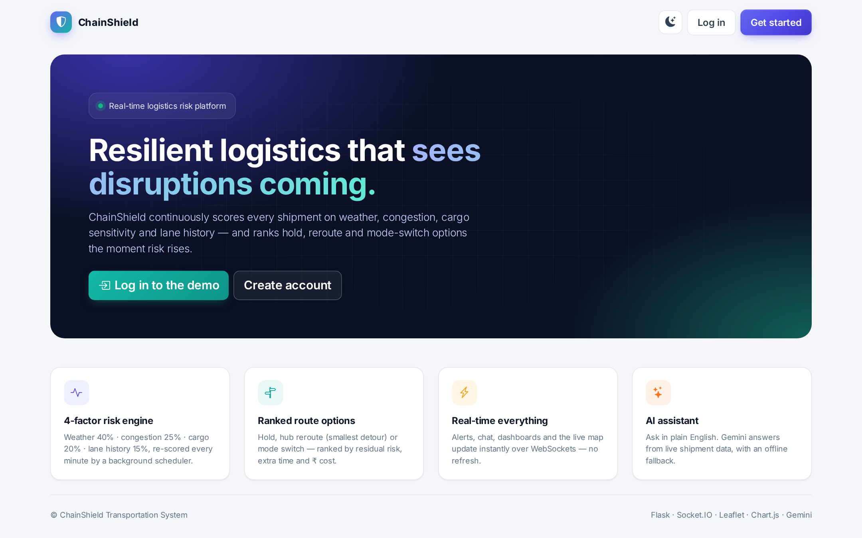
Fig 4.10 — Landing Page
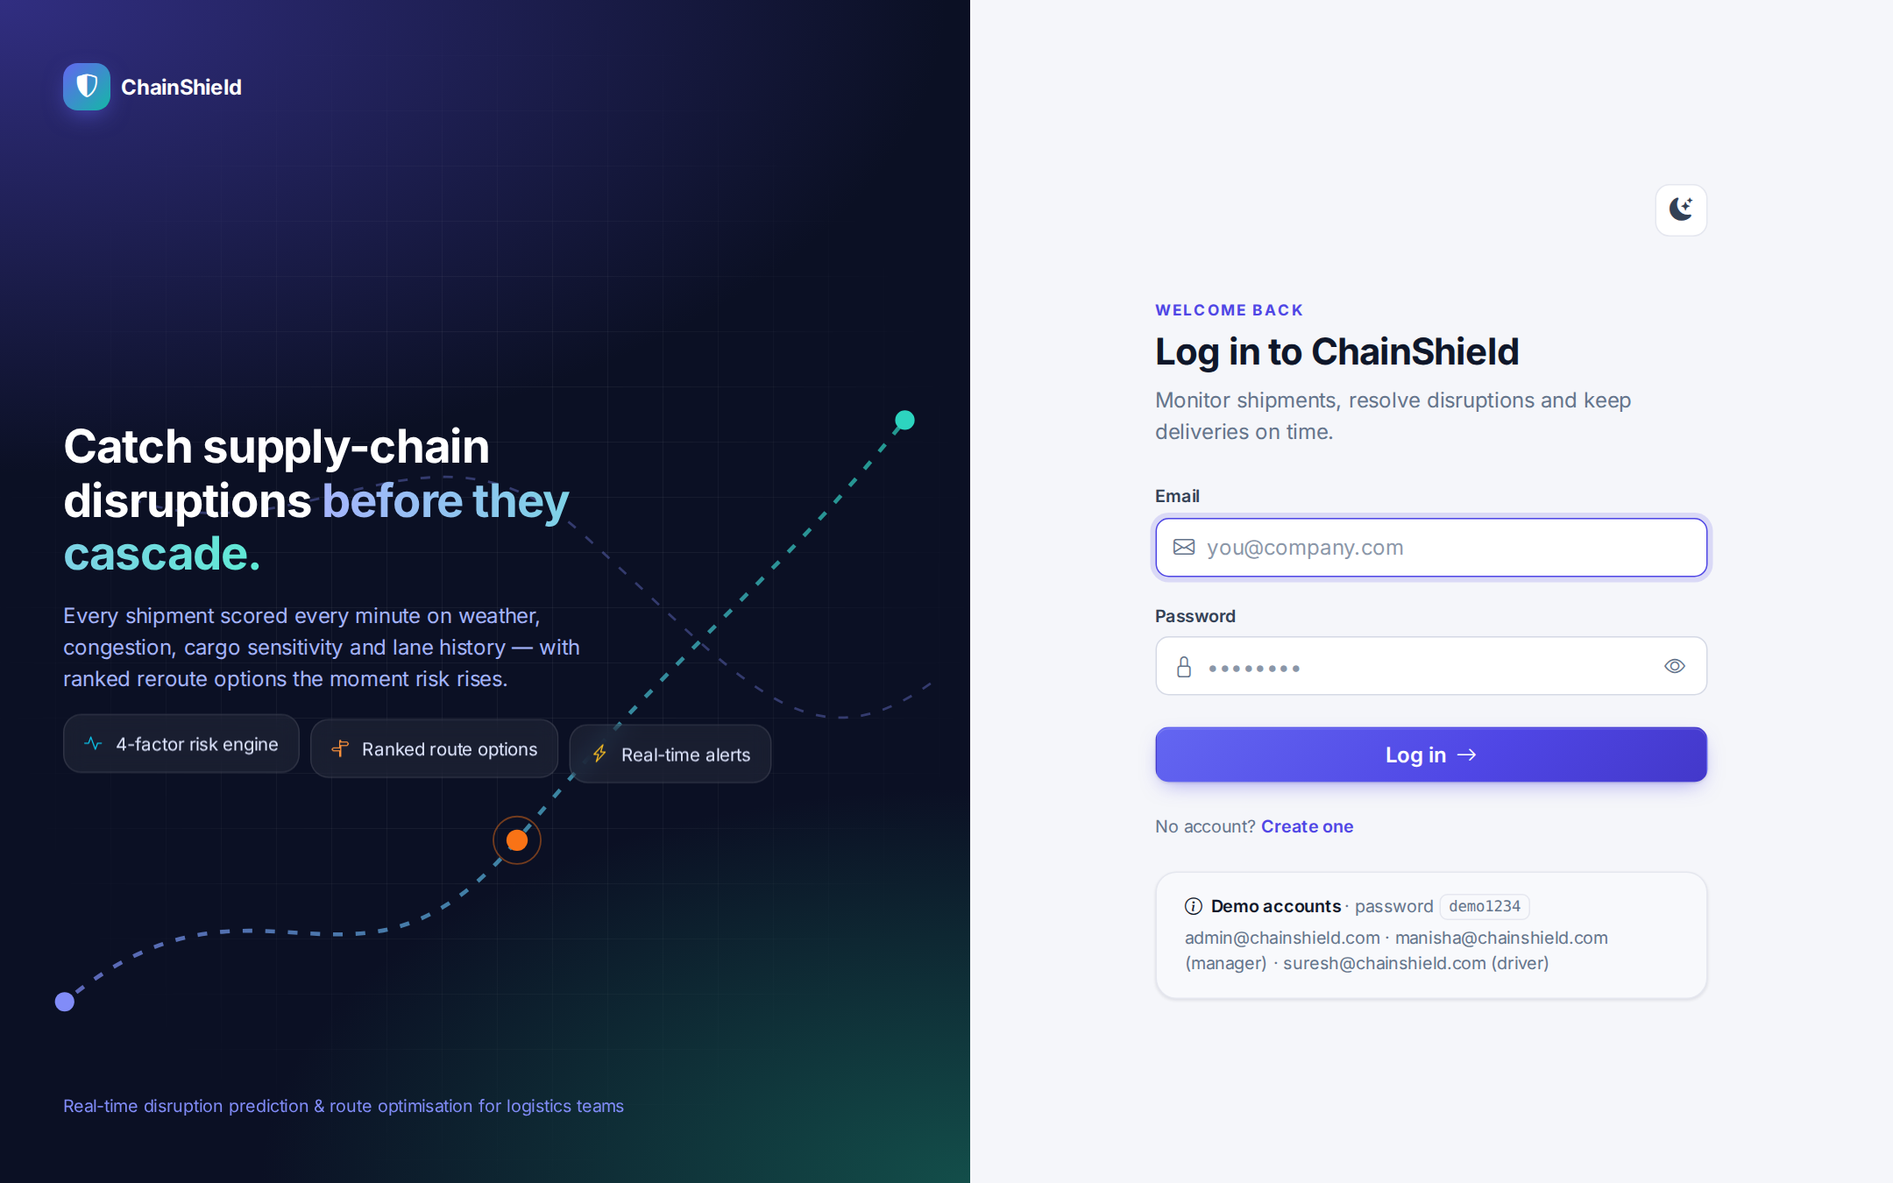
Fig 4.11 — Login Screen
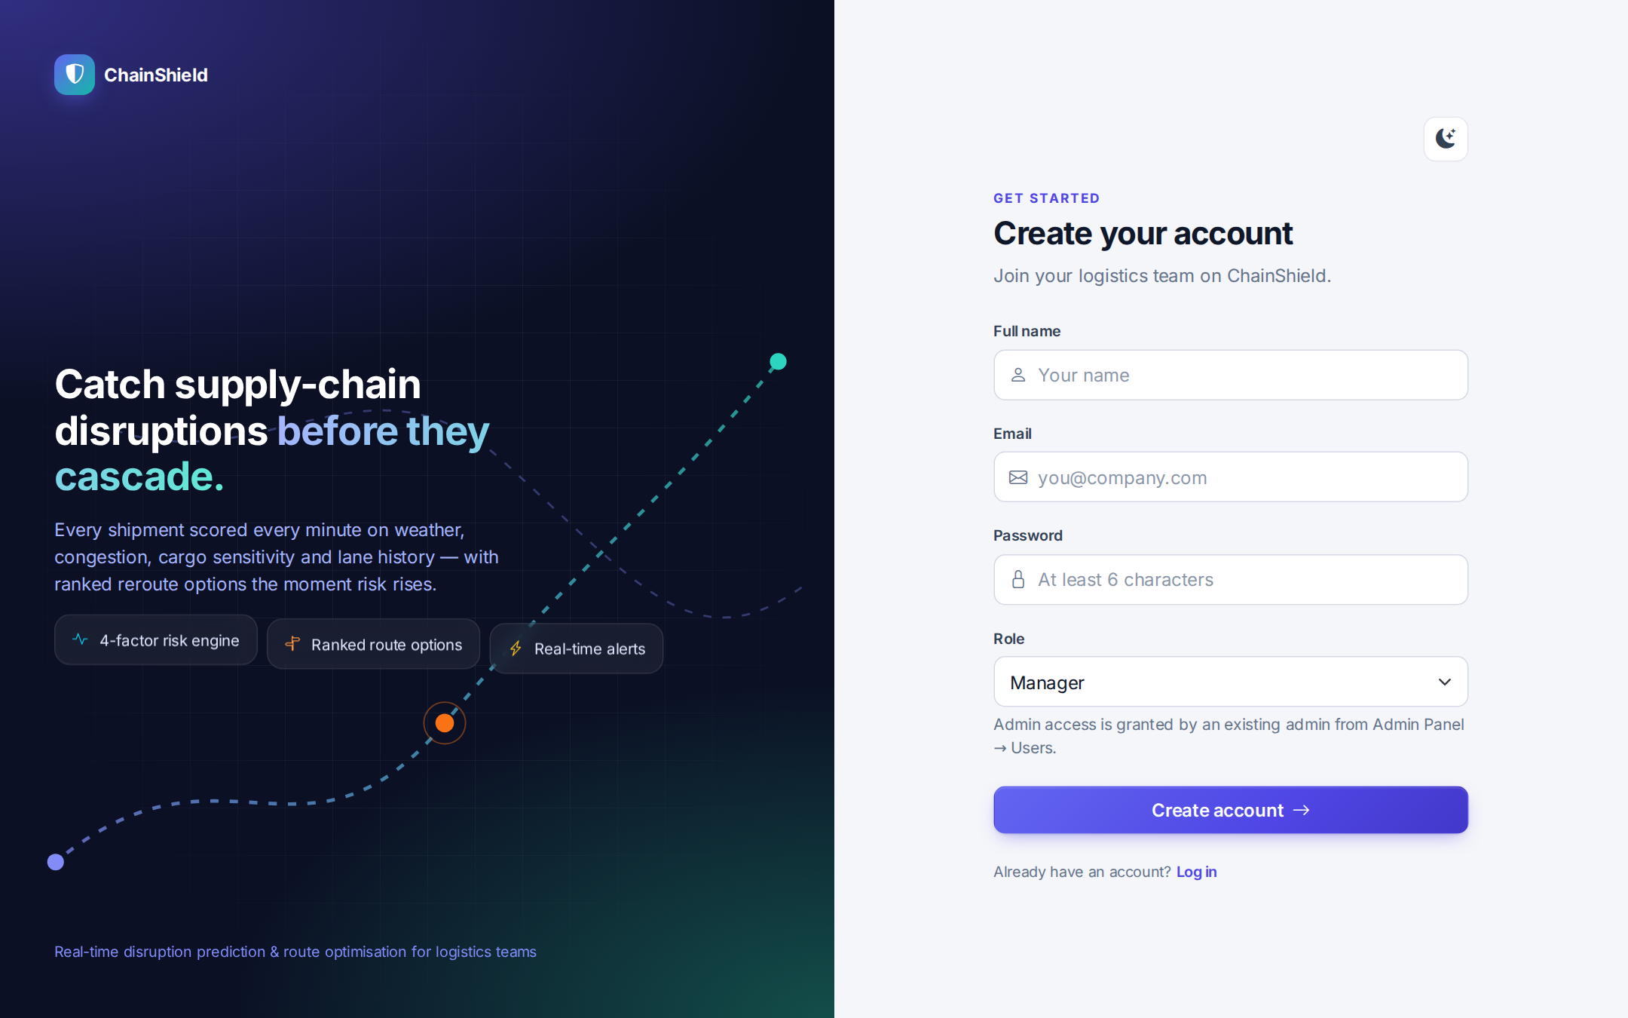
Fig 4.12 — Registration Screen
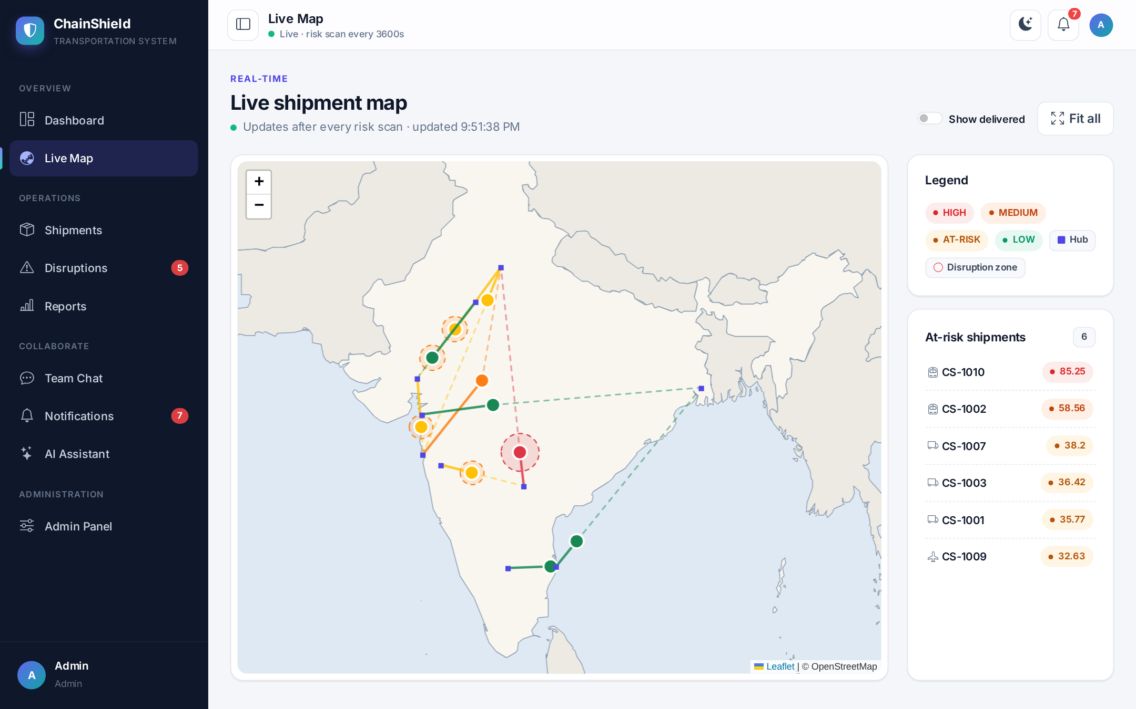
Fig 4.13 — Live Shipment Map with Disruption Zones
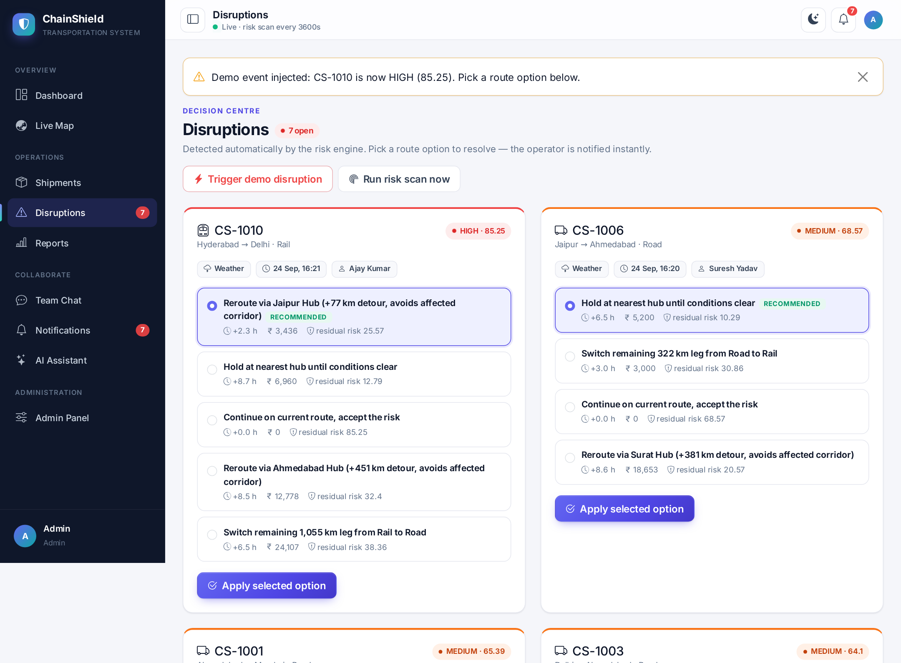
Fig 4.14 — Disruptions with Ranked Route Options
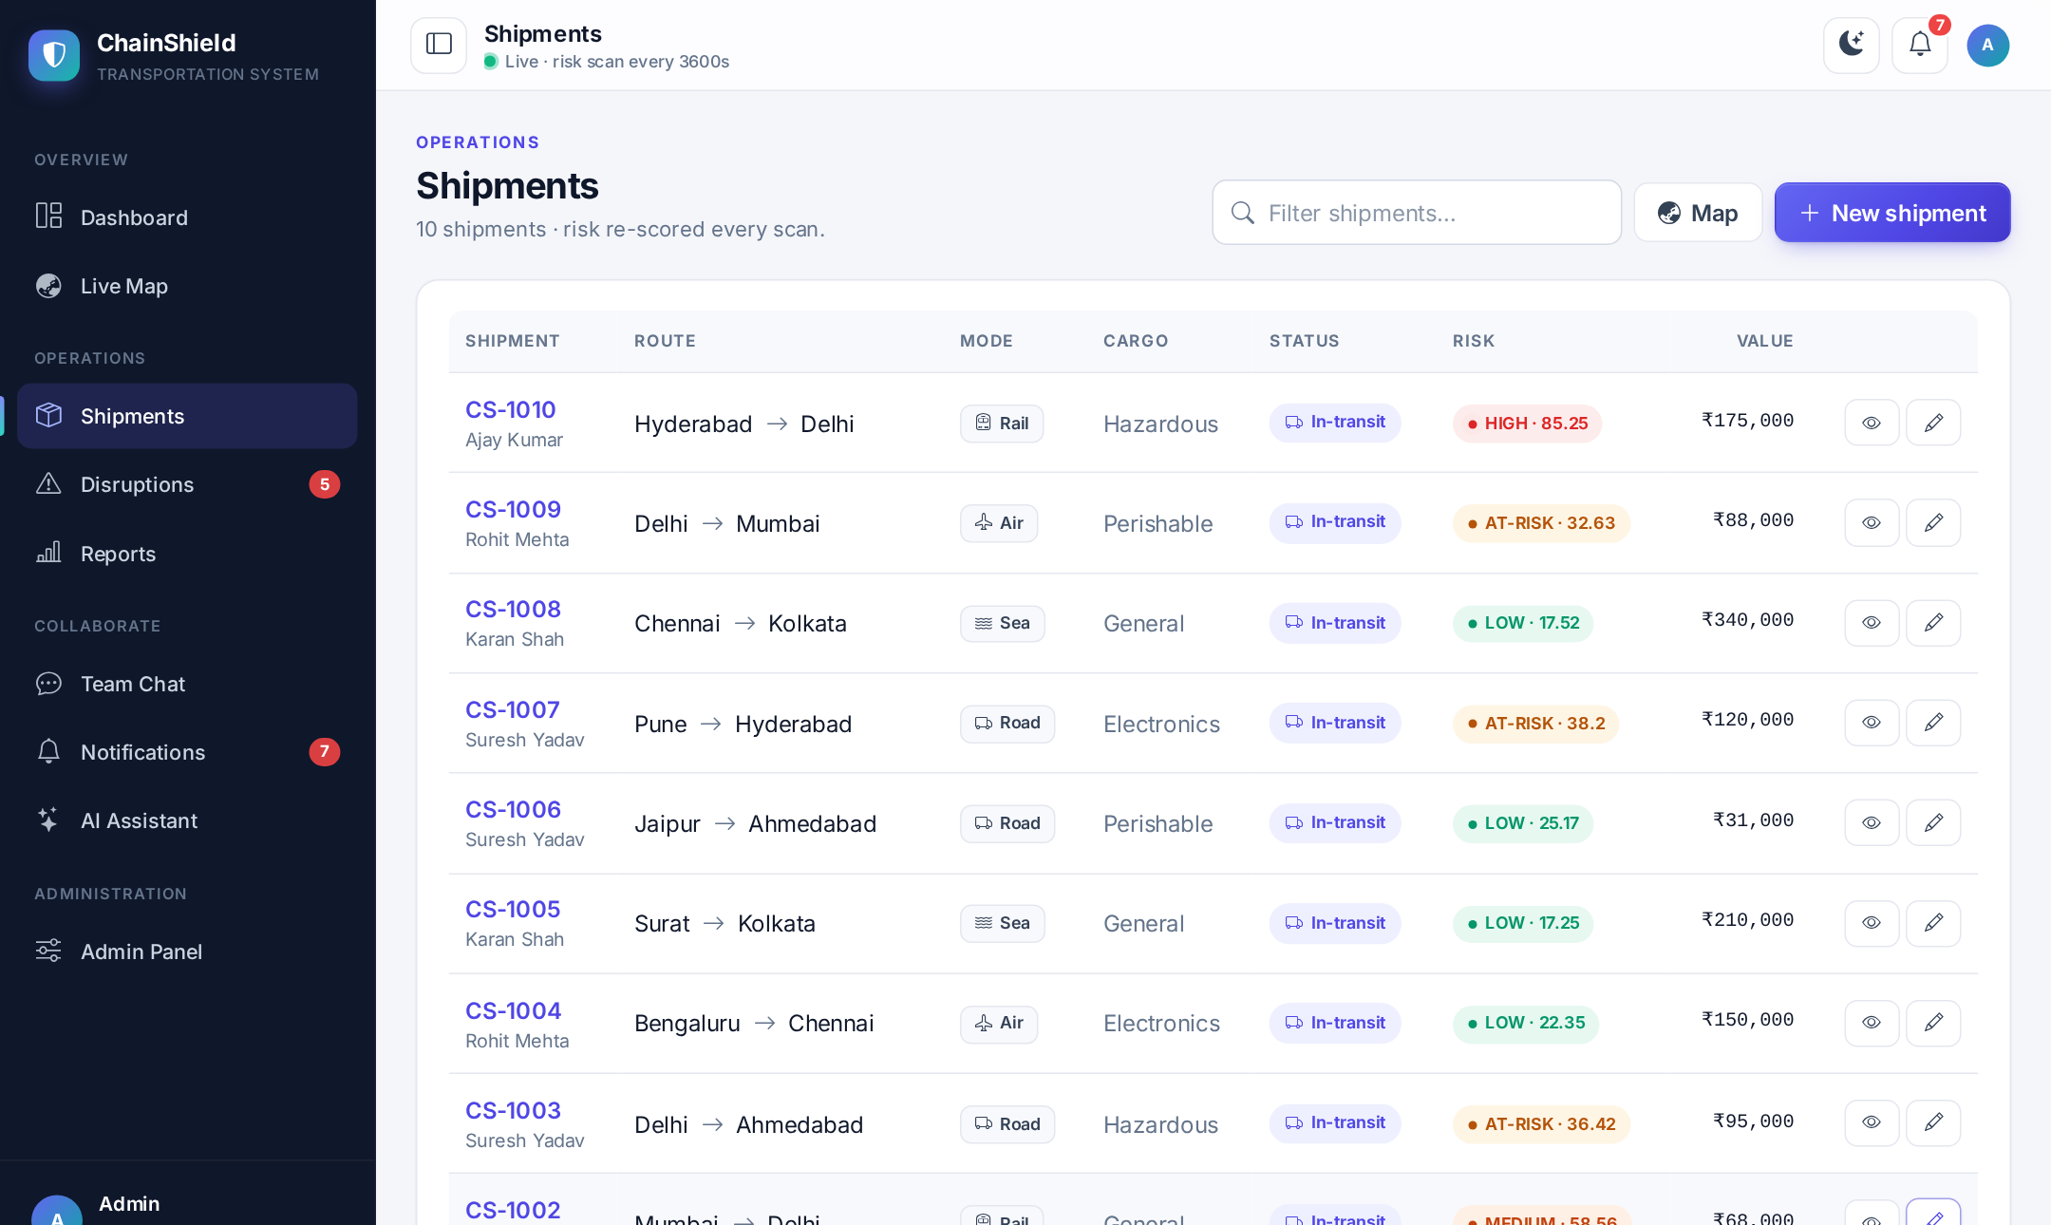
Fig 4.15 — Shipment List
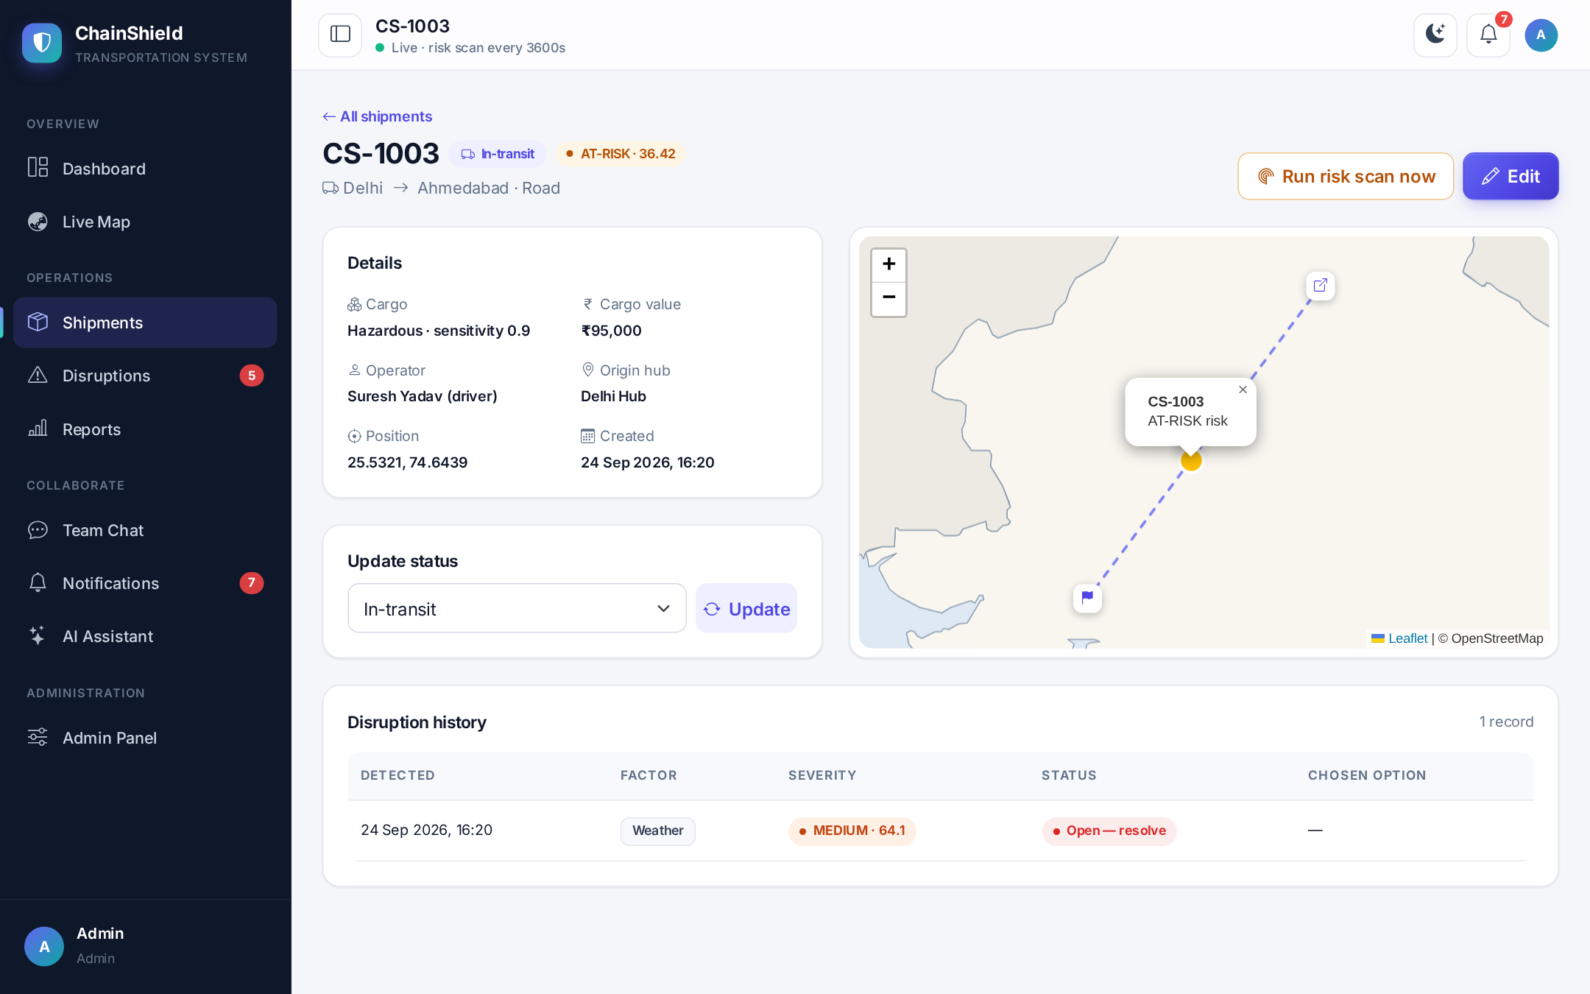
Fig 4.16 — Shipment Detail with Mini-map and History
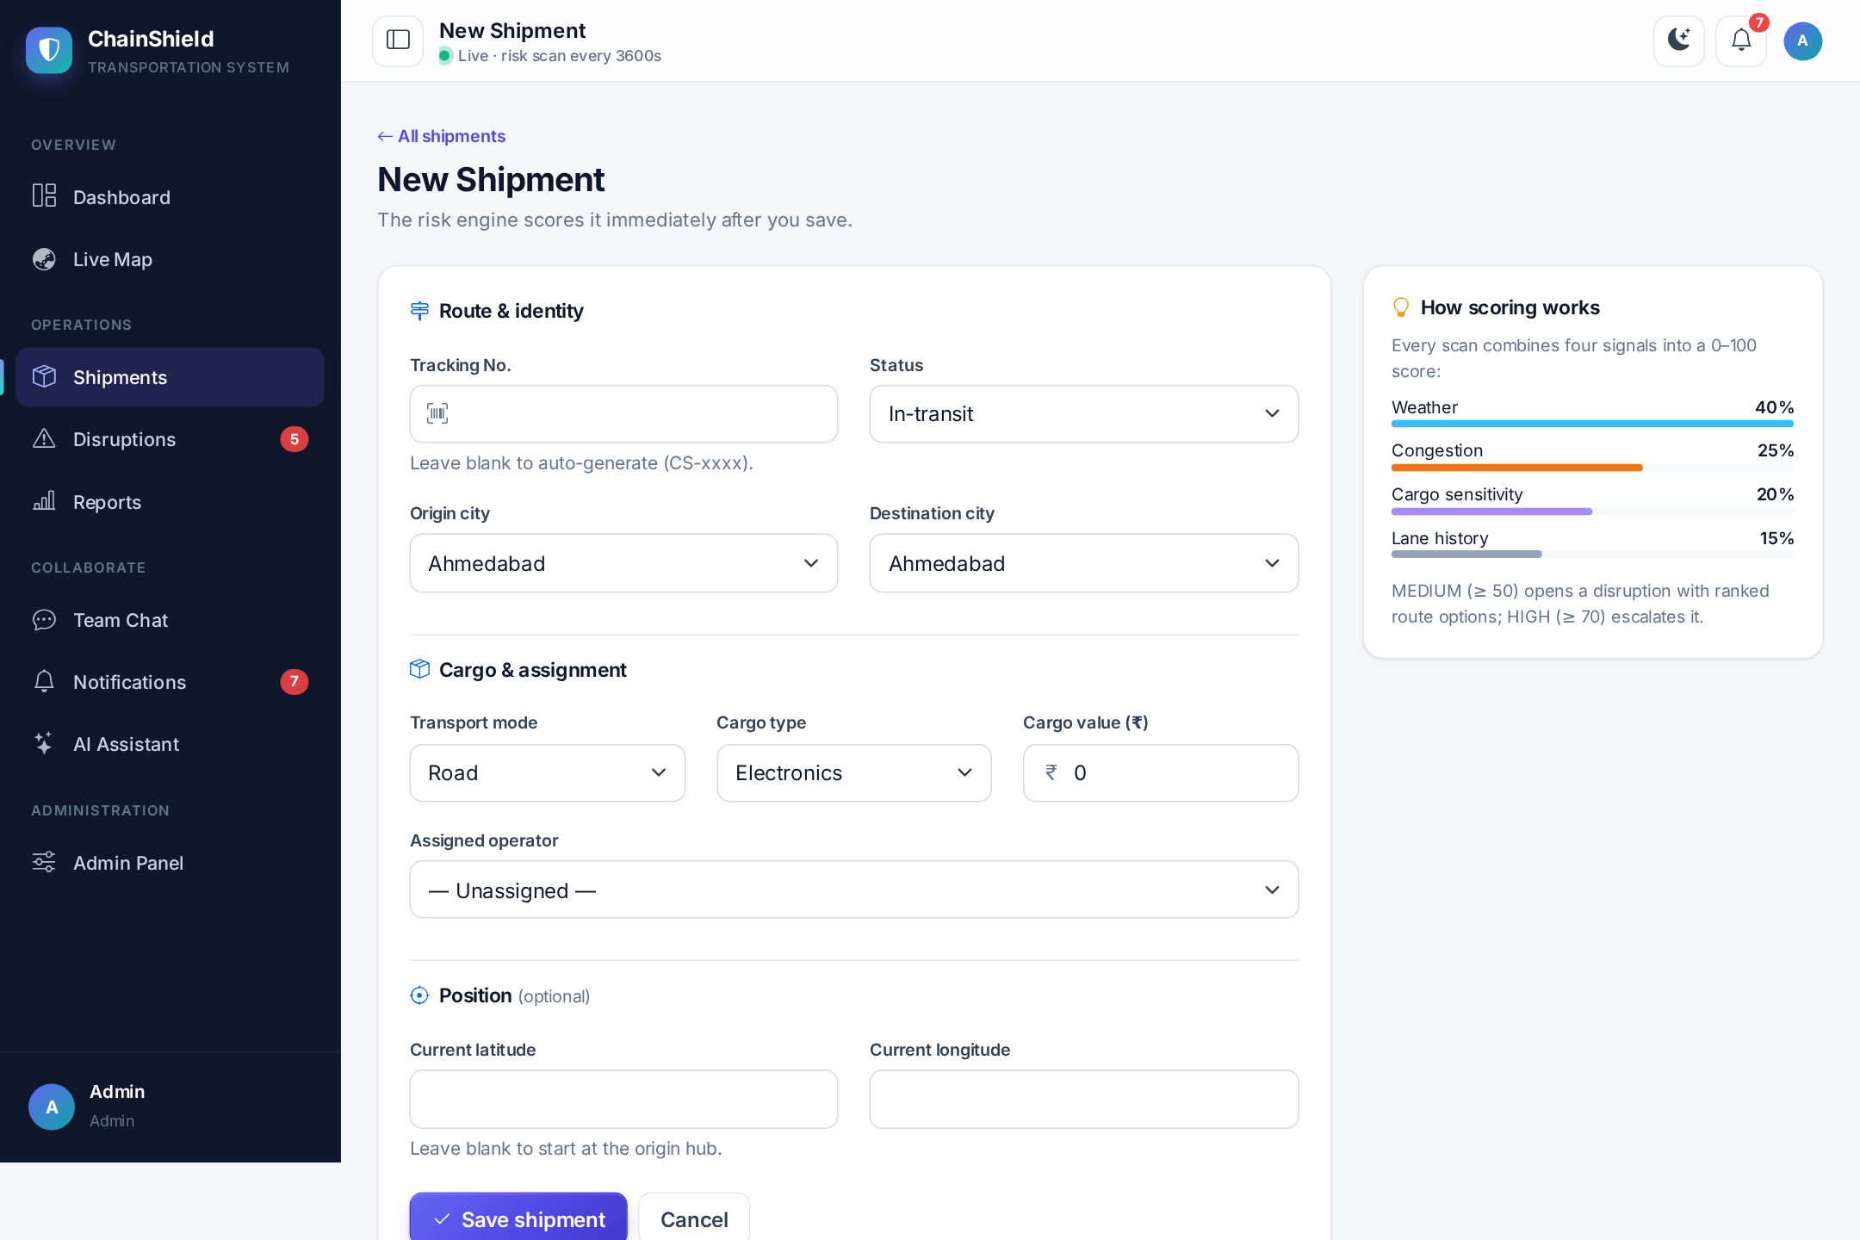
Fig 4.17 — Create Shipment Form
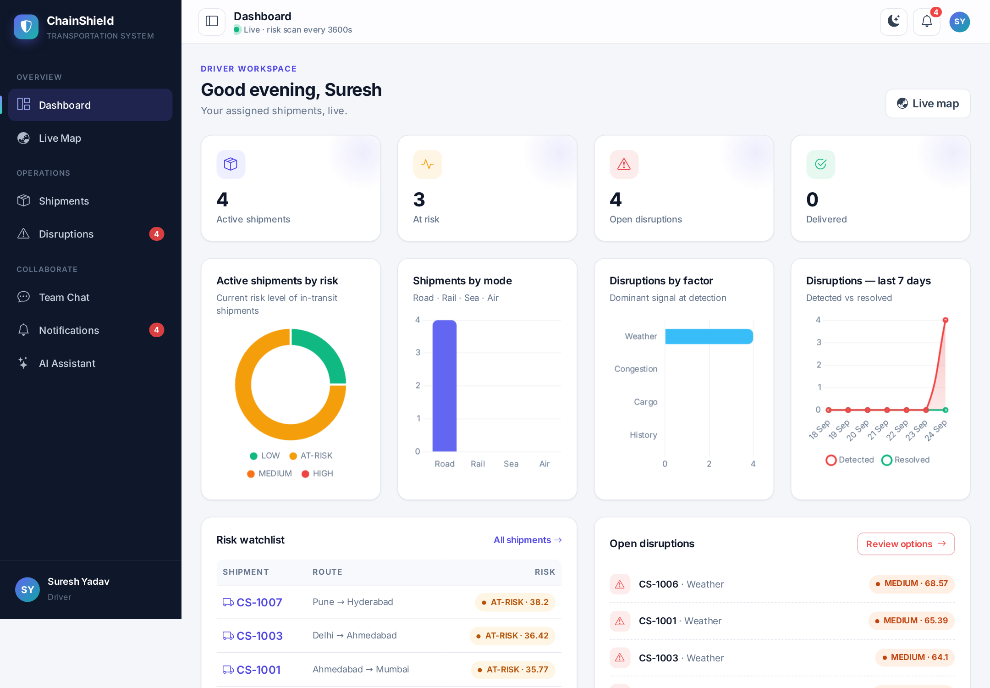
Fig 4.18 — Field Operator (Driver) Dashboard
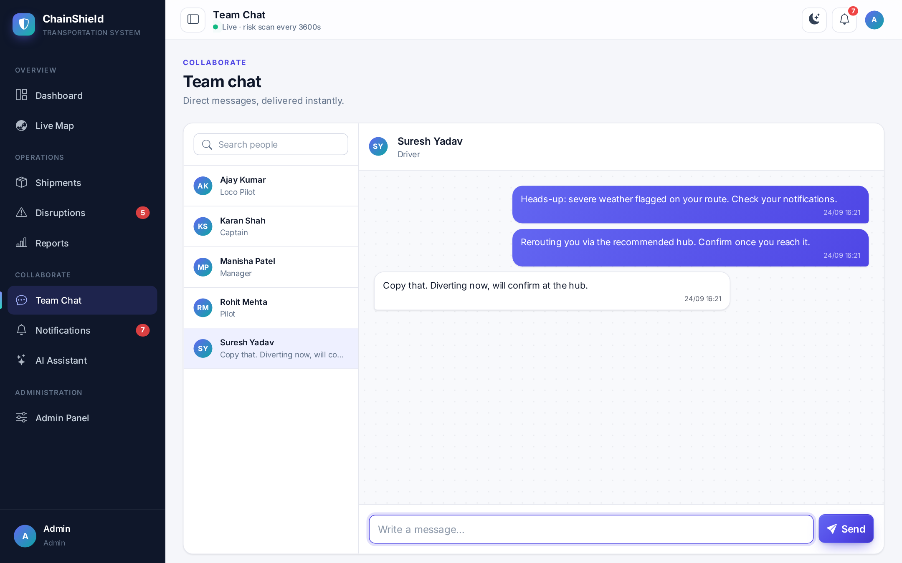
Fig 4.19 — Real-time Team Chat
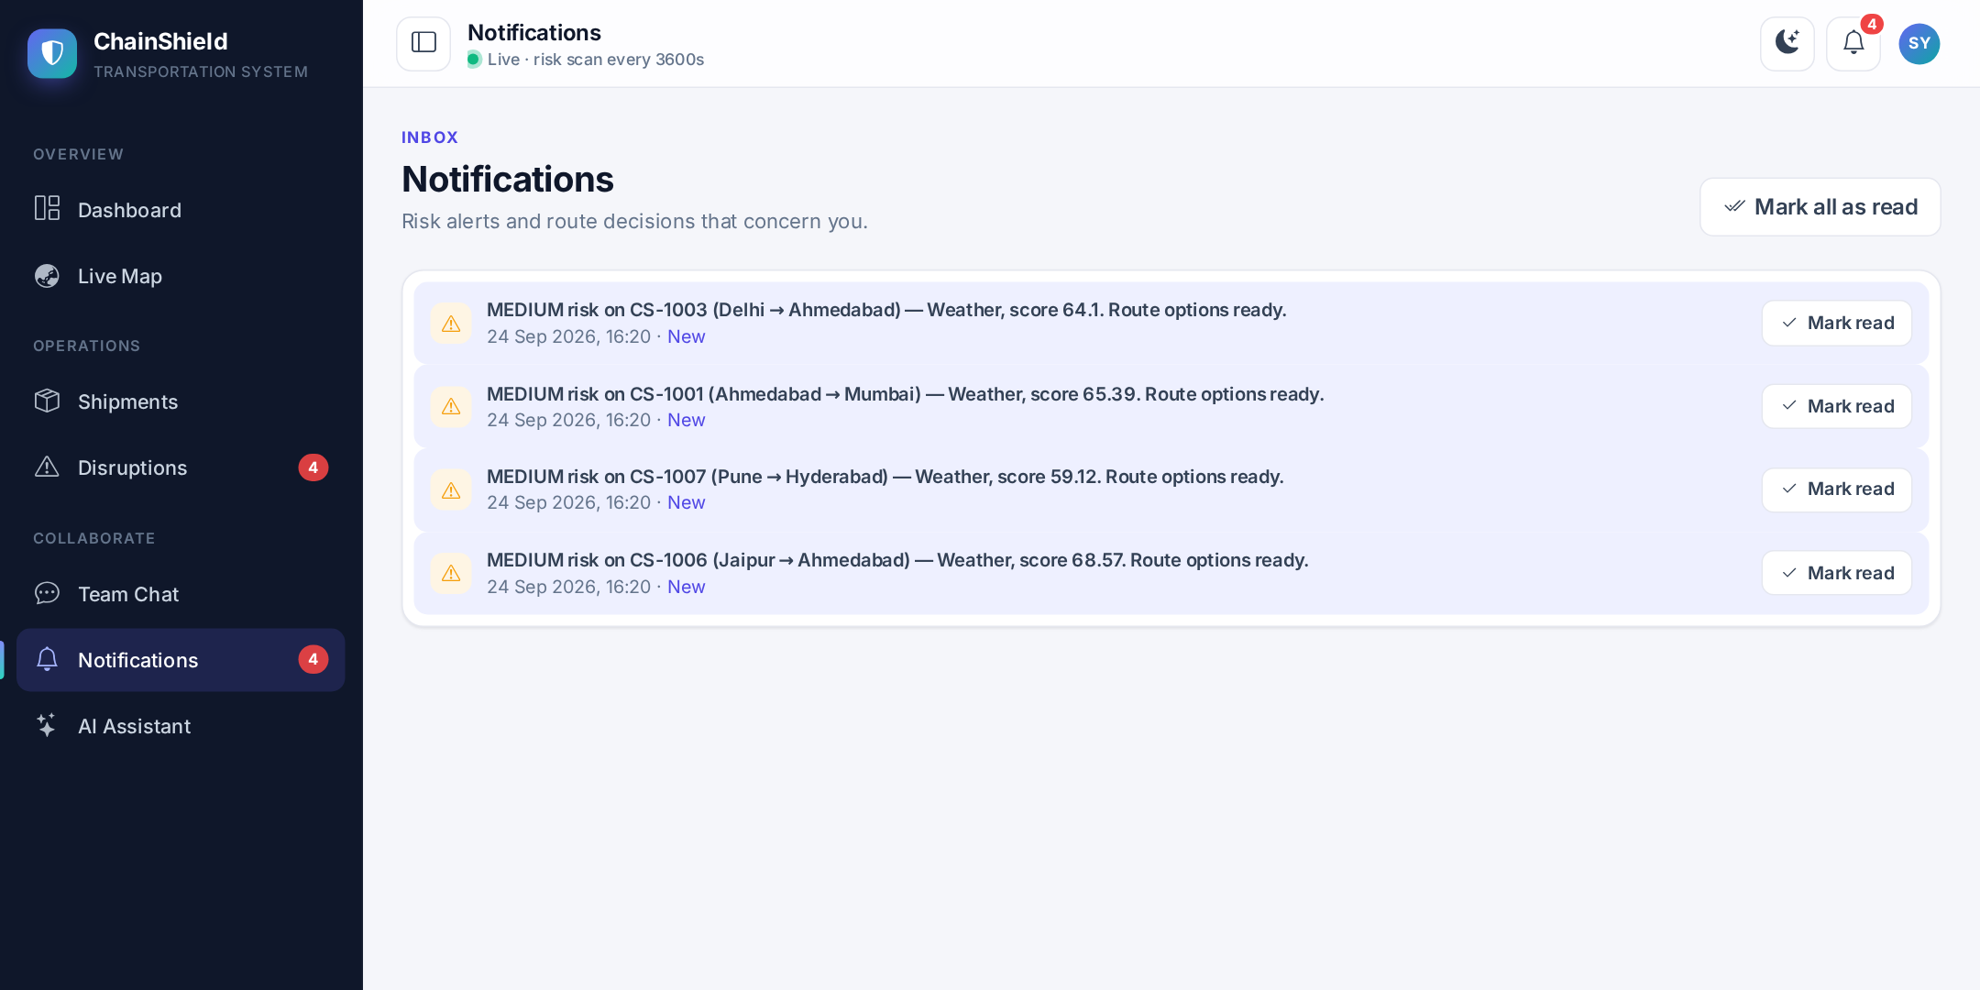
Fig 4.20 — Notification Feed
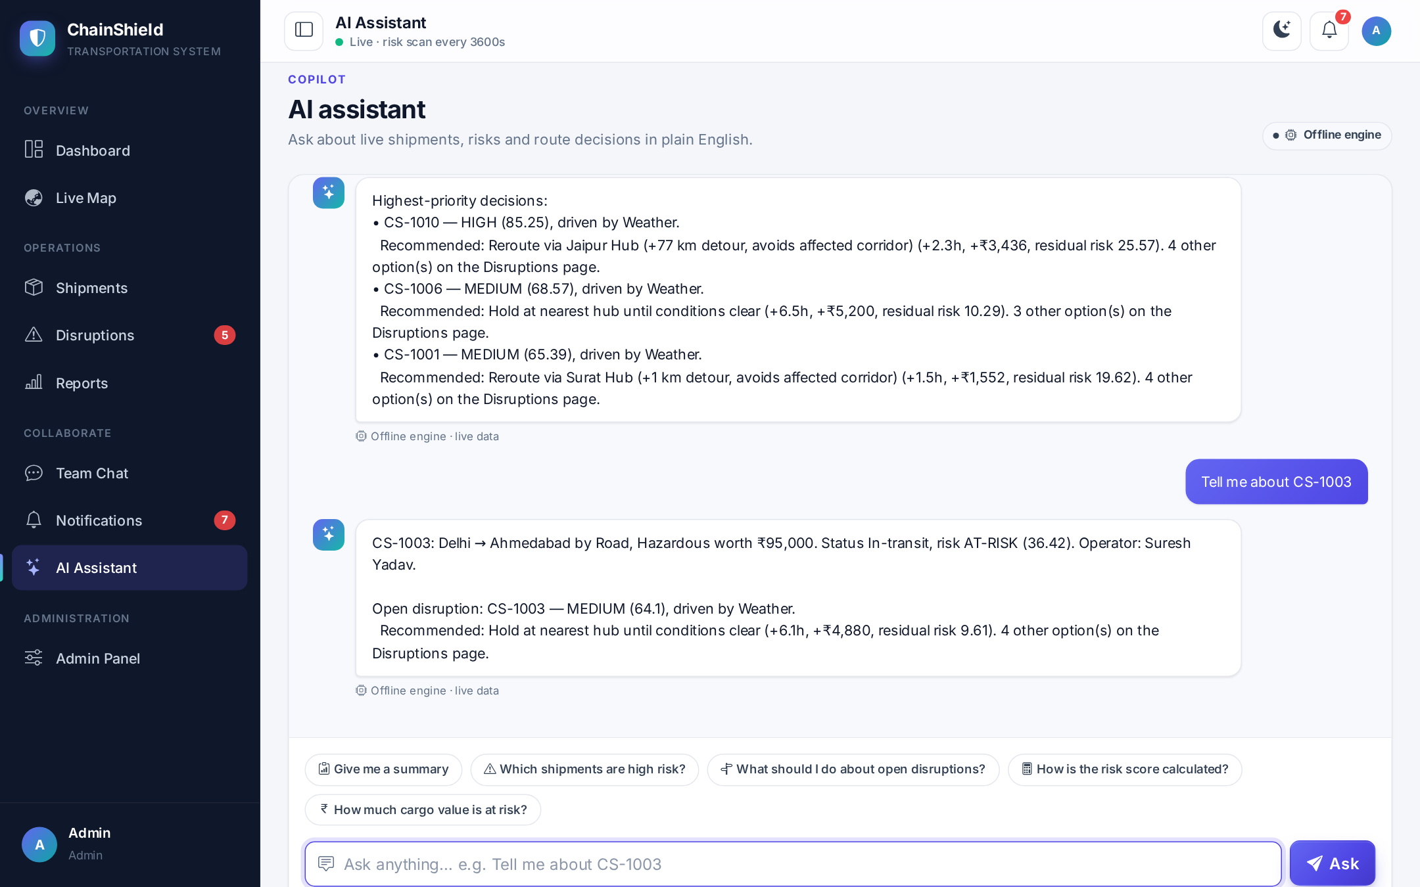
Fig 4.21 — AI Assistant with Suggested Questions
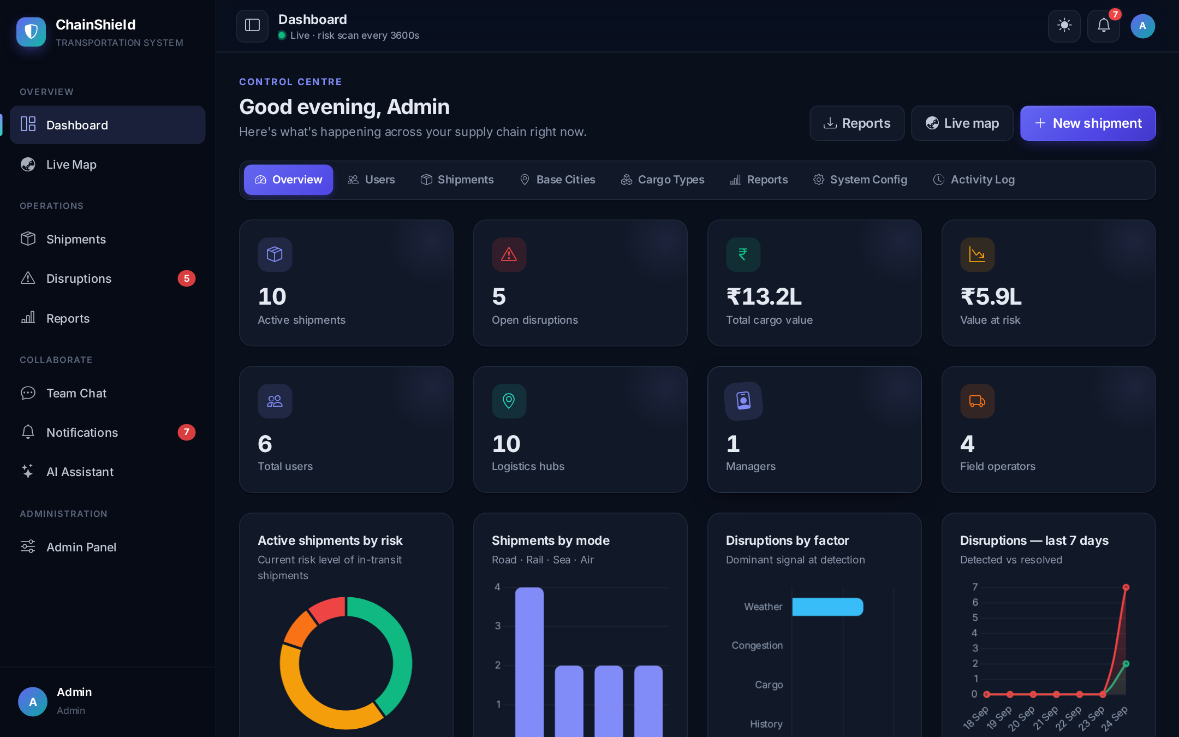
Fig 4.22 — Dark Theme — Dashboard
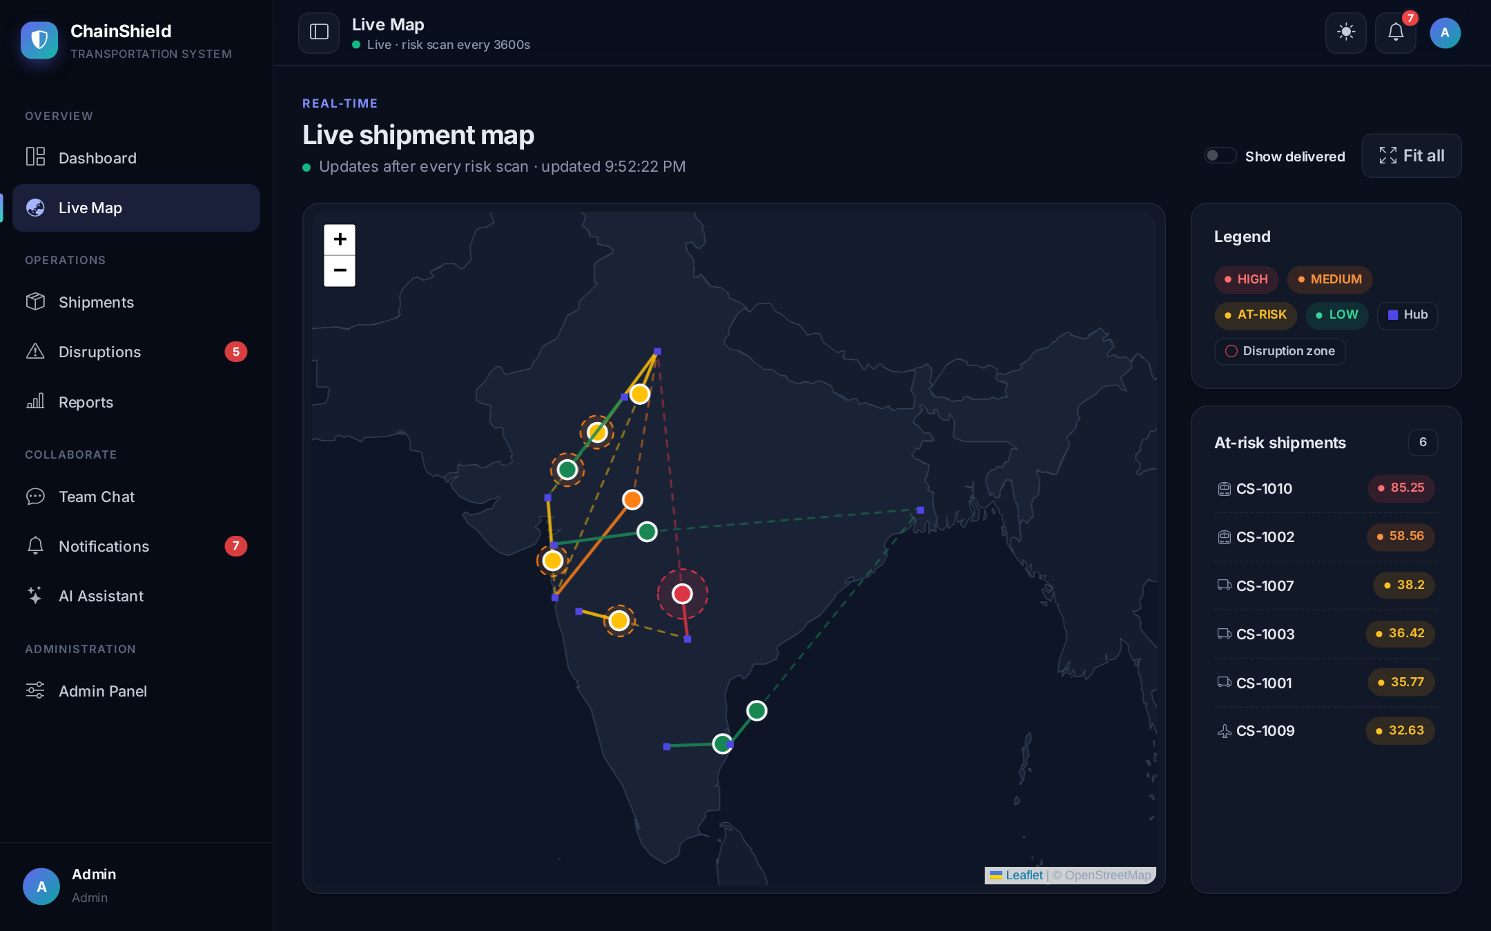
Fig 4.23 — Dark Theme — Live Map
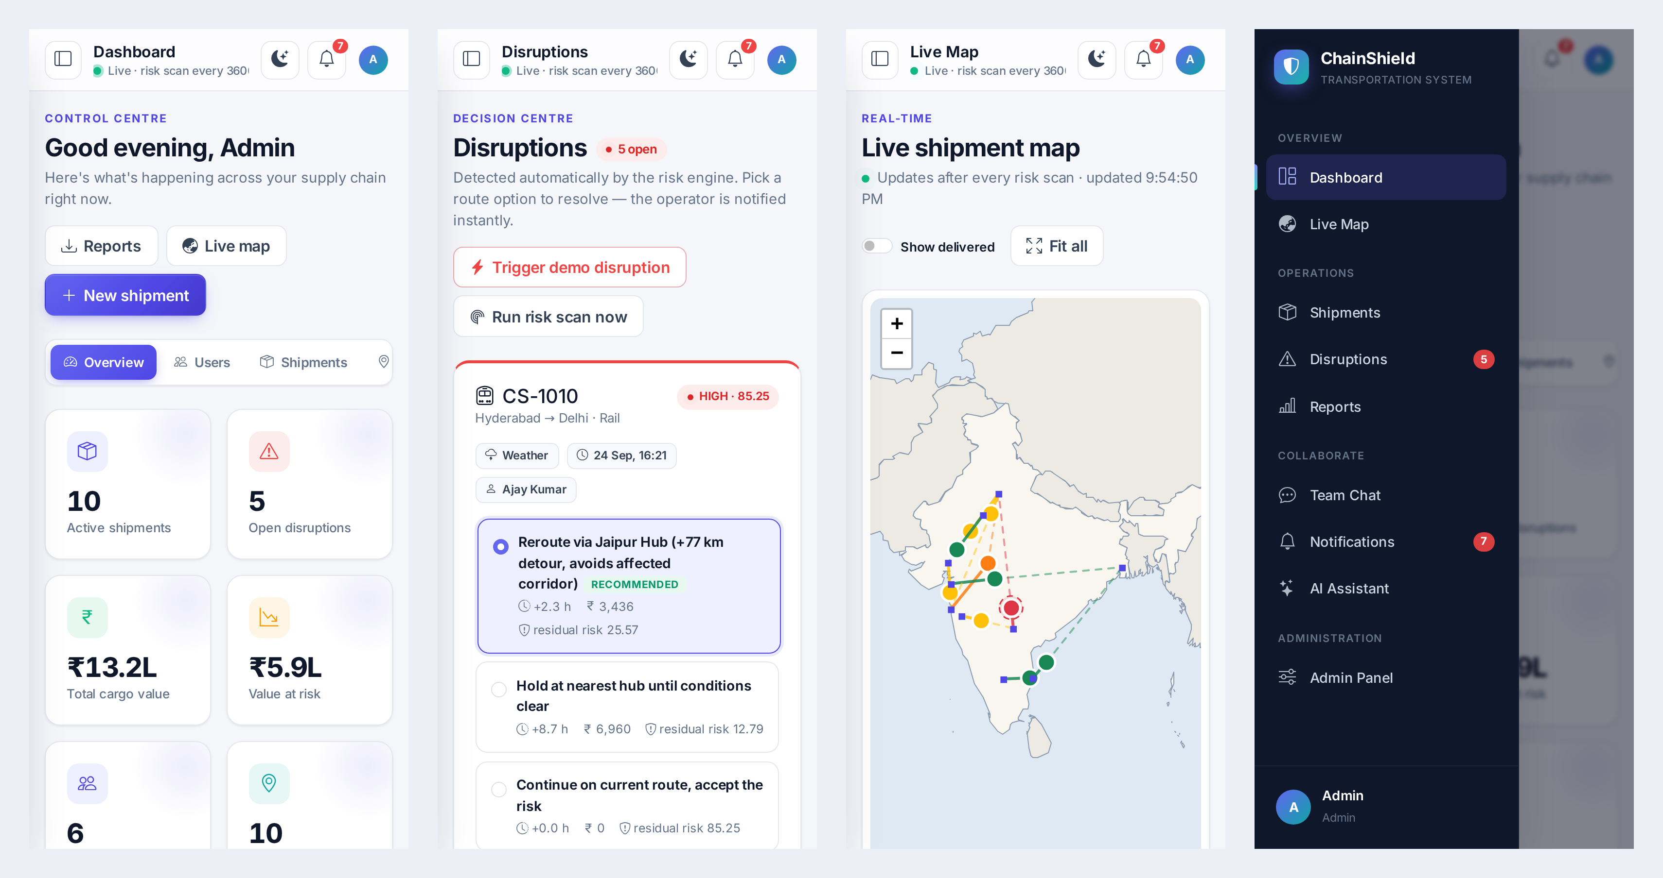
Fig 4.24 — Mobile Views — Dashboard, Disruptions, Live Map and Navigation Drawer

5. TESTING

5.1 Test Cases
Testing combined an automated test script (tests/smoke_test.py, 159 checks run through Flask's test client and the Socket.IO test client, covering every route, role restriction, the risk and route-solver logic, sea routing, real-time events, chat, the assistant, reports and admin CRUD), manual testing of every screen in the browser, and a Docker deployment test. The representative test cases are described below.

Test Case 1 — User Login
Field | Details
Test ID | TC001
Description | Verify that a registered user can log in with correct credentials.
Pre-conditions | User account exists in the database.
Test Data | email = manisha@chainshield.com, password = demo1234
Expected Result | User is authenticated and redirected to the role-specific dashboard.
Actual Result | User is authenticated and redirected to the role-specific dashboard.
Status | Pass

Test Case 2 — Risk Score Calculation
Field | Details
Test ID | TC002
Description | Verify the risk engine computes the composite score from the 4 factors.
Pre-conditions | Weights configured as 0.40 / 0.25 / 0.20 / 0.15.
Test Data | Weather = 80, Congestion = 60, Cargo = 50, History = 40
Expected Result | Score = 0.40×80 + 0.25×60 + 0.20×50 + 0.15×40 = 63 (MEDIUM)
Actual Result | Score = 0.40×80 + 0.25×60 + 0.20×50 + 0.15×40 = 63 (MEDIUM)
Status | Pass

Test Case 3 — Automatic Disruption & Escalation
Field | Details
Test ID | TC003
Description | Verify a disruption is auto-created at MEDIUM and escalated at HIGH.
Pre-conditions | Scheduler running; in-transit shipment with no open disruption.
Test Data | Scan 1: score 55 (MEDIUM); Scan 2: score 74 (HIGH)
Expected Result | One disruption opened at MEDIUM with ≥ 3 ranked solutions, then escalated to HIGH with re-planned options.
Actual Result | One disruption opened at MEDIUM with ≥ 3 ranked solutions, then escalated to HIGH with re-planned options.
Status | Pass

Test Case 4 — Route Solution & Notification
Field | Details
Test ID | TC004
Description | Verify resolving a disruption notifies the assigned field operator.
Pre-conditions | Open disruption with ranked solutions; manager logged in.
Test Data | Manager selects Option 1 “Reroute via Jaipur Hub”
Expected Result | Disruption becomes Resolved; operator receives a live notification; action logged.
Actual Result | Disruption becomes Resolved; operator receives a live notification; action logged.
Status | Pass

Test Case 5 — Admin CRUD (Cargo Type)
Field | Details
Test ID | TC005
Description | Verify admin can add, edit and delete a cargo type.
Pre-conditions | Admin logged in.
Test Data | name = Pharma, weight 0.9 → 0.85; weight 1.5 (invalid)
Expected Result | Cargo type saved, edited and deleted; weight outside 0.0–1.0 rejected.
Actual Result | Cargo type saved, edited and deleted; weight outside 0.0–1.0 rejected.
Status | Pass

Test Case 6 — Docker Container Startup
Field | Details
Test ID | TC006
Description | Verify the application starts inside Docker.
Pre-conditions | Docker Desktop on Windows 11.
Test Data | docker compose up --build
Expected Result | Image builds; Gunicorn + eventlet starts on port 5000; /health returns ok.
Actual Result | Image builds; Gunicorn + eventlet starts on port 5000; /health returns ok.
Status | Pass

Test Case 7 — Role-Based Access Control
Field | Details
Test ID | TC007
Description | Verify field operators cannot reach admin/manager pages.
Pre-conditions | Driver account with 3 assigned shipments.
Test Data | GET /dashboard/users, /shipments/new, /reports
Expected Result | 403 Forbidden for admin/manager pages; 404 for other operators' shipments.
Actual Result | 403 Forbidden for admin/manager pages; 404 for other operators' shipments.
Status | Pass

Test Case 8 — Real-time Chat Delivery
Field | Details
Test ID | TC008
Description | Verify a chat message is stored and delivered live.
Pre-conditions | Admin and driver logged in (two browsers).
Test Data | Admin sends “Hold CS-1001 at Surat”
Expected Result | Message saved and appears instantly in the driver's open chat.
Actual Result | Message saved and appears instantly in the driver's open chat.
Status | Pass

Test Case 9 — AI Assistant with Fallback
Field | Details
Test ID | TC009
Description | Verify the assistant answers from live data, with or without Gemini.
Pre-conditions | Shipments and open disruptions exist.
Test Data | “Give me a summary” with valid and invalid key
Expected Result | Gemini answer with valid key; offline engine answers with invalid key.
Actual Result | Gemini answer with valid key; offline engine answers with invalid key.
Status | Pass

Test Case 10 — Reports and CSV Export
Field | Details
Test ID | TC010
Description | Verify reports render and export for managers with date filter.
Pre-conditions | Manager logged in; data exists.
Test Data | /reports?from=2026-09-01&to=2026-09-30; disruptions.csv
Expected Result | Four reports shown; CSV opens in Excel; filter limits rows.
Actual Result | Four reports shown; CSV opens in Excel; filter limits rows.
Status | Pass

Test Case 11 — User Deactivation
Field | Details
Test ID | TC011
Description | Verify a deactivated user cannot log in.
Pre-conditions | Admin logged in; target user has a session.
Test Data | Admin clicks Deactivate
Expected Result | Login refused with message; open session logged out.
Actual Result | Login refused with message; open session logged out.
Status | Pass

Test Case 12 — Demo Disruption Trigger
Field | Details
Test ID | TC012
Description | Verify the demo trigger creates a HIGH disruption instantly.
Pre-conditions | Manager logged in; in-transit shipment exists.
Test Data | Click “Trigger demo disruption”
Expected Result | HIGH disruption with ranked options, map zone and live alert appear.
Actual Result | HIGH disruption with ranked options, map zone and live alert appear.
Status | Pass

Test Case 13 — Responsive Layout and Themes
Field | Details
Test ID | TC013
Description | Verify the UI works on phones and theme preference is kept.
Pre-conditions | Browser at 390 × 844 and 1440 × 900.
Test Data | Open 8 main pages; toggle dark mode
Expected Result | No sideways scrolling on phone; drawer works; theme remembered.
Actual Result | No sideways scrolling on phone; drawer works; theme remembered.
Status | Pass

6. PROPOSED ENHANCEMENT
The current version fulfils the objectives of the MCA Semester 3 project. The following enhancements have been identified as valuable future work:
• Real GPS / telematics integration — replace simulated shipment positions with live feeds from vehicle trackers.
• PostgreSQL database — migrate from SQLite for multi-server, production-scale deployment.
• Machine-learning risk model — train a predictive model on historical disruption data to support or replace the current weighted formula.
• Mobile app / PWA for field operators — an installable app with push notifications for status updates on the move.
• Multi-tenant support — let several independent logistics companies use isolated instances of the platform.
• More notification channels — SMS and WhatsApp alerts alongside in-app notifications.
• Customs and port-authority APIs — verified real-time congestion data.
• Road-network routing — use a routing service such as OSRM to measure real road and rail distances and draw the chosen reroute on the live map.
• Smarter AI assistant — better prompts, conversation memory and suggested actions.
• PDF reports and scheduled e-mails — PDF export and a daily risk-summary e-mail.

7. CONCLUSION
ChainShield Transportation System addresses a well-defined, real-world problem: supply-chain disruptions are usually discovered only after delivery timelines are already compromised. By continuously scoring every active shipment with a transparent, weighted risk model, and by pairing every detected disruption with concrete, ranked route alternatives, the system moves logistics management from a reactive posture to a preemptive one.
The system was built from scratch as a self-contained Python (Flask) and SQLite application, containerised with Docker so that it runs identically on any server. This makes it practical for a logistics company to deploy it on its own infrastructure, connect its own weather and AI keys, and start monitoring its shipments immediately.
Group 59 translated the requirement analysis and system design in this report into a working, tested application: a scheduled risk engine, automatic disruption detection with escalation, a multi-objective route solver, a live map, role-based dashboards, real-time notifications and chat, a Gemini-powered assistant, reports with CSV export, a full admin panel and a responsive interface with light and dark themes — verified by 159 automated checks, visual checks on desktop and phone, and a Docker deployment test.

8. BIBLIOGRAPHY

Books Referred
1. Miguel Grinberg, Flask Web Development, 2nd Edition, O'Reilly Media.
2. Eric Matthes, Python Crash Course, 3rd Edition, No Starch Press.
3. Ramez Elmasri & Shamkant B. Navathe, Fundamentals of Database Systems, Pearson.
4. Ian Sommerville, Software Engineering, 10th Edition, Pearson.

Websites Referred
1. https://flask.palletsprojects.com/
2. https://docs.python.org/3/
3. https://www.sqlite.org/docs.html
4. https://docs.docker.com/
5. https://getbootstrap.com/docs/5.3/
6. https://leafletjs.com/reference.html
7. https://flask-socketio.readthedocs.io/
8. https://apscheduler.readthedocs.io/
9. https://www.chartjs.org/docs/
10. https://ai.google.dev/gemini-api/docs
11. https://openweathermap.org/api
12. https://developer.mozilla.org/
13. https://pypi.org/project/searoute/
14. https://www.geeksforgeeks.org/

