WEEK 3 PROJECT REPORT
Advanced Data Analysis and Visualization in Logistics
Project: Data-Driven Inventory and Delivery Optimization for an E-Commerce Logistics Company
Tools: Python, Pandas, NumPy, Matplotlib

1. Introduction
This report presents an exploratory data analysis (EDA) and visualization exercise for an e-commerce logistics company. It continues the data-preparation work from Week 2 and uses a hypothetical but realistic logistics dataset to examine delivery performance, shipment volumes, transportation costs, distance, and warehouse-level differences. The objective is to convert operational data into useful business insights that can support evidence-based decisions.
The analysis uses Python with Pandas, NumPy, and Matplotlib. Descriptive statistics are used to understand central tendencies and variability, while correlation analysis is used to examine relationships between numerical variables. Visualizations are embedded throughout the report so that trends, distributions, comparisons, and potential bottlenecks can be interpreted clearly.

2. Analytical Objectives
- Understand the distribution and typical values of delivery time, distance, shipment volume, and transportation cost.
- Compare delivery performance across warehouses.
- Identify monthly shipment-volume trends.
- Examine the relationship between delivery distance and transportation cost.
- Identify correlations among major numerical logistics variables.
- Compare transportation costs across product categories.
- Measure the proportion of on-time and late deliveries.
- Translate analytical findings into practical logistics recommendations.

3. Dataset Simulation
A hypothetical dataset containing 240 shipment records was generated for demonstration. The records cover January through June 2026 and represent four warehouses and four product categories. The dataset is designed to resemble the type of operational data that could be obtained from order-management, warehouse, and transportation systems.
Variable | Description | Example
Order_ID | Unique shipment identifier | ORD1001
Order_Date | Date of order | 2026-01-01
Warehouse | Fulfillment warehouse | WH-A
Product_Category | Product grouping | Electronics
Quantity | Units ordered | 4
Distance_KM | Delivery distance | 72.4
Shipment_Volume | Shipment workload measure | 51
Delivery_Time_Days | Delivery duration | 3.4
Transportation_Cost | Transportation cost | ₹735
Delivery_Status | On-time/late indicator | On Time

4. Python Setup and Data Loading
import pandas as pd
import numpy as np
import matplotlib.pyplot as plt
df = pd.read_csv("clean_logistics_data.csv")
df["Order_Date"] = pd.to_datetime(df["Order_Date"])
print(df.head())
print(df.info())
print(df.describe())

5. Exploratory Data Analysis

5.1 Central Tendency and Descriptive Statistics
Mean, median, minimum, maximum, and standard deviation provide a first understanding of the data. The mean indicates the average operational value, the median shows the middle observation, and standard deviation indicates how much the values vary around the mean.
Variable | Mean | Median | Std. Dev. | Minimum | Maximum
Quantity | 3.98 | 4.00 | 1.68 | 1.00 | 9.00
Distance_KM | 81.79 | 68.30 | 52.66 | 11.40 | 286.80
Shipment_Volume | 50.51 | 51.00 | 7.37 | 31.00 | 71.00
Delivery_Time_Days | 3.07 | 3.00 | 1.10 | 1.00 | 6.65
Transportation_Cost | 828.98 | 739.41 | 327.81 | 310.09 | 2007.70

numeric_cols = [
"Quantity", "Distance_KM", "Shipment_Volume",
"Delivery_Time_Days", "Transportation_Cost"
]
summary = df[numeric_cols].describe()
print(summary)
print("Mean delivery time:", df["Delivery_Time_Days"].mean())
print("Median delivery time:", df["Delivery_Time_Days"].median())

5.2 Delivery-Time Distribution
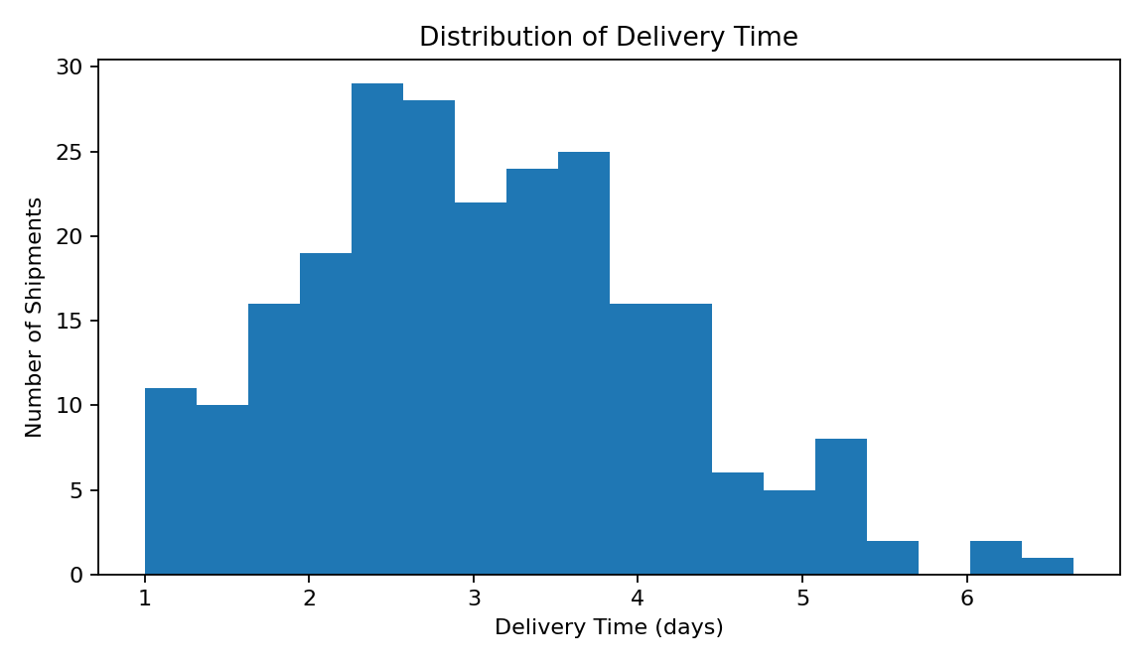
Interpretation: The histogram shows how delivery times are distributed across shipments. Most observations are concentrated within a relatively small range, while a smaller number of longer deliveries create the upper tail. This distribution helps management understand typical service performance and investigate unusually slow shipments.
plt.hist(df["Delivery_Time_Days"], bins=18)
plt.title("Distribution of Delivery Time")
plt.xlabel("Delivery Time (days)")
plt.ylabel("Number of Shipments")
plt.show()

5.3 Average Delivery Time by Warehouse
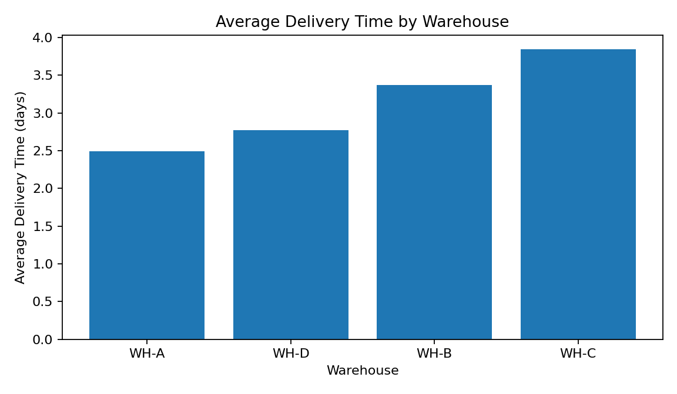
Interpretation: Warehouse WH-A has the lowest simulated average delivery time at 2.50 days, while WH-C has the highest at 3.84 days. This difference suggests that warehouse location, processing capacity, routing, or carrier allocation may influence delivery performance. Management should investigate the operational processes at the slower warehouse rather than assuming that the difference is caused by one factor alone.
avg_delivery = df.groupby("Warehouse")["Delivery_Time_Days"].mean()
avg_delivery.plot(kind="bar")
plt.title("Average Delivery Time by Warehouse")
plt.xlabel("Warehouse")
plt.ylabel("Average Delivery Time (days)")
plt.show()

5.4 Monthly Shipment Volume
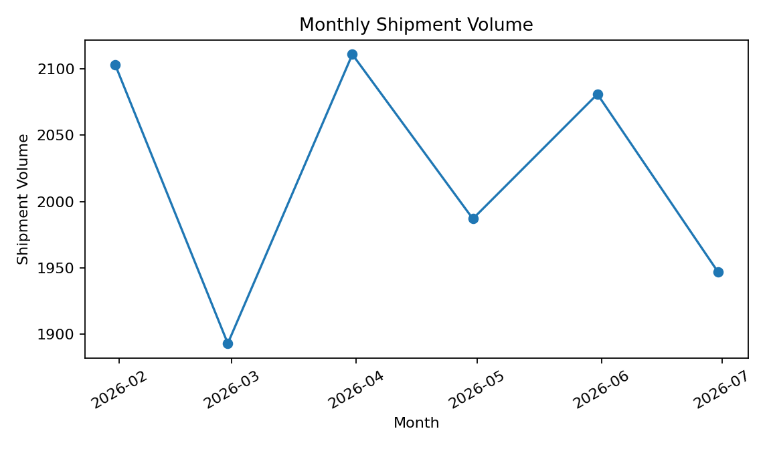
Interpretation: The monthly line chart shows changes in shipment workload over time. Rising volume can place pressure on warehouse picking, packing, transportation capacity, and delivery networks. Logistics managers can use this information to plan staffing, vehicle capacity, and inventory replenishment before high-volume periods.
monthly_volume = (
df.set_index("Order_Date")
.resample("M")["Shipment_Volume"]
.sum()
)
monthly_volume.plot(marker="o")
plt.title("Monthly Shipment Volume")
plt.ylabel("Shipment Volume")
plt.show()

5.5 Delivery-Time Variation by Warehouse
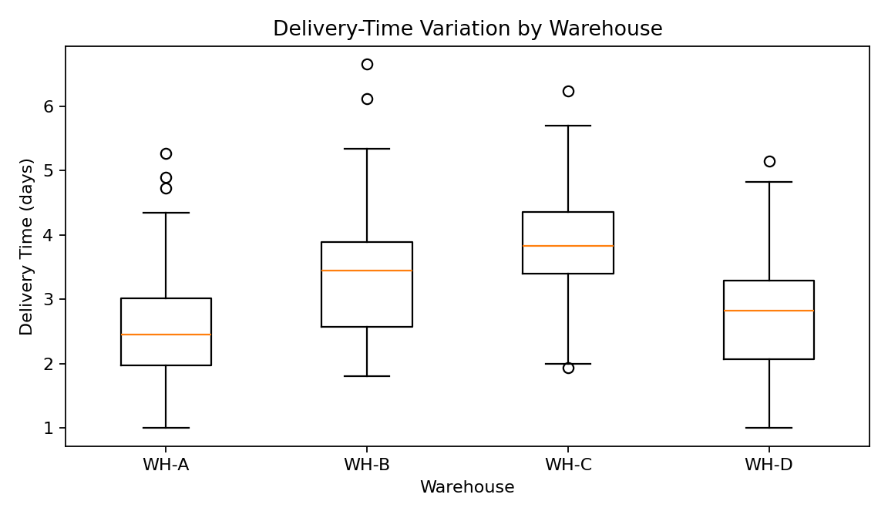
Interpretation: The box plot compares the median, spread, and unusual delivery times across warehouses. A warehouse with a wider box or longer whiskers has more variable delivery performance. Consistency is important because customers generally prefer predictable delivery times, not only a low average.
import seaborn as sns
sns.boxplot(data=df, x="Warehouse", y="Delivery_Time_Days")
plt.title("Delivery-Time Variation by Warehouse")
plt.show()

5.6 Distance and Transportation Cost
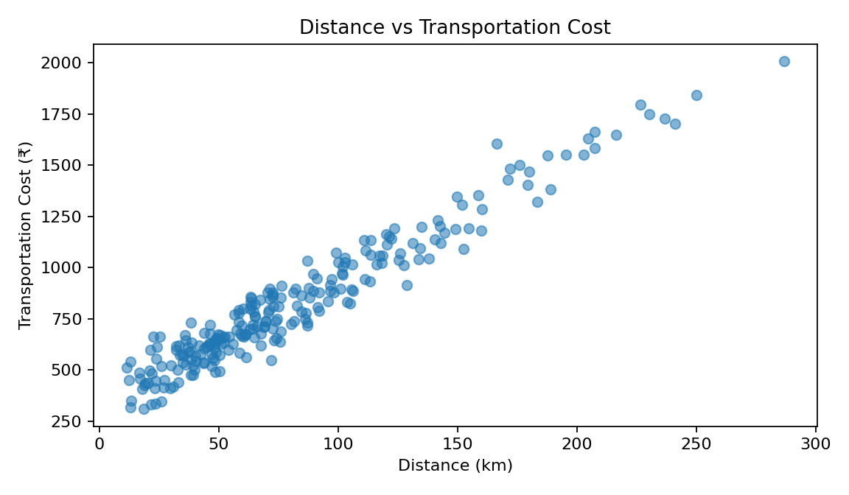
Interpretation: The scatter plot shows a positive relationship between delivery distance and transportation cost in the simulated data. The Pearson correlation is approximately 0.97, indicating that longer delivery routes are generally associated with higher transportation costs. However, the spread of points also indicates that distance is not the only cost driver; shipment volume and operational factors can contribute as well.
plt.scatter(df["Distance_KM"], df["Transportation_Cost"], alpha=0.6)
plt.xlabel("Distance (km)")
plt.ylabel("Transportation Cost (₹)")
plt.title("Distance vs Transportation Cost")
plt.show()

5.7 Correlation Analysis
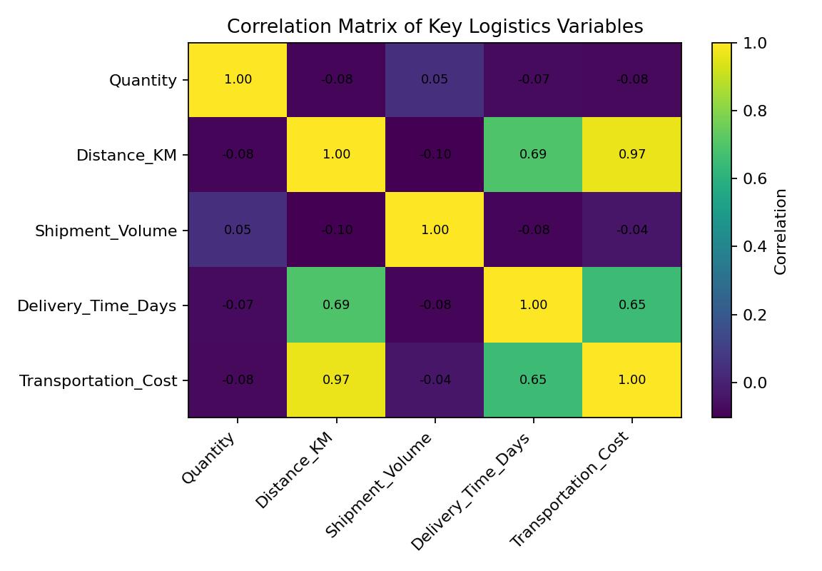
Interpretation: The correlation matrix summarizes linear relationships among the main numerical variables. Strong positive correlation between distance and transportation cost would support the need to control route length and carrier pricing. Correlation should not be interpreted as proof of causation; operational context and additional variables must be considered.
corr = df[
["Quantity", "Distance_KM", "Shipment_Volume",
"Delivery_Time_Days", "Transportation_Cost"]
].corr()
print(corr)

5.8 Transportation Cost by Product Category
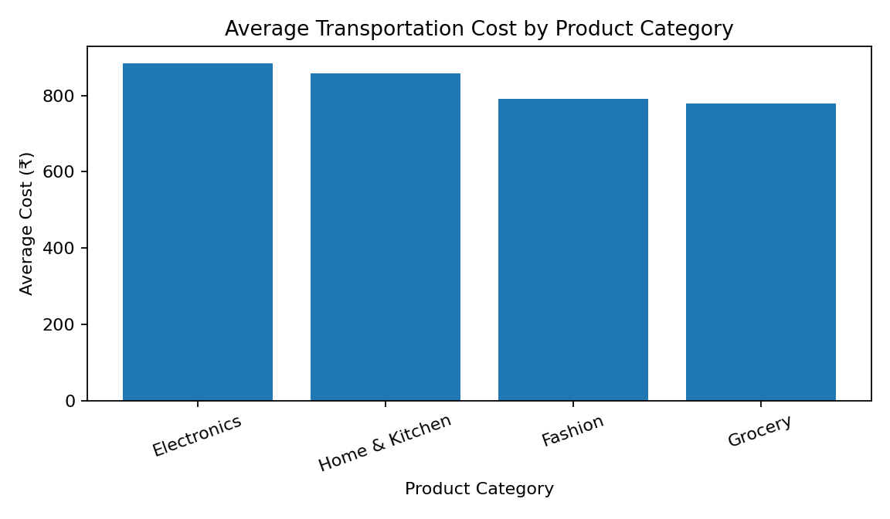
Interpretation: Comparing average transportation cost by product category helps identify categories that may require more expensive transportation because of shipment size, handling requirements, weight, or delivery patterns. These findings can support category-level pricing, packaging, consolidation, and carrier decisions.
category_cost = df.groupby("Product_Category")["Transportation_Cost"].mean()
category_cost.plot(kind="bar")
plt.title("Average Transportation Cost by Product Category")
plt.ylabel("Average Cost (₹)")
plt.show()

5.9 Delivery Status
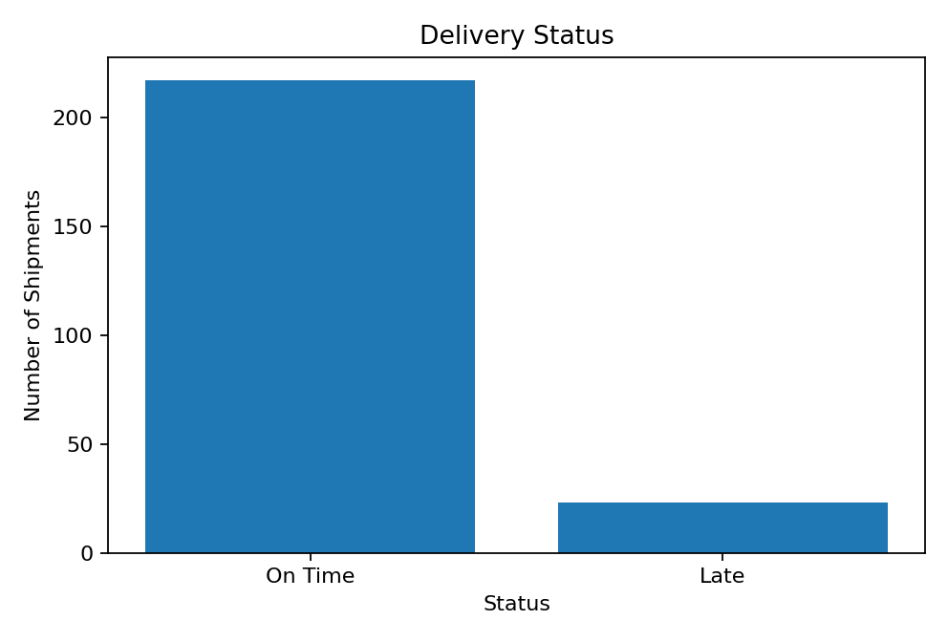
Interpretation: The simulated dataset contains approximately 90.4% on-time deliveries and 9.6% late deliveries. The on-time rate is an important service KPI because repeated delays can reduce customer satisfaction and increase support and operational costs.
status_counts = df["Delivery_Status"].value_counts()
status_counts.plot(kind="bar")
plt.title("Delivery Status")
plt.ylabel("Number of Shipments")
plt.show()

6. Key Analytical Insights
- Warehouse performance is not uniform. The simulated average delivery time ranges from 2.50 to 3.84 days, indicating an opportunity to investigate process and routing differences.
- Distance is an important transportation-cost driver, with a simulated correlation of 0.97 between distance and cost.
- Shipment volume and transportation cost also show a correlation of approximately -0.04; workload and shipment characteristics should therefore be considered during cost planning.
- Monthly shipment-volume trends can be used to anticipate capacity requirements for warehouse staff, vehicles, and delivery partners.
- Delivery-time variation is important in addition to average delivery time. A stable process can provide customers with more predictable service.
- Product-category cost comparisons can highlight categories that may require different packaging, consolidation, or carrier strategies.
- The simulated on-time delivery rate is approximately 90.4%, making late shipments an important area for operational monitoring.

7. Potential Bottlenecks
Potential Bottleneck | Evidence/Indicator | Recommended Investigation
Slow warehouse | WH-C has the highest average delivery time | Review picking, packing, dispatch and carrier handoff times
Long-distance routes | Positive distance-cost relationship | Review route design, consolidation and carrier rates
High-volume periods | Monthly shipment fluctuations | Plan capacity and staffing in advance
Late deliveries | 9.6% simulated late shipments | Analyze delay reasons by warehouse, carrier and route
High-cost categories | Category-level cost differences | Review packaging, weight, handling and delivery patterns

8. Recommendations
- Investigate the operational causes of slower warehouse performance and compare processing times across facilities.
- Use route and shipment data to identify opportunities for consolidation and more efficient transportation planning.
- Forecast shipment volume to support workforce and vehicle-capacity planning during high-demand periods.
- Track on-time delivery rate and average delivery time at warehouse and carrier level rather than only at overall company level.
- Use product-category cost analysis to review packaging and shipping strategies for high-cost categories.
- Continue the project with predictive models that estimate delivery delays and identify high-risk shipments.

9. Methodology and Visualization Justification
Visualization | Purpose | Why Appropriate for Logistics
Histogram | Shows distribution | Identifies typical delivery times and long-delay tails
Bar chart | Compares groups | Useful for warehouse and category comparisons
Line chart | Shows time trends | Useful for shipment-volume planning
Box plot | Shows spread and outliers | Compares consistency across warehouses
Scatter plot | Shows relationships | Helps examine cost drivers such as distance
Correlation heatmap | Summarizes numerical relationships | Highlights variables worth investigating

10. Conclusion
This Week 3 analysis demonstrates how exploratory data analysis and visualization can transform logistics records into actionable information. Descriptive statistics establish the central tendencies and variability of operational variables, while visualizations make differences, trends, and relationships easier to communicate. The simulated results indicate that warehouse performance, delivery distance, shipment volume, and product category can influence logistics efficiency and cost. These insights can help managers prioritize investigations and allocate resources more effectively. The next stage of the project can build on this analysis by applying predictive modeling, clustering, and optimization techniques to support proactive logistics decisions.

11. References and Resources
Pandas Documentation: https://pandas.pydata.org/docs/
NumPy Documentation: https://numpy.org/doc/
Matplotlib Documentation: https://matplotlib.org/stable/
Seaborn Documentation: https://seaborn.pydata.org/
Scikit-learn Documentation: https://scikit-learn.org/stable/
World Bank Logistics Performance Index: https://lpi.worldbank.org/

