INTRODUCTION

India, a diverse and culturally rich country in South Asia, is known for its vast landscapes, ancient heritage, and bustling cities. With a population of over 1.3 billion people, India is one of the world's largest democracies and holds significant geopolitical influence on the global stage. Its diverse cultural tapestry, historical landmarks, and rapid economic growth make it a dynamic and vibrant nation.
Analysing crime data is essential for understanding law enforcement needs, identifying emerging trends, and informing policy decisions aimed at promoting public safety and social justice. Crime data provides valuable insights into the prevalence and nature of criminal activities, enabling law enforcement agencies and policymakers to allocate resources effectively and implement targeted interventions to address specific challenges.

In the context of India, where socioeconomic disparities, cultural diversity, and rapid urbanization pose unique challenges for law enforcement and social development, analysing crime data takes on added significance. By examining patterns and trends in crime rates across different regions, demographic groups, and types of offenses, we can gain a deeper understanding of the underlying factors contributing to crime and victimization.
The objectives of this study are
: firstly, to analyse the relationship between socioeconomic factors and crime rates in India, and secondly, to identify key patterns and trends in crime data that can inform evidence-based policy interventions. By exploring the complex relationship between social and economic variables and crime outcomes and second is by applying statistical test we will tested that our assumption is true or not, we aim to contribute to the development of effective strategies for crime prevention, law enforcement, and community engagement in India. Through collaboration with stakeholders and policymakers, we seek to promote safer and more resilient communities where all individuals can live free from fear and insecurity.

2.Literature and Review

- According to “CRIME, CRISES AND ECONOMIC GROWTH” AT EASTERN ILLINOIS UNIVERSITY BY ANKITA THAPA:

This report investigate the impact of socio-economic conditions on five major crime heads from 2001-2019 using a panel data set for the Indian states. The paper focus on the great recession of 2008-09, economic growth of the states, and deterrence variables.
The study found that the great recession positively impacted total crime, violent crime, and crime against women. The economic growth (State’s GDPs) positively affects total crime, economic offenses, and crime against women. The study also found evidence of an inverted U-shaped curve (non-linear relationship) between three crime categories and economic growth. The deterrence variables do not seem to have a deterrence effect on crime in the Indian states. However, their coefficients are highly significant but positive. Poverty and unemployment only seem to impact total crime out of all major crime categories.

- Crime in India: Interstate analysis by Neha Gupta. In this paper Neha Gupta presents general profile of crime in India.

This paper investigates the relative impact of social economic variables such as Unemployment, Poverty, Education and Gender Ratio on crime rate in India. State level data of sixteen major states are used on the social economic variables for the period 1991 to 2011.

- Analysing the impact of the world's largest public works project that is MGNNREGA on crime: By Economic Enquiry written by SATADRU DAS and NACI MOCAN
In this paper they exploit the design and implement of this program to investigate its employment impact on various types of crimes ranging from burglary to kidnapping.

3.1 Legal Framework
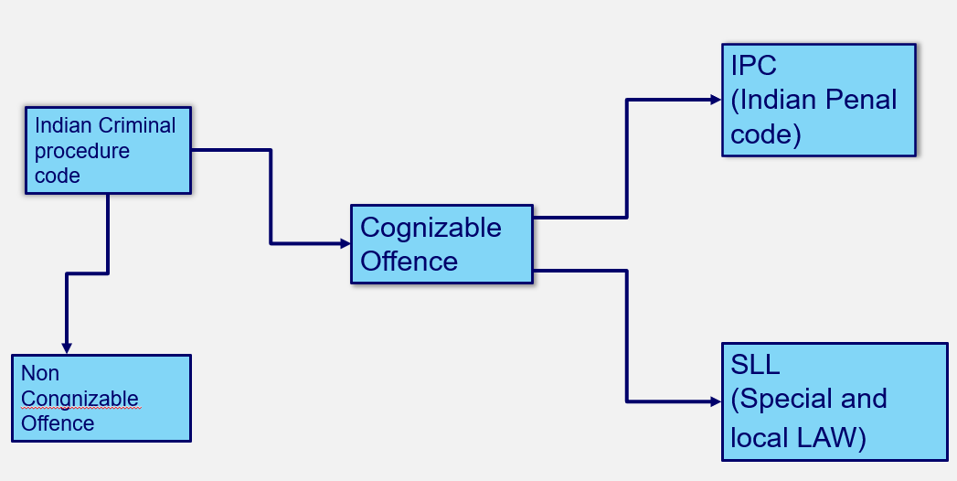
Understanding the Indian Criminal Justice System: Categorization of Offenses

The Indian criminal justice system operates under a comprehensive framework that categorizes offenses based on their severity and procedural requirements. This system is essential for maintaining law and order, ensuring justice for victims, and upholding the rule of law.
1. Cognizable Offence:
- Definition: Cognizable offenses are serious crimes for which a police officer can make an arrest without a warrant and initiate an investigation without a court order.
- Examples: Murder, robbery, rape, etc.
- Procedural Framework: Governed by the Criminal Procedure Code (CrPC) and the Indian Penal Code (IPC).
- Significance: Cognizable offenses often involve grave violations of law and require immediate police intervention to ensure public safety and apprehend the offenders.

2. Non-Cognizable Offence:
- Definition: Non-cognizable offenses are less severe crimes for which a police officer cannot make an arrest without a warrant and typically require a court order to initiate an investigation.
- Examples: Defamation, simple assault, etc.
- Procedural Framework: Investigation and trial process governed by the CrPC and IPC.
- Significance: non-cognizable offenses, while less serious, still necessitate legal action and adherence to due process to address grievances and uphold the rights of both the accused and the victim.

3. IPC (Indian Penal Code):
- Definition: The IPC is the primary criminal code of India, which defines various offenses and prescribes punishments for them.
- Coverage: Crimes against persons, property, and public order.
- Procedural Framework: Provides the legal framework for prosecuting offenders and seeking justice for victims.
- Significance: The IPC forms the backbone of criminal law in India and serves as a comprehensive guide for law enforcement agencies, prosecutors, and the judiciary in handling criminal cases.

4. SLL (Special and Local Law):
- Definition: Special and Local Laws refer to statutes enacted by the central or state governments to address specific types of offenses or issues.
- Examples: Narcotic Drugs and Psychotropic Substances Act, Information Technology Act, etc.
- Procedural Framework: Supplement the provisions of the IPC and CrPC.
- Significance: SLLs cater to specialized areas of law and provide additional legal tools for combating emerging crimes and addressing societal challenges.

Key Factors influencing crime in India
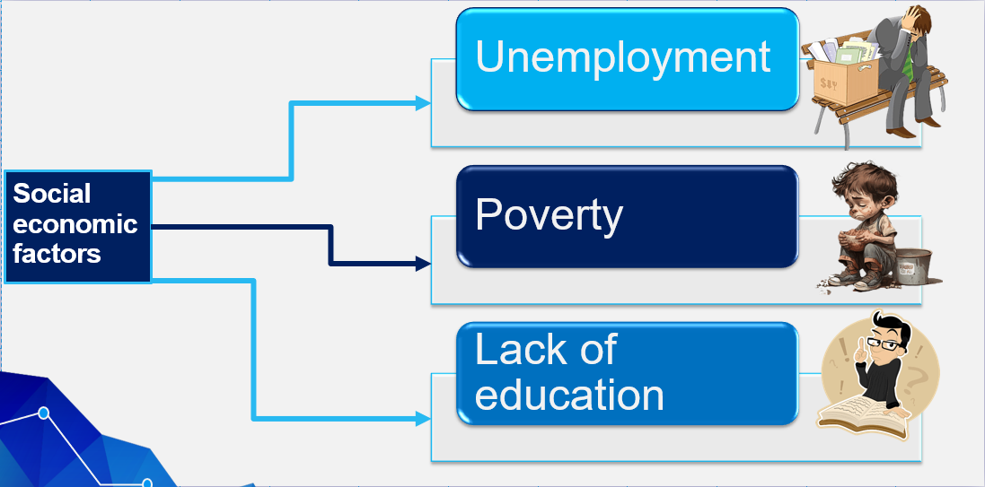

- Unemployment
When periodic labour for survey was released in 2017 8 revealed the unemployment rate of India to be 6.1 the highest ever recorded in India unemployment is not synonymous with jobless ness the International Labour Organisation (ILO) defines unemployment as being out of job being available to take job and accurate engaged in searching for works therefore and individual work who has lost work but does not look for another job is not unemployed the labour force is define as the sum of employed and the unemployed person those neither employed nor unemployed such as student and those engaged in unpaid domestic work are considered out of the labour force the unemployment rate is fall if and economy is not generating in a job or if people decide not to search for work.The situation is complicated in a developing economy, because decisions to search for work are constrained by social norms. According to a 2009-10 survey undertaken by the National Sample Survey Organisation (NSSO), 33.3% of rural women and 27.2% of urban women aged 15 and above who were engaged in domestic work reported willingness to work if it were made available within the premises of the household. This represents 18.8% of the rural female population aged 15 and up; the labour force participation rate (LFPR) for rural women that year was 26.5%. These women would not be counted among the unemployed because they are not actively looking for work. A definition of unemployment that focuses on actively searching for a job may underestimate the true picture in a developing economy. When periodic labour force survey was released in 2017 it revealed the unemployment rate of India to be 6.1 the highest ever recorded in India. unemployment is not synonymous with joblessness the International Labour Organisation (ILO) defines unemployment as being out of job, being available to take job and actually engaged in searching for work therefore an individual who has lost work but does not look for another job is not unemployed the labour force is define as the sum of employed and unemployed person those neither employed nor unemployed such as student and those engage in unpaid domestic work are considered out of the labour force the unemployment rate is fall if an economy is not generating enough jobs if people decide not to search for work. The formula for calculating the unemployment rate is unemployment rate = number of unemployed persons / labor force. Remember that the labor force includes those who are employed and those who are unemployed.
Measuring unemployment in India is difficult due to the informal nature of jobs. Unlike developed economies, individuals do not hold one job year-round. An individual may be unemployed this week, but may have worked as a casual labourer last month, and as a farmer for most of the year. Are they to be counted as unemployed?
The NSSO adopts two major measures for classifying the working status of individuals in India — the Usual Principal and Subsidiary Status (UPSS) and the Current Weekly Status (CWS). An individual’s principal status, whether employed, unemployed or out of the labour force, is based on the activity in which they “…spent relatively long time…” in the previous year. A person who is not a worker, according to the principal status, would still be counted as employed according to the UPSS if they were engaged in some economic activity in a subsidiary role for a period “…not less than 30 days”. Thus, an individual unemployed for five months and working for seven months in the previous year would be considered a worker according to the principal status, while an individual unemployed for nine months but working for three months would be counted as employed as per the UPSS. In the first effect, the positive relationship between the unemployment rate and crime is due to the motivation effect that unemployment motivates people to commit crimes. The negative relationship is due to the opportunity effect in the second effect. The crime rate may decrease due to increased unemployment as the opportunity to commit the crime is reduced because of increased guardianship by the unemployed population. The relationship between and crime suffers from inconsistencies in empirics throughout the literature. Researchers found positive, negative, and no relationship between the unemployment

Methodology

The National Crime Records Bureau (NCRB), a renowned Indian government agency, is primarily responsible for the collection and analysis of crime data. This data is defined and outlined by the Indian Penal Code (IPC) and Special and Local Laws (SLL). The bureau's operations are based out of New Delhi, and it functions under the Ministry of Home Affairs (MHA), Government of India.
Crime on the rise: In 2022, there was an increase in crimes against women, Scheduled Castes (SC), Scheduled Tribes (ST), children, cyber-crimes, and anti-state crimes compared to the previous year.
Crimes against women: The number of registered cases of crimes against women increased in 2022. Most of cases involved "cruelty of the husband or his relatives." This was followed by "rape and robbery of women," "attack on women with the aim of inciting a woman's submissive rage," and "rape."
Crimes against children: The registration of crimes against children also increased in 2022 compared to the previous year.
Youth in conflict with the law: There was a slight decrease in the number of youth cases registered in 2022 compared to the previous year.
Crime against the elderly: Registered cases of crimes against the elderly increased in 2022.
Cybercrime: The number of recorded cybercrime incidents increased. The majority was related to fraud, followed by extortion and sexual abuse.
Decrease in criminal registrations: Overall, case registrations decreased compared to the previous year. This was particularly true in cases registered as "violation of orders duly declared by officers."
Calculation of Charges: Kerala, Puducherry, and West Bengal had the highest rates of violations by State/UT as per the Indian Penal Code (IPC).
Metropolitan cities: Kochi, Patna, and Kozhikode had the highest number of prosecutions under IPC offense . Delhi reported the highest number of theft cases.
Here we first find relationship between crime rate and social economic factors. For this we use correlation coefficient. A correlation coefficient is a number between -1 and 1 that tells you the strength and direction of a relationship between variables. In other words, it reflects how similar the measurements of two or more variables are across a dataset.

3.1 Data Source

In India, the Criminal Procedure Code divides crimes into two heads: cognizable and non-cognizable. The police have the responsibility to take prompt action on receipt of a complaint or of credible information in the case of cognizable crimes. Cognizable crimes are again sub-divided as those falling under either the Indian Penal Code (IPC), or under the Special and Local Laws (SLL). Non-cognizable crimes, on the other hand, are left to be pursued by the affected parties themselves in Courts. The police force initiates investigation into such crimes except with magisterial permission. In India statistics on crime are published annually by the National Crime Records Bureau, under the Ministry of Home Affairs. State, City and district wise data is available on number of different crimes committed, judicial institutions and enforcement mechanism in a standardized format. 'Crime in India' was first brought out 1954. Since then it is being regularly published. The focus of this study will be only on IPC crimes (cognizable crime)

Data collection method
For the purpose of research, the secondary data was collected through a online sources Due to unavailability and shortage of time no books were studied in the physical form. The secondary sources were mostly used for designing the review of literature for the project.

Statistical techniques used
Here we first find relationship between crime rate and social economic factors. For this we use correlation coefficient. A correlation coefficient is a number between -1 and 1 that tells you the strength and direction of a relationship between variables. In other words, it reflects how similar the measurements of two or more variables are across a dataset.
To test our hypothesis for comparing two correlation coefficients we used z test statistics.
When conducting correlation analyses by two independent groups of different sample sizes, typically, a comparison between the two correlations is examined. This is recommended when the correlations are conducted on the same variables by two different groups, and if both correlations are found to be statistically significant. The way to do this is by transforming the correlation coefficient values, or r values, into z scores. This transformation, also known as Fisher’s r to z transformation, is done so that the z scores can be compared and analysed for statistical significance by determining the observed z test statistic.
We used software like Minitab, excel to draw graph and to find correlation coefficient. Using r software, we tested the two-population correlation coefficient.
Pearson’s correlation coefficient
A correlation coefficient is a number between -1 and 1 that tells you the strength and direction of a relationship between variables. In other words, it reflects how similar the measurements of two or more variables are across a dataset.

Fisher’s Z-Transformation
To test our hypothesis for comparing two correlation coefficients we used z test statistics.
With the observed z test statistic (z observed) at a set alpha level (level of significance), statistical significance can be assessed. SPSS does not conduct this analysis, and so alternatively, this can be done by hand or an online calculator. The first step is to run the correlation analyses between the two independent groups and determine their correlation coefficients (r); any negative signs can be ignored. The next step is to note, or write down, the sample sizes per each independent group. Then, using a statistical chart with z values and calculator, or an online calculator, determine the z values (z1 and z2) that correspond to the correlation coefficients (r). Usually, with an online calculator, significance is also calculated once you enter in the two correlation values and different sample sizes (N1 and N2). But in lieu of the online calculator, and with just a statistical chart with z values and calculator, the following formula is implemented:
$$Z observed =\frac{(z1-z2)}{\sqrt{\frac{1}{N1-3}+ \frac{1}{N2-3}}}$$
Once the observed z value has been determined, statistical significance can be assessed by checking to see if the observed value is greater than the critical value. For example, if the observed value was z observed = -1.97 and your level of significance is set at .05, which
indicates that the critical value is ± 1.96, your z observed falls into the rejection region and is greater than your critical value; thus, statistical significance. You can reject the null hypothesis that the two correlations are not significantly different.

4. DATA ANALYSIS
- Trend analysis:
Here we analysed the trend of IPC crime of India.
- Interpretation
The chart is showing the Change in the crime rate of India from 1991 to 2020. Although it is not showing the smooth trend, here we can see that there a slight increasing trend in crime rate
Here we find the trend analysis of literacy rate.

- Interpretation

The literacy rate is showing the uptrend this implies the education in India is going better and better over a period of time.

Here we find trend of Unemployment.

- Interpretation
This chart is showing the unemployment rate data from 1991 to 2019. Here we can see that the last decades the rate is slightly decreased but we can see that the overall rate is showing the increasing trend. In 1991 the unemployment rate was 12% it increases till 2018 from 12% to 26% for 2019 it slightly decreases 23%

- Interpretation

The poverty trend is down trend this implies that the poverty in India is decreasing. From 1993 to 2015 the poverty graphs the continuously decreasing but from 2016 to 2018 we can see the sudden decrease in poverty rate and increase in 2019

- Scatter plot.

Scatter plot of literacy rate, Unemployment, and poverty Rate in India

- Correlation coefficient
- Hypothesis 1
- H0: there is positive relationship between crime rate and Unemployment rate
- H1: There is negative relationship between the Crime rate and Unemployment rate.
- Hypothesis 2
- H0: there is positive relationship between crime rate and literacy rate
- H1: There is negative relationship between the Crime rate and literacy rate
- Hypothesis 3
- H0: there is positive relationship between crime rate and poverty rate
- H1: There is negative relationship between the Crime rate and poverty rate

CORRELATION
CRIME RATE AND UNEMPLOYMENT | 0.955
CRIME RATE AND LITERACY | 0.452
CRIME RATE AND POVERTY | -0.89

Interpretation
1. Crime Rate and Unemployment (0.962): ): Since, Correlation coefficient > 0 , Accept H0
- This strong positive correlation suggests that there is a direct relationship between unemployment and crime rate. When unemployment rates rise, there tends to be an increase in crime rates. This could be due to various factors such as financial strain, limited opportunities, and increased desperation among the unemployed population, leading to resorting to criminal activities to meet their needs or desires.

2. Crime Rate and Literacy (0.452): Since, Correlation coefficient > 0 , reject H0
- This moderate positive correlation indicates that there is a relationship between literacy levels and crime rates, albeit not as strong as unemployment. Higher literacy levels are associated with slightly lower crime rates. This could be attributed to the fact that education and literacy provide individuals with better opportunities for employment, critical thinking skills, and understanding of legal consequences, thus reducing the likelihood of engaging in criminal behaviour.

3. Crime Rate and Poverty ( -0.89): Since, Correlation coefficient < 0, reject H0
- This strong negative correlation suggests an inverse relationship between poverty and crime rate. As poverty decreases (or wealth increases), crime rates tend to decrease. This is because poverty is often linked to socioeconomic disadvantages such as lack of access to education, employment opportunities, and basic necessities. As individuals' economic conditions improve, they may be less inclined to engage in criminal activities as a means of survival or economic gain.
Thus, we conclude that the unemployment strongly affects the crime rate in India. Hence, we decided to do further analysis with unemployment rate. For comparison purpose we take Brazil country for applying correlation analysis.
- Crime trend analysis

- Interpretation
The crime rate in Brazil does not showing a smooth trend but from 1992 to 2003 it is showing the increasing trend then from 2003 to 2011 there is no significant change after that we can in 2017 crime rate increased and sudden fall in fall in 2019.
- Here we find trend of Unemployment.

- Interpretation
This chart shows the change in unemployment rate in Brazil from 1991 to 2020, here we can see that there is slightly increasing trend in unemployment rate of Brazil.

- Here we find the trend analysis of literacy rate

- Interpretation
The chart is showing the change in literacy rate of Brazil, here we can see that there is the small change in literacy means the literacy rate is increasing gradually in Brazil.
- Here we find trend analysis of poverty rate in Brazil.

- Interpretation:
The chart shows the changes in poverty rate of Bazil, here we can clearly see that the poverty rate is decreasing in Brazil the trend showing the downward trend.
- Correlation

Hypothesis 4
H0: there is positive relationship between crime rate and Unemployment rate
H1: There is negative relationship between the Crime rate and Unemployment rate.
Hypothesis 5
H0: there is positive relationship between crime rate and literacy rate
H1: There is negative relationship between the Crime rate and literacy rate
Hypothesis 6
H0: there is positive relationship between crime rate and poverty rate
H1: There is negative relationship between the Crime rate and poverty rate
CORRELATION COEFFICENTS IN BRAZIL
CRIME RATE AND UNEMPLOYMENT | 0..470
CRIME RATE AND LITERACY | 0.680
CRIME RATE AND POVERTY | -0.73056
>
1. Crime Rate and Unemployment (0.470): Since, Correlation coefficient > 0 , Accept H0
- Interpretation:
The moderate positive correlation suggests that as unemployment rates rise, there tends to be a moderate increase in the crime rate. This indicates that economic factors play a significant role in influencing criminal behaviour, with higher unemployment rates contributing to a greater likelihood of engaging in criminal activities.
2. Crime Rate and Literacy (0.680): Since, Correlation coefficient > 0 , reject H0
- Interpretation:
The strong positive correlation implies that as literacy rates increase, there tends to be a strong increase in the crime rate. This unexpected relationship suggests that factors beyond basic literacy skills, such as access to education, job opportunities, and social support systems, may influence the likelihood of engaging in criminal behaviour.
3. Crime Rate and Poverty (-0.73056): Since, Correlation coefficient < 0, reject H0
- Interpretation:
The strong negative correlation indicates that as poverty rates increase, there tends to be a strong decrease in the crime rate. This suggests that socioeconomic factors associated with poverty, such as lack of resources and opportunities, contribute significantly to higher crime rates. As poverty decreases, there is a corresponding decrease in the prevalence of criminal activities within a community.

- Descriptive Statistics
Descriptive | INDIA |  | BRAZIL
 | Unemployment | Crime rate | Unemployment | Crime rate
Mean | 17.53% | 18.8041 | 19.30% | 25.2041
Standard deviation | 0.0523761 | 3.27 | 0.0507971 | 3.51081
Variance | 0.0027433 | 10.75 | 0.0025803 | 12.3258
Meadian | 15.74% | 17.41 | 19.45% | 26.04

