OGP Development Setup Process- Spring 2017

Linux

Apache Tomcat 7

Installed in /var/lib/tomcat7
Webapps folder should contain geoserver.war, solr, host-manager, manager, opengeoportal

OpenGeoportal

Once OGP2 is checked out, build it using Maven and generate the opengeoportal.war file that is to be copied to tomcat’s webapps folder.

Apache Solr

Installed version: 4.6.1

Solr home: mkdir <solr database directory>
cp -R ~/solr-<version>/example/solr/* <solr database directory>

Bhavika’s solr_home: /Desktop/GIS/OGPSetup/solr_home

Go to the webapp folder you’ve created for Solr. In this example:
<tomcat directory>/webapps/solr/
jar -xvf solr.war

The solr webapp is incomplete. Copy logging jars from the downloaded package.
cp <download-dir>/solr-<version>/example/lib/ext/*
<tomcat-dir>/webapps/solr/WEB-INF/lib/

Copy logging properties. (create /classes if it’s not there yet)
cp <download-dir>/solr-<version>/example/resources/log4j.properties
<tomcat-dir>/webapps/solr/WEB-INF/classes/

Copy schema.xml and synonym files from the github repository
(​http://github.com/OpenGeoportal/ogpSolrConfig​ ) to ​ <solr dat abase
directory>/collection1/conf/

Adding a data import handler to Solr

Get this JAR - solr-dataimporthandler-4.6.1.jar
Save it in /var/lib/tomcat7/webapps/solr/WEB-INF/lib

Now go to Desktop/GIS/OGPSetup/solr_home or wherever your solr_home is located.
Create a new core (folder) - ogp_gmu. It should have a conf, data directory and core.properties.

The contents of conf should be as shown below:

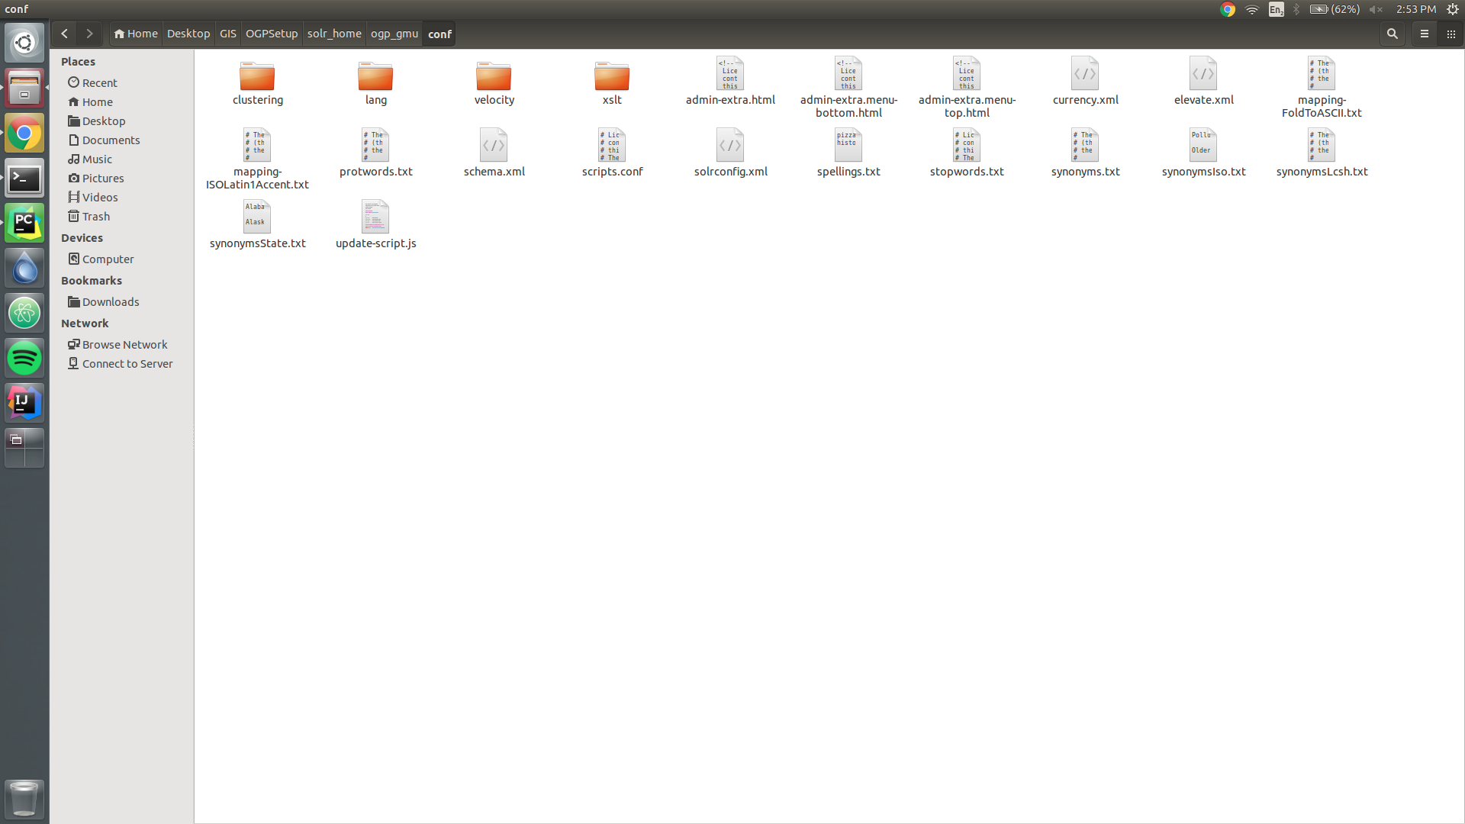

Edit the solrconfig.xml file (in conf) to contain this snippet:

<lib dir="/var/lib/tomcat7/webapps/solr/WEB-INF/lib/" regex=".*\.jar"/>
<lib dir="../../../dist/" regex="solr-dataimporthandler-\d.*\.jar"/>

This links the JAR file you downloaded earlier and points solr to it.

Now add a request handler for data imports.
This can be done by adding the following snippet to solrconfig.xml

<requestHandler name="/dataimport" class="solr.DataImportHandler">
<lst name="defaults">
<str name="config">data-config.xml</str>
</lst>
</requestHandler>

After this, check your solr logs for any errors. Restart tomcat.

The ogp_gmu solr core would look like this if everything is setup correctly.

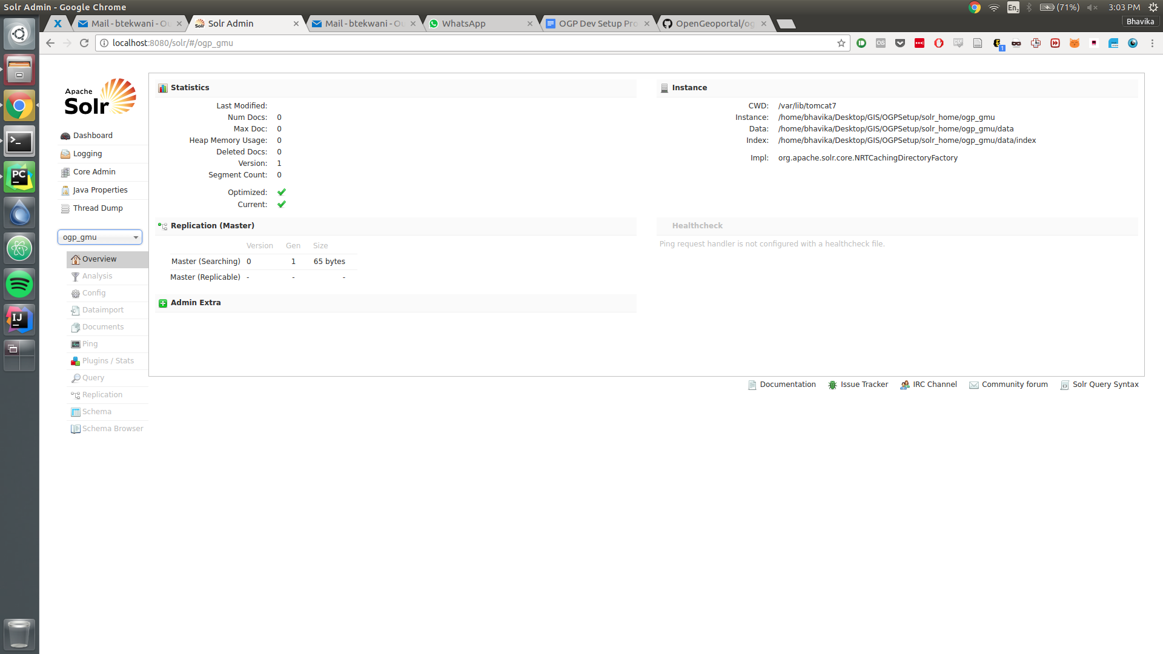

Geoserver

To install Geoserver on your existing Apache Tomcat setup, you need to get the web archive file.
I’ve installed version 2.8.5 for compatibility with Java 8.
This setup is relatively straightforward.
Instructions are here: http://docs.geoserver.org/stable/en/user/installation/war.html

ogpIngest

Build it using mvn package in the directory with pom.xml
Move the .war file to tomcat’s webapps.
ogpIngest is now running on localhost:8080/ogpIngest.
Username: ogpAdmin
Password: koala

Resolved:
Building ogpIngest with Maven gives this error - (use -source 5 or higher to enable generics) for multiple Java features.

Go to path home/bhavika/.m2/repository/org/apache/maven/plugins/maven-compiler-plugin/3.0/maven-compiler-plugin-3.0.pom

Adding GMU to the institutions list -
- Go to tomcat7/webapps/ogpIngest/WEB-INF/views/jspf
- Open institutions.jspf, add <option value="GMU">GMU</option> in the <select> tab.

bldg_polygon.shp

This is the first file I tried processing through ogpIngest because the metadata is ingestible for Solr without having to edit it at first.

To prepare this for indexing, click on Preprocess Metadata in ogpIngest. Add the .xml file using ‘Add Files’ and start processing. Once the processed metadata is downloaded as a zip file, you have to extract it.

Now click on Upload Metadata, select Institution as “GMU” and Ingest to Solr only.
Uncheck Title, Publisher, Originator, Abstract, Theme Keywords since we do not have these fields in our metadata.
Now, process and upload this metadata. If all goes well, the ingest report will only give you warnings for the missing fields and no errors. OpenGeoportal should not show this indexed metadata when you search for it (the layer may or may not show up depending on whether you have setup the layer on Geoserver correctly).

Windows

Joy’s computer is bound to 8009 because 8080 was already in use.

Joy's default login is what Geoserver's defaults are (Google it).
Sometimes Google Maps may not load the basemap - it is because of a change in the API.
Google Maps API v3 requires an API key to load the maps.

To resolve this, you can go to the Google Maps API page and generate a key.
Delete the opengeoportal.war and opengeoportal folder from Tomcat’s webapps folder.

Now go to OGP2/geoportal_1/src/main/webapp/WEB_INF/views/jspf and open the includes.jspf file.

In this file - remove the following tag

<script src="//maps.google.com/maps/api/js?v=3.10&sensor=false"></script>

Add the following tag to the top of the file (this order matters) for JS async reasons
Replace YOUR_API_KEY with the key you generated. This is only suitable for localhost/development environment due to the rate limits.

<script src="https://maps.googleapis.com/maps/api/js?key=YOUR_API_KEY&callback=initMap"
async defer></script>

Recompile the geoportal_1 folder with `mvn package` in the folder where the pom.xml is present. Now there should be a folder called target where we have a new opengeoportal.war file. Copy this to Tomcat’s webapps folder.

Now try reloading localhost:8080/opengeoportal and see if the base map loads.

Uploading new layers using gmu_script.py

- Once you change the path and run the script, all the .shp files will get pushed to the local Geoserver instance.
- Now, preprocess the metadata (FGDC) in OGPIngest and upload the processed zip file to ‘Solr only’.
- Check whether the layers appear in OGP’s search.
- If you select a layer and get a pink/red overlay and the error looks like
“GET http://localhost:8080/opengeoportal/info/wmsInfo?ogpid=GMU.RAIL_L 500 (Internal Server Error)” it is most likely an error with geoserver locating the layer.
The layer name should match the request - therefore, a prefix such as “GMU” is required in Geoserver’s layer store and layer name. Additionally, the case for the whole string should match.
5) Reload the layers in OGP and see if the error in step 4 is resolved.

Troubleshooting

1) When you preprocess a new metadata file using ogpIngest, you may see an error like:

org.codehaus.jackson.map.exc.UnrecognizedPropertyException:Could not read JSON: Unrecognized field "workspaces" (Class org.OpenGeoPortal.Geoserver.REST.AvailableVectorsResponseJson), not marked as ignorable
at [Source: org.apache.http.conn.EofSensorInputStream@8e223ed; line: 1, column: 16] (through reference chain: org.OpenGeoPortal.Geoserver.REST.AvailableVectorsResponseJson["workspaces"]); nested exception is org.codehaus.jackson.map.exc.UnrecognizedPropertyException: Unrecognized field "workspaces" (Class org.OpenGeoPortal.Geoserver.REST.AvailableVectorsResponseJson), not marked as ignorable
at [Source: org.apache.http.conn.EofSensorInputStream@8e223ed; line: 1, column: 16] (through reference chain: org.OpenGeoPortal.Geoserver.REST.AvailableVectorsResponseJson["workspaces"])

This essentially is a Solr error at the source.

Make sure you have a data-config.xml file in your solr_home/conf directory.
Bhavika's laptop: /home/bhavika/Desktop/GIS/OGPSetup/solr_home/ogp_gmu/conf/data-config.xml

Add the following into your data-config.xml file:

<dataConfig>
<dataSource type="JdbcDataSource"
driver="com.mysql.jdbc.Driver"
url="jdbc:mysql://localhost/dbname"
user="user-name"
password="password"/>
<document>
<entity name="id"
query="select id,name,desc from mytable">
</entity>
</document>
</dataConfig>

Solr Operations

- To delete a document in a core by using a property (tag):

http://localhost:8080/solr/<corename>/update?stream.body=%3Cdelete%3E%3Cquery%3E<node>:<value>%3C/query%3E%3C/delete%3E&commit=true

Example:

http://localhost:8080/solr/GMUGeodata/update?stream.body=%3Cdelete%3E%3Cquery%3ELayerId:GMU.BLDG%3C/query%3E%3C/delete%3E&commit=true

Delete all on AWS:
http://52.200.35.9/solr/collection1/update?stream.body=<delete><query>LayerId:*.*</query></delete>&commit=true

- To add a document using the Post tool:

In Solr 4.6.1, the SimplePost tool is in solr-4.6.1/example/exampledocs.

Run:

java -Durl=http://localhost:8080/solr/<corename>/update -jar post.jar file.xml
Example:
java -Durl=http://localhost:8080/solr/GMUGeodata/update -jar post.jar /home/bhavika/Downloads/bldg_polygon_8696.xml

Updates on 02/14/2018:

- bldg_polygon.xml was updated with proper Abstract <abstract>, Purpose <purpose>, <origin>, <publish>, <publisher>, <srccitea>, <caldate>, <themekt>, <themekey> <onlink>,
values.
- Now ingesting this file with the correct ingest.properties file works and we get a new document in Solr (tested with ogpIngest and Solr's Post tool both).

Questions

1) In the document that gets ingested to Solr, what are CollectionId, WorkspaceName – should WorkspaceName match the Geoserver workspace we have?
2) How do we modify ogpIngest source code to inject a WorkspaceName into the new XML document? Relevant source code seems to be here: https://github.com/OpenGeoportal/ogpIngest/blob/master/ogpIngest/src/main/java/org/OpenGeoPortal/Layer/Deprecated/ToSolrOld.java

