**WORD COUNTER**

# A MINI PROJECT REPORT

*Submitted by*

**Group/ Team No:G21/T12**

**BHAVIKA GOYAL - 2210990219**

**BHAVIKA ARORA - 2210990220**

**BHAVIKA CHOPRA - 2210990221**

**BHAVLEEN SINGH - 2210990222**

***in partial fulfilment for the award of the degree of***

# BACHELEOR OF ENGINEERING

***in***

# COMPUTER SCIENCE & ENGINEERING



**CHITKARA UNIVERSITY CHANDIGARH-PATIALA NATIONAL HIGHWAY RAJPURA (PATIALA) PUNJAB-140401 (INDIA)**

**MAY,2023**

# ABSTRACT

The countdown timer project is an application that allows users to set a specific date and time for a future event or deadline, and then displays a countdown of the remaining time until that event. The project is developed using HTML, CSS, and JavaScript, and includes features such as user input forms, real-time updates, and customizable styling options. By completing this project, developers can deepen their understanding of web development technologies and techniques, as well as practice their problem-solving and design skills. The resulting countdown timer can be used in a variety of settings, such as event websites, marketing campaigns, and productivity applications, to help users stay on track and meet their goals.

By building this project, developers can practice their skills in web development, user experience design, and project management, and gain experience in working with popular web development frameworks and libraries. The resulting countdown timer can be used in a wide range of contexts, from event websites and social media campaigns to productivity applications and personal projects. With its simple and intuitive interface, the countdown timer project provides an engaging and informative way to keep users informed and motivated about upcoming events and deadlines.

## TABLE OF CONTENTS

|  |  |  |
| --- | --- | --- |
| S.no | Section | Page |
| 1. | INTRODUCTION | 4 |
| 2. | PROBLEM STATEMENT | 5 |
| 3. | TECHNICAL DETAILS | 6 |
| 4. | KEY FEATURES | 7 |
| 5. | PROJECT ADVANTAGES | 8 |
| 6. | CODE AND ITS OUTPUT  EXPLAINATION | 9-13 |
| 7. | CONCLUSION AND FUTURE SCOPE | 14 |
| 8. | LIST OF  REFERENCES | 15 |

# INTRODUCTION

Countdown timers are a popular feature in many web applications and websites, providing users with a visual representation of the time remaining until an event or deadline. A countdown timer can be used in a variety of contexts, from event websites and marketing campaigns to productivity applications and personal projects. Building a countdown timer project using HTML, CSS, and JavaScript is an excellent way for developers to deepen their understanding of web development technologies and techniques, and to practice their skills in user experience design, project management, and teamwork.

In this project, we will develop a countdown timer application that allows users to set a specific date and time for a future event or deadline, and then displays a countdown of the remaining time until that event. We will use HTML to create the user interface for the application, CSS to style the interface and make it responsive for different devices, and JavaScript to handle user input, real-time updates, and other application logic. Along the way, we will explore best practices in web development, such as code organization, testing, and optimization, and discuss strategies for collaborating effectively as a team. By the end of the project, we will have a fully functional countdown timer application that can be customized and integrated into a wide range of web projects.

Goals of this project are : Creating a functional and accurate timer. It should be able to accurately count down from the specified time interval to zero and trigger an event or message when the time is up.

Customizing the design. It can be styled to fit the aesthetic of the website or application it is being used on. This may involve choosing the font, color scheme, and overall layout of the timer.

Adding interactivity. Depending on the requirements, the timer can be made interactive by allowing users to pause, restart or set a new time interval.

**PROBLEM STATEMENT**

The problem that this HTML project on a countdown timer aims to solve is to provide a clear and accurate way for users to track the time remaining until a specific event or deadline. By creating a visually appealing and responsive countdown timer, the project aims to make it easy for users to see at a glance how much time is left, without having to perform any calculations or consult an external source. Additionally, by allowing users to specify the end date and time themselves, the project aims to provide a customizable tool that can be used for a wide range of purposes, from tracking the time until a product launch to counting down to a personal event like a birthday or wedding.

Countdown timers are a common feature on websites and applications, and are used for a wide range of purposes, from creating a sense of urgency for sales or limited-time offers, to tracking the time until a specific event or deadline. Countdown timers can also be used as a tool to improve user engagement and retention on a website or application, by providing a visual cue to users that something is about to happen, and encouraging them to stay engaged with the platform.HTML provides a number of built-in features and tools that can be used to create a countdown timer, including the ability to create and style text, graphics, and animations, as well as the ability to interact with user input through forms and JavaScript.

# TECHNICAL DETAILS

* **HTML:** The basic structure of the word counter HTML project is built using HTML. HTML is a markup language used to create web pages.
* **CSS:** CSS is used to style the HTML elements of the word counter HTML project. It is used to define the appearance of the web page, including font size, color, and layout.
* **JavaScript:** JavaScript is used to provide interactivity and functionality to the word counter HTML project. It is used to count the number of words entered into the text area, update the word count in real-time, and perform other functions like resetting the word count.
* **Regular Expressions:** Regular expressions are used to split the text entered into the text area into individual words. Regular expressions provide a powerful way to match patterns in text.

# KEY FEATURES

* The countdown timer is displayed in a clear and visually appealing format, such as "Days : Hours : Minutes : Seconds". The display is easy to read and understandable, and includes labels or icons to indicate which units of time are being displayed.
* The countdown timer is customizable in terms of its appearance and styling, so that it can be integrated into a wide range of websites and applications. This can be achieved using CSS, which can be used to adjust the color, size, and positioning of the timer display.
* The countdown timer is updated in real-time, without requiring the page to be refreshed. This can be achieved using JavaScript, which can periodically check the current time and update the timer display accordingly.
* The countdown timer is designed to work well on both desktop and mobile devices, with a responsive layout that adjusts to different screen sizes and orientations.

# PROJECT ADVANTAGES

* Improved understanding of web development: Building a countdown timer project using HTML can help to deepen the understanding of web development technologies and techniques, such as HTML, CSS, and JavaScript, as well as the interactions between them.
* Practice of problem-solving and critical thinking skills: Developing a countdown timer project requires developers to identify and solve problems related to time calculation, user input, real-time updates, and responsive design, among others. This can help developers to practice their problem-solving and critical thinking skills.
* Enhanced creativity and design skills: Creating a visually appealing and user-friendly countdown timer display will require developers to use their creativity and design skills, such as choosing the right colors, fonts, and visual cues to communicate the countdown timer information effectively.
* Customizability and versatility: A countdown timer project using HTML can be customized and integrated into a wide range of web projects, from event websites and social media campaigns to productivity applications and personal projects, providing developers with a versatile and flexible tool for their web development projects.
* Portfolio showcase: Completing a countdown timer project using HTML can provide developers with a tangible example of their skills and abilities in web development, which they can showcase to potential employers or clients in their portfolio or resume.

# CODE AND ITS OUTPUT EXPLAINATION

Html code:

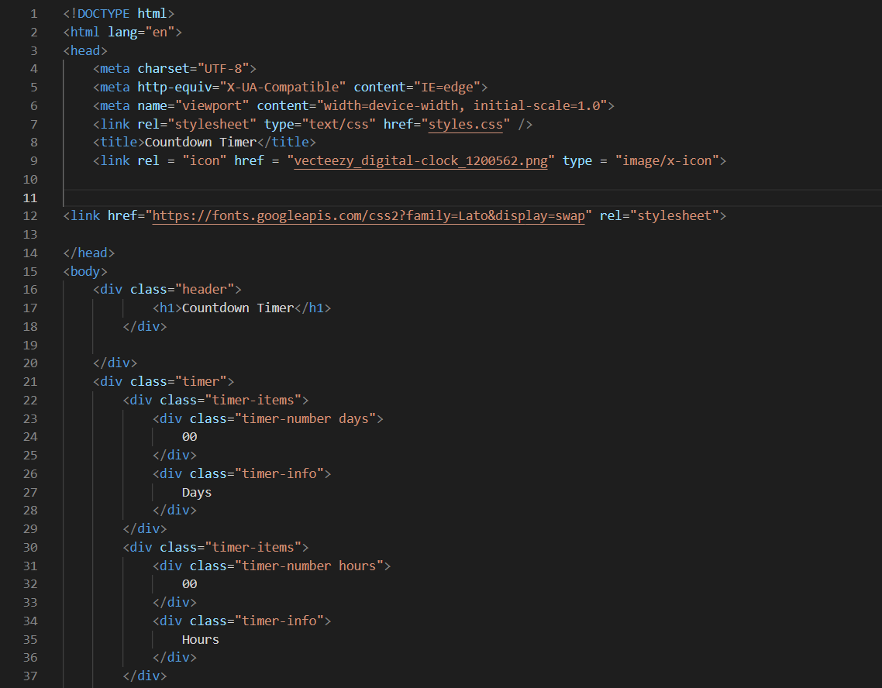

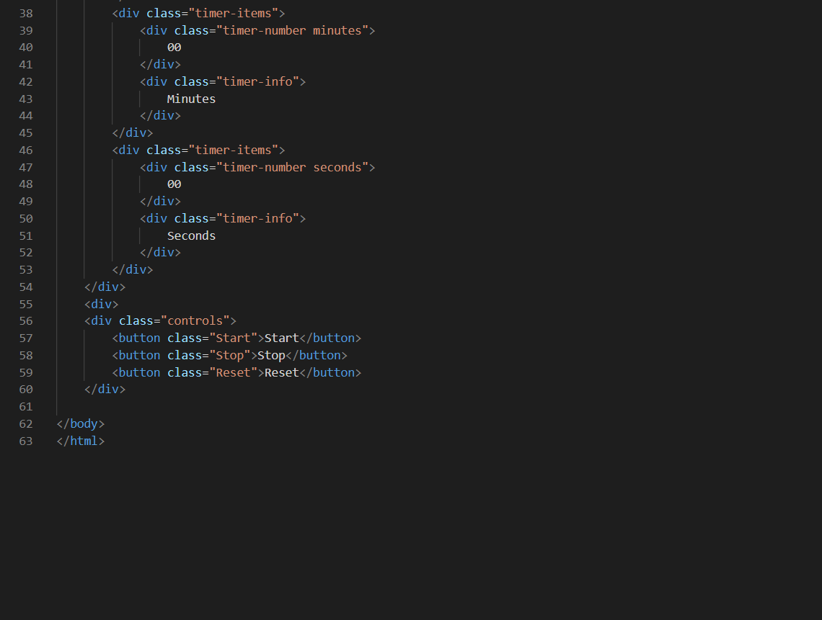

This code includes a header with a title and a stylesheet reference. The body of the page consists of a timer and three buttons for controlling the timer. The timer displays the countdown in days, hours, minutes, and seconds. Each timer item is displayed as a block element with a number and a label. The controls include a Start button, a Stop button, and a Reset button. The styles for the page are defined in an external stylesheet referenced in the head section of the HTML document. The stylesheet defines the font-family, font-size, background color, and border radius for various elements on the page.

**CSS code:**

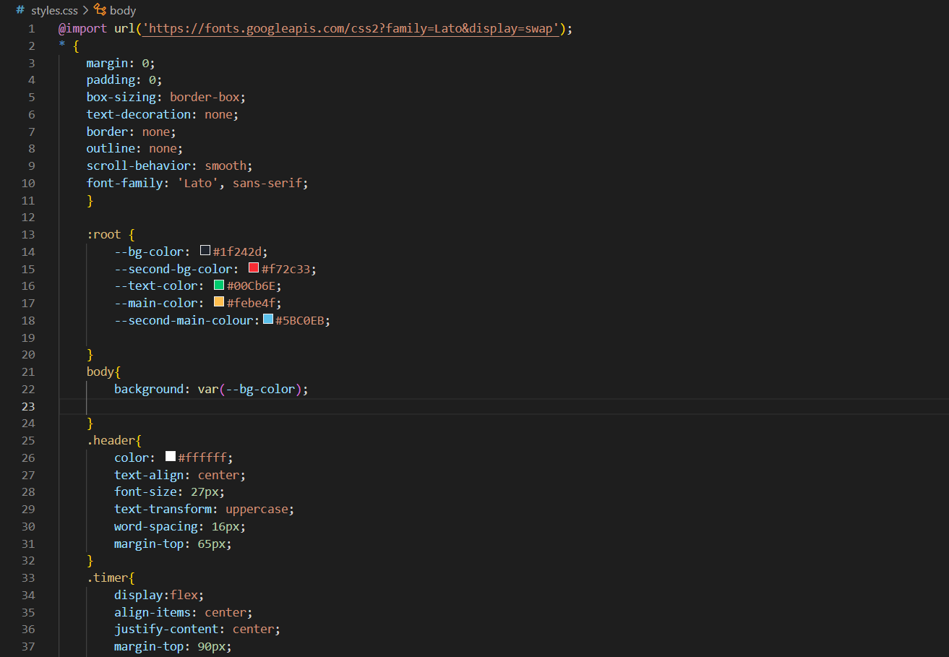

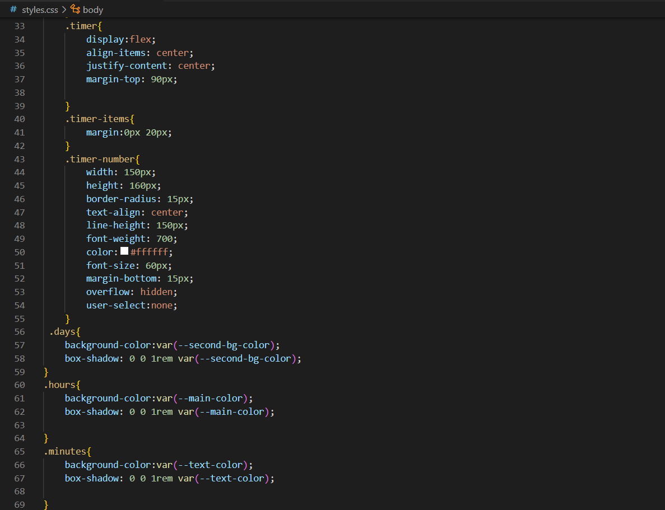

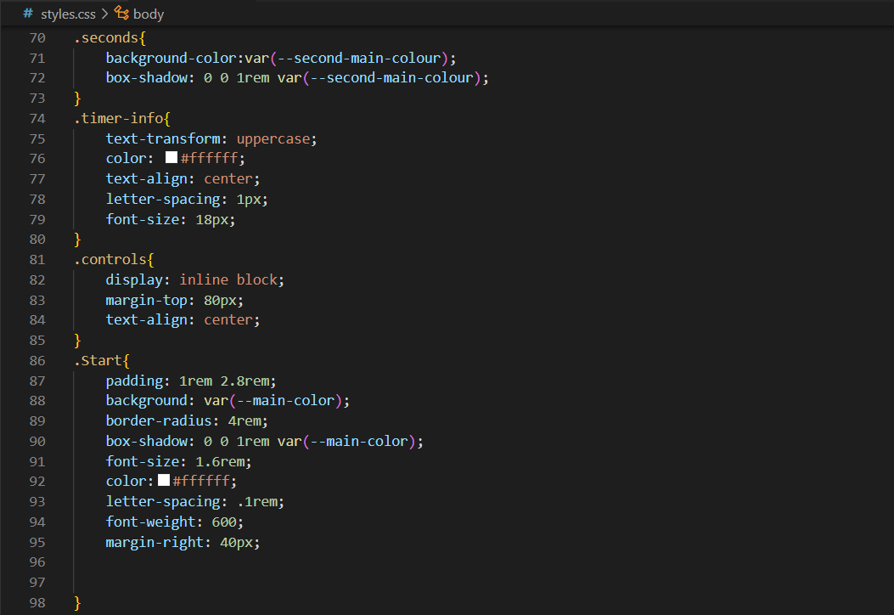

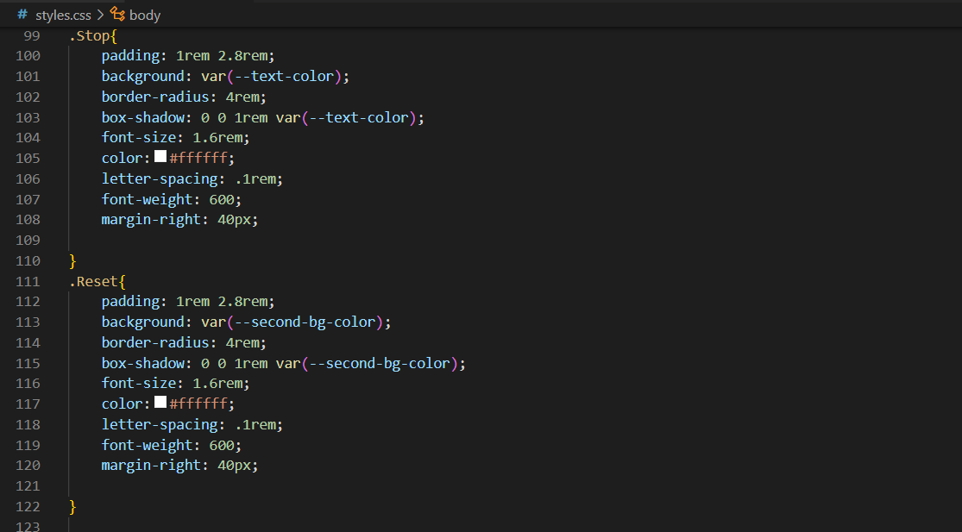

The code begins with a Google Font import for the "Lato" font family, followed by a set of global styles for various HTML elements. The ":root" selector defines custom CSS variables for the background color, text color, and other colors used in the design. The ".header" class styles the page title and the ".timer" class styles the display of the timer digits. Each digit is given a ".timer-number" class and a corresponding ".timer-info" class for the unit of time it represents. The colors of each digit are defined by their respective classes. Finally, there is a set of styles for the control buttons with classes of ".Start", ".Stop", and ".Reset". Each button has a background color, a border radius, a box shadow, a font size, and a font weight. The ".controls" class styles the container for the control buttons.

Output:

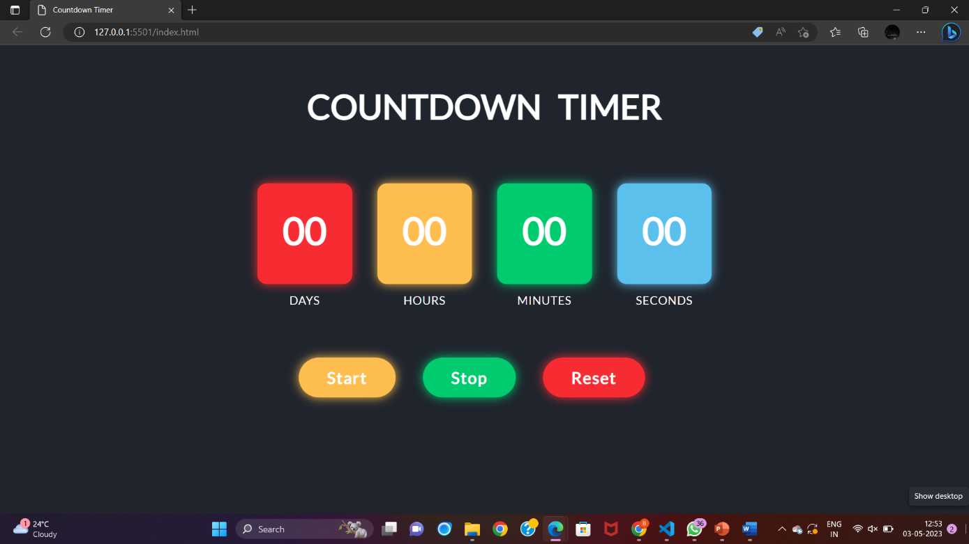

# CONCLUSIONS AND FUTURE SCOPE

In conclusion, building a countdown timer project using HTML can be an excellent way to practice the web development skills, deepen their understanding of web technologies and techniques, and create a versatile and customizable tool for a wide range of web projects. By using HTML, CSS, and JavaScript, developers can create a visually appealing and user-friendly interface for the countdown timer, handle user input and real-time updates, and customize the display to suit their needs.

In terms of future scope, there are several ways in which the countdown timer project could be expanded or improved. For example:

Customization options: The countdown timer project could be expanded to include more customization options, such as the ability to choose different visual styles, sounds, or notifications for the countdown timer.

Multi-language support: The countdown timer project could be expanded to include support for multiple languages, making it accessible to a wider audience.

Collaboration and sharing features: The countdown timer project could be expanded to include collaboration and sharing features, such as the ability to share the countdown timer with others, or to collaborate on a countdown timer project with a team.

# LIST OF REFERENCES

* <https://youtu.be/AbmVRYZ_AwE>
* <https://youtu.be/CeLu1vSuaTQ>