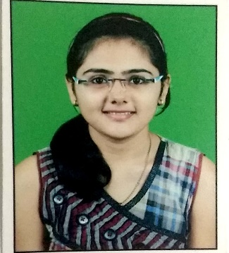

**Bhavika Gujare**

[bhavikagujare@gmail.com](mailto:bhavikagujare@gmail.com)

312, Shree sai visava blg,

Nr Ruhia college,

Dadar 419000

9765823997

**Objective : To get better experience and understanding of professional environment in IT field. To get more practical exposure of IT. Learn more skills which I want to develop in myself and will increase my working capability.**

**Academic Qualifications:**

|  |  |  |  |
| --- | --- | --- | --- |
| **Course** | **Institution** | **Board** | **Percentage** |
| BE in Information Technology  Post-Matric  Matric | Vidyalankar Institute of Technology  Archana college of Science and commerce  Jindal Vidya Mandir | Mumbai University  HSC  CBSE | CGPA:8.7  80.00%  93.00% |

**Project:**

**Hospital management system using Python:** A working interactive system was made using python. It was having a database connectivity with sqlite3. It contained all the operations we have to with the database tables. It can store, display, delete records for doctors, patients and appointments.

**Food delivery website:** Working Website using html, css, javascript, php and bootstrap. It was having database connectivity. It can store the records of restaurants, orders and customers. It has searching mechanism and quick links.

**Car game using Java:** With help of Java applets a simple car game was made in work. It can be played simply and can go forward with increasing difficulty as we complete our level.

**Database:** MySql, postgreSQL

**Editor**: Sublime / Eclipse, Pycharm

**Operating System** – Windows, Linux OS.

**Certifications:**

Web development certificate from college work.

Google certification on Digital Marketing.

Udemy Certification on Python and Advance Database.

**Personal Skills:**

1.Good management skills

2.Better understanding.

3.Good listener.

4.Good confidence.

**Personal Dossier:**

Language proficiency:

English

Hindi

Marathi

**Declaration:**

All the information mentioned in the resume is faithful without a single fake word.

Place:Mumbai

Date:1/08/2019

Signature