***EXP.-2→ LED CHASHER***

**Circuit Diagram:**

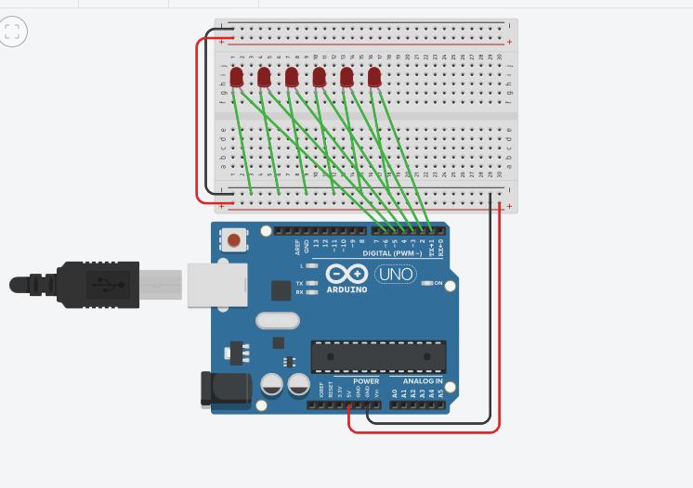

**Theory:**

*Concept Used: In this experiment we have done coding to flash LED (Light Emitting Diode), which is held together on the Breadboard .*

**Learning and Observations :**

*The coding is done on computer from which the instructions are given to the Arduino Uno board .Coding done on Arduino software is C++ . Arduino is a single-board microcontroller meant to make the application more accessible which are interactive objects and its surroundings .This micro controller gives the valid instruction to the elements fitted on the breadboard according to coding done on software.*

**Precautions:**

*1-The coding done on the software should be correct in every manner. All the errors should be avoided i.e. syntax,logical errors etc.. 2-All the wires and elements should be connected tightly and according to the coding done on the system. 3-Postive and Negative terminals should be put in correct order.*

**Problems and Trouble shooting:**

*1-The incorrect coding might cause problems in the working of hardware. This can be corrected by learning C++ and practicing it on the software. 2-Hardware should be correctly fitted on the Breadboard or they might get fuse or get permanently damaged . 3-Arduino wire must be checked if they are loose or not. And the ports should be properly cleaned before using ,they might cause problem in future.*

**Learning Outcome:**

*From this experiment we have learn how to code in the software . This project was the pillar for the upcoming project we are going to do in upcoming semester. In this project we learned how to flash a LED bulb and how to code it on the software.*