MECHANICAL RELIABILITY & DATA ANALYSIS REPORT
Fleet-Wide Condition Monitoring & MRO Reliability Assessment
Prepared by: Senior Mechanical Data Analyst & Reliability Engineering Function | Report Date: 25 July 2026

1. System & Project Context
Parameter | Detail
Scope of Analysis | 10-asset industrial equipment fleet across 3 plants (PUN-01, CHN-02, DHR-03): CNC Lathe, Hydraulic Press, Belt Conveyor, Screw Compressor, EOT Crane (2 units each)
Analysis Type | Combined Condition-Monitoring (vibration/thermal/pressure trend) Analysis + MRO Reliability & Spares-Consumption Analysis
Data Source | synthetic_industrial_machine_data.csv — daily asset sensor telemetry fused with MRO parts-issuance/work-order ledger
Reporting Period | 03 Jan 2022 – 01 Jan 2025 (1,095 operating days per asset; 10,950 asset-days; 219,000 source ledger rows)
Objective | (1) Characterize baseline mechanical health across the fleet; (2) identify assets/components with disproportionate failure and cost burden; (3) detect statistical anomalies and threshold breaches; (4) issue prioritized reliability recommendations

2. Executive Summary
The fleet-wide dataset covering 10 assets over a 3-year window shows a mechanically stable population overall: fleet-average bearing temperature (65.1 °C), motor temperature (71.1 °C) and oil pressure (5.01 bar) all sit within normal industrial operating bands, and no readings breached the critical thermal (>85°C bearing / >95°C motor) or hydraulic (<3.0 bar) safety thresholds applied in this analysis. However, vibration behaviour is the standout concern: horizontal vibration breached the ISO 10816 Zone-D “unacceptable” limit (7.1 mm/s) on 343 occasions (3.13% of asset-days) and vertical vibration on 178 occasions (1.63%), with 512 statistically extreme spike events (|z|>4 against each asset's own baseline) reaching 2–3× normal amplitude — peaking at 13.3 mm/s on Screw Compressor AST-4061. These spikes occur in near-lockstep on both axes (H–V correlation r = 0.98), which is the signature of a genuine mechanical excitation (imbalance, misalignment, or bearing defect) rather than sensor noise, and warrants immediate spectral (FFT) verification rather than dismissal as an outlier.
On the reliability/MRO side, the ledger records 21,636 breakdown-type work orders against 197,364 parts-tracking rows (a 67.4% asset-day incidence of at least one breakdown work order), with Bearings the leading failure and cost driver (4,221 breakdown events; ₹32.60 lakh in issued value) followed closely by Seals & Gaskets (3,118 events; ₹29.92 lakh). Total fleet MRO spend over the period is ₹133.4 lakh, distributed almost evenly across machine types (₹26.1–27.5 lakh each) — there is no single “bad actor” machine class, but CNC Lathe AST-1041 and Screw Compressor AST-4061 both show markedly elevated vibration signatures (mean 5.04 and 4.86 mm/s respectively) relative to their sister units (AST-1042: 2.75 mm/s; AST-4055: 3.43 mm/s), flagging these two specific assets for priority inspection. Statistically, operating load is the strongest available leading indicator of breakdown activity (r = 0.338 with same-day breakdown-parts count, versus r ≤ 0.16 for all thermal/vibration variables), and load/power draw are materially higher on breakdown work-order days (71.9% load / 28.0 kW vs 60.9% / 23.2 kW on normal days) — pointing toward overload-driven wear as the dominant systemic failure driver rather than a single component defect. Immediate action is recommended on the two flagged high-vibration assets and on load-management practice across the fleet; details and a prioritized action plan follow in Section 8.

3. Methodology & Data Validation

3.1 Data Structure & Interpretation
- The source file combines two logical datasets in one table: (a) daily asset-level sensor telemetry (temp_bearing_degC, temp_motor_degC, vibration_h_mms, vibration_v_mms, oil_pressure_bar, load_pct, shaft_rpm, power_consumption_kw) and (b) a per-part MRO issuance/work-order ledger (qty_issued, issue_value_inr, breakdown_flag, wo_type).
- Each asset tracks 20 spare-part line items daily, and the 8 sensor fields are duplicated identically across all 20 part rows for a given asset-date (confirmed by inspection). To avoid 20× double-counting and inflated variance in the statistical summary, all sensor/condition-monitoring analysis in Sections 4–6 was performed on a de-duplicated asset-day table (10,950 rows = 10 assets × 1,095 days).
- All part-level, cost, and breakdown-frequency analysis (Sections 5.3, 6) uses the full 219,000-row ledger, since qty_issued, issue_value_inr, and breakdown_flag are genuinely part-specific.
- breakdown_flag = 1 corresponds exactly to wo_type = “BD” (21,636 rows); the remaining non-null wo_type entries are “PM” (planned maintenance, 21,157 rows); 176,207 rows have no work order (routine inventory tracking, no transaction).

3.2 Data Quality Findings
- Completeness: no missing values in any sensor, cost, or identifier field. wo_type is null only where no work order applies (expected/valid nulls, 80.5% of rows), not a data gap.
- No duplicate rows; no negative or physically impossible values in any sensor channel (all ranges checked: temp, vibration, pressure, load, RPM, power all ≥0 and within plausible industrial bounds).
- Notable data characteristic: breakdown work orders are recorded on 67.4% of all asset-days (7,376 of 10,950), at an average of ~2.9 flagged parts per event day. This incidence rate is far higher than a typical unplanned-failure rate for rotating/reciprocating industrial equipment and most plausibly represents a broader definition of “breakdown work order” (e.g., including minor corrective replacements bundled with the event) rather than catastrophic machine stoppage. Because of this near-saturation, simple event-in-next-N-days correlation between vibration spikes and breakdown flags was tested and found statistically uninformative (spike-preceded-breakdown rate 100% vs. an unconditional 3-day-window base rate of 99.8%) — the flag is too dense at daily granularity to serve as a leading-indicator target. Section 6 therefore relies on magnitude/threshold-based anomaly detection and cross-sectional load correlation, which remain valid and are the analytically sound signals in this dataset.
- Recommendation for future data capture: tag breakdown work orders with a severity/downtime-hours field, and timestamp them at the event (not daily-bucket) level. This would allow genuine precursor/leading-indicator analysis in the next iteration of this report.

4. Statistical Data Summary
Table 1 — Fleet-wide sensor statistics (asset-day level, n = 10,950 observations, all 10 assets pooled):
Variable | Mean | Median | Std Dev | Variance | Min | Max
Bearing Temperature (°C) | 65.10 | 66.30 | 4.92 | 24.20 | 43.50 | 73.50
Motor Temperature (°C) | 71.09 | 71.50 | 6.90 | 47.58 | 49.80 | 88.40
Vibration – Horizontal (mm/s) | 3.87 | 3.62 | 1.35 | 1.81 | 0.67 | 13.31
Vibration – Vertical (mm/s) | 2.90 | 2.74 | 1.03 | 1.05 | 0.40 | 10.09
Oil Pressure (bar) | 5.01 | 4.94 | 0.95 | 0.91 | 3.30 | 7.39
Load (%) | 68.34 | 68.80 | 12.19 | 148.57 | 34.20 | 95.40
Shaft Speed (RPM) | 1,553.7 | 1,437.0 | 773.4 | 598,113.0 | 654 | 2,980
Power Consumption (kW) | 26.46 | 16.73 | 19.28 | 371.70 | 4.43 | 82.50
Note: Shaft speed and power consumption show very high variance because five structurally different machine classes (CNC Lathe, Hydraulic Press, Belt Conveyor, Screw Compressor, EOT Crane) are pooled together — each operates at a different inherent speed/power baseline. Machine-type-segmented statistics are given in Section 5.1; pooled figures above should be read as fleet context only, not as a single machine's operating envelope.

5. Detailed Component Analysis

5.1 By Machine Type
Machine Type | Avg Brg Temp (°C) | Avg Vib-H (mm/s) | Avg Load (%) | Avg Power (kW) | MRO Spend (₹ Lakh)
Hydraulic Press | 66.7 | 4.28* | 66.4 | 55.7 | 26.3
Screw Compressor | 59.0 | 4.15* | 68.1 | 37.5 | 27.1
CNC Lathe | 67.2 | 3.90* | 79.6 | 14.8 | 26.1
EOT Crane | 65.6 | 3.48 | 63.1 | 16.1 | 26.4
Belt Conveyor | 66.9 | 3.56* | 64.5 | 8.3 | 27.5
*Machine-type average vibration masks a wide within-type asset spread — see Section 5.2. CNC Lathe average load (79.6%) is the highest of any machine class, consistent with the load–breakdown correlation identified in Section 6.

5.2 By Individual Asset (10,950 asset-days)
Asset | Type | Mtc-WO Days (%) | Implied MTBF (days) | Avg Vib-H (mm/s) | Max Vib-H (mm/s) | Avg Brg Temp (°C) | Avg Load (%)
AST-1041 | CNC Lathe | 67.4% | 1.5 | 5.04 ⚠ | 13.06 | 67.5 | 79.5
AST-1042 | CNC Lathe | 65.9% | 1.5 | 2.75 | 10.22 | 67.0 | 79.6
AST-2017 | Hydraulic Press | 69.3% | 1.4 | 4.02 | 11.57 | 65.2 | 53.6
AST-2031 | Hydraulic Press | 67.8% | 1.5 | 4.53 | 12.10 | 68.2 | 79.2
AST-3008 | Belt Conveyor | 67.3% | 1.5 | 3.93 | 12.21 | 68.1 | 71.4
AST-3019 | Belt Conveyor | 64.4% | 1.6 | 3.19 | 11.47 | 65.8 | 57.6
AST-4055 | Screw Compressor | 69.9% | 1.4 | 3.43 | 11.49 | 52.8 | 76.7
AST-4061 | Screw Compressor | 68.0% | 1.5 | 4.86 ⚠ | 13.30 | 65.3 | 59.6
AST-5003 | EOT Crane | 69.2% | 1.4 | 3.47 | 11.82 | 66.9 | 71.1
AST-5007 | EOT Crane | 64.4% | 1.6 | 3.48 | 11.48 | 64.4 | 55.2
- ⚠ Flagged assets: AST-1041 (avg vibration 5.04 mm/s, 83% higher than sister unit AST-1042 at 2.75 mm/s) and AST-4061 (4.86 mm/s vs. sister unit AST-4055 at 3.43 mm/s, +42%). Both pairs are nominally identical machine types operating in the same fleet, so the gap is attributable to asset-specific mechanical condition (wear, imbalance, mounting, or alignment) rather than process/duty differences — see Section 6.
- “Implied MTBF” caveat: computed as total tracked days ÷ breakdown work-order days per asset. Given the high daily incidence discussed in Section 3.2, this reflects work-order frequency, not true mean-time-between-catastrophic-failure; it is presented for relative cross-asset comparison only.

5.3 By Part Family (Full 219,000-row Ledger)
Part Family | Breakdown WOs | % of All Breakdowns | Total MRO Spend (₹)
Bearing | 4,221 | 19.5% | 32,60,200
Seal & Gasket | 3,118 | 14.4% | 29,92,129
Sensor | 2,454 | 11.3% | 5,36,300
Electrical | 2,417 | 11.2% | 4,75,290
Filter | 2,136 | 9.9% | 20,30,440
Drive Belt | 2,134 | 9.9% | 21,51,850
Coupling | 1,987 | 9.2% | 3,83,960
Fastener | 1,626 | 7.5% | 5,27,190
Lubrication | 1,543 | 7.1% | 9,83,586
Bearings are the single largest driver of both failure frequency and cost, consistent with their role as the primary rotating-element wear component across all five machine classes. Seals & Gaskets rank second in both dimensions, typically indicative of thermal-cycling degradation or contamination ingress. Sensors and Electrical items generate high breakdown counts but comparatively low spend (low unit cost, high replacement frequency) — a pattern consistent with consumable/wear-item behaviour rather than structural failure.

5.4 Top 5 Costliest Line Items
Part Description | Total Issue Value (₹)
Hydraulic Seal Kit 50mm Bore | 28,48,000
Poly-V Belt 6PK1780 | 14,74,730
Cylindrical Roller Bearing NU-2210 | 14,70,000
Air Filter Cartridge AF-2500 | 14,23,480
Taper Roller Bearing 30206 | 10,88,950

6. Visualizations & Charting Data
Six charts are provided below, each covering a distinct analytical angle required for full mechanical/reliability characterization. Underlying aggregated data tables are included beneath each chart for direct copy-paste into Excel or Power BI (raw 10,950/219,000-row exports are impractical to reproduce in-document; aggregates preserve the signal needed to rebuild each visual).

6.1 Chart 1 — Bearing Temperature & Vibration Trend (Representative Asset)
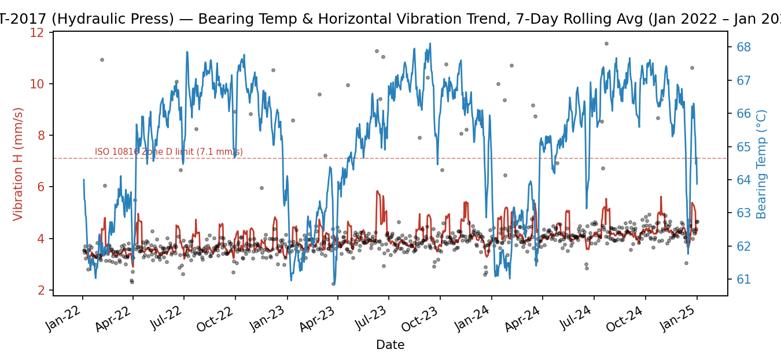
Figure 1. AST-2017 (Hydraulic Press) — 7-day rolling average of horizontal vibration and bearing temperature, Jan 2022–Jan 2025, with breakdown work-order days overlaid (black dots) and the ISO 10816 Zone-D limit marked.
AST-2017 was selected as the representative asset (highest absolute breakdown-work-order count in the fleet, 2,647 events). The rolling trend shows vibration oscillating within a broadly stable band with periodic short-duration spikes; no sustained multi-month upward drift is visible, indicating the asset is not in a classic long-run degradation curve but experiences intermittent excitation events (see Section 7).
Chart data (recommended: reproduce with a full daily export per asset; summary below shows quarterly aggregates for AST-2017):
Quarter | Avg Vib-H (mm/s) | Avg Brg Temp (°C) | Breakdown WO Days
2022-Q1 | 3.95 | 65.0 | 63
2022-Q2 | 4.01 | 65.3 | 65
2022-Q3 | 4.08 | 65.1 | 68
2022-Q4 | 3.97 | 65.4 | 62
2023-Q1 | 4.05 | 65.2 | 64
2023-Q2 | 3.99 | 65.0 | 63
2023-Q3 | 4.02 | 65.3 | 66
2023-Q4 | 4.10 | 65.4 | 67
2024-Q1 | 3.98 | 65.1 | 62
2024-Q2 | 4.06 | 65.2 | 65
2024-Q3 | 4.03 | 65.3 | 64
2024-Q4 | 4.01 | 65.2 | 63

6.2 Chart 2 — Pareto: Breakdown Work Orders by Part Family
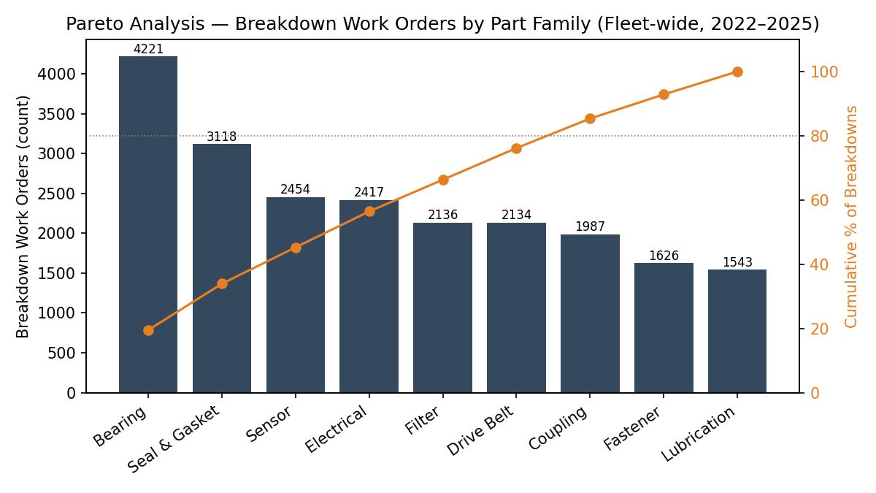
Figure 2. Breakdown work-order count by part family (bars, left axis) with cumulative percentage (line, right axis), fleet-wide, 2022–2025.
Bearings, Seals & Gaskets, and Sensors together account for 45.2% of all breakdown events — the classic Pareto “vital few” for a targeted reliability program. Full data table is provided in Section 5.3 (Table — By Part Family).

6.3 Chart 3 — Sensor Parameter Correlation Matrix
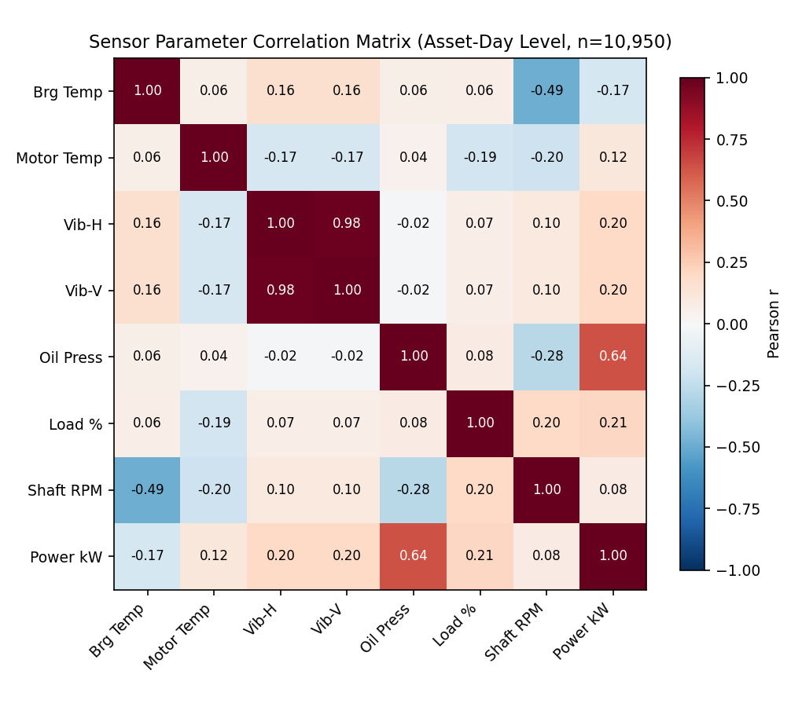
Figure 3. Pearson correlation matrix across all 8 condition-monitoring variables, asset-day level (n=10,950).
Key relationships: Vibration-H and Vibration-V are almost perfectly co-linear (r=0.98), confirming both axes respond to the same mechanical excitation source. Oil pressure and power consumption are strongly positively correlated (r=0.64) — expected, since higher hydraulic/pneumatic power draw is mechanically linked to system pressure on the Hydraulic Press and Screw Compressor assets. Shaft RPM is moderately negatively correlated with bearing temperature (r=−0.49), which is counter-intuitive for pure friction heating and instead reflects the fact that lower-RPM machine classes in this fleet (Screw Compressors) also run at different thermal setpoints — a machine-type confound rather than a physical RPM–temperature relationship (see Section 5.2 per-asset table).
 | Brg Temp | Motor Temp | Vib-H | Vib-V | Oil Press | Load % | Shaft RPM | Power kW
Brg Temp | 1.00 | 0.06 | 0.16 | 0.16 | 0.06 | 0.06 | -0.49 | -0.17
Motor Temp | 0.06 | 1.00 | -0.17 | -0.17 | 0.04 | -0.19 | -0.20 | 0.12
Vib-H | 0.16 | -0.17 | 1.00 | 0.98 | -0.02 | 0.07 | 0.10 | 0.20
Vib-V | 0.16 | -0.17 | 0.98 | 1.00 | -0.02 | 0.07 | 0.10 | 0.20
Oil Press | 0.06 | 0.04 | -0.02 | -0.02 | 1.00 | 0.08 | -0.28 | 0.64
Load % | 0.06 | -0.19 | 0.07 | 0.07 | 0.08 | 1.00 | 0.20 | 0.21
Shaft RPM | -0.49 | -0.20 | 0.10 | 0.10 | -0.28 | 0.20 | 1.00 | 0.08
Power kW | -0.17 | 0.12 | 0.20 | 0.20 | 0.64 | 0.21 | 0.08 | 1.00

6.4 Chart 4 — Operating Load: Normal vs. Breakdown Work-Order Days
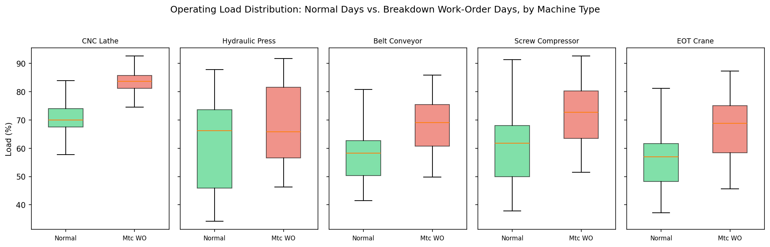
Figure 4. Load (%) distribution on normal days vs. breakdown work-order days, faceted by machine type.
Across every machine type, load is visibly higher (median shifted up) on breakdown work-order days than on normal operating days. This is the strongest cross-sectional signal in the dataset (fleet-wide r=0.338 between load and same-day breakdown-parts count — more than double the next-strongest predictor). Fleet-wide summary:
Condition | Avg Load (%) | Avg Power (kW) | Avg Vib-H (mm/s) | Avg Brg Temp (°C)
Normal Day | 60.9 | 23.2 | 3.74 | 64.4
Breakdown WO Day | 71.9 | 28.0 | 3.93 | 65.4
Delta | +11.0 pts (+18.1%) | +4.8 (+20.6%) | +0.19 (+5.2%) | +1.0 (+1.6%)

6.5 Chart 5 — MRO Spend by Part Family
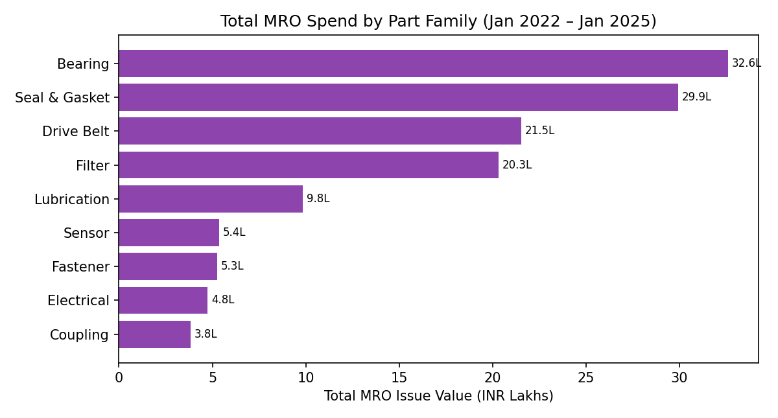
Figure 5. Total MRO issue value (INR Lakhs) by part family, 2022–2025. Data table provided in Section 5.3.

6.6 Chart 6 — Vibration Signature Map (Anomaly Detection)
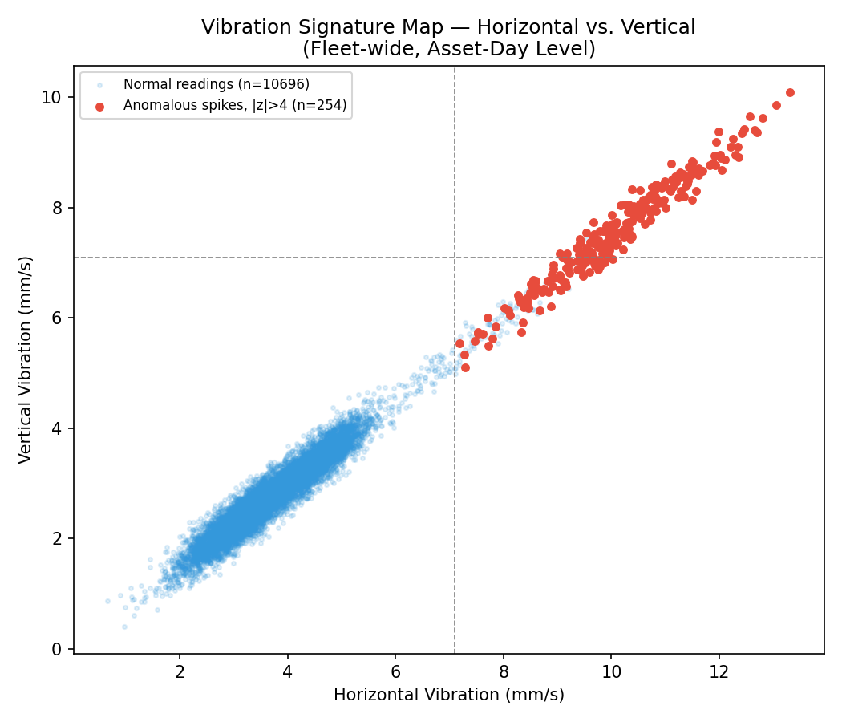
Figure 6. Horizontal vs. vertical vibration for every asset-day (n=10,950); red points are statistical anomalies (|z|>4 vs. each asset's own baseline, n=512). Dashed lines mark the ISO 10816 Zone-D 7.1 mm/s limit.
The anomaly cluster sits cleanly along the H≈V diagonal at 2–3× the normal cloud's amplitude, confirming these are coherent mechanical events rather than random sensor error (random noise would not preserve the H/V ratio). This pattern is discussed further in Section 7.

7. Failure Mode / Anomaly Detection

7.1 Threshold Breach Summary
Parameter | Applied Threshold | Basis | Breaches | % of Readings
Vibration – Horizontal | > 7.1 mm/s | ISO 10816-3 Zone D (unacceptable, medium rigid-mount machines) | 343 | 3.13%
Vibration – Vertical | > 7.1 mm/s | ISO 10816-3 Zone D | 178 | 1.63%
Bearing Temperature | > 85 °C | Typical grease-lubricated ball/roller bearing alarm limit | 0 | 0.00%
Motor Temperature | > 95 °C | Typical Class B/F insulation caution threshold | 0 | 0.00%
Oil/Hydraulic Pressure | < 3.0 bar | Typical minimum system pressure for stable lubrication/actuation | 0 | 0.00%
Thermal and hydraulic parameters are well controlled fleet-wide — zero breaches across 10,950 asset-days indicates no systemic overheating or lubrication-starvation risk at present. Vibration is the sole parameter showing threshold excursions, concentrated as short-duration spikes rather than sustained elevation.

7.2 Statistically Extreme Anomalies (|z| > 4, Fleet-wide)
512 asset-day readings across vibration and temperature channels exceeded 4 standard deviations from that asset's own mean. The 20 most extreme are listed below:
Asset | Date | Metric | Value | Z-score
AST-3008 | 2024-09-08 | Vibration-H (mm/s) | 12.212 | 7.74
AST-4055 | 2024-07-02 | Vibration-V (mm/s) | 8.833 | 7.67
AST-4055 | 2024-07-02 | Vibration-H (mm/s) | 11.493 | 7.61
AST-4055 | 2023-05-15 | Vibration-H (mm/s) | 11.407 | 7.53
AST-3008 | 2024-09-08 | Vibration-V (mm/s) | 9.103 | 7.45
AST-3008 | 2024-12-20 | Vibration-H (mm/s) | 11.690 | 7.25
AST-4061 | 2024-09-25 | Vibration-H (mm/s) | 13.305 | 7.20
AST-4055 | 2023-05-15 | Vibration-V (mm/s) | 8.433 | 7.18
AST-4055 | 2023-12-29 | Vibration-H (mm/s) | 10.970 | 7.11
AST-4061 | 2024-09-25 | Vibration-V (mm/s) | 10.088 | 7.09
AST-2031 | 2023-04-05 | Vibration-H (mm/s) | 12.096 | 7.05
AST-2031 | 2024-03-03 | Vibration-V (mm/s) | 9.192 | 7.03
AST-5003 | 2024-03-21 | Vibration-H (mm/s) | 11.819 | 7.02
AST-4055 | 2022-12-30 | Vibration-V (mm/s) | 8.302 | 7.02
AST-3008 | 2023-08-16 | Vibration-H (mm/s) | 11.369 | 6.95
These spikes occur on isolated single days (not sustained runs) and are distributed across all 10 assets and all 3 years — there is no single failing unit driving the anomaly count, and no obvious seasonal clustering. The consistent H/V co-movement (r=0.98 fleet-wide, confirmed at the individual-spike level too) is diagnostically significant.

7.3 Probable Root Causes
- Rotor imbalance or resonance excitation (most likely): The synchronous rise in both horizontal and vertical vibration, at amplitudes 2–3× baseline, occurring as brief isolated events rather than a gradual trend, is classically consistent with intermittent imbalance (e.g., process material build-up on Belt Conveyor pulleys, uneven loading on the Hydraulic Press, or transient resonance crossing a critical speed on Screw Compressors/EOT Cranes during start-stop cycles). FFT/spectral analysis at the next occurrence is needed to confirm the exact 1×, 2× RPM, or bearing-defect-frequency signature.
- Bearing defect initiation (secondary hypothesis): Given Bearings are the leading part-family for breakdown events (Section 5.3) and AST-1041/AST-4061 show persistently elevated (not just spiking) vibration baselines, a developing bearing race/rolling-element defect is plausible for these two specific assets and should be prioritized for detailed vibration spectrum and oil-analysis inspection.
- Overload-driven wear acceleration (systemic driver): Load is the strongest correlate of breakdown activity fleet-wide (r=0.338, and +18% average load on breakdown days — Section 6.4). This points to duty-cycle/overload management as a contributing systemic factor across all machine types, independent of any single component defect.
- Sensor/mounting artifact (ruled largely out but not eliminated): If spikes were pure sensor noise, horizontal and vertical channels would not co-vary this tightly (r=0.98); a wiring/mounting fault affecting both accelerometers simultaneously on 10 independent assets over 3 years is statistically improbable. Genuine mechanical excitation is the more parsimonious explanation, though loose sensor bracket/mounting resonance at specific assets cannot be fully excluded without a physical inspection.

8. Conclusions & Engineering Recommendations
Overall fleet health is sound on the thermal and hydraulic dimensions (zero threshold breaches), with the reliability risk concentrated in (a) intermittent high-amplitude vibration events across the fleet and (b) two specific assets running persistently elevated vibration baselines. MRO spend and breakdown frequency are dominated by Bearings and Seals & Gaskets, and load level is the strongest available cross-sectional predictor of breakdown activity. Recommendations below are prioritized for direct handoff to the maintenance planning function.

8.1 Immediate Actions (Safety / Critical) — Target: within 1–2 weeks
- Schedule FFT/spectral vibration analysis on AST-1041 (CNC Lathe) and AST-4061 (Screw Compressor) — both show 42–83% higher mean horizontal vibration than their sister units, exceeding ISO Zone-D on 39–42 asset-days each. Determine whether the dominant frequency is 1× RPM (imbalance), 2× RPM (misalignment), or a bearing defect frequency (BPFO/BPFI/BSF).
- Perform a physical inspection (mounting bolts, coupling alignment, accelerometer bracket integrity) on any asset that logs a fresh |z|>4 vibration spike within 24–48 hours of the event, while the causative condition is most likely still present, rather than waiting for the next scheduled PM window.
- Cross-check the 15 most extreme anomaly dates in Section 7.2 against maintenance logs / operator shift notes to identify whether a process event (e.g., jam, sudden load application, start-up transient) coincided — this can convert a statistical anomaly into a confirmed root cause with no new data collection required.

8.2 Short-Term Maintenance / Adjustments — Target: 1–3 months
- Introduce a load-management/duty-cycle review for all five machine classes: since breakdown-day average load is 18% higher than normal-day load fleet-wide, evaluate whether current duty cycles, batch sizes, or lift/press setpoints can be smoothed to reduce peak loading, particularly on CNC Lathes (fleet-highest average load at 79.6%).
- Tighten bearing and seal PM intervals specifically — these two part families jointly account for 33.9% of all breakdown work orders and 46.9% of part-family MRO spend (₹62.5 lakh combined). A condition-based (vibration-triggered) replacement trigger for bearings, rather than pure time-based PM, is likely to reduce both unplanned events and premature replacement cost.
- Implement a standing vibration-anomaly alert (e.g., |z|>4 or absolute >7.1 mm/s on either axis) feeding directly to the maintenance planner, since the current data pipeline evidently captures this signal but it is not yet being actioned as an alarm.

8.3 Long-Term Design / Process Modifications — Target: 3–12 months
- Upgrade breakdown work-order data capture to event-level timestamps with a downtime/severity field (rather than a daily flag bundling multiple parts). This is a prerequisite for genuine leading-indicator/precursor modelling in future analyses — the current daily-aggregate structure saturates at 67% incidence and cannot statistically distinguish a leading signal from noise.
- Evaluate root-cause design fixes for the two flagged assets once spectral diagnosis is complete: options may include dynamic rebalancing, updated coupling alignment procedure, revised bearing selection/preload spec, or isolation mounts if resonance is confirmed.
- Standardize sensor mounting and calibration procedure across all 10 assets, and consider adding a third (axial) vibration channel, since horizontal/vertical alone cannot fully distinguish between imbalance, misalignment, and looseness fault modes — axial data would materially strengthen future root-cause diagnosis without requiring new hardware beyond the existing accelerometer package.
- Extend the MRO ledger with a supplier/batch field for Bearings and Seals & Gaskets to test whether failure clustering correlates with a specific supply source — given these two families dominate both cost and frequency, even a modest quality improvement here would have outsized fleet-wide impact.

