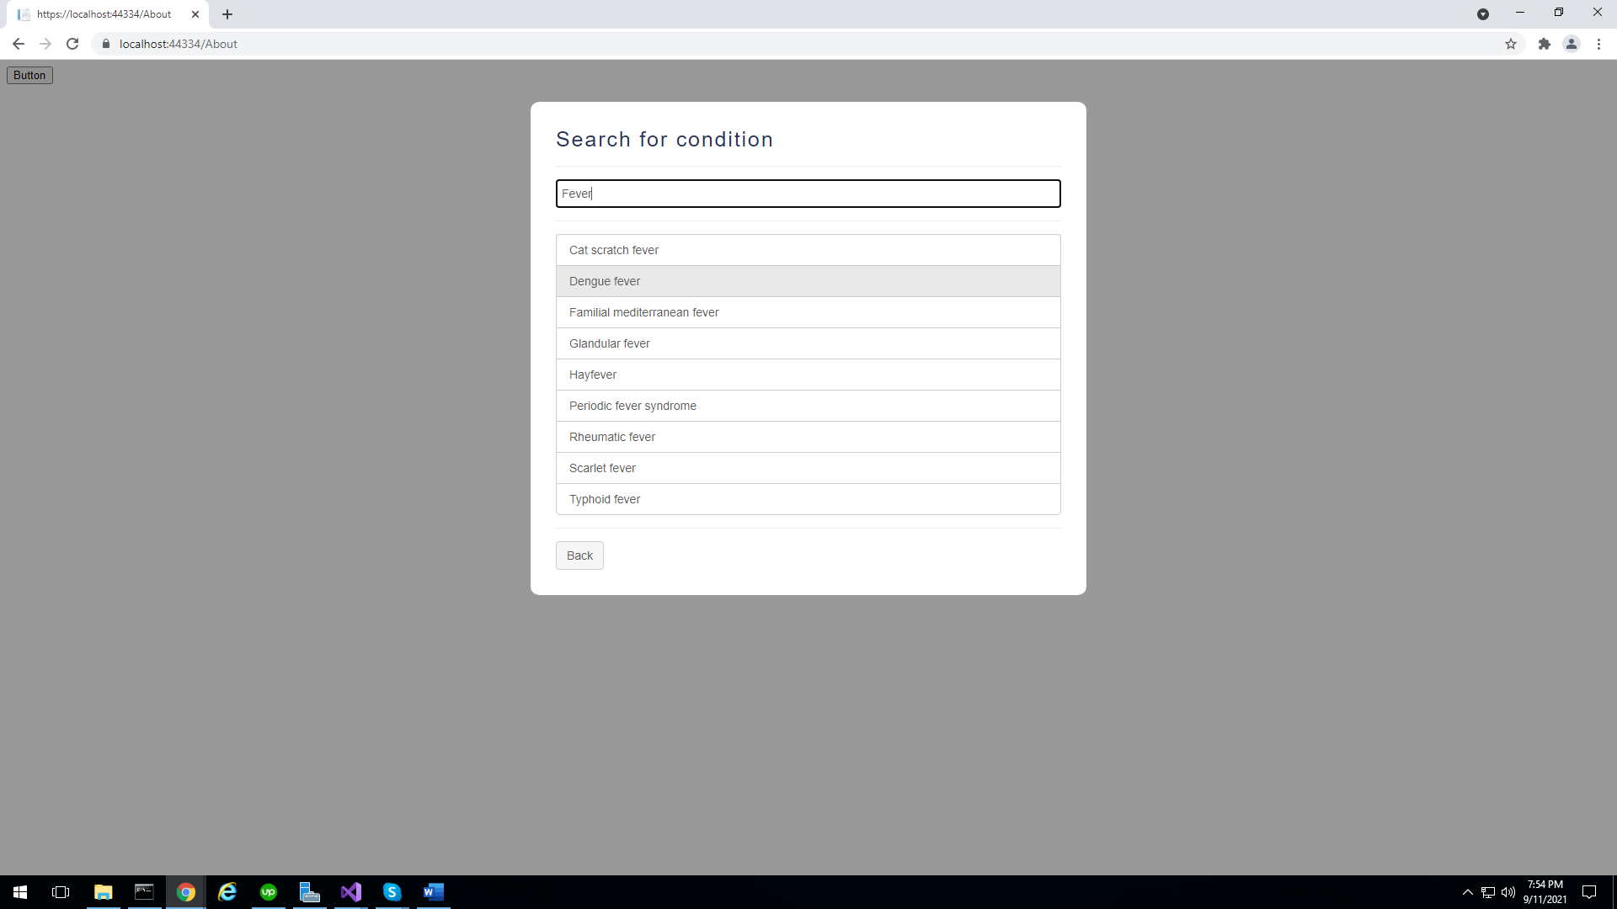

**Step 1-- First I select the Dengue Fever in Search Conditions and Add into the Conditions.**

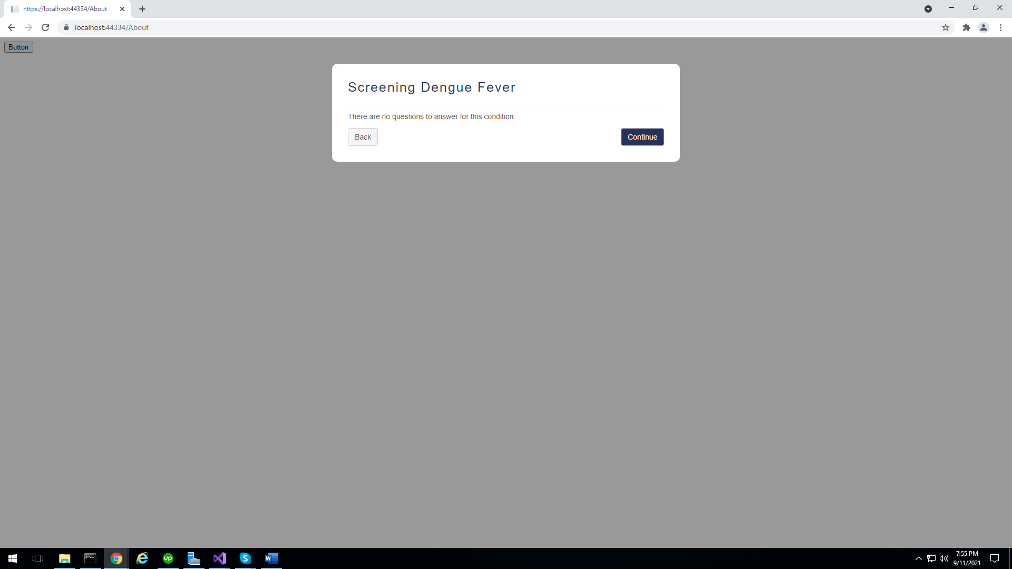

**Step -2 – Here you see there Is no Question In This Conditions**

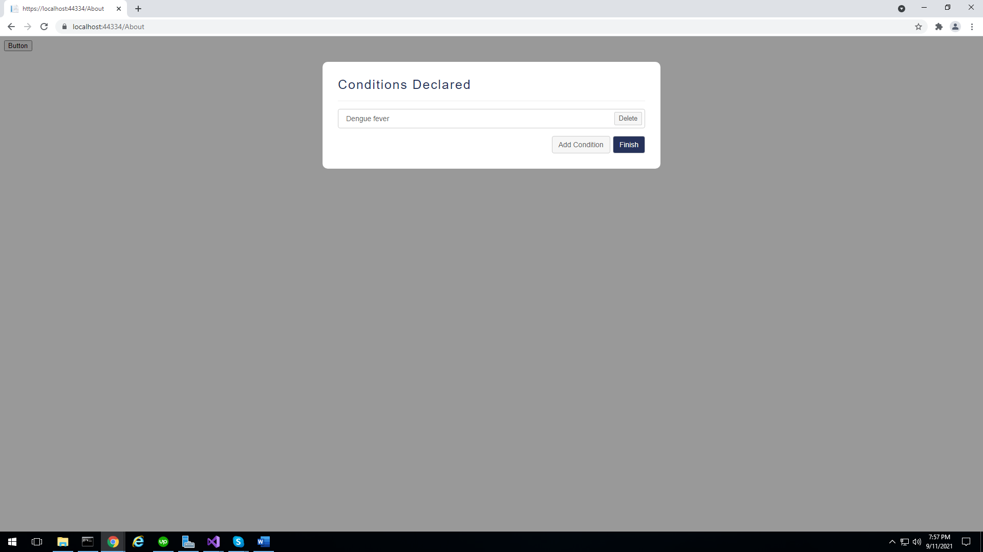

**Step-3 – Click On finish**

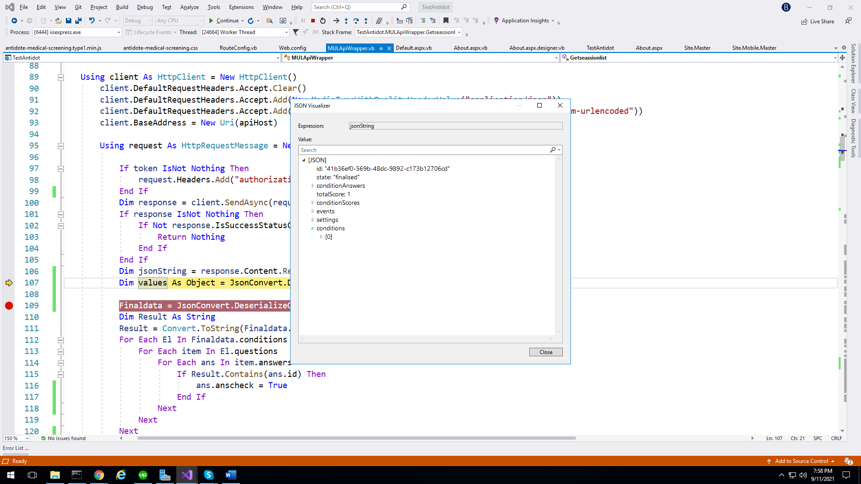

**Here you can See we have conditions but its showing Question [] like this**

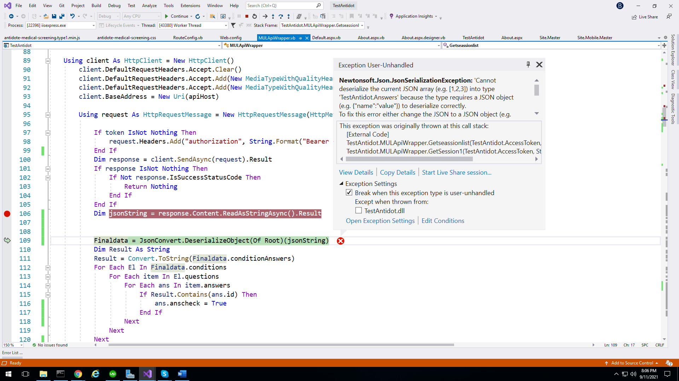

**This is the Error :--**

**Newtonsoft.Json.JsonSerializationException: 'Cannot deserialize the current JSON array (e.g. [1,2,3]) into type 'TestAntidot.Answers' because the type requires a JSON object (e.g. {"name":"value"}) to deserialize correctly. To fix this error either change the JSON to a JSON object (e.g. {"name":"value"}) or change the deserialized type to an array or a type that implements a collection interface (e.g. ICollection, IList) like List<T> that can be deserialized from a JSON array. JsonArrayAttribute can also be added to the type to force it to deserialize from a JSON array. Path 'events[2].data.answers', line 1, position 1146.'**

**This Error is for when Conditions don’t have any Questions and Answers then the Answer class does not gave any json oject and but its Requires Json Object.**