MINI PROJECT PHASE 2

COMPUTER ARCHITECTURE LAB

CS210 FINAL PROJECT

TWO CARD FLIP GAME

BY BHAVIK

INSTRUCTIONS FOR THE GAME IN PROJECT:

STEP 1:

Load the game.c file attached along with the submitted folder in Intel FPGA Monitor Program. Connect the Intel DE1 – SoC Board with the system and load that file on the board. Make sure to connect the FPGA Board with VGA display along with PS2 keyboard for game inputs.

STEP 2:

Initially, the screen will be blank. After that, you have 4 options for playing game. Push buttons [3:0] are assigned for choosing the level of game.

PB-0 : Easy (1 x 4 cards)

PB-1 : Medium (2 x 4 cards)

PB-2 : Hard (3 x 4 cards)

PB-3 : Very Hard (4 x 4 cards)

STEP 3:

After choosing the level, a screen will pop up. An example is shown below:

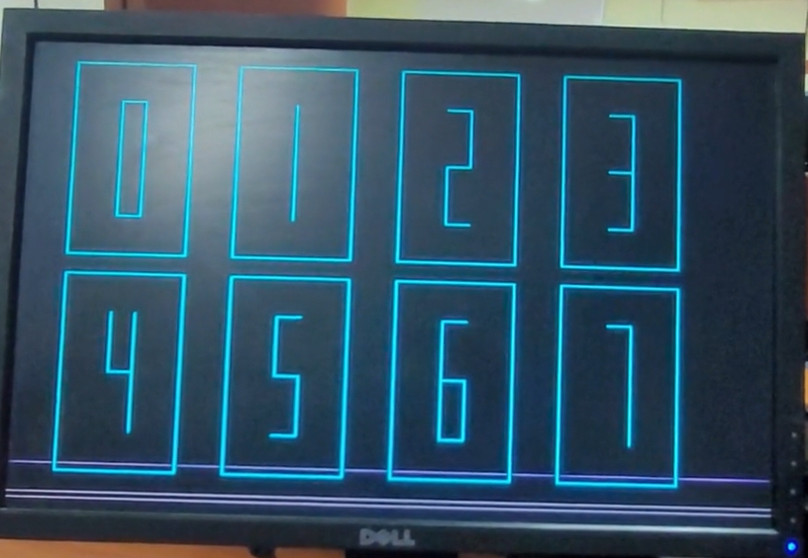

STEP 4:

After completion of the above steps, you will have to choose a card from PS2 keyboard using the literals written above the card which will flip that card. Again, choose a card. If two consecutive cards have same shapes behind them, the card will consider else the previous flipped card will get flipped again to its initial position.

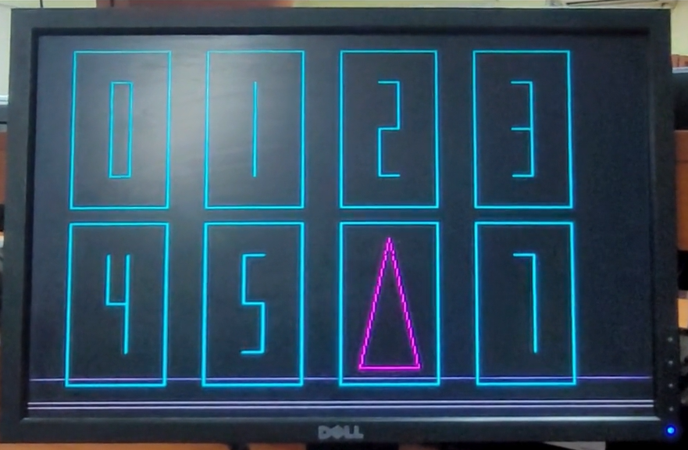

STEP 5:

After all the card gets flipped, the game will end and restarts and will ask for level using Push Buttons.

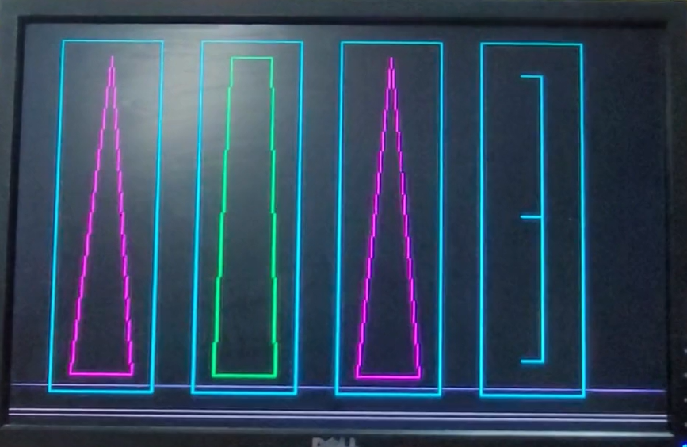

THANK YOU