1. HOMOGRAPHY ESTIMATION
2. Describe your solution, including any interesting parameters or implementation choices for feature extraction, putative matching, RANSAC, etc.

Solution:

1. Load images and perform histogram equalization on them.
2. Find features in both images – features are corners. Given harris detector function was used.
3. Extract neighborhood for each feature.
4. Find normalized correlation between each pair of feature descriptors from both images.
5. Select top few desired number of putative matches.
6. Run RANSAC algorithm on top putative matches – this step returns homography matrix, number of inliers, number of outliers, consensus group, the 4 best randomly picked matches.
7. Stitch the images based on the computed homographhy.

Interesting choices:

1. First interesting choice was to perform histogram equalization on the images. This equalized the contrast in respective images which increased the chances of getting better matches by performing a pseudo normalization on intensity values across both the images.
2. Second interesting choice was to use normalized correlation between feature descriptors to find putative matches. Since normalized correlation is invariant to intensity values, better matches were computed.
3. Both point b and point a ensured that the putative matches passed to the RANSAC algorithm were as optimum as possible to reduce any error that may arise from bad putative matches. As a direct result, number of iterations required by RANSAC are low and RANSAC produces almost same homography matrix every time the code is run with a very high inlier count.
4. Third interesting choice was to use to the SVD method to compute H. This ensured that H33 would not be unnecessarily set to 1 and eliminated any errors arising out of that.
5. For the uttower pair provided, report the number of homography inliers and the average residual for the inliers (squared distance between the point coordinates in one image and the transformed coordinates of the matching point in the other image). Also, display the locations of inlier matches in both images.

|  |  |  |
| --- | --- | --- |
| Sr Nos | Parameters | Observed values |
| 1 | Number of inliers | 50 |
| 2 | Average residual | 17.1438 |

Number of matches feed to RANSAC = 100

Number of iterations = 500

Threshold for loss function = 1

Plot of inliers: UTTOWER

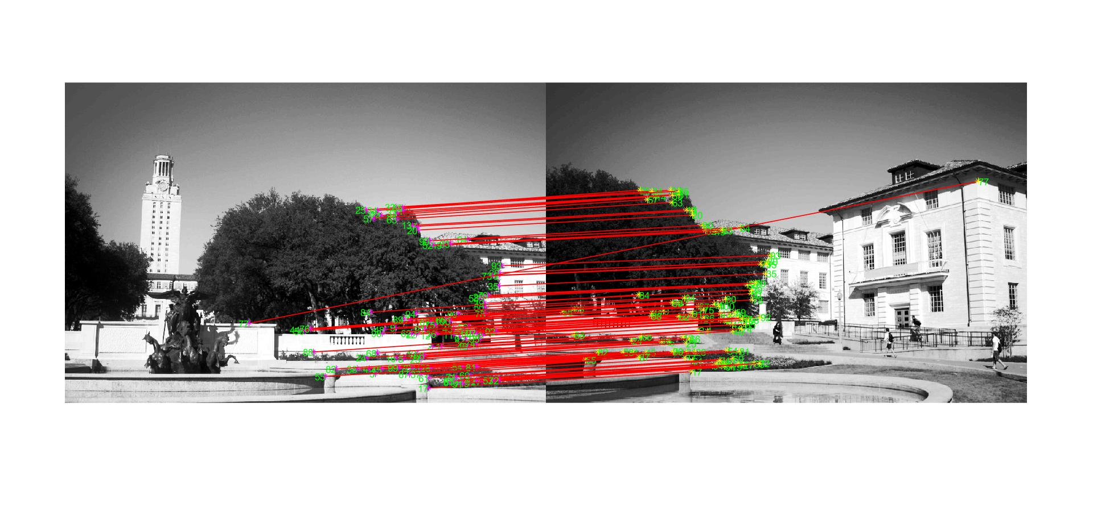

Before applying RANSAC

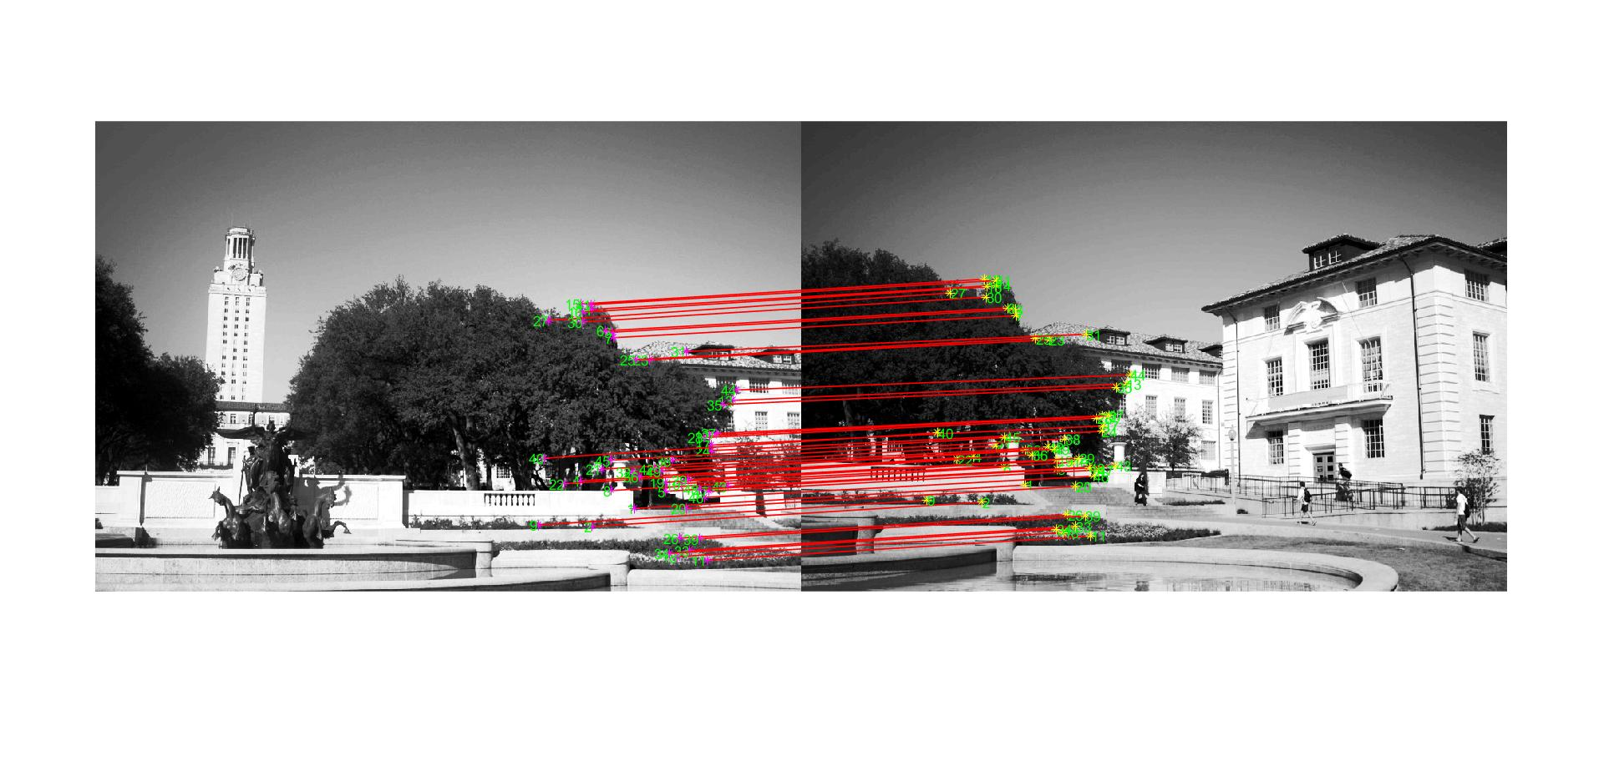

B apply RANSAC

Plot of inliers: Ledge

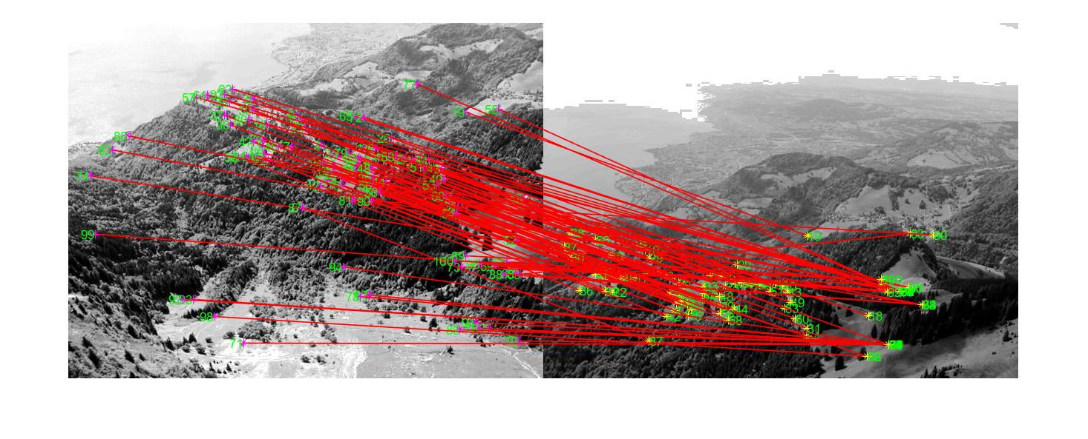

Before applying RANSAC

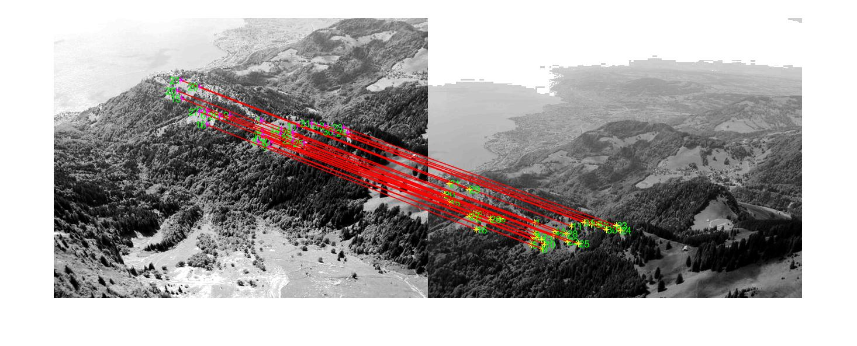

After applying RANSAC

1. Display the final result of your stitching.

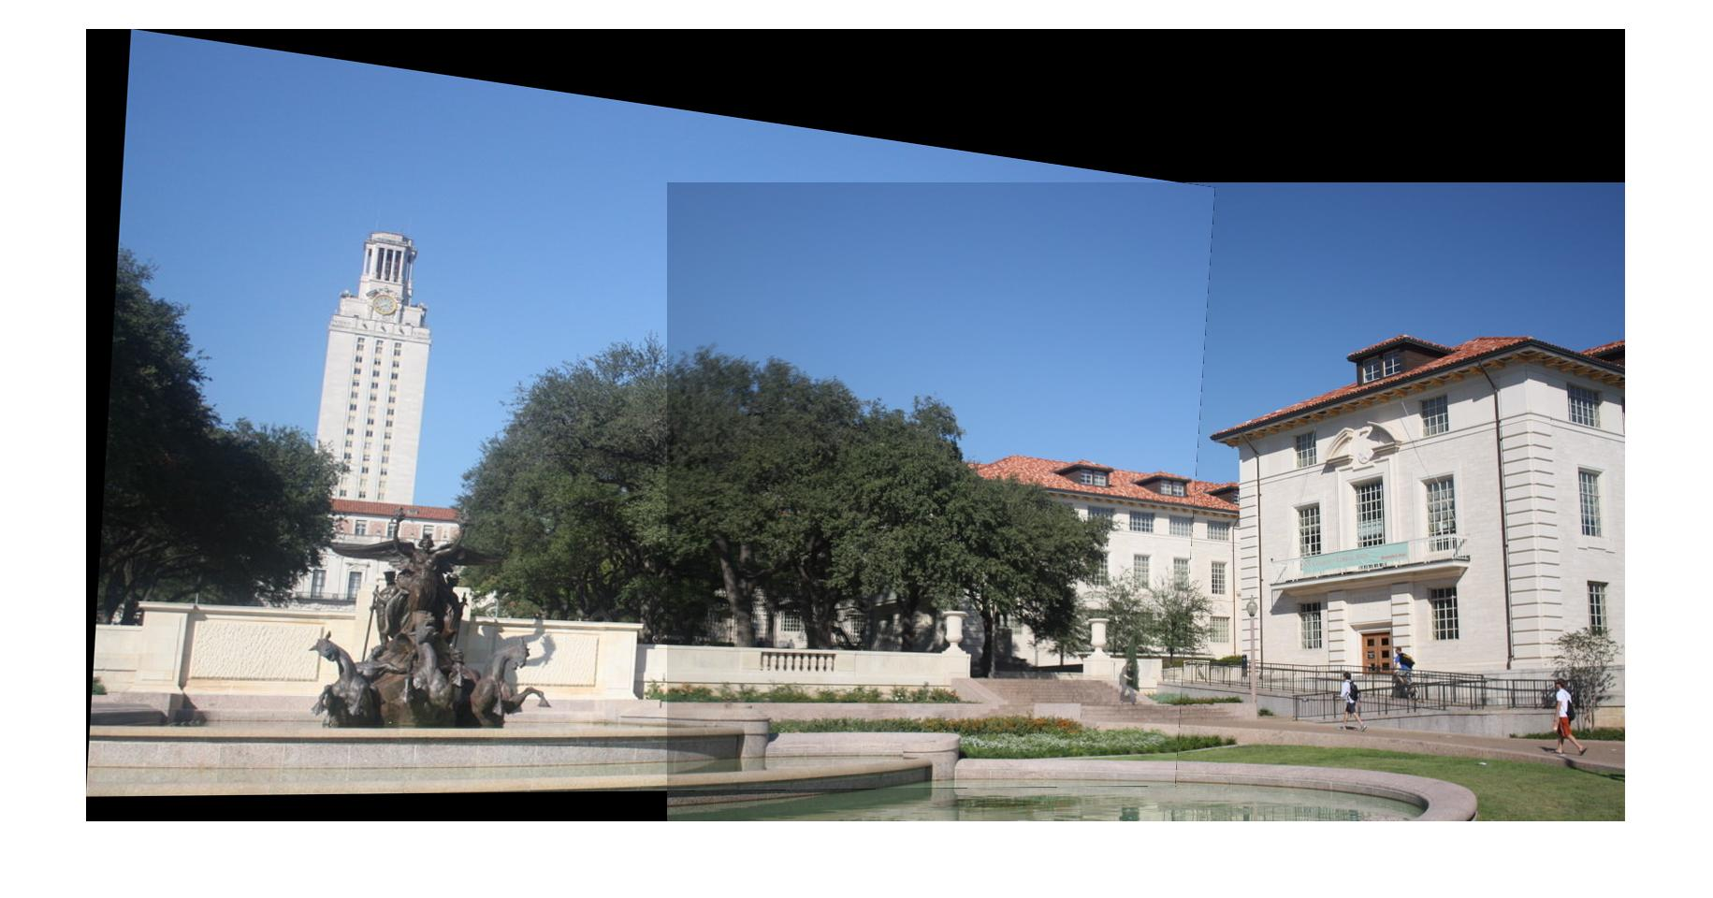

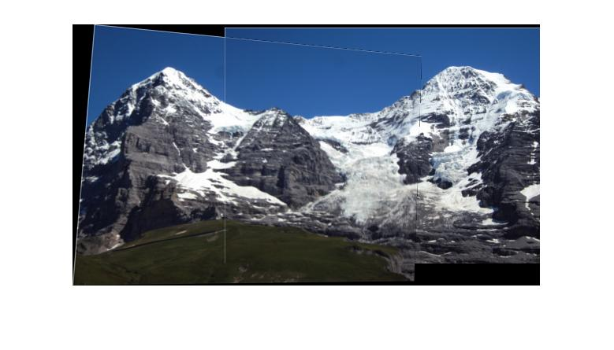

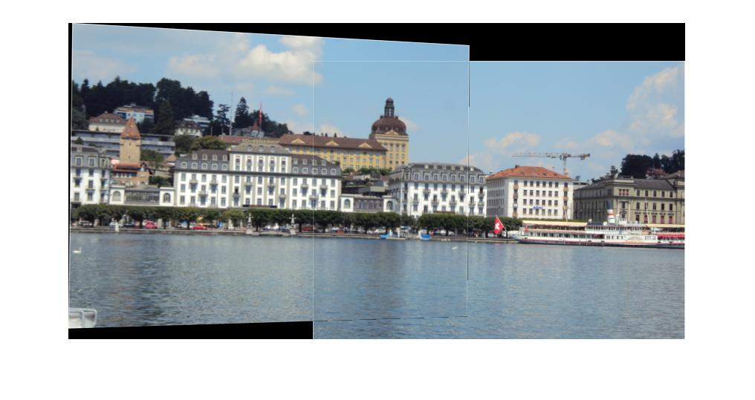

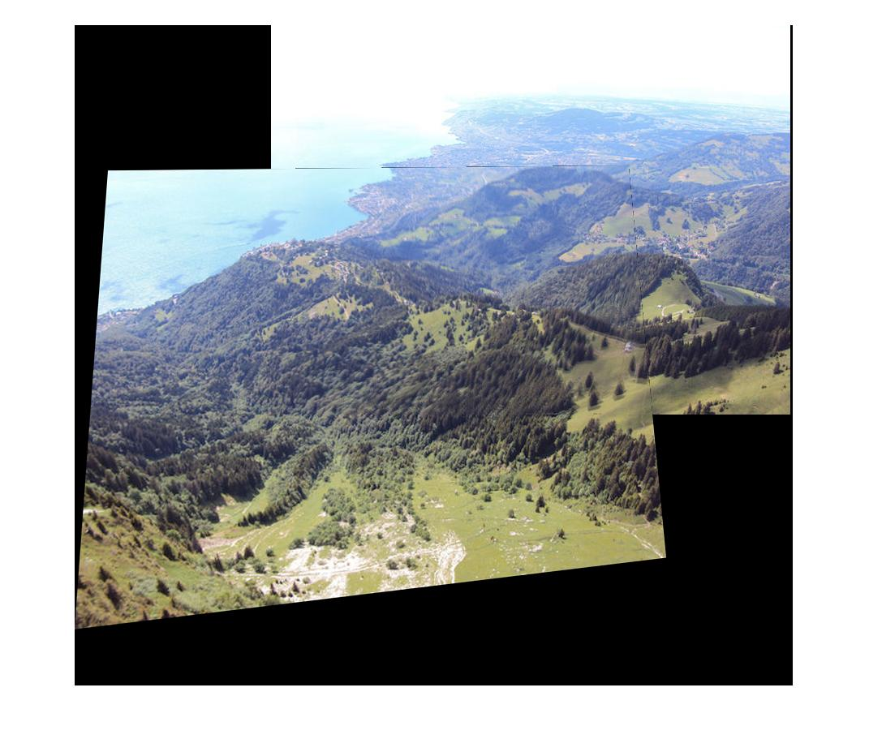

1. FUNDAMENTAL MATRIX ESTIMATION
2. For both image pairs, for both unnormalized and normalized estimation using ground truth matches, display your result and report your residual.

Unnormalized fundamental matrix

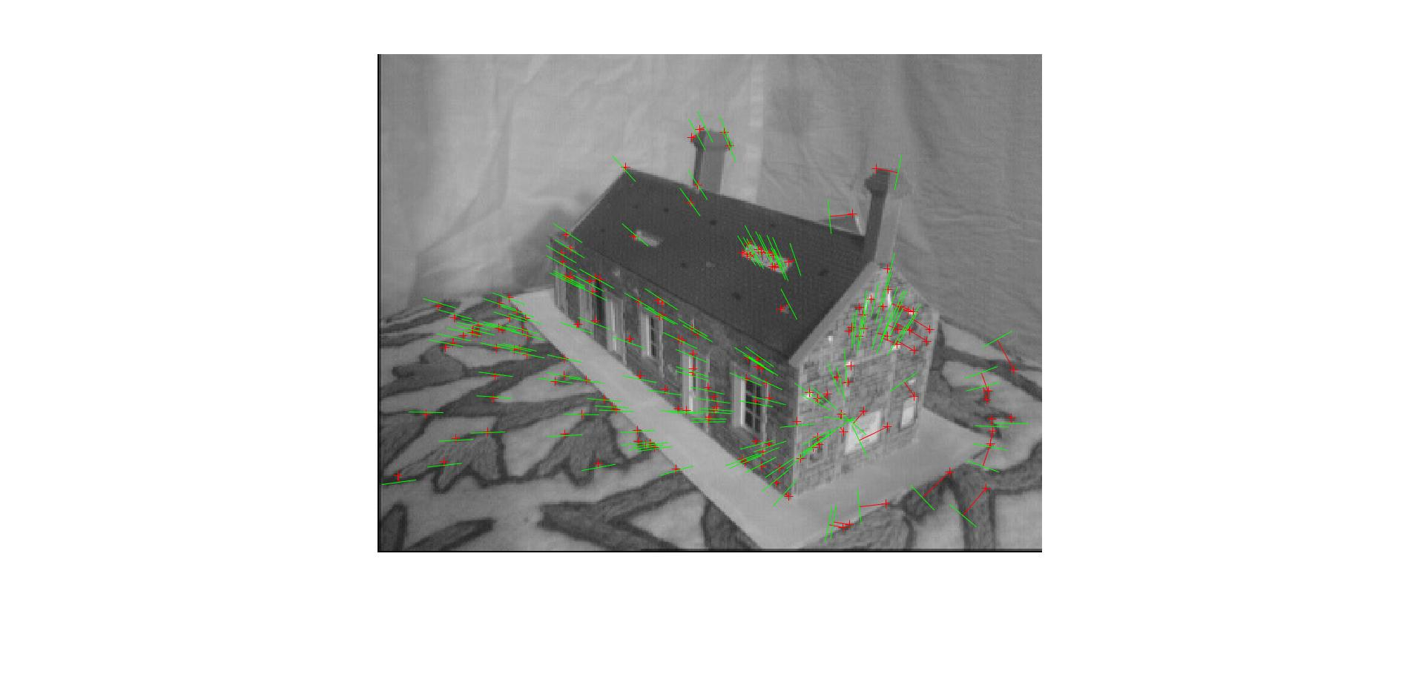

Normalized fundamental matrix

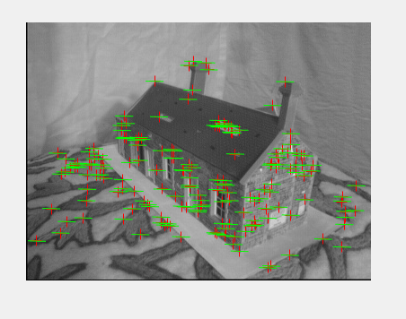

|  |  |  |
| --- | --- | --- |
| Sr Nos | Unnormalized | Normalized |
| 1. Avg algebraic dist | 3.44051e-05 | 9.3086e-09 |
| 2. Avg geometric dist | 42.8993 | 0.1387 |

1. For both image pairs, for normalized estimation without ground truth matches, display your result and report your number of inliers and residual for inliers.

House:

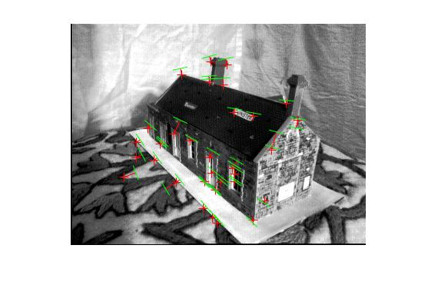

Library:

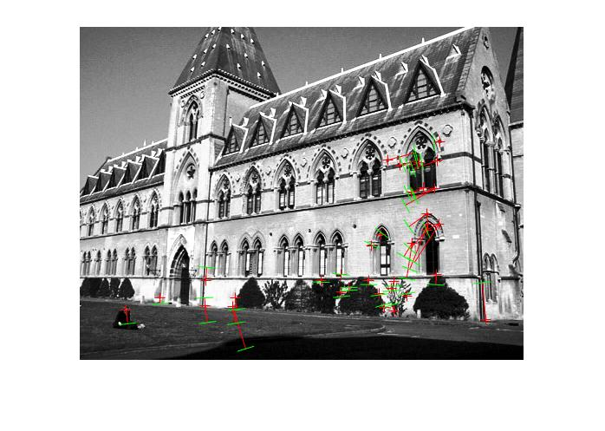

|  |  |  |
| --- | --- | --- |
| Sr nos | Image | Mean squared residue |
| 1. | House | 8.5634e-07 |
| 2. | Library | 0.0025 |

1. For both image pairs, visualize 3D camera centers and triangulated 3D points.

House: Yellow and red stars are 2 cameras respectively.

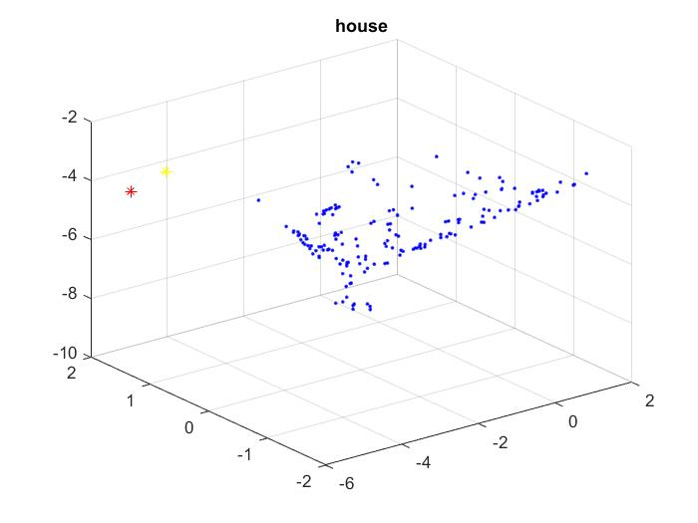

Library: Yellow and red stars are cameras respectively.

