

PROJECT REPORT
EMPLOYEE LEAVE MANAGEMENT SYSTEM
A web-based application for employee leave applications and administrative approvals
Submitted in partial fulfilment of the requirements for
Bachelor of Computer Applications (BCA)
Course: Full Stack Web Development
Course Code: DSC-M-BCA-471P

Submitted by:
Parmar Bhavik Maheshkumar
Roll No : 4003
&
Solanki Dhruv Manojkumar
Roll No : 4004

Under the guidance of
Naina Asnani

Asia Pacific BCA College
Gujarat University
Academic Year : [2026 - 2027]

DECLARATION
We, "Parmar Bhavik"," Solanki Dhruv" hereby declare that the project entitled “Employee Leave Management System” has been prepared by us as part of our BCA Full Stack Web Development coursework. This report describes the application structure, features, technologies, database design, and testing of the project.
We submit this project for academic evaluation. The references section acknowledges the external resources used for learning and implementation.
Signatures:
Parmar Bhavik: ____________________

Solanki Dhruv: ____________________

Date: ______________________________________

Place: _____________________________________

COLLEGE CERTIFICATE
This is to certify that the project report entitled “Employee Leave Management System” is submitted by the student named below as part of the academic requirements for the Bachelor of Computer Applications (BCA) programme.
The project demonstrates the use of ASP.NET Core MVC, C#, Razor Views, Entity Framework Core, SQL Server, ASP.NET Core Identity, and REST API concepts.

Student Name: ______________________________
Enrollment No.: ____________________________

Project Guide: ______________________________
Signature: __________________________________
Head of Department: _________________________
College Seal: _______________________________
Date: ______________________________________
Note: Replace this sample certificate page with the official certificate format and signatures provided by your college.

ACKNOWLEDGEMENT
I would like to express my sincere gratitude to my college and department for providing the opportunity to develop the Employee Leave Management System as part of the BCA Full Stack Web Development course.
I am thankful to my project guide and faculty members for their guidance, feedback, and support throughout the planning and development process. Their suggestions helped me understand the practical use of web development concepts such as MVC architecture, database connectivity, authentication, authorization, and form validation.
I also acknowledge the documentation and learning resources provided by Microsoft and the .NET community, which were useful for understanding ASP.NET Core, Entity Framework Core, and ASP.NET Core Identity.
Finally, I thank everyone who supported me during the preparation of this project and report.
— Student

INDEX
No. | Description | Page No.
1 | College Certificate | 3
2 | Acknowledgement | 4
3 | Project Overview | 6
4 | Purpose and Scope of the Project | 7
5 | Existing vs Proposed System | 8
6 | Feasibility Study | 9
7 | Hardware and Software Requirement Specification | 10
8 | Project Folder Structure | 11
9 | Core Modules | 12
10 | Screenshots | 13
11 | Limitations | 17
12 | Future Enhancements | 18
13 | References | 19

Page numbers are indicative. Update the index after making final edits or adding the official college certificate and application screenshots.

1. PROJECT OVERVIEW

1.1 Introduction
The Employee Leave Management System (ELMS) is a database-driven web application that organizes employee leave requests and administrative decisions in one place. Employees can sign in, view their dashboard, submit leave applications, track request status, review leave history, and change their password. Administrators can manage employee profiles, inspect leave requests, and approve or reject pending applications.

1.2 Problem Statement
When leave requests are handled through paper forms, messages, or spreadsheets, records can be misplaced, status updates may be delayed, and it can be difficult to identify overlapping leave dates. The proposed system centralizes employee and leave information in a relational database and provides role-based access to the main operations.

1.3 Project Objectives
- Provide a central place for employees to submit and track leave requests.
- Allow administrators to manage employee profiles and review leave applications.
- Store employee details and leave records in SQL Server through Entity Framework Core.
- Use secure sign-in and role-based authorization for Admin and Employee users.
- Validate leave dates and prevent overlapping approved leave periods.
- Demonstrate MVC architecture, Razor Views, database migrations, and REST API endpoints.

1.4 Project Summary
Item | Description
Project name | Employee Leave Management System
Academic course | BCA – Full Stack Web Development
Course code | DSC-M-BCA-471P
Application type | Web application
Primary users | Administrator and Employee
Main technology | ASP.NET Core MVC with C#
Database | Microsoft SQL Server / LocalDB
Data access | Entity Framework Core
Authentication | ASP.NET Core Identity
UI approach | Razor Views with plain CSS

2. PURPOSE AND SCOPE OF THE PROJECT

2.1 Purpose
The purpose of ELMS is to make leave management more organized, traceable, and convenient. It reduces the need to maintain separate paper forms or spreadsheets and helps employees and administrators view the current status of each request.

2.2 Project Scope
The current implementation focuses on the core leave workflow and employee record management. It is intended as an academic project and a foundation that can be extended for real organizational use after additional security, deployment, and policy requirements are addressed.

2.3 Included Features
- Login and logout using ASP.NET Core Identity.
- Role-based access for Admin and Employee accounts.
- Employee creation, listing, searching, editing, and details pages.
- Employee login account creation when an administrator creates an employee profile.
- Employee self-service password change requiring the current password.
- Leave application with leave type, start date, end date, and reason.
- Leave status tracking: Pending, Approved, Rejected, and Cancelled.
- Administrator review with an optional comment.
- Validation for past start dates, invalid date ranges, and overlapping approved leave.
- REST API endpoints for employee and leave data.

2.4 Out of Scope
- Payroll processing and salary calculations.
- Attendance, biometric devices, and shift scheduling.
- Automated email/SMS notifications.
- Organization-specific holiday calendars and leave-balance accrual.
- Advanced analytics, audit trails, and multi-branch policy configuration.

2.5 Intended Users
User | Main responsibilities
Administrator | Manage employee profiles; view leave requests; approve or reject pending requests; access protected administrative functions.
Employee | View own dashboard; apply for leave; check own request history and status; cancel pending requests; change own password.

3. EXISTING VS PROPOSED SYSTEM

3.1 Existing System
In a manual or semi-manual process, employees may submit leave requests using paper forms, email, messaging applications, or spreadsheets. The responsible person then records the request and communicates the decision separately.

3.2 Issues in the Existing System
- Requests and approvals may be spread across different places.
- Employees may need to ask an administrator for status updates.
- Duplicate or incomplete records can occur during manual entry.
- Searching old requests can take time.
- Overlapping leave dates may be harder to notice.
- Access to sensitive employee information may not be consistently controlled.

3.3 Proposed System
The proposed ELMS provides a web interface connected to a central SQL Server database. Identity manages user accounts and roles. MVC controllers process requests, validate inputs, and call Entity Framework Core to read or save data. Razor Views present the pages to users, while protected API controllers expose selected data as JSON.

3.4 Comparison
Basis | Existing / Manual System | Proposed ELMS
Record keeping | Paper, messages, or spreadsheets | Central SQL Server database
Request submission | Manual communication | Online form
Status visibility | Requires follow-up | Available through leave history
Approval process | Manual update or message | Admin review and status update
Validation | Depends on manual checking | Application-level validation
Access control | May be informal | Identity authentication and role authorization
Search | Manual scanning | Search and database queries
Extensibility | Difficult to standardize | Can add modules and API endpoints

3.5 Expected Benefits
- Improved visibility of employee leave requests.
- More consistent storage of employee and leave information.
- Clear separation between administrative and employee actions.
- Reduced manual effort for common leave-management tasks.
- A foundation for future HR-related features.

4. FEASIBILITY STUDY

4.1 Technical Feasibility
The project uses the .NET ecosystem, ASP.NET Core MVC, Entity Framework Core, and SQL Server. These technologies support web applications, database access, authentication, and API development. The project can be developed in VS Code with the .NET SDK and a local SQL Server or LocalDB instance.

4.2 Economic Feasibility
The project can be developed using freely available development tools such as the .NET SDK and Visual Studio Code. SQL Server LocalDB can be used for local academic testing. Hosting, production database services, domain registration, and operational support may introduce costs if the system is deployed for real users.

4.3 Operational Feasibility
The system uses familiar web forms, tables, buttons, and status labels. Employees can submit and review their own requests, while administrators manage employee records and make decisions. Basic training and clear usage instructions should be sufficient for a demonstration.

4.4 Schedule Feasibility
The project is modular and suitable for academic development in stages: setup, database design, authentication, employee management, leave workflow, API implementation, testing, and documentation. The final schedule depends on the student's available time and review requirements.

4.5 Legal and Security Considerations
A real deployment should follow applicable privacy and employment rules, use HTTPS, protect database credentials, restrict access to employee information, and apply an organizational leave policy. The academic version should use test data and should not store real sensitive information without approval.

4.6 Feasibility Conclusion
The project is technically and operationally feasible as a BCA web development project. Production use would require further testing, deployment planning, policy configuration, monitoring, and a formal security review.

5. HARDWARE AND SOFTWARE REQUIREMENT SPECIFICATION

5.1 Hardware Requirements
Component | Minimum practical requirement
Processor | Dual-core processor or better
RAM | 4 GB minimum; 8 GB recommended
Storage | At least 2 GB free for tools and project files, plus database space
Display | 1366 × 768 resolution or higher recommended
Network | Internet connection for initial tool/package installation; local network optional

5.2 Software Requirements
Software | Purpose
Windows 10/11 or compatible OS | Development and local execution environment
.NET 10 SDK | Build and run the ASP.NET Core application
Visual Studio Code | Code editor
C# Dev Kit / C# extension | C# language support and debugging
SQL Server LocalDB or SQL Server Express | Relational database
Entity Framework Core tools | Apply migrations and manage schema
Web browser | Access and test the application
Git (optional) | Version control

5.3 Frameworks and Libraries
- ASP.NET Core MVC: routes requests to controllers and views.
- Razor Pages: supports Identity account pages and the password-change page.
- ASP.NET Core Identity: handles login, password hashing, and role management.
- Entity Framework Core: maps C# entities to database tables and performs queries.
- SQL Server provider: connects EF Core to SQL Server.
- Swashbuckle / Swagger: documents and displays available API endpoints in Development.

5.4 Configuration Notes
The project targets .NET 10. Its connection string is configured in appsettings.json. For a fresh database, apply the included InitialCreate migration with the Entity Framework command `dotnet ef database update`. Development admin credentials should be provided through environment variables or secure configuration and should never be committed to source control.

6. PROJECT FOLDER STRUCTURE
The main application folder is Employee_Leave_Management_System. The following list summarizes the important files and directories in the supplied project archive.
Folder / File | Purpose
Program.cs | Registers services, configures middleware, routes, Identity, Swagger, and database initialization.
appsettings.json | Contains application configuration, including the database connection string.
EmployeeLeaveManagementSystem.csproj | Defines the target framework and NuGet package references.
Controllers/ | MVC controllers for dashboard, employee management, and leave requests.
Controllers/Api/ | Protected REST API controllers for employee and leave data.
Models/ | Entity classes for ApplicationUser, Employee, and LeaveRequest.
ViewModels/ | Form-specific models such as leave application and decision input.
Data/ApplicationDbContext.cs | Entity Framework Core database context.
Data/SeedData.cs | Creates required roles and configured development admin account.
Migrations/ | EF Core migration and model snapshot used to create/update database schema.
Areas/Identity/Pages/Account/ | Identity account pages, including ChangePassword.
Views/Dashboard/ | Admin and employee dashboard views.
Views/Employees/ | Employee list, create, edit, details, and delete views.
Views/LeaveRequests/ | Leave application, history, and review views.
Views/Shared/ | Shared layout and common navigation.
wwwroot/css/site.css | Styles for page layout, forms, tables, and status messages.

6.1 Application Flow
- The user opens the application in a web browser.
- ASP.NET Core routing selects the relevant MVC controller or Razor Page.
- Authentication identifies the signed-in user and authorization checks their role.
- The controller validates the request and uses ApplicationDbContext or Identity services.
- Entity Framework Core communicates with SQL Server.
- The application returns a Razor View or JSON response.

7. CORE MODULES

7.1 Authentication and Authorization
ASP.NET Core Identity manages login, logout, password hashing, and user roles. The application defines Admin and Employee roles. Controller and API attributes restrict protected operations. Password changes are performed through Identity and require the current password.

7.2 Employee Management
The Employees module allows an administrator to view and search employee records, create a profile, edit details, view employee information, and delete a record when it has no leave history. Employee details include full name, email, department, designation, joining date, and the optional linked Identity user ID.

7.3 Employee Dashboard
The employee dashboard is intended to show employee-facing information. If an account is not linked to an employee profile, the application displays a profile-missing message and asks the user to contact the administrator.

7.4 Leave Application
An authenticated employee can apply for Casual, Sick, or Earned leave. The form collects leave type, start date, end date, and reason. The application checks that the start date is not in the past, the end date is not before the start date, and the request does not overlap an already approved leave period.

7.5 Leave History and Status Tracking
Leave requests are stored with the employee ID, leave type, date range, reason, application timestamp, status, and optional administrator comment. Status values are Pending, Approved, Rejected, and Cancelled. Employees see their own requests; administrators can review requests across employees.

7.6 Leave Review and Decision
Administrators can open a pending request and approve or reject it, optionally adding a comment. Only pending requests can be reviewed. Before approval, the system checks for overlap with another approved request for the same employee.

7.7 REST API
Method | Route | Access / purpose
GET | /api/employees | Admin: list employee records
GET | /api/employees/{id} | Admin: retrieve one employee record
GET | /api/leaves | Authenticated: list leave records; employees are limited to their own
GET | /api/leaves/{id} | Authenticated: retrieve a leave request subject to ownership checks
POST | /api/leaves | Employee/Admin: submit a leave request using JSON
POST | /api/leaves/{id}/decision | Admin: approve or reject a pending request

The Development environment enables Swagger UI at `/swagger`. Protected API endpoints require authentication. The API should be tested using an appropriate authenticated session or a configured API authentication flow.

7.8 Database Design
Entity / table | Key information
Identity tables | User accounts, password hashes, roles, and role assignments.
Employees | Employee profile and optional one-to-one link to an Identity user.
LeaveRequests | Leave type, dates, reason, status, timestamp, and admin comment.

One employee can have multiple leave requests. An Identity user can be linked to zero or one employee profile. Employee deletion is blocked when leave history exists.

8. SCREENSHOTS
Insert actual screenshots from the running application in the spaces below. Use screenshots captured from your own project; do not submit sample or imagined screens as proof of execution.

8.1 Login Page
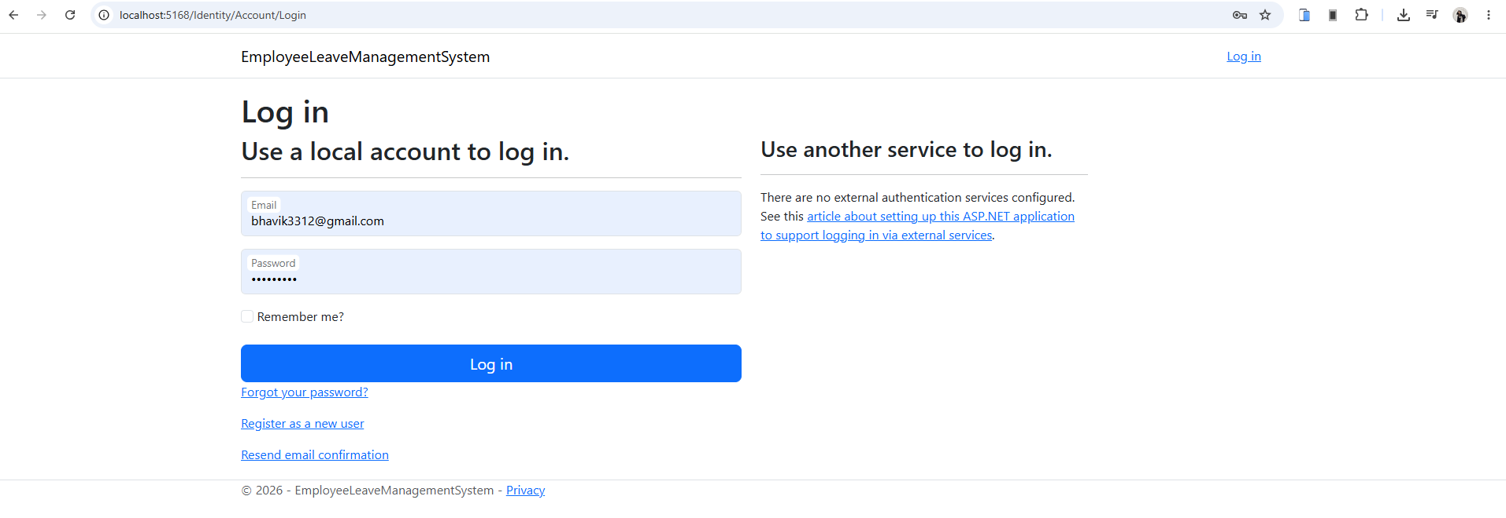

8.2 Admin Dashboard
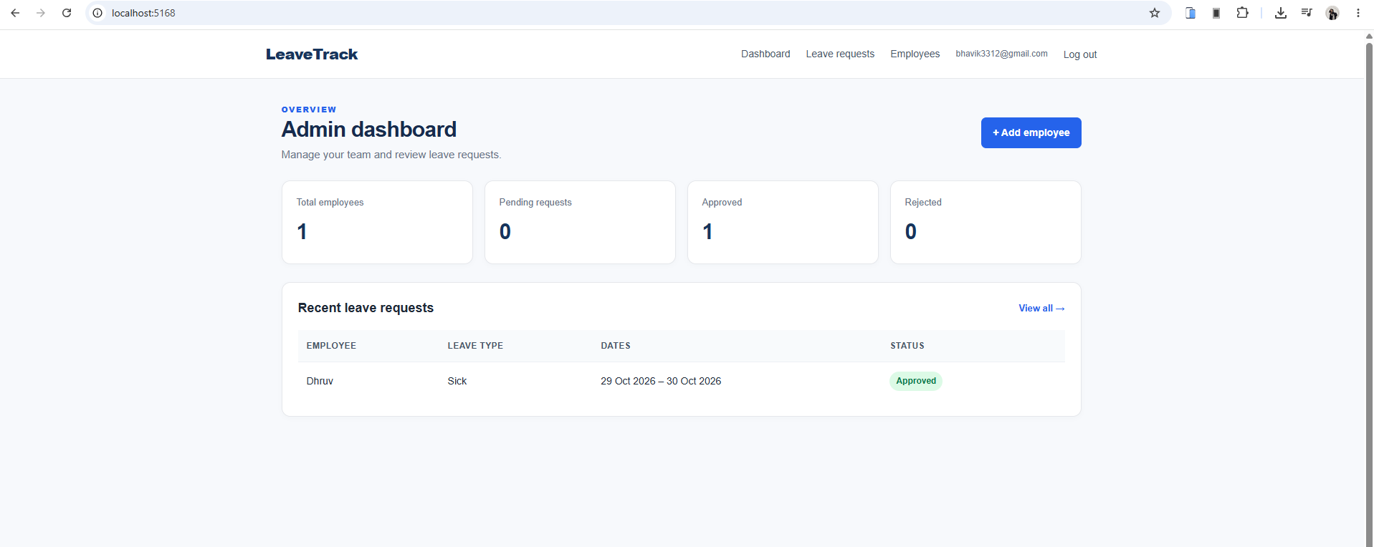

8.3 Employee List / Create Employee
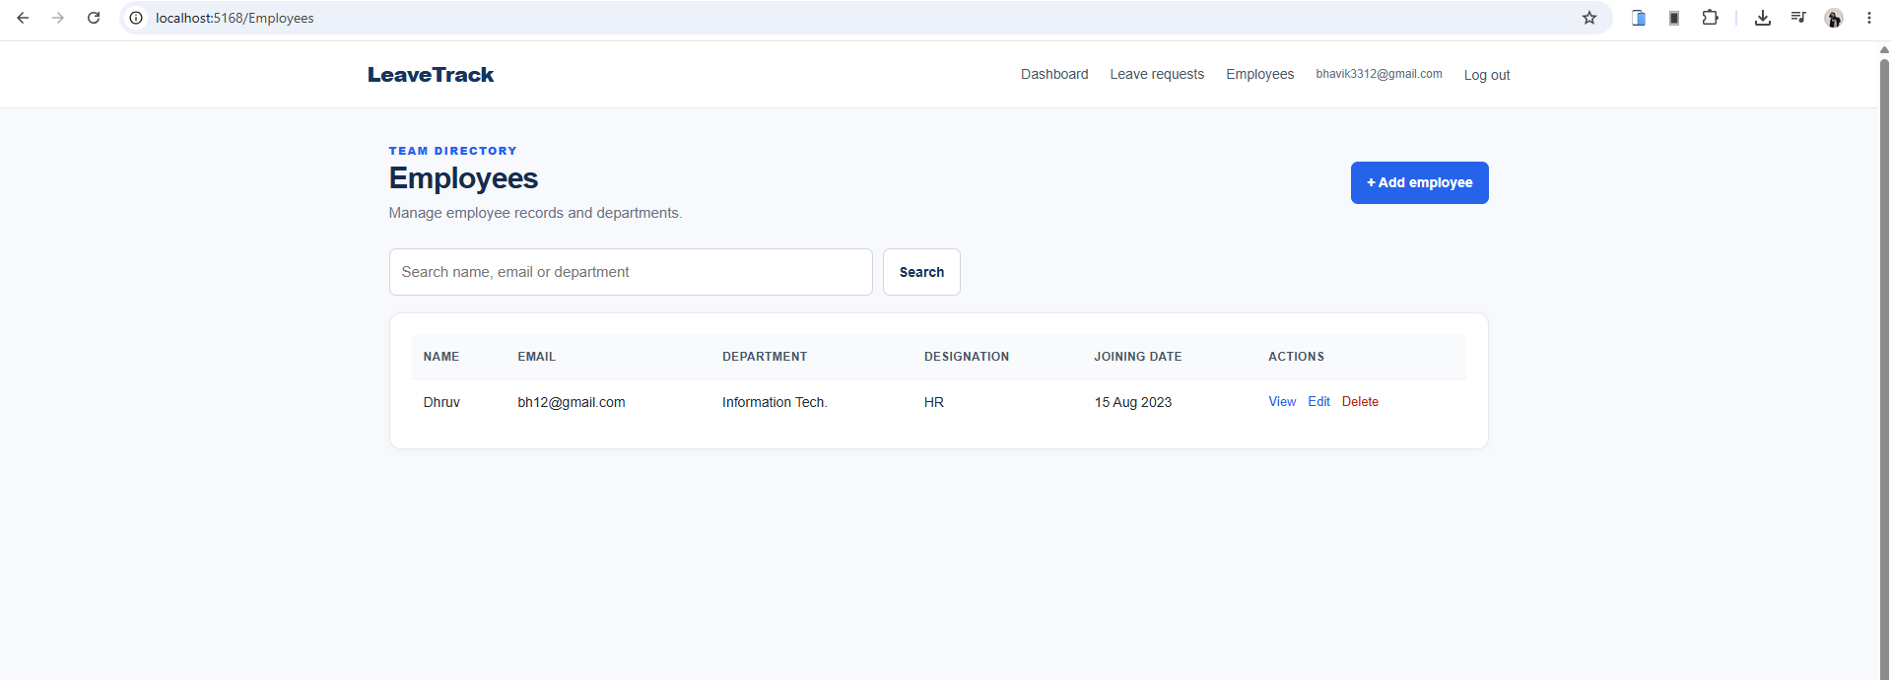

8.4 Employee Dashboard
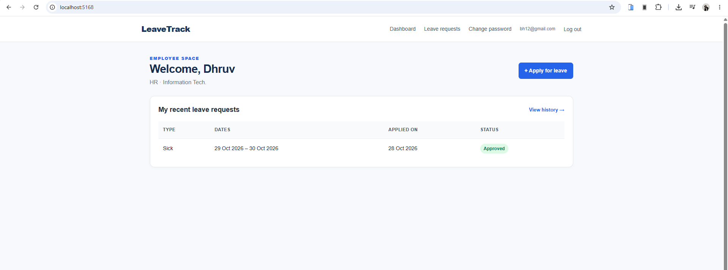

8.5 Apply for Leave
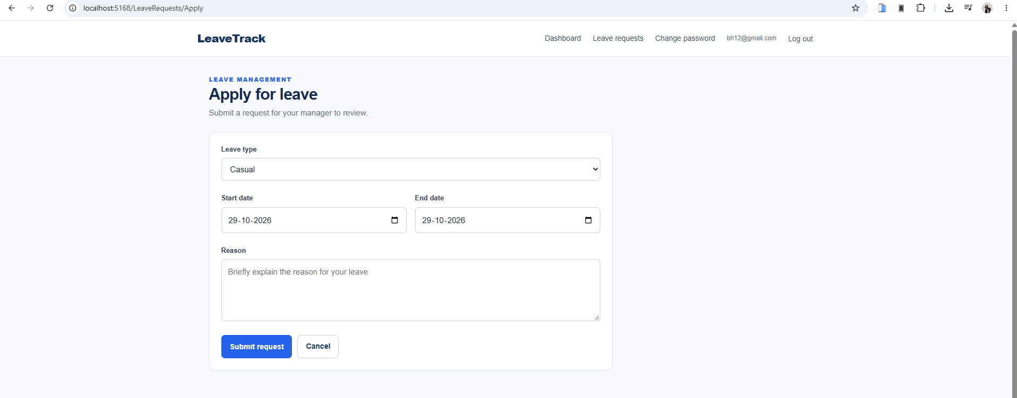

8.6 Leave History
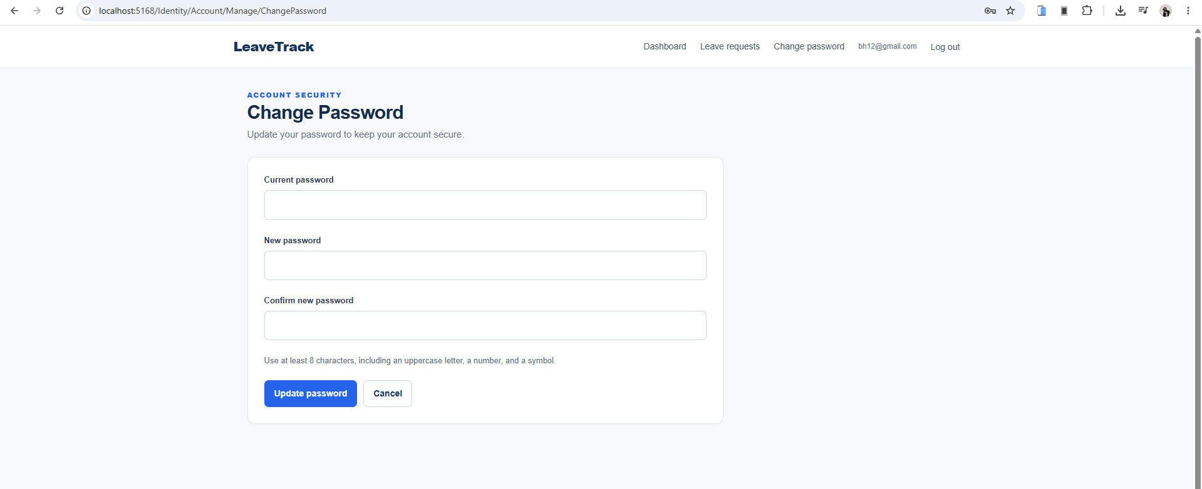

8.8 Change Password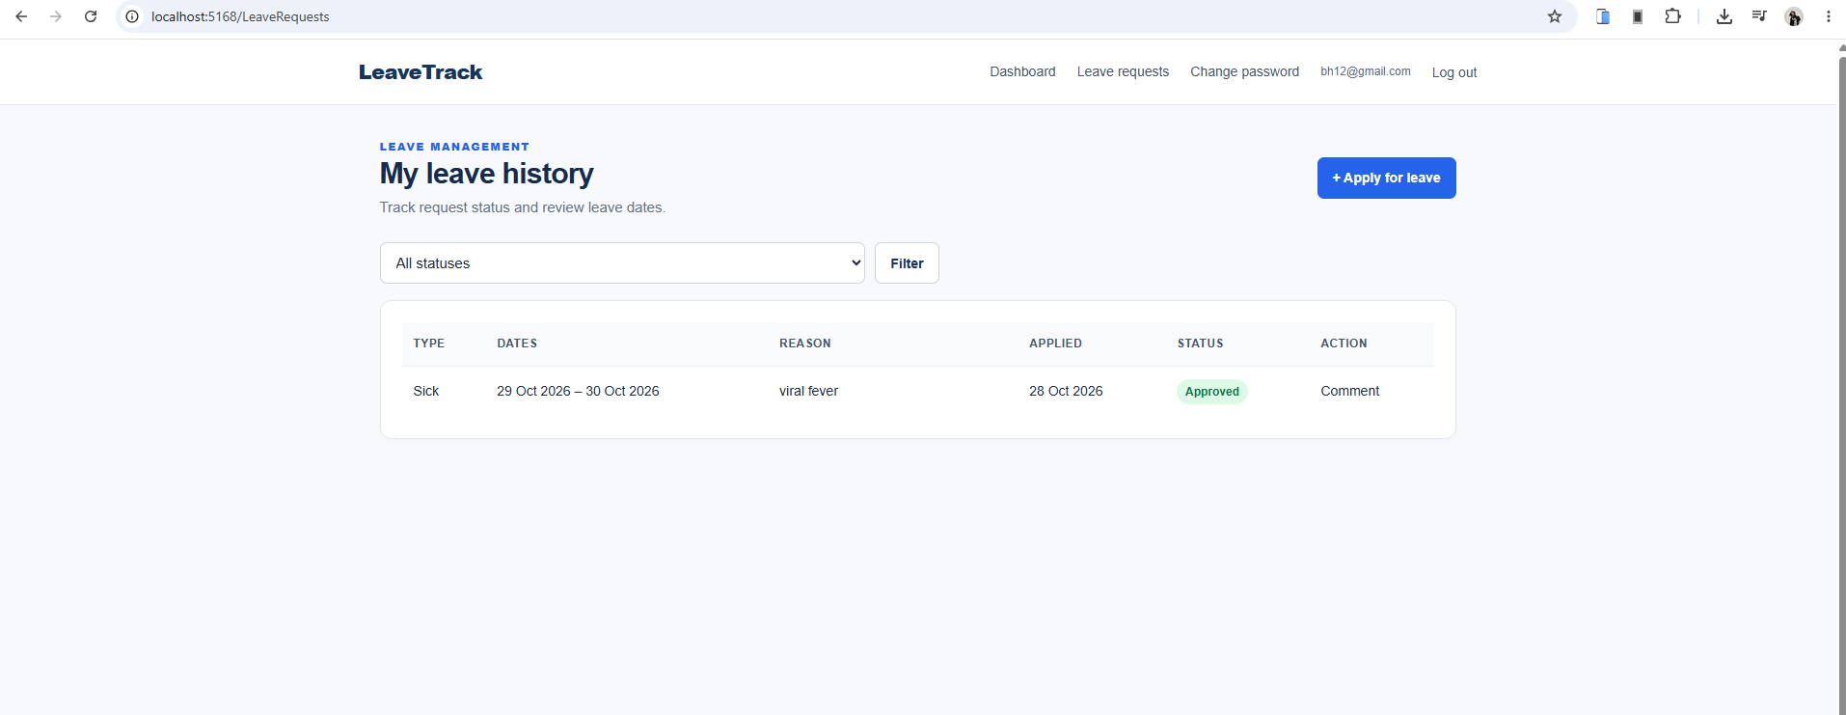

9. LIMITATIONS
- Email and SMS notifications are not implemented in the current version.
- Leave balances, accrual rules, and organization-specific holiday calendars are not included.
- Attendance, payroll, and shift management are outside the project scope.
- Advanced audit logging and detailed reporting are not implemented.
- API routes are protected and require an appropriate authentication setup for external clients.
- The project has not been independently security-audited for production deployment.
- Successful build and database tests must be confirmed on the target machine with the required .NET SDK and SQL Server installed.

9.1 Risk Mitigation
Use test accounts during demonstrations, keep passwords private, configure HTTPS, store secrets outside source code, back up the database, and test both Admin and Employee permissions before presenting the application.

10. FUTURE ENHANCEMENTS
- Email notifications for submission, approval, rejection, and cancellation.
- Leave balance tracking and configurable leave policies.
- Holiday calendar and organization-specific working days.
- Monthly and yearly leave reports with export to PDF or Excel.
- Audit logs for employee changes and administrative decisions.
- Department-level approval workflows and multiple administrator roles.
- Profile editing and account recovery features with secure verification.
- Improved API authentication for external applications.
- Automated unit, integration, and end-to-end tests.
- Deployment to a secure hosting platform with HTTPS, logging, backups, and monitoring.

10.1 Conclusion
The Employee Leave Management System demonstrates a practical use of full-stack web development concepts. It combines an MVC web interface, role-based authentication, relational data storage, leave validation, administrative review, and REST API endpoints. The project provides a useful academic foundation that can be expanded with organization-specific policies, notifications, reports, and production-grade operational controls.

11. REFERENCES
- Microsoft Learn — ASP.NET Core documentation: https://learn.microsoft.com/aspnet/core
- Microsoft Learn — ASP.NET Core Identity: https://learn.microsoft.com/aspnet/core/security/authentication/identity
- Microsoft Learn — Entity Framework Core: https://learn.microsoft.com/ef/core
- Microsoft Learn — SQL Server provider for EF Core: https://learn.microsoft.com/ef/core/providers/sql-server
- Microsoft Learn — ASP.NET Core Web API: https://learn.microsoft.com/aspnet/core/web-api
- Swashbuckle.AspNetCore / Swagger documentation: https://github.com/domaindrivendev/Swashbuckle.AspNetCore
- GitHub Repository: Employee Leave Management System
- Repository URL: https://github.com/bhavikparmar2006-i/Employee_Leave_Management_System.git

