MARKET ANALYSIS

Developing a Market Analysis for a new business or new product provides an entrepreneur a better understanding of the size and specific segments of a market, as well as an evaluation to determine if the target market will support the business’ growth plans. The Market Analysis is a critical part of any business plan created, whether to inform the business or to communicate to potential investors the size of the opportunity.

This analysis documents an overview of the industry that your business will participate in. As you narrow this sector down to the ideal customer based on your business strategy, you will define your target market. A detailed description and sizing of the target market will help the reader understand the market value you are pursuing (the number of potential customers multiplied by the average revenue for your product or service).

In defining the target market, you will identify key elements such as geographic location, demographics, buyer characteristics, your target market's needs and how these needs are being met currently. If there are any direct competitors, these should be compared to how your offering will solve it in the future.

This section may also include a SWOT (Strengths, Weaknesses, Opportunities, and Threats) Analysis as necessary, to better assess your business’ position against the competition.

Depending on the type of business you are operating, you may or may not need the following sections. Only include what you need and remove everything else.

**Industry Type:** Begin with the broader descriptions of your market opportunity. For instance, if you are planning to open a jewelry store, the industry type would be retail sales, but only locally versus if you sold online. Within the retail jewelry industry, globally, revenues are expected to exceed $250 billion by 2020, but your local jewelry store will have a much smaller market. Identify the number of families or customers in your local geography that might fit into your demographic target group.

* **Industry Category:** Describe the broad industry you will be working in. You want to look up specific SIC codes over the internet for the broad groupings.
* **Industry Characteristics:** What are the specific characteristics of the industry? Who are the main participants, at a high level? Customers, suppliers, competitors?
* **Trends:** How is it trending in terms of growth, new participants, new products?
* **Stability:** Comment on how stable the industry has been historically and how dynamic it is currently.

**Market Segmentation:** This section is where you will define the main market segments as well as the one or two you will be targeting. Begin with the Total Available Market (TAM) within the industry you plan to compete for. This includes all types of customers that have an interest in or need for your particular products or services. The Serviceable Available Market (SAM), is the subset of the TAM that your company can reasonably serve or market to effectively. Within the last group, is your Target Market which is a segment defined as a group of people (or other businesses). As your business expands, you can begin to assess what percentage of your target market you are winning, also defined as your market share.

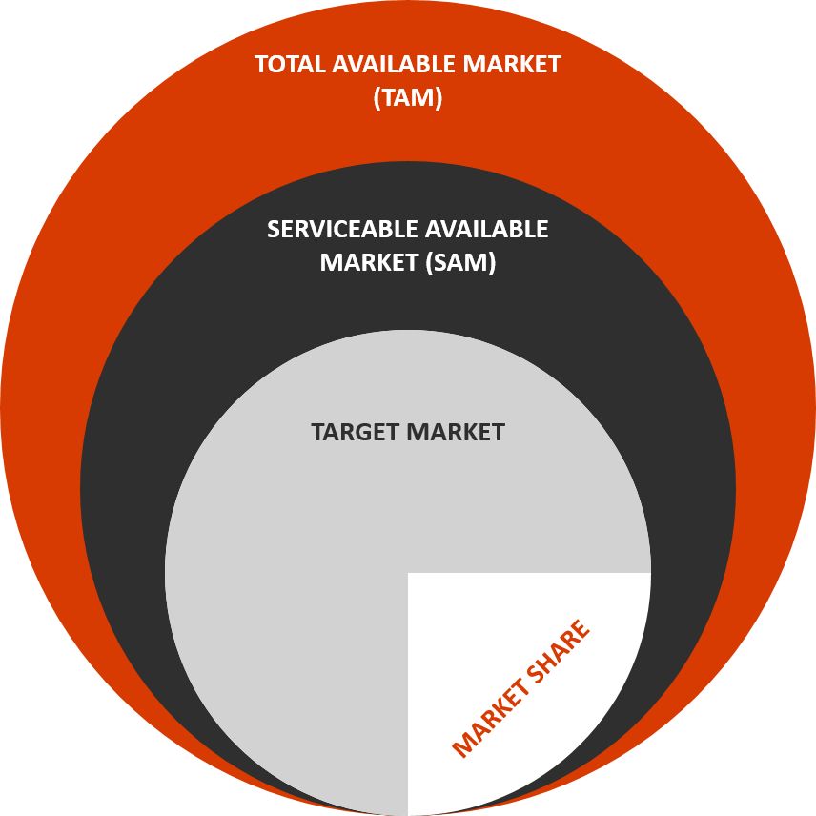

As one example, if your industry to do business in is the jewelry industry, the TAM would be everyone that is in the market for jewelry. The SAM, might be those in your city, if you are a local store. If you are an online jeweler, your SAM might be the entire United States. Finally, as you develop your unique offers, you might define your focus or target market (segment) as fine jewelry or wedding rings or casual jewelry within the geography you can service. You can also segment the market by criteria such as quality, price, range of products, geography, ethnicity, age group, or others. A few other elements to consider would be to answer questions such as: Is your segment growing, shrinking, or will it be flat for the next few years? What percentage of the market do you think you will be able to reach? What share of the market do you anticipate having within the next 2-3 years? Graphics are best used in a section like this to either show growth (line graph) or percentages of markets or groups (pie chart).

* **Total Available Market (TAM):** After defining the industry, provide some data on the total number of prospects in the industry or your more narrowly defined market. Is it the number of people above a certain income or households? Is it all businesses between $50 and $150 million? Is it all mothers? Is it all teenagers that drive cars?
* **Serviceable Available Market (SAM):** From the TAM described above, begin to narrow this down by the actual prospective customers you can reach (service, market to, supply, etc.). If you are a store selling goods, this might be all prospect types within a 10-mile radius. If you sell online, it might be across the country’s you target. For businesses, can you sell to all business anywhere or do they need to be within a certain geography?
* **Market Segments:** What are the main segments or groupings that could be defined from the overall industry? How do you categorize them: geography, customer demographics, ethnicity, age, type of business, prospective business customer type, etc.?
* **Target Market:** Now, after identifying various market segments, define your Target Market, specifically. Why are you choosing this target? Why do you think you will have success with this group? Why are you narrowing to only this group? Will you expand your Target Market in the future, why?

**Competition:** Businesses all compete in one way or another. It may be with specific, direct competitors or it may be with the way customers have been doing things for a long time. They solve their problem in a different way. When identifying the competition, you should identify who else is providing products or services to solve the same problem you are addressing? What are your business’ advantages over these competitors? How will your voice be heard over the noise of competitors? Sometimes a business plan includes a matrix of features and compares how each business offers or doesn’t offer those features. This section should reflect how your solution is different and better suited for the target market you have identified than the competition.

* **Direct Competitors:** Who are the main competitors you will go up against? How long have they been in the market? What are their advantages?
* **Status Quo:** Are you competing with the way people or businesses do things now? Do you have a disruptive product or service that will change their minds?
* **Messaging:** How will your product or service be positioned over the existing competition or status quo?
* **Uniqueness:** Why will your product or service capture market share? Will you be growing into parts of the market the competition has not reached or will have to have a customer switch to your product or service? How will you do this?

**SWOT Analysis:** You can include a SWOT analysis by completing the boxes below to assess your business in the current environment in terms of strengths and weaknesses (internal) and opportunities and threats (external). This is a good exercise to go through on an annual basis. After completing your analysis, provide your thoughts on: how your strengths can help you to maximize opportunities and minimize threats; how your weaknesses can slow your ability to capitalize on the opportunities; and how could your weaknesses expose you to threats?

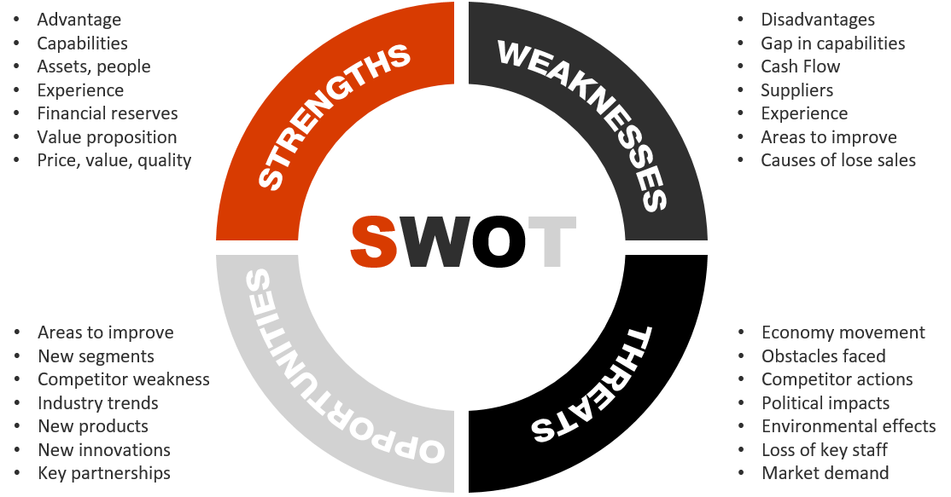

* **Strengths:** What will be your company’s strengths when you launch? How do you see this changing in the future?
* **Weaknesses:** **I**f you were the competition, what would you say to prospective customers about where your company’s products or services are weak or deficient? What are the most important weaknesses to overcome first?
* **Opportunities:** With product improvements or new partnerships, where could your business grow? What new segments could you enter in the future?
* **Threats:** What external factors could put pressure on your business growth or cash flow? Which of these threats can you control? Which ones can’t you control?