WCF Service Basics

1. **What is WCF?**

WCF or **Windows Communication Foundation** is a programming model to create service oriented applications. It is used to create and deploy the service that is accessible to lots of different clients. It provides an environment where you can create a service which can be accessible to Windows clients as well as Linux clients or any others. It provides more features compared to web services.

It will let you do the communication like MS messaging Queuing, Services, Remoting and so on. It also allows you talk with other.NET apps, or non-Microsoft technologies (like J2EE).

1. **Main components of WCF**

**Service**: Working business logic here

**Host**: The path where the data is saved. E.g., .exe, process, windows service

**Endpoints**: The way the service is exposed to the outside world

1. **How does WCF work?**

WCF follows the “**Software as a Service**” model, where all units of functionality are defined as services. For communication, each point is a portal or connection either with the client or other services. It is a program that exposes a collection of endpoints.

1. **Difference between web services (ASMX) and WCF**

**Web Service (ASMX)** was used to create services but that type of service is only accessible to Windows client hosted on HTTP protocol. But **WCF** services are accessible with different protocols like http, tcp, msmq (Microsoft Message Queuing), etc.

1. **WCF Architecture and fundamentals**

WCF is a runtime and a set of APIs for creating systems that sends messages between services and clients. The same infrastructure and APIs are used to create applications that communicate with other applications on the same computer system or on a system that resides in another company and is accessed over the Internet.

The WCF architecture consists of the following layers: (4 Major layers)

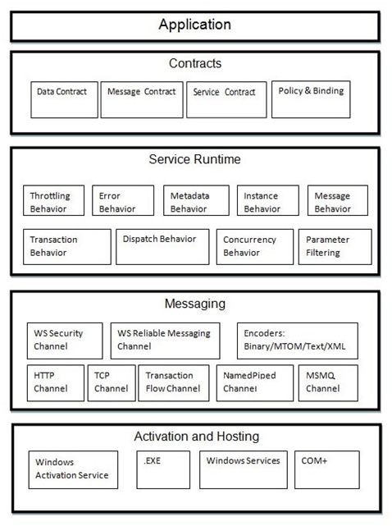

1. **Why to use WCF?**

* To exchange messages in XML format using HTTP protocol for interoperability.
* A remoting service to exchange messages in binary format using TCP protocol for performance.
  + A **secure service** to process business transactions.
  + A service that **supplies current data** to others, such as a traffic report or other monitoring service.
  + A **chat service** that allows two people to communicate or exchange data in real time.
  + A **dashboard application** that polls one or more services for data and presents it in a logical presentation.
  + A **Silverlight application to poll** a service for the latest data feeds.

1. **Advantages of WCF?**

* Service Oriented
* Location Independent
* Language Independent
* Platform Independent
* Support Multiple operation
* WCF can maintain transaction (like COM+ Does)
* It can maintain state
* It can control concurrency
* It can be hosted **on IIS, WAS, Self-hosting, Windows services**.

1. **WCF Contract types**

* **Service** Contracts
* **Data** Contracts
* **Fault** Contracts
* **Message** Contracts

1. **WCF supports below transport schemas**

* HTTP
* TCP
* Peer network
* IPC (Inter Process Communication)
* MSMQ

1. **List out the types of binding available in WCF?**

* BasicHttpBinding
* NetTcpBinding
* WSHttpBinding
* NetMsmqBinding