University of Waterloo Enrolment Prediction
Using Apache Spark MLlib

Project Report
Bhavin Prajapati, Amaru Izarra-Jacome, Anson Ho, Andrew Mathieu
Group 1
April 2026

Introduction
Universities face mounting pressure to forecast enrolment accurately. Budget allocations, staffing decisions, course scheduling, and infrastructure investments all depend on reliable projections of how many students will enroll in any given term, program, or campus. When these forecasts are inaccurate, institutions risk overspending on underutilized resources or being unable to accommodate student demand.
This report presents the findings of a data analytics project undertaken to address this challenge at the University of Waterloo. Using eight years of historical enrolment data (2016/17 through 2023/24) and Apache Spark MLlib, the team developed, evaluated, and deployed a machine learning system capable of predicting student headcounts across a wide range of academic configurations.
The dataset contains 61,273 records across 13 columns after cleaning, with a mean headcount of approximately 13.96 students per record, a standard deviation of 30.20, and values ranging from 1 to 552. Three regression models were built and compared: Linear Regression, Random Forest, and Gradient-Boosted Trees (GBT). The GBT model delivered the strongest predictive performance, explaining approximately 82.98% of the variance in enrolment headcounts (R² = 0.8298) with a mean absolute error of 4.61 students per record and an RMSE of 12.68.
The trained model was deployed through a FastAPI backend and paired with an interactive React-based frontend dashboard, allowing institutional planners to explore enrolment scenarios in real time.
Key findings from the exploratory analysis: undergraduate enrolment (716,370 total headcounts) dominates over graduate (138,748); Fall term accounts for the highest enrolment (325,000) followed by Winter (312,894) and Spring (217,224); the Faculty of Engineering has the largest total headcount followed by Mathematics and Arts; and the University of Waterloo main campus accounts for 831,903 out of 855,119 total headcounts across all campuses.

1. Objectives

1.1 Problem Statement
Enrolment forecasting at the University of Waterloo is complicated by the number of interacting variables that influence student headcounts. A student's choice to enrol in a given term depends on their career stage (undergraduate vs. graduate), program level (diploma, bachelor, master, doctoral), faculty, campus, attendance type, co-op status, visa category, and the fiscal year in question. Manual forecasting methods are poorly suited to capturing these interactions at scale.
The central question this project seeks to answer is: given a specific combination of academic and demographic parameters, how many students can the University of Waterloo expect to enrol? Answering this accurately and at scale requires a machine learning approach backed by a distributed computing framework.

1.2 Project Goals
The project was structured around five core objectives:
- Build a scalable data processing pipeline using Apache Spark capable of handling the full historical enrolment dataset.
- Develop and train multiple machine learning regression models to predict student headcounts.
- Evaluate and compare model performance using standard regression metrics to identify the best-performing approach.
- Deploy the selected model through a RESTful API backend to support real-time predictions.
- Create an interactive frontend dashboard allowing planners to configure scenarios and visualize predicted enrolment.

1.3 Research Questions
The exploratory analysis addressed four descriptive questions aligned with institutional planning needs:
- Who is enrolling? Analysis of undergraduate vs. graduate students, co-op vs. regular, and enrollment by study year.
- What programs are students enrolling in? Distribution across program levels, faculties, and top program groupings.
- Where are students enrolling? Breakdown by campus, including the University of Waterloo main campus and affiliated colleges.
- When are students enrolling? Analysis by term type and trends across fiscal years 2016/17 through 2023/24.

1.4 Hypothesis
The team hypothesized that tree-based ensemble models (Random Forest and Gradient-Boosted Trees) would outperform linear regression given the highly non-linear relationships between categorical enrolment factors and headcount outcomes. The skewed distribution of the target variable (mean approximately 13.96, standard deviation 30.20, maximum 552) further suggested that a log-transformation of the target would improve model stability. Both hypotheses were confirmed by the experimental results.

2. Data Preparation

2.1 Data Source
The dataset used in this project is the University of Waterloo Enrolment Dataset, published on Kaggle and sourced from the University of Waterloo's open institutional data portal. The dataset covers eight fiscal years from 2016/17 to 2023/24 and contains 61,273 records after data cleaning, across 13 columns. The dataset was accessed at: https://www.kaggle.com/datasets/chromaa/university-of-waterloo-enrolement

2.2 Dataset Structure
The dataset contains 12 categorical feature columns and one integer target column (Student Headcounts). A summary is provided in Table 1 below.

Table 1: Dataset features, types, and key statistics confirmed from notebook output.
Feature | Type | Description / Distinct Values
Fiscal Year | Categorical | Academic year (e.g., 2023/24) | 8 distinct values
Term Type | Categorical | Fall term, Winter term, Spring term | 3 distinct values
Career | Categorical | Undergraduate or Graduate | 2 distinct values
Program Level | Categorical | Diploma, Bachelors, Masters, Doctoral, etc. | 6 distinct values
Study Year | Categorical | Year of study (1, 2, 3, 4, M, D, N, S) | 8 distinct values
Campus | Categorical | UW main campus and 5 affiliated campuses | 6 distinct values
Faculty (group) | Categorical | ENG, MATH, ARTS, SCI, HEA, ENV, etc. | 11 distinct values
Program Grouping | Categorical | Specific program name | 144 distinct values
Coop Regular | Categorical | Co-op or Regular | 2 distinct values
Work Term | Categorical | Academic Term or Work Term | 2 distinct values
Attendance | Categorical | Full-Time or Part-Time | 3 distinct values
Visa Status | Categorical | Canadian, Canadian Permanent Resident, International | 3 distinct values
Student Headcounts | Integer (Target) | Count: 61,273 | Mean: 13.96 | Std: 30.20 | Min: 1 | Max: 552 | 337 distinct values

2.3 Data Quality
The dataset was of good overall quality. No significant encoding errors or structural issues were identified. Rows containing null values in any column were removed to produce the final 61,273-record working dataset. The target variable (Student Headcounts) exhibits a heavily right-skewed distribution (mean 13.96, std 30.20, max 552), which was addressed through log-transformation during preprocessing.

2.4 Data Procurement
The dataset was downloaded directly from the Kaggle platform and loaded into Apache Spark using PySpark's CSV reader with schema inference enabled. No web scraping or proprietary data access was required.

2.5 Preprocessing and Feature Engineering
The following preprocessing steps were applied to prepare the data for machine learning:
- Null removal: All rows with null values in any column were dropped prior to modelling.
- Log transformation of the target: A log1p transformation (log(1 + x)) was applied to the target variable to address its right-skewed distribution. Predictions are inverse-transformed using expm1() before evaluation.
- Numeric year extraction: A continuous numeric feature (numeric_year) was extracted from the Fiscal Year string (e.g., '2016/17' becomes 2016.0) to capture year-over-year trends as a continuous signal.
- StringIndexer encoding: All 12 categorical columns were encoded using PySpark's StringIndexer, converting string categories to integer indices.
- OneHotEncoder (Linear Regression only): For the linear model, indexed categories were further one-hot encoded. Tree-based models used integer indices directly, which is more efficient for high-cardinality features like Program Grouping (144 distinct values).
- VectorAssembler: Encoded feature columns and numeric_year were assembled into a single feature vector for model input.

The 80/20 train-test split produced a training set of 49,087 records and a test set of 12,186 records (random seed = 42).

3. Analysis

3.1 Exploratory Data Analysis

3.1.1 Who is Enrolling?
Undergraduate students account for the large majority of enrolment activity with 716,370 total headcounts across the study period (50,015 records), compared to 138,748 for graduate students (11,258 records). Co-op students account for 517,106 headcounts versus 338,012 for Regular stream students, reflecting the prominence of co-op programs at Waterloo.
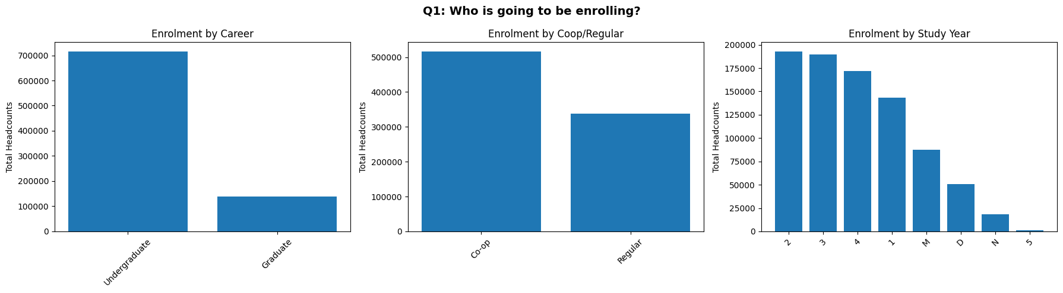
Figure 1: Q1 analysis showing enrolment by career, co-op stream, and study year.

3.1.2 What Programs are Students Enrolling In?
Bachelor's programs dominate enrollment by a wide margin. At the faculty level, Engineering (ENG) has the highest total headcount, followed by Mathematics (MATH), Arts (ARTS), and Science (SCI). Computer Science is the single largest program grouping, followed by Mathematics, Accounting and Financial Management, and Mechanical Engineering.
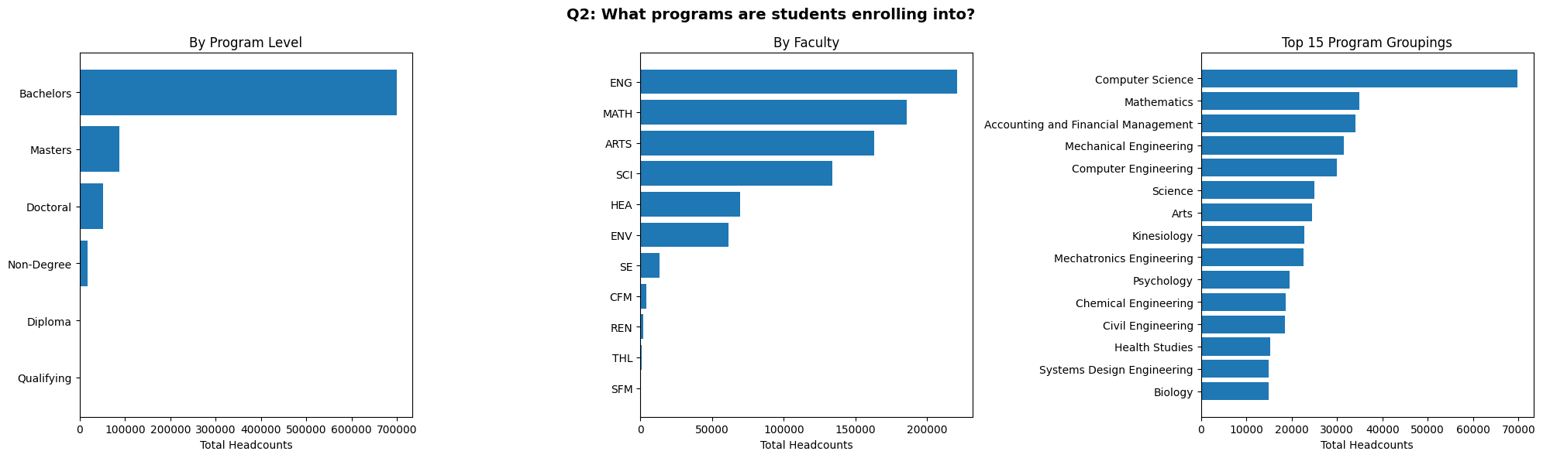
Figure 2: Q2 analysis showing enrolment by program level, faculty, and top 15 program groupings.
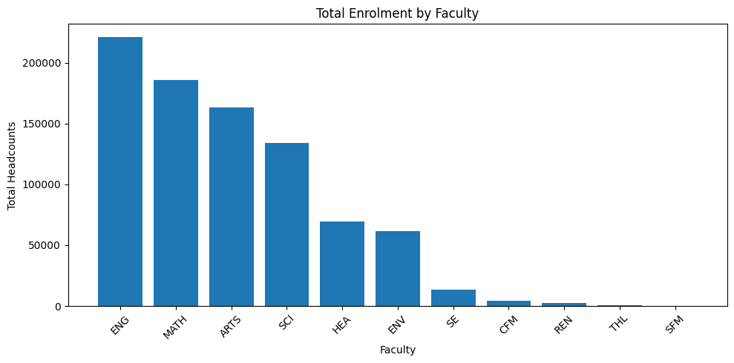
Figure 3: Total enrollment by faculty across all fiscal years.

3.1.3 Where are Students Enrolling?
The University of Waterloo main campus accounts for 831,903 headcounts out of 855,119 total. Renison University College contributes 12,168, St. Jerome's University 10,171, Conrad Grebel University College 629, Online Renison 168, and Online 79. All affiliated campuses are small relative to the main campus.
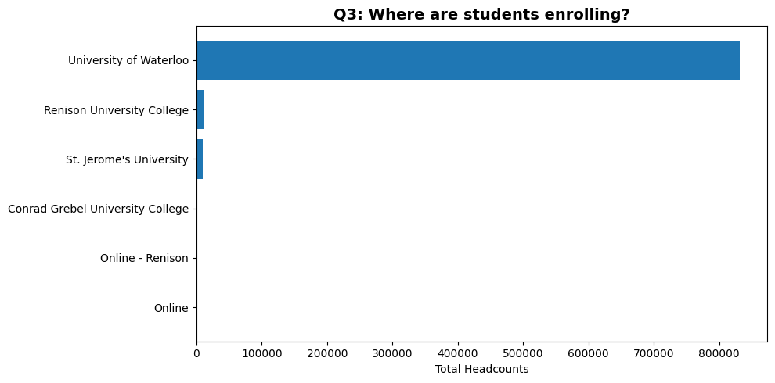
Figure 4: Q3 analysis showing enrollment by campus.

3.1.4 When are Students Enrolling?
Fall term has the highest total headcount (325,000) followed by Winter term (312,894) and Spring term (217,224). Total annual headcounts grew from approximately 98,000 in 2016/17 to a peak of approximately 112,000 in 2021/22 before stabilizing near that level through 2023/24.
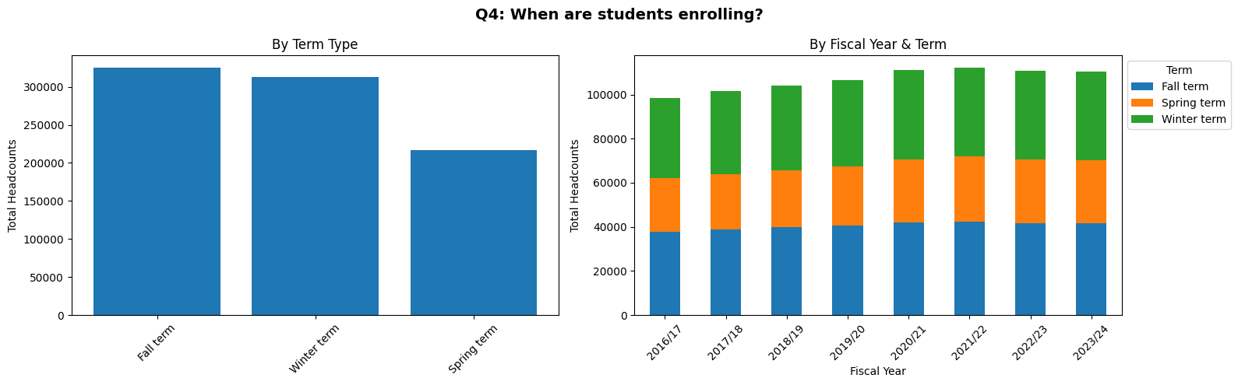
Figure 5: Q4 analysis showing enrolment by term type and by fiscal year and term.
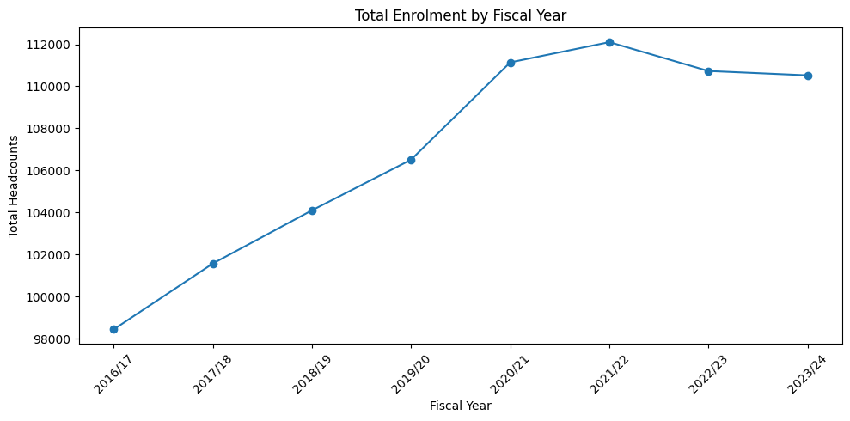
Figure 6: Total enrollment trend by fiscal year (2016/17 through 2023/24).

3.2 Model Training and Cross-Validation
Three regression models were trained using PySpark MLlib with 3-fold cross-validation for hyperparameter tuning. Cross-validation was performed on the training set of 49,087 records, and final evaluation was conducted on the held-out test set of 12,186 records. The CV evaluator used RMSE on log-transformed labels for tuning; final reported metrics are on the original headcount scale after inverse-transforming predictions with expm1().
The hyperparameter grids explored during cross-validation were as follows. Linear Regression: regParam values {0.001, 0.01, 0.1}; elasticNetParam values {0.0, 0.5, 1.0}; maxIter = 100. Random Forest: numTrees = 200; maxDepth values {10, 15}; featureSubsetStrategy = 'sqrt'; maxBins = 150. Gradient-Boosted Trees: maxIter = 100; maxDepth values {5, 8}; stepSize values {0.05, 0.1}; subsamplingRate = 0.8; maxBins = 150.

3.3 Model Comparison Results
The performance of all three models on the held-out test set is summarized in Table 2 below.

Table 2: Model performance on the held-out test set (12,186 records, original headcount scale). All values taken directly from notebook output.
Model | RMSE | R² | MAE
Linear Regression | 27.4351 | 0.2033 | 10.4167
Random Forest | 18.5091 | 0.6374 | 6.4850
Gradient-Boosted Trees (selected) | 12.6811 | 0.8298 | 4.6121

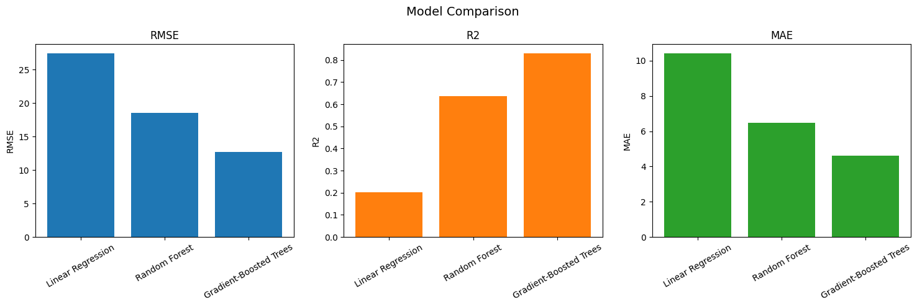
Figure 7: Model comparison showing RMSE, R², and MAE across all three models.
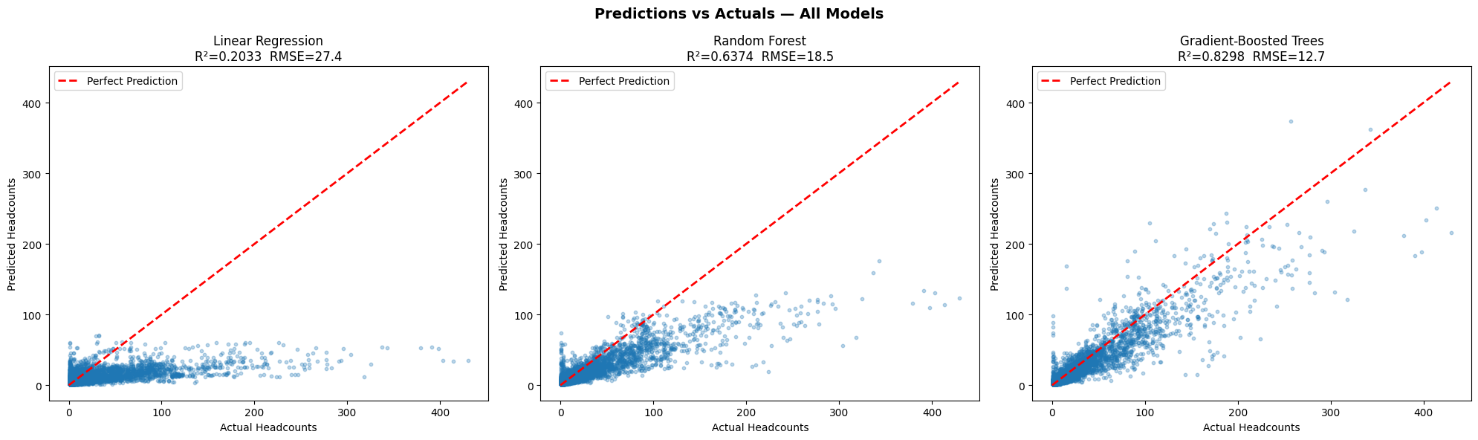
Figure 8: Predictions vs. Actuals scatter plots for all three models. The dashed red line represents a perfect prediction.
Linear Regression performed poorly with an R² of 0.2033, confirming that a linear combination of encoded categorical features cannot adequately capture enrolment patterns. Random Forest improved substantially to R² = 0.6374 and MAE = 6.4850. Gradient-Boosted Trees delivered the best performance across all three metrics, with R² = 0.8298, RMSE = 12.6811, and MAE = 4.6121 students per record.

3.4 Feature Importance
The Random Forest model provides feature importance scores indicating which variables drive headcount predictions. Program Grouping is by far the most important feature, followed by Visa Status and Attendance. Faculty (group) and Study Year are moderately important, while Career and numeric_year have the lowest importance scores.
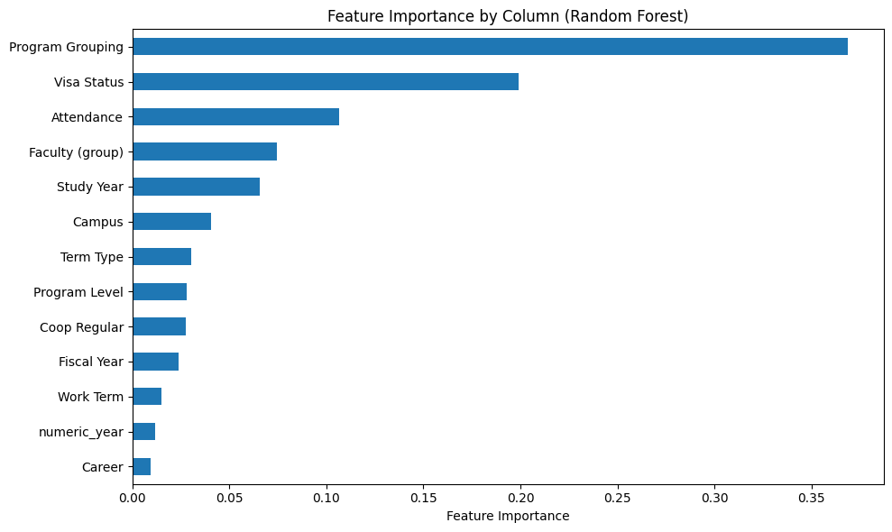
Figure 9: Feature importance scores from the Random Forest model, ranked by contribution.

3.5 Methodological Notes
Two methodological observations are worth noting for transparency. First, cross-validation tuned hyperparameters using RMSE on log-transformed labels, while final model selection used R² on original-scale predictions. In this case all three models ranked identically under both criteria, so the inconsistency did not affect the outcome. Second, all three models were evaluated on the same test set, and the winning model was selected based on those test scores. This means the test set played a dual role (evaluation and selection), which can produce mildly optimistic reported metrics. Given that only three models were compared, the magnitude of this effect is small. Both observations are acknowledged as known limitations of the current methodology.

4. System Architecture and Deployment
A key distinguishing feature of this project is that it goes beyond a standalone modelling exercise to deliver a fully operational prediction system. The architecture consists of three layers: a trained machine learning backend, a RESTful API middleware, and an interactive frontend dashboard.

4.1 Machine Learning Backend
All three trained models are serialized as PySpark PipelineModel objects and saved to disk under the models/ directory, with each pipeline encapsulating both the preprocessing stages and the trained regressor. A metadata JSON file (models/metadata.json) records each model's evaluation metrics and identifies the best-performing model, allowing the API to discover the optimal model at startup without hardcoded references.

4.2 FastAPI Backend
The API is implemented using FastAPI and exposes three endpoints: GET /models returns all available models with their evaluation metrics; POST /predict accepts a JSON enrolment scenario and returns the predicted headcount using the best model by default, with an optional query parameter to select a specific model; and POST /predict/batch accepts a list of scenarios for bulk prediction. The server starts on http://localhost:8000 with interactive documentation available at http://localhost:8000/docs.

4.3 React Frontend Dashboard
The frontend is built with React and Vite and provides an interactive enrollment prediction dashboard. Users select parameters from dropdown menus covering all 12 input features and receive a predicted headcount in real time. This provides non-technical institutional planners with direct access to enrolment estimates without interacting with the API directly.

5. Conclusions

5.1 Key Findings
This project successfully demonstrated that scalable machine learning techniques can be applied to predict university enrolment headcounts with meaningful accuracy. The principal findings are as follows:
- The Gradient-Boosted Trees model is the best-performing regressor for this dataset with R² = 0.8298, RMSE = 12.6811, and MAE = 4.6121 students per record, making it practically useful for planning purposes at the program or faculty level.
- Linear models are insufficient for this task. The R² of 0.2033 for Linear Regression confirms that complex interactions between categorical enrolment factors cannot be captured linearly.
- Program Grouping and Visa Status are the two most important predictors of enrollment headcount according to the Random Forest feature importance analysis.
- Enrolment is dominated by undergraduate students (716,370 vs. 138,748 for graduate), by the University of Waterloo main campus (831,903 out of 855,119 total headcounts), and by Fall and Winter terms (325,000 and 312,894 respectively vs. 217,224 for Spring).
- Total annual enrolment grew from approximately 98,000 headcounts in 2016/17 to a peak of approximately 112,000 in 2021/22 and has remained near that level through 2023/24.
- Engineering is the largest faculty by total headcount, followed by Mathematics, Arts, and Science.

5.2 Limitations
Several limitations should be considered when interpreting these results:
- External factors such as tuition fee changes, immigration policy shifts, and global economic conditions are not represented in the model.
- The model is trained on historical patterns from 2016/17 through 2023/24 and may not generalize well to unprecedented structural changes in enrollment.
- The test set was used for both evaluation and model selection, introducing mild optimism into the reported metrics for the winning model.
- The dataset ends at fiscal year 2023/24; periodic retraining will be necessary as new data becomes available.

5.3 Recommendations
Based on the findings of this project, the following recommendations are offered to the University of Waterloo:
- Retrain the model annually as new fiscal year data becomes available to maintain prediction accuracy.
- Incorporate additional predictors where available, such as admission acceptance rates, tuition data, and national immigration policy indicators.
- Track prediction accuracy against actual enrollment outcomes each term. Significant degradation in R² or MAE is a signal to retrain.
- Generate headcount projections across multiple scenarios simultaneously to support strategic what-if analysis.

5.4 Summary
This project produced a functional, end-to-end enrolment prediction system grounded in rigorous data analysis and validated against held-out test data. The Gradient-Boosted Trees model, served through a FastAPI backend and accessible via an interactive React dashboard, provides institutional planners with a practical tool for exploring enrollment projections. The methodology is transparent, reproducible via the accompanying Jupyter notebook, and extensible as new data and requirements emerge.

References
chromaa. (2024). University of Waterloo Enrolment [Data set]. Kaggle. https://www.kaggle.com/datasets/chromaa/university-of-waterloo-enrolement

Apache Software Foundation. (2024). MLlib: Machine Learning Library. Apache Spark Documentation. https://spark.apache.org/docs/latest/ml-guide.html

FastAPI. (2024). FastAPI Documentation. https://fastapi.tiangolo.com

Friedman, J. H. (2001). Greedy function approximation: A gradient boosting machine. Annals of Statistics, 29(5), 1189-1232. https://doi.org/10.1214/aos/1013203451

Appendix A: Sample Data Records
The following table presents the first ten records from the dataset as shown by df.show(10) in the notebook, illustrating its structure and content.

Table A1: First 10 records from waterloo-enrolement-2024.csv. HC = Student Headcounts; CA PR = Canadian Permanent Resident; UW = University of Waterloo.
F.Year | Term | Career | Prog.Lvl | Yr | Campus | Fac. | CoOp | Attend. | Visa | HC
2016/17 | Fall | Graduate | Diploma | N | UW | ENG | Regular | Part | CA PR | 1
2016/17 | Fall | Graduate | Diploma | N | UW | ENG | Regular | Part | Canadian | 2
2016/17 | Fall | Graduate | Diploma | N | UW | ENG | Regular | Part | CA PR | 1
2016/17 | Fall | Graduate | Diploma | N | UW | ENG | Regular | Part | Canadian | 1
2016/17 | Fall | Graduate | Diploma | N | UW | ENV | Regular | Part | Canadian | 1
2016/17 | Fall | Graduate | Doctoral | D | UW | ARTS | Regular | Full | Intl. | 4
2016/17 | Fall | Graduate | Doctoral | D | UW | ARTS | Regular | Full | CA PR | 1
2016/17 | Fall | Graduate | Doctoral | D | UW | ARTS | Regular | Full | Canadian | 7
2016/17 | Fall | Graduate | Doctoral | D | UW | ARTS | Regular | Part | CA PR | 1
2016/17 | Fall | Graduate | Doctoral | D | UW | ARTS | Regular | Full | Intl. | 10

Appendix B: API Reference
The following summarizes the REST API endpoints exposed by api.py. Interactive documentation is available at http://localhost:8000/docs when the server is running.

Table B1: API endpoint summary.
Method | Endpoint | Description
GET | /models | Returns all available models with RMSE, R², and MAE metrics.
POST | /predict | Accepts a JSON enrolment scenario and returns the predicted headcount. Optional ?model_name= selects a specific model.
POST | /predict/batch | Accepts a list of enrolment scenarios and returns batch predictions.

B.1 Predict Request Body Fields

Table B2: POST /predict request body fields.
Field | Example Value | Notes
fiscal_year | "2023/24" | 8 values: 2016/17 through 2023/24
term_type | "Fall term" | Fall term, Winter term, Spring term
career | "Undergraduate" | Undergraduate or Graduate
program_level | "Bachelors" | Diploma, Bachelors, Masters, Doctoral, Non-Degree, Qualifying
study_year | "3" | 1, 2, 3, 4, M, D, N, S
campus | "University of Waterloo" | 6 campuses including affiliated colleges
faculty_group | "MATH" | 11 faculties: ENG, MATH, ARTS, SCI, HEA, ENV, SE, CFM, REN, THL, SFM
program_grouping | "Computer Science" | 144 distinct program groupings
coop_regular | "Co-op" | Co-op or Regular
work_term | "Academic Term" | Academic Term or Work Term
attendance | "Full-Time" | Full-Time or Part-Time
visa_status | "Canadian" | Canadian, Canadian Permanent Resident, International

