**User Manual:**

Here are basic operations which user would like to perform. Here are steps to perform basic operations. I have attached urls and screen shots for each operation so you can perform each operation and compare output for doctor patient webservices.

[**Prerequisites**](https://www.google.com/search?q=Prerequisites&spell=1&sa=X&ved=0ahUKEwius9Gfq7zMAhXCuIMKHacqBEMQvwUIGigA)**:**

1. Deploy drpatients webservice successfully.

After you copy FinalProject folder, go to command prompt and go to FinalProject Folder. Run ant script to create a drpatients webservices.

**ant -Dwar.name=drpatients deploy**

1. Make sure Tomcat server is up and running.

**Basic Operations:**

* **Get a list of all doctors along with their patients in XML and plain text.**

Get a list of all doctors along with their patients in plain text

[**http://localhost:8080/drpatients/resourcesDr/plain**](http://localhost:8080/drpatients/resourcesDr/plain)

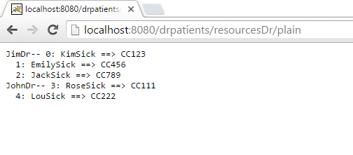

Get a list of all doctors along with their patients in XML text

**http://localhost:8080/drpatients/resourcesDr/xml**

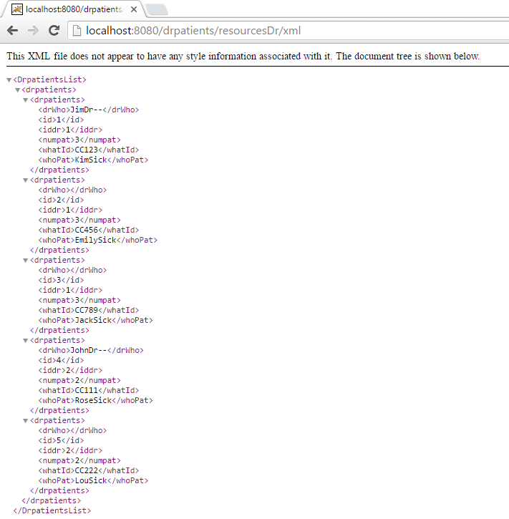

* **Get a list of an individual doctor and his/her patients in XML and plain text: (given an id for the individual doctor)**

Get a list of an individual doctor and his/her patients in plain text using id

**http://localhost:8080/drpatients/resourcesDr/plain/1**

[**http://localhost:8080/drpatients/resourcesDr/plain/2**](http://localhost:8080/drpatients/resourcesDr/plain/2)

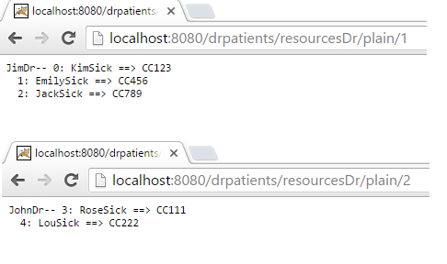

Get a list of an individual doctor and his/her patients in xml using id

[**http://localhost:8080/drpatients/resourcesDr/xml/1**](http://localhost:8080/drpatients/resourcesDr/xml/1)

[**http://localhost:8080/drpatients/resourcesDr/xml/2**](http://localhost:8080/drpatients/resourcesDr/xml/2)

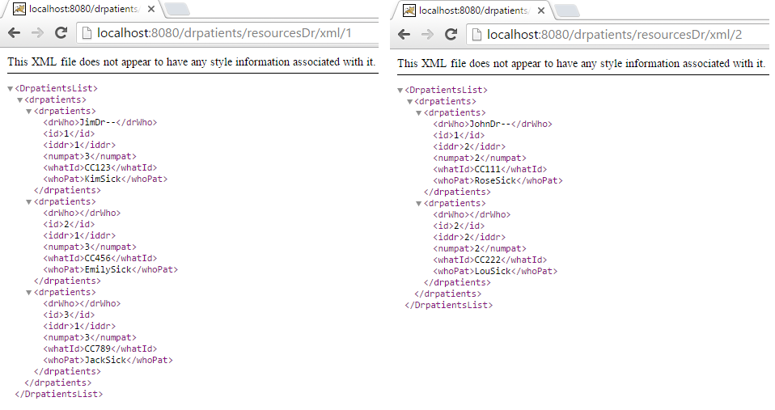

* **Add or create a new doctor along with his/her patients to the existing list.**

1. Go to folder in command prompt where curl utility is installed.
2. Create a doctor and his and her patients to existing list.

Curl –-request POST –data "id=3&dr=JohnDr!2&paients=MaySick!CC001,LoySick!CC002" <http://localhost:8080/drpatients/resourcesDr/create>

1. Make sure your doctor and patient is created by running get operations.

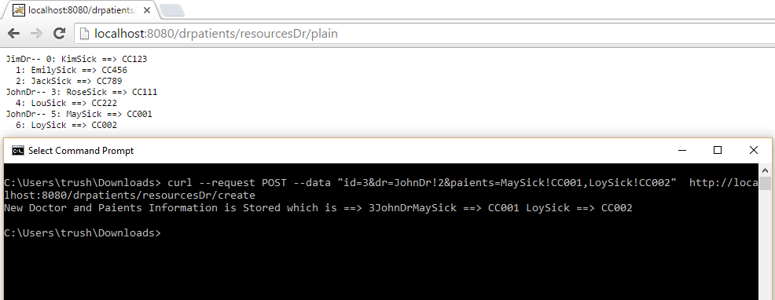

* **Update (modify) a doctor’s name only on an existing list of doctor-patients: (given an id for the doctor along with a new name).**

1. Go to folder in command prompt where curl utility is installed.
2. Update a doctor from a existing list by given doctor id.

curl –-request PUT -–data "id=3&dr=JamesDr!2" <http://localhost:8080/drpatients/resourcesDr/update>

1. Make sure your doctor and patient is created by running get operations.

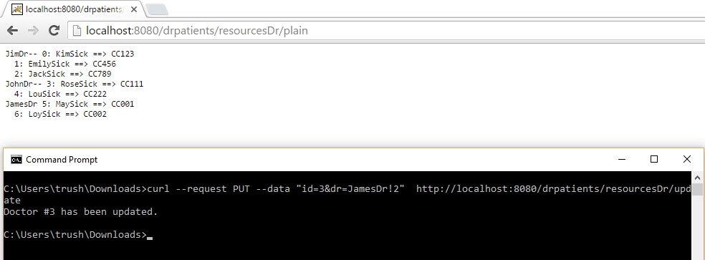

* **Delete or remove an existing doctor along with his/her patients: (given an id for the doctor).**

1. Go to folder in command prompt where curl utility is installed.
2. Delete a doctor from a existing list by given doctor id.

curl --request DELETE http://localhost:8080/drpatients/resourcesDr/delete/3

1. Make sure your doctor and patient is created by running get operations.

